WEATHER CLIMATE WATER

GLOBAL SEASONAL
CLIMATE UPDATE
Pre-Operational Phase
TARGET SEASON: March-April-May 2020

Issued: 25 February 2020

Summary
Observed sea surface temperatures anomalies in the east-central topical Pacific were in a neutral El Niño condition during November 2019-January 2020 with somewhat above-normal conditions near the date line. However, a notable feature was a strong positive phase of the Indian Ocean Dipole (IOD) with large below-normal sea surface temperature anomalies in the eastern Indian Ocean south of Indonesian Archipelago. The strength of the IOD, however, declined from previous months. The sea surface temperatures in the Niño 3.4 and Niño 3 regions, both of which are often used to characterize ENSO conditions, are predicted to decrease from approximately 0.5 or 0.6 to 0.3 or 0.4 °C during the March-May 2020 season, and hence, are expected to remain in a near-average range.
Influences from the expected tendency towards positive sea surface temperature anomalies across sizeable portions of the globe, both in the tropics (except for near-average conditions in the central and eastern Pacific) and extra-tropics, are seen in the temperature forecast for March-May 2020, which leans quite strongly, on average, towards above-normal land temperature, particularly at tropical latitudes. The near-average sea surface conditions predicted in much of the eastern equatorial Pacific may noticeably affect the overlying tropical atmospheric circulation and climate, as they participate in the SST gradients with positive SST anomalies in the western Pacific. A global warming trend also contributes to the sea surface temperature and air temperature forecast, leading to a general prevalence towards a positive tilt in anomalies defined using the climatological base period (1993–2009) centred more than 10 years in the past.
Near-average precipitation conditions are expected in the central and eastern equatorial Pacific, and an enhanced probability for above normal precipitation is expected just north of the equator in the central tropical Pacific and southwestern Indian Ocean extending into eastern equatorial Africa. Some tilts of the odds for precipitation are likely associated with sea surface temperature anomalies, such as the above-average precipitation in eastern equatorial Africa with the positive sea surface temperature anomalies in the western Indian Ocean. A southwest to northeast band of below-normal odds for precipitation also stretches from the western tropical to northern extratropical Pacific. An enhanced probability for below-normal precipitation is predicted for northern South America, Central America and the Caribbean.

Surface Air Temperature, MAM 2020  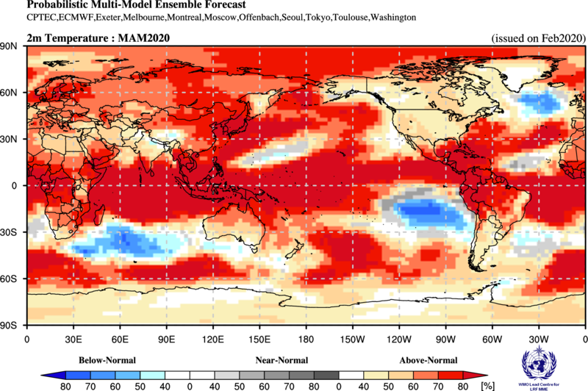 | Precipitation, MAM 2020  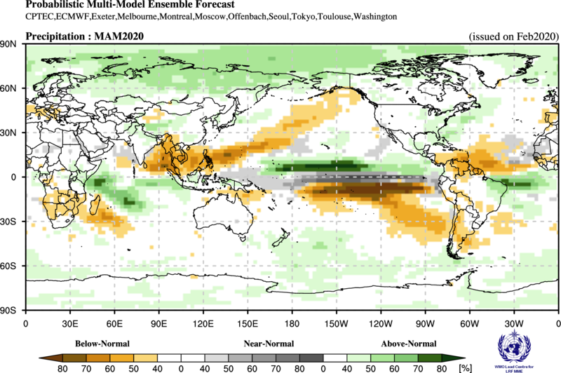

Figure 1. Probabilistic forecasts of surface air temperature and precipitation for the season March-April-May 2020. The tercile category with the highest forecast probability is indicated by shaded areas. The most likely category for below-normal, above-normal and near-normal is depicted in blue, red and grey shadings respectively for temperature, and orange, green and grey shadings respectively for precipitation. White areas indicate equal chances for all categories in both cases. The baseline period is 1993–2009.

1. Observations: November 2019 – January 2020
In the following sections, observed temperature and precipitation patterns for the period November 2019 – January 2020 are briefly described. For more detailed information about regional and local climate anomalies, the reader is referred to the concerned WMO Regional Climate Centres (RCCs) or RCC Networks, listed in Section 5.

1.1 Large-scale sea surface temperature (SST) indices
Except for the far eastern Pacific region of Niño 1+2, where sea surface temperatures (SST) were near normal, SSTs were either just slightly above-normal (Niño 3) or were more clearly above-normal across other ENSO regions of the Pacific during November 2019-January 2020, more so in the central Pacific (Niño 4) than in the east-central Pacific (Niño 3.4). The SST conditions generally characterized a neutral ENSO system. SST anomalies in Niño 4 and Niño 3.4 regions increased from their somewhat above-normal values in August-October 2019, indicating an increasing tilt towards El Niño conditions. The Indian Ocean Dipole (IOD) over the period had a strong decline from strongly positive towards neutral conditions. The North Tropical Atlantic (NTA) SST index was near neutral and the South Tropical Atlantic (STA) index showed above normal conditions.

Month | Niño 1+2 | Niño 3 | Niño 4 | Niño 3.4 | IOD | NTA | STA
Nov 2019 | -0.27 | 0.48 | 0.84 | 0.61 | 1.89 | 0.11 | 0.65
Dec 2019 | 0.34 | 0.33 | 1.01 | 0.50 | 0.89 | 0.09 | 0.8
Jan 2020 | -0.04 | 0.16 | 0.97 | 0.51 | 0.16 | 0.17 | 1.15
Nov 2019-Jan 2020 | 0.01 | 0.32 | 0.94 | 0.54 | 0.98 | 0.12 | 0.87

Table 1. Large-scale oceanic indices (°C). Anomalies are with respect to the 1981–2010 average. (Source: U.S. Climate Prediction Center)

1.2 Observed temperature
Temperature anomalies across the globe continued the trend of warmer-than-normal conditions for the months of November 2019-January 2020 (Figure 2, top). Above-normal temperatures dominated the globe, with a few areas of cool anomalies, primarily interspersed over the oceans. The warmest land anomalies occurred over Northern Europe, Australia, east Asia, southwest Africa and South America. Embedded within the general warmth over land, regions of below-normal land temperature were located over northwest North America and southwest Asia north of the Arabian sea.
With the exception of small areas of cooler-than-normal temperatures in the extratropical southern oceans and southeast equatorial Pacific, most oceanic regions had positive temperature anomalies. SSTs in the equatorial central Pacific indicated weak El Niño conditions in the west-central equatorial Pacific. SST anomalies throughout the extratropical North Pacific and equatorial Atlantic Ocean were generally positive.
Consistent with the seasonal mean anomalies, warm extremes dominated (Figure 2, bottom panel). Warm extremes (exceeding all seasonal mean temperatures observed during 1981–2010) occurred over central and southwest Africa, Australia and over some regions of tropical eastern South America. No significant cold temperature was found over land areas. The only cold extreme over oceans was found in the southern ocean southeast of the African continent.

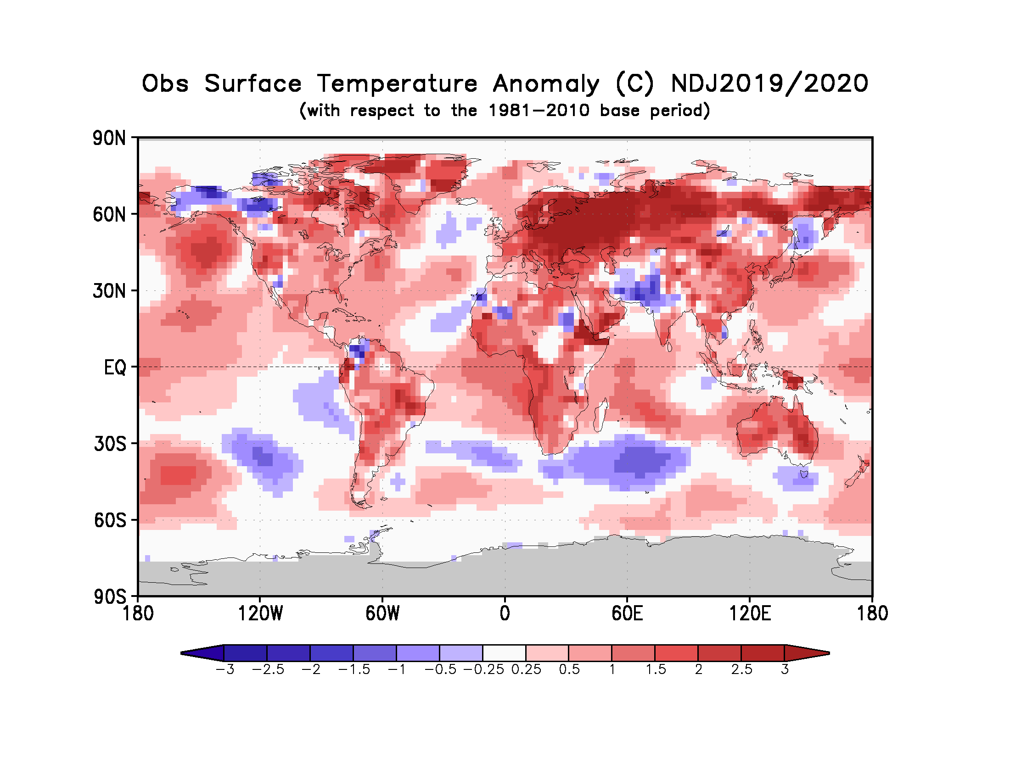
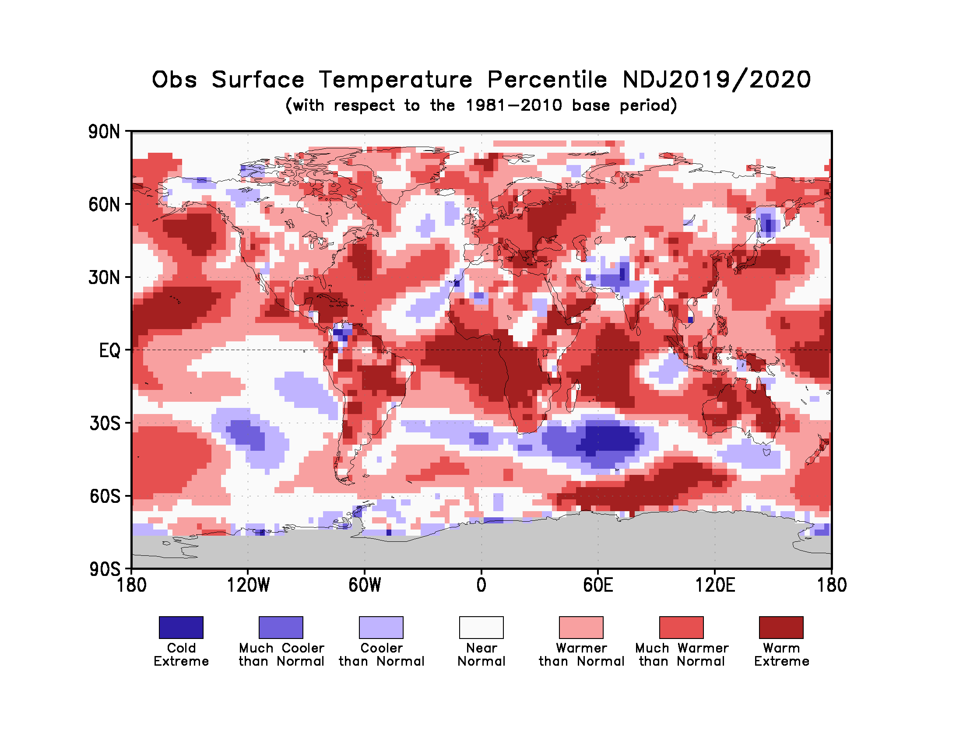
Figure 2. Observed November 2019-January 2020 near-surface temperature anomalies relative to 1981–2010 (top). The Cooler than Normal, Near Normal, and Warmer than Normal shadings on the percentile map (bottom) indicate that seasonal mean anomalies were in the bottom, middle, and upper tercile of the 1981–2010 distribution, respectively. Regions with anomalies in the lowest and highest decile (or 10%) of the distribution are marked as Much Cooler than Normal and Much Warmer than Normal, respectively. The Cold Extreme and Warm Extreme shadings indicate that the anomalies exceeded the coldest and warmest temperature values of the 1981–2010 period for the season. Grey shading indicates areas where observational analysis was not available. (Source: U.S. Climate Prediction Center).

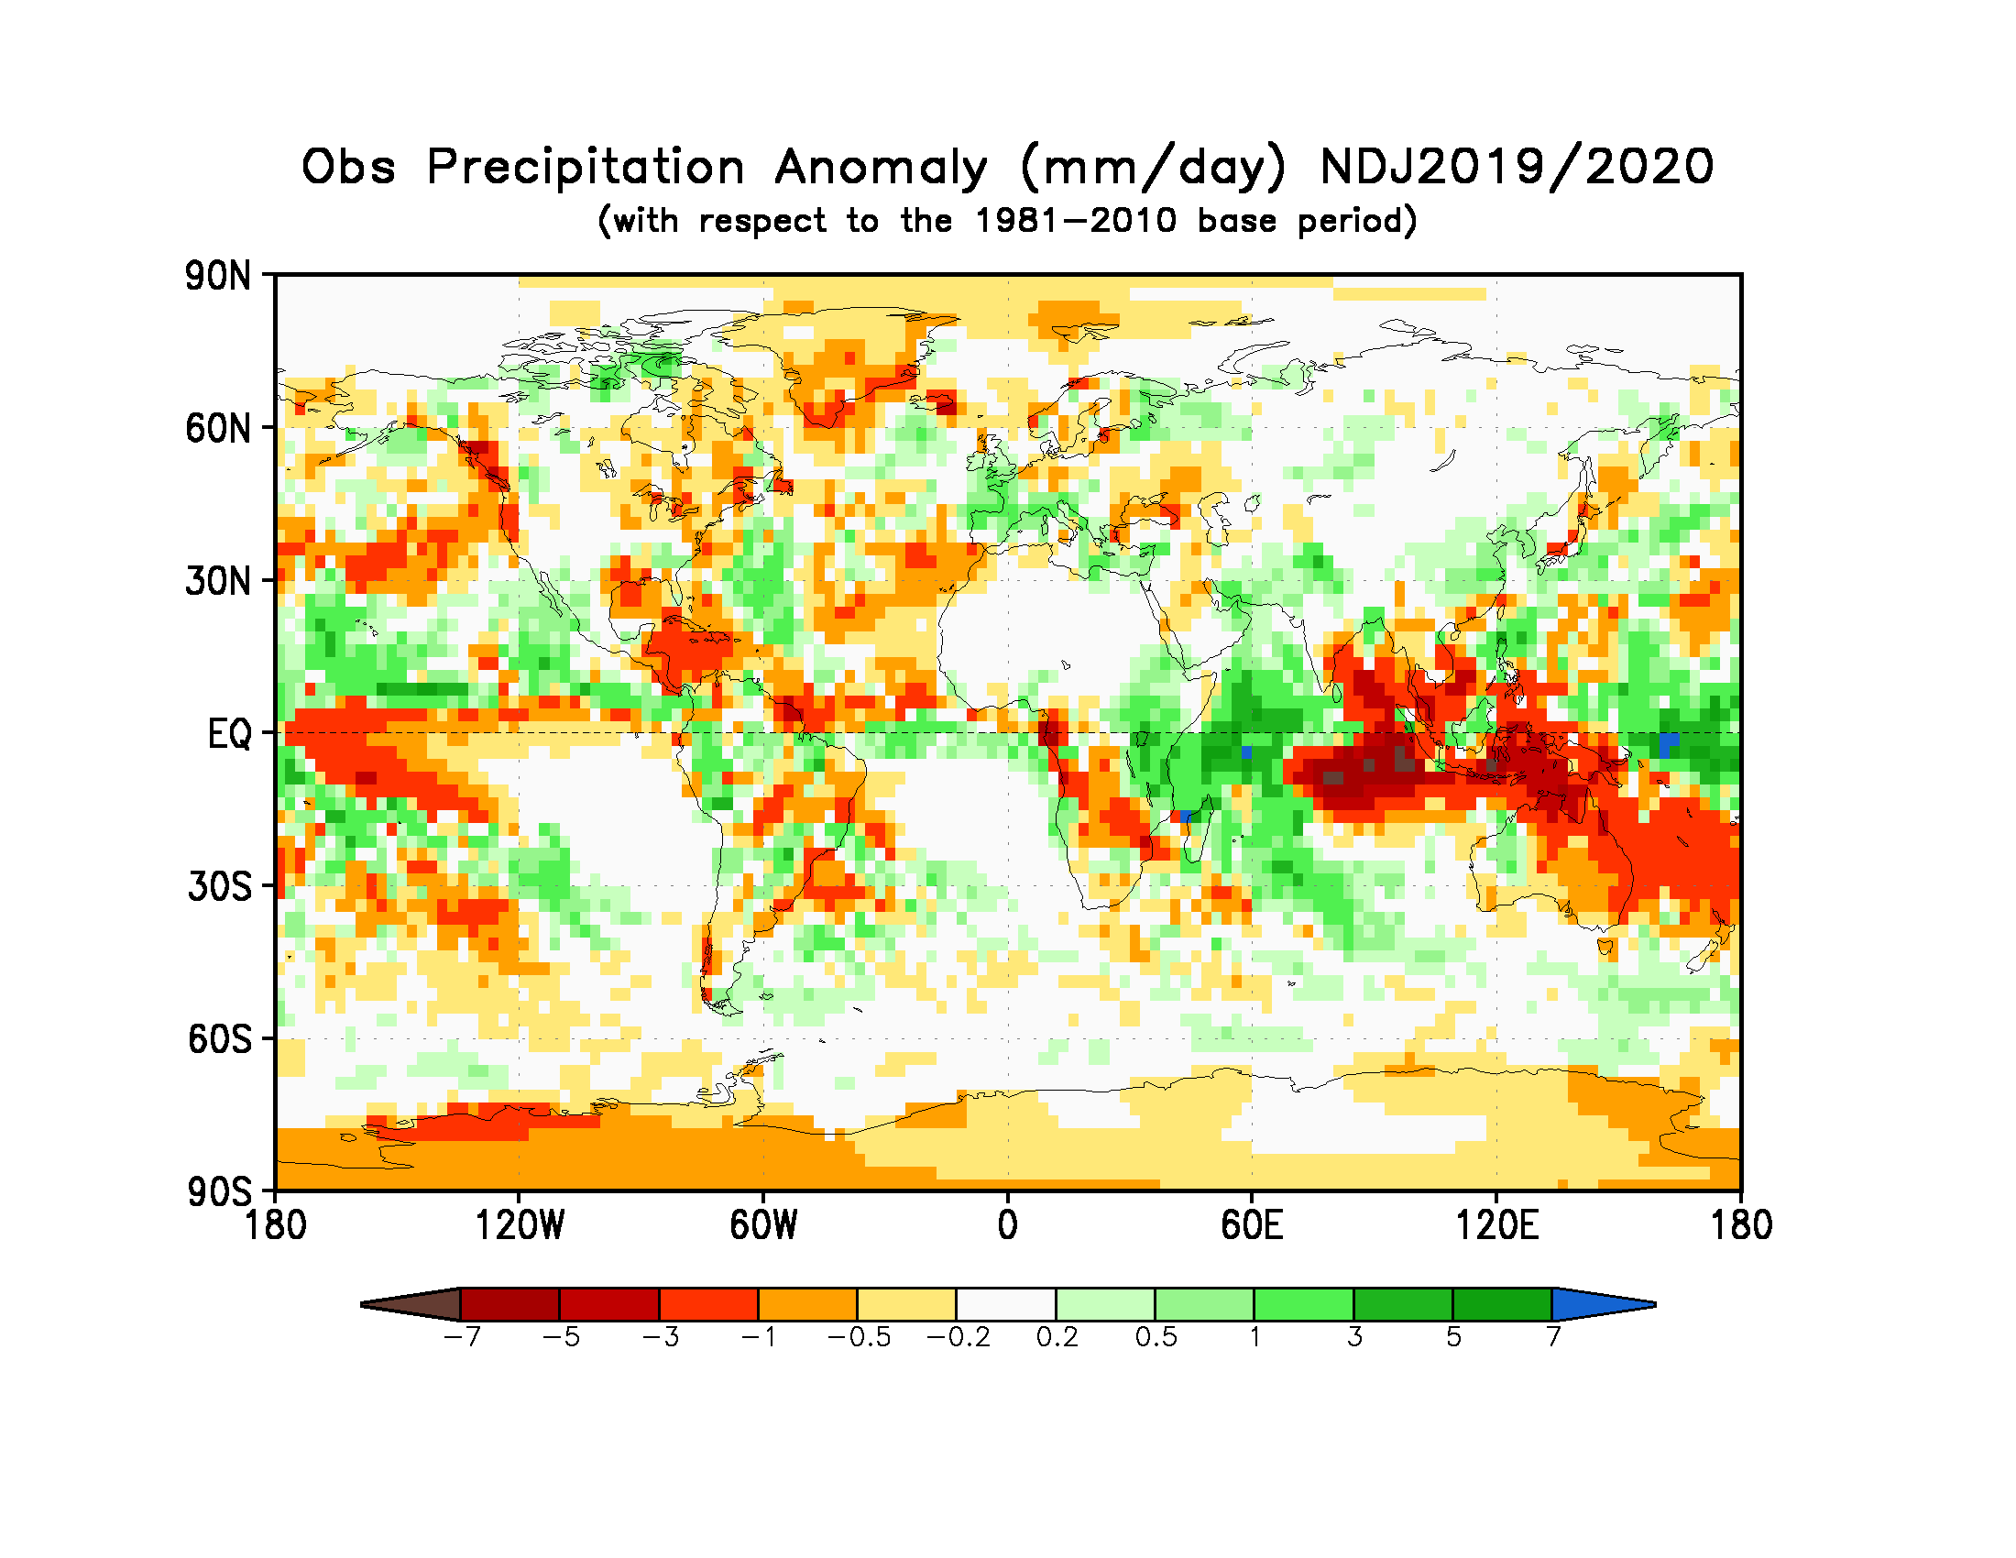
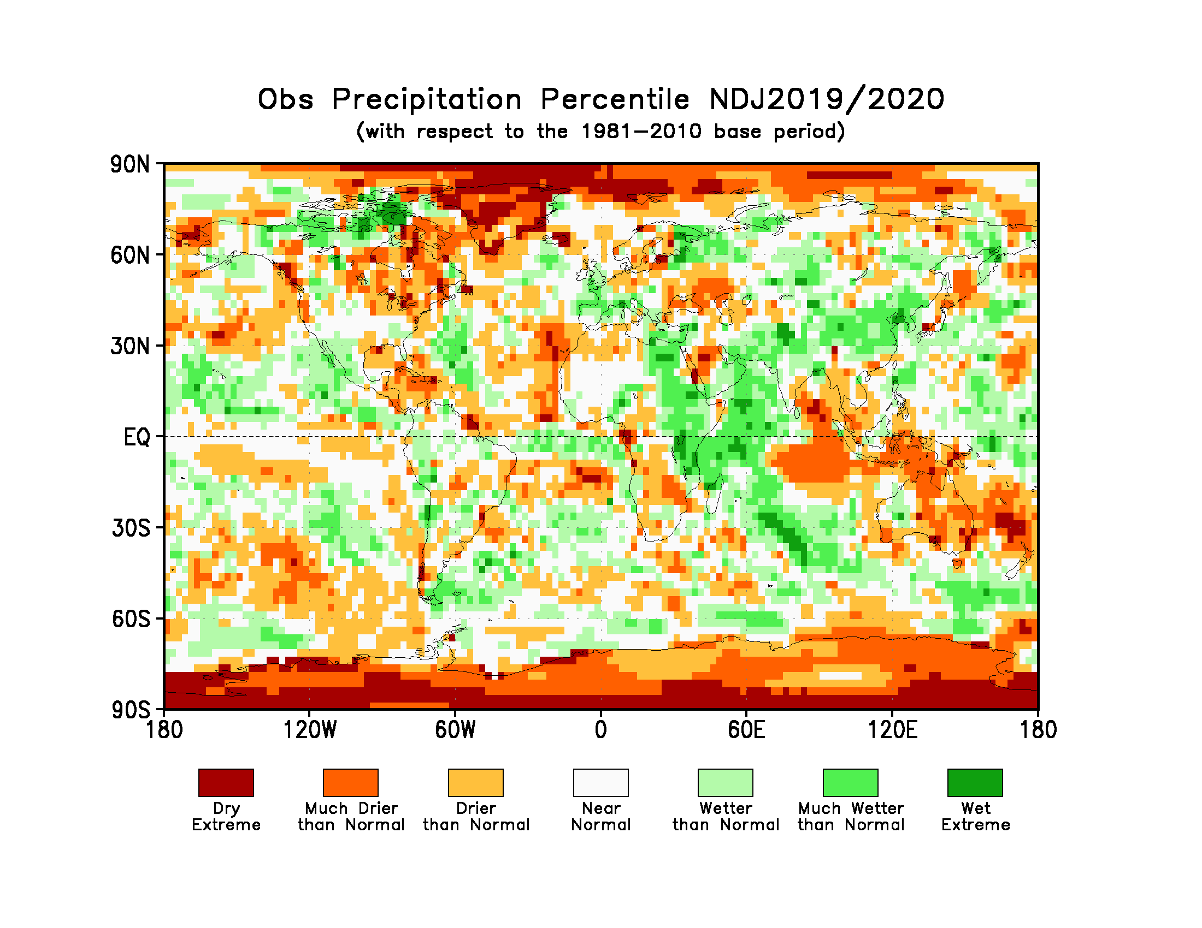
Figure 3. Observed precipitation anomalies for November 2019-January 2020, relative to 1981–2010 base period (top). The Drier than Normal, Near Normal and Wetter than Normal shadings on the percentile map (bottom) indicate that seasonal mean anomalies were in the bottom, middle, and upper tercile of the 1981–2010 distribution, respectively. Regions with anomalies in the lowest and highest decile (or 10%) of the distribution are marked as Much Drier than Normal and Much Wetter than Normal, respectively. The Dry Extreme and Wet Extreme shadings indicate that the anomalies exceeded the driest and wettest values of the 1981–2010 period for the season.
(Source: U.S. Climate Prediction Center).

1.3 Observed precipitation
For November 2019-January 2020 the largest below-normal precipitation anomalies were located near the Indonesian Archipelago, consistent with a strong positive phase of the Indian Ocean Dipole. West of these below-normal precipitation anomalies, above-normal precipitation anomalies were located over the Indian Ocean and eastern parts of equatorial Africa. In the equatorial western Pacific above-normal precipitation anomalies were observed and were located east of below-normal anomalies over the Indonesian Archipelago; these anomalies were also flanked by below normal precipitation anomalies over the central Pacific. A zonal band of below-normal precipitation anomalies stretched across the central and eastern equatorial Pacific and were flanked by above-normal precipitation anomalies to the north. Below-normal precipitation occurred over most of Australia with the largest values over the north and northeast regions. A northwest-to-southeast band of below-normal precipitation anomalies stretched across from western equatorial Africa to southeast Africa. A band of negative precipitation anomalies extended from the eastern north-equatorial Atlantic into the Caribbean and Central America. Over South America, interspersed patches of below- and above-normal precipitation anomalies were spread throughout the continent.
No large-scale systematic regions with dry or wet extremes (precipitation below or above all seasonal totals observed during 1981-2010) over land occurred, with the exception of a few isolated pockets that were observed over Greenland (dry). In general, the global precipitation anomaly pattern exhibited large-scale spatial coherence only in the equatorial tropics consistent with SST conditions associated with the IOD and weak El Niño conditions in the central Pacific.

2. Potential evolution of the state of the climate over the next three months (March-April-May 2020)

2.1 Large-scale SST-based indices, March-Apil-May 2020
Month | Nino 1+2 | Nino 3 | Nino 4 | Nino3.4 | IOD | NTA | STA
March 2020 | 0.48±0.28 | 0.45±0.20 | 0.86±0.15 | 0.57±0.15 | 0.46±0.15 | 0.19±0.26 | 0.14±0.13
April 2020 | 0.38±0.28 | 0.42±0.22 | 0.73±0.14 | 0.54±0.17 | 0.44±0.15 | 0.21±0.27 | 0.37±0.12
May 2020 | 0.18±0.46 | 0.28±0.29 | 0.60±0.17 | 0.41±0.22 | 0.45±0.25 | 0.22±0.28 | 0.33±0.10
March-April-May 2020 | 0.34±0.36 | 0.38±0.24 | 0.73±0.18 | 0.51±0.19 | 0.45±0.18 | 0.20±0.26 | 0.37±0.12

Table 2: Multi-model forecasts for oceanic indices (℃), with standard deviation. Values are the equal-member-weighting average of those derived, using each GPC models own hindcast climate mean, from the GPCs supplying SST forecasts (GPC CPTEC, ECMWF, Exeter, Melbourne, Montreal, Moscow, Offenbach, Seoul, Tokyo, Toulouse, Washington). The standard deviation is calculated on all ensemble members. The latitude/longitude bounds of the regions are given in the supplementary information section.
Observed sea surface temperatures in the central topical Pacific were in warm-neutral ENSO conditions during November 2019 -January 2020. The sea surface temperatures in the Niño 3.4 and Niño 3 regions, both of which are often used to characterize ENSO conditions, are predicted to maintain neutral levels with anomaly values of approximately 0.5 to 0.4 ºC during the March-May 2020 season. Farther west in the Niño 4 region, the sea surface temperature is predicted to remain somewhat more above-average with a value of approximately 0.7 ºC. The IOD prediction is for above-average values, and the March-May 2020 average is predicted to be above the value observed in January 2020.. The northern equatorial Atlantic SST (NTA) is predicted to be near-average to slightly above average during the season, and the southern equatorial Atlantic SST (STA) is predicted to be somewhat above average.

2.2 Predicted temperature, March-April-May 2020
For information on the construction of the multi-model forecast maps refer to the supplementary information section. (Note: Maps indicating forecast consistency among GPC models are available in the supplementary information).

Figure 4. Probabilistic forecasts of surface air temperature for December 2019-January-Februaey 2020. The tercile category with the highest forecast probability is indicated by shaded areas. The most likely category for below-normal, above-normal and near-normal is depicted in blue, red and grey shadings respectively. White areas indicate equal chances for all categories in both cases. The baseline period is 1993–2009. Figure is generated by The WMO Lead Centre for Long-Range Forecast Multi-Model Ensemble.
Influences from the expected tendency towards positive sea surface temperature anomalies are seen in the temperature forecast for March-May 2020 across sizeable portions of the globe, both in the tropics (except for near-average to slightly below-average conditions in the south-east Pacific) and extra-tropics. The prediction of below-average temperature is generally absent over land areas, as prediction for above-normal temperature dominates. Above-average sea surface conditions are predicted throughout equatorial Pacific, more so in western and central Pacific; this condition may still noticeably affect the overlying atmospheric circulation and climate, as it will enhance the SST gradients the with positive SST anomalies in the western Pacific. A global warming trend also contributes to the sea surface temperature and air temperature forecast, leading to a general prevalence towards a positive tilt in anomalies defined using the climatological base period (1993–2009) centred more than 10 years in the past.
RA I (Africa): An enhanced probability for above-normal temperature is predicted over virtually all of Africa, with strong model-to-model consistency. Weaker tilts of the odds towards above-normal are predicted for some portions of the northern regions of the continent. Weak tilts of the odds towards above-normal are also predicted over the most of the southern region of Africa. The strongest tilts of odds for above-normal are predicted over the western equatorial South Africa and over the Greater Horn, with strong model consistency. It is noted that above-normal temperature in most of locations would imply a continuation of the above-normal temperatures observed over most of Africa during November 2019-January 2020.
RA II (Asia): Weakly to moderately enhanced probabilities for above-normal temperature are predicted over most of central Asia and all of northern Asia, while more strongly enhanced chances for above-normal are predicted for part of eastern maritime Asia and part of southeast Asia extending northward along the coastal regions. Model consistency for most of these regions is moderately strong. A weak enhanced probability for below-normal temperature is predicted for the mountainous regions of the Indian subcontinent, with weak to moderate model consistency. Much of the area forecast to be above-normal would experience a continuation of the above-normal conditions observed during November 2019-January 2020.
RA III (South America): Enhanced probabilities for above-normal temperature are predicted for much of the equatorial tropical regions and the northwest portion of the continent, both regions having moderate to strong model consistency. A weak tilts of odds for above-normal temperature are predicted over the southern regions and northeast South America where model consistency is also relatively lower. No regions over South America are predicted to have odds tilted towards below-normal temperature. The tilt of the odds towards above-normal temperature represents a continuation of above-normal temperature during November 2019-January 2020 throughout South America.
RA IV (North America, Central America and the Caribbean): Strongly enhanced probabilities for above-normal temperature are predicted in Central America, the Caribbean, and other adjacent portions of southern North America, all with strong model consistency. Much of these regions also experienced above-normal temperatures during November 2019-January 2020. The remainder of the continent has a weak tilt of the odds towards above-normal, with some regions, for example, western and southern coastal regions of North America, having strong model consistency.
RA V (Southwest Pacific): Moderately to strongly enhanced probabilities for above-normal temperature are predicted in most of northern Australia, the Indonesian Archipelago and the southwest Pacific islands. No exceptions for tilts of odds towards below-normal temperature are predicted over land areas. Virtually all of the areas with a warm-tilting forecast have moderate to strong model consistency. A considerable portion of these areas also experienced above-normal temperature in November 2019-January 2020.
RA VI (Europe): Weakly to moderately enhanced probabilities for above-normal temperature are predicted in most of Europe and Iceland, but not Greenland. Probabilities for above-normal are stronger in parts of northern Europe. Consistency among individual models for the areas having an above-normal prediction is moderate to strong. This prediction for above-normal temperature follows up on generally above-normal temperatures observed over most of mainland Europe in November 2019-January 2020.

2.3 Predicted precipitation, March-April-May 2020

Figure 5. Probabilistic forecasts of precipitation for the season for December 2019-January-Februaey 2020. The tercile category with the highest forecast probability is indicated by shaded areas. The most likely category for below-normal, above-normal and near-normal is depicted in orange, green and grey shadings respectively. White areas indicate equal chances for all categories in both cases.
The baseline period is 1993–2009. Figure is generated by The WMO Lead Centre for Long-Range Forecast Multi-Model Ensemble.

Near-average SST conditions are expected during the March-May 2020 season in the central and eastern equatorial Pacific, with anomalously positive SST conditions in the western Pacific and western Indian Ocean. Some of the predicted large-scale seasonal precipitation anomalies are consistent with this spatial pattern, as for example, an enhanced likelihood of above-average precipitation in the western Indian Ocean and eastern equatorial Africa in association with the warm SST in the western Indian Ocean. In the equatorial Pacific, a tilt of odds towards near-normal conditions is predicted, with an east-west band of enhanced likelihood for above-normal precipitation north of the equator and for tilt of odds towards below-normal precipitation south of the equator in the central Pacific. Outside of these regions, most tilts of the odds towards above-normal or below-normal for oceanic precipitation are not particularly strong.
RA I (Africa): Enhanced probabilities for below-normal precipitation are predicted from southern Africa to the island regions farther east with moderate to strong model consistency. This forecast represents a continuation of dry conditions in southern Africa experienced in November 2019-January 2020. An enhanced probability for above-normal precipitation is predicted for eastern equatorial Africa, particularly the portion just south of the equator extending into the western Indian Ocean. Having moderate model consistency, this prediction marks a continuation of above-normal rains observed in November 2019-Jauary 2020. Isolated regions of enhanced probabilities of near-normal precipitation are forecast in regions of the Sahel and Sahara where no rain is expected during this time of year.
RA II (Asia): Weakly enhanced probabilities for above-normal precipitation are predicted in much of northern Asia as well as the northern region of southeast Asia, all with moderate model consistency. A small region of weakly enhanced probability for below-normal precipitation is predicted for part of southeast Asia, with moderate model consistency. Elsewhere over Asia little or no discernible predictive signal is found.
RA III (South America): An enhanced probability for below-normal precipitation is predicted over part of southern South America, as well as for the far northern parts of the continent. Model consistency for these areas is moderately strong. Enhanced probabilities for above-normal precipitation are forecast for a narrow band in the eastern equatorial region extending into the Atlantic Ocean, with moderate model consistency. Forecasts for all of the above areas for below-normal or above-normal generally do not coincide with systematic precipitation anomalies during November 2019-January 2020.
RA IV (North America, Central America and the Caribbean): Enhanced probability for below-normal precipitation is predicted for Central America and the Caribbean, with moderate to strong model consistency. Weakly enhanced probabilities of above-normal precipitation are forecast in the eastern portions North America, as well as part of the northwest portion of the continent. These above-normal forecast regions have mainly a weak to moderate model consistency. A sizable portion of the area in Central America and Caribbean having a below-normal forecast also experienced below-normal precipitation during November 2019-January 2020.
RA V (Southwest Pacific): Enhanced probabilities for below-normal precipitation are predicted for the northern parts of the Indonesia Archipelago, part of extreme north Australia and the southwest partion of the Pacific islands. A southwest-to-northeast band of enhanced probability for below-normal precipitation also stretches from the western tropical Pacific to the northeast extratropical Pacific. The southern parts of the Indonesia Archipelago are predicted to have a tilt in odds towards above-normal precipitation. A tilt of the odds towards above-normal is also forecast for New Zealand with moderate model consistency. These regions all show moderate model consistency.
RA VI (Europe): A weakly enhanced probability of above-normal precipitation is predicted over much of northern Europe, Iceland, and eastern Greenland, with moderate model consistency. A weak tilt of the odds towards below-normal is forecast for parts of extreme southern Europe, including the Iberian Peninsula, with moderate model consistency.

3. Latest updates for monitoring and prediction information
Each month, the latest updates for the real-time monitoring and seasonal mean predictions included in GSCU can be found at:
Monitoring:
https://ftp.cpc.ncep.noaa.gov/mingyue/GSCUWMO/
Predictions:
https://www.wmolc.org/modules/data/plot/autograds4/download_PMME.php?filename=wmo/WMOLC_T2M.gif
https://www.wmolc.org/modules/data/plot/autograds4/download_PMME.php?filename=wmo/WMOLC_PREC.gif

4. How to use the Global Seasonal Climate Update
The GSCU is intended as guidance for RCCs, Regional Climate Outlook Forums (RCOFs) and National Meteorological and Hydrological Services (NMHSs). It does not constitute an official forecast for any region or nation. Seasonal outlooks for any region or nation should be obtained from the relevant RCCs (see below for contact details) or NMHS.
Seasonal forecasts are probabilistic in nature. Although the text and figures used in the GSCU highlight the tercile categories that is predicted with the highest probability, it is important to recognize that the other tercile categories may also have substantial (though lower) probability.
The geographical areas occupied by the forecast signals should not be considered precise. Similarly, signals with small spatial extent may be unreliable.
The skill of seasonal forecasts is substantially lower than that of weather timescales and skill may vary considerably with region and season. It is important to view the forecast maps together with the skill maps provided in the supplementary appendices.
For reference, the six WMO Regional Associations domains are depicted in the figure below.
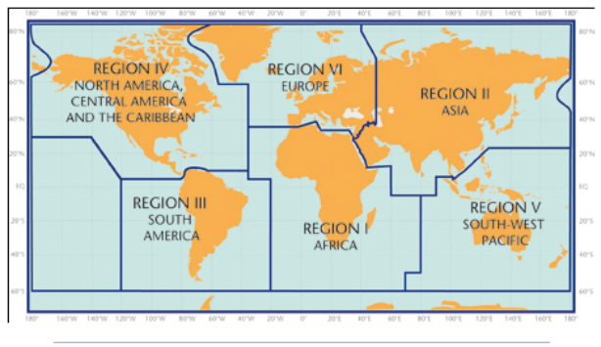

5. Designated and developing WMO Regional Climate Centres and Regional Climate Centre Networks
- RA I: http://www.wmo.int/pages/prog/wcp/wcasp/RCC-Africa.html
- RA II: http://www.wmo.int/pages/prog/wcp/wcasp/RCC-Asia.html
- RA III: http://www.wmo.int/pages/prog/wcp/wcasp/RCC-SouthAmerica.html
- RA IV: http://www.wmo.int/pages/prog/wcp/wcasp/RCC-NorthAmerica.html
- RA V: http://www.wmo.int/pages/prog/wcp/wcasp/RCC-SouthwestPacific.html
- RA VI: http://www.wmo.int/pages/prog/wcp/wcasp/RCC-Europe.html

6. Resources
Sources for the graphics used in the GSCU:
- The WMO Lead Centre for Long-Range Forecast Multi-Model Ensemble (LC-LRFMME): http://www.wmolc.org
- WMO portal to the Global Producing Centres for Long-range Forecasts (GPCs-LRF): http://www.wmo.int/pages/prog/wcp/wcasp/clips/producers_forecasts.html
- WMO GSCU portal
http://www.wmo.int/pages/prog/wcp/wcasp/LC-LRFMME/index.php
- WMO portal for Regional Climate Outlook Forums (RCOFs):
https://public.wmo.int/en/our-mandate/climate/regional-climate-outlook-products
- International Research Institute for Climate and Society (IRI):
http://portal.iri.columbia.edu/portal/server.pt
- NOAA Climate Prediction Centre (CPC):
http://www.cpc.noaa.gov

7. Acknowledgements
This Global Seasonal Climate Update was jointly developed by the WMO Commission for Climatology and Commission for Basic Systems with contributions from:
- WMO Lead Centre for Long-Range Forecast Multi-Model Ensemble (LC-LRFMME), Korea Meteorological Administration, NOAA National Centers for Environmental Prediction
- WMO Global Producing Centres for Long-Range Forecast (GPCs-LRF): GPC-Beijing (China Meteorological Administration), GPC-CPTEC (Center for Weather and Climate Studies, Brazil), GPC-ECMWF (European Center for Medium-Range Forecast), GPC-Exeter (UK Met Office),GPC- Melbourne (Bureau of Meteorology), GPC-Montreal (Meteorological Services of Canada), GPC-Moscow (Hydro meteorological Center of Russia), GPC-Offenbach Deutscher Wetterdienst), GPC-Pretoria (South African Weather Services), GPC-Seoul (Korea Meteorological Administration), GPC-Tokyo (Japan Meteorological Agency), GPC-Toulouse (Météo-France), GPC-Washington (National Centers for Environmental Prediction)
- International Research Institute for Climate and Society (IRI)

File with supplementary information can be downloaded from https://ftp.cpc.ncep.noaa.gov/mingyue/GSCUWMO/Supplementary/GSCU_MAM2020_supplementary_info_LC-LRFMME.docx

