WEATHER CLIMATE WATER

GLOBAL SEASONAL
CLIMATE UPDATE
Pre-Operational Phase
TARGET SEASON: June-July-August 2020

Issued: 25 May 2020
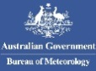

Summary
Observed sea surface temperatures in the east-central topical Pacific were in a neutral El Niño condition during February-April 2020 despite being slightly above-average levels. The strong positive phase of the Indian Ocean Dipole (IOD) that occurred in late 2019 returned to a near-neutral condition and is predicted to continue this trend to slightly below-average value. The sea surface temperatures in the Niño 3.4 and Niño 3 regions, both of which are often used to characterize ENSO conditions, are predicted to decrease from approximately 0.5 °C during the February-April 2020 season to -0.2 or -0.3 during June-August, and hence, are expected to remain in the near-average range.
Influences from the expected tendency towards positive sea surface temperature anomalies across sizeable portions of the globe, both in the tropics (except for near-or below-average conditions in the central and eastern Pacific) and extra-tropics, are seen in the temperature forecast for June-August 2020, which leans quite strongly, on average, towards above-normal land temperature, particularly at tropical latitudes. The relatively cool sea surface conditions predicted in much of the eastern equatorial Pacific may noticeably affect the overlying tropical atmospheric circulation and climate, as they create SST gradients with positive SST anomalies in the western Pacific and in the subtropical eastern North Pacific. A global warming trend also contributes to the sea surface temperature and air temperature forecast, leading to a general prevalence of increased chances of above-average temperatures compared to a climatological base period (1993–2009) that is centred nearly 20 years in the past.
Below-average precipitation conditions are expected in the central and eastern equatorial Pacific, and an enhanced probability for above normal precipitation is expected just north of the equator in the eastern tropical Pacific, the central and western Indonesian Archipelago, and southwestern tropical Indian Ocean. Some tilts of the odds for precipitation are likely associated with sea surface temperature anomalies, such as the above-average precipitation in much of the Indonesian Archipelago with the positive sea surface temperature anomalies in that vicinity. A southwest to northeast band of enhanced likelihood for below-normal precipitation also stretches from the northwest tropical to north-central subtropical Pacific. An enhanced probability for below-normal precipitation is predicted for the Caribbean, while a shift of the odds towards above-normal precipitation is predicted for northern South America.

Surface Air Temperature, JJA 2020  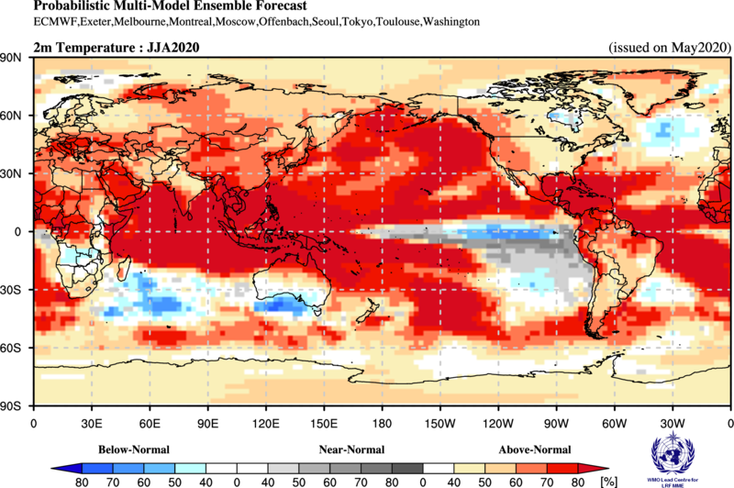 | Precipitation, JJA 2020  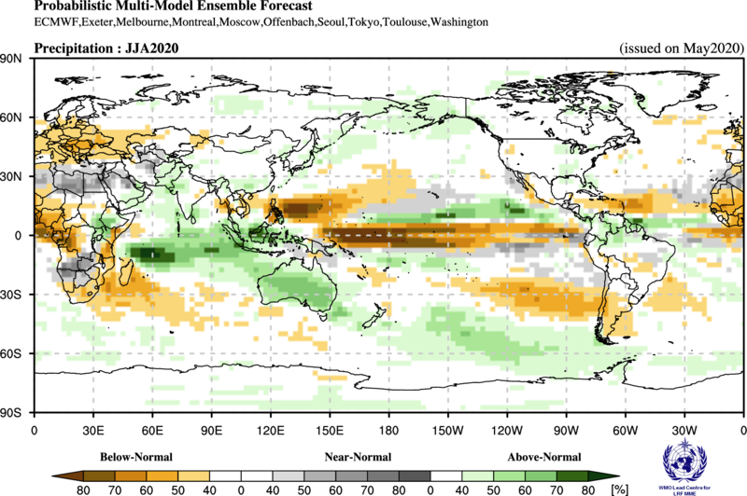

Figure 1. Probabilistic forecasts of surface air temperature and precipitation for the season June-August 2020. The tercile category with the highest forecast probability is indicated by shaded areas. The most likely category for below-normal, above-normal and near-normal is depicted in blue, red and grey shadings respectively for temperature, and orange, green and grey shadings respectively for precipitation. White areas indicate equal chances for all categories in both cases. The baseline period is 1993–2009.

1. Observations: February – April 2020
In the following sections, observed temperature and precipitation patterns for the period November February-April 2020 are briefly described. For more detailed information about regional and local climate anomalies, the reader is referred to the concerned WMO Regional Climate Centres (RCCs) or RCC Networks, listed in Section 5.

1.1 Large-scale sea surface temperature (SST) indices
All Niño sea surface temperature (SST) indices were positive with larger positive values in east-central Pacific (Niño 3.4) and central Pacific (Niño 4) during February – April 2020. The SST conditions generally characterized a neutral ENSO system with a continuation of similar conditions from the prior season. SST anomalies in Niño 4 and Niño 3.4 regions maintained their somewhat above-normal values from November 2019 – January 2020. The Indian Ocean Dipole (IOD) over the period was weakly negative. The North Tropical Atlantic (NTA) SST and South Tropical Atlantic (STA) indices were consistent with near neutral conditions.

Month | Niño 1+2 | Niño 3 | Niño 4 | Niño 3.4 | IOD | NTA | STA
Feb 2020 | 0.42 | 0.24 | 1.08 | 0.42 | -0.24 | 0.36 | 0.48
Mar 2020 | 0.48 | 0.29 | 1.03 | 0.61 | -0.10 | 0.56 | 0.68
Apr 2020 | 0.43 | 0.52 | 0.79 | 0.55 | -0.09 | 0.41 | 0.16
Feb -Apr 2020 | 0.44 | 0.35 | 0.97 | 0.53 | -0.14 | 0.44 | 0.44

Table 1. Large-scale oceanic indices (°C). Anomalies are with respect to the 1981–2010 average. (Source: U.S. Climate Prediction Center)

1.2 Observed temperature
Temperature anomalies across the globe continued their trend of warmer-than-normal conditions for the months of February – April 2020 (Figure 2, top). Above-normal temperatures dominated the globe. The most strongly positive land temperature anomalies occurred over northeast Europe and central and northern Asia. Exceptions to positive land anomalies were negative temperature anomalies over the northern regions of North America, the central region of the Indian sub-continent, southeast Australia and part of far eastern Asia.
With the exception of small areas of cooler-than-normal temperatures in the extratropical southern oceans in the latitude belt around 30ºS and the southeast equatorial Pacific, most oceanic regions had positive temperature anomalies. SSTs in the equatorial central Pacific indicated weak El Niño conditions, with positive anomalies extending to the west-central equatorial Pacific. SST anomalies throughout the extratropical North Pacific and equatorial Atlantic Ocean were generally positive. A notable region of largest warm ocean temperature anomaly was in the northeast Pacific.
Consistent with the seasonal mean anomalies, warm extremes dominated (Figure 2, bottom panel). Warm extremes (exceeding all seasonal mean temperatures observed during 1981–2010) occurred over the northernmost parts of Asia, and central South America. No significant extreme cold temperature was found over land areas. Some oceanic regions also had warm extremes, notably the equatorial Atlantic, subtropical southern Indian Ocean and equatorial western Pacific.

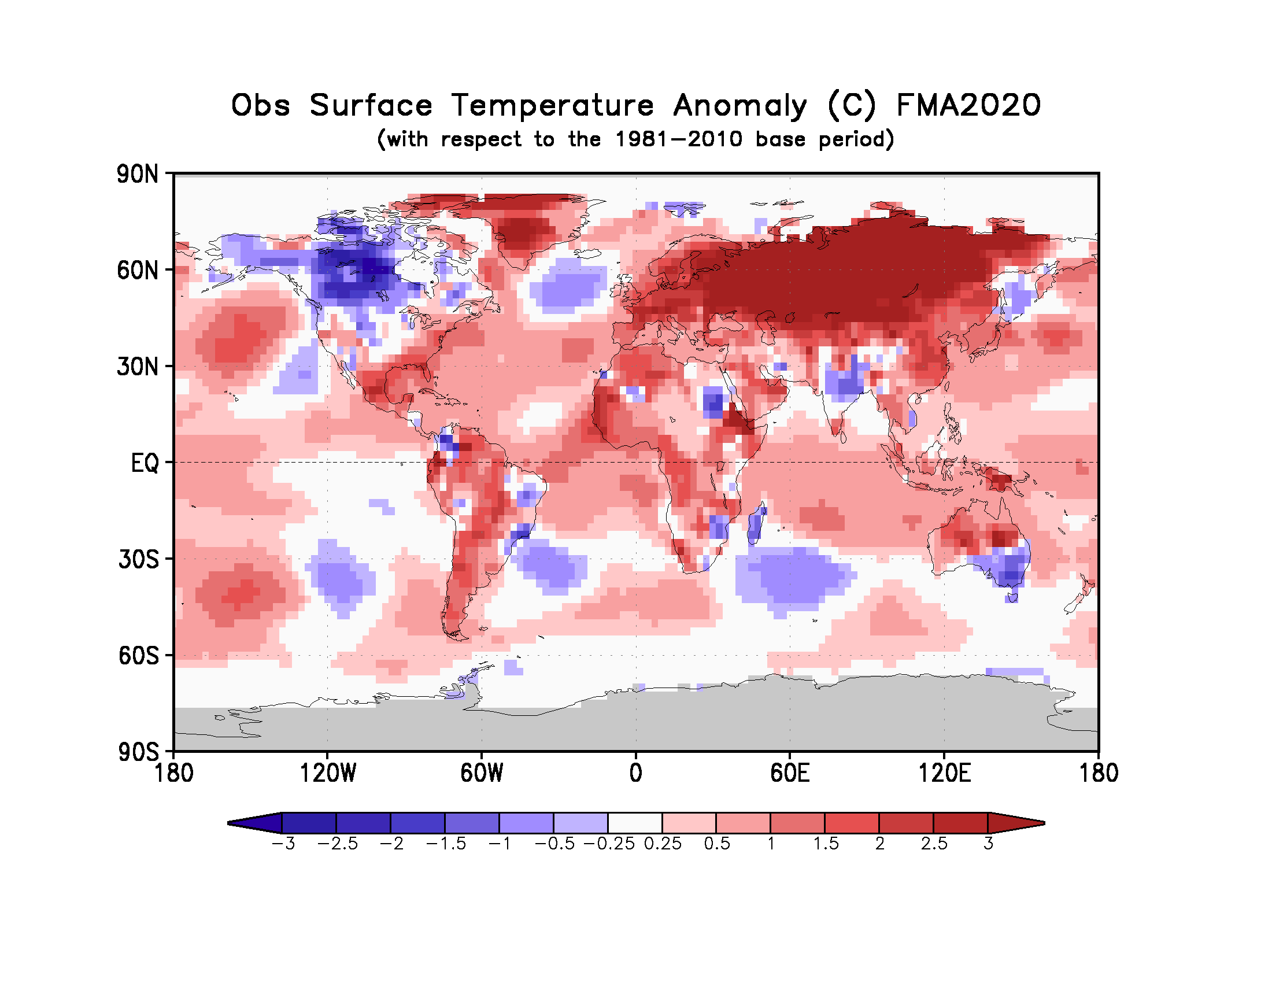
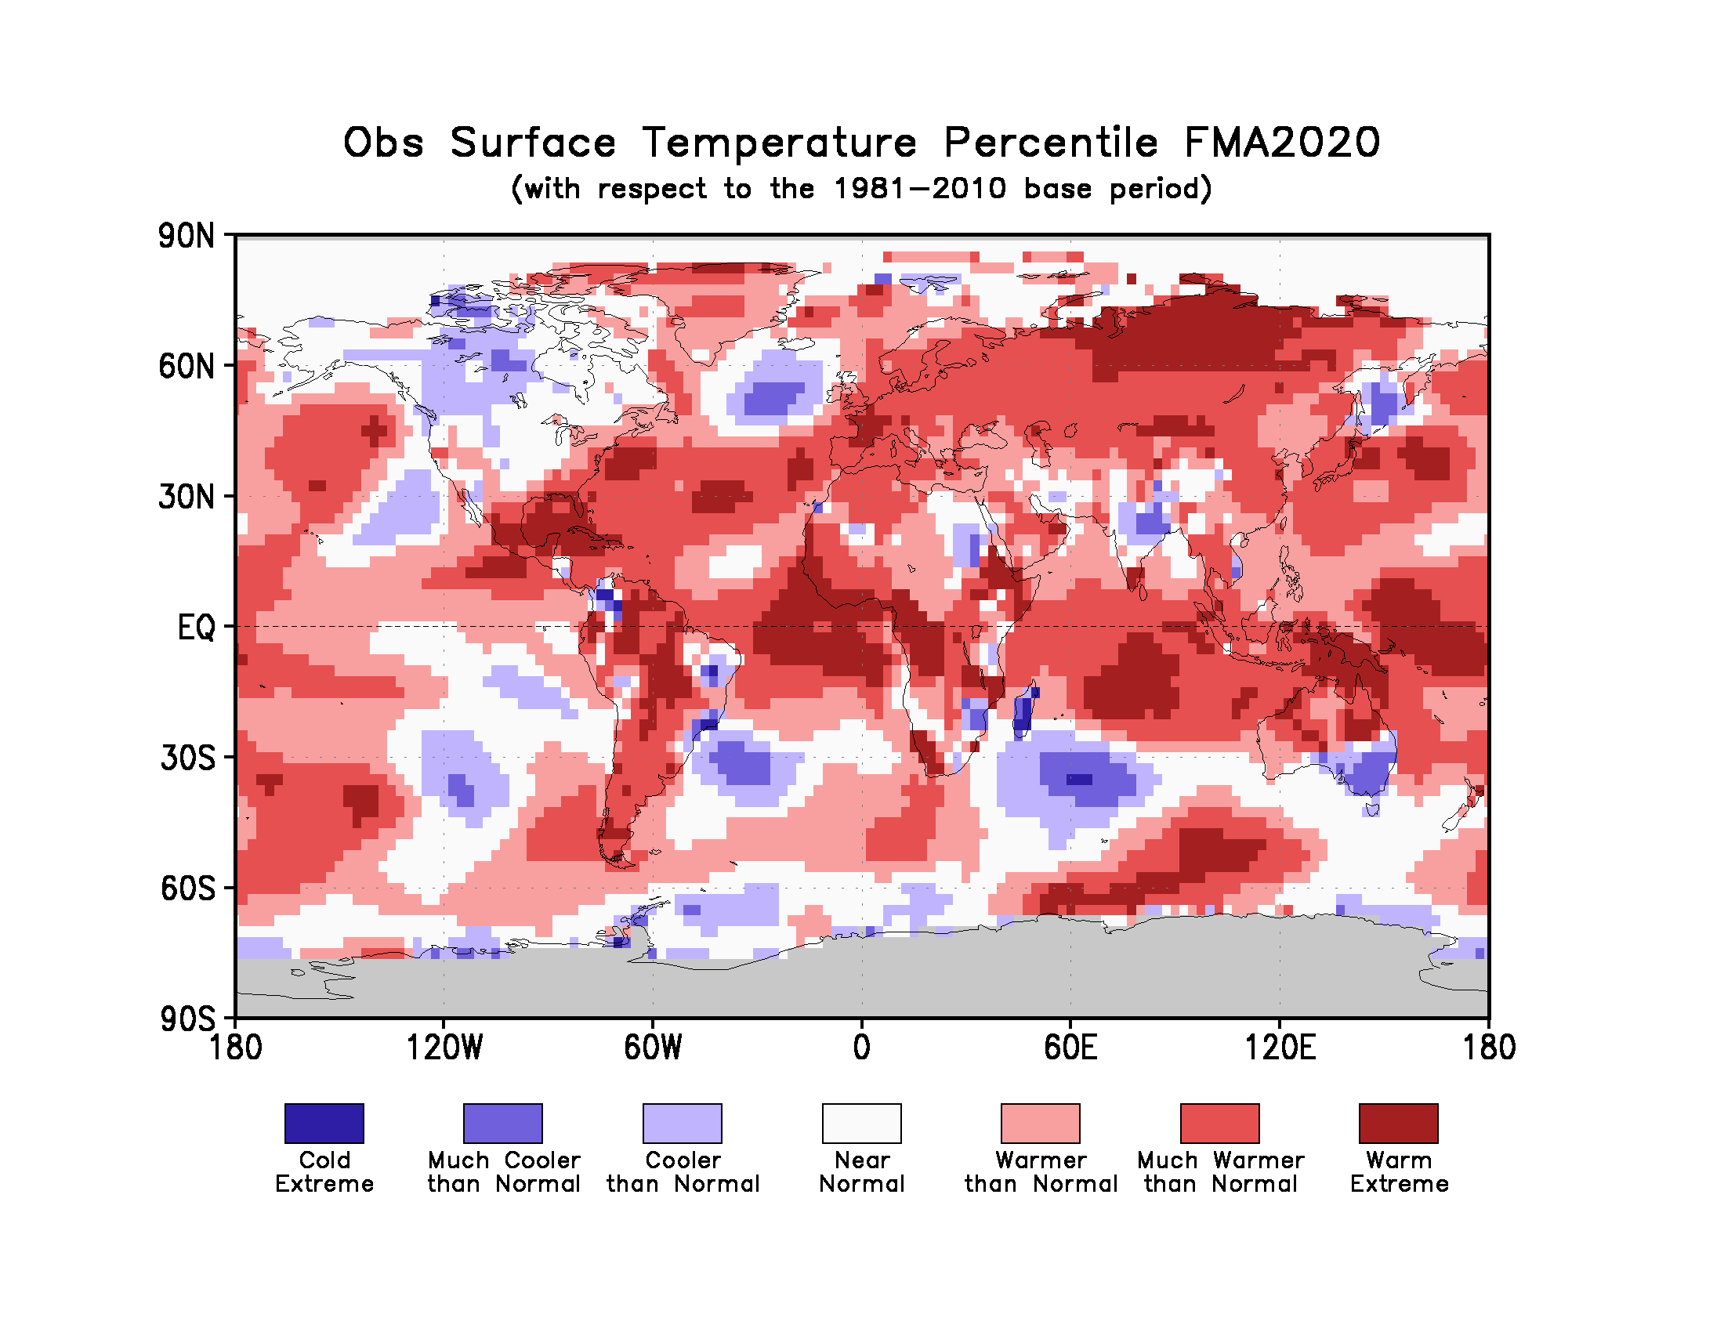
Figure 2. Observed February – April 2020 near-surface temperature anomalies relative to 1981–2010 (top). The Cooler than Normal, Near Normal, and Warmer than Normal shadings on the percentile map (bottom) indicate that seasonal mean anomalies were in the bottom, middle, and upper tercile of the 1981–2010 distribution, respectively. Regions with anomalies in the lowest and highest decile (or 10%) of the distribution are marked as Much Cooler than Normal and Much Warmer than Normal, respectively. The Cold Extreme and Warm Extreme shadings indicate that the anomalies exceeded the coldest and warmest temperature values of the 1981–2010 period for the season. Grey shading indicates areas where observational analysis was not available. (Source: U.S. Climate Prediction Center).

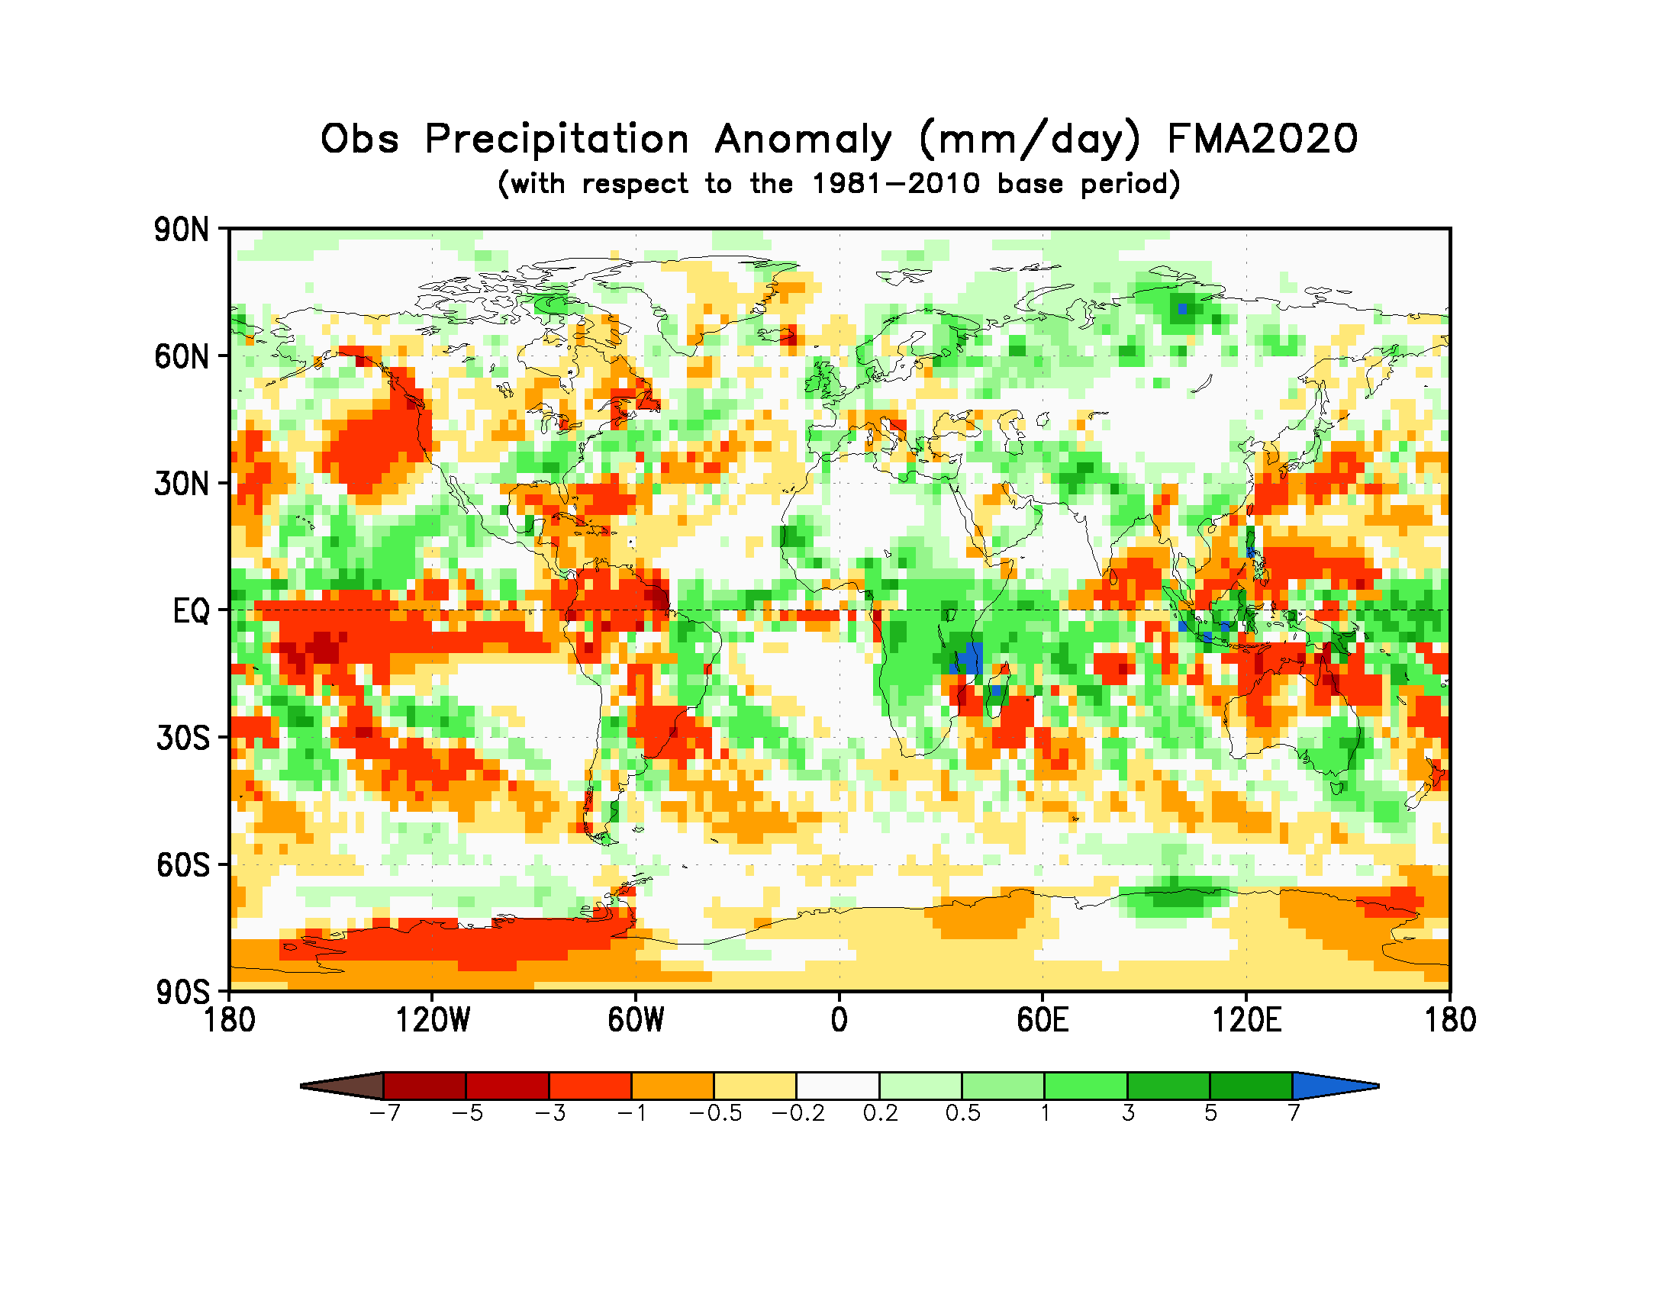
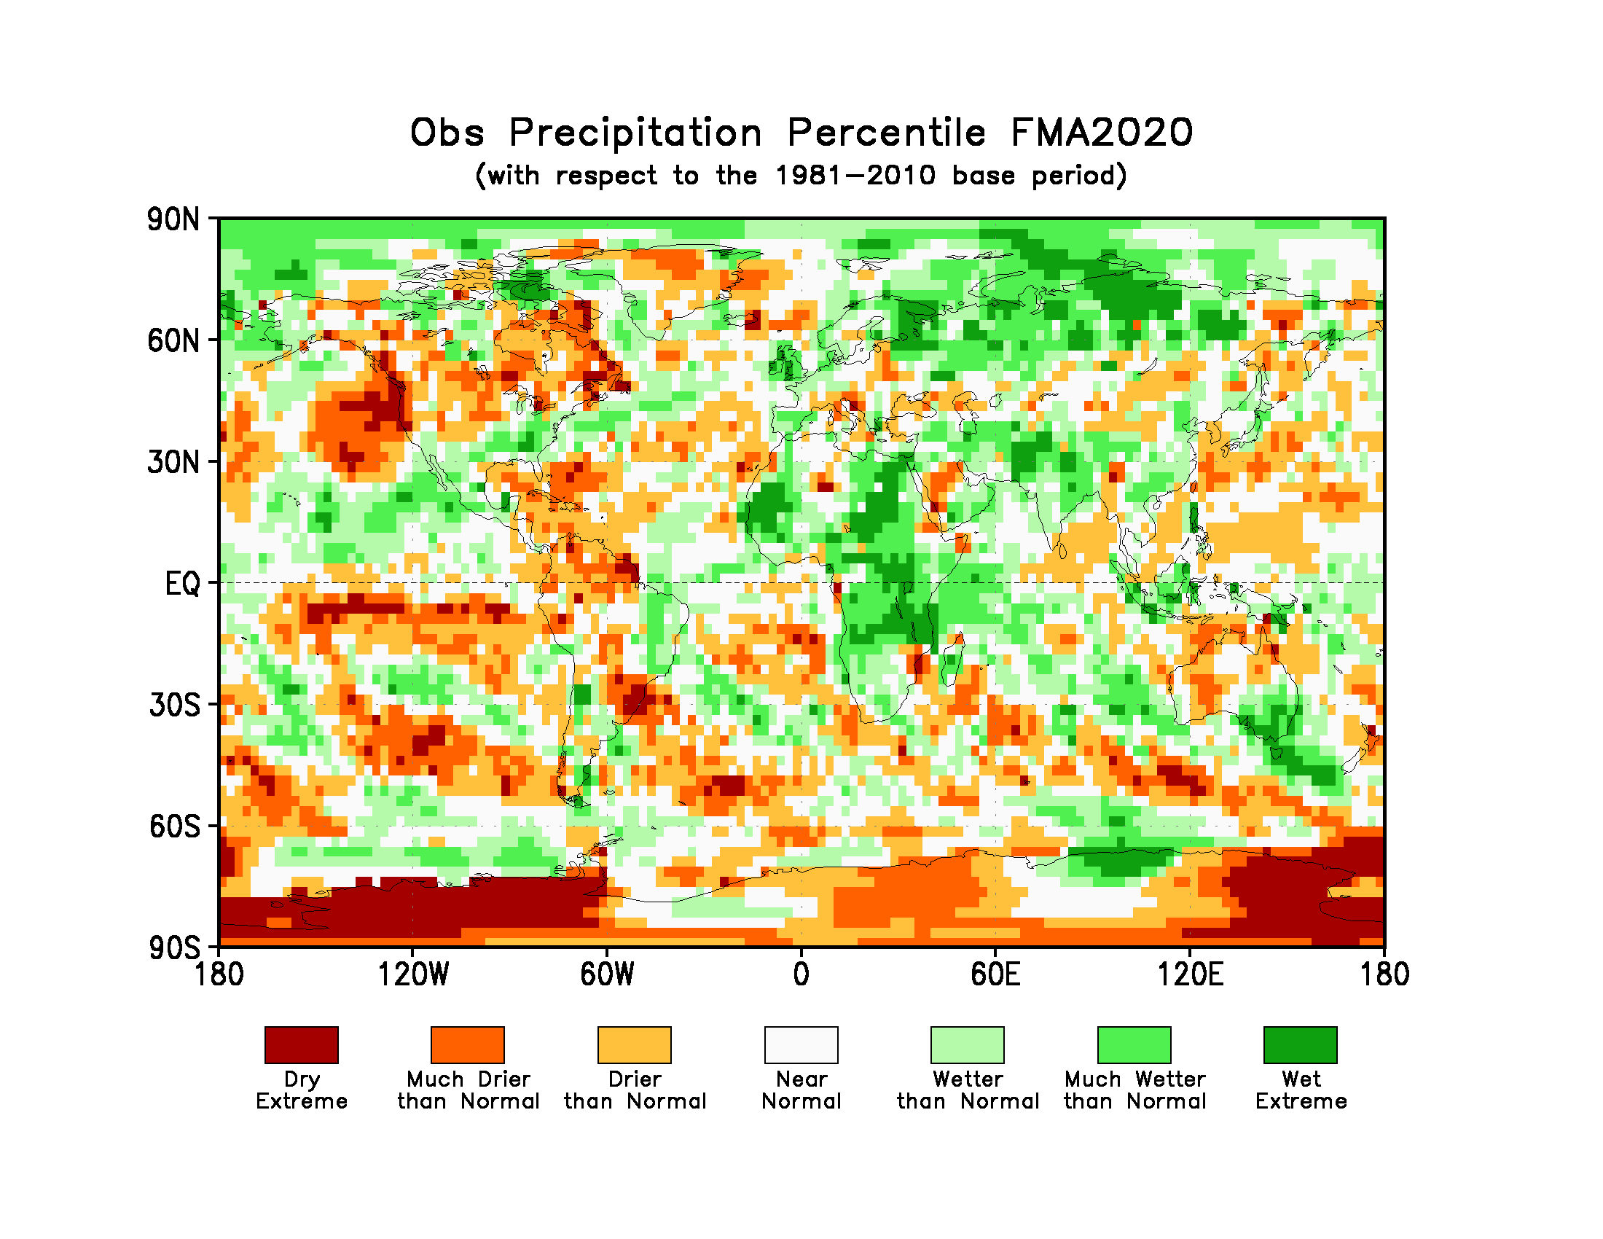
Figure 3. Observed precipitation anomalies for February – April 2020, relative to 1981–2010 base period (top). The Drier than Normal, Near Normal and Wetter than Normal shadings on the percentile map (bottom) indicate that seasonal mean anomalies were in the bottom, middle, and upper tercile of the 1981–2010 distribution, respectively. Regions with anomalies in the lowest and highest decile (or 10%) of the distribution are marked as Much Drier than Normal and Much Wetter than Normal, respectively. The Dry Extreme and Wet Extreme shadings indicate that the anomalies exceeded the driest and wettest values of the 1981–2010 period for the season.
(Source: U.S. Climate Prediction Center).

1.3 Observed precipitation
For February-April 2020, the largest negative precipitation anomalies were located in the equatorial central Pacific. West of these negative anomalies, positive precipitation anomalies stretched from the equatorial western Pacific into the Indonesian Archipelago. These positive anomalies were flanked by negative precipitation anomalies immediately to the north and south. Positive precipitation anomalies also occurred over most of the subtropical southern Indian Ocean and over a band extending from the western Pacific to the southwest coast of North America.
Below-normal precipitation occurred over most of the Caribbean and northwest South America. Below-normal precipitation anomalies also occurred over southeast South America, western central and northeast Australia, northern New Zealand and northwest coastal regions of North America. Weak below-normal precipitation anomalies were located over northeast North America. Over South America, above-normal precipitation anomalies were located over the northeast region and extended south along the eastern coastal regions. Nearly the entire equatorial and southern Africa also had above-normal precipitation anomalies. Other land regions with above-normal precipitation anomalies included northern and eastern parts of Indian subcontinent, southeast Australia, the Indonesian Archipelago, northern Europe abd Asia and southeast North America.
No large-scale systematic regions with dry or wet extremes (precipitation below or above all seasonal totals observed during 1981-2010) over land occurred, with the exception of a few isolated pockets of extreme wet extremes that were observed over different regions in Africa and most of northern Asia. In general, the global precipitation anomaly pattern did not exhibit large-scale spatial coherence collocated with SST anomalies.

2. Potential evolution of the state of the climate over the next three months (June - August 2020)

2.1 Large-scale SST-based indices, June - August 2020
Month | Nino 1+2 | Nino 3 | Nino 4 | Nino3.4 | IOD | NTA | STA
June 2020 | -0.07±0.28 | -0.14±0.37 | 0.13±0.23 | -0.06±0.39 | -0.00±0.21 | 0.29±0.15 | 0.38±0.09
July 2020 | -0.34±0.37 | -0.30±0.40 | 0.01±0.32 | -0.18±0.40 | -0.45±0.26 | 0.29±0.15 | 0.32±0.09
August 2020 | -0.39±0.41 | -0.36±0.42 | -0.17±0.33 | -0.25±0.39 | -0.62±0.30 | 0.28±0.17 | 0.29±0.10
June-July-August 2020 | -0.25±0.38 | -0.27±0.40 | 0.02±0.30 | -0.16±0.39 | -0.36±0.24 | 0.29±0.15 | 0.33±0.10

Table 2: Multi-model forecasts for oceanic indices (℃), with standard deviation. Values are the equal-member-weighting average of those derived, using each GPC models own hindcast climate mean, from the GPCs supplying SST forecasts (GPC CPTEC, ECMWF, Exeter, Melbourne, Montreal, Moscow, Offenbach, Seoul, Tokyo, Toulouse, Washington). The standard deviation is calculated on all ensemble members. The latitude/longitude bounds of the regions are given in the supplementary information section.
Observed sea surface temperatures in the central topical Pacific were in warm-neutral ENSO ranges during February-April 2020. The sea surface temperatures in the Niño 3.4 and Niño 3 regions are predicted to decrease, but still to maintain neutral levels with anomaly values of approximately -0.2 to -0.3 ºC during the June-August 2020 season. Farther west in the Niño 4 region, the sea surface temperature is predicted to remain close to average with a value of approximately 0.0 ºC. The IOD prediction is for below-average values, and the June-August 2020 average is predicted to be near -0.4 ºC, and is below the value observed in April 2020. The northern and southern equatorial Atlantic SST (NTA) is predicted to be slightly above average during the season.

2.2 Predicted temperature, June - August 2020
For information on the construction of the multi-model forecast maps refer to the supplementary information section. (Note: Maps indicating forecast consistency among GPC models are available in the supplementary information).

Figure 4. Probabilistic forecasts of surface air temperature for June–August 2020. The tercile category with the highest forecast probability is indicated by shaded areas. The most likely category for below-normal, above-normal and near-normal is depicted in blue, red and grey shadings respectively. White areas indicate equal chances for all categories in both cases. The baseline period is 1993–2009. Figure is generated by The WMO Lead Centre for Long-Range Forecast Multi-Model Ensemble.
Influences from the expected tendency towards positive sea surface temperature anomalies are seen in the temperature forecast for June-August 2020 across sizeable portions of the globe, both in the tropics (except for below-average conditions in the eastern tropical Pacific and southeast Pacific) and extra-tropics (except for a few relatively small pockets, such as immediately south of Australia). Below-average temperature is generally unlikely over land areas, with increased chances of above-normal temperatures dominating. Above-average sea surface temperatures are predicted in the western tropical Pacific, while below-average is predicted along the immediate equator in the eastern tropical Pacific. These SST conditions introduce gradients that may noticeably affect the overlying atmospheric circulation and climate, even though positive SST anomalies predominate. A global warming trend also contributes to the sea surface temperature and air temperature forecast, leading to a general prevalence of increased chances of positive anomalies defined with respect to the climatological base period (1993–2009), which is centred nearly 20 years in the past.
RA I (Africa): An enhanced probability for above-normal temperature is predicted over at least half of Africa, including most of northern, western and central Africa. These regions show strong model-to-model consistency. Weak tilts of the odds towards below-normal are predicted over much of southern Africa, the interior portion of eastern equatorial Africa with consistency across models. Weak tilts of the odds towards above-normal are also predicted over the southernmost part of Africa. It is noted that above-normal temperature in more than half of the above locations would imply a continuation of the above-normal temperatures observed over most of Africa during February-April 2020.
RA II (Asia): Weakly to moderately enhanced probabilities for above-normal temperature are predicted over most of central Asia, nearly all of southeast and parts of north/northwest and southwest Asia. Model consistency for most of these regions is strong, and very strong in parts of central and northern Asia. Most of the area forecast to be above-normal would experience a continuation of the above-normal conditions observed during February-April 2020, with the exception of part of southeast Asia, which reported near-normal or below-normal conditions.
RA III (South America): Enhanced probabilities for above-normal temperature are predicted for much of northern, northeast, western and extreme southern South America, all having moderate to strong model consistency. A weak tilts of odds for above-normal temperature are also predicted over some of the south-central region, where model consistency is still strong. The tilt of the odds towards above-normal temperature represents a continuation of above-normal temperature during February-April 2020 in much of South America, with the exception of small, isolated parts of the northeast, northwest and southeast South America.
RA IV (North America, Central America and the Caribbean): Enhanced probabilities for above-normal temperature are predicted in Central America, the Caribbean, and portions of western, northwest and south/southeast North America, all with moderate to strong model consistency. While Central America, the Caribbean, and southeast North America likewise experienced above-normal temperatures during February-April 2020, much of the central and northwest portion of the continent were either near- or below-normal in February-April. Most of the remainder of the continent has a weak tilt of the odds towards above-normal, with some regions, for example, western and southern coastal regions of North America, having strong model consistency.
RA V (Southwest Pacific): Strongly enhanced probabilities for above-normal temperature are predicted in the northern tier of Australia, the Indonesian Archipelago and the southwest Pacific islands, all with strong model consistency. A tilt of odds towards below-normal temperature is predicted over part of the immediate southern Australia coast, with weak to moderate model consistency. This tilt of the odds is undoubtedly associated with the below-average SST predicted just south of Australia. Representing a continuation of the observations in February-April, all of these areas also experienced above-normal temperature in February-April 2020, while extreme southeast Australia reported below-normal temperature.
RA VI (Europe): A weakly enhanced probability of above-normal temperature is predicted in most of Europe, Iceland and Greenland. Stronger tilts of the odds towards above-normal are predicted in much of southern and part of northeast Europe, and extreme northern Greenland. Consistency among individual models for these areas is moderate to strong, particularly in southern Europe. This prediction for above-normal temperature follows up on generally above-normal temperatures observed over most of mainland Europe and Greenland in February-April 2020.

2.3 Predicted precipitation, June-July-August 2020

Figure 5. Probabilistic forecasts of precipitation for the season for June-August 2020. The tercile category with the highest forecast probability is indicated by shaded areas. The most likely category for below-normal, above-normal and near-normal is depicted in orange, green and grey shadings respectively. White areas indicate equal chances for all categories in both cases.
The baseline period is 1993–2009. Figure is generated by The WMO Lead Centre for Long-Range Forecast Multi-Model Ensemble.

Slightly below-average SSTs are expected during the June-August 2020 season in the central and especially the eastern equatorial Pacific, with anomalously positive SST conditions in the western Pacific and eastern Indian Ocean. Some of the predicted large-scale seasonal precipitation anomalies are consistent with this spatial pattern, as for example, an enhanced likelihood of above-average precipitation in the Indonesian archipelago in association with the above-average SST in the same vicinity. In the equatorial Pacific, a tilt of the odds towards below-normal rainfall is predicted, with an east-west band of enhanced likelihood for above-normal precipitation north of the equator. Outside of these regions, tilts of the odds towards above-normal oceanic precipitation are seen in the southwest tropical Indian Ocean, while a tilt towards below-normal is located in the western subtropical Pacific.
RA I (Africa): Enhanced probabilities for below-normal precipitation are predicted from southeast Africa, including the island regions farther east, extending northward into coastal eastern equatorial Africa, with moderately strong model consistency. A tilt towards below-normal is also forecast for the Gulf of Guinea and western Sahel, with moderately strong model consistency. Both of these forecasts mostly represent a reversal from the above-normal rainfall experienced in February-April 2020. An enhanced probability for above-normal precipitation is predicted for a small portion of interior eastern equatorial Africa, with moderate model consistency, marking a continuation of above-normal rains observed in February-April. A tilt of the odds towards near-normal precipitation is forecast for the northern portion of southern Africa, and for part of far northern Africa.
RA II (Asia): Weakly enhanced probabilities for below-normal precipitation are predicted in a relatively small part of western Asia (with moderately strong model consistency), with stronger tilts towards below-normal predicted for the island nations off the coast of southeast Asia (with strong model consistency, and not observed during February-April 2020). Other than a weak tilt of the odds towards above-normal in small parts of southern Asia, most of the remainder of the continent shows no discernible forecast signal.
RA III (South America): A weakly enhanced probability for below-normal precipitation is predicted over part of southern South America, with strong model consistency. Over a small part of northern South America, a weak tilt of the odds towards above-normal rainfall is predicted, with weak to moderate model consistency. Both of the above forecasts represent a reversal of the conditions observed in February-April 2020 (below normal in the northern area, above-normal in the southern location).
RA IV (North America, Central America and the Caribbean): An enhanced probability for below-normal precipitation is predicted for the central and southeast Caribbean, with strong model consistency. This forecast marks a continuation of the below-average rainfall observed during February-April 2020. Weakly enhanced probabilities of above-normal precipitation are forecast in southern Central America, with moderate model consistency. Throughout most of North America there is little forecast signal.
RA V (Southwest Pacific): Enhanced probabilities for above-normal precipitation are predicted for substantial portions of the Indonesia archipelago and much of Australia, both regions showing moderate or strong model consistency. This forecast represents a continuation of the above-normal precipitation observed in February-April 2020 in the Indonesia Archipelago and southeast Australia, but a reversal from last season’s conditions in northern and western Australia. A tilt of the odds towards below-normal precipitation is forecast for some of the small islands just to the northeast of the Indonesia archipelago, marking a reversal from the previously observed above-normal precipitation.
RA VI (Europe): A weakly enhanced probability of below-normal precipitation is predicted over much of central and southern Europe, with the exception of the Iberian peninsula. Model consistency for this dry-leaning region is moderate to strong. While some of the area with below-normal prediction was also below-normal in February-April 2020, most of the area experienced above-normal precipitation, so that the prediction would mark a reversal.

3. Latest updates for monitoring and prediction information
Each month, the latest updates for the real-time monitoring and seasonal mean predictions included in GSCU can be found at:
Monitoring:
https://ftp.cpc.ncep.noaa.gov/mingyue/GSCUWMO/
Predictions:
https://www.wmolc.org/modules/data/plot/autograds4/download_PMME.php?filename=wmo/WMOLC_T2M.gif
https://www.wmolc.org/modules/data/plot/autograds4/download_PMME.php?filename=wmo/WMOLC_PREC.gif

4. How to use the Global Seasonal Climate Update
The GSCU is intended as guidance for RCCs, Regional Climate Outlook Forums (RCOFs) and National Meteorological and Hydrological Services (NMHSs). It does not constitute an official forecast for any region or nation. Seasonal outlooks for any region or nation should be obtained from the relevant RCCs (see below for contact details) or NMHS.
Seasonal forecasts are probabilistic in nature. Although the text and figures used in the GSCU highlight the tercile categories that is predicted with the highest probability, it is important to recognize that the other tercile categories may also have substantial (though lower) probability.
The geographical areas occupied by the forecast signals should not be considered precise. Similarly, signals with small spatial extent may be unreliable.
The skill of seasonal forecasts is substantially lower than that of weather timescales and skill may vary considerably with region and season. It is important to view the forecast maps together with the skill maps provided in the supplementary appendices.
For reference, the six WMO Regional Associations domains are depicted in the figure below.
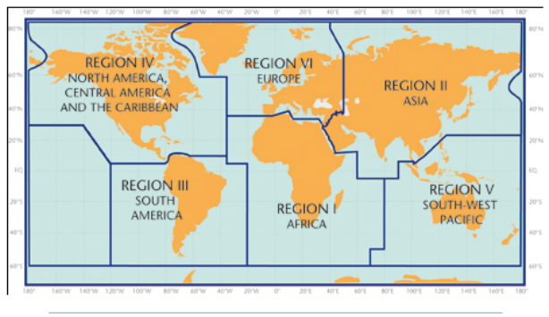

5. Designated and developing WMO Regional Climate Centres and Regional Climate Centre Networks
- RA I: http://www.wmo.int/pages/prog/wcp/wcasp/RCC-Africa.html
- RA II: http://www.wmo.int/pages/prog/wcp/wcasp/RCC-Asia.html
- RA III: http://www.wmo.int/pages/prog/wcp/wcasp/RCC-SouthAmerica.html
- RA IV: http://www.wmo.int/pages/prog/wcp/wcasp/RCC-NorthAmerica.html
- RA V: http://www.wmo.int/pages/prog/wcp/wcasp/RCC-SouthwestPacific.html
- RA VI: http://www.wmo.int/pages/prog/wcp/wcasp/RCC-Europe.html

6. Resources
Sources for the graphics used in the GSCU:
- The WMO Lead Centre for Long-Range Forecast Multi-Model Ensemble (LC-LRFMME): http://www.wmolc.org
- WMO portal to the Global Producing Centres for Long-range Forecasts (GPCs-LRF): http://www.wmo.int/pages/prog/wcp/wcasp/clips/producers_forecasts.html
- WMO GSCU portal
http://www.wmo.int/pages/prog/wcp/wcasp/LC-LRFMME/index.php
- WMO portal for Regional Climate Outlook Forums (RCOFs):
https://public.wmo.int/en/our-mandate/climate/regional-climate-outlook-products
- International Research Institute for Climate and Society (IRI):
http://portal.iri.columbia.edu/portal/server.pt
- NOAA Climate Prediction Centre (CPC):
http://www.cpc.noaa.gov

7. Acknowledgements
This Global Seasonal Climate Update was jointly developed by the WMO Commission for Climatology and Commission for Basic Systems with contributions from:
- WMO Lead Centre for Long-Range Forecast Multi-Model Ensemble (LC-LRFMME), Korea Meteorological Administration, NOAA National Centers for Environmental Prediction
- WMO Global Producing Centres for Long-Range Forecast (GPCs-LRF): GPC-Beijing (China Meteorological Administration), GPC-CPTEC (Center for Weather and Climate Studies, Brazil), GPC-ECMWF (European Center for Medium-Range Forecast), GPC-Exeter (UK Met Office),GPC- Melbourne (Bureau of Meteorology), GPC-Montreal (Meteorological Services of Canada), GPC-Moscow (Hydro meteorological Center of Russia), GPC-Offenbach Deutscher Wetterdienst), GPC-Pretoria (South African Weather Services), GPC-Seoul (Korea Meteorological Administration), GPC-Tokyo (Japan Meteorological Agency), GPC-Toulouse (Météo-France), GPC-Washington (National Centers for Environmental Prediction)
- International Research Institute for Climate and Society (IRI)

File with supplementary information can be downloaded from https://ftp.cpc.ncep.noaa.gov/mingyue/GSCUWMO/Forecasts/GSCU_JJA2020_Supplementary_Info_LC_LRFMME.docx

