WEATHER CLIMATE WATER

GLOBAL SEASONAL
CLIMATE UPDATE
TARGET SEASON: June-July-August 2023

Issued: 26 May 2023

Summary
During February-April 2023, Pacific Niño sea-surface temperature (SST) index in the eastern Pacific (Niño 1+2) were above-normal while the other three indices in central Pacific were near-normal. The observed SST conditions in the equatorial Pacific were characterized by an ENSO neutral state. The Indian Ocean Dipole (IOD) over the observed period had a positive value. The North Tropical Atlantic (NTA) SST index was near zero while the South Tropical Atlantic (STA) SST index was positive.
Above-normal sea-surface temperature anomalies in the Niño 3.4 and Niño 3 regions are predicted during the June-August (JJA) 2023 season indicating the development of moderate to strong El Niño conditions. Farther west in the Niño 4 region, the sea-surface temperature anomaly is also predicted to be above-normal. The IOD is predicted to be above-normal in JJA 2023. In the equatorial Atlantic, SSTs are predicted to be above-normal in both the northern (NTA) and the southern (STA) areas during the season.
Consistent with the predicted development of above-normal sea-surface temperatures over much of the global oceans, there is widespread prediction of above-normal temperatures over almost all land areas. Positive temperature anomalies are expected over almost the entire Northern Hemisphere except for an area along the south-west coast of North America that extends into the central Pacific at about 20º N, over parts of the Arctic Ocean, and over the northern Bering Sea. The largest increase in probabilities for above-normal temperatures in the Northern Hemisphere is predicted generally south of about 30º N, and also over parts of Central Asia, northern parts of North America, and Greenland. Elsewhere in the Northern Hemisphere, including Europe and Asia north of about 45º N, much of East Asia, and in North America along about 45º N and in the northwest, the probabilities for above-normal temperature are moderately increased. There are also enhanced probabilities for above-normal temperatures over most of the Southern Hemisphere, except for the areas bordering the eastern tropical Indian Ocean, northern Australia, the southernmost part of South America. Over most other Southern Hemisphere land areas north of about 30º S, as well as over New Zealand, the probabilities for above-normal temperature are strongly increased. However, over Australia, and over the central and eastern Pacific Ocean islands south of about 20º S the probabilities for above-normal temperatures are only weakly increased. Probabilities for above-normal temperatures are also moderately increased over South America south of about 20º S and north of the area of predicted below-normal temperatures at the far south-western tip of the continent.
Predictions for rainfall are similar to some of the canonical rainfall impacts of El Niño, which is expected to strengthen in JJA 2023. Probabilities for above-normal rainfall are enhanced over a narrow band along and just north of the equator from the Philippines extending across the equator to the west coast of South America. This anomalously wet area extends discontinuously westward and with weaker signal and is most evident in the western part of south-east Asia, coastal parts of South Asia, and along the southern part of West Africa, extending most of the way across the Atlantic Ocean. Across most of the Pacific Ocean south of about 25º N, and immediately to the north of the wet band, rainfall is predicted to be below-normal. This area of dryness extends across much of the northern part of South America north of about 5º S, southern parts of Central America and the southern Caribbean, and the west coast of Central America. There is another band of predicted below-normal rainfall in the Central South Pacific east of the Dateline and extending in a narrowband to a little beyond 120º W. Over the south-central and western parts of the Maritime continent, below-normal rainfall is also predicted. This area extends along the equator almost to the east coast of Africa, but also to the south and east, so that most of Australia and the northern part of New Zealand have increased probabilities of below-normal rain. The probability of below-normal rainfall is also increased over much of the Indian subcontinent and over inland parts of East Africa. Over much of the rest of Africa north of the equator and over southern parts of Europe, the probabilities for above-normal rainfall are weakly to moderately increased. Outside of the tropics, there are no large-scale strong indications of anomalous rainfall over land.

Surface Air Temperature, JJA 2023 Precipitation, JJA 2023
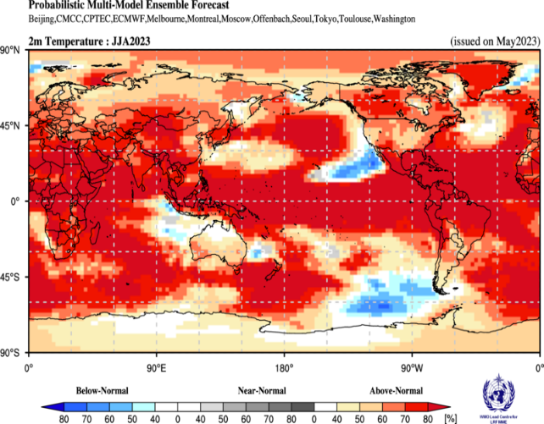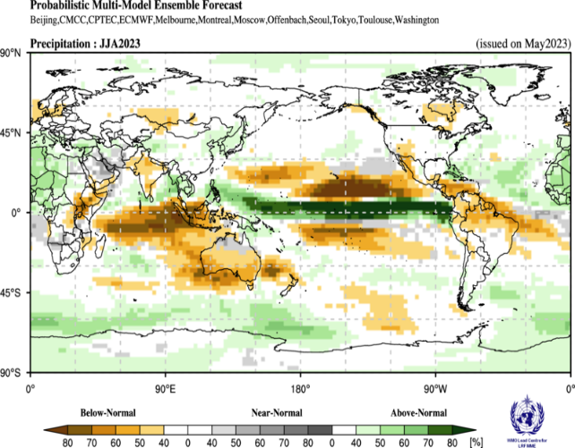

Figure 1. Probabilistic forecasts of surface air temperature and precipitation for the season June-August 2023. The tercile category with the highest forecast probability is indicated by shaded areas. The most likely category for below-normal, above-normal, and near-normal is depicted in blue, red, and grey shadings respectively for temperature, and orange, green and grey shadings respectively for precipitation. White areas indicate equal chances for all categories in both cases. The baseline period is 1993–2009.

1. Observations: February - April 2023
In the following sections, observed temperature and precipitation patterns for the previous season are discussed. For more detailed information about regional and local climate anomalies, the reader is referred to the concerned WMO Regional Climate Centres (RCCs) or RCC Networks, listed in Section 5.

1.1 Large-scale sea-surface temperature (SST) indices
During February-April 2023, Pacific Niño sea-surface temperature (SST) index in the eastern Pacific (Niño 1+2) were above-normal while the other three indices in the central Pacific were near-normal. The observed SST conditions in the equatorial Pacific were characterized by an ENSO neutral state. The Indian Ocean Dipole (IOD) over the observed period had a positive value. The North Tropical Atlantic (NTA) SST index was near zero while the South Tropical Atlantic (STA) SST index was positive.

Month | Niño 1+2 | Niño 3 | Niño 4 | Niño 3.4 | IOD | NTA | STA
February 2023 | 0.7 | -0.1 | -0.5 | -0.4 | 0.3 | -0.1 | 0.5
March 2023 | 1.5 | 0.4 | -0.1 | 0.0 | 0.4 | 0.0 | 0.5
April 2023 | 2.5 | 0.4 | 0.3 | 0.2 | 0.4 | -0.1 | 0.7
February - April 2023 | 1.6 | 0.2 | -0.1 | -0.1 | 0.4 | -0.1 | 0.6

Table 1. Large-scale oceanic indices (°C). Anomalies are with respect to the 1991–2020 average. (Source: U.S. Climate Prediction Center)

1.2 Observed temperature
Over land areas, temperature anomalies for February-April 2023 were a mix of above- and below-normal conditions (Figure 2, top). In the northern hemisphere, positive land-temperature anomalies occurred over eastern regions of North America, Greenland, Europe (except over the northern parts), north-western Africa, and almost over the entire Asia. Negative temperature anomalies were observed over western half of North America between 30º-60º N, northern Europe, a southwest to northeast oriented band in the interior regions of Africa between equator and 30ºN, and the Greater Horn of Africa. In the southern hemisphere, positive temperature anomalies occurred over New Zealand, over much of South America south of 15º S, and between equator and 20ºS over Africa. Negative temperature anomalies were observed over most of Australia, north-western and eastern regions of South America, and Madagascar.
Over the oceans, in the eastern Pacific the coastal regions of South America, and south of the equator had below-normal temperatures. In the extratropical southern Pacific Ocean along 60º S and between 180º-60º W, below average temperatures were observed. SSTs in the equatorial central Pacific indicated ENSO neutral state, with positive anomalies in the western equatorial Pacific and negative anomalies in the eastern Pacific - a pattern that indicates enhanced zonal SST gradients across the equatorial Pacific. SST anomalies in the Pacific north of 30º N and in the southern Pacific along 45º S were positive. A band of positive SST anomalies also extended from the Maritime continent towards the southern coast of South America. A notable region having the largest positive ocean-temperature anomaly was observed in the northwest Pacific. SSTs in the Indian Ocean were near average. SSTs in the western Caribbean and off the eastern coast of North America extending into the Atlantic Ocean were above-normal. Positive SST anomalies also extended from the coastal regions of Africa above the equator into the Mediterranean and northward along the coastal regions of Europe.
Warm extremes (exceeding all seasonal mean temperatures observed during 1991–2020), occurred over a few patchy regions - south of 30ºS in South America, and extreme south-eastern region of North America. Some oceanic regions also had warm extremes, notably the extratropical Pacific along 45º N, and over the western Pacific east of the Maritime continent. A region of cold extreme was observed over the coastal regions of eastern Australia.

1.2 Observed precipitation
For February-April 2023, the largest negative precipitation anomalies were in the equatorial Pacific near the dateline extending into the western Pacific to about 150º E with a band extending into the south-eastward to 120º W in southern Pacific, and another discontinuous band extending along the equator into the eastern Pacific (Fig. 3, top panel). Below-normal precipitation anomalies dominated the Indian Ocean, particularly below the equator in the southern Indian Ocean. Positive precipitation anomalies occurred in the oceanic regions in the vicinity of the Indonesian Archipelago, Coral Sea, and equatorial Atlantic. Located in the equatorial western Pacific, a band of positive precipitation anomalies extended south-eastward into the South Pacific and arched south-westward towards New Zealand.
Over land, negative precipitation anomalies were observed over Greenland, northeastern and coastal regions of northwestern North America, western parts of southern Europe. Over South America, except for a small region of positive rainfall anomalies along 25º S in the interior of the continent, the rainfall anomalies were mostly negative below the equator. Over Africa, except near the coastal regions below the equator in the west, positive rainfall anomalies dominated the continent. Positive rainfall anomalies were also observed over the Indian subcontinent, and over patchy regions scattered throughout over Asia. Negative rainfall anomalies generally dominated over Australia particularly in the east.
Small regions of wet extremes (exceeding all seasonal mean rainfall observed during 1991-2020) were observed over equatorial and northern Africa. Dry extremes were located over Greenland and north-eastern regions of North America.

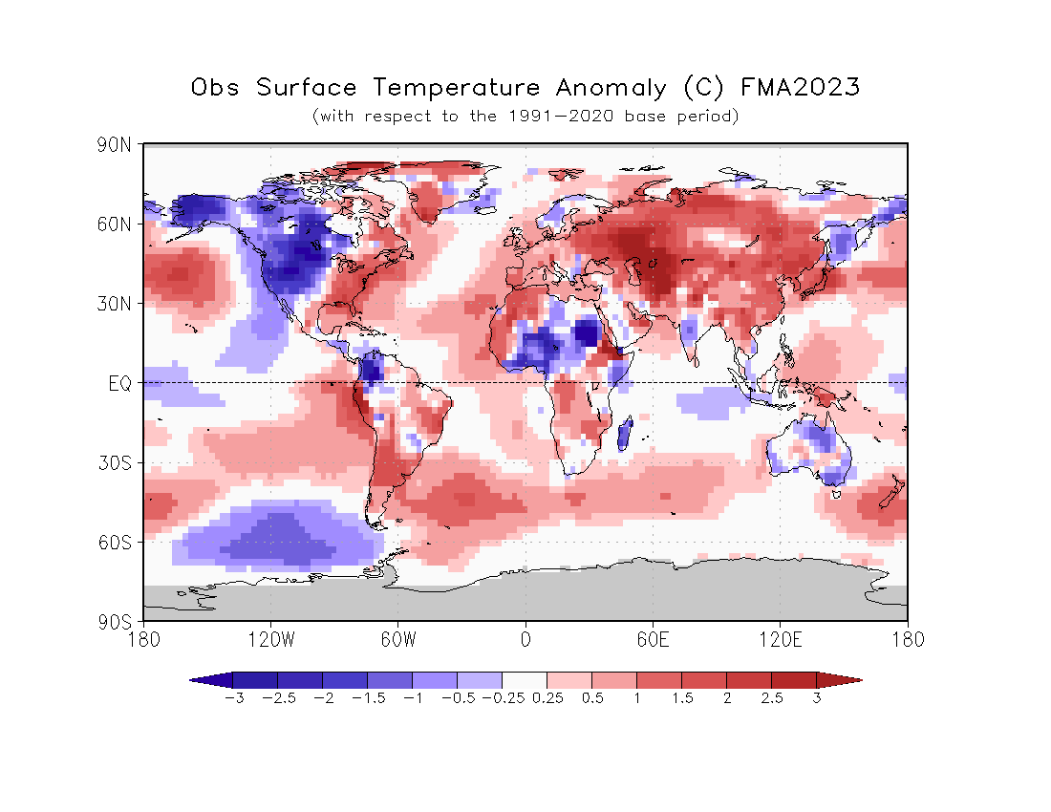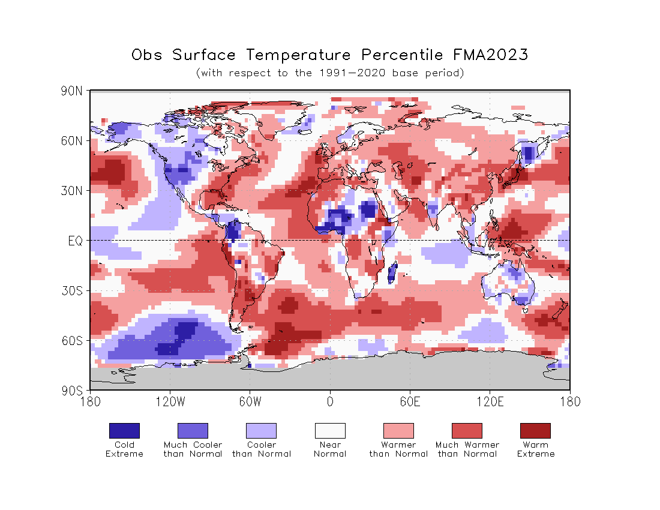
Figure 2. Observed February-April 2023 near-surface temperature anomalies relative to 1991–2020 (top). The Cooler than Normal, Near Normal, and Warmer than Normal shadings on the percentile map (bottom) indicate that seasonal mean anomalies were in the bottom, middle, and upper tercile of the 1991–2020 distribution, respectively. Regions with anomalies in the lowest and highest decile (or 10%) of the distribution are marked as Much Cooler than Normal and Much Warmer than Normal, respectively. The Cold Extreme and Warm Extreme shadings indicate that the anomalies exceeded the coldest and warmest temperature values of the 1991–2020 period for the season. Grey shading indicates areas where observational analysis was not available. (Source: U.S. Climate Prediction Center).

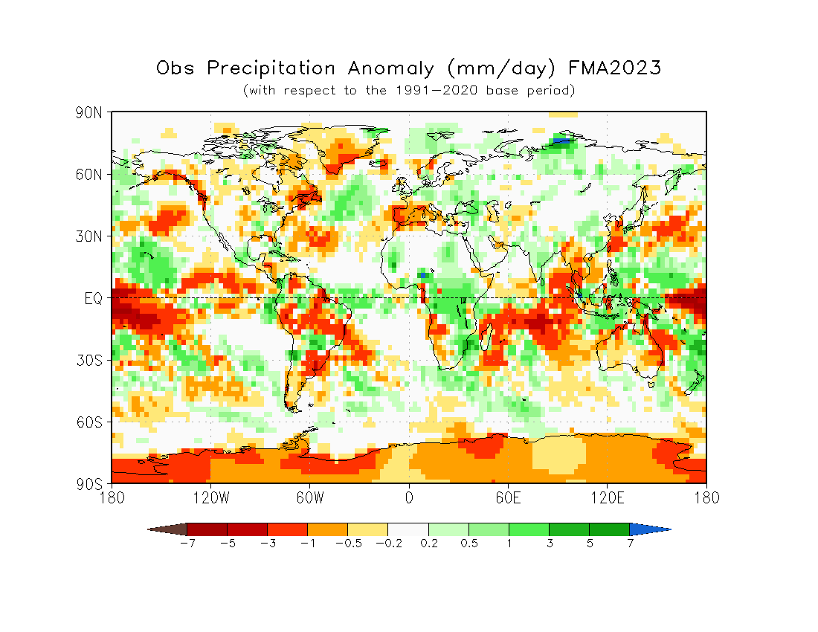
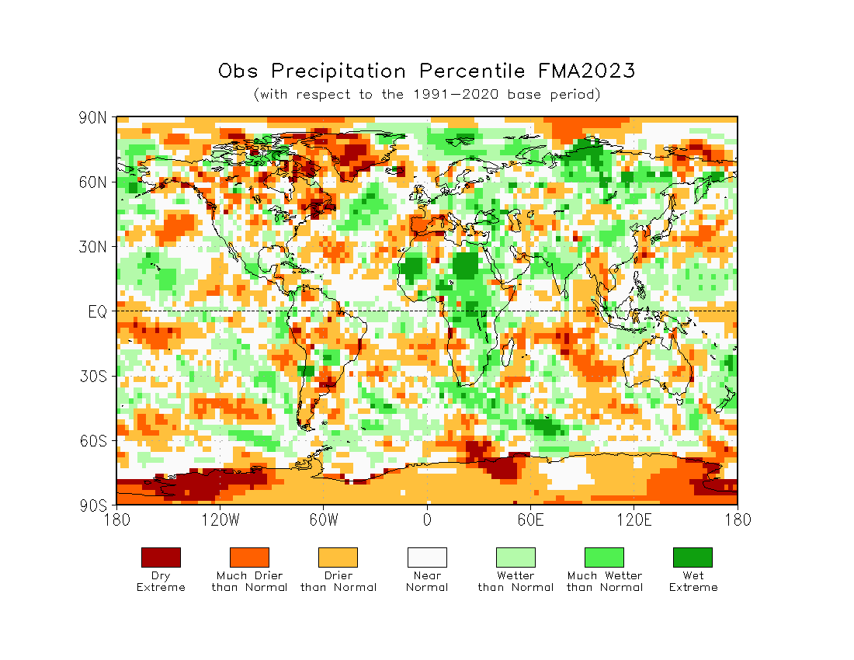
Figure 3. Observed precipitation anomalies for February-April 2023, relative to 1991–2020 base period (top). The Drier than Normal, Near Normal and Wetter than Normal shadings on the percentile map (bottom) indicate that seasonal mean anomalies were in the bottom, middle, and upper tercile of the 1991–2020 distribution, respectively. Regions with anomalies in the lowest and highest decile (or 10%) of the distribution are marked as Much Drier than Normal and Much Wetter than Normal, respectively. The Dry Extreme and Wet Extreme shadings indicate that the anomalies exceeded the driest and wettest values of the 1991–2020 period for the season.
(Source: U.S. Climate Prediction Center).

2. Potential evolution of the state of the climate over the next three months (June-August 2023 )

2.1 Large-scale SST-based indices, June-August (JJA) 2023
Month | Nino 1+2 | Nino 3 | Nino 4 | Nino3.4 | IOD | NTA | STA
June 2023 | 2.6±0.4 | 1.5±0.3 | 0.6±0.2 | 1.0±0.2 | 0.4±0.2 | 0.8±0.2 | 0.6±0.3
July 2023 | 2.7±0.4 | 1.9±0.3 | 0.8±0.2 | 1.4±0.3 | 0.8±0.3 | 0.8±0.2 | 0.6±0.3
August 2023 | 2.6±0.5 | 2.2±0.4 | 1.1±0.3 | 1.7±0.4 | 1.0±0.4 | 0.8±0.1 | 0.6±0.2
June-August 2023 | 2.7±0.5 | 1.7±0.4 | 0.7±0.3 | 1.1±0.3 | 0.6±0.3 | 0.8±0.2 | 0.6±0.3

Table 2: Multi-model forecasts for oceanic indices (℃), with standard deviation. Values are the equal-member-weighting average of those derived, using each GPC model’s own hindcast climate mean, from the GPCs supplying SST forecasts (GPC Beijing, CMCC, ECMWF, Exeter, Melbourne, Montreal, Offenbach, Seoul, Tokyo, Toulouse, Washington). The standard deviation is calculated on all ensemble members. The latitude/longitude bounds of the regions are given in the supplementary information section.
Observed sea-surface temperatures in the central tropical Pacific were in an ENSO neutral condition during February-April 2023. Above-normal sea-surface temperature anomalies in the Niño 3.4 and Niño 3 regions are predicted during the June-August (JJA) 2023 season indicating the development of moderate to strong El Niño conditions. Farther west in the Niño 4 region, the sea-surface temperature anomaly is also predicted to be above-normal. The IOD is predicted to be above-normal in JJA 2023. In the equatorial Atlantic, SSTs are predicted to be above-normal in both the northern (NTA) and the southern (STA) areas during the season.

2.2 Predicted temperature, June-August 2023
For information on the construction of the multi-model forecast maps, refer to the supplementary information section. (Note: Maps indicating forecast consistency among GPC models are available in the supplementary information).
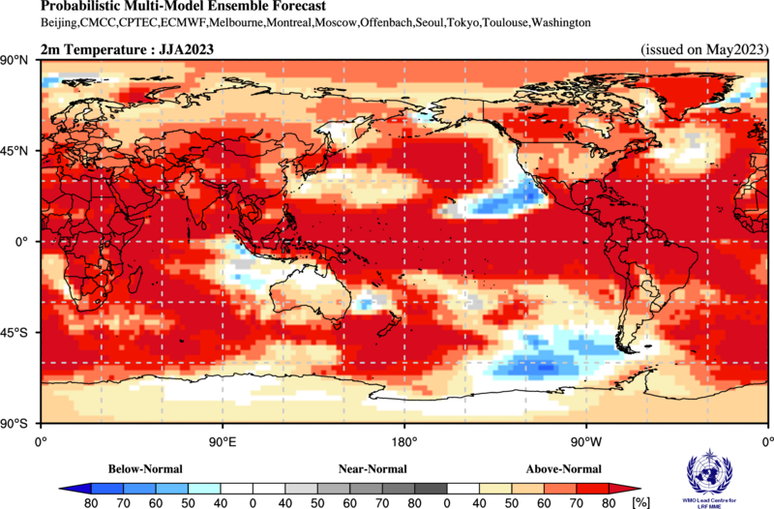

Figure 4. Probabilistic forecasts of surface air temperature for June-August 2023. The tercile category with the highest forecast probability is indicated by shaded areas. The most likely category for below-normal, above-normal, and near-normal is depicted in blue, red, and grey shadings, respectively. White areas indicate equal chances for all categories in both cases. The baseline period is 1993–2009. Figure is generated by The WMO Lead Centre for Long-Range Forecast Multi-Model Ensemble.
Consistent with the predicted development of above-normal sea-surface temperatures over much of the global oceans, there is widespread prediction of above-normal temperatures over almost all land areas. Positive temperature anomalies are expected over almost the entire Northern Hemisphere except for an area along the south-west coast of North America that extends into the central Pacific at about 20º N, over parts of the Arctic Ocean, and over the northern Bering Sea. The largest increase in probabilities for above-normal temperatures in the Northern Hemisphere is predicted generally south of about 30º N, and also over parts of Central Asia, northern parts of North America, and Greenland. Elsewhere in the Northern Hemisphere, including Europe and Asia north of about 45º N, much of East Asia, and in North America along about 45º N and in the northwest, the probabilities for above-normal temperature are moderately increased. There are also enhanced probabilities for above-normal temperatures over most of the Southern Hemisphere, except for the areas bordering the eastern tropical Indian Ocean, northern Australia, the southernmost part of South America. Over most other Southern Hemisphere land areas north of about 30º S, as well as over New Zealand, the probabilities for above-normal temperature are strongly increased. However, over Australia, and over the central and eastern Pacific Ocean islands south of about 20º S the probabilities for above-normal temperatures are only weakly increased. Probabilities for above-normal temperatures are also moderately increased over South America south of about 20º S and north of the area of predicted below-normal temperatures at the far south-western tip of the continent.
RA I (Africa): Enhanced probabilities of above-normal temperatures are indicated over virtually all of mainland Africa and Madagascar. The probability increases are strong everywhere except along a small area of the west coast of Southern Africa and along the northwest coast, but model consistency is strong only along the equator, near 30º S and in the northeast. Elsewhere, including over Madagascar, consistency is moderate to strong.
RA II (Asia): Enhanced probabilities for above-normal temperatures are indicated over almost all mainland Asia. Probabilities for above-normal temperatures are high almost everywhere south of about 50º N but are strongest over central inland Asia at about 90º E, over the Arabian Peninsula. Over these regions model consistency is moderate to strong. North of 50º N above-normal temperatures is still the most likely outcome, but probabilities are weaker than they are further south, and model consistency is moderate. The only places where above-normal temperatures do not have an increased probability are along a narrow coastal strip of the Maritime Continent bordering the Indian Ocean, where the predicted positive phase of the IOD indicates sea-surface temperatures are likely to be below-normal; and over some small areas bordering the Sea of Okhotsk.
RA III (South America): Strongly enhanced probabilities for above-normal temperatures are indicated over South America north of about 20º S and extending to about 30º S along the west coast. Model consistency is high over most of this region. Further south, weak to moderately enhanced probabilities for above-normal temperature are indicated, except in the far southwestern coastal strip and over the Falkland Islands. Model consistency is low south of about 35º S.
RA IV (North America, Central America, and the Caribbean): There are enhanced probabilities for above-normal temperatures over all of North America, except for the Baja California Peninsula, and in the northern Bering Sea. The probabilities for above-normal temperatures are strongest over Central America and the Caribbean but are also strong over the central northern areas. Model consistency is a little patchy but is moderate to strong virtually everywhere. Along parts of the southwest coast of North America there are weak probabilities of below-normal temperature, consistent with an area of predicted negative sea-surface temperature anomalies. However, model consistency is only moderate to strong over the oceans.
RA V (Southwest Pacific): Strongly enhanced probabilities for above-normal temperatures are predicted across the whole of the Pacific Ocean within about 10 to 15º latitude of the equator. Further south, there are patches where probabilities for above-normal rainfall are also strongly increased, including a large area extending from south of Australia, across New Zealand to about 150º W. Model consistency is moderate to high over most of these regions. Many of the southwest Pacific islands lie within these areas of above-normal temperatures, but there are some small patches of normal to below-normal predicted temperatures along about 30º S. Over Australia, above-normal temperatures are indicated only in the southern two-thirds, and model consistency is moderate to strong. North of the equator, above-normal temperatures are predicted almost everywhere except for an area of predicted below-normal temperatures extending from about 150º W towards North America. Model consistency is moderate in this cold area. From south of Japan to about the dateline the probabilities for above-normal temperature are weaker than elsewhere, but above-normal temperature still has the highest probability.
RA VI (Europe): The probabilities for above-normal temperatures are increased over all of Europe with stronger probabilities located in the west, over Greenland, and along about 45º N. The model-to-model consistency is moderate to high. Below-normal temperatures are indicated in a small area over the Arctic Ocean extending from the East coast of Greenland to near Svalbard.

2.3 Predicted precipitation, June-August 2023
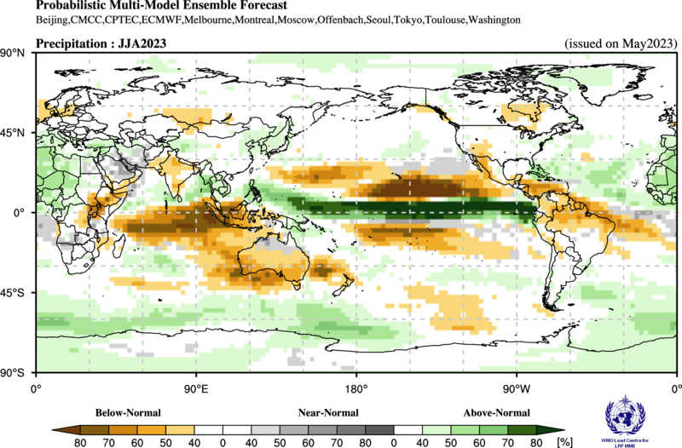

Figure 5. Probabilistic forecasts of precipitation for the season for June-August 2023. The tercile category with the highest forecast probability is indicated by shaded areas. The most likely category for below-normal, above-normal, and near-normal is depicted in orange, green and grey shadings, respectively. White areas indicate equal chances for all categories in both cases. The baseline period is 1993–2009. Figure is generated by The WMO Lead Centre for Long-Range Forecast Multi-Model Ensemble.

Predictions for rainfall are similar to some of the canonical rainfall impacts of El Niño, which is expected to strengthen in JJA 2023. Probabilities for above-normal rainfall are enhanced over a narrow band extending along and just north of the equator from the Philippines extending across the equator to the west coast of South America. This anomalously wet area extends discontinuously westward and with weaker signal and is most evident in the western part of south-east Asia, coastal parts of South Asia, and along the southern part of West Africa, extending most of the way across the Atlantic Ocean. Across most of the Pacific Ocean south of about 25º N, and immediately to the north of the wt band, rainfall is predicted to be below-normal. This area of dryness extends across much of the northern part of South America north of about 5º S, southern parts of Central America and the southern Caribbean, and the west coast of Central America. There is another band of predicted below-normal rainfall in the Central South Pacific east of the Dateline and extending in a narrowband to a little beyond 120º W. Over the south-central and western parts of the Maritime continent, below-normal rainfall is also predicted. This area extends along the equator almost to the east coast of Africa, but also to the south and east, so that most of Australia and the northern part of New Zealand have increased probabilities of below-normal rain. The probability of below-normal rainfall is also increased over much of the Indian subcontinent and over inland parts of East Africa. Over much of the rest of Africa north of the equator and over southern parts of Europe, the probabilities for above-normal rainfall are weakly to moderately increased. Outside of the tropics, there are no large-scale strong indications of anomalous rainfall over land.
RA I (Africa): Enhanced probabilities for below-normal precipitation are predicted over inland parts of eastern Africa extending into an area of Central Africa to the southwest, with another extension northward to the Gulf of Aden. There is an additional small area of predicted below-normal precipitation on the far northeastern coast of southern Africa, reaching discontinuously over Madagascar. Model consistency is moderate in the core of these areas. There are patchy areas of increased probabilities for normal rainfall in other parts of southern Africa, but June – August represents the dry season here. Over the whole of Africa west of about 25º E and north of the equator there are weak to moderate increases in the probability of above-normal rainfall, with weak to moderate consistency. North of about 15º N this area extends in patches towards the east and covers most of the north coast of Africa.
RA II (Asia): Over the southwestern half of the Maritime Continent and extending across most of the equatorial Indian Ocean to about 15º S, probabilities for below-normal rainfall are strongly enhanced. Model consistency is strong or moderate in this area. Immediately to the north of this dry band is an area of predicted above-normal rainfall that extends from off the coast of the Greater Horn of Africa, around the coast of the Indian subcontinent, through southeast Asia and the Philippines. Model consistency is strong only over a small area of southeast Asia, and to the east of the Philippines. There are other areas of weakly increased probabilities of above-normal rainfall along about 40º N over parts of east Asia, central Asia, and in the far west. Model consistency is weak to moderate. Over much of the Indian subcontinent and over the southeastern part of the Arabian Peninsula there are enhanced probabilities for below-normal rainfall, but model consistency is weak. Most of the rest of the Arabian Peninsula and neighboring parts of southwest Asia have indications of increased probabilities for normal precipitation.
RA III (South America): Over the far west coast of South America and near the equator, above-normal rainfall is predicted with high probability and strong model consistency. Elsewhere in South America north of about 10º S and extending to about 20º S on the east coast, predictions indicate increased probability for below-normal rainfall (model-to-model consistency is mostly moderate). Further south, there is no clear signal.
RA IV (North America, Central America, and the Caribbean): There are weak to moderate increases in probabilities for below-normal precipitation indicated for southern parts of the Caribbean and of Central America, and western parts of Central America extending north to about 40º N. Model consistency is low to moderate. Over the northern part of the Caribbean, probabilities for above-normal precipitation are increased, and this area extends with a very weak signal along the east coast of North America. Model consistency is moderate to weak. Over most of North America there is no clear signal, although an area of predicted below-normal precipitation appears with weak probabilities and low model consistency around Hudson Bay.
RA V (Southwest Pacific): Probabilities for above-normal rainfall are strongly enhanced over a narrow area extending along the equator from about 140º E to the coast of South America. Model consistency is moderate to high. At about 140º E, this area reaches to the northwest, where it weakens in both directions. The southward branch extends to the south-east, as far as about 40º S, in an area of very weakly enhanced probabilities for increased precipitation. Many of the islands in the Southwest Pacific are located in this branch. Immediately to the north and the south of the equatorial wet band are areas centered at about 150º W, where probabilities for below-normal rainfall are predicted to be moderately to strongly increased. The increases in probabilities are stronger in the north Pacific where it extends to almost 30º N and spans almost the full width of the Ocean. Model consistency is strong. There is another area of predicted increases in the probability for below-normal precipitation that reaches from the eastern Indian Ocean across most of Australia and to the northern part of New Zealand. Within this area, probabilities are most enhanced along the southern part of Australia and off the east coast of Australia. Model consistency is moderate to strong. The northern part of Australia has indications of increased probabilities for normal precipitation. Other areas of normal precipitation are predicted to the north of the dry bands in both the North and South Pacific.
RA VI (Europe): Most of Europe has little to no signal, but there are weak indications of enhanced probability of above-normal precipitation in southern Europe, and of below-normal precipitation over the North and Baltic Seas and neighboring land areas. Model consistency is moderate to low for southern Europe, and low for the dry area further north.

3. Latest updates for monitoring and prediction information
Each month, the latest updates for the real-time monitoring and seasonal mean predictions included in GSCU can be found at:
Monitoring:
https://ftp.cpc.ncep.noaa.gov/mingyue/GSCUWMO/
Predictions:
www.wmolc.org/board/downloadExt?fn=WMOLC_T2M.png
http://www.wmolc.org/board/downloadExt?fn=WMOLC_PREC.png

4. How to use the Global Seasonal Climate Update
The GSCU is intended as guidance for RCCs, Regional Climate Outlook Forums (RCOFs) and National Meteorological and Hydrological Services (NMHSs). It does not constitute an official forecast for any region or nation. Seasonal outlooks for any region or nation should be obtained from the relevant RCCs (see below for contact details) or NMHS.
Figure 4 shows the spatial pattern of seasonal mean surface air temperature forecast probabilities. Probabilities are calculated for the average temperature for the season being in the highest third (above-normal or warm), middle third (normal) or lowest third (below-normal or cold) ranges of the baseline record (1993-2009) at each location. Colour code is indicated only for the category that has the highest probability of occurrence. For example, for regions highlighted in red, the most likely forecast category for seasonal mean surface air temperature to occur is warmer than normal. Similarly, the blue colour highlights regions where the seasonal mean surface air temperature forecast indicates the colder than normal category as most likely, while grey colour highlights regions where the seasonal mean temperature forecast indicates the near normal category as most likely. Deeper shades of respective colours highlight increasing probability for the seasonal mean temperature to be in the indicated category. White areas indicate equal chances for all categories.
A particular colour does not assure that the seasonal mean temperature is “certain” to be observed in the most likely forecast category that is shown, but rather its probability of being in that category. As a consequence, the observed seasonal mean temperatures have a non-negligible probability to be observed in a category different from the category indicated on the map as most likely. Users need to take the probabilistic nature of seasonal forecasts into account when making decisions. It should also be noted that the absolute values for the surface air temperature corresponding to the definitions of the above normal (warm), normal or below normal (cold) categories depend on the climatology (historical information) at the location, and therefore, is location dependent.
The interpretation of the probabilities for the rainfall forecast (Figure 5) is the same as that for the seasonal mean surface air temperature except that green and brown colours indicate whether the forecasted seasonal mean precipitation is most likely to be in the wet or dry category. As for surface temperature, grey colour highlights regions where the seasonal mean rainfall forecast indicates the near normal category as the most likely.
The skill of seasonal forecasts is substantially lower than that of weather timescales and skill may vary considerably with region and season. It is important to view the forecast maps together with the skill maps provided in the supplementary material.
For reference, the six WMO Regional Associations domains are depicted in the figure below.

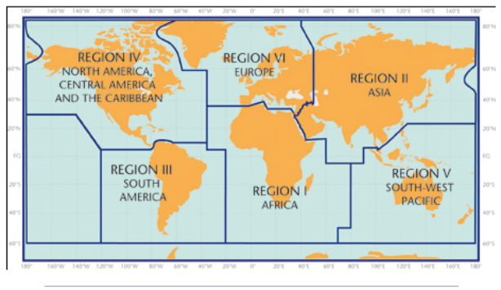

5. Designated and developing WMO Regional Climate Centres and Regional Climate Centre Networks
- https://public.wmo.int/en/our-mandate/climate/regional-climate-centres

6. Resources
Sources for the graphics used in the GSCU:
- The WMO Lead Centre for Long-Range Forecast Multi-Model Ensemble (LC-LRFMME): http://www.wmolc.org
- WMO portal to the Global Producing Centres for Long-range Forecasts (GPCs-LRF): https://public.wmo.int/en/programmes/global-data-processing-and-forecasting-system/global-producing-centres-of-long-range-forecasts
- WMO portal for Regional Climate Outlook Forums

https://public.wmo.int/en/our-mandate/climate/regional-climate-outlook-products
- International Research Institute for Climate and Society (IRI):
https://iri.columbia.edu/
- NOAA Climate Prediction Centre (CPC):
http://www.cpc.ncep.noaa.gov

7. Acknowledgements
This Global Seasonal Climate Update was jointly developed by the WMO Infrastructure (INFCOM) and Services (SERCOM) Commissions with contributions from:
- WMO Lead Centre for Long-Range Forecast Multi-Model Ensemble (LC-LRFMME), Korea Meteorological Administration, NOAA National Centers for Environmental Prediction
- WMO Global Producing Centres for Long-Range Forecast (GPCs-LRF): GPC-Beijing (China Meteorological Administration), GPC-CPTEC (Center for Weather Forecast and Climate Studies, Brazil), GPC-ECMWF (European Center for Medium-Range Forecast), GPC-Exeter (UK Met Office),GPC- Melbourne (Bureau of Meteorology), GPC-Montreal (Meteorological Services of Canada), GPC-Moscow (Hydro meteorological Center of Russia), GPC-Offenbach Deutscher Wetterdienst), GPC-Pretoria (South African Weather Services), GPC-Seoul (Korea Meteorological Administration), GPC-Tokyo (Japan Meteorological Agency), GPC-Toulouse (Météo-France), GPC-Washington (National Centers for Environmental Prediction), GPC-CMCC (Centro Euro-Mediterraneo sui Cambiamenti Climatici).
- International Research Institute for Climate and Society (IRI)

File with supplementary information can be downloaded from https://ftp.cpc.ncep.noaa.gov/mingyue/GSCUWMO/Forecasts/GSCU_JJA2023_supplementary_info_LC-LRFMME.docx

