WEATHER CLIMATE WATER

GLOBAL SEASONAL
CLIMATE UPDATE
Pre-Operational Phase
TARGET SEASON: December-January-February 2019-2020

Issued: 25 November 2019
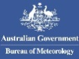

Summary
Observed sea surface temperatures anomalies in the east-central topical Pacific were in a neutral El Niño condition during August-October 2019. However, a notable feature was a strong positive phase for the Indian Ocean Dipole (IOD) with large below-normal sea surface temperature anomalies in the eastern Indian Ocean south of Indonesian Archipelago. The sea surface temperatures in the Niño 3.4 and Niño 3 regions, both of which are often used to characterize ENSO conditions, are predicted to decrease from approximately 0.2 to 0.1 °C during the December-February 2019-20 season, and hence, are expected to remain in a near-average range.
Influences from the expected tendency towards positive sea surface temperature anomalies across sizeable portions of the globe, both in the tropics (except for near-average conditions in the central and eastern Pacific) and extra-tropics, are seen in the temperature forecast for December 2019-January-February 2020, which leans quite strongly, on average, towards above-normal land temperature, particularly at tropical latitudes. Below-average sea surface temperature is predicted in relatively smaller areas, such as south of Australia, in the southeast equatorial Pacific near the coast of South America, south of Greenland and in relatively small areas in the South Atlantic Ocean and the Southern Hemisphere extratropics. The near-average sea surface conditions predicted in much of the eastern equatorial Pacific may noticeably affect the overlying tropical atmospheric circulation and climate, as they participate in the SST gradients with positive SST anomalies in the western Pacific. A global warming trend also contributes to the sea surface temperature and air temperature forecast, leading to a general prevalence towards a positive tilt in anomalies defined using the climatological base period (1993–2009) centred more than 10 years in the past.
Near-average precipitation conditions are expected in the central and eastern equatorial Pacific, and an enhanced probability for above normal precipitation is expected in the western tropical Pacific (particularly just north of the equator) and southwestern Indian Ocean extending into eastern equatorial Africa. Some tilts of the odds for precipitation are likely associated with sea surface temperature anomalies related to the predicted positive phase of the Indian Ocean Dipole, such as the enhanced probability for below-average precipitation over much of the Indonesian Archipelago and northern Australia.

Surface Air Temperature, DJF 2019/2020  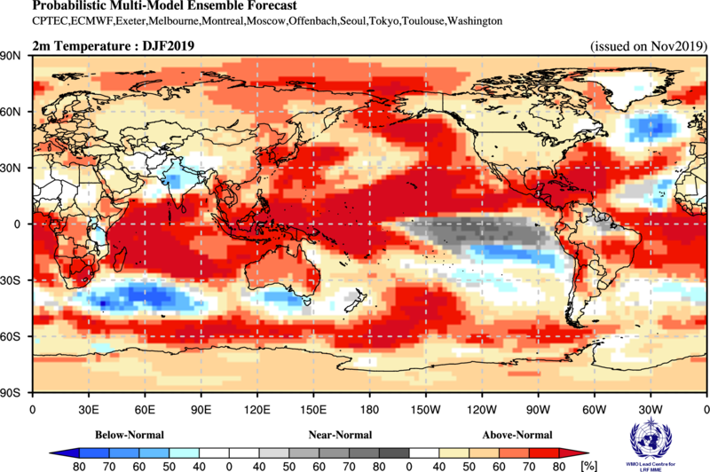 | Precipitation, DJF 2019/2020  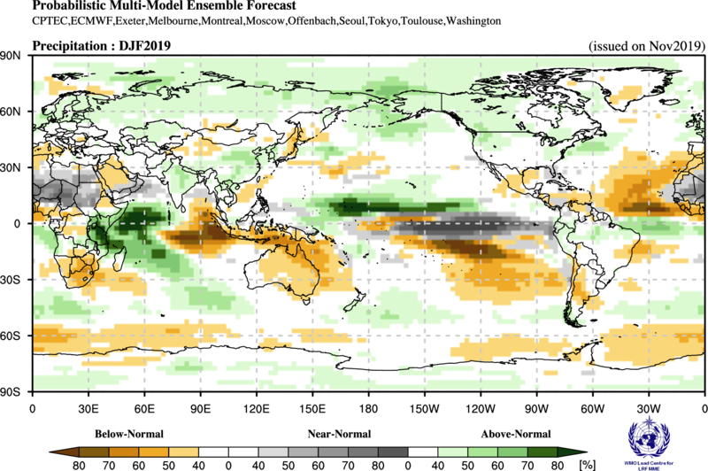

Figure 1. Probabilistic forecasts of surface air temperature and precipitation for the season December 2019-January-February 2020. The tercile category with the highest forecast probability is indicated by shaded areas. The most likely category for below-normal, above-normal and near-normal is depicted in blue, red and grey shadings respectively for temperature, and orange, green and grey shadings respectively for precipitation. White areas indicate equal chances for all categories in both cases. The baseline period is 1993–2009.

1. Observations: August-September-October 2019
In the following sections, observed temperature and precipitation patterns for the period August-October 2019 are briefly described. For more detailed information about regional and local climate anomalies, the reader is referred to the concerned WMO Regional Climate Centres (RCCs) or RCC Networks, listed in Section 5.

1.1 Large-scale sea surface temperature (SST) indices
Except for the far eastern Pacific region of Niño 1+2, where sea surface temperatures (SST) were below normal, SSTs were either close to normal (Niño 3) or were above-normal across other ENSO regions of the Pacific during August-October 2019, more so in the central Pacific (Niño 4) than in the east-central Pacific (Niño 3.4). The SST conditions showed the characteristic of a neutral El Niño/Southern Oscillation system. Except for the Niño 4 region, SST anomalies in all ENSO regions also declined from their somewhat further above-normal values in May-July 2019, indicating a weakening of El Niño conditions. The Indian Ocean Dipole (IOD) over the period had a strong amplification to higher positive values and was thus in a strong positive phase. The North Tropical Atlantic (NTA) and the South Tropical Atlantic (STA) index showed near-neutral conditions.

Month | Niño 1+2 | Niño 3 | Niño 4 | Niño 3.4 | IOD | NTA | STA
Aug 2019 | -0.44 | -0.01 | 0.82 | 0.15 | 1.52 | 0.07 | -0.24
Sep 2019 | -0.84 | -0.24 | 0.64 | -0.02 | 1.48 | 0.35 | -0.04
Oct 2019 | -0.79 | 0.2 | 0.98 | 0.62 | 1.95 | 0.46 | -0.07
Aug 2019-Oct 2019 | -0.69 | -0.05 | 0.81 | 0.25 | 1.65 | 0.29 | -0.12

Table 1. Large-scale oceanic indices (°C). Anomalies are with respect to the 1981–2010 average. (Source: U.S. Climate Prediction Center)

1.2 Observed temperature
Temperature anomalies across the globe continued the trend of warmer-than-normal conditions for the months of August-October 2019 (Figure 2, top). Above-normal temperatures dominated the globe, with a few areas of cool anomalies interspersed. The warmest land anomalies occurred over Alaska, southeast North America, South America, Africa, Southern Europe, and east Asia. Embedded within the general warmth over land, regions of below-normal land temperature were located over northwest North America and southern Indonesian Archipelago.
With the exception of small areas of cooler-than-normal temperatures in the eastern Indian Ocean south of the Indonesian Archipelago, the eastern and southeastern equatorial Pacific, the Southern Hemisphere oceans (southwest of South America and southeast of Africa), most oceanic regions had positive temperature anomalies. SSTs in the equatorial Pacific indicated neutral El Niño conditions in the east-central equatorial Pacific. SST anomalies throughout the extratropical North Pacific Ocean were generally positive.
Consistent with the seasonal mean anomalies, warm extremes dominated (Figure 2, bottom panel). Warm extremes (exceeding all seasonal mean temperatures observed during 1981–2010) occurred over central and southern Africa and over some regions of tropical eastern South America. Much cooler than normal temperatures (in lowest decile) were found over part of northeast North America, far northern South America, and over a small region in north-equatorial central Africa.

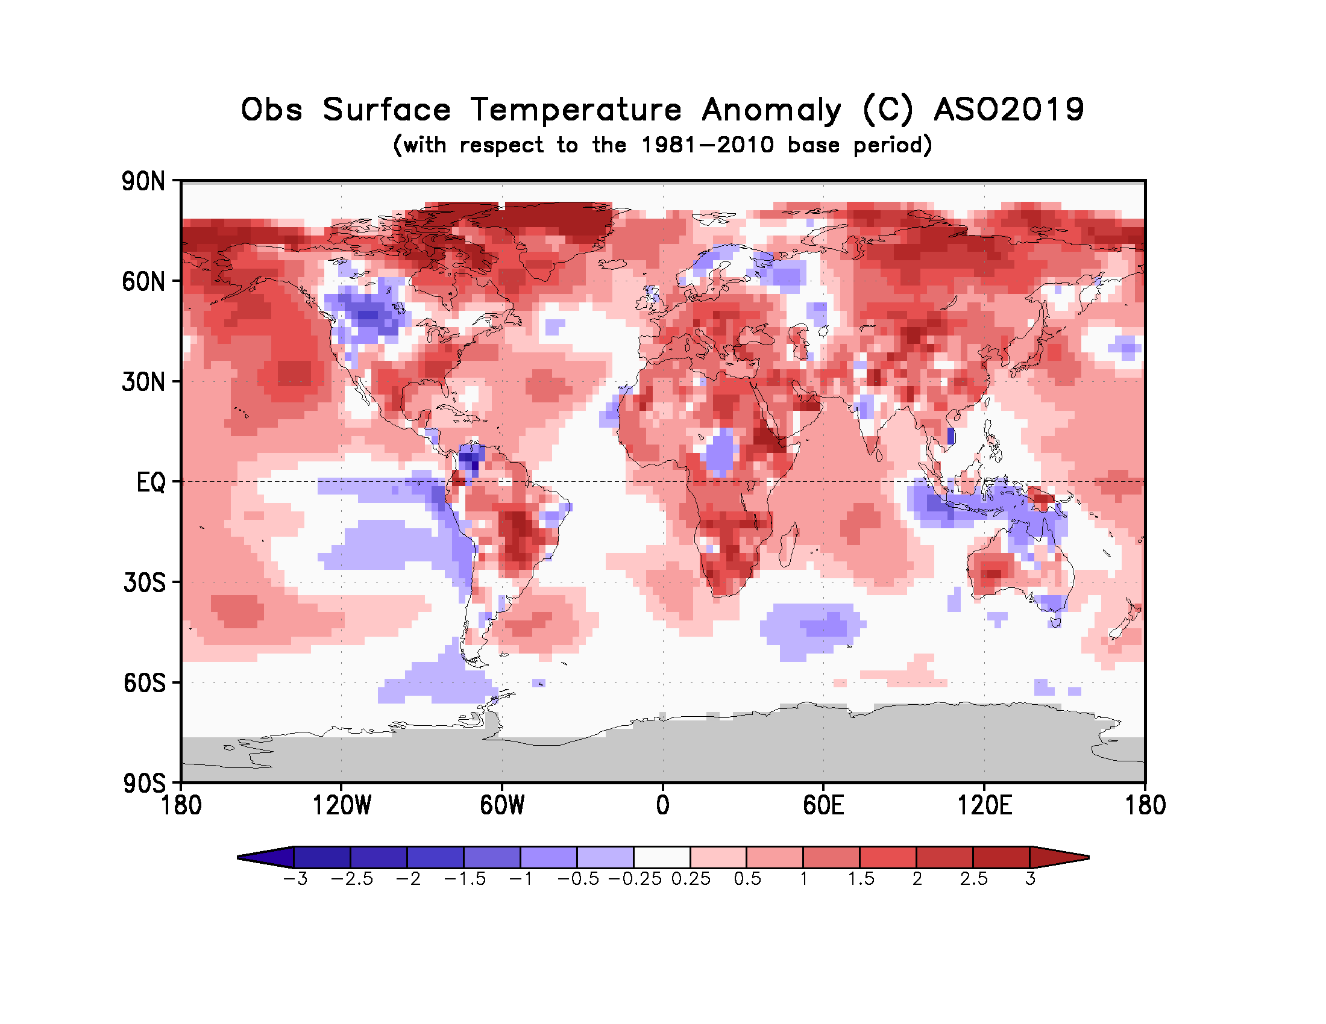
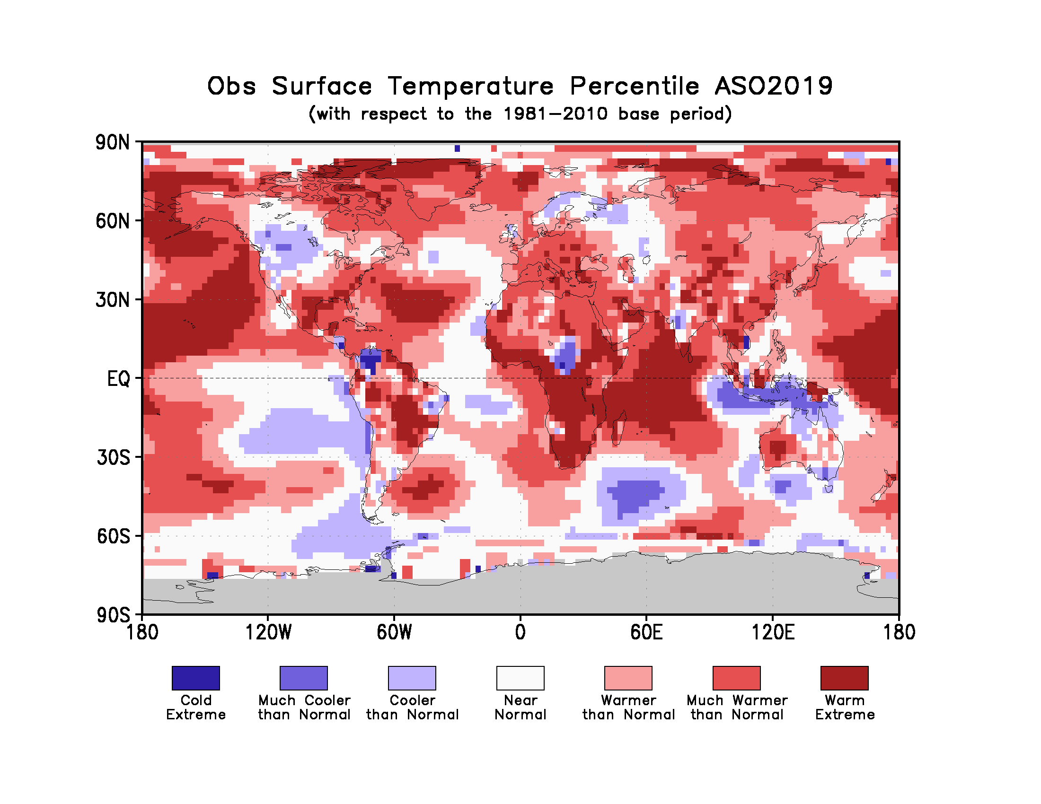
Figure 2. Observed August-October 2019 near-surface temperature anomalies relative to 1981–2010 (top). The Cooler than Normal, Near Normal, and Warmer than Normal shadings on the percentile map (bottom) indicate that seasonal mean anomalies were in the bottom, middle, and upper tercile of the 1981–2010 distribution, respectively. Regions with anomalies in the lowest and highest decile (or 10%) of the distribution are marked as Much Cooler than Normal and Much Warmer than Normal, respectively. The Cold Extreme and Warm Extreme shadings indicate that the anomalies exceeded the coldest and warmest temperature values of the 1981–2010 period for the season. Grey shading indicates areas where observational analysis was not available. (Source: U.S. Climate Prediction Center).

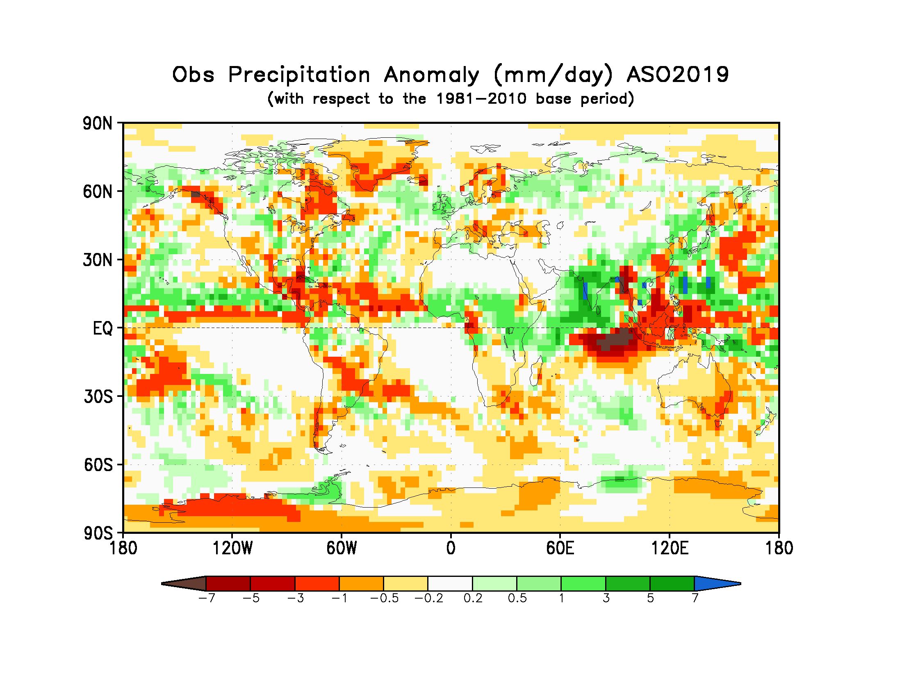
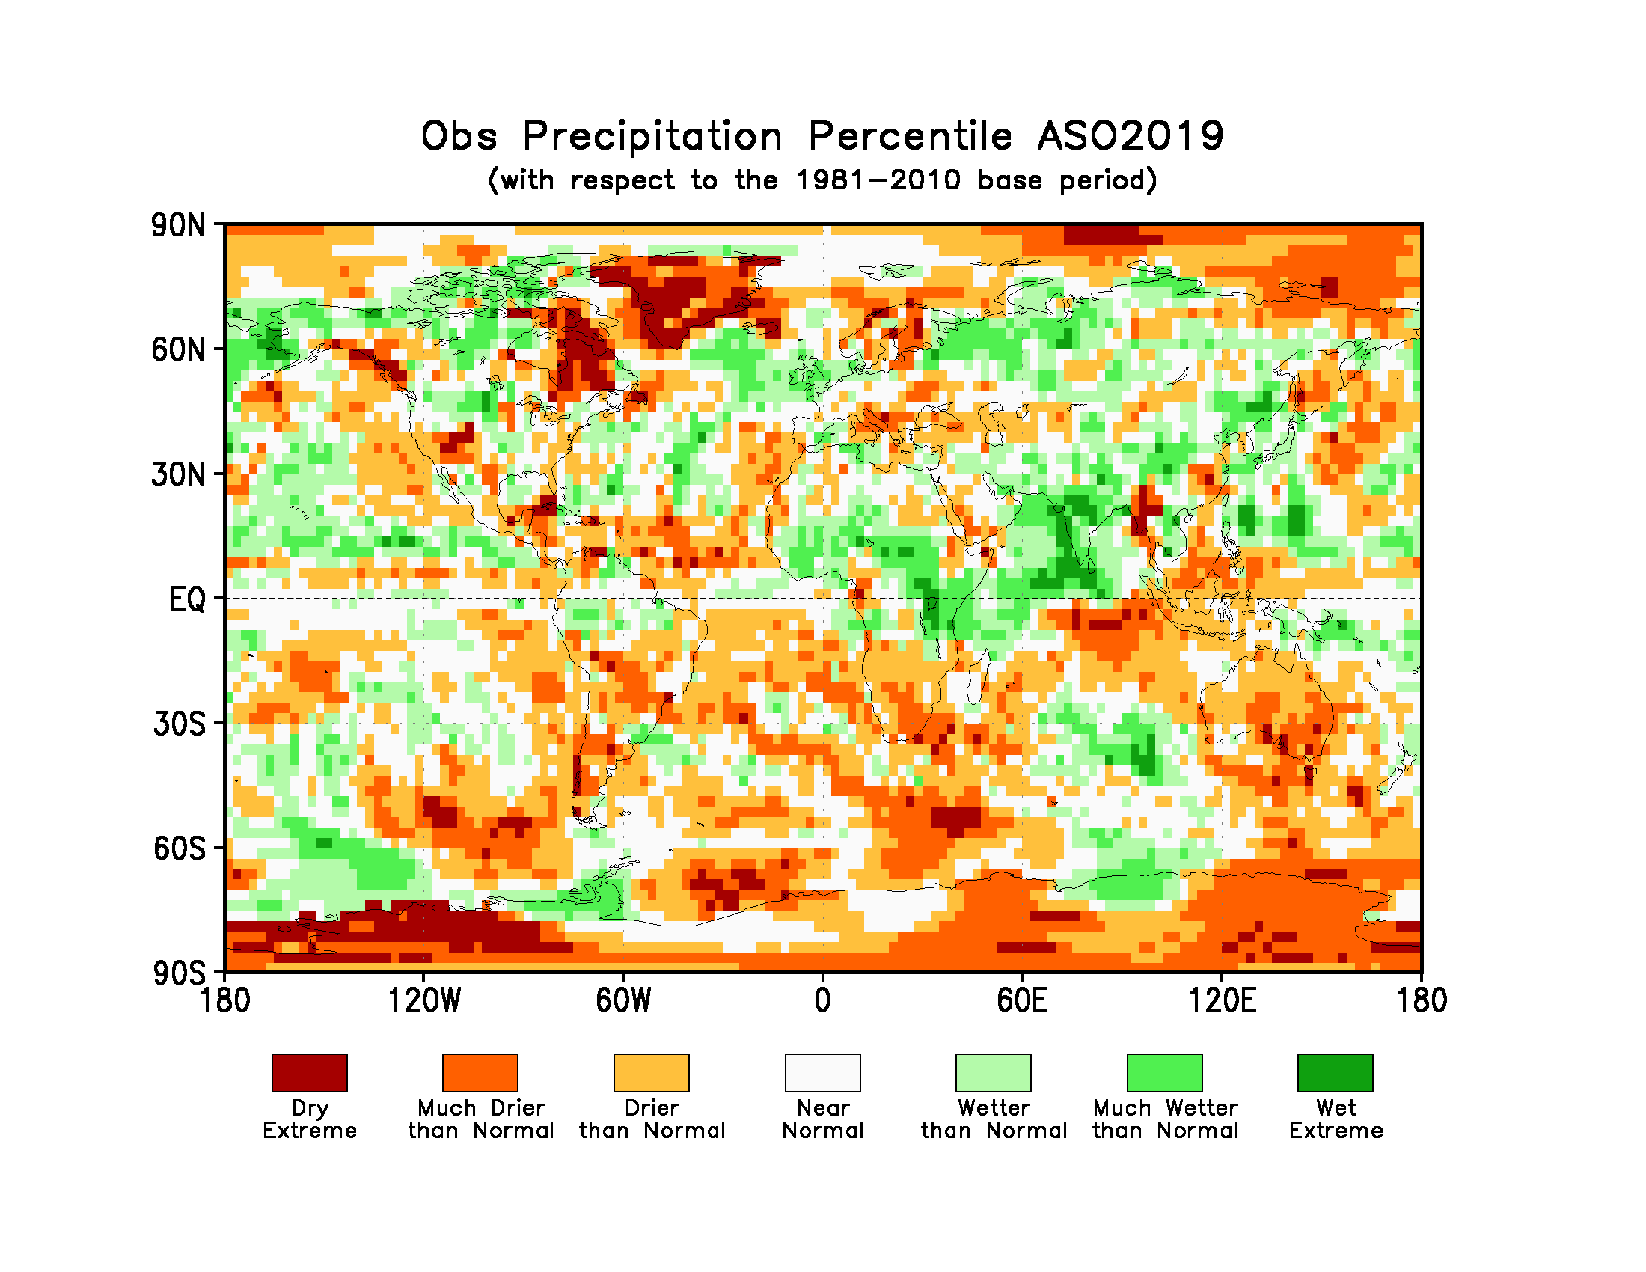
Figure 3. Observed precipitation anomalies for August-October 2019, relative to 1981–2010 base period (top). The Drier than Normal, Near Normal and Wetter than Normal shadings on the percentile map (bottom) indicate that seasonal mean anomalies were in the bottom, middle, and upper tercile of the 1981–2010 distribution, respectively. Regions with anomalies in the lowest and highest decile (or 10%) of the distribution are marked as Much Drier than Normal and Much Wetter than Normal, respectively. The Dry Extreme and Wet Extreme shadings indicate that the anomalies exceeded the driest and wettest values of the 1981–2010 period for the season.
(Source: U.S. Climate Prediction Center).

1.3 Observed precipitation
For August-October 2019 the largest below-normal precipitation anomalies were located near the Indonesian Archipelago, consistent with a strong positive phase of the IOD. Northwest of these below-normal precipitation anomalies above-normal precipitation anomalies were located over the Indian subcontinent (and were associated with the southwest summer monsoon). A zonal band of below-normal precipitation anomalies stretched across the central and eastern equatorial Pacific and were flanked by above-normal precipitation anomalies to the north. Below-normal precipitation occurred over Australia with the largest values over the southeast regions. Equatorial Africa generally had positive precipitation anomalies with negative precipitation anomalies in southern Africa. Over South America a northwest-southeast band of below-normal precipitation anomalies stretched across the region below the equator; below-normal precipitation anomalies also occurred over the southern regions of South America. A band of negative precipitation anomalies extended from eastern subtropical North Pacific into Central America and the Caribbean.
No large-scale systematic regions with dry or wet extremes (precipitation below or above all seasonal totals observed during 1981-2010) over land occurred, with the exception of a few small isolated pockets that were observed such as northeast extreme of North America (dry), Greenland (dry), and parts of India (wet). In general, the global precipitation anomaly pattern did not exhibit large-scale spatial coherence because the El Niño conditions were weak.

2. Potential evolution of the state of the climate over the next three months (December 2019-January-February 2020)

2.1 Large-scale SST-based indices, December 2019-January-February 2020
Month | Nino 1+2 | Nino 3 | Nino 4 | Nino3.4 | IOD | NTA | STA
December2019 | 0.09 ± 0.52 | 0.19 ± 0.29 | 0.48 ± 0.35 | 0.21 ± 0.31 | 0.72 ± 0.21 | 0.14 ± 0.19 | 0.58 ± 0.43
January2020 | 0.16 ± 0.51 | 0.09 ± 0.31 | 0.46 ± 0.42 | 0.12 ± 0.41 | 0.52 ± 0.29 | 0.11 ± 0.18 | 0.56 ± 0.42
February2020 | 0.09 ± 0.51 | 0.12 ± 0.33 | 0.38 ± 0.43 | 0.11 ± 0.41 | 0.42 ± 0.28 | 0.09 ± 0.17 | 0.51 ± 0.39
December2019-February2020 | 0.11 ± 0.50 | 0.13 ± 0.30 | 0.44 ± 0.39 | 0.15 ± 0.37 | 0.55 ± 0.29 | 0.12 ± 0.17 | 0.55 ± 0.40

Table 2: Multi-model forecasts for oceanic indices (℃), with standard deviation. Values are the equal-member-weighting average of those derived, using each GPC models own hindcast climate mean, from the GPCs supplying SST forecasts (GPC CPTEC, ECMWF, Exeter, Melbourne, Montreal, Moscow, Offenbach, Seoul, Tokyo, Toulouse, Washington). The standard deviation is calculated on all ensemble members. The latitude/longitude bounds of the regions are given in the supplementary information section.
Observed sea surface temperatures in the east-central topical Pacific were at ENSO-neutral levels during August-October 2019, but increased toward the threshold of weak El Niño during October and early November due to sub-seasonal activity. The sea surface temperatures in the Niño 3.4 and Niño 3 regions, both of which are often used to characterize ENSO conditions, are predicted to maintain neutral levels with anomaly values of approximately 0.1 to 0.2 ºC during the December-February 2019-20 season. Farther west in the Niño 4 region, the sea surface temperature is predicted to remain slightly above-average with a value of approximately 0.4 ºC. The IOD prediction is for above-average values, but gradually weakening towards average during December-February 2019-20. The northern equatorial Atlantic SST (NTA) is predicted to be near-average to slightly above average during the season, and the southern equatorial Atlantic SST (STA) is predicted to be somewhat above average.

2.2 Predicted temperature, December 2019-January-February 2020
For information on the construction of the multi-model forecast maps refer to the supplementary information section. (Note: Maps indicating forecast consistency among GPC models are available in the supplementary information).

Figure 4. Probabilistic forecasts of surface air temperature for December 2019-January-Februaey 2020. The tercile category with the highest forecast probability is indicated by shaded areas. The most likely category for below-normal, above-normal and near-normal is depicted in blue, red and grey shadings respectively. White areas indicate equal chances for all categories in both cases. The baseline period is 1993–2009.
Influences from the expected tendency towards positive sea surface temperature anomalies are seen in the temperature forecast for December-February 2019-20 across sizeable portions of the globe, both in the tropics (except for near-average to slightly below-average conditions in the central and eastern Pacific) and extra-tropics. Below-average temperature is predicted in relatively smaller land areas, such as in south-central Asia and part of eastern equatorial Africa. Near-average sea surface conditions are predicted in the eastern equatorial Pacific but this condition may still noticeably affect the overlying atmospheric circulation and climate, as they enhance the SST gradients the with positive SST anomalies in the western Pacific. A global warming trend also contributes to the sea surface temperature and air temperature forecast, leading to a general prevalence towards a positive tilt in anomalies defined using the climatological base period (1993–2009) centred more than 10 years in the past.
RA I (Africa): An enhanced probability for above-normal temperature is predicted over most of southern Africa, with strong model-to-model consistency. Weaker tilts of the odds towards above-normal are predicted for some portions of the northern two-thirds of the continent, including the immediate Gulf of Guinea coast and the northern part of the Greater Horn. An enhanced probability for below-normal temperature is predicted for the southern portion of eastern equatorial Africa. It is noted that above-normal temperature in most of these locations would imply a continuation of the above-normal temperatures observed in at least 90% of Africa during August-October 2019, while the below-normal forecast for part of eastern equatorial Africa would mark a reversal in the departure from normal.
RA II (Asia): Weakly to moderately enhanced probabilities for above-normal temperature are predicted over most of central Asia and all of northern Asia, while more strongly enhanced chances for above-normal are predicted for part of eastern maritime Asia and part of southeast Asia. Model consistency for most of these regions is moderately strong. An enhanced probability for below-normal temperature is predicted for south-central Asia, with weak to moderate model consistency. Much of the area forecast to be above-normal would experience a continuation of the above-normal conditions observed during August-October, and south-central Asia’s forecast for below-normal would likewise represent a continuation of these same conditions observed last season.
RA III (South America): Enhanced probabilities for above-normal temperature are predicted for much of the southern tropical portion and the northwest tip of the continent, both regions having moderate to strong model consistency. While the southern tropical portion experienced above-normal during August-October, the northwest tip was below-normal, making the forecast a reversal of the departure from normal. An enhanced probability for near-normal temperature is predicted for part of the northern coastal portion of the continent, an area that had above-normal temperature observations in August-October.
RA IV (North America, Central America and the Caribbean): Strongly enhanced probabilities for above-normal temperature are predicted in Central America, the Caribbean, and other adjacent portions of southern North America, all with strong model consistency. Much of these regions experienced above-normal temperatures during August-October, a prominent exception being a portion of Central America, where below-normal was observed. The remainder of the continent has either no forecast signal or a weak tilt of the odds towards above-normal, examples of the latter being the south-central and far northern portions.
RA V (Southwest Pacific): Moderately to strongly enhanced probabilities for above-normal temperature are predicted in most of Australia, the Indonesian Archipelago and the southwest Pacific islands. Exceptions are found in a small part of southern Australia and most New Zealand, which lack a forecast signal. Virtually all of the areas with a warm-tilting forecast has moderate to strong model consistency. Much of these areas also experienced above-normal temperature in August-October; however, in the southern Indonesian Archipelago and northern Australia the forecast would mark a reversal of below-normal observations last season.
RA VI (Europe): Weakly enhanced probabilities for above-normal temperature are predicted in most of Europe and Iceland, but not Greenland. Probabilities for above-normal are stronger in parts of southern Europe. Consistency among individual models for the areas having an above-normal prediction is moderate to strong. This prediction for above-normal temperature follows up on generally above-normal temperatures observed over most of mainland Europe in August-October but is opposite to the observed below-average observed in small parts of northeast Europe.

2.3 Predicted precipitation, December 2019-January-February 2020

Figure 5. Probabilistic forecasts of precipitation for the season for December 2019-January-Februaey 2020. The tercile category with the highest forecast probability is indicated by shaded areas. The most likely category for below-normal, above-normal and near-normal is depicted in orange, green and grey shadings respectively. White areas indicate equal chances for all categories in both cases.
The baseline period is 1993–2009.

Near-average SST conditions are expected during the December-February 2019-20 season in the central and eastern equatorial Pacific, with anomalously positive SST conditions in the western Pacific and western Indian Ocean. Some of the predicted large-scale seasonal precipitation anomalies are consistent with this spatial pattern, as for example an enhanced likelihood of above-average precipitation in eastern equatorial Africa in association with the warmed SST in the western Indian Ocean. Likewise, tendencies towards below-normal rainfall in southern Africa, Australia and the Indonesian Archipelago may be attributed in part to this positive phase Indian Ocean Dipole. Outside of these regions, most tilts of the odds towards above-normal or below-normal precipitation are not particularly strong.
RA I (Africa): Enhanced probabilities for below-normal precipitation are predicted in southern Africa, the Gulf of Guinea and part of northwest Africa, all with strong model consistency. This forecast represents a continuation of dry conditions in southern Africa experienced in August-October, but a reversal from wet conditions observed in the Gulf of Guinea. An enhanced probability for above-normal is predicted for eastern equatorial Africa, particularly the portion south of the equator. Having moderate model consistency, this prediction marks a continuation of above-normal rains seen in August-October. Enhanced probabilities of near-normal precipitation are forecast in regions of the Sahel and Sahara where no rain is expected during this time of year.
RA II (Asia): Weakly enhanced probabilities for above-normal precipitation are predicted in much of northern Asia as well as southeast and south-central Asia, all with moderate model consistency. Weakly enhanced probabilities for below-normal are predicted for the Arabian Peninsula, and for small parts of central and eastern Asia, with fairly strong model consistency in the Arabian Peninsula, but moderate consistency in the other two areas. Elsewhere over Asia no discernible predictive signal is found.
RA III (South America): An enhanced probability for below-normal precipitation is predicted over part of southern South America, as well as in part of the far eastern and far northern parts of the continent. Model consistency for these areas is moderately strong. Weakly enhanced probabilities for above-normal are forecast for a narrow band spanning east to west along the equator, with weak to moderate model consistency. Forecasts for all of the above areas for below-normal or above-normal are generally continuations of the observations during August-October.
RA IV (North America, Central America and the Caribbean): A weakly enhanced probability for below-normal precipitation is predicted for southern North America, including Central America, with moderate model consistency. Weakly enhanced probabilities of above-normal precipitation are forecast in the northern and northwest portions North America, as well as part of the eastern portion of the continent. These above-normal forecast regions have mainly moderate to moderately strong model consistency. A sizable portion of the area in northern North America having an above-normal forecast also experienced above-normal precipitation during August-October.
RA V (Southwest Pacific): Enhanced probabilities for below-normal precipitation are predicted for the southern two-thirds of the Indonesia Archipelago, much of Australia, and the southernmost southwest Pacific islands. These regions all show moderately strong to strong model consistency. A tilt of the odds towards above-normal is forecast for southern New Zealand with moderate model consistency. Most of the areas having a below-normal forecast also experienced below-normal precipitation during August-October.
RA VI (Europe): A weakly enhanced probability of above-normal precipitation is predicted over much of northern Europe, with moderate model consistency. A weak tilt of the odds towards below-normal is forecast for parts of extreme southern Europe and over south-central Greenland, with moderate model consistency.

3. Latest updates for monitoring and prediction information
Each month, the latest updates for the real-time monitoring and seasonal mean predictions included in GSCU can be found at:
Monitoring:
https://ftp.cpc.ncep.noaa.gov/mingyue/GSCUWMO/
Predictions:
https://www.wmolc.org/modules/data/plot/autograds4/download_PMME.php?filename=wmo/WMOLC_T2M.gif
https://www.wmolc.org/modules/data/plot/autograds4/download_PMME.php?filename=wmo/WMOLC_PREC.gif

4. How to use the Global Seasonal Climate Update
The GSCU is intended as guidance for RCCs, Regional Climate Outlook Forums (RCOFs) and National Meteorological and Hydrological Services (NMHSs). It does not constitute an official forecast for any region or nation. Seasonal outlooks for any region or nation should be obtained from the relevant RCCs (see below for contact details) or NMHS.
Seasonal forecasts are probabilistic in nature. Although the text and figures used in the GSCU highlight the tercile categories that is predicted with the highest probability, it is important to recognize that the other tercile categories may also have substantial (though lower) probability.
The geographical areas occupied by the forecast signals should not be considered precise. Similarly, signals with small spatial extent may be unreliable.
The skill of seasonal forecasts is substantially lower than that of weather timescales and skill may vary considerably with region and season. It is important to view the forecast maps together with the skill maps provided in the supplementary appendices.
For reference, the six WMO Regional Associations domains are depicted in the figure below.
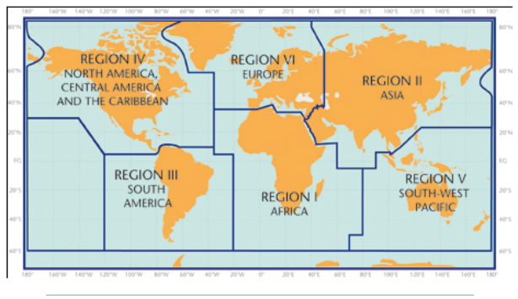

5. Designated and developing WMO Regional Climate Centres and Regional Climate Centre Networks
- RA I: http://www.wmo.int/pages/prog/wcp/wcasp/RCC-Africa.html
- RA II: http://www.wmo.int/pages/prog/wcp/wcasp/RCC-Asia.html
- RA III: http://www.wmo.int/pages/prog/wcp/wcasp/RCC-SouthAmerica.html
- RA IV: http://www.wmo.int/pages/prog/wcp/wcasp/RCC-NorthAmerica.html
- RA V: http://www.wmo.int/pages/prog/wcp/wcasp/RCC-SouthwestPacific.html
- RA VI: http://www.wmo.int/pages/prog/wcp/wcasp/RCC-Europe.html

6. Resources
Sources for the graphics used in the GSCU:
- The WMO Lead Centre for Long-Range Forecast Multi-Model Ensemble (LC-LRFMME): http://www.wmolc.org
- WMO portal to the Global Producing Centres for Long-range Forecasts (GPCs-LRF): http://www.wmo.int/pages/prog/wcp/wcasp/clips/producers_forecasts.html
- WMO GSCU portal
http://www.wmo.int/pages/prog/wcp/wcasp/LC-LRFMME/index.php
- WMO portal for Regional Climate Outlook Forums (RCOFs):
https://public.wmo.int/en/our-mandate/climate/regional-climate-outlook-products
- International Research Institute for Climate and Society (IRI):
http://portal.iri.columbia.edu/portal/server.pt
- NOAA Climate Prediction Centre (CPC):
http://www.cpc.noaa.gov

7. Acknowledgements
This Global Seasonal Climate Update was jointly developed by the WMO Commission for Climatology and Commission for Basic Systems with contributions from:
- WMO Lead Centre for Long-Range Forecast Multi-Model Ensemble (LC-LRFMME), Korea Meteorological Administration, NOAA National Centers for Environmental Prediction
- WMO Global Producing Centres for Long-Range Forecast (GPCs-LRF): GPC-Beijing (China Meteorological Administration), GPC-CPTEC (Center for Weather and Climate Studies, Brazil), GPC-ECMWF (European Center for Medium-Range Forecast), GPC-Exeter (UK Met Office),GPC- Melbourne (Bureau of Meteorology), GPC-Montreal (Meteorological Services of Canada), GPC-Moscow (Hydro meteorological Center of Russia), GPC-Offenbach Deutscher Wetterdienst), GPC-Pretoria (South African Weather Services), GPC-Seoul (Korea Meteorological Administration), GPC-Tokyo (Japan Meteorological Agency), GPC-Toulouse (Météo-France), GPC-Washington (National Centers for Environmental Prediction)
- International Research Institute for Climate and Society (IRI)

File with supplementary information can be downloaded from https://ftp.cpc.ncep.noaa.gov/mingyue/GSCUWMO/Supplementary/GSCU_DJF2019_2020_supplementary_info_LC-LRFMME.docx

