Dynamical−Statistical Prediction of Week-2 Severe Weather for the United States
Hui Wang¹, Arun Kumar¹, Alima Diawara^{1,2}, David DeWitt¹
¹ NOAA/NWS/NCEP/Climate Prediction Center, College Park, Maryland
² Innovim LLC, Greenbelt, Maryland

To be submitted to
Weather and Forecasting
30 September 2019

Corresponding author address: Hui Wang, NOAA Climate Prediction Center, 5830 University Research Court, NCWCP, College Park, MD 20740.
E-mail: hui.wang@noaa.gov

Abstract
A dynamical–statistical model is developed for forecasting week-2 severe weather (hail, tornadoes, and damaging winds) over the U.S. Supercell Composite Parameter (SCP) is used as a predictor, which is derived from the 16-day dynamical forecasts of the National Centers for Environmental Prediction (NCEP) Global Ensemble Forecast System (GEFS) model and represents the large-scale convective environments influential on severe weather. The hybrid model forecast is based on the empirical relationship between GEFS hindcast SCP and observed weekly severe weather activity during 1996–2012, the GEFS hindcast period. Cross validations suggest that the hybrid model has a low skill for week-2 severe when applying simple linear regression method at 0.5º × 0.5º (latitude × longitude) grid data. However, the forecast can be improved by using the 5º × 5º area-averaged data because weekly severe weather in such an extended area is spatially more coherent and more closely related to the large-scale environments, and is thus more predictable. The forecast skill can be further improved by using the empirical relationship depicted by the singular value decomposition method, which takes into account the spatial covariations of weekly severe weather. The hybrid model was tested for real-time forecast in spring 2019 and demonstrated considerable skillful forecasts of week-2 severe weather over the U.S.

1. Introduction
Hail, tornadoes, and high winds are severe convective storm events, which can cause significant property damages and personal injuries or death with billions of dollars in losses every year in the U.S. (NOAA, 2019). These events are characterized by small spatial scales and short lifetime (e.g., severe thunderstorms of 10 to15 miles in diameter and a lifetime of 20 to 30 minutes) and thus pose a challenge to forecasting severe weather. Skillful severe weather outlooks and warnings are of critical importance to one of the National Oceanic and Atmospheric Administration (NOAA) missions to protect lives and property.
In general, severe weather forecasts can be divided into three different timescales, namely, short term, extended range, and long range. The short-term forecast for several days is mainly determined by atmospheric initial conditions. Currently, the NOAA’s Storm Prediction Center (SPC) issues convective outlooks operationally for day 1 to day 3. The long-range forecast is from one month to several seasons. At this timescale, slow evolving components, such as sea surface temperature, sea ice, soil moisture, and low-frequency modes, provide the sources of predictability (e.g., Shepherd et al. 2009; Allen et al. 2015; Lee et al. 2016; Trapp and Hoogewind 2018). In-between is the extended-range forecast from week 2 to week 4. At this timescale, the predictability of severe weather is low due to lack of the source of predictability.
Developing week-2 to week-4 severe weather outlooks is one of the NOAA’s Climate Prediction Center (CPC) projects under the Office of Science and Technology Policy initiative. The goals of this project are (1) to expand development and perform evaluation of week-2 severe weather model guidance, and (2) to explore the potential and develop experimental forecast tools for week-3 and week-4 severe weather. As the first step, the present work focuses on developing week-2 severe weather outlook for the U.S.
Given their small spatial scales and short lifetime, severe convective storms cannot be sufficiently resolved by current operational global forecasting models (Weisman et al. 1997; Gensini and Mote 2014). However, these global models can predict the large-scale environments that may affect severe weather, even beyond one week. Previous studies (Doswell 1980; Brooks et al. 2003; Thompson et al. 2003, 2007) have introduced a variable, the so-called Supercell Composite Parameter (SCP), to characterize the large-scale convective environments that are influential in the development of severe weather. In particular, Carbin et al. (2016) use the SCP predicted by a dynamical model as environment guidance for extended-range forecasts of severe thunderstorms.
The present study complements Carbin et al. (2016) by taking one more step to explicitly forecast week-2 severe weather based on dynamical model predicted week-2 SCP and the empirical relationship between model hindcast SCP and observed weekly severe weather in historical records, a dynamical–statistical approach (e.g., Wang et al. 2009; Harnos et al. 2017). The forecast skill of such a hybrid model is mainly determined by the strength of the statistical relationship between the SCP and severe weather. We will show that weekly severe weather averaged in a relatively large domain (e.g., 5º × 5º latitude × longitude box) is more closely related to the large-scale environments (SCP) than that in a small area (0.5º × 0.5º box). The forecast skill can also be improved by considering the spatial covariations of weekly severe weather with its surroundings.
The present study is aimed at developing a forecast tool for week-2 severe weather over the U.S. The primary foci are (a) to characterize the seasonality and spatial coherence of severe weather in the U.S., (b) to establish empirical relationships between large-scale environments (SCP) and weekly severe weather, (c) to develop and cross-validate the hybrid dynamical–statistical forecast model, and (d) to test the model for real-time forecast for spring 2019.

2. Data and methodology
The data used in this study consist of both observational data and model forecast/hindcast data. For observations, the National Weather Service (NWS) Local Storm Report (LSR, available at https://www.spc.noaa.gov/wcm/#data) and the National Centers for Environmental Prediction (NCEP) Climate Forecast System Reanalysis (CFSR, Saha et al. 2010) are employed. The LSR includes three types of severe weather, namely, hail, tornado, and damaging wind, as well as their location, date/time, and intensity. In this paper, we focus on developing the forecast tool for weekly total number of severe weather events, referred to as LSR3 hereafter, without distinguishing them for any specific types of severe weather. Daily LSR data are re-gridded to a 0.5º × 0.5º (latitude × longitude) grid by counting the number of LSRs within a 24-hour period for each 0.5º × 0.5º box centered at each grid point. Weekly LSR values are the sum of corresponding 7-day LSRs.
Following Carbin et al. (2016), the SCP is expressed as
SCP = (CAPE/1000 J kg⁻¹) × (SRH/50 m⁻² s⁻²) × (BWD/20 m s⁻¹),
where CAPE is convective available potential energy, SRH is storm-relative helicity, and BWD is bulk wind difference. Three constants are used to normalize SCP so that when SCP is greater than 1, severe weather is likely to occur. To derive SCP from both observational data (CFSR; Saha et al. 2010) and model forecasts, 6-hourly lower-level CAPE in the layer of 180 – 0 hPa above the ground, SRH in the layer of 3000 – 0 m above the ground, and BWD between 500 hPa and 10 m are used. Similar to Carbin et al. (2016), daily SCP is the average of 6-hourly SCP from 12Z to 12Z (average of five instantaneous values at 12Z, 18Z, 00Z, 06Z, and 12Z).
Given that the current operational global dynamical models cannot resolve the characteristic spatial and temporal scales of severe weather, the forecast tool for LSR3 developed in this study is thus a hybrid dynamical-statistical model (e.g., Wang et al. 2009; Harnos et al. 2017). Briefly, it uses the dynamical model predicted SCP as a predictor, and then forecasts LSR3 based on the statistical relationship between model predicted SCP and observed LSR3 in historical records. The dynamical model employed is the NCEP Global Ensemble Forecast System (GEFS, Wei et al. 2008), an atmospheric model. The GEFS makes 16-day forecasts with horizontal resolutions of T254 (∼55 km) for days 1–8 and T190 (∼70 km) for days 9–16, and 42 vertical levels (Zhou et al. 2017).
A 17-year GEFS hindcast dataset (Guan et al. 2015) is used to establish the empirical relationship between model SCP and observed LSR3. The GEFS hindcasts are five members initialized at 00Z and four days apart with a total of 455 (91 × 5) 16-day forecasts each year from 1996 to 2012. The SCP derived from the GEFS hindcasts is the five-member ensemble mean value. For the real-time prediction of LSR3, the operational GEFS products are used, which consist of 20 runs initialized every 6 hours with a daily total of 80 ensemble member forecasts. The model predicted week-1 (week-2) mean SCP is the average of 7-day SCP from the GEFS day-0 to day-6 (day-7 to day-13) forecasts.
The statistical relationship between the GEFS predicted SCP and observed LSR3 is the basis for the dynamical-statistical prediction. The forecast skill of the hybrid model for LSR3 largely depends on the strength of this relationship. There are at least two ways to establish the relationship. One is the simple linear regression method, in which the relation between SCP and LSR3 is found for each grid point, based on the SCP and LSR3 values only at that grid point over the GEFS hindcast period. Therefore, the SCP-LSR3 relation based on the linear regression is not affected by the SCP values and several weather activities at adjacent grid points.
The second method is the singular value decomposition (SVD) technique (Bretherton et al. 1992), which can objectively identify the coupled spatial patterns of SCP and LSR3 with maximum temporal covariance between the two fields. Each SVD mode consists of two spatial patterns and two time series for SCP and LRS3, respectively. The SVD-based hybrid model first projects the week-2 GEFS SCP onto the SCP SVD modes (SCP spatial patterns) and then predicts LSR3 based on the SCP-LSR3 relationship depicted by the two SVD time series, as well as the LSR3 SVD patterns (e.g., Wang et al. 1999; Pan et al. 2018).
The forecast skill for week-2 severe weather is cross-validated over the GEFS hindcast period (1996–2012). In this procedure, the forecast target year is removed from the data. The forecasts for the target year are made with the statistical model based on the training data taken from the rest of 16 years. The same procedure is repeated for each target year from 1996 to 2012. The forecast skill is evaluated by the anomaly correlation between the predicted and observed weekly LSR3. For a comparison purpose, the forecast skill for week 1 severe weather is also displayed.

3. Seasonality and spatial coherence of severe weather
The seasonality of severe weather over the U.S. is examined first. Figure 1 shows the observed climatological monthly total severe weather events (LSR3) from January to December, respectively. The seasonal variation of LSR3 is characterized by strong severe weather activity in spring and summer (Figs. 1c–1h) and weak activity in winter and fall (Figs. 1a, 1b, 1i–1l). The regions of the highest activity are found in the Central and Eastern U.S. during May and June (Figs. 1e, 1f) with maximum LSR3 greater than 10. The U.S. severe weather thus displays strong seasonal and geographical dependence.
The contributions of individual types of severe weather to the observed climatological LSR3 are shown in Fig. 2 for winter (December – February, DJF), spring (March – May, MAM), summer (June – August, JJA), and fall (September – November, SON), respectively. In general, hails dominate the severe weather activity (greater than 60%) over the Central U.S. in all seasons (Figs. 2a–2d), as well as over the Eastern U.S. in spring (Fig. 2b). In contrast, damaging winds mainly dominate over the Eastern U.S. (Figs. 2i–2l). The tornado activity is relatively weak, accounting for less than 10% of total severe weather activity over most of the U.S. (Figs. 2e–2h). The tornado activity is relatively high in the Gulf States and the Southeast during fall (Fig. 2h), likely associated with landfalling Atlantic hurricanes and tropical storms.
Figure 3 shows the climatological monthly mean daily SCP from January to December, derived from the CFSR data. The seasonal variation of SCP is characterized by relatively large values of SCP (0.2 ∼ 0.4) in the Gulf States during winter months (Figs. 3a, 3b, 3l). Then, SCP intensifies during spring (Figs. 3c–3e) and peaks in May (Fig. 3e). In the meantime the region of large SCP moves northward from the Southern Plain in spring to the Northern Plain in summer (Figs. 3c–3g). From the summer to the following winter (Figs. 3h–3l), the SCP value decreases and the center of the maximums moves back to the south. The seasonal march of SCP in the Central U.S. is similar to that of SLR3 (Fig. 1). Therefore, in terms of seasonal cycle, there is a good correspondence between severe weather and SCP in the Central U.S. However, during spring and summer, there are also strong severe weather activities in the Eastern U.S. (Figs. 1c–1h) where SCP values are generally small (Figs. 3c–3h). Since the majority of the severe weather events in the Eastern U.S. are damaging winds (Fig.2, right panels), the convective environments described by SCP thus may be more closely linked to the development of hails and tornedoes than the damaging winds.
The spatial coherence of severe weather over the U.S. is demonstrated by a one-point-correlation map, in which weekly LSR3 anomaly at a selected point (here 95.5ºW, 37.5ºN) is correlated with weekly LSR3 at every grid point over the U.S. in the period of 1996 – 2012, as shown in Fig. 4a. The correlations of weekly LSR3 at a 0.5º × 0.5º grid with those in the surrounding areas are generally small, except for the correlation with itself. Therefore, weekly severe weather activities within a 0.5º × 0.5º area are largely isolated events with small spatial coherence. In contrast, the one-point-correlation map for SCP in CFSR at the 0.5º × 0.5º grid (Fig. 4b) shows high correlations between the selected grid point and the surrounding grid points, indicating that SCP has a large-scale feather and high spatial coherence. It is interesting to note that when averaging LSR3 over a 5º×5º box and then re-calculating the one-point correlation, the result (Fig. 4c) shows much higher spatial coherence for LSR3. Its large scale feature is comparable to that of the 5º × 5º area-averaged SCP (Fig. 4d). The increase in spatial coherence for LSR3 from the 0.5º × 0.5º grid to the 5º × 5º box (Figs. 4a and 4c) is much more significant than that of SCP (Figs. 4b and 4d), which already shows high spatial coherence at the 0.5º × 0.5º grid (Fig. 4b). Therefore, it is reasonable to expect that weekly severe weather over a larger domain may have higher predictability than that over a small area.

4. GEFS forecast skill for SCP
Because the GEFS predicted SCP will be used as the predictor for LSR3, whether the model can skillfully forecast SCP is an important issue. The climatological monthly mean daily SCP derived from the GEFS hindcasts displays very similar seasonal variations to the observations (Fig. 3) for lead times from 1 day to 14 days (not shown). The amplitude of the GEFS-predicted mean SCP, however, decreases with lead time. For example, Fig. 5 shows the long-term mean SCP in May, when the SCP is largest, at different lead times from 2 days to 12 days based on the GEFS hindcasts. The 2-day forecasts of the mean SCP in May (Fig. 5a) is comparable to the observed (Fig. 3e) in terms of both spatial distribution and magnitude. The maximum value of the SCP decreases from above 1.6 at the 2-day lead (Fig. 5a) to 1.2 at the 12-day lead (Fig. 5f), about 25% reduction over the 10-day difference in lead time. Despite of this, the GEFS model captures the mean SCP reasonably well.
The GEFS forecast skill for SCP is assessed by anomaly correlation (AC) between GEFS SCP and CFSR SCP. The forecast skill decreases with lead time from 1 day to 14 days (not shown). In particular, there is a sharp decrease in the AC skill from day 7 to day 8 forecasts (not shown). Figure 6 shows the anomaly correlation between weekly SCPs from CFSR and GEFS hindcasts for week 1 and week 2, respectively, over the 1996 –2012 period. Consistent with the AC skill for daily SCP forecasts, the week-2 forecast skill (Fig. 6b) is much lower than the week-1 (Fig. 6a).

5. Empirical relationship between SCP and LSR3
a. SCP–LSR3 relationship depicted by simple linear correlation
To develop a hybrid forecast model, some statistical relationships between GEFS predicted SCP and observed LSR3 need to be established first. Given the strong seasonality of both SCP and SLR3 (Figs. 1 and 3), a 3-month moving window is used in the analysis. For example, March, April, and May (MAM) data are used to set up the relationship for the forecast target month of April. Figures 7b and 7c show the correlations between observed weekly LSR3 and GEFS week-1 and week-2 forecasts of SCP, respectively, at each 0.5º × 0.5º grid point over MAM 1996–2012, the peak severe weather seasons. For comparison, the SCP–LSR3 relationship in observations is also presented in Fig. 7a. The relationships between the observed weekly LSR3 and model predicted week-1 SCP (Fig. 7b) are slightly weaker than those in observations (Fig. 7a), with correlations ranging from 0.2 to 0.3 over most of the Central and Eastern U.S. and exceeding 0.5 at some spots. However, the correlations of LSR3 with the GEFS predicted week-2 SCP (Fig. 7c) is much weaker than the observations and the week-1 forecasts.
Similar relationships between LSR3 and SCP are reestablished using the 5º × 5º area-averaged anomalies, also shown in Fig. 7 (right panels). Their correlations are significantly enhanced for both week 1 (Fig. 7e) and week 2 (Fig. 7f), as well as observations (Fig. 7d). The result indicates stronger relationships between LSR3 and the model predicted SCP when considering the severe weather activity in a larger domain. It may also imply that the mean LSR3 in the 5º × 5º box is more controlled by the large-scale convective environments than the LSR3 in a 0.5º × 0.5º box. The relationships between LSR3 and SCP for other 3-month windows are generally similar to those of MAM presented in Fig. 7.

b. SCP–LSR3 relationship identified by leading SVD modes
In addition to the local relationship between SCP and LSR3 at each grid point, their empirical relationship can also be established by the SVD technique (Bretherton et al. 1992). This method can objectively identify pairs of modes (spatial patterns) for SCP and LSR3, both of which vary with maximum temporal covariance between the two fields. As shown in Fig. 4, the 5º × 5º area-averaged anomalies have higher spatial coherence than the 0.5º × 0.5º grid data, especially for LSR3. Therefore, both the 5º × 5º area-averaged SCP and LSR3 data over the U.S. are used in the SVD analysis to enhance their covariations spatially and temporally.
Figure 8 presents the spatial patterns of the three leading SVD modes for weekly SCP (left) and LSR3 (right), respectively, using the observational data in MAM 1996–2012. Each SVD mode is characterized by a distinctive pattern with consistent spatial distributions of SCP and LSR3. The first mode displays a monopole structure with above-normal (below-normal) SCP linked to above-normal (below-normal) severe weather activity in the Central and Southeast U.S. (Figs. 8a and 8d). In contrast, both the second and third modes exhibit a dipole structure in the meridional (Figs. 8b and 8e) and zonal (Figs. 8c and 8f) directions, respectively. The second mode suggests that positive SCP anomalies in the Midwest and negative anomalies in the Gulf States are associated with more severe weather in the Midwest and less severe weather in the Gulf States (Figs. 8b and 8e). The third mode indicates that positive SCP anomalies in the South and negative anomalies in the Southeast are related to above-normal and below-normal severe weather activities, respectively, in the two regions (Figs. 8c and 8f). The three modes account for 62% of total weekly LSR3 variance.
A similar SVD analysis using the GEFS week-2 forecasts of SCP can reproduce the observed relationship between SCP and LSR3 well, as shown in Fig. 9. Together, the three modes account for 58% of total weekly LSR3 variance, comparable to that in observations. The results of the SVD analysis using the GEFS week-1 SCP and observed LSR3 (not shown) are similar to those in Fig. 9. Furthermore, the first three modes explain 37%, 13%, and 12% of total weekly LSR3 variance, respectively, same as the observations.

6. Dynamical–statistical forecast of week-2 severe weather
a. Forecast skill assessed through cross validation
A hybrid model is developed to forecast the number of week-2 severe weather events (LSR3) using the GEFS predicted week-2 SCP as a predictor and based on their empirical relationships depicted in either Fig. 7 or Fig. 9. The former applies a linear regression model to forecast LSR3 at each grid point, whereas the latter projects the week-2 GEFS SCP onto the first three SCP SVD modes and then predicts LSR3 based on the SCP–LSR3 relationship depicted by the SVD analysis (Fig. 9). The forecast skill for week-2 severe weather is cross-validated over the GEFS hindcast period (1996–2012).
Figure 10 shows the AC skill of both week-1 (left) and week-2 (right) LSR3 forecasts for MAM 1996–2012 with different methods. When applying the linear regression model using the 0.5º × 0.5º grid data, the AC skill ranges from 0.2 to 0.4 and from 0 to 0.2 for week-1 (Fig. 10a) and week-2 (Fig. 10d) forecasts, respectively, over most of the Central and Eastern U.S. By averaging the data over the 5º × 5º box and then using the linear regression model, the AC skill is significantly improved for both week 1 (0.3 ∼ 0.5, Fig. 10b) and week 2 (0.1 ∼ 0.3, Fig. 10e) over these regions. The AC skill of the linear regression model is mainly determined by the strength of the empirical relationship between SCP and LSR3, and is thus very similar to the corresponding correlation map between GEFS SCP and LSR3 (Figs. 7b vs. 10a, 7c vs. 10d, 7e vs. 10b, and 7f vs. 10e).
The AC skill is further improved (Figs. 10c and 10f) when using the SVD-based SCP–LSR3 relationships. For the week-1 forecast, the SVD-based forecast skill (Fig. 10c) is better than the linear regression model (Fig. 10b) in the Central U.S., but worse in the Upper Midwest, east coast, and Northeast. For the week-2 forecast, the SVD-based forecast skill (Fig. 10f) is better than the linear regression model (Fig. 10d) in the Lower Midwest, South and Southeast regions. These improvements are likely due to the inclusion of the spatial covariations of both SCP and LSR3 with their surrounding areas in the SVD relationship, whereas the linear regression model is only based on the relationship determined by the SCP and LSR3 values at individual grid points.

b. Real-time forecast for spring 2019
The hybrid dynamical–statistical tool with the linear regression model and using the 5º × 5º area-averaged data has been tested and implemented for experimental real-time forecast of week-2 severe weather in 2019. The forecast is updated at 10:00 AM Eastern Standard Time on a daily basis. The week-2 SCP is derived from the 80-member GEFS operational 16-day forecasts with 20 runs initialized at 00Z and 06Z of the present day and 12Z and 18Z of previous day, respectively. The real-time week-2 severe weather forecasts consist of both deterministic and probabilistic formats. The former is the 80-memnber ensemble mean forecast of week-2 LSR3. The latter is the percentage distribution of the 80-member forecasts in three categories, namely, above normal, near normal, and below normal. The thresholds for the three categories are determined by the week-2 LSR3 forecast values in the cross validations over the 1996–2012 period, so that each category accounts for 33.3% of the total events.
Figure 11 shows an example of the real-time week-2 severe weather forecast for the week of 19–25 May 2019 issued on 12 May 2019. During that week, there was a severe weather outbreak sequence with 79 EF1–EF3 tornadoes across the Central U.S. and the Mid-Atlantic (Livingston and Wheatley, 2019). Figure 11a presents the observed total LSR3 during the 7-day period. Compared to the observations (Fig. 11a), the 80-member ensemble mean week-2 forecast indicates broader but less intense severe weather activities (Fig. 11b). The predicted weekly LSR3 is slightly lower but comparable to the observed in the Central U.S., and much lower than the observed in the Mid-Atlantic. The probabilistic forecast is shown in Figs. 11d–11f, respectively, for the three categories. Most of the Central and Eastern U.S. are in the above-normal category (Fig. 11d), except the Southeast U.S. in the near-normal category (Fig. 11e). In particular, almost all regions of the observed LSR3 (circled by red line in Fig. 11d) were predicted with more than 50% chance of above-normal severe weather activity.
Figure 11c shows the forecast skill measured by the anomaly correlation between the observed and predicted 7-day LSR3 for MAM 2019 with a total of 92 week-2 forecasts. The AC skill is generally greater than 0.3 in the Central and Eastern U.S., which is above the 99% significance level (0.27). However, the forecast skill is low in the Great Plains, especially in the Northern Plain with negative AC coefficients. Overall, Fig. 11c indicates considerable skills of the hybrid model in forecasting week-2 severe weather over the Central and Eastern U.S. for spring 2019.

7. Conclusions
The development and evaluation of the hybrid dynamical–statistical model for forecasting week-2 severe weather over the U.S. have been presented. Following the work of Carbin et al. (2016), the Supercell Composite Parameter (SCP) was selected as a predictor to represent the large-scale environments and link the dynamical model forecast to actual severe weather. The performance of the hybrid model has been cross-validated over the 1996–2012 period and also tested in real time for spring 2019.
The hybrid model forecasts suggest a low skill for week-2 severe weather when applying the linear regression model to the 0.5º × 0.5º grid data. Weekly severe weather in such a small area is largely isolated from its surroundings and is less controlled by large-scale convective environments. However, the forecast skill can be improved by applying the linear regression model to the 5º×5º area-averaged anomalies. The weekly severe weather in such an extended area displays some large-scale features with higher spatial coherence, and is thus more closely related to the large-scale environments. It is also demonstrated that the forecast skill can be further improved by using the SVD-based statistical relationship. The SVD method objectively picks out the dominant spatial patterns of weekly severe weather that co-vary with the large-scale SPC patterns. The SVD-based SCP–LSR3 relationship thus accounts for more variance of weekly severe weather than the relationships established by the simple linear regression at individual grid points.
Experimental week-2 severe weather outlooks have been tested in real time for spring 2019, using the linear regression approach and the 5º × 5º area-averaged data. Both the case study for the week of 19–25 May 2019, when there was a severe weather outbreak sequence affecting the Central and Eastern U.S., and the anomaly correlation between forecasts and observations across the entire season suggest considerable skill for week-2 severe weather over the U.S. It is expected that the dynamical–statistical tool developed in this study will be implemented into operations in 2020.

Acknowledgments. The authors would like to thank Stephen Baxter, Mike Charles, Daniel Harnos, Melissa Ou, Brad Pugh, Matthew Rosencrans, and Wanqiu Wang at the NCEP Climate prediction Center (CPC) for helpful discussions and also Hong Guan and Yuejian Zhu at the NCEP Environmental Modeling Center (EMC) for providing GEFS model forecast data.

REFERENCES
Allen, J. T., M. K. Tippett, and A. H. Sobel, 2015: Influence of the El Nino/Southern Oscillation on tornado and hail frequency in the United States. Nature Geosic., 8, 278–283, https://www.nature.com/articles/ngeo2385.
Bretherton, C. S., C. Smith, and J. M. Wallace, 1992: An intercomparison of methods for finding coupled patterns in climate data. J. Climate, 5, 541–560, https://doi.org/10.1175/1520-0442(1992)005<0541:AIOMFF>2.0.CO;2
Brooks, H. E., J. W. Lee, and J. P. Craven, 2003: The spatial distribution of severe thunderstorm and tornado environments from global reanalysis data. Atmos. Res., 67–68, 73–94, https://doi.org/10.1016/S0169-8095(03)00045-0.
Carbin, G. W., M. K. Tippett, S. P. Lillo, and H. E. Brooks, 2016: Visualizing long-range severe thunderstorm environment guidance from CFSv2. Bull. Amer. Meteor. Soc., 97, 1021–1031, http://doi.org/10.1175/BAMS-D-14-00136.1.
Doswell, C. A., III, 1980: Synoptic-scale environments associated with High Plains severe thunderstorms. Bull. Amer. Meteor. Soc., 61, 1388–1400, https://doi.org/10.1175/1520-0493(1993)121<0416:TSSEAW>2.0.CO;2.
Gensini, V. A., and T. L. Mote, 2014: Estimations of hazardous convective weather in the United States using dynamical downing. J. Climate, 27, 6581–6589, https://doi.org/10.1175/ JCLI-D-13-00777.1.
Guan, H., B. Cui, and Y. Zhu, 2015: Improvement of statistical postprocessing using GEFS reforecast information. Wea. Forecasting, 30, 841–854, https://doi.org/10.1175/WAF-D-14-00126.1.
Harnos, D. S., J.-K. E. Schemm, H. Wang, C. A. Finan, 2017: NMME-based hybrid prediction of Atlantic hurricane season activity. Climate Dyn., https://doi.org/10.1007/s00382-017-3891-7.
Lee, S.-K., A. T. Wittenberg, D. B. Enfield, S. J. Weaver, C. Wang, and R. Atlas, 2016: US regional tornado outbreaks and their links to spring ENSO phases and North Atlantic SST variability. Enviro. Res. Lett., 11, 044008, https://iopscience.iop.org/article/10.1088/ 1748-9326/11/4/044008.
Livingston, I., and K. Wheatley, 2019: The tornado outbreak sequence of May 2019. U.S. Tornadoes, May 30, 2019. Retrieved September 26, 2019 from https://www.ustornadoes. com/2019/05/30/the-tornado-outbreak-sequence-of-may-2019/.
NOAA, 2019: Billion-dollar weather and climate disasters: Overview. Retrieved September 27, 2019 from https://www.ncdc.noaa.gov/billions/.
Pan, Y., N. Zeng, A. Mariotti, H. Wang, A. Kumar, R. L. Sanchez, and B. Jha, 2018: Covariability of Central America/Mexico winter precipitation and tropical sea surface temperatures. Climate Dyn., 50, 4335–4346, https://link.springer.com/article/10.1007/ s00382-017-3878-4.
Saha, S., and Coauthors, 2010: The NCEP Climate Forecast System Reanalysis. Bull. Amer. Meteor. Soc., 91, 1015–1058, https://doi.org/10.1175/2010BAMS3001.1.
Shepherd, M., D. Niyogi, and T. L. Mote, 2009: A seasonal-scale climatological analysis correlating spring tornadic activity with antecedent fall-winter drought in the southeastern United States. Environ. Res. Lett., 4, 024012, https://iopscience.iop.org/article/10.1088/ 1748-9326/4/2/024012.
Thompson, R. L., R. Edwards, J. A. Hart, K. L. Elmore, and P. M. Markowski, 2003: Close proximity soundings within supercell environments obtained from the Rapid Update Cycle. Wea. Forecasting, 18, 1243–1261, https://doi.org/10.1175/1520-0434(2003)018 <1243:CPSWSE>2.0.CO;2.
Thompson, R. L., C. M. Mead, and R. Edwards, 2007: Effective storm-relative helicity and bulk shear in supercell thunderstorm environments. Wea. Forecasting, 22, 102–115, https://doi.org/10.1175/WAF969.1.
Trapp, R. J., and K. A. Hoogewind, 2018: Exploring a possible connection between U.S. tornado activity and Arctic sea ice. Climate Atmos. Sci., 1, 14, https://www.nature.com/ articles/s41612-018-0025-9.
Wang H., J.-K. E. Schemm, A. Kumar, W. Wang, L. Long, M. Chellian, G. D. Bell, and P. Peng, 2009: A statistical forecast model for Atlantic seasonal hurricane activity based on the NCEP dynamical seasonal forecast. J. Climate, 22, 4481–4500, https://doi.org/10.1175 /2009JCLI2753.1.
Wang, H., M. Ting, and M. Ji, 1999: Prediction of seasonal mean United States precipitation based on El Niño sea surface temperatures. Geophys. Res. Ltee., 26, 1341–1344, https://doi.org/10.1029/1999GL900230.
Wei, M., Z. Toth, R. Wobus, and Y. Zhu, 2008: Initial perturbations based on the ensemble transform (ET) technique in the NCEP global operational forecast system. Tellus, 60A, 62–79, https://doi.org/10.1111/j.1600-0870.2007.00273.x.
Weisman, M. L., W. C. Skamarock, and J. B. Klemp, 1997: The resolution dependence of explicitly modeled convective system. Mon. Wea. Rev., 125, 527–548, https://doi.org/10.1175/1520-0493(1997)125<0527:TRDOEM>2.0.CO;2.
Zhou, X., Y. Zhu, D. Hou, Y. Luo, J. Peng, and R. Wobus, 2017: Performance of the new NCEP Global Ensemble Forecast System in a parallel experiment. Wea. Forecasting, 32, 1989–2004. https://doi.org/10.1175/WAF-D-17-0023.1.

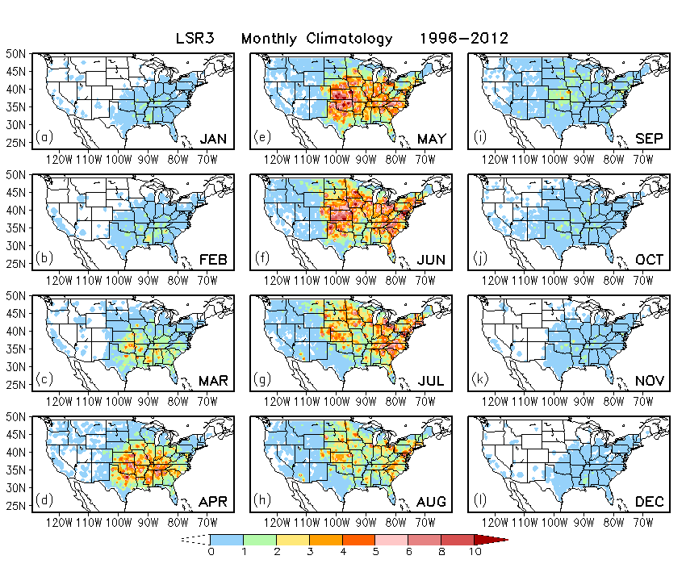
FIG. 1. Climatological monthly total number of Local Storm Reports (LSR3), including hail events, tornadoes, and damaging wind events from January to December in the period of 1996–2012.

/cpc/home/hwang/2017_wk34SWx/CFSR/xx_month_clm/WF_Fig_LSR3clim.gs
Plot: WF_Fig_LSR3clim.gif

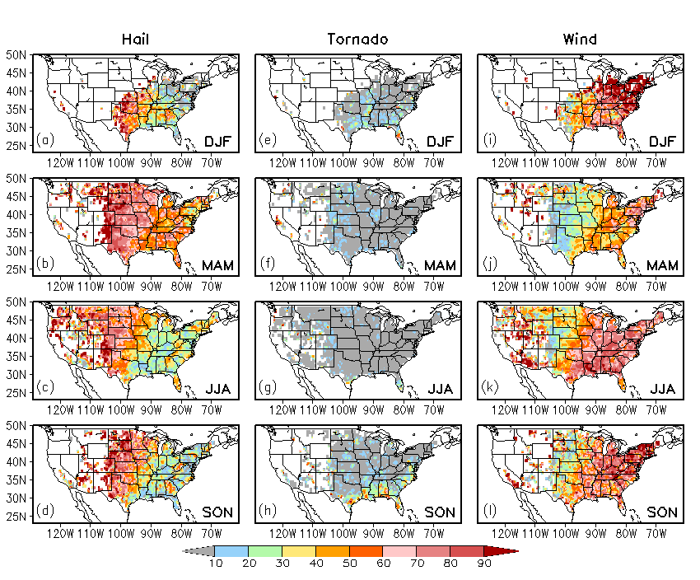
FIG. 2. Ratio (%) of climatological seasonal total number of individual type of severe weather to the climatological seasonal total number of LSR3 for hail (left), tornado (middle), and damaging wind (right), respectively, in (a,e,i) DJF, (b,f,j) MAM, (c,g,k) JJA, and (d,h,l) SON.

/cpc/home/hwang/2017_wk34SWx/CFSR/xx_month_clm/WF_Fig_H-T-Wclim.gs
WF_Fig_H-T-Wclim.gif

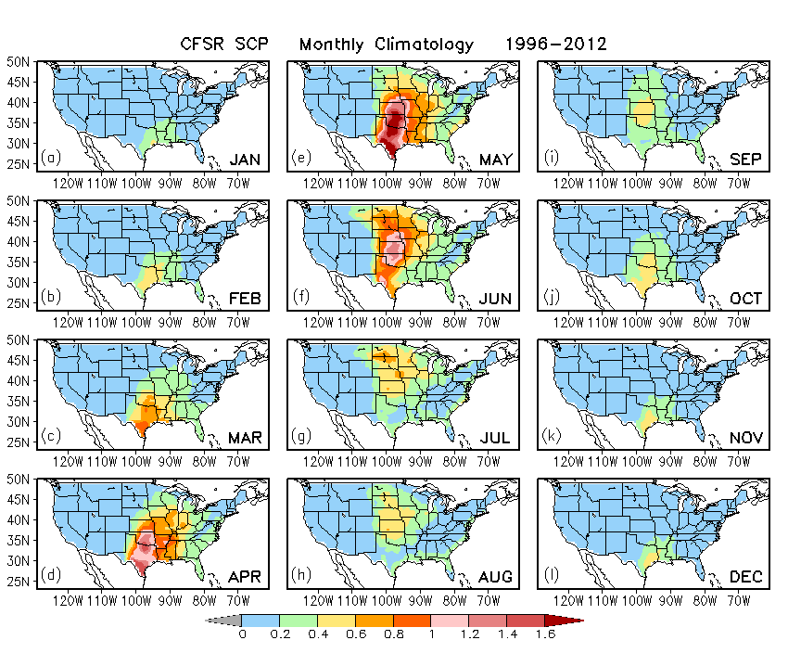
FIG. 3. Climatological monthly mean daily SCP from (a) January to (l) December derived from the CFSR data in the period of 1996−2012.

20181207
/cpc/home/hwang/2017_wk34SWx/CFSR/xx_month_clm/WF_Fig_SCPclim.gs
Plot: WF_Fig_SCPclim.gif

FIG. 4. One-point correlation maps for weekly (a) LSR3 and (b) SCP anomalies with data at 0.5º ×0.5º grid and weekly (c) LSR3 and (d) SCP anomalies with data averaged in the 5º × 5º box, respectively, over the period of 1996 – 2012. The base time series is selected at grid point (95.9ºW, 37.5ºN), which is marked with “×” in (b).

/cpc/home/hwang/2017_wk34SWx/CFSR/xx_1POINT_COR.anm_887week/
WF_cor_1point.weekly887.anm.gs

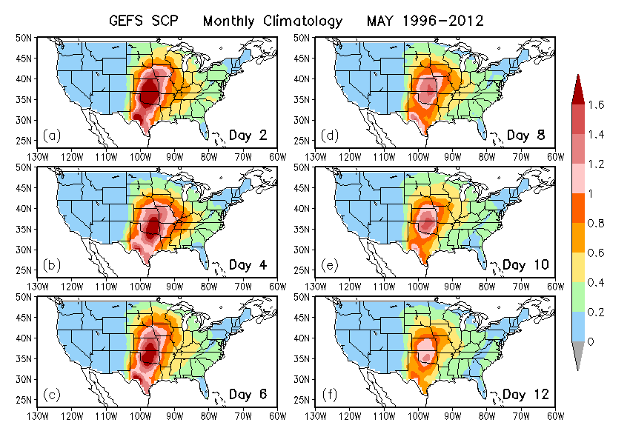
FIG. 5. Climatological monthly mean daily SCP in May derived from the GEFS hindcast data in the period of 1996−2012 for different lead times from (a) 2 days to (f) 12 days.

/cpc/home/hwang/2017_wk34SWx/GEFS_0.5/SCP_x-y
WF_Fig.SCPclim-GEFS.MAY.gs

FIG. 6. Anomaly correlation (AC) between SCPs from CFSR and the GEFS hindcasts for (a) week 1 and (b) week 2 over the 1996–2012 period.

/cpc/home/hwang/2017_wk34SWx/GEFS_0.5/SCP_x-y/
WF_Fig.AC.SCP.cfsr-gefs.Week1-2.gs

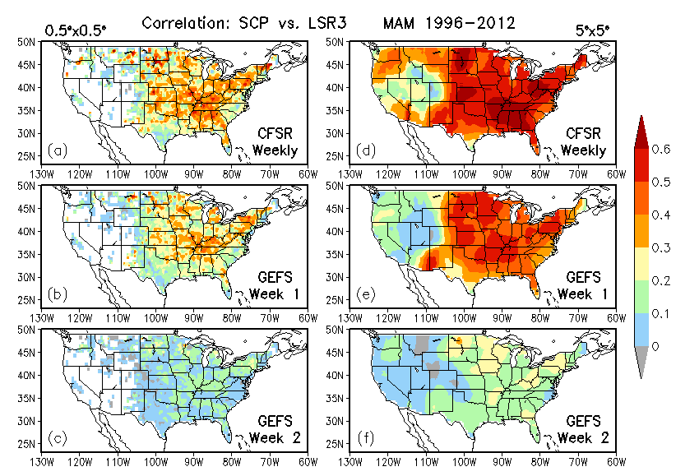
FIG. 7. Correlation between observed weekly LSR3 and weekly SCP derived from (a) CFSR and the GEFS hindcasts for (b) week 1 and (c) week2 with anomalies at the 0.5º × 0.5º grid (left), and also correlation between observed weekly LSR3 and weekly SCP derived from (d) CFSR and the GEFS hindcasts for (e) week 1 and (f) week2 with anomalies area-averaged over the 5º × 5º box (right), respectively, during MAM 1996–2012.

/cpc/home/hwang/2017_wk34SWx/GEFS_0.5/SCP_x-y/x_AreaAve.5x5_CORRECTION
WF_Fig.AC.SCPgefs-LSR3.week1-2.AreaAve.gs

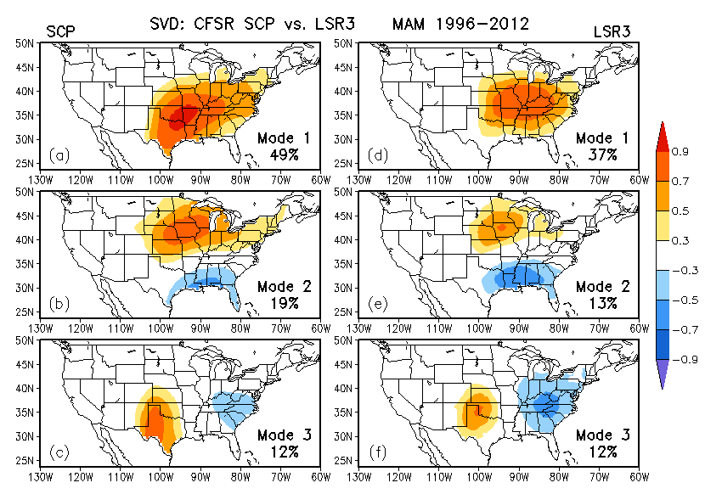
FIG. 8. Maps of homogeneous correlation for the first three SVD modes between 5º × 5º area-averaged weekly CFSR SCP and observed LSR3 over the U.S. during MAM 1996–2012. The percentage of the variance explained by each SVD mode is also provided at the bottom right of each panel for SCP (left panels) and LSR3 (right panels).

/cpc/namecpt/hui/2018_daySST/Y.svd.SCPcfsr-LSR3.1996-2012
WF_COR_svd_LSR3.MAM.homo.2.gs

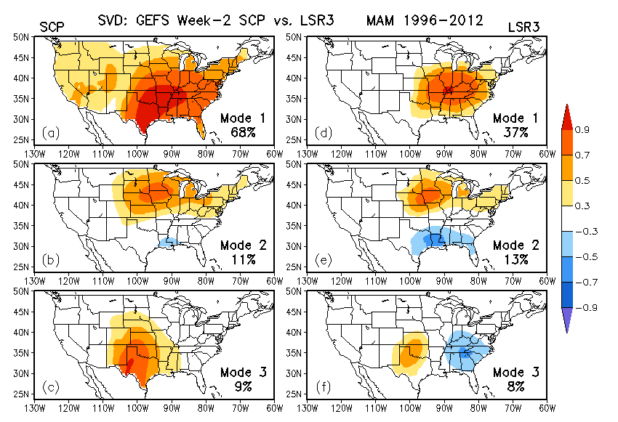
FIG. 9. Same as Fig. 8, but for the three leading SVD modes between the GEFS week-2 SCP and observed LSR3.

/cpc/namecpt/hui/2018_daySST/Y.svd.SCPgefs-LSR3.1996-2012.Week1/svd.391.Week2.Wrong/
WF_svd_LSR3.MAM.homo.2.gs

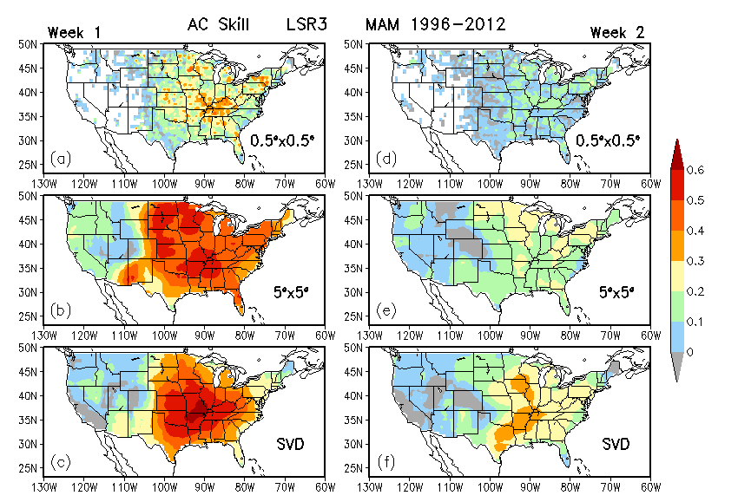
FIG. 10. Forecast skill measured by the anomaly correlation (AC) between the observed and predicted weekly LSR3 for week 1 (left) and week 2(right) using the simple linear regression model with (a, d) the anomalies in the 0.5º ×0.5º grid box and (b, e) the anomalies averaged over the 5º × 5º box, and (c, f) using the SVD-based forecast model also with the anomalies averaged over the 5º × 5º box. The AC skill is assessed based on cross-validations over the MAM of 1996–2012 with a total of 391 weeks.

/cpc/home/hwang/2017_wk34SWx/GEFS_0.5/SCP_x-y/x_AreaAve.5x5_CORRECTION
WF_Fig.SKILL.SCPgefs-LSR3.week1-2.gs

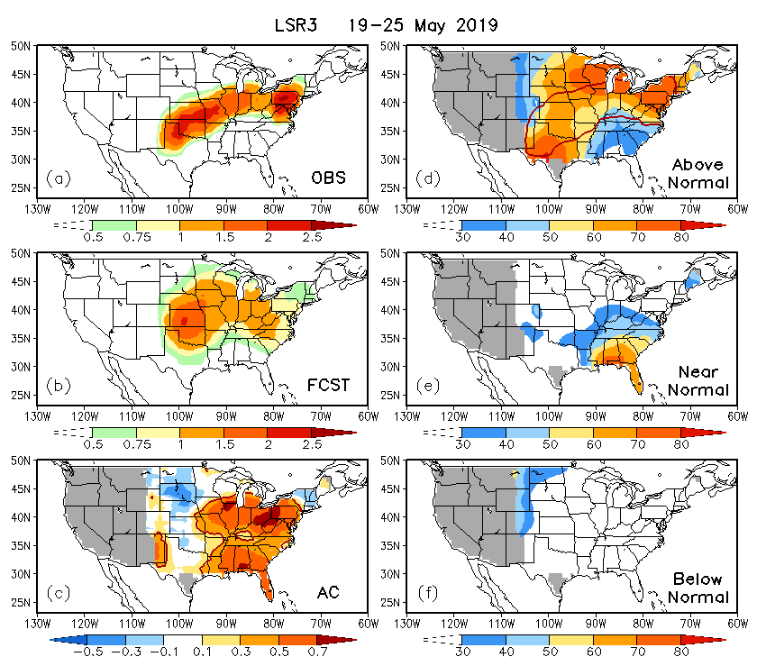
FIG. 11. (a) Observed and (b) linear regression model predicted LSR3 averaged over the 5º × 5º box for the week of 19–25 May 2019, (c) anomaly correlation (AC) skill of the real-time forecasts for weekly LSR3 during MAM 2019, and the probability forecasts of LSR3 for (d) above-normal, (e) near-normal, and (f) below-normal categories in the week of 19–25 May 2019, based on 80 ensemble members of the GEFS SCP forecasts. The red line in (c) denotes the 99% significance level estimated by the two-tailed t-test. The red contour in (d) is 0.5 of the observed weekly LSR3 shown in (a).

/cpc/namecpt/hui/2018_GEFS_rt/obs_2019/Ana
WF_Fig.Real-time.MAM2019.gs

