Covariability of Central America/Mexico Precipitation and Tropical Sea Surface Temperature under a Warming Climate and Associated Hydrological Cycle

Yutong Pan

Advisor: Dr. Ning Zeng

A dissertation prospectus submitted in partial fulfillment of
the requirements for the degree of
Doctor of Philosophy

Examination Committee:
Dr. E. Hugo Berbery
Dr. James A. Carton
Dr. Zeng-Zhen Hu
Dr. Da-Lin Zhang

Department of Atmospheric and Oceanic Science
University of Maryland, College Park
August 2019

Table of Contents
Abstract 2
1. Introduction 3
1.1 Identification of the problem 3
1.2 Influences of tropical Pacific vs. tropical Atlantic 3
1.3 Objectives and significance of proposed research 4
2. Data and Methodology 5
3. Preliminary Results 7
3.1 Covariability of CAM precipitation and tropical SST in winter 7
3.1.1 Climatology and variability of CAM winter precipitation 7
3.1.2 Relationship between CAM winter precipitation and tropical SST 7
3.1.3 Associated atmospheric circulation 8
3.1.4 Relationship between CAM precipitation and tropical SST in AMIP simulations 8
3.1.5 Remarks 9
3.2 Covariability of CAM precipitation and tropical SST in summer 10
3.2.1 Climatology and variability of CAM summer precipitation 10
3.2.2 Relationship between CAM summer precipitation and tropical SST 10
3.3 Regional hydrological cycle: present-day climate vs. future warmer climate 11
4. Future Research Plan 12
4.1 Covariability of CAM precipitation and tropical SST in winter 12
4.2 Covariability of CAM precipitation and tropical SST in summer 12
4.3 Regional hydrological cycle: present-day climate vs. future warmer climate 12
5. Timeline 13
Acknowledgements 13
References 13
Tables 16
Figures 18

Abstract
Since the beginning of the 21st century, widespread droughts have been repeatedly striking Central America and Mexico (CAM). The prolonged drought has led to devastating social and economic impacts in CAM, including significant reductions in agricultural production, increased risk of food insecurity, and more stressed water supplies. The ongoing food security crisis across Honduras, Guatemala, and El Salvador caused by droughts and water shortages might be one of the primary reasons for current Central American migration to the U.S. It is thus important to know what the contributing factors are to the prolonged drought over CAM.
It has been well recognized that El Niño–Southern Oscillation (ENSO) in the tropical Pacific is an important factor modulating the precipitation in CAM. Our prior research reveals that in addition to the impact of ENSO, a warming trend in tropical Atlantic sea surface temperature (SST), which is closely related to global warming in recent decades, also exerts a significant impact on CAM precipitation and suppresses rainfall in both winter and summer. As the pace of global warming is faster than ever, a thorough examination of its impact on CAM precipitation and regional hydrological cycle is of particular importance to understanding regional climate change.
The proposed research is primarily aimed at describing and understanding the relationships between CAM precipitation and tropical Pacific/Atlantic SST in winter and summer, through the analysis of observations and simulations with both atmospheric model and coupled climate models. More specifically, the objectives of this thesis work are to
- Quantify the relationships between CAM precipitation and tropical SSTs in winter and summer based on observations;
- Determine the relative importance of tropical Pacific and Atlantic SSTs to the variability of the CAM precipitation, in particular, the contribution of the Atlantic SST warming trend associated with global warming;
- Characterize the seasonality of the relationships between CAM precipitation and tropical SSTs;
- Understand the relationships between CAM precipitation and tropical SSTs by examining the associated atmospheric circulation in both observations and SST-forced simulations with an atmospheric model;
- Assess the projected changes in CAM precipitation and regional hydrological cycle through the comparison between the present-day climate simulations and future climate simulations (projections) using coupled global climate models.
The proposed work will help improve seasonal climate predictions for the CAM region through a better understanding of the relationships between CAM precipitation and the tropical Pacific/Atlantic SSTs. It is also expected that the proposed research will provide useful information for understanding CAM precipitation change under a warmer climate, future climate projections and associated regional hydrological cycle change in the CAM region, as well as for local governments and policymakers in making climate adaptation decision, migrating people, achieving sustainable food and nutrition security, and developing rainwater harvesting and storage systems.

1. Introduction
1.1 Identification of the problem
Since the beginning of the 21st century, widespread droughts have been repeatedly striking Central America, leading to devastating social and economic impacts (Robjhon and Thiaw 2015; Steffens 2018). According to the reports from the United Nations (e.g., OCHA 2014; Fion 2018), more than two million people in Central America are at the risk of food insecurity due to crop losses caused by the droughts. The United Nations’ agencies, including the Food and Agriculture Organization and the World Food Programme, as well as the U.S. Government, particularly concern about the effect of the drought on migration (e.g., Barrett 2019). It is argued that the ongoing food security crisis across Honduras, Guatemala, and El Salvador caused by droughts and water shortages might be the primary reason for current Central American migration to the U.S.
Further to the north, a prolonged drought has also been afflicting Mexico (e.g., Salazar and Rodriguez 2011; Bnamericans 2016), which reduced Mexico’s agricultural production by 40% (e.g., Rodriguez 2012). Additionally, water supplies in this country are increasingly stressed because of the drought and population growth (Climate Reality 2018). The threat of the prolonged drought in Central America and Mexico (CAM) immediately raises one question, namely, what are the contributing factors to the drought over CAM?
1.2 Influences of tropical Pacific vs. tropical Atlantic
Sea surface temperatures (SSTs) in the adjacent oceans have been identified as important factors modulating the precipitation in CAM (e.g., Cavazos and Hastenrath 1990; Enfield 1996; Enfield and Alfaro 1999; Pavia et al. 2006; Karnauskas and Busalacchi 2009; Mendez and Magana 2010; Bhattacharya and Chiang 2014), including El Niño–Southern Oscillation (ENSO) in the tropical Pacific and SST in the tropical Atlantic. The former is a major source of interannual variability of CAM precipitation (e.g., Giannini et al. 2000), whereas the latter is a combination of climate variabilities from interannual to multi-decadal time scales (e.g., Handoh et al. 2006; Enfield et al. 2001; Ting et al. 2011), as well as a proxy of global warming used for future climate projections for the CAM region (e.g., Fuentes-Franco et al. 2015).
The association between CAM precipitation and Pacific SST has been examined in many previous studies. It is well recognized that winter precipitation in most of Mexico tends to be above-normal (below-normal) during El Niño (La Niña), but precipitation anomalies in Central America tend to be opposite (e.g., Cavazos and Hastenrath 1990; Magana et al. 2003; Seager et la. 2009). For example, the 2015 El Niño, the strongest warm event so far in the 21st century, was blamed for the development of a new drought after the 2014 drought in Central America (Fion 2018). Studies also reveal different effects of ENSO on CAM precipitation between winter and summer seasons (e.g., Bravo-Cabrera et al. 2017).
It is also found that there is a strong association between CAM precipitation and Atlantic SST (e.g., Enfield 1996; Enfield and Alfaro 1999; Taylor et al. 2002). Most of these studies, however, focus on the influence of the Atlantic SST at the interannual time scale. In addition to the interannual variability of the tropical Atlantic SST, a basin-wide warming in the Atlantic during recent decades is closely related to global warming (Wang and Dong 2010). In the recent years, the pace of global warming is faster than ever, leading to 2017 being the hottest year for the world’s oceans (Gibbens 2018), and 2017 and 2018 being the third and fourth warmest years on record for the global mean temperature (NOAA 2018; NASA 2019). The other two warmest years are 2016 (warmest) and 2015 (second warmest).
Because all these warmest years occurred in the past five years, how the warming trend in the Atlantic SST associated with global warming affects CAM precipitation, in particular, how it contributes to the recent drought in CAM has not been thoroughly examined. From a historical perspective, it is also essential to quantify the relative importance of the SSTs in the tropical Pacific vs. tropical Atlantic in determining the CAM precipitation variability, as the Atlantic SST is more dominated by the warming trend.
Another important issue related to the precipitation variability and water supply in CAM is regional hydrological cycle. The CAM region is characterized by a variety of climate regimes, such as semiarid climate, monsoon, and tropical rainforest (Durán-Quesada et al. 2010). The regional water cycle is thus geographically and seasonally dependent. Previous studies have examined the projections of climate change in CAM (e.g., Karamalkar et al. 2011; Lyra et al. 2017; Imbach et al. 2018). However, none of them has examined the associated water cycle. Mariotti et al. (2015) demonstrate that hydrological cycle is one of the key processes for understanding the projected climate change in the Mediterranean region. Here, the same approach will be used to analyze the change in water cycle for CAM under global warming.
1.3 Objectives and significance of proposed research
The objectives of this proposed thesis work include:
- Quantify the relationships between CAM precipitation and tropical SSTs in winter and summer based on historical observations;
- Determine the relative importance of tropical Pacific and Atlantic SSTs to the variability of the CAM precipitation, in particular, the contribution of the Atlantic SST warming trend associated with global warming;
- Characterize the seasonality of the relationships between CAM precipitation and tropical SSTs;
- Understand the relationships between CAM precipitation and tropical SSTs by examining the associated atmospheric circulation in both observations and SST-forced simulations with an atmospheric model;
- Assess the projected changes in CAM precipitation and regional hydrological cycle through the comparison between the present-day climate simulations and future climate simulations (projections) using coupled global climate models.
This thesis work is primarily aimed at describing and understanding the relationships between CAM precipitation and tropical SSTs in winter and summer, through the analyses of observations and model outputs from both atmospheric model and coupled models. In consort with these objectives, the research will attempt to prove that in addition to the tropical Pacific ENSO SST, tropical Atlantic SST, especially the warming trend associated global warming, also exerts a significant influence on CAM precipitation. A better understanding of the relationships between CAM precipitation and the tropical Pacific/Atlantic SSTs will be helpful for improving seasonal climate predictions. It is also expected that the proposed research will provide useful information for understanding CAM precipitation change under a warmer climate and future climate projections in the CAM region, as well as for local governments and policymakers in making climate adaptation decision, migrating people, achieving sustainable food and nutrition security, and developing rainwater harvesting and storage systems.
2. Data and Methodology
The data used in this thesis work consist of both observational data and model outputs. Main variables used for the analysis are monthly mean precipitation and surface air temperature (2-m temperature) over land, SST, atmospheric wind and geopotential height, evaporation, soil moisture, and runoff. For the observational data used to study the covariability between CAM precipitation and tropical SSTs, the CAM precipitation is taken from the National Oceanic and Atmospheric Administration (NOAA) Precipitation Reconstruction over Land (PREC/L) dataset (Chen et al. 2002) on a 1º × 1º (latitude × longitude) grid. The tropical SST is taken from the NOAA Extended Reconstructed SST (ERSST) version 3b (Smith et al. 2008) on a 2º × 2º grid. The atmospheric wind and geopotential height are the National Centers for Environmental Prediction–National Center for Atmospheric Research (NCEP–NCAR) Reanalysis products (Kalnay et al. 1996) with a 2.5º × 2.5º resolution. These observational data cover a 71-year period from 1948 to 2018. The analysis focuses on both winter (December−February, DJF, or January−March, JFM) and summer (June−August, JJA) seasons.
Longer records of observations are also employed for comparisons with the 20th Century historical climate simulations. For this purpose, both the land precipitation and land surface air temperature are obtained from the Climate Research Unit (CRU) dataset from 1901–2009 on a 0.5º × 0.5º grid (Jones et al. 2012). The surface air temperatures are also from the Met Office Hadley Centre and CRU (HadCRUT4) dataset from 1850–2012 on a 5º × 5º grid (Morice et al. 2012). The total soil moisture and land evapotranspiration are from the National Centre for Meteorological Research (CNRM) datasets (Alkama et al. 2010; Douville et al. 2012).
In addition to the observational analyses, data from simulations of two types of global models are also utilized to reproduce the observed relationships between CAM precipitation and tropical SST, and to assess and project regional climate change over CAM. They are the Atmospheric Model Intercomparison Project (AMIP) simulations and the Coupled Model Intercomparison Project Phase 5 (CMIP5) simulations. In the AMIP simulations, SST is prescribed as a boundary forcing for the model atmosphere. In this way, the precipitation–SST linkage found in the simulations mainly results from the atmospheric response to SST. Therefore, any similarity between the observations and model results would help understand the causality of the observed relationship between CAM precipitation and tropical SST.
The AMIP model used in this study is the NCEP Global Forecast System (GFS), an atmospheric component of the NCEP Climate Forecast System (CFS) version 2 (Saha et al. 2014) with a horizontal resolution of T126 (∼105 km) and 64 vertical layers. The model was driven by the observed time-varying global SSTs from the Hadley Centre Sea Ice and SST (HadISST) dataset (Rayner et al. 2003) for 1957–2008 and from the NOAA Optimum Interpolation SST (OISST) v2 dataset (Reynolds et al. 2002) for 2009–2018. The observed monthly mean SSTs are linearly interpolated to daily values and prescribed in the model. In addition to the SST forcing, the model was also forced by the observed time-varying sea ice and greenhouse gas concentrations. The latter increases with time and contributes to the global warming over time. There are 18 ensemble runs with each realization starting from a different initial condition on 1 January 1957 and integrated up to the present. The AMIP runs are maintained by Dr. Bhaskar Jha, my colleague at CPC. The analysis focuses on the 62-year (1957–2018) winter and summer precipitation and circulation derived from the GFS 18-member ensemble averages.
To assess and project precipitation and associated hydrological cycle changes in the CAM region, the CIMP5 simulations for both the present-day climate (historical experiments from 1860 to 2005 under changing conditions consistent with observations) and future climate projections (RCP45 experiments from 2005 to 2100 with radiative forcing stabilized at 4.5W m⁻² after 2100) are analyzed. The RCP45 scenario is selected because its greenhouse gas concentrations somewhat intermediate as compared to other RCP scenarios (Taylor et al. 2011). The multi-model ensemble (MME) for this thesis research includes 17 CMIP5 regular climate models and eight CMIP5 Earth System models (ESM). The eight CMIP5 ESM models have the same experimental configurations as the 17 regular models. The model data were downloaded from the CMIP5 data website (http://pcmdi9.llnl.gov) and processed into seasonal means for DJF and JJA on a common grid (2º×2º). The data have been used for the study of the climate change in the Mediterranean region (Alessandri et al. 2014; Mariotti et al. 2015) and also my M.S. thesis work at UMD. More details of the 25 models, including their names, model resolution, the number of ensemble members, and the period of model integrations are summarized in Table 1.
The relationships between CAM precipitation and tropical SSTs are examined by using the singular value decomposition (SVD) method (Bretherton et al. 1992). This method can objectively identify couples of modes (spatial patterns) of precipitation and SST, both of which vary with a maximum temporal covariance between each other (e.g., Pan et al. 2018). Each SVD mode also provides a pair of time series for precipitation and SST that can be used as two base time series to link this SVD mode of precipitation and SST to other atmospheric and oceanic fields through statistical analyses, such as correlation, linear regression, and composite. The significance of these statistical results is determined by the two-tailed t-test (Snedecor and Cochran 1989). The SVD analysis identifies empirical linkages between precipitation and SST, but it does not infer any causal relationships between the two fields. Whether the precipitation–SST linkages obtained based on observational data are atmospheric responses to SST is further verified with the AMIP simulations in which the observed SST is prescribed as a forcing.
To assess the projected climate change over the CAM region, time series of both the observational and CMIP5 model data, including the historical simulations and RCP45 simulations, are constructed by averaging the seasonal mean data over the land area of the CAM domain for the entire regions, north of 17ºN for sub-regions in the North, and south of 17ºN for sub-regions in the South, respectively. Anomalies are defined with respect to the 1980–2005 climatology. The seasonality of the climate changes is examined by comparing the seasonal mean data between winter (DJF) and summer (JJA).
The uncertainty of the MME means is estimated by the one standard deviation of the spreads of all individual ensemble members around the MME means, which is a measure of inter-member variability. Linear trends are derived for precipitation and surface air temperature anomalies over certain periods to characterize their long-term trend. The statistical significance of the trends is assessed based on the Monte Carlo test (Wilks 1995). It is basically a resampling process, which generates a large number of new time series (e.g., 1000) with the same size as the original time series by randomly reordering the temporal points from the original data. Linear trends derived from these new time series create a pool of reference test statistics. If the positive (negative) trend of the original data is high enough to fall into the top (bottom) 5% or 1% rank in the reference test statistics, then it is defined as above the 95% or 99% significance level.

3. Preliminary Results
The prior research related to this thesis work includes (1) covariability of CAM winter precipitation and tropical SST, (2) CAM summer precipitation variability and its relationship to tropical SST, and (3) CAM regional hydrological cycle in CMIP5 present-day climate and future warmer climate simulations. The work of part 1 has been published (Pan et al. 2018), whereas the analyses for parts 2 and 3 are very preliminary.
3.1 Covariability of CAM precipitation and tropical SST in winter
3.1.1 Climatology and variability of CAM winter precipitation
The observed climatology (68 years, 1948–2015) of CAM winter (JFM) precipitation is characterized by abundant precipitation (> 2 mm day⁻¹) over Central America and relatively dry conditions (< 1 mm day⁻¹) across Mexico (Fig. 1a). The winter mean precipitation contributes about 10%–30% to the annual total rainfall over most of CAM (Fig. 1b). The variability of winter precipitation (Fig. 1c), quantified by the standard deviation of JFM seasonal mean precipitation, displays strong variability in Central America and weak variability to the north. Consistently, the time series of area-averaged winter precipitation in Central America exhibits larger interannual variability than in Mexico, with a corresponding standard deviation of 0.40 and 0.24 mm day⁻¹, respectively. The correlation between the two time series is −0.02, indicating that the overall variations of winter precipitation over Central America and Mexico are largely independent. Additionally, a trend of decreasing precipitation (−0.05 mm day⁻¹ per decade) is found over Central America, whereas virtually no trend (0.005 mm day⁻¹ per decade) is found for Mexico. The precipitation anomalies averaged over the two regions have been largely negative since 2000, consistent with the prolonged drought in CAM.
3.1.2 Relationship between CAM winter precipitation and tropical SST
The relationship between CAM precipitation and tropical SST is quantified by an SVD analysis based on the covariance matrices of winter CAM precipitation and SSTs in the tropical Pacific and Atlantic (30ºS–30ºN, 120ºE–30ºE). Table 2 summarizes the statistics of two leading SVD modes. Together the two modes account for 87% of the covariance between the SST and precipitation fields, and also account for 52% (32%) of the SST (precipitation) variance.
The first SVD mode of SST (Fig. 2a) shows a typical La Niña SST pattern. Negative SST anomalies are also found across the tropical Atlantic and Indian Ocean, consistent with the interactions between ENSO and the tropical Atlantic/Indian Ocean (e.g., Wang et al. 2013; Terray et al. 2016). The precipitation pattern (Fig. 2b) shows large negative correlations in northern and central Mexico and positive correlations in Central America. Therefore, associated with La Niña, winter tends to be drier than normal in Mexico, but wetter than normal in Central America, consistent with previous studies (Cavazos and Hastenrath 1990; Magana et al. 2003; Seager et la. 2009).
The second SVD mode of SST is characterized by two broad regions of positive correlations spanning across the tropical Atlantic and the tropical Indian Ocean–western Pacific sector (Fig. 2c). The mode 2 precipitation has a spatially coherent pattern with large negative correlations in Central America and southern Mexico (Fig. 2d). The second mode thus represents a link between a general warming in the tropical oceans and winter drought in Central America and southern Mexico.
The correlation between the SVD SST and precipitation time series is 0.70 in mode 1 (Fig. 2e) and 0.63 in mode 2 (Fig. 2f). The mode 1 SST time series (red bars) exhibits large positive (negative) values in La Niña (El Niño) years. The mode 1 precipitation time series (green bars) also show coherent positive (negative) fluctuations with La Niña (El Niño). This mode explains 67% of the covariance between the SST and precipitation fields, indicating the predominant role played by ENSO in the covariability between winter tropical SST and CAM precipitation. In contrast, mode 2 explains 20% of the covariance between the two fields. Both time series are characterized by an upward trend, with a transition of SST from cold anomalies to warm anomalies in the 1980s and 1990s (Fig. 2f). The timing of this change coincides with unprecedented warming of the global mean temperature in the late twentieth century (IPCC 2007). Associated with the SST warming trend, the mode 2 precipitation time series has persistent large positive values in the most recent decade (2005–2015). Mode 2 thus links the prolonged drought in Central America to the warming of tropical SST.
The SVD analysis confirms the relationship between wintertime CAM precipitation and tropical Pacific ENSO SST that has been documented in many previous studies. It also links the prolonged drought in CAM during the last 10 years to the warming of SST in the tropical Atlantic, western Pacific, and Indian Ocean. Besides, the analysis quantifies these relationships and their relative importance to the variability of CAM winter precipitation (Table 2).
3.1.3 Associated atmospheric circulation
To understand the physical processes linking CAM precipitation to the tropical SST, Fig. 3 shows the circulation anomalies associated with the SVD mode 1 and mode 2 SSTs obtained based on linear regressions of 68-year data against the corresponding SVD SST time series. The 500-hPa height anomalies related to mode 1 exhibit a typical Pacific/North American (PNA) pattern (Fig. 3a), indicating a wave train originating from the tropical Pacific in response to La Niña. As part of the wave train over CAM, the positive height anomalies to the north and the negative to the south (Fig. 3c), respectively with low-level divergent and convergent flows, are dynamically consistent with the precipitation distribution in Fig. 2b.
Associated with the mode 2 SST, the 500-hPa height is dominated by positive anomalies in the tropics (Fig. 3b), consistent with the general warming of tropical SST (Fig. 2c). A wave train is also found over the PNA region (Fig. 3b). Positive height anomalies downstream over CAM (Fig. 3d) favor local dry conditions and are likely driven by warm SST anomalies in the adjacent oceans (Fig. 2c). Additionally, two centers of 925-hPa divergence (Fig. 3d) coincide with the precipitation deficits in Fig. 2d. The 850-hPa northwesterly wind anomalies in the Caribbean Sea suppress local low-level jet, conducive for less precipitation in Central America. The consistency between the SST-related circulation and the CAM precipitation suggests that the atmosphere links the tropical SST and CAM precipitation depicted by the two SVD modes.
3.1.4 Relationship between CAM precipitation and tropical SST in AMIP simulations
To verify the precipitation anomalies identified in the observational analysis (Fig. 2b, d) are the response to the tropical SSTs (Fig. 2a, c), an SVD analysis is applied to the 18-member ensemble mean CAM precipitation form the AMIP runs and tropical SST. The SST was prescribed as a boundary forcing in the model. Therefore, the ensemble mean precipitation may indicate the precipitation response to the SST. The first SVD mode (Fig. 4a, b) displays similar SST and precipitation patterns to the observations (Fig. 2a, b), suggesting the out-of-phase precipitation anomalies in CAM are the response to the ENSO SST. Unlike the mode 2 SST in observations (Fig. 2c), the observed positive correlations in the western Pacific and South Pacific convergence zone show up in the second mode of the AMIP simulations (Fig. 4c). The observed positive correlations in the Indian Ocean and tropical Atlantic (Fig. 2c) appear in the third mode of the AMIP runs (Fig. 4e). In response to the mode 2 and mode 3 SSTs (Fig. 4c, e), negative correlations are found in precipitation over the southern and central Mexico (Fig. 4d) and Central America (Fig. 4f), respectively, which are consistent with the mode 2 precipitation in Fig. 2d. The counterpart of mode 2 in observations thus spreads into two modes in the AMIP runs.
Consistently, the time series of both SST and model precipitation exhibit strong interannual variability in the first mode (Fig. 5a) and an upward trend in the second and third modes (Fig. 5b, c). The correlation between the two SST time series of the first mode (red bars, Figs. 2e and 5a) is 0.99 over the common period of 1957–2015, indicating that the ENSO-related mode in the observations is well picked out in the AMIP simulations. The correlations of the mode 2 SST time series in observations (Fig. 2f) with those of modes 2 and 3 in the AMIP runs (red bars, Fig. 5b, c) are 0.56 and 0.42, respectively, both exceeding the 99% significance level (0.33). The model results (Figs. 4c–f, 5b, c) suggest that the prolonged drought in CAM in recent decade (Fig. 2d, f) are indeed the response to the warming of tropical SST.
Table 3 summaries the statistics of the three SVD modes. Together the three modes count for 96% of covariance between the SST and precipitation fields, higher than the two leading modes in the observations (87%, Table 2). Similar to the observations, the correlation between each pair of the SVD time series is highly significant, ranging from 0.61 to 0.73. The total SST variance represented by the three modes is 48%, comparable to the observations (52%). However, the precipitation variance explained by the three modes in the model is much higher than in the observations (81% vs. 32%). The higher percentages of the covariance and the precipitation variance explained are due to the ensemble average procedure, which reduces the internal variability and thus amplifies the signal to noise ratio (Kumar and Hoerling 1995).
3.1.5 Remarks
The present work complements the previous studies on the relationships between CAM precipitation and tropical SST (e.g., Enfield 1996; Enfield and Alfaro 1999; Taylor et al. 2002) in two aspects. First, the contributions of the tropical Pacific (17%) and Atlantic (15%) to the CAM winter precipitation are objectively quantified by the SVD analysis, with distinctive regional influence. The Pacific SST has a broad influence across CAM (Fig. 2b), whereas the influence of Atlantic SST is confined more to the south (Fig. 2d). Second, the Atlantic influence is more related to the warming trend, rather than the interannual SST variability found in the early studies. With the continuous warming in the 21st century, it is reasonable to expect that the influence of the Atlantic SST warming trend may become predominant over the influence of the interannual SST variability on the CAM precipitation. With the additional impact of the interannual SST variability that has been identified in the previous studies, the tropical Atlantic could be more influential than the tropical Pacific in modulating CAM winter precipitation.
Additionally, some modeling studies of climate projections (e.g., Karmalkar et al. 2011; Rauscher et al. 2011; Fuentes-Franco et al. 2015) based on CMIP simulations (Meehl et al. 2007; Taylor 2012) have shown that under a future warmer climate, the warming of the tropical Atlantic could significantly reduce precipitation in CAM. This study indicates that the impact of global warming on the CAM precipitation detected in the future climate projections is also found in the observational record.
3.2 Covariability of CAM precipitation and tropical SST in summer
3.2.1 Climatology and variability of CAM summer precipitation
The observed 71-year (1948–2018) mean summer (JJA) precipitation over CAM generally decreases from the south to the north (Fig. 6a). Maximum precipitation exceeds 10 mm day⁻¹ over Central America and southern Mexico. Compared to Fig. 1a, summer mean precipitation is about twice as much as the winter mean precipitation across CAM. Although the mean summer precipitation is lees in Mexico north of 20ºN (Fig. 6a), it contributes significantly (greater than 50%) to the annual total over the western half of the country (Fig. 6b), indicating the importance of the summertime North American monsoon precipitation to this region. Similar to the seasonal mean precipitation (Fig. 6a), the interannual variability of summer precipitation is strong in Central America and southern Mexico, but weak in northern Mexico (Fig. 6c).
Consistently, the area-averaged summer precipitation in Central America (red line, Fig. 6d) displays larger amplitudes of interannual anomalies than in Mexico (blue line), with standard deviations of 0.98 and 0.51 mm day⁻¹, respectively. The correlation between the two time series is 0.51, suggesting that to some degree the variations of summer precipitation over Central America and Mexico are related to each other. For example, the two time series exhibit similar variations in the 2000s. In particular, the precipitation anomalies over the two regions have been largely negative since 2000, consistent with the prolonged drought in CAM. Central America is also characterized by a long-term trend of decreasing precipitation at the rate of −0.19 mm day⁻¹ per decade. In contrast, not obvious trend is found in Mexico (−0.021 mm day⁻¹ per decade). Summer precipitation in the two regions thus exhibits distinctive features.
3.2.2 Relationship between CAM summer precipitation and tropical SST
The relationship between CAM summer precipitation and tropical SST is examined also by the SVD method. Table 4 lists the statistics of the first two SVD modes, which represent 84% of the covariance between the SST and precipitation fields and account for 50% (35%) of the SST (precipitation) variance. The SVD mode 1 SST (Fig. 7a) is characterized by positive correlations across the tropical oceans, indicating warming of the tropics when the SST time series is positive. The strongest signals (highest correlations) are found in the tropical Pacific and Indian Oceans, different from the winter with the strongest signals in the tropical Atlantic and Indian Oceans (Fig. 2c). The mode 1 precipitation shows large negative correlations in Central America and along Mexico’s Pacific coast (Fig. 7b). Therefore, associated with tropical warming, precipitation tends to decrease in these regions. The mode 2 SST exhibits an El Niño SST pattern in the Pacific and negative correlations in the Atlantic (Fig. 7c). The mode 2 precipitation shows significant negative correlations in southern and central Mexico (Fig. 7d). The second mode relates drier summer in southern and central Mexico to the El Niño SST in the tropical Pacific and colder SST in the tropical Atlantic.
The correlation of the pair of the SVD time series is 0.55 for mode 1 (Fig. 7e) and 0.60 for mode 2 (Fig. 7f). Both the mode 1 SST and precipitation time series are dominated by an upward trend, indicating persistent warm SST anomalies in the tropical oceans (Fig. 7a) starting from 1990 and prolonged rainfall deficits in Central America and west Mexico (Fig. 7b) since 2000. Both the mode 2 SST and precipitation exhibit consistent interannual fluctuations in most summers, with warm (cold) ENSO SST anomalies in the tropical Pacific related to less (more) precipitation over the central and southern Mexico (Fig. 7c, d). In particular, all strong summer El Niño events with JJA Nino 3.4 SST index greater than 1ºC (e.g., CPC, 2019), including 1957, 1965, 1972, 1987, 1997, and 2015, project onto the SVD mode 2 SST pattern with a projection coefficient greater than one standard deviation (Fig. 7f). It is also true for strong summer La Niña events (1973, 1988, 1999, and 2010). Mode 2 suggests a strong association between the ENSO SST and summer precipitation in central and southern Mexico, the summer monsoon region, but a weak connection with precipitation in Central America. Therefore, summer precipitation in Mexico covaries with both the long-term trend and interannual change in SST, while precipitation in Central America mainly covaries with the long-term trend in tropical SST. The SVD analysis also reveals that the SST warming trend dominates the covariability with CAM precipitation in summer, in contrast to the dominance of the ENSO SST in winter. Further analysis of the associated atmospheric circulation and AMIP simulations are required to understand the relationship between summer CAM precipitation and tropical SST.
3.3 Regional hydrological cycle: present-day climate vs. future warmer climate
The observational analysis shows that the tropical SST warming trend is linked to CAM rainfall deficits in both winter and summer (Figs. 2c, d, 7a, b). The multi-model ensemble (MME) difference between the CMIP5 RCP45 runs (2071–2100) and the present-day climate runs (1980–2005) projects 1–2 K warming of tropical SST (Fig. 8a, b) and 1.5–3 K warming of surface air temperature over CAM (Fig. 8c, d) in both winter and summer by the later 21st century (2071–2010). Under such a warmer climate, how the CAM precipitation would change will be assessed based on the future climate projections by the CMIP5 RCP 45 runs.
Compared to the precipitation observations (Fig. 9b, d, also Figs. 1a, 6a), the CMIP5 presented-day climate simulations (Fig. 9a, c) can reproduce the observed climatological winter and summer precipitation reasonably well in CAM. This provides some confidence of using the CMIP5 simulations to project rainfall change in the future for the CAM region. Relative to the 1980–2005 MME climatology, the CMIP5 RCP45 runs project decreases in seasonal mean precipitation up to 0.5 mm day^{–1} in Mexico during winter (Fig. 9e) and over 0.5 mm day^{–1} in Central America and southern Mexico during summer (Fig. 9g) for 2071–2100. It is interesting to note that the projected summer precipitation decrease (Fig. 9g) collocates with the rainfall decrease associated with the SST warming trend depicted by the SVD analysis (Fig. 7a).
The difference between precipitation (P) and evaporation (E), namely P–E, determines surface downward freshwater flux. It is an important component of the hydrological cycle and has critical impacts on water sensitive systems and could also pose significant economic, ecological, and societal threats. For instance, over land, P–E affects the water available for irrigation and other use. Therefore, the projected change in P–E is an important indicator for future climate change. The projected mean P–E for 2071–2010 relative to 1980–2005 decreases in the regions where the projected mean precipitation also decreases for both winter and summer (Fig. 9f, h). The land of CAM is thus expected to experience loss of water and face drier conditions in the future warmer climate.
The time series of the MME means of surface air temperature anomalies (red line, Fig. 10a, b) and P–E anomalies (red line, Fig. 10c, d) averaged over the CAM region show persistent warming and decrease in P–E in the 21st century. The MME mean mainly represents the externally forced response (e.g., Mariotti et al. 2015). The projected changes in CAM precipitation and regional hydrological cycle will be studied in detail in the proposed research with a focus on the seasonality and the difference between the northern and southern regions.
4. Future Research Plan
4.1 Covariability of CAM precipitation and tropical SST in winter
As a part of the thesis, the analysis of the CAM precipitation and tropical SST for the winter season should be consistent with the rest of the thesis in terms of data period and months for the winter season. Therefore, for consistency, the analysis in Section 3.1 (also Pan et al. 2018) will be performed by extending the observational data from 2015 to 2018 (consistent with the analysis for summer) and using DJF for winter instead of JFM (consistent with the analysis with CMIP5). The proposed analyses include
- SVD analysis of CAM precipitation and tropical SST using observational data (DJF, 1948–2018)
- Analysis of the associated atmospheric circulation anomaly using the NCEP–NCAR Reanalysis data (DJF, 1948–2018)
- SVD analysis using the AMIP data (DJF, 1957–2018)
The results based on the observational data will be compared with those of the AMIP simulations. It is expected that the results will not be much different from Pan et al. (2018) using the data of JFM 1948–2015.
4.2 Covariability of CAM precipitation and tropical SST in summer
The analysis of the CAM summer precipitation and tropical SST will be in parallel with the analysis for winter. Therefore, in addition to the observational analysis presented in Section 3.2, the proposed work for the summer season also consists of
- Analysis of the SVD-related atmospheric circulation anomaly to understand the dynamic processes responsible for the observed linkage between CAM precipitation and tropical SST in summer (JJA, 1948–2018)
- SVD analysis of summer CAM precipitation and tropical SST using the ensemble mean data derived from the 18-member AMIP simulations (JJA, 1957–2018)
- Comparison between observations and the model results to verify if the observed SVD precipitation patterns are the response to tropical SST
- Comparison between winter and summer to characterize the seasonality of the relationship between CAM precipitation and tropical SST
4.3 Regional hydrological cycle: present-day climate vs. future warmer climate
The preliminary results (Section 3.3) based on the analysis of CMIP5 MME present-day climate simulations and RCP45 future climate simulations show a strong seasonality of the projected decrease in CAM precipitation and P–E in the later 21st century. To further characterize the change in regional hydrological cycle, the following analysis will be conducted.
- Analysis of the projected changes in soil moisture and runoff in response to global warming, in addition to precipitation and evaporation
- Comparison of seasonal mean hydrological cycles between winter and summer
- Comparison of the seasonal mean hydrological cycle between the present-day climate and the future warmer climate
- Comparison of seasonal mean hydrological cycles between the northern region (Mexico, monsoon region) and southern region (Central America, tropical rainforest)
5. Timeline
The proposed research will be conducted over eight and half months from September 01, 2019 to May 15, 2020. In the first two and half months (09/01/2019–11/15/2019), the analysis for the winter season (Section 4.1), including the related thesis chapter writing, will be performed using the extended data of DJF 1948–2018. In the following three months (11/16/2019–02/15/2020), I will work on the analysis for the summer season (Section 4.2) and the related thesis writing. In the meantime, a manuscript summarizing this part of work will be prepared and submitted to Climate Dynamics. During 02/16/2020–05/15/2020, the hydrological cycle in CMIP5 simulations will be analyzed (Section 4.3). I plan my thesis defense around May 16, 2020.

Acknowledgements
I would like to thank my advisor, Dr. Ning Zeng, for his consistent support and guidance throughout my graduate studies, and Dr. Annarita Mariotti for supervising my M.S. thesis research. Her knowledge of climate change and the skill of CMIP5 model analysis benefited me greatly. I would also like to thank the Examination Committee members, Drs. E. Hugo Berbery, James A. Carton, Zeng-Zhen Hu, and Da-Lin Zhang, for their very helpful comments and suggestions.

References
Alessandri, A., M. D. Felice, N. Zeng, A. Mariotti, Y. Pan, A. Cherchi, J.-Y. Lee, B. Wang, K.-J. Ha, P. Ruti, and V. Artale, 2014: Robust assessment of the expansion and retreat of Mediterranean climate in the 21st century. Sci. Reports, 4, 7211, doi:1038/srep07211.
Alkama R., B. Decharme, H. Douville, M. Becker, A. Cazenave, J. Sheffield, A. Voldoire, S. Tyteca, and P. Le Moigne, 2010: Global evaluation of the ISBA-TRIP continental hydrologic system. Part 1: A twofold constraint using GRACE Terrestrial Water Storage estimates and in-situ river discharges. J. Hydrometeor., 11, 583-600, doi: 10.1175/2010 JHM1211.1.
Barrett, O.-L., 2019: Central America: climate, drought, migration and border. The Center for Climate and Security, 17 April 2019. [Available at https://climateandsecurity.org/ 2019/04/17/central-america-climate-drought-migration-and-the-border/]
Bhattacharya, T., and J. C. H. Chiang, 2014: Spatial variability and mechanism underlying El Niño-induced droughts in Mexico. Climate Dyn., 43, 3309–3326.
Bnamericans, 2016: Mexico to face severe drought in 2017, warns water authority. Bnamericas, 20 October 2016. [Available at https://www.bnamericas.com/en/news/mexico-to-face-severe-drought-in-2017-warns-water-authority]
Bravo-Cabrera, J. L., E. Azpra-Romero, V. Zarraluqui-Such, and C. Gay-Garcia, 2017: Effects of El Nino in Mexico during rainy and dry seasons: an extended treatment. Atmósfera, 30, 221–232.
Bretherton, C. S., C. Smith, and J. M. Wallace, 1992: An intercomparison of methods for finding coupled patterns in climate data. J. Climate, 5, 541–560.
Cavazos, T., and S. Hastenrath, 1990: Convection and rainfall over Mexico and their modulation by the southern oscillation. Int. J. Climatol., 10, 377–386.
Chen, M., P. Xie, J. E. Janowiak, and P. A. Arkin, 2002: Global land precipitation: A 50-yr monthly analysis based on gauge observations. J. Hydrometeor., 3, 249–266.
Climate Reality, 2018: How is climate change affecting Mexico? The Climate Reality Project, 15 February 2018. [Available at https://www.climaterealityproject.org/blog/how-climate-change-affecting-mexico]
CPC, 2019: Historical El Nino/La Nina episodes (1950–present): Cold and warm episodes by season. NWS, CPC [Available at https://origin.cpc.ncep.noaa.gov/products/analysis_ monitoring/ensostuff/ONI_v5.php]
Douville, H., B. Decharme, A. Ribes, R. Alkama, J. Sheffield, 2012: Anthropogenic influence on multi-decadal changes in reconstructed global evapotranspiration. Nature Climate Change, doi: 10.1038/NCLIMATE 1632.
Duran-Quesada, A. M., L. Gimeno, J. A. Amador, and R. Nieto, 2010: Moisture sources for Central America: Identification of moisture sources using a Lagrangian analysis technique. J. Geophys. Res., 115, D05103, doi:10.1029/2009JD012455.
Enfield, D. B., 1996: Relationship of inter-American rainfall to tropical Atlantic and Pacific SST variability. Geophys. Res. Lett., 23, 3305–3308.
Enfield, D. B., and E. J. Alfaro, 1999: The dependence of Caribbean rainfall on the interaction of the tropical Atlantic and Pacific Oceans. J. Climate, 12, 2093–2103.
Enfield, D. B., A. M. Mestas-Nuñez, and P.J. Trimble, 2001: The Atlantic multidecadal oscillation and its relationship to rainfall and river flows in the continental U.S. Geophys. Res. Lett., 28, 2077–2080.
Fion, F., 2018: Central America: drought, resulting crop losses threaten food security of two million people, UN warns. UN News, Economic Development, 24 August 2018. [Available at https://news.un.org/en/story/ 2018/08/1017712]
Fuentes-Franco R., E. Coppola, F. Giorgi, E. G. Pavia, G. T. Diro, and F. Graef, 2015: Inter-annual variability of precipitation over southern Mexico and Central America and its relationship to sea surface temperature from a set of future projections from CMIP5 GCMs and RegCM4 CORDEX simulations. Climate Dyn., 45, 425–440.
Giannini, A., Y. Kushnir, M. A. Cane, 2000: Interannual variability of Caribbean rainfall, ENSO, and the Atlantic ocean. J. Climate, 13, 297–311.
Gibbens, S., 2018: 2017 was the hottest year yet in the world’s ocean. National Geographic. [Available at https://news.nationalgeographic.com/2018/01/hottest-year-record-global-warming-oceans-spd/]
Handoh, I. C., A. J. Matthews, G. R. Bigg, and D. P. Stevens, 2006: Interannual variability of the tropical Atlantic independent of and associated with ENSO: Part 1. The north tropical Atlantic. Int. J. Climatol., 26, 1937–1956.
Imbach, P., S. C. Chou, A. Lyra, D. Rodrigues, D. Rodrigues, D. Latinovic, et al., 2018: Future climate change scenarios in Central America at high spatial resolution. PloS One, 13, e0193570. [Available at https://doi.org/10.1371/journal.pone.0193570]
IPCC, 2007: Climate Change 2007: The Physical Science Basis, Contribution of Working Group I to the Third Assessment Report of the Intergovernmental Panel on Climate Change. Solomon S et al. Eds, Cambridge University Press, Cambridge, 996 pp
Jones, P. D., D. H. Lister, T. J. Osborn, C. Harpham, M. Salmon, and C. P. Morice, 2012: Hemispheric and large-scale land surface air temperature variations: An extensive revision and an update to 2010, J. Geophys. Res., 117, D05127, doi: 10.1029/2011JD 017139.
Kalnay, E., and Coauthors, 1996: The NCEP–NCAR 40-Year Reanalysis Project. Bull. Amer. Meteor. Soc., 77, 437–471.
Karmalkar, A. V., R. S. Bradley, and H. F. Diaz, 2011: Climate change in Central America and Mexico: regional climate model validation and climate change projections. Climate Dyn., 37, 605–629.
Karnauskas, K. B., and A. J. Busalacchi, 2009: The role of SST in the East Pacific warm pool in the interannual variability of Central American rainfall. J. Climate, 22, 2605–2623.
Kumar, A., and M. P. Hoerling, 1995: Prospects and limitations of atmospheric GCM climate predictions. Bull. Amer. Meteor. Soc., 76, 335–345.
Lyra, A., P. Imbach, D. Rodriguez, S. C. Chou, S. Georgiou, and L. Garofolo, 2017: Projections of climate change impacts on Central America tropical rainforest. Climate Change, 141, 93– 105.
Magaña, V. O., J. L. Vázquez, J. L. Pérez, J. B. Pérez, 2003: Impact of El Niño on precipitation in Mexico. Geofisica Internacional, 42, 313–330.
Mariotti, A., Y. Pan, N. Zeng, and A. Alessandri, 2015: Long-term climate change in the Mediterranean region in the midst of decadal variability. Climate Dyn., 44, 1437–1456.
Meehl GA et al., 2007: Global climate projections. Climate Change 2007: The Physical Science Basis. Solomon S et al. Eds, Cambridge University Press, Cambridge, 747–846.
Mendez, M., and V. Magana, 2010: Regional aspects of prolonged meteorological droughts over Mexico and Central America. J. Climate, 23, 1175–1188.
Morice, C. P., J. J. Kennedy, N. A. Rayner, and P. D. Jones, 2012: Quantifying uncertainties in global and regional temperature change using an ensemble of observational estimates: The HadCRUT4 dataset, J. Geophys. Res., 117, D08101, doi: 10.1029/2011JD017187.
NASA, 2019: 2018 fourth warmest year in continued warming trend, according to NASA, NOAA. News, 6 February 2019. [Available at https://climate.nasa.gov/news/2841/2018-fourth-warmest-year-in-continued-warming-trend-according-to-nasa-noaa/]
NOAA, 2018: 2017 was third warmest year on record for the globe. News and Features. [Available at http://www.noaa.gov/news/noaa-2017-was-3rd-warmest-year-on-record-for-globe]
OCHA, 2014: Drought in Central America, Situation Report No. 1 (December 10, 2014), the United Nations’ Region Office for Latin America and the Caribbean. [Available at https://reliefweb.int/report/ guatemala/drought-central-america-situation-report-no-01-december-10-2014]
Pavia, E. G., F. Graef, and J. Reyes, 2006: PDO–ENSO effects in the climate of Mexico. J Climate, 19, 6433–6438.
Pan, Y., N. Zeng, A. Mariotti, H. Wang, A. Kumar, R. L. Sanchez, B. Jha, 2018: Covariability of Central America/Mexico winter precipitation and tropical sea surface temperatures. Climate Dyn., 50, 4335–4346.
Rauscher, S. A., F. Kucharski, D. B. Enfield, 2011: The role of regional SST warming variations in the drying of Meso-America in future climate projections. J. Climate, 24, 2003–2016.
Rayner, N. A., D. E. Parker, E. B. Horton, C. K. Folland, L. V. Alexander, D. P. Rowell, E. C. Kent, A. Kaplan, 2003: Global analysis of sea surface temperature, sea ice, and night marine air temperature since the late nineteenth century. J. Geophys. Res., 108, 4407
Reynolds, R. W., N. A. Rayner, T. M. Smith, D. C. Stokes, W. Wang, 2002: An improved in situ and satellite SST analysis for climate. J Climate, 15, 1609–1625.
Robjhon, M., W. Thiaw, 2015: The 2014 primera drought over Central America. Sci. Tech. Infusion Climate Bull., NOAA NWS, 40th NOAA Annual Climate Diagnostics and Prediction Workshop, Denver, CO, 26–29 October 2015.
Rodriguez, O. R., 2012: North Mexico drought worst on record. Huffington Post
Saha, S., and Coauthors, 2014: The NCEP Climate Forecast System Version 2. J. Climate, 27, 2185–2208.
Salazar, F., and O. R. Rodriguez, 2011: Mexico drought is worst in 70 years. SFGate, 3 December 2011. [Available at https://www.sfgate.com/world/article/Mexico-drought-is-worst-in-70-years-2345008.php]
Seager, R., M. Ting, M. Davis, M. Cane, N. Naik, J. Nakamura, C. Li, E. Cook, and D. W. Stahle, 2009: Mexican drought: an observational modeling and tree ring study of variability and climate change. Atmosfera, 22, 1–31.
Snedecor, G. W., and W. G. Cochran, 1989: Statistical Methods, 8 ed. Iowa State Univ. Press, pp503.
Smith, T. M., R. W. Reynolds, T. C. Peterson, and J. Lawrimore, 2008: Improvements to NOAA’s historical merged land–ocean surface temperature analysis (1880–2006). J. Climate, 21, 2283–2296.
Steffens, G., 2018: Changing climate forces desperate Guatemalams to migrate. National Geographic, 23 October 2018. [Available at https://www.nationalgeographic.com/ environment/2018/10/drought-climate-change-force-guatemalans-migrate-to-us/]
Taylor, M. A., D. B. Enfield, A. A. Chen, 2002: Influence of the tropical Atlantic versus the tropical Pacific on Caribbean rainfall. J Geophys. Res., 107, 3127.
Taylor, K. E, R. J. Stouffer, and G. A. Meehl, 2012: An overview of the CMIP5 and the experiment design. Bull. Amer. Meteor. Soc., 93, 485–498.
Terray, P., S. Masson, C. Prodhomme, M. K. Roxy, and K. P. Sooraj, 2016: Impacts of Indian and Atlantic oceans on ENSO in a comprehensive modeling framework. Climate Dyn., 46, 2507–2533.
Ting, M., Y. Kushnir, R. Seager, and C. Li, 2011: Robust features of Atlantic multi-decadal variability and its climate impacts. Geophys. Res. Lett., 38, L17705, doi:10.1029/2011 GL048712.
Wang, C., and S. Dong, 2010: Is the basin-wide warming in the North Atlantic Ocean related to atmospheric carbin dioxide and global warming? Geophys. Res. Lett., 37, L08707, doi:10.1029/2010GL042743.
Wang, H., A. Kumar, W. Wang, 2013: Characteristics of subsurface ocean response to ENSO assessed from simulations with the NCEP Climate Forecast System. J. Climate, 26, 8065–8083.
Wilks, D. S., 1995: Statistical Methods in the Atmospheric Sciences. Academic Press, 467 pp.

Table 1. List of CMIP5 model experiments used in this study, including model name, number of ensemble members, time period of model integrations, and model resolution. A subset of models available for soil moisture analyses are denoted by an “*” for surface soil moisture analysis and by “♦” for total soil moisture analysis. Multi-model ensemble means are computed for the period of January 1860 – December 2100, which is common to all models.
Model | Ensemble runs | Historical | RCP4.5 | Spatial resolution
GISS- E2-R * ♦ | 5 | 1850.01-2005.12 | 2006.01-2300.12 | 2.5 º x2 º
IPSL-CM5A-MR * ♦ | 1 | 1850.01-2005.12 | 2006.01-2100.12 | 2.5 º x1.27 º
MIROC5 * | 3 | 1850.01-2005.12 | 2006.01-2100.12 | 1.4 ºx1.4 º
HadGEM2-CC * ♦ | 1 | 1859.12-2005.11 | 2005.12-2100.12 | 1.875 º x1.25 º
HadGEM2-ES * ♦ | 4 | 1859.12-2005.11 | 2005.12-2100.12 | 1.875 º x1.25 º
bcc-csm1-1 * | 1 | 1850.12-2005.12 | 2006.01-2300.12 | 2.8125 º x2.8125 º
CNRM-CM5 * ♦ | 1 | 1850.12-2005.12 | 2006.01-2300.12 | 1.40625 º x1.40625 º
inmcm4 * ♦ | 1 | 1850.01-2005.12 | 2006.01-2100.12 | 2 º x1.5 º
CCSM4 ♦ | 6 | 1850.01-2005.12 | 2006.01-2100.12 | 1.25 º x0.9375 º
CSIRO-Mk3-6-0 * ♦ | 10 | 1850.12-2005.12 | 2006.01-2100.12 | 1.875 º x1.875 º
IPSL-CM5B-LR * ♦ | 1 | 1850.01-2005.12 | 2006.01-2100.12 | 3.75 º x1.89 º
ACCESS1-0 * ♦ | 1 | 1850.12-2005.12 | 2006.01-2100.12 | 1.875 º x1.25 º
MRI-CGCM3 * ♦ | 1 | 1850.01-2005.12 | 2006.01-2100.12 | 1.125 º x1.125 º
HadGEM2-AO | 1 | 1860.01-2005.12 | 2006.01-2099.12 | 1.875 º x1.25 º
FGOALS-s2 * | 1 | 1850.01-2005.12 | 2006.01-2100.12 | 2.8125 º x1.67 º
CMCC-CM ♦ | 1 | 1850.12-2005.12 | 2006.01-2100.12 | 0.75 º x0.75 º
IPSL-CM5A-LR * ♦ | 3 | 1850.01-2005.12 | 2006.01-2100.12 | 3.75 º x1.89 º
MPI-ESM-LR ♦ | 3 | 1850.01-2005.12 | 2006.01-2100.12 | 1.875 º x1.875 º
MIROC-ESM | 1 | 1850.01-2005.12 | 2006.01-2300.12 | 2.8125 º x2.8125 º
MPI-ESM-MR ♦ | 1 | 1850.01-2005.12 | 2006.01-2100.12 | 1.875 º x1.875 º
NorESM1-M * ♦ | 1 | 1850.01-2005.12 | 2006.01-2300.12 | 2.5 º x1.8947 º
NorESM1-ME * ♦ | 1 | 1850.01-2005.12 | 2006.01-2102.12 | 2.5 º x1.8947 º
MIROC-ESM-CHEM | 1 | 1850.01-2005.12 | 2006.01-2100.12 | 2.8125 º x2.8125 º
CanESM2 | 3 | 1850.01-2005.12 | 2006.01-2100.12 | 2.8125 º x2.8125 º
BNU-ESM * ♦ | 1 | 1850.01-2005.12 | 2006.01-2100.12 | 2.8125 º x2.8125 º
Table 2 Statistics of two leading SVD modes of winter (JFM) tropical Pacific/Atlantic SST and CAM precipitation (Pr) based on 1948–2015 observational data, including the percentage of covariance explained by each mode, the temporal correlation between pairs of SVD time series, and the variance of individual fields explained by each mode.
SVD mode | Covariance | Correlation | SST variance | Pr variance
Mode 1 | 67% | 0.70 | 37% | 17%
Mode 2 | 20% | 0.63 | 15% | 15%

Table 3 Same as Table 2, but for the three leading SVD modes of winter (JFM) tropical Pacific/Atlantic SST and CAM precipitation (Pr) based on 18-member ensemble mean JFM data of the 1957–2015 AMIP simulations.
SVD mode | Covariance | Correlation | SST variance | Pr variance
Mode 1 | 73% | 0.61 | 31% | 44%
Mode 2 | 17% | 0.66 | 9% | 28%
Mode 3 | 6% | 0.73 | 8% | 9%

Table 4 Same as Table 2, but for the two leading SVD modes of summer (JJA) tropical Pacific/Atlantic SST and CAM precipitation (Pr) based on 1948–2018 observational data.
SVD mode | Covariance | Correlation | SST variance | Pr variance
Mode 1 | 58% | 0.55 | 29% | 23%
Mode 2 | 26% | 0.60 | 21% | 12%

Figures
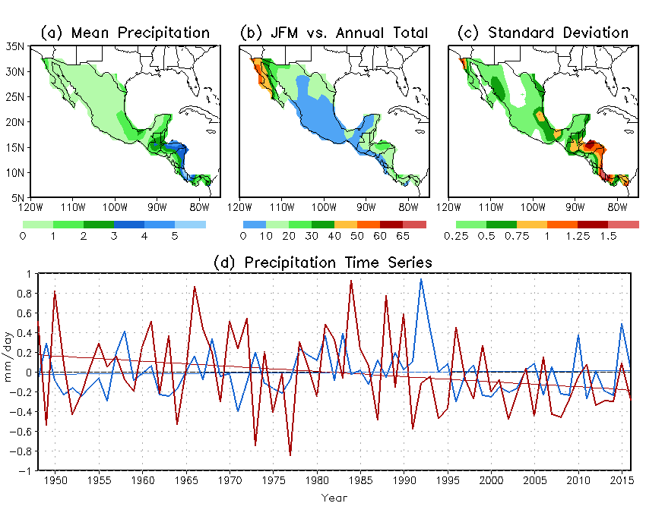
Fig. 1 (a) Climatological winter (JFM) seasonal mean precipitation (mm day⁻¹) in Central America and Mexico, (b) its ratio (%) to climatological annual total precipitation, (c) standard deviation (mm day⁻¹) based on 1948–2015 observations, and (d) time series of precipitation anomalies (mm day⁻¹) averaged over Central America south of 17ºN (thick red line) and Mexico north of 17ºN (thick blue line). The thin red and blue lines in (d) are the corresponding linear trends.

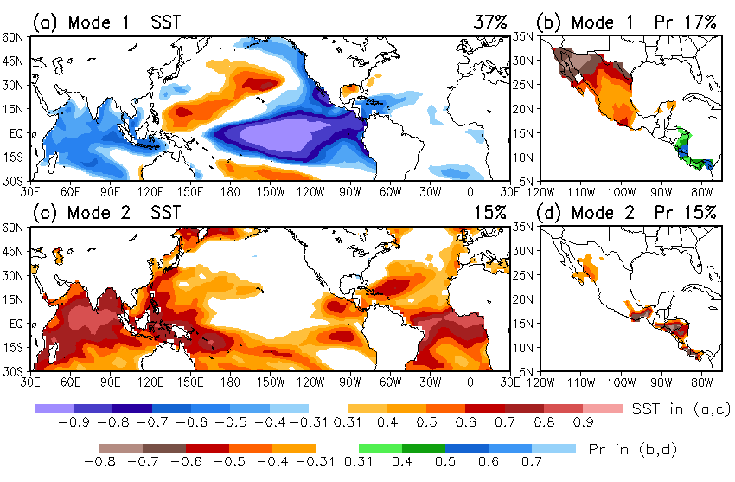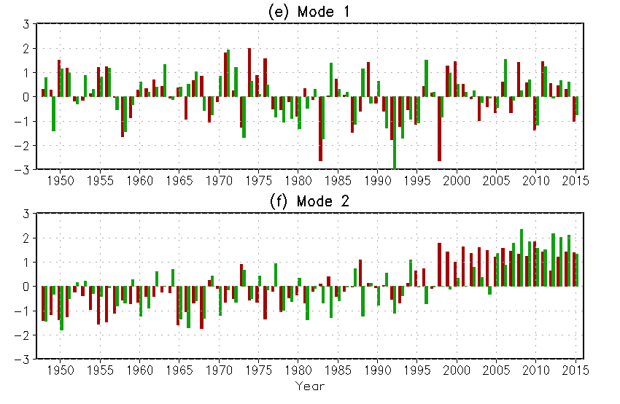
Fig. 2 Homogeneous correlation maps of the first (a, b) and second (c, d) SVD modes between (a, c) winter SST in the tropical Pacific and Atlantic and (b, d) precipitation in Central America and Mexico, and normalized SVD time series of SST (red bars) and precipitation (green bars) from JFM 1948 to 2015 for (e) the first and (f) second modes based on observations from 1948 to 2015. The correlations shown in shadings (> 0.31) are above the 99% significance level. The percentage of the total variance explained by each mode for SST (a, c) and precipitation (b, d) is listed at the top right of each panel.

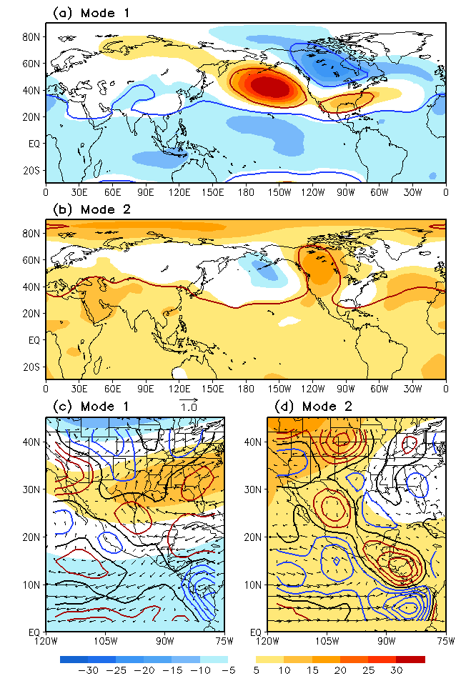
Fig. 3 Circulation anomalies of (a, b) 500-hPa height (gpm), (c, d) 850-hPa wind (vector, m s⁻¹) and 925-hPa divergence (contour, s⁻¹) associated with one standard deviation of the SVD SST time series, obtained based on linear regression against the SVD SST time series for mode 1 (a, c) and mode 2 (b, d) using observational data. Contour interval in (c, d) is 2.0×10⁻⁷ s⁻¹, with positive in red, negative in blue, and zero contour in thick black. Shadings in (c, d) are same as in (a, b). The height anomalies circled by red (blue) lines in (a, b) are positively (negatively) correlated with the SVD SST trim series above the 99% significance level.
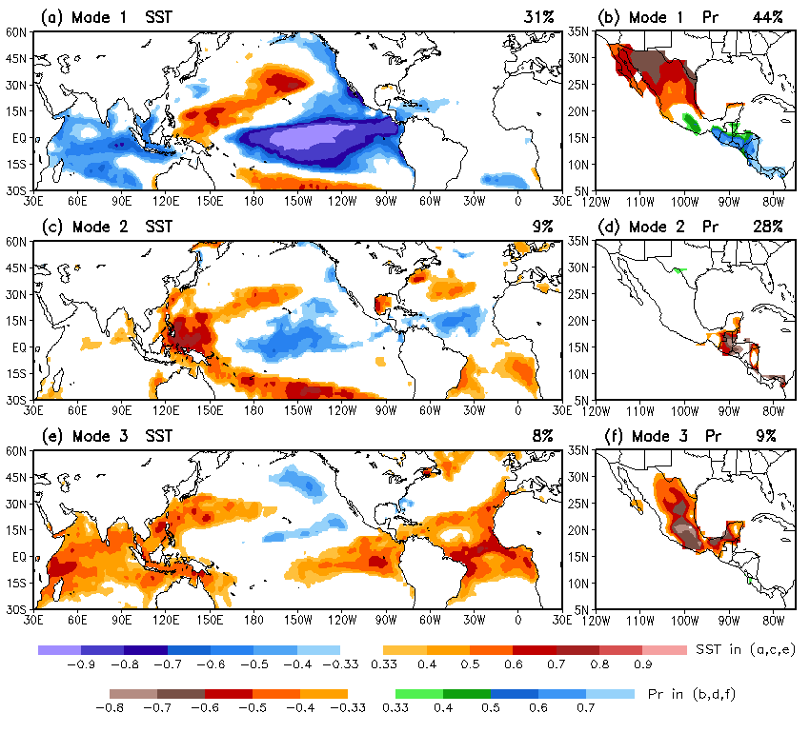
Fig. 4 Homogeneous correlation maps of (a, b) the first, (c, d) second, and (e, f) third SVD modes between (a, c, e) winter (JFM) SST in the tropical Pacific and Atlantic and (b, d, f) precipitation in CAM based on 18-member ensemble mean AMIP simulations from 1957 to 2015. The correlations shown in shadings (> 0.33) are above the 99% significance level.

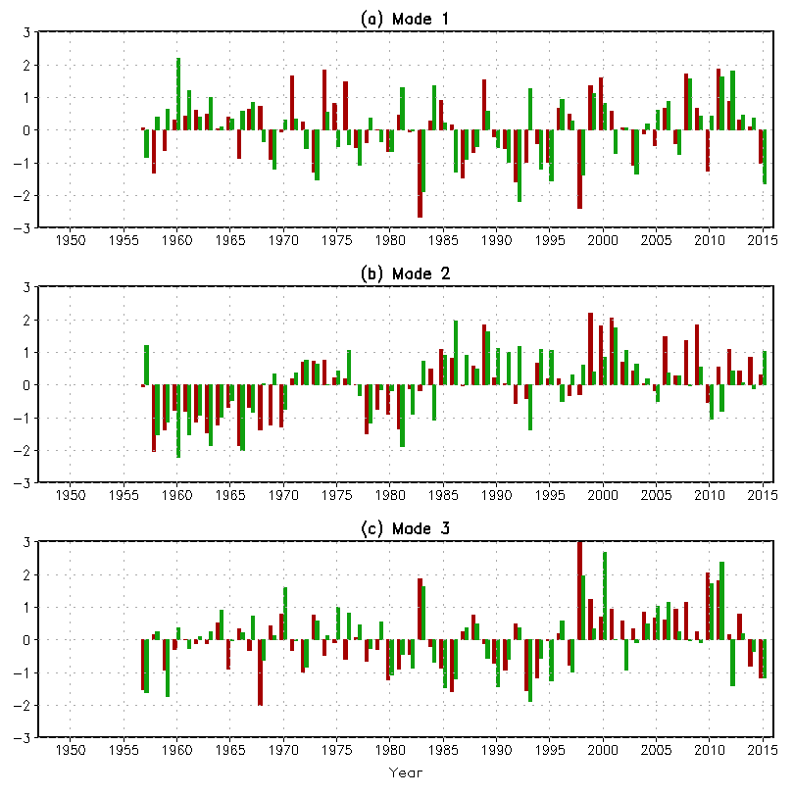
Fig. 5 Normalized SVD time series of winter (JFM) SST (red bars) and precipitation (green bars) for (a) the first, (b) the second, and (c) the third modes from the 18-member ensemble mean data of the 1957–2015 AMIP simulations.

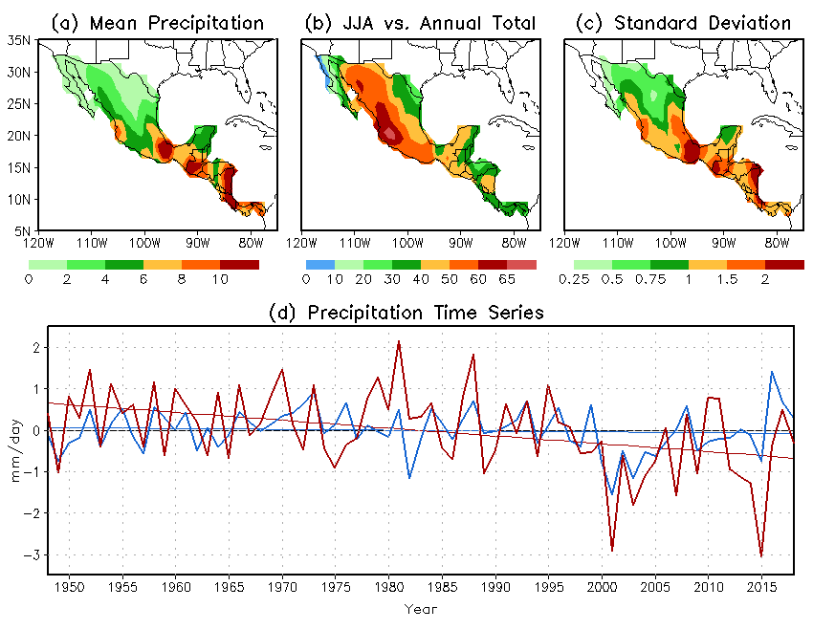
Fig. 6 (a) Long-term mean summer (JJA) precipitation (mm day⁻¹), (b) its ratio (%) to climatological annual total precipitation, (c) standard deviation (mm day⁻¹) of summer precipitation in Central America and Mexico derived from 71-year (1948–2018) observations, and (d) time series of summer precipitation anomalies (mm day⁻¹) averaged over Central America (south of 17ºN, thick red line) and Mexico (north of 17ºN, thick blue line) from 1948 to 2018, and corresponding linear trends (thin red and blue straight lines).

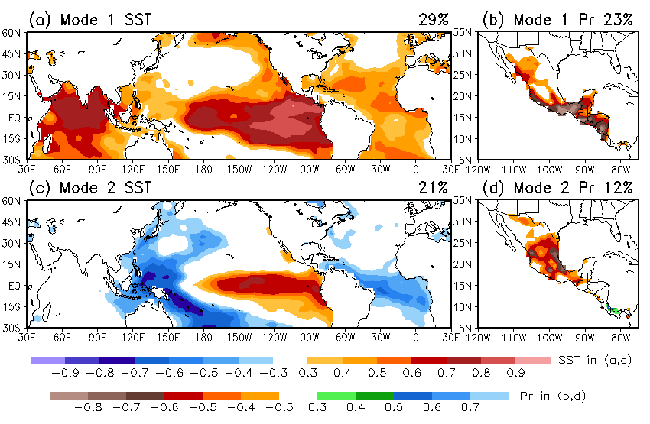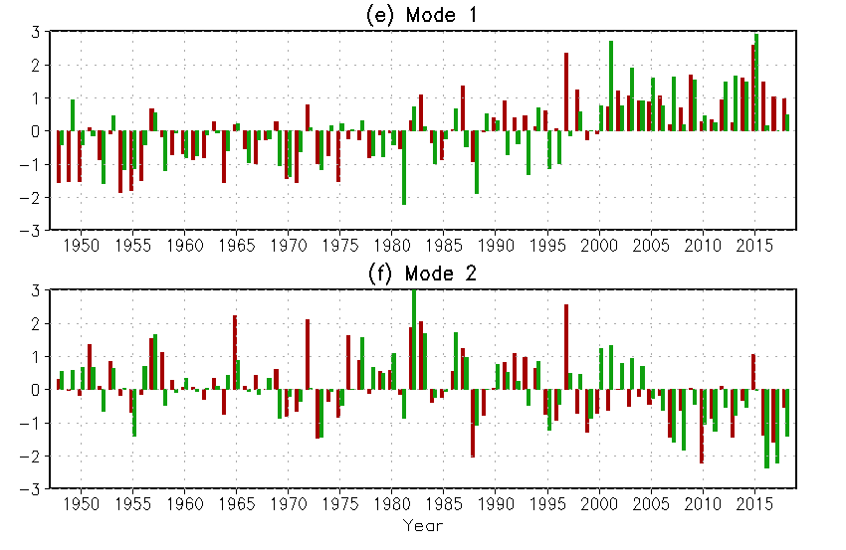
Fig. 7 Homogeneous correlation maps of the first (a, b) and second (c, d) SVD modes between (a, c) summer (JJA) SST in the tropical Pacific and Atlantic and (b, d) precipitation in CAM, and normalized SVD time series of summer SST (red bars) and precipitation (green bars) from 1948 to 2018 for (e) the first and (f) the second modes based on observational data. The correlations shown in shadings (> 0.3) are above the 99% significance level. The percentage of the total variance explained by each mode for SST (a, c) and precipitation (b, d) is listed at the top right of each panel.

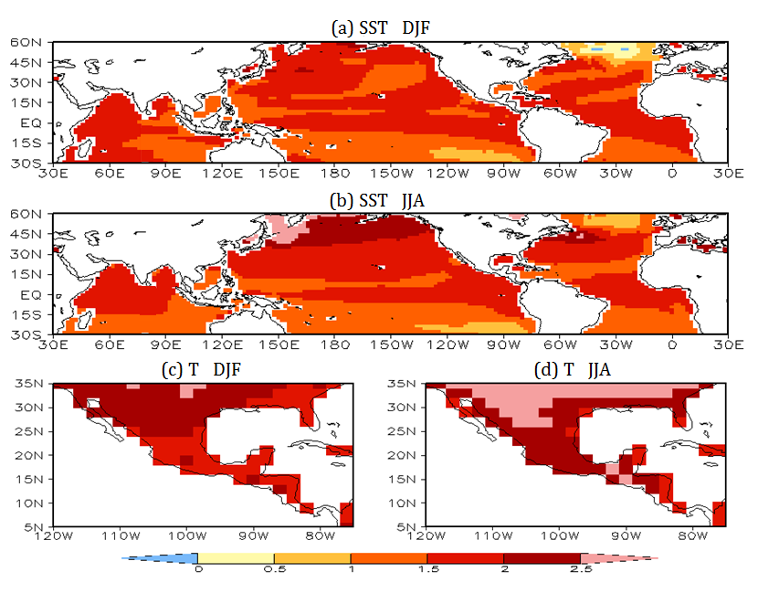
Fig. 8 Projections of (a, b) SST change (unit: K) and (c, d) CAM surface air temperature (2-m temperature) change (unit: K) over the 2071–2100 period relative to the 1980–2005 reference period in winter (a, c) and summer (b, d) derived from the CMIP5 multi-model ensemble (MME) means. They are the differences between the mean temperatures averaged over the 2071–2100 and 1980–2005 periods.

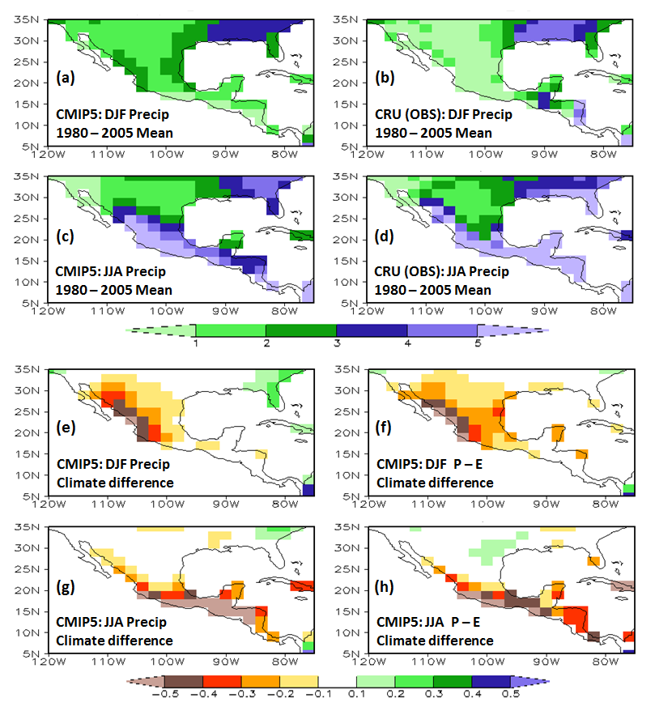
Fig. 9 Long-term (1980–2005) seasonal mean precipitation derived from (a, c) CMIP5 MME averages of the present-day climate simulations and (b, d) CRU observations, and CMIP5 MME projections of (e, g) precipitation change and (f, h) P–E change for the period of 2071–2100 relative to 1980–2005 over CAM in winter (a, c, e, g) and summer (b, d, f, h), respectively. The unit is mm day^{–1}.

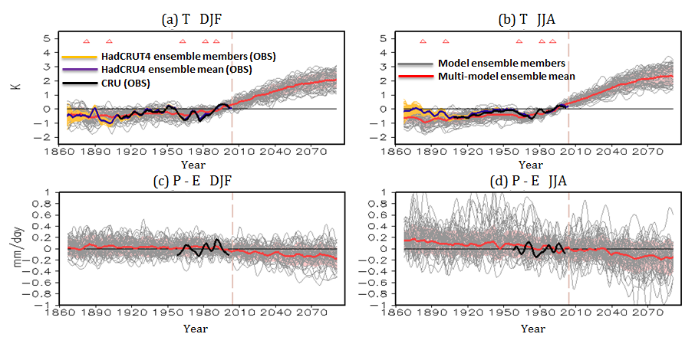
Fig. 10 Time series of (a, b) surface air temperature anomalies (unit: K) and (c, d) P–E anomalies (unit: mm day^{–1}) relative to the 1980–2005 climatology averaged over the CAM land area from 1860 to 2100 by combining the CMIP5 present-day climate simulations and the RCP45 simulations together for winter (a, c) and summer (b, d). The CMIP5 MME mean (red line) is shown along with individual model simulations (gray lines; 7-year running means). The observed temperature anomalies based on the HadCRUT4 and the CRU datasets are also plotted for the period of 1850–2005. The observed P–E anomalies (black line) are plotted for the period of 1958–2009. Red triangle denotes the years of volcanic eruptions. The vertical dash line separates the CMIP5 present-day climate simulations and the RCP45 future climate simulations.

