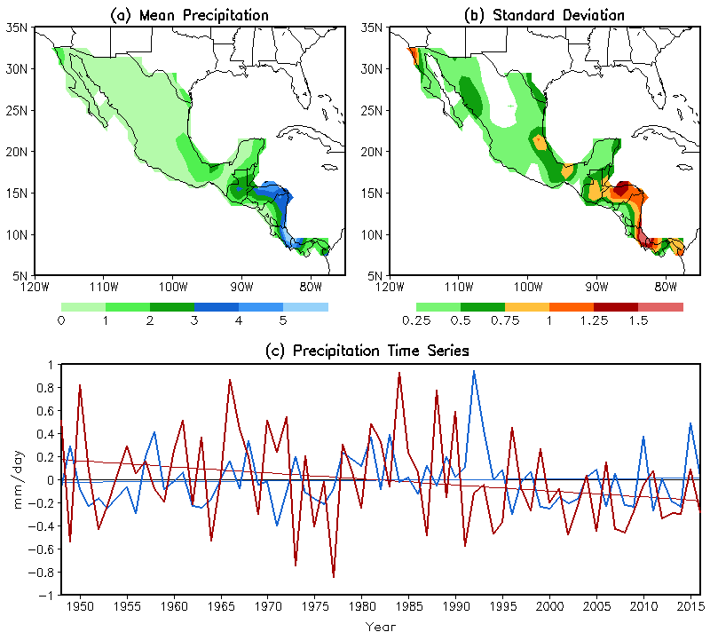

/cpc/home/hwang/2015_Mexico/2016_OBS_pr
s2c_clm-sd_dex_Fig1.gs
Fig1.gif

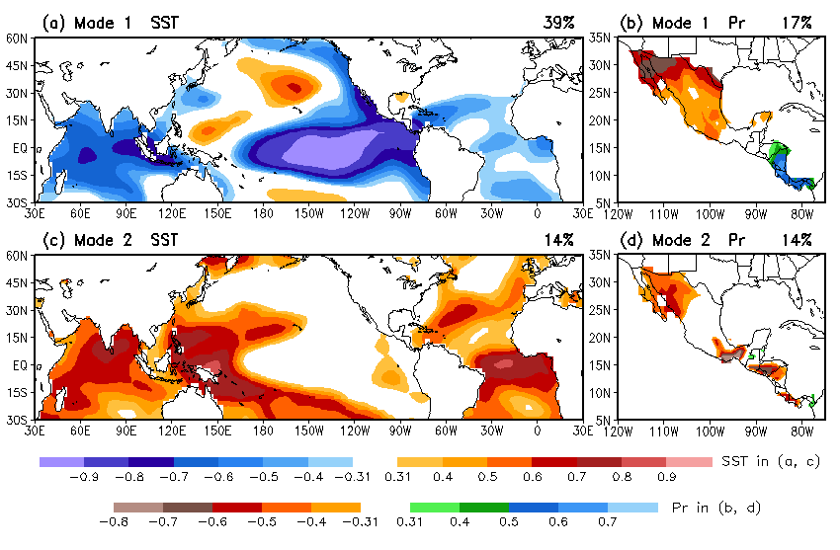

/cpc/home/hwang/2015_Mexico/2016_OBS_svd
s4e_svd_Fig2_rev.gs
Fig2.gif

/cpc/home/hwang/2015_Mexico/2016_OBS_svd
s4g_svd-time_Fig3-nino34.gs
Fig3.gif

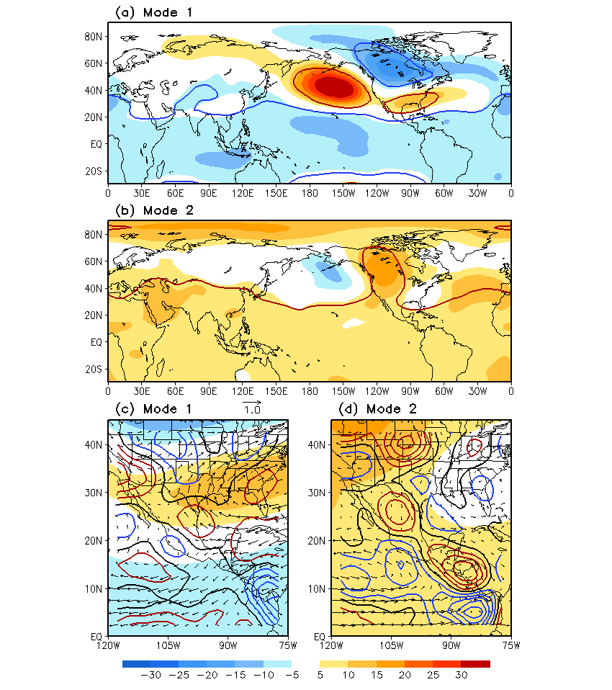
/cpc/home/hwang/2015_Mexico/OBS_R1
Fig4.R1.gs
Fig4.gif

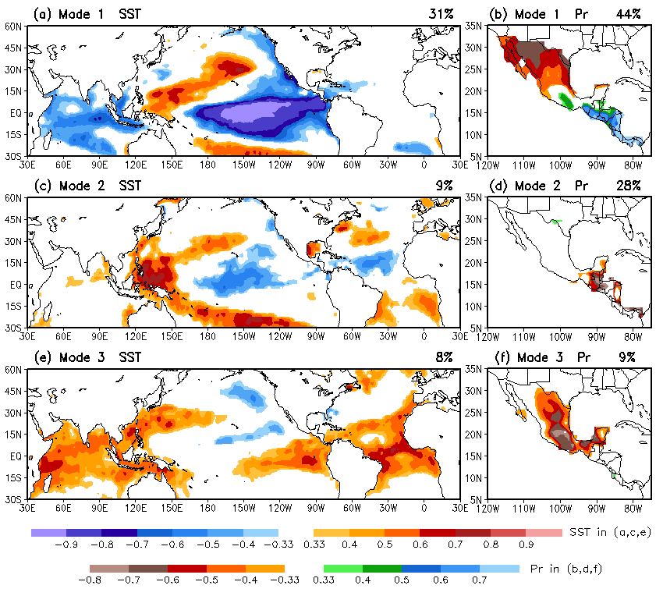
WCOSS
/sss/cpc/shared/Hui.Wang/2016_CAM_AMIP/
Fig_svd.3.gs
Fig5.gif
Data also scp to work1
/cpc/home/hwang/2015_Mexico/2016_CAM_AMIP

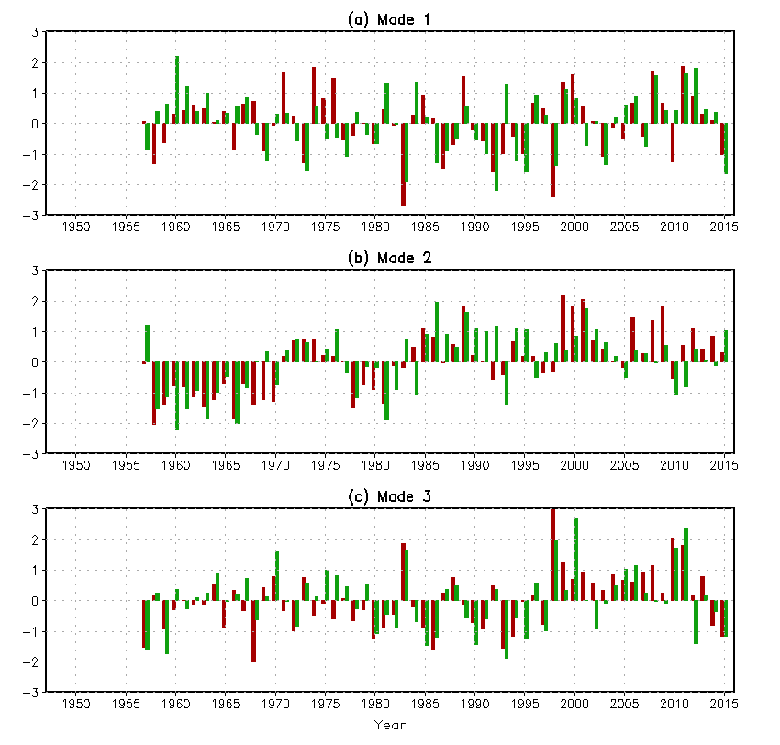
WCOSS
/sss/cpc/shared/Hui.Wang/2016_CAM_AMIP/
Fig_svd_time.3.gs
Fig6.gif
Data also scp to work1
/cpc/home/hwang/2015_Mexico/2016_CAM_AMIP

/cpc/home/hwang/2015_Mexico/OBS_R1
Fig7.gs
Fig7.eps

