FY2019 Milestone Progress Report
Development and Evaluation of Experimental Severe Weather Forecasts for the Week Two Timescale
Climate Prediction Center
NOAA/NWS/NCEP

1. Background and Goals
Tornadoes, hail and damaging winds are severe weather events, which can cause significant property damages and personal injuries or death. These events are characterized by small spatial scales and short lifetime and thus pose a forecasting challenge. Skillful severe weather outlooks and warnings at various lead times are of critical importance to one of the NOAA missions to protect lives and property.
Developing week-2 severe weather outlooks is one of the CPC projects under the Office of Science and Technology Policy (OSTP) initiative. Previously, the NOAA Storm Prediction Center explored the use of the Supercell Composite Parameter (SCP) derived from the CFSv2 45-day forecast to provide extended-range severe weather environment guidance (Carbin et al. 2016). This project takes one step further to explicitly forecast week-2 severe weather based on the empirical relationship between model hindcast week-2 SCP and observed weekly severe weather activity in the historical record, a hybrid dynamical-statistical approach.
The overall goals of this project are:
- To develop forecast tools for week-2 sever weather, including tornadoes, hails, and damaging winds recorded by NWS Local Storm Reports (LSR3), and evaluate forecast skill; and
- To implement the forecast tools into operation at CPC for different time ranges, including week 2, days 8–10, 10–12, and 12–14. The forecast products will support the CPC’s Week-2 U.S. Hazards Outlook.

2. Results and Accomplishments
a. Real-time week-2 severe weather forecast for 2019
The forecast tool developed in this project is a dynamical-statistical model, which uses the dynamical model (GEFS or CFSv2) predicted week-2 SCP as a predictor, and then forecasts week-2 severe weather (LSR3) based on the statistical relationship between model SCP and observed weekly LSR3 in historical record with a linear regression model. The GEFS-based hybrid model was implemented to forecast week-2 severe weather in real time for 2019, available at https://ftp.cpc.ncep.noaa.gov/hwang/week2sw/. Figure 1 shows the web page designed for the experimental week-2 severe weather outlook for the latest month (October 2019 at the time of submission of this report) with the archive at the bottom for earlier months. The outlook is updated daily at 10:00 AM and consists of both deterministic and probabilistic forecasts. The former is the 80-member ensemble mean forecast of week-2 LSR3 (e.g., Fig. 2b), whereas the latter is the percentage distribution of the 80-member forecasts in three categories (above normal, near normal, and below normal, e.g., Figs. 2d–2f). The week-2 forecasts are made not only for LSR3, but also for individual types of severe weather (tornadoes, hail, and damaging winds).
The real-time forecasts are verified by observations and forecast skill is assessed for spring 2019. Figure 2 shows an example of the real-time week-2 severe weather forecast for the week of 19–25 May 2019 generated on 12 May 2019. During that week, there was a severe weather outbreak sequence with 79 EF1–EF3 tornadoes across the Central U.S. and the Mid-Atlantic (Fig. 2a). Compared to the observations, the week-2 forecast indicates broader but less intense severe weather activities (Fig. 2b). The probabilistic forecast (Figs. 2d–2f) shows that most of the Central and Eastern U.S. are in the above-normal category. Particularly, almost all regions of the observed LSR3 (circled by red line in Fig. 2d) were predicted with more than 50% chance of above-normal severe weather activity. The anomaly correlation between week-2 forecasts and observations over March–May 2019 (Fig. 2c) suggests considerable skills of the hybrid model in forecasting week-2 severe weather over the Central and Eastern U.S.

b. Assessment of forecast skill for days 8–10, 10–12, and 12–14
To provide guidance for CPC’s Day 8–14 U.S. Hazard Outlook, the GEFS-based hybrid model has also been tested for severe weather (LSR3) forecasts for different time ranges, including days 8–10, 10–12, and 12–14. The forecast skill is cross-validated over the GEFS hindcast period (1996–2012). Figure 3 shows the anomaly correlation (AC) skill for these time ranges, as well as the skill of week 2 (day 8–14) for comparison purposes. Overall, the forecast skill of Day 8–10 (Fig. 3a) is better than the skill of week 2 forecast (Fig. 3d), but the skills of Days 10–12 and 12–14 (Figs. 3b and 3c) are lower than the week 2.

c. Development of CFSv2-based hybrid forecast model for week-2 severe weather
The dynamical–statistical approach has been applied to the CFSv2 45-day forecast dataset to develop a hybrid forecast model for week-2 severe weather. The forecast skill is cross-validated over the CFSv2 hindcast period (1999–2010) and compared with the GEFS-based hybrid model. The anomaly correlation skills are shown in Fig. 4 for both week-1 and week-2 severe weather forecasts with the two models, respectively. In general, the skill of the CFSv2-based forecasts (Figs. 4a, 4b) is lower than the GEFS-based forecasts (Figs. 4c, 4d). This is likely due to (a) lower horizontal resolution for the CFSv2, and (b) CFSv2 uses an older version of atmospheric model compared to GEFS.

d. Milestone accomplishments
The following milestones were accomplished:
- Implemented the GEFS-based dynamical–statistical model for real-time week-2 severe weather forecast for 2019, including both deterministic and probabilistic forecasts for all three types of severe weather (LSR3), as well as individual types of severe weather (tornadoes, hail, and damaging winds), with real-time verification and skill assessment.
- Evaluated the skill of the GEFS-based hybrid model for days 8–10, 10–12, and 12–14, respectively, as requested by CPC Operational Prediction Branch (OPB) in support of the CPC’s Day 8–14 U.S. Hazards Outlook.
- Developed the CFSv2-based hybrid forecast model for week-2 severe weather (LSR3) and compared its forecast skill with the GEFS-based hybrid model.
3. Work Plan for FY2020
- Collaborate with the NOAA Storm Prediction Center (SPC) and CPC Operational Prediction Branch (OPB) on the transition of the severe weather forecast tools developed in this project (for different time ranges, including week 2, days 8–10, 10–12, and 12–14) into operations.
- Continue to explore the feasibility of forecasts for week 3–4 severe weather by making use of the CFSv2 45-day forecast product and based on stronger relationships between model SCP and observed LSR3 depicted by leading SVD modes.

4. Publications and Presentations
Wang, H., A. Kumar, A. Diawara, and D. DeWitt: Dynamical-statistical prediction of week-2 severe weather for the United States. Weather and Forecasting, to be submitted, 2019.
Wang, H., A. Diawara, A. Kumar, and D. DeWitt: Developing an experimental week 2 severe weather outlook for the United States. The 43rd NOAA Climate Diagnostics and Prediction Workshop Special Issue, Climate Prediction S&T Digest, 37–41, 2019, https://doi.org/10.25923/ae2c-v522.
Diawara, A., H. Wang, A. Kumar, and D. DeWitt: Predictive capacity of week 3–4 severe weather outlook for the United States using CFSv2 45-day hindcast data. The 43rd NOAA Climate Diagnostics and Prediction Workshop, Santa Barbara, California, 23–25 October 2018.
Wang, H., A. Diawara, A. Kumar, and D. DeWitt: Experimental week-2 severe weather outlook. CPC/OMB Branch Meeting, College Park, Maryland, 20 June 2019.
Wang, H., A. Diawara, A. Kumar, and D. DeWitt: CPC’s Week 3-4 Severe Weather Project. CPC Week 3-4/GTH Working Group Meeting, College Park, Maryland, 22 March 2019.
Wang, H., A. Diawara, A. Kumar, and D. DeWitt: Updates on the Subseasonal Severe Weather Project. Briefing to CPC/OPB, College Park, Maryland, 11 March 2019.

Reference
Carbin, G. W., M. K. Tippett, S. P. Lillo, and H. E. Brooks, 2016: Visualizing long-range severe thunderstorm environment guidance from CFSv2. Bull. Amer. Meteor. Soc., 97, 1021–1032.

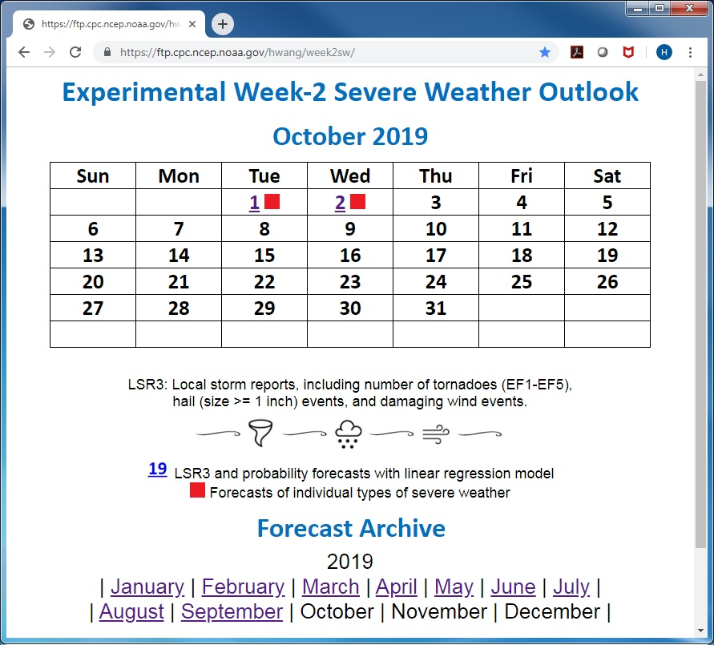
Fig. 1. Web page (https://ftp.cpc.ncep.noaa.gov/hwang/week2sw/) of the experimental week-2 severe weather forecast for the U.S.

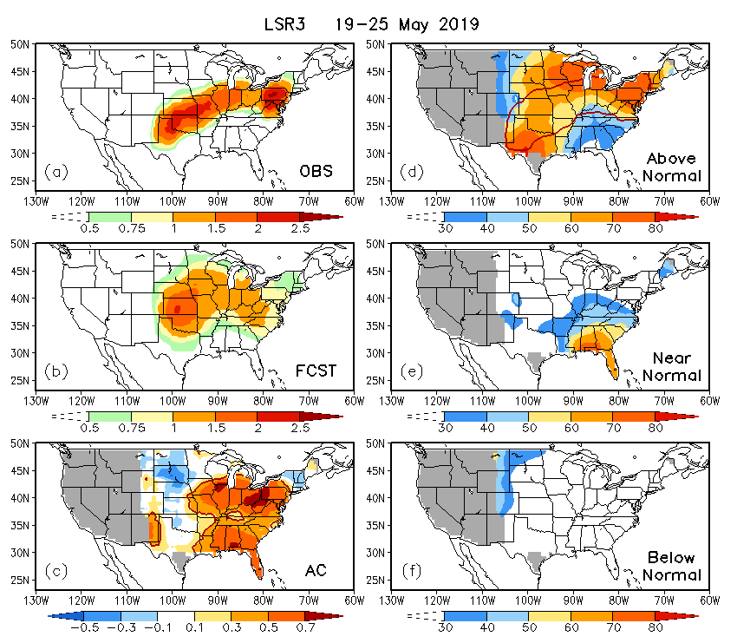
Fig. 2. (a) Observed and (b) predicted week-2 LSR3 for the week of 19–25 May 2019, (c) anomaly correlation (AC) skill of the real-time forecasts for weekly LSR3 during MAM 2019, and the probability forecasts of week-2 LSR3 for (d) above-normal, (e) near-normal, and (f) below-normal categories in the week of 19–25 May 2019, based on 80 ensemble members of the GEFS SCP forecasts. The red line in (c) denotes the 99% significance level estimated by the two-tailed t-test. The red contour in (d) is 0.5 of the observed weekly LSR3 shown in (a). Grey shading in (c–f) masks out the regions with observed zero LSR3 climatology.

Fig. 3. Anomaly correlation (AC) skill between observed and predicted severe weather (LSR3) for (a) Day 8–10, (b) Day 10–12, (c) Day 12–14, and (d) Week 2 (Day 8–14) over MAM 1996–2012 with the GEFS-based hybrid model.

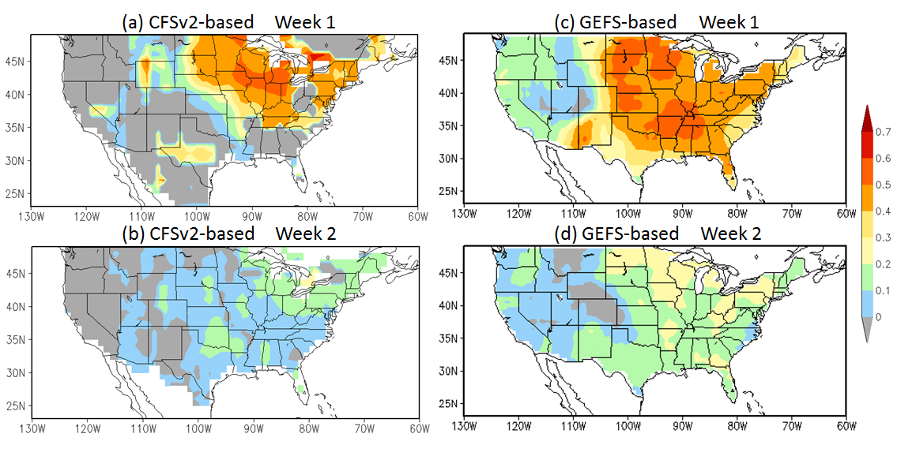
Fig. 4. Anomaly correlation (AC) skill between observed and predicted weekly severe weather (LSR3) for (a, c) week 1 and (b, d) week 2 with the CFSv2-based (left panels) and the GEFS-based (right panels) hybrid models, respectively.

