Developing an Experimental Week 2 Severe Weather Outlook for the United States
Hui Wang¹, Alima Diawara^{1,2}, Arun Kumar¹, David DeWitt¹
¹ NOAA/NWS/NCEP/Climate Prediction Center, College Park, MD
² Innovim LLC, Greenbelt, MD

1. Introduction
Developing week 2 to 4 severe weather outlooks is one of the CPC projects under the Office of Science and Technology Policy initiative. The goals of this project are (1) to expand development and perform evaluation of week-2 severe weather model guidance, and (2) to explore the potential and develop experimental forecast tools for week 3 and 4 severe weather. The results presented at the workshop focus on week-2 severe weather forecast.
A study by Carbin et al. (2016) uses the Supercell Composite Parameter (SCP) derived from the CFSv2 45-day forecasts to provide extended-range severe weather environment guidance. When SCP is greater than 1, the chance for severe weather to occur is high. Here we take one more step to explicitly forecast severe weather based on the empirical relationship between model-predicted SCP and actual severe weather activity in historical records.
2. Data and methods
The data used in this study include both observational dada and model forecasts. For observations, the NCEP Climate Forecast System Reanalysis (CFSR) and NWS local storm reports (LSRs) are employed. The LSR consists of hail, tornado, and damaging wind reports, as well as their location, time and intensity. The sum of the LSRs for hail, tornado and damaging wind are referred to as LSR3 hereafter. They are re-gridded to a 0.5º×0.5º grid. We use the NCEP GEFS 16-day hindcasts to develop the forecast model for week-2 severe weather. The hindcast period is from 1996 to 2012. The hindcasts were made every 4 days with 5 members and a 0.5º×0.5º resolution. The analysis presented was performed using the 5-member ensemble mean forecasts.
Following Carbin et al. (2016), the SCP is defined as
SCP = (CAPE/1000 J kg⁻¹) × (SRH/50 m⁻² s⁻²) × (BWD/20 m s⁻¹),
where CAPE is convective available potential energy, SRH storm-relative helicity, and BWD bulk wind difference. The three constants are used to normalize SCP so that when SCP is greater than 1, severe weather likely occurs.
The forecast model developed in this study is a hybrid dynamical-statistical model (e.g., Wang et al. 2009). It uses the dynamical model (GEFS) predicted SCP as a predictor, and then forecast severe weather (LSR3) based on the statistical relationship between model SCP and actual LSR3 in historical records. The forecast skill is cross-validated over the GEFS hindcast period (1996–2012).
3. Results
The observed seasonality of SCP is examined first. Figure 1 (left) shows the climatological seasonal mean daily SCP over the U.S. for the four seasons (DJF, MAM, JJA, and SON), respectively, derived from CFSR. The seasonal variation of SCP is characterized by relatively large values of SCP appearing in the Gulf States during winter. Then SCP intensifies and peaks in spring. The region of the maximums moves northward from the Southern Plain in spring to the Northern Plain in summer. From summer to fall, the SCP value decreases and the center of the maximums movers back to the south. The SCP displays strong seasonality over the central U.S. Over the same region, the LSR3 also shows similar seasonality with strong severe weather activity in spring and summer (Fig. 1, right). During these two seasons, however, there are also strong activities in the eastern U.S. where SCP value is small. Therefore, in terms of the seasonal cycle, there is a good correspondence between SCP and LSR3 in the central U.S. The SCP from the GEFS forecasts captures the observed seasonality of SCP for both week 1 and week 2 (not shown).
The difficulty in forecasting severe weather is mainly due to its short lifetime and a small spatial scale. Figure 2a–b shows the one-point correlation map for weekly CFSR SCP and LSR3, respectively, at the 0.5º×0.5º grid. It is the correlation map between weekly anomaly at one grid point (here 95.5ºW, 37.5ºN) and that at every grid point over the U.S. For SCP (Fig. 2a), there are high correlations between the selected grid point and the surrounding grid points, indicating that SCP has a large-scale feature. For LSR3 (Fig. 2b), in contrast, the correlations are small, except for the correlation with itself, consistent with the small spatial scale of severe weather. However, when averaging LSR3 over a 5º×5º box and then re-calculating the one-point correlation, the result (Fig. 2d) shows much higher spatial coherence for LSR3 and is comparable to that of SCP (Fig. 2c). It is thus reasonable to expect that forecasting weekly severe weather over a larger domain may have a better skill.
To develop a hybrid forecast model, we first establish some statistical relationship between GEFS predicted SCP and observed LSR3. Given the strong seasonality of both SCP and SLR3 (Fig. 1), a 3-month moving window is used in the analysis. Figure 3a–b shows the correlations between observed LSR3 and GEFS week-1 and week-2 forecasts of SCP at the 0.5º × 0.5º grid, respectively, for MAM, the peak severe weather season. The correlation with the week-2 forecast is less than the week-1 forecast, indicating a weak relationship between GEFS SCP and LSR3 for week 2. However, when using the 5º×5º area-averaged anomalies to reestablish the relationship between model SCP and observed LSR3, their correlations (Fig. 3c–d) are much higher than those at the 0.5º×0.5º grid (Fig. 3a–b) for both week 1 and week 2. The result indicates a stronger relationship between the model SCP and LSR3 when considering averaging severe weather activity over a larger domain.
In addition to the relationship between the GEFS SCP and LSR3 at each grid point, their statistical relationship can also be established by the singular value decomposition (SVD) technique (Bretherton et al. 1992). This method can objectively identify pairs of modes (spatial patterns) of SCP and LSR3, both of which vary with a maximum temporal covariance between each other. Figure 4 shows the spatial patterns of the three leading SVD modes for weekly SCP (left) and LSR3 (right), respectively, using the observational data. Each SVD mode displays a distinctive pattern with consistent distributions between SCP and LSR3. The three modes account for 62% of weekly LSR3 variance. A similar SVD analysis using the GEFS week-2 SCP (Fig. 5) can reproduce the observed relationship between SCP and LSR3 well (Fig. 4).
A hybrid model is developed to forecast the number of severe weather (LSR3) using the GEFS predicted week-2 SCP as a predictor and based on their relationships depicted in either Fig. 3 or Fig. 5. The former applies a linear regression model to forecast LSR3 at each grid point, whereas the latter projects the week-2 GEFS SCP onto the SCP SVD modes and then predicts LSR3 based on the SCP-LSR3 relationship depicted by the SVD analysis (Fig 5).
The forecast skill for week-2 severe weather is cross-validated over the GEFS hindcast period (1996–2012). The anomaly correlation skill at the 0.5º × 0.5º grid is relatively low (Fig. 6a), and is very similar to the corresponding correlation between GEFS SCP and LSR3 (Fig. 3b). The forecast skill of the hybrid model is improved (Fig. 6b) by using the 5º×5º area-averaged anomalies, consistent with the stronger relationship between model SCP and LSR3 (Fig. 3d). The forecast skill is significantly improved (Fig. 6c) when using the SVD-based relationship. This may be due to the inclusion of the covariation of both SCP and LSR3 with their surrounding regions.
4 Conclusions
Following Carbin’s work, the Supercell Composite Parameter (SCP) was selected as a variable to represent the large-scale environment and link the model forecast to actual severe weather. The hybrid model forecasts suggest a low skill for week-2 severe weather. However, the forecast can be improved by using the 5º×5º area-averaged anomalies and the SVD-based statistical relationship. Based on the analysis and results presented at the workshop, an experimental week-2 severe weather outlook has been implemented in real time.
For future work, we plan to extend the analysis for weeks 3 and 4 using the CFSv2 45-day hindcasts and forecasts. Because the forecast skill for week 3 and 4 SCP is expected to be low, we may consider forecasting week 3 and 4 severe weather over a larger domain, such as Midwest and Southeast US..

Acknowledgments
We would like to thank our colleagues Stephen Baxter, Jon Gottshalck, Daniel Harnos, Melissa Ou, Brad Pugh, and Matthew Rosencrans at CPC for helpful discussions and also Yuejian Zhu and Hong Guan at EMC for providing GEFS model forecast data.

References
Bretherton, C. S., C. Smith, J. M. Wallace JM, 1992: An intercomparison of methods for finding coupled patterns in climate data. J Climate, 5, 541–560.
Carbin, G. W., M. K. Tippett, S. P. Lillo, and H. E. Brooks, 2016: Visualizing long-range severe thunderstorm environment guidance from CFSv2. Bull. Amer. Meteor. Soc., 97, 1021–1032.
Wang H., J.-K. E. Schemm, A. Kumar, W. Wang, L. Long, M. Chellian, G. D. Bell, and P. Peng, 2009: A statistical forecast model for Atlantic seasonal hurricane activity based on the NCEP dynamical seasonal forecast. J. Climate, 22, 4481–4500.

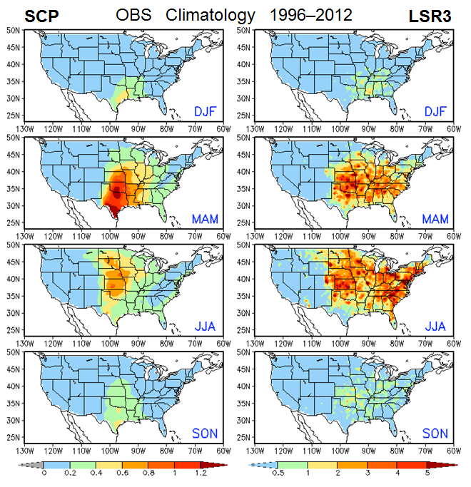
Fig. 1 Observed seasonal climatology of SCP (left) and LSR3 (right) for the four seasons.

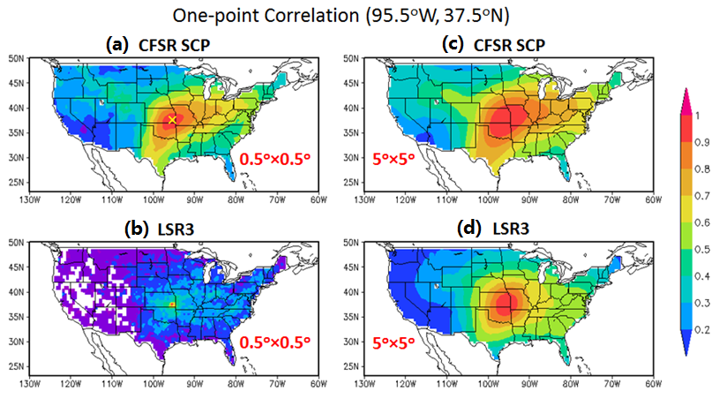
Fig. 2 Maps of one-point correlation for weekly SCP (top) and LSR3 (bottom) with anomalies at the 0.5º × 0.5º grid (left) and those area-averaged over the 5º × 5º box (right), respectively.

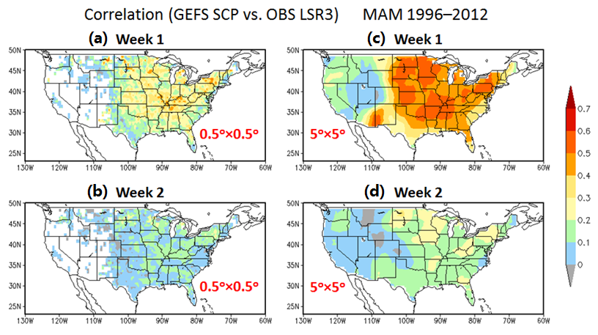
Fig. 3 Correlation between the GEFS predicted SCP and observed LSR3 for week 1 (top) and week2 (bottom) with anomalies at the 0.5º × 0.5º grid (left) and those area-averaged over the 5º × 5º box (right), respectively.

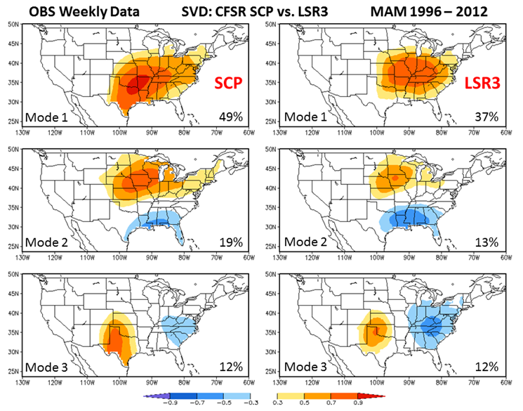
Fig. 4 Maps of homogeneous correlation for the first three SVD modes between weekly CFSR SCP and observed LSR3 during the MAM of 1996–2012. The percentage of the variance explained by each SVD mode is also provided at the bottom right of each panel.
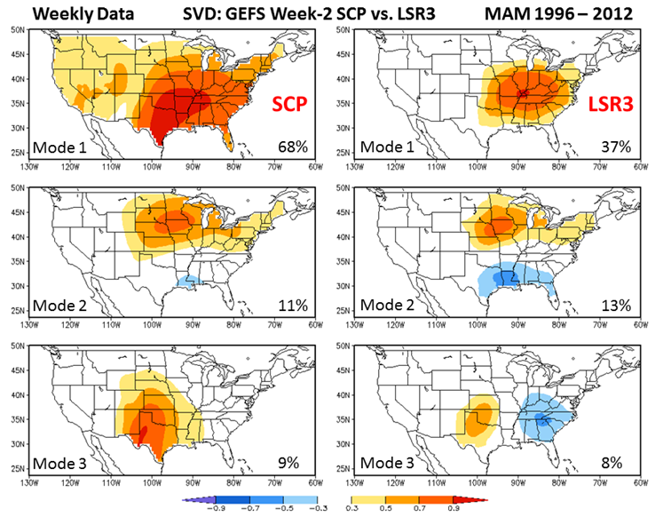
Fig. 5 Same as Fig. 4, but for the three leading SVD modes between the GEFS week-2 SCP and observed LSR3.

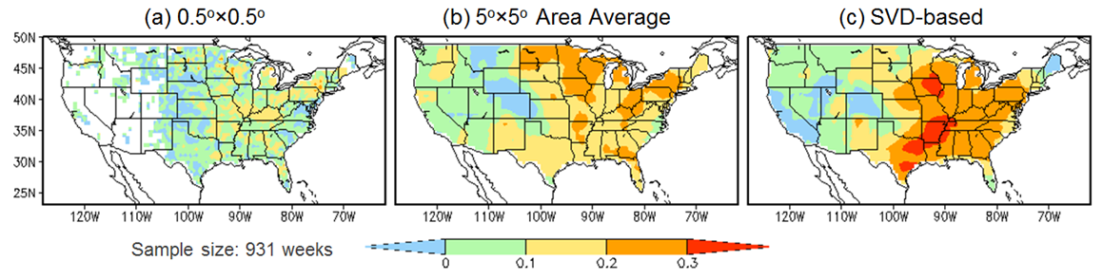
Fig. 6 Forecast skills for week-2 severe weather cross-validated over MAM 1996–2012 with (a) simple linear regression model at the 0.5º × 0.5º grid, (b) 5º × 5º area-averaged anomalies, and (c) the SVD-based hybrid model.

