WEATHER CLIMATE WATER

GLOBAL SEASONAL
CLIMATE UPDATE
Pre-Operational Phase
TARGET SEASON: September-October-November 2020

Issued: 25 August 2020
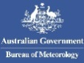

Summary
Observed sea surface temperatures in the east-central topical Pacific were in a neutral ENSO condition (i.e., neither El Niño nor La Niña was occurring) during May-July 2020 despite being at slightly below-average levels. The Indian Ocean Dipole (IOD) remained in a near-neutral condition and is predicted to continue being neutral to slightly below-average value. The sea surface temperatures in the Niño 3.4 and Niño 3 regions, both of which are often used to characterize ENSO conditions, are predicted to decrease from approximately -0.3 °C during the May-July 2020 season to -0.7 during September-November, and hence, are expected to be in a weak La Niña condition.
Influences from the expected tendency towards positive sea surface temperature anomalies over much of the globe are seen in the temperature forecast for September-November 2020 across sizeable portions of the globe, both in the tropics (except for below-average conditions in the eastern tropical Pacific and southeast Pacific) and extra-tropics (except for a few relatively small pockets mainly in southern oceans, such as immediately southeast of Africa and south of Australia). Below-average temperature is generally unlikely over land areas, with increased chances of above-normal temperatures dominating. Above-average sea surface temperatures are predicted in the western tropical Pacific, while below-average temperature is predicted along the immediate equator in the central and eastern tropical Pacific. These SST conditions introduce east-west gradients will affect the overlying atmospheric circulation and climate, especially if below-average SST anomalies in the central and eastern Pacific are indicative of weak/moderate La Niña rather than borderline La Niña. A global warming trend also contributes to the sea surface temperature and air temperature forecast, leading to a general prevalence of increased chances of positive anomalies defined with respect to the climatological base period (1993–2009), which is centred nearly 20 years in the past.
An enhanced probability for above normal precipitation is expected in Indonesian Archipelago, eastern half of Australia, eastern Indian ocean and Indian subcontinent. Some tilts of the odds for precipitation are likely associated with expected sea surface temperature anomalies, such as the above-average precipitation in much of the Indonesian Archipelago with the positive sea surface temperature anomalies predicted in that vicinity. In the equatorial Pacific, a tilt of the odds towards near-normal rainfall is predicted east of the dateline, with an enhanced likelihood for below-normal precipitation in the western and central Pacific extending southeast towards the South American coast. Outside of these regions, tilts of the odds towards below normal oceanic precipitation are seen in the equatorial western Indian Ocean. Extratropical oceans in both hemispheres have alternating bands of enhanced probabilities for below- and above-normal precipitation anomalies that originate in tropical latitudes and extend into extratropics.

Surface Air Temperature, SON 2020  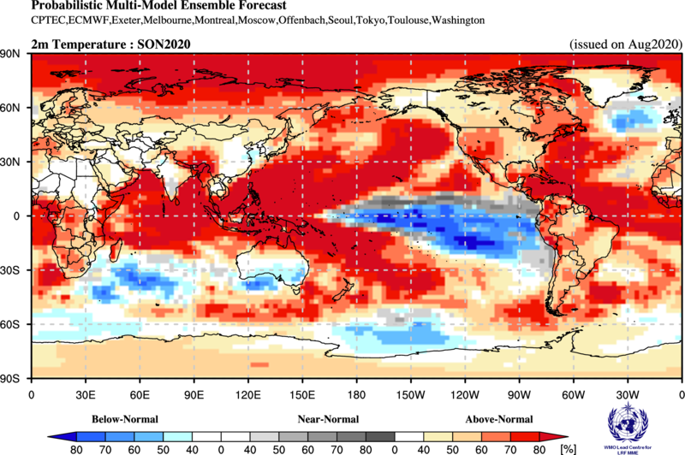 | Precipitation, SON 2020  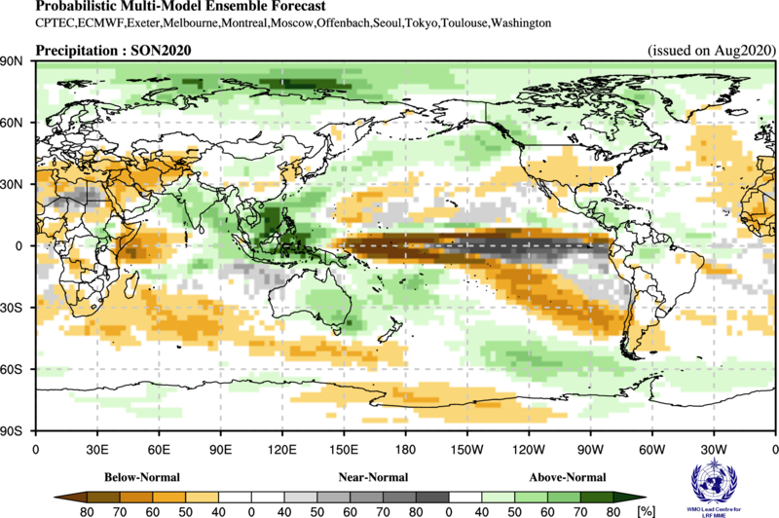

Figure 1. Probabilistic forecasts of surface air temperature and precipitation for the season September-November 2020. The tercile category with the highest forecast probability is indicated by shaded areas. The most likely category for below-normal, above-normal and near-normal is depicted in blue, red and grey shadings respectively for temperature, and orange, green and grey shadings respectively for precipitation. White areas indicate equal chances for all categories in both cases. The baseline period is 1993–2009.

1. Observations: May - July 2020
In the following sections, observed temperature and precipitation patterns for the period May-July 2020 are briefly described. For more detailed information about regional and local climate anomalies, the reader is referred to the concerned WMO Regional Climate Centres (RCCs) or RCC Networks, listed in Section 5.

1.1 Large-scale sea surface temperature (SST) indices
During May–July, the four Niño sea surface temperature (SST) indices in central and eastern Pacific turned negative, with larger negative values in the eastern Pacific. The Niño 4 SST Index near the date line was weakly positive, even though the overall tendency in all SST indices was towards a negative value. The SST conditions generally characterized a neutral El Niño-Southern Oscillation (ENSO) system and was a continuation of neutral (although warmer) conditions from the prior season. The Indian Ocean Dipole (IOD) over the period was weakly positive. The North Tropical Atlantic (NTA) SST and South Tropical Atlantic (STA) indices were positive.

Month | Niño 1+2 | Niño 3 | Niño 4 | Niño 3.4 | IOD | NTA | STA
May 2020 | -0.04 | -0.27 | 0.15 | -0.26 | 0.44 | 0.27 | 0.61
Jun 2020 | -0.74 | -0.68 | 0.23 | -0.35 | 0.65 | 0.55 | 0.37
Jul 2020 | -1.15 | -0.51 | 0.05 | -0.29 | 0.30 | 0.54 | 0.01
May - Jul 2020 | -0.64 | -0.49 | 0.14 | -0.30 | 0.46 | 0.45 | 0.33

Table 1. Large-scale oceanic indices (°C). Anomalies are with respect to the 1981–2010 average. (Source: U.S. Climate Prediction Center)

1.2 Observed temperature
Both over land and ocean, temperature anomalies across the globe continued their trend of warmer-than-normal conditions for the season of May–July 2020 (Figure 2, top), and in general, above-normal temperatures dominated the globe. The most strongly positive land temperature anomalies occurred over northern Asia, equatorial South America, and the equatorial western and Greater Horn regions of Africa. Exceptions to positive land anomalies were negative temperature anomalies over the northwest regions of North America and southeast Australia.
Over the oceans, the eastern equatorial Pacific and southwest Indian Ocean (off the souheast coast of southern Africa) had cooler-than-normal temperatures. In the extratropical southern oceans near-average temperature generally prevailed. SSTs in the equatorial central Pacific indicated a neutral ENSO conditions, with positive anomalies in the western equatorial Pacific and negative anomalies in central and eastern Pacific; a pattern that indicates enhanced zonal SST gradients across the equatorial Pacific. SST anomalies throughout the extratropical North Pacific and equatorial Atlantic Ocean were generally positive. A notable region having the largest observed warm ocean temperature anomaly was in the northeast Pacific.
Consistent with the seasonal mean anomalies, warm extremes dominated (Figure 2, bottom panel). Warm extremes (exceeding all seasonal mean temperatures observed during 1981–2010) occurred over the northernmost parts of Asia, equatorial South America and equatorial western and Greater Horn regions of Africa. No significant extreme cold temperature was found over land areas. Some oceanic regions also had warm extremes, notably the equatorial central and eastern Indian Ocean and equatorial western Pacific.

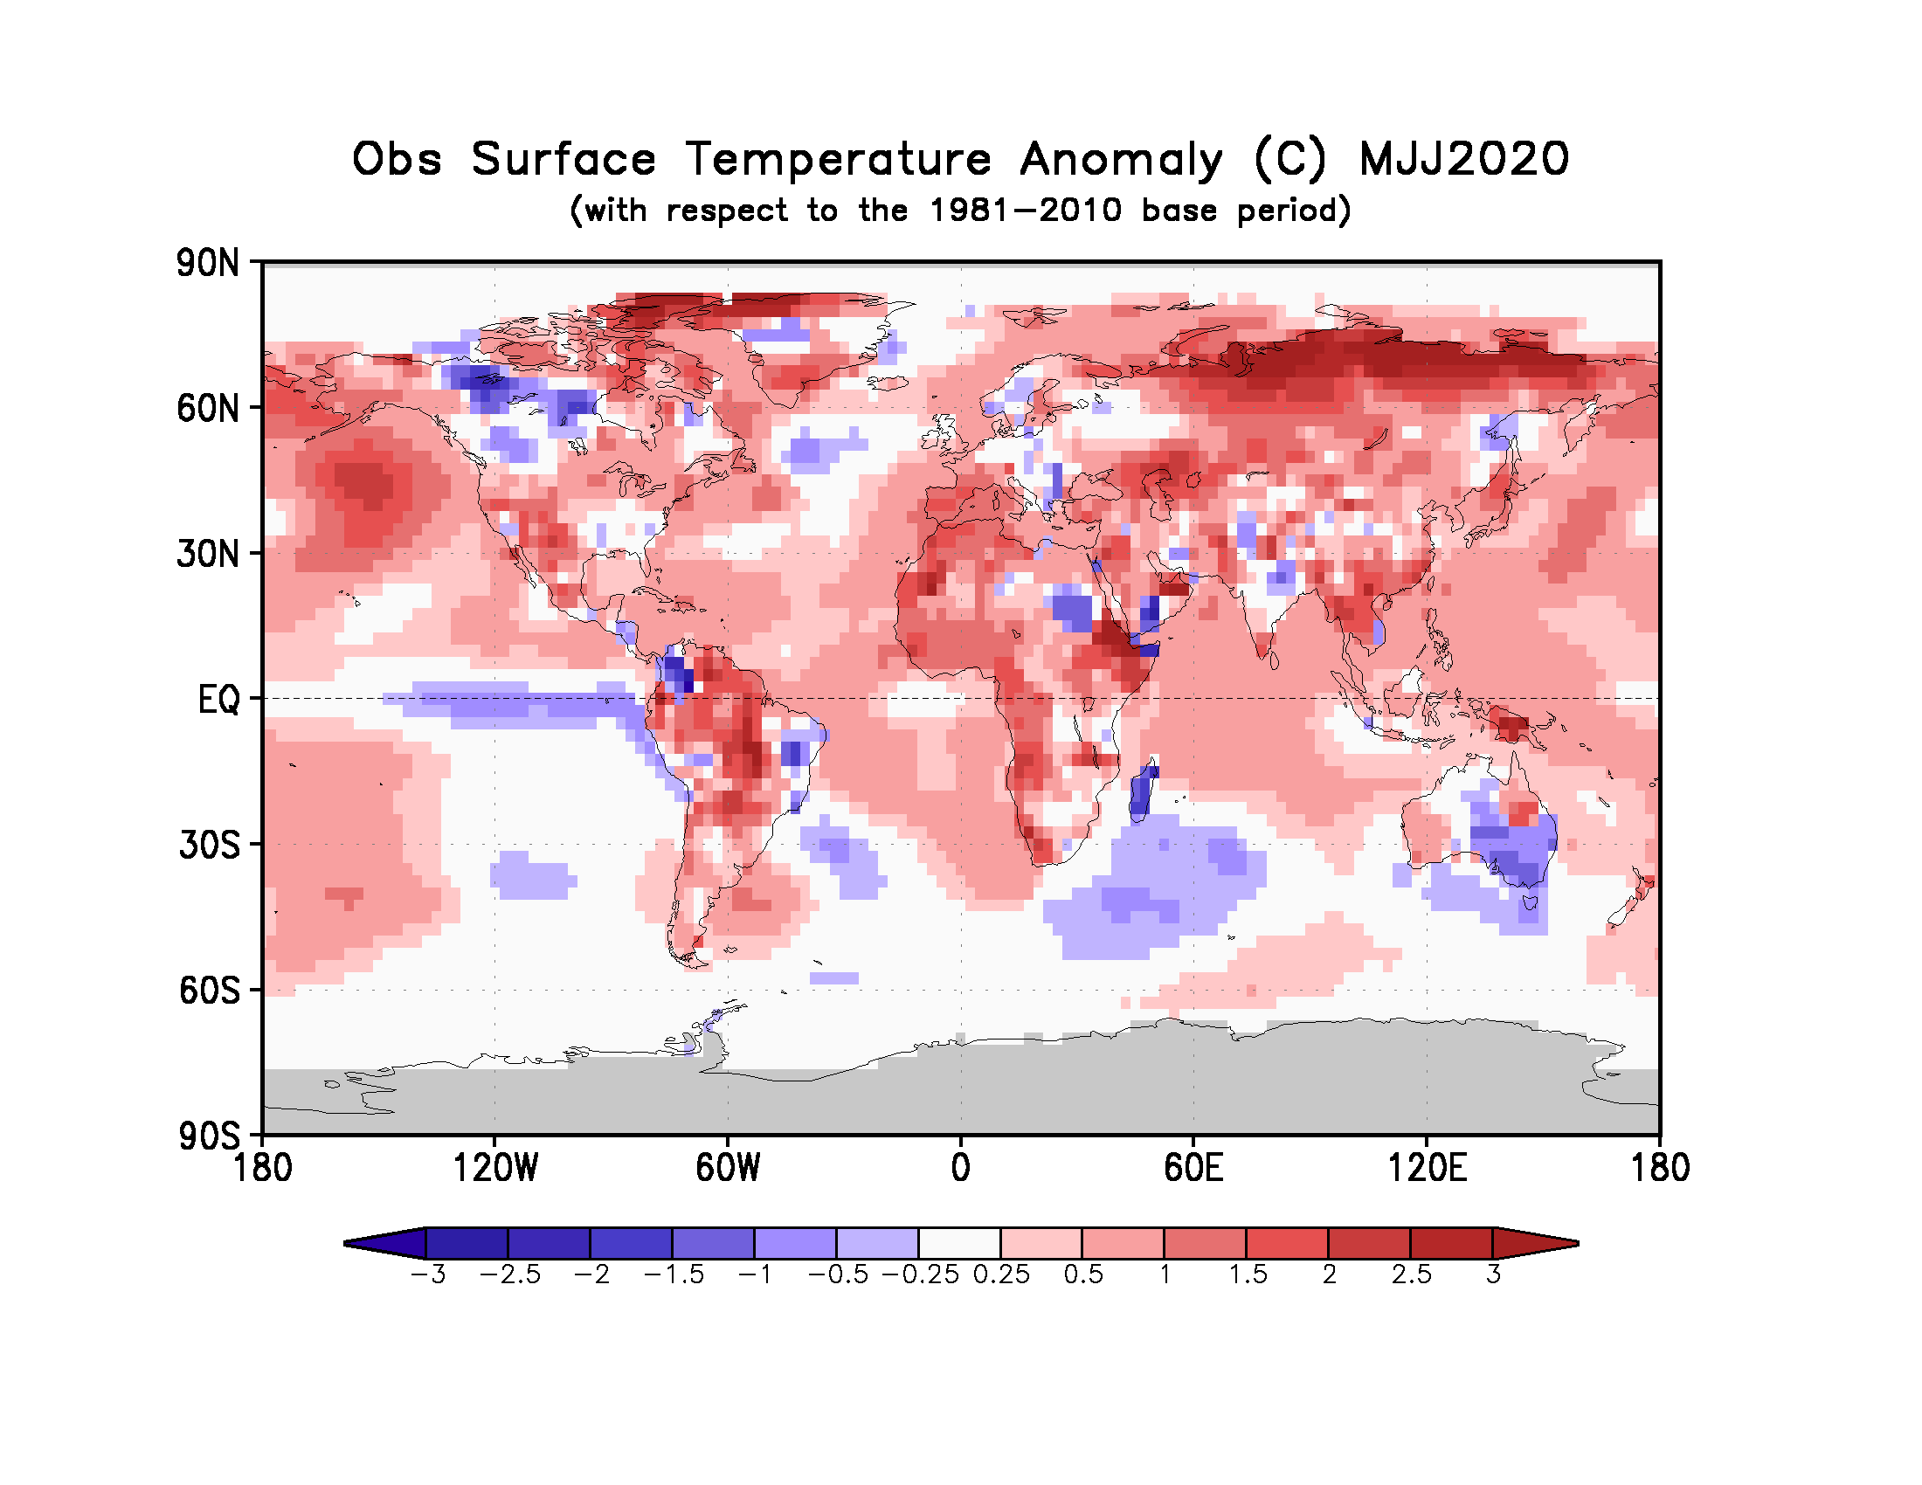
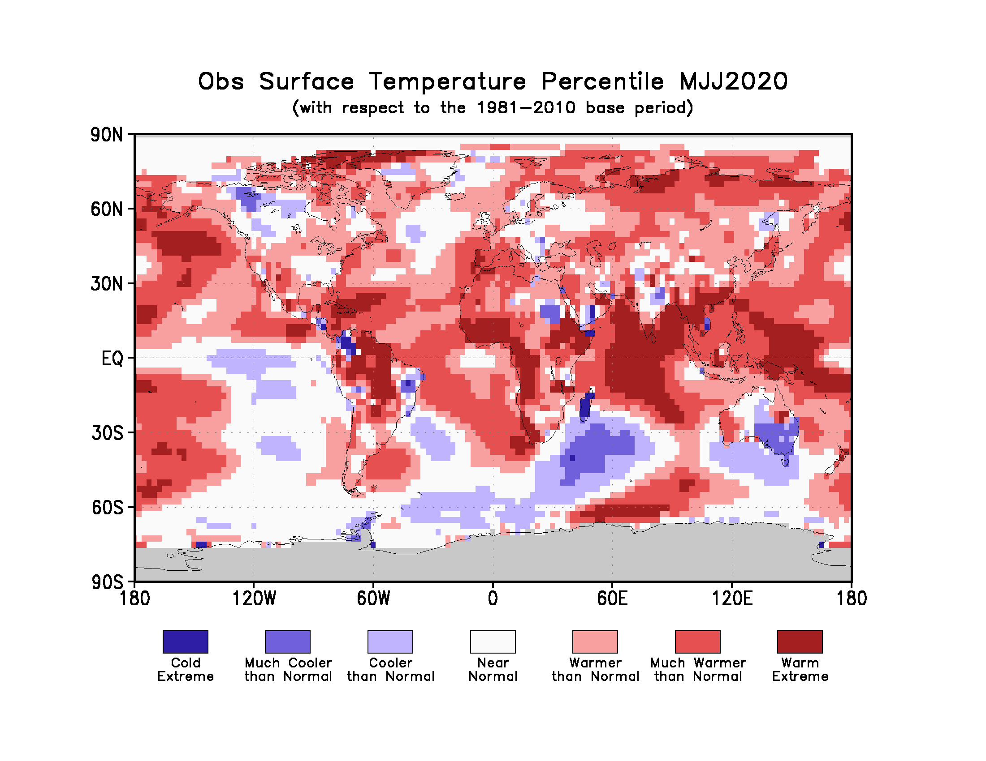
Figure 2. Observed May - July 2020 near-surface temperature anomalies relative to 1981–2010 (top). The Cooler than Normal, Near Normal, and Warmer than Normal shadings on the percentile map (bottom) indicate that seasonal mean anomalies were in the bottom, middle, and upper tercile of the 1981–2010 distribution, respectively. Regions with anomalies in the lowest and highest decile (or 10%) of the distribution are marked as Much Cooler than Normal and Much Warmer than Normal, respectively. The Cold Extreme and Warm Extreme shadings indicate that the anomalies exceeded the coldest and warmest temperature values of the 1981–2010 period for the season. Grey shading indicates areas where observational analysis was not available. (Source: U.S. Climate Prediction Center).

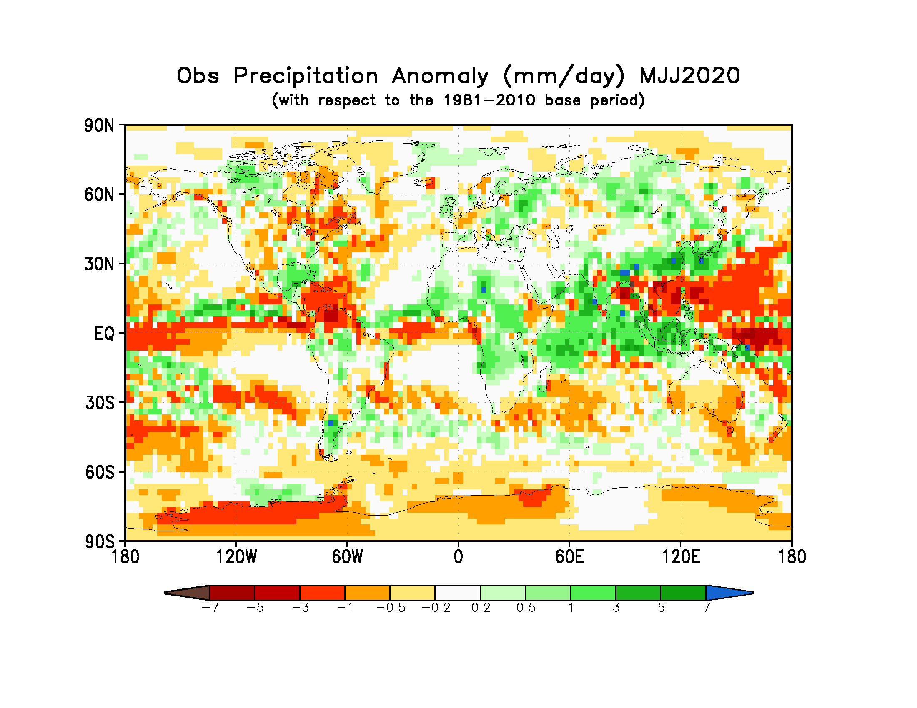
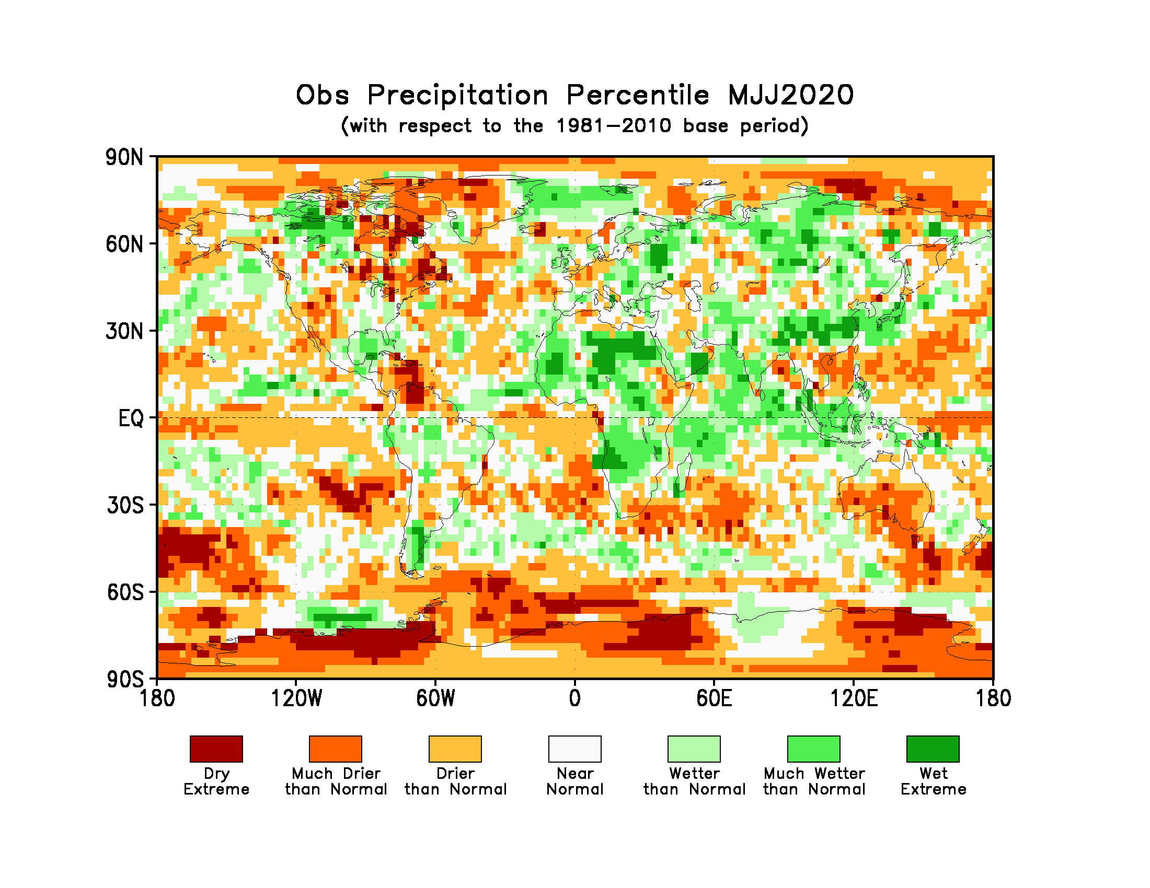
Figure 3. Observed precipitation anomalies for May – July 2020, relative to 1981–2010 base period (top). The Drier than Normal, Near Normal and Wetter than Normal shadings on the percentile map (bottom) indicate that seasonal mean anomalies were in the bottom, middle, and upper tercile of the 1981–2010 distribution, respectively. Regions with anomalies in the lowest and highest decile (or 10%) of the distribution are marked as Much Drier than Normal and Much Wetter than Normal, respectively. The Dry Extreme and Wet Extreme shadings indicate that the anomalies exceeded the driest and wettest values of the 1981–2010 period for the season.
(Source: U.S. Climate Prediction Center).

1.3 Observed precipitation
For May-July 2020, the largest negative precipitation anomalies were in the equatorial Pacific near the date line with a narrower band extending into the eastern Pacific. West of these negative anomalies, positive precipitation anomalies stretched from the Indonesian Archipelago into the equatorial Indian Ocean. These positive anomalies were flanked by negative precipitation anomalies in the sub-tropical northwest Pacific and the Bay of Bengal. Positive precipitation anomalies also occurred over most of the Arabian Sea and in the north equatorial Atlantic. Bands of negative precipitation anomalies stretched across the sub-tropical and extratropical southern oceans.
Below-normal precipitation occurred over most of the Caribbean and northwest South America. Below-normal precipitation anomalies also occurred over part of western and northeast North America, Greenland, coastal regions of Gulf of Guinea, northern Greater Horn of Africa, Australia, New Zealand, and south-central South America. Positive precipitation anomalies occurred in much of equatorial Africa, Indian subcontinent, Indonesian Archipelago, southeast North America, the southernmost regions of South America, and northeast Europe.
No large-scale systematic regions with dry or wet extremes (precipitation below or above all seasonal totals observed during 1981-2010) over land occurred, with the exception of a few isolated pockets of wet extremes that were observed over different regions in Africa and southern regions of East Asia. An extreme dry region was observed in the northwest South America.

2. Potential evolution of the state of the climate over the next three months (Spetember - November 2020)

2.1 Large-scale SST-based indices, September - November 2020
Month | Nino 1+2 | Nino 3 | Nino 4 | Nino3.4 | IOD | NTA | STA
September 2020 | -0.72±0.30 | -0.62±0.31 | -0.42±0.21 | -0.62±0.27 | -0.32±0.23 | 0.34±0.21 | 0.13±0.14
October 2020 | -0.62±0.33 | -0.67±0.32 | -0.48±0.23 | -0.76±0.33 | -0.36±0.32 | 0.28±0.19 | 0.09±0.14
November 2020 | -0.54±0.34 | -0.77±0.31 | -0.52±0.28 | -0.88±0.36 | -0.26±0.24 | 0.27±0.18 | 0.03±0.13
September-October-November 2020 | -0.62±0.32 | -0.69±0.31 | -0.47±0.24 | -0.75±0.33 | -0.31±0.26 | 0.30±0.19 | 0.08±0.14

Table 2: Multi-model forecasts for oceanic indices (℃), with standard deviation. Values are the equal-member-weighting average of those derived, using each GPC models own hindcast climate mean, from the GPCs supplying SST forecasts (GPC CPTEC, ECMWF, Exeter, Melbourne, Montreal, Moscow, Offenbach, Seoul, Tokyo, Toulouse, Washington). The standard deviation is calculated on all ensemble members. The latitude/longitude bounds of the regions are given in the supplementary information section.
Observed sea surface temperatures in the central topical Pacific were in a coolish but near-neutral ENSO condition during May- uly 2020. The sea surface temperatures in the Niño 3.4 and Niño 3 regions are predicted to decrease to a weak La Niña range, with anomaly values of approximately -0.6 to -0.9 ºC during the September-November 2020 season. Farther west in the Niño 4 region, the sea surface temperature is also predicted to decrease to a value of approximately -0.5 ºC. The IOD prediction is for below-average values, and the September-November 2020 average is predicted to be near -0.3 ºC, which is lower than the positive value observed in May-July 2020. The northern and southern equatorial Atlantic SST (NTA) are predicted to be slightly above average during the season.

2.2 Predicted temperature, September – November 2020
For information on the construction of the multi-model forecast maps refer to the supplementary information section. (Note: Maps indicating forecast consistency among GPC models are available in the supplementary information).

Figure 4. Probabilistic forecasts of surface air temperature for September - November 2020. The tercile category with the highest forecast probability is indicated by shaded areas. The most likely category for below-normal, above-normal and near-normal is depicted in blue, red and grey shadings respectively. White areas indicate equal chances for all categories in both cases. The baseline period is 1993–2009. Figure is generated by The WMO Lead Centre for Long-Range Forecast Multi-Model Ensemble.
Influences from the expected tendency towards positive sea surface temperature anomalies are seen in the temperature forecast for September-November 2020 across sizeable portions of the globe, both in the tropics (except for below-average conditions in the eastern tropical Pacific and southeast Pacific) and extra-tropics (except for a few relatively small pockets mainly in southern oceans, such as immediately southeast of Africa and south of Australia). Below-average temperature is generally unlikely over land areas, with increased chances of above-normal temperatures dominating. Above-average sea surface temperatures are predicted in the western tropical Pacific, while below-average temperature is predicted along the immediate equator in the central and eastern tropical Pacific. These SST conditions introduce east-west gradients will affect the overlying atmospheric circulation and climate, especially if below-average SST anomalies in the central and eastern Pacific are indicative of weak/ moderate La Niña rather than borderline La Niña. A global warming trend also contributes to the sea surface temperature and air temperature forecast, leading to a general prevalence of increased chances of positive anomalies defined with respect to the climatological base period (1993–2009), which is centred nearly 20 years in the past.

RA I (Africa): An enhanced probability for above-normal temperature is predicted over at least half of Africa, including most of northwest, equatorial-central, southern and eastern Africa. These regions show moderate model-to-model consistency. The region with strongest probability for above-normal temperature is in the western equatorial, eastern coastal regions, and Greater Horn of Africa with strong model-to-model consistency. Weak tilts of the odds towards above-normal temperature is also predicted over the southern Africa. No regions in Africa are predicted to have odds of probability towards below-normal temperature. It is noted that above-normal temperature would imply a continuation of the above-normal temperatures observed over most of Africa during May-July 2020.
RA II (Asia): Weakly to moderately enhanced probabilities for above-normal temperature are predicted over most of central and eastern Asia. Model-to-model consistency for most of these regions is generally moderate. The strongest tilt of odds for above-normal temperature is predicted over the northernmost regions of Asia with very strong model consistency. A small pocket of enhanced probability for above-normal temperature is also predicted over the southeast portion of central Asia. Most of the area forecast to be above-normal would experience a continuation of the above-normal conditions observed during May-July 2020.
RA III (South America): Weakly enhanced probabilities for above-normal temperature are predicted over the entire South American continent with weak to moderate model consistency. The tilt of the odds towards above-normal temperature represents a continuation of above-normal temperature during May-July 2020 in much of South America, with the exception in the eastern coastal region.
RA IV (North America, Central America and the Caribbean): Enhanced probabilities for above-normal temperature are predicted over much of North America. The strongest tilts in the odds for above-average temperatures is predicted in the Caribbean, southern Central America and part of western North America, all with very strong model-to-model consistency. Weakly enhanced probabilities for above-normal temperature are predicted over the northern Central America and eastern and northern regions of North America. While Central America, the Caribbean, and southeast North America experienced above-normal temperatures during May-July 2020, much of the northern portion of the continent were either near- or below-normal.
RA V (Southwest Pacific): Strongly enhanced probabilities for above-normal temperature are predicted in the northern tier of Australia, the Indonesian Archipelago and the southwest Pacific islands, all with strong model consistency. Representing a continuation of the observations, nearly all of these areas also experienced above-normal temperature in May-July 2020. A tilt of odds towards below-normal temperature is predicted over part of the immediate southern Australia coast, with weak to moderate model consistency. This tilt of the odds is likely associated with the below-average SST predicted just south of Australia and is a continuation of below-normal temperature observed in May-July 2020.
RA VI (Europe): A weakly enhanced probability of above-normal temperature is predicted in most of Europe and Greenland. Consistency among individual models for these areas is moderate to strong, particularly in southeast Europe. This prediction for above-normal temperature follows up on generally above-normal temperatures in the Iberian Peninsula with near-normal conditions in much of the rest of Europe and Greenland in May-July 2020.

2.3 Predicted precipitation, September - November 2020

Figure 5. Probabilistic forecasts of precipitation for the season for September – November 2020. The tercile category with the highest forecast probability is indicated by shaded areas. The most likely category for below-normal, above-normal and near-normal is depicted in orange, green and grey shadings respectively. White areas indicate equal chances for all categories in both cases.
The baseline period is 1993–2009. Figure is generated by The WMO Lead Centre for Long-Range Forecast Multi-Model Ensemble.

Somewhat below-average SSTs are expected during the September-November 2020 season in the central and the eastern equatorial Pacific (associated with a weak La Niña), with anomalously positive SST conditions in the western Pacific and eastern Indian Ocean. Some of the predicted large-scale seasonal precipitation anomalies are consistent with this spatial pattern and with the east-west SST gradient associated with it, as for example, an enhanced likelihood of above-average precipitation in the Indonesian archipelago in association with the above-average SST in the same vicinity. In the equatorial Pacific, a tilt of the odds towards near-normal rainfall is predicted east of the dateline, with an enhanced likelihood for below-normal precipitation in the western and central Pacific extending southeast towards the South American coast. Outside of these regions, tilts of the odds towards below normal oceanic precipitation are seen in the equatorial western Indian Ocean. Extratropical oceans in both hemispheres have alternating bands of enhanced probabilities for below- and above-normal precipitation anomalies that originate in tropical latitudes and extend into extratropics.
RA I (Africa): Enhanced probabilities for below-normal precipitation are predicted over most of Africa with moderate model-to-model consistency. The prediction mostly represents a reversal from the above-normal precipitation observed in May-July 2020. An exception to the below-normal precipitation forecast is above-normal precipitation predicted for a small portion of interior eastern equatorial Africa, with a moderate model consistency. Region for enhanced probability for below-normal precipitation extends to the island regions on the southeast side of the continent.
RA II (Asia): Enhanced probabilities for below-normal precipitation are predicted in southwest Asia (with moderately strong model consistency). Enhanced probabilities for above-normal precipitation are predicted over the Indian subcontinent, far northern Asia, and the island nations off the coast of southeast Asia, all with moderate to strong model consistency. Only weak probabilities for below-normal or above-normal precipitation are predicted in some regions of central Asia with moderate model-to-model consistency. Most of the large remaining areas of the continent shows no discernible forecast signal.
RA III (South America): A weakly enhanced probability for below-normal precipitation is predicted over part of southern South America, with moderate model consistency. Over a small part of northern South America, a weak tilt of the odds towards above-normal rainfall is predicted, with weak to moderate model consistency. The forecast in the northern area represents a continuation of above-normal observed there in May-July 2020, while the forecast in the southern location marks a reversal of the above-normal conditions observed in May-July 2020.
RA IV (North America, Central America and the Caribbean): An enhanced probability for below-normal precipitation is predicted for the south-central regions of North America, with moderate model consistency. This forecast mainly marks a continuation of a general tendency for below-average rainfall observed during May-July 2020. Weakly enhanced probabilities of above-normal precipitation are forecast in central and southern Central America, with moderate model consistency. Weakly enhanced probabilities for above-normal precipitation are predicted in some of the northern regions of North America.
RA V (Southwest Pacific): Enhanced probabilities for above-normal precipitation are predicted for substantial portions of the Indonesia archipelago and much of the eastern part of Australia extending into islands of Melanesia, all regions showing moderate or strong model consistency. This forecast represents a continuation of the above-normal precipitation over the Indonesian Archipelago but a reversal of below-normal precipitation over the eastern parts of Australia observed in May-July 2020. A tilt of the odds towards below-normal precipitation is forecast for the islands in Micronesia and in Polynesia, marking a continuation of observed below-normal precipitation in May-July 2020.
RA VI (Europe): A weakly enhanced probability of below-normal precipitation is predicted over the Iberian Peninsula in Europe. Model consistency for this dry-leaning region is moderate to strong. A weakly enhanced probability for above-normal precipitation is predicted over northern Scandinavia, and part of Greenland. For other regions of Europe there is no discernible forecast signal.

3. Latest updates for monitoring and prediction information
Each month, the latest updates for the real-time monitoring and seasonal mean predictions included in GSCU can be found at:
Monitoring:
https://ftp.cpc.ncep.noaa.gov/mingyue/GSCUWMO/
Predictions:
https://www.wmolc.org/modules/data/plot/autograds4/download_PMME.php?filename=wmo/WMOLC_T2M.gif
https://www.wmolc.org/modules/data/plot/autograds4/download_PMME.php?filename=wmo/WMOLC_PREC.gif

4. How to use the Global Seasonal Climate Update
The GSCU is intended as guidance for RCCs, Regional Climate Outlook Forums (RCOFs) and National Meteorological and Hydrological Services (NMHSs). It does not constitute an official forecast for any region or nation. Seasonal outlooks for any region or nation should be obtained from the relevant RCCs (see below for contact details) or NMHS.
Seasonal forecasts are probabilistic in nature. Although the text and figures used in the GSCU highlight the tercile categories that is predicted with the highest probability, it is important to recognize that the other tercile categories may also have substantial (though lower) probability.
The geographical areas occupied by the forecast signals should not be considered precise. Similarly, signals with small spatial extent may be unreliable.
The skill of seasonal forecasts is substantially lower than that of weather timescales and skill may vary considerably with region and season. It is important to view the forecast maps together with the skill maps provided in the supplementary appendices.
For reference, the six WMO Regional Associations domains are depicted in the figure below.
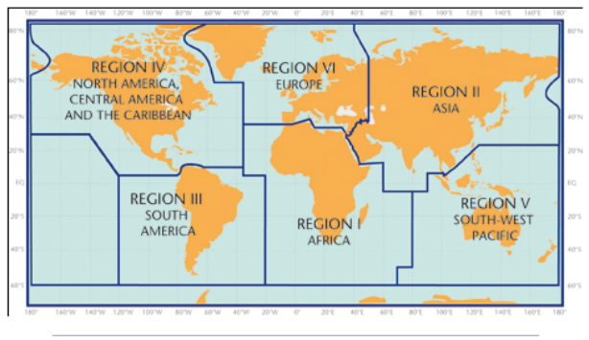

5. Designated and developing WMO Regional Climate Centres and Regional Climate Centre Networks
- RA I: http://www.wmo.int/pages/prog/wcp/wcasp/RCC-Africa.html
- RA II: http://www.wmo.int/pages/prog/wcp/wcasp/RCC-Asia.html
- RA III: http://www.wmo.int/pages/prog/wcp/wcasp/RCC-SouthAmerica.html
- RA IV: http://www.wmo.int/pages/prog/wcp/wcasp/RCC-NorthAmerica.html
- RA V: http://www.wmo.int/pages/prog/wcp/wcasp/RCC-SouthwestPacific.html
- RA VI: http://www.wmo.int/pages/prog/wcp/wcasp/RCC-Europe.html

6. Resources
Sources for the graphics used in the GSCU:
- The WMO Lead Centre for Long-Range Forecast Multi-Model Ensemble (LC-LRFMME): http://www.wmolc.org
- WMO portal to the Global Producing Centres for Long-range Forecasts (GPCs-LRF): http://www.wmo.int/pages/prog/wcp/wcasp/clips/producers_forecasts.html
- WMO GSCU portal
http://www.wmo.int/pages/prog/wcp/wcasp/LC-LRFMME/index.php
- WMO portal for Regional Climate Outlook Forums (RCOFs):
https://public.wmo.int/en/our-mandate/climate/regional-climate-outlook-products
- International Research Institute for Climate and Society (IRI):
http://portal.iri.columbia.edu/portal/server.pt
- NOAA Climate Prediction Centre (CPC):
http://www.cpc.ncep.noaa.gov

7. Acknowledgements
This Global Seasonal Climate Update was jointly developed by the WMO Commission for Climatology and Commission for Basic Systems with contributions from:
- WMO Lead Centre for Long-Range Forecast Multi-Model Ensemble (LC-LRFMME), Korea Meteorological Administration, NOAA National Centers for Environmental Prediction
- WMO Global Producing Centres for Long-Range Forecast (GPCs-LRF): GPC-Beijing (China Meteorological Administration), GPC-CPTEC (Center for Weather and Climate Studies, Brazil), GPC-ECMWF (European Center for Medium-Range Forecast), GPC-Exeter (UK Met Office),GPC- Melbourne (Bureau of Meteorology), GPC-Montreal (Meteorological Services of Canada), GPC-Moscow (Hydro meteorological Center of Russia), GPC-Offenbach Deutscher Wetterdienst), GPC-Pretoria (South African Weather Services), GPC-Seoul (Korea Meteorological Administration), GPC-Tokyo (Japan Meteorological Agency), GPC-Toulouse (Météo-France), GPC-Washington (National Centers for Environmental Prediction)
- International Research Institute for Climate and Society (IRI)

File with supplementary information can be downloaded from https://ftp.cpc.ncep.noaa.gov/mingyue/GSCUWMO/Forecasts/GSCU_SON2020_supplementary_info_LC-LRFMME.docx

