WEATHER CLIMATE WATER

GLOBAL SEASONAL
CLIMATE UPDATE
Pre-Operational Phase
TARGET SEASON: May-June-July 2020

Issued: 25 April 2020

Summary
Observed sea surface temperatures anomalies in the east-central topical Pacific were in a neutral El Niño condition during January-February-March 2020 with somewhat above-normal conditions near the date line. Further, the strong positive phase of the Indian Ocean Dipole (IOD) with large below-normal sea surface temperature anomalies in the eastern Indian Ocean south of Indonesian Archipelago that was present at the end of 2019 returned to a neutral phase. The sea surface temperatures in the Niño 3.4 and Niño 3 regions, both of which are often used to characterize ENSO conditions, are predicted to decrease further during the May-June-July 2020 season, and hence, are expected to remain in a near-average range.
Influences from the expected tendency towards positive sea surface temperature anomalies across sizeable portions of the globe, both in the tropics (except for near-average conditions in the central and eastern Pacific) and extra-tropics, are seen in the temperature forecast for May-June 2020, which leans quite strongly, on average, towards above-normal land temperature, particularly at tropical and northern extratropical latitudes. The near-average sea surface conditions predicted in much of the eastern equatorial Pacific may noticeably affect the overlying tropical atmospheric circulation and climate, as they participate in the SST gradients with positive SST anomalies in the western Pacific. A global warming trend also contributes to the sea surface temperature and air temperature forecast, leading to a general prevalence towards a positive tilt in anomalies defined using the climatological base period (1993–2009) centred more than 10 years in the past.
Near-average precipitation conditions are expected in the central and eastern equatorial Pacific, and an enhanced probability for above normal precipitation is expected just north of the equator in the central tropical Pacific and in the eastern Indian Ocean extending into western Indian Ocean. Some tilts of the odds for precipitation are likely associated with the underlying sea surface temperature anomalies, such as the above-average precipitation in the Indian Ocean with the positive sea surface temperature anomalies. A southwest to northeast band of below-normal odds for precipitation also stretches from the western tropical to northern extratropical Pacific. An enhanced probability for below-normal precipitation is predicted for southern South America, Caribbean, equatorial South America and Indian sub-continent. An enhanced probability of above-normal precipitation is predicted over Australia and western portion of Indonesian Archipelago.

Surface Air Temperature, MJJ 2020  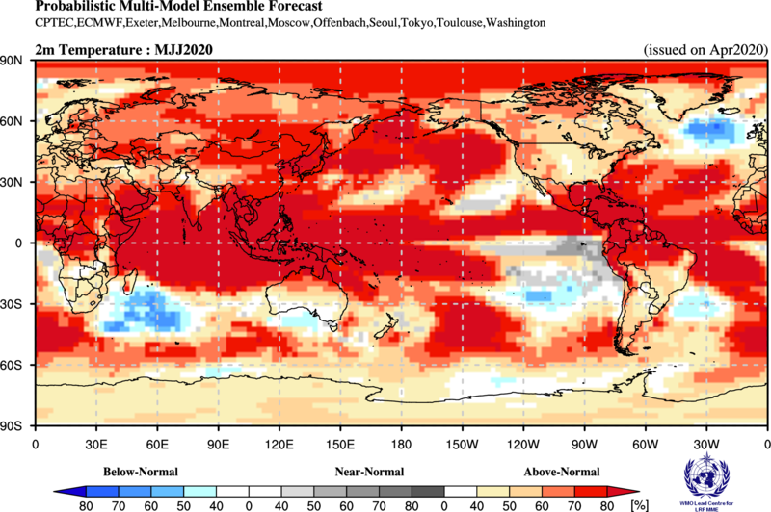 | Precipitation, MJJ 2020  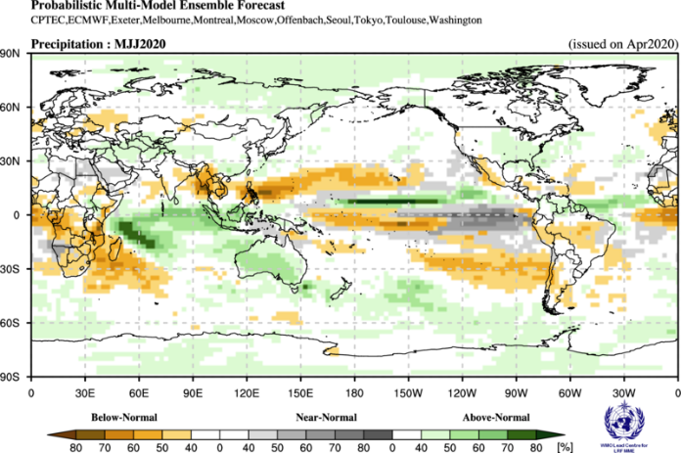

Figure 1. Probabilistic forecasts of surface air temperature and precipitation for the season May-June-July 2020. The tercile category with the highest forecast probability is indicated by shaded areas. The most likely category for below-normal, above-normal and near-normal is depicted in blue, red and grey shadings respectively for temperature, and orange, green and grey shadings respectively for precipitation. White areas indicate equal chances for all categories in both cases. The baseline period is 1993–2009.

