(PRE-OPERATIONAL PHASE)
Issued: 21 May 2019 Target Season: June-July-August2019
Supplementary Information

Table of Contents
APPENDIX - Prediction 5
2.1 Surface Temperature 6
2.1.1 Individual GPC ensemble mean forecasts of 2m temperature anomalies relative to 1993-2009 6
2.1.3 Forecast consistency map (13 GPCs): 2m Temperature 9
2.1.4 DMME (13GPCs), using the same baseline for all models (1993-2009): 2m temperature 9
2.1.5 DMME (13GPCs), for each model using its own baseline: 2m temperature 10
2.1.6 PMME (13 GPCs), using the same baseline for all models (1993-2009): 2m temperature 10
2.1.7 Verification of GPC ensemble mean 2m temperature anomaly forecasts, 1993-2009 11
2.1.8 Verification of GPC 2m temperature probabilistic forecasts, 1993-2009 13
2.1.9 Verification of GPC 2m temperature probabilistic forecasts, 1993-2009 21
2.1.10 Verification of GPC 2m temperature probabilistic forecasts, 1993-2009 24
2.2 Precipitation 27
2.2.1 Individual GPC ensemble mean forecasts of precipitation anomalies relative to 1993-2009 27
2.2.4 DMME (13 GPCs), using the same baseline for all models (1993-2009): precipitation 30
2.2.5 DMME (13 GPCs), for each model using its own baseline: precipitation 31
2.2.6 PMME (13 GPCs), using the same baseline for all models (1993-2009): precipitation 32
2.2.7 Verification of GPC ensemble mean precipitation anomaly forecasts, 1993-2009 32
2.2.8 Verification of GPC precipitation probabilistic forecasts, 1993-2009 35
2.2.9 Verification of GPC precipitation probabilistic forecasts, 1993-2009 41
2.2.10 Verification of GPC precipitation probabilistic forecasts, 1993-2009 44
2.3 Sea Surface Temperature (SST) 47
2.3.1 Individual GPC ensemble mean forecasts of SST anomalies relative to 1993-2009 47
2.3.3 Forecast consistency map (12 GPCs): SST 50
2.3.5 DMME (12 GPCs), for each model using its own baseline: SST 51
2.3.6 Verification of GPC ensemble mean SST anomaly forecasts, 1993-2009 51
2.4 500 hPa Geopotential Height 54
2.4.1 Individual GPC ensemble mean forecasts of 500hPa height anomalies relative to 1993-2009 54
2.4.3 Forecast consistency map (13 GPCs): 500hPa height 57
2.4.4 DMME (13 GPCs), using the same baseline for all models (1993-2009): 500hPa height 58
2.4.5 DMME (13 GPCs), for each model using its own baseline: 500hPa height 58
2.4.6 PMME (13 GPCs), using the same baseline for all models (1993-2009): 500hPa height 60
2.4.7 Verification of GPC ensemble mean 500hPa height anomaly forecasts, 1993-2009 61
2.4.8 Verification of GPC 500hPa height probabilistic forecasts, 1993-2009 64
2.4.9 Verification of GPC 500hPa height probabilistic forecasts, 1993-2009 71
2.4.10 Verification of GPC 500hPa height probabilistic forecasts, 1993-2009 74
2.5 Mean Sea Level Pressure 77
2.5.1 Individual GPC ensemble mean forecasts of MSLP anomalies relative to 1993-2009 77
2.5.3 Forecast consistency map (13 GPCs): MSLP 81
2.5.4 DMME (13 GPCs), using the same baseline for all models (1993-2009): MSLP 82
2.5.5 DMME (13 GPCs), for each model using its own baseline: MSLP 82
2.5.6 PMME (13 GPCs), using the same baseline for all models (1993-2009): MSLP 83
2.5.7 Verification of GPC ensemble mean MSLP anomaly forecasts, 1993-2009 84
2.5.8 Verification of GPC MSLP probabilistic forecasts, 1993-2009 87
2.5.9 Verification of GPC MSLP probabilistic forecasts, 1993-2009 94
2.5.10 Verification of GPC MSLP probabilistic forecasts, 1993-2009 97
2.6 Ensemble mean predictions of global mean seasonal temperature anomaly for 1993-2009 100
2.7 Predictions of monthly SST indices: each model with its own baseline 101
2.8 Further information on GPC hindcasts and forecasts 105

APPENDIX - Prediction
This appendix contains supporting material for the probabilistic forecast maps and SST indices described in the main part of this Update. The same sequence of global maps is shown for each of the five variables in the following order:
i. Surface air temperature;
ii. Precipitation;
iii. Sea Surface Temperature (except for 6, 8, 9 and 10 below);
iv. 500 hPa Geopotential Height; and
v. Mean sea-level pressure
For each of these variables the following sequence of maps/charts is shown:
1. Ensemble mean anomalies for individual GPCs relative to the common baseline of 1993-2009;
2. Ensemble mean anomalies for those GPCs for which forecast anomalies relative to 1993-2009 are not available;
3. Forecast consistency map showing the number of GPCs (out of 13) with positive/negative ensemble mean anomalies (relative to their own baseline period);
4. Deterministic Multi-Model Ensemble (DMME) forecast constructed using 13 GPCs and the common baseline (1993-2009). The same 13 GPCs used for the Probabilistic Multi-Model Ensemble (PMME) forecasts (those supplying hindcast data for 1993-2009) are used for consistency;
5. DMME forecast constructed using 13 GPCs and each model’s own baseline;
6. PMME forecast constructed using 13 GPCs (see 4 above) and the 1993-2009 common baseline;
7. Anomaly Correlation Coefficient (ACC) verification for the 13 GPC DMME (top left) and each GPC (as available) over the period 1993-2009; or over the GPCs own hindcast period if hindcasts are provided and do not encompass the 1993-2009 period.
8. ROC map verification for the 13 GPC PMME (top left) and each GPC (as available) over the period 1993-2009; or over the GPCs own hindcast period if hindcasts are provided and do not encompass the 1993-2009 period.
9. ROC Curve and Score verification for the 13 GPC PMME (top left) and each GPC (as available) over the period 1993-2009; or over the GPCs own hindcast period if hindcasts are provided and do not encompass the 1993-2009 period.
10. Reliability Diagram verification for the 13 GPC PMME (top left) and each GPC (as available) over the period 1993-2009; or over the GPCs own hindcast period if hindcasts are provided and do not encompass the 1993-2009 period.
In addition, predictions of the following derived parameters are also provided:
vi. Global seasonal mean temperature
vii. SST indices
- Nino1.2
- Nino3
- Nino4
- Nino3.4
- Indian Ocean Dipole (IOD)
- North Tropical Atlantic (NTA)
- South Tropical Atlantic (STA)
Finally, some information is also included on the forecast and hindcast data provided by the GPCs.

2.1 Surface Temperature

2.1.1 Individual GPC ensemble mean forecasts of 2m temperature anomalies relative to 1993-2009
Beijing CPTEC
Baseline:1993-2009 Baseline:1993-2009
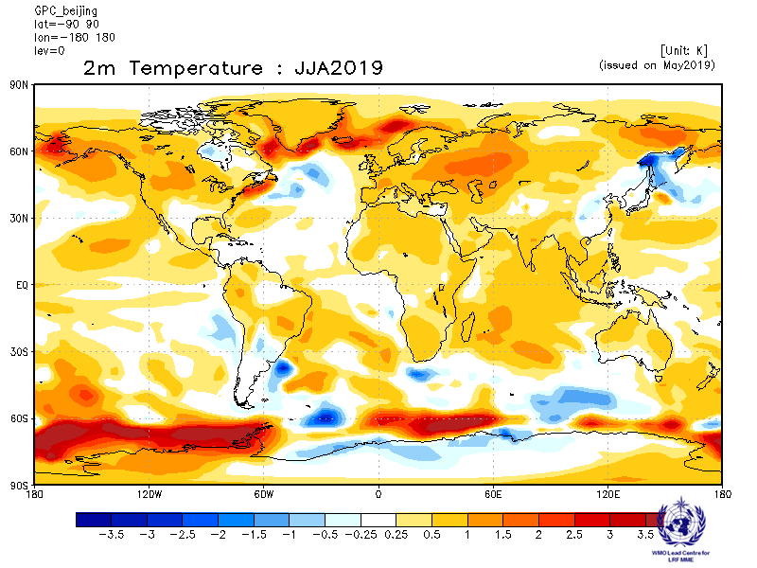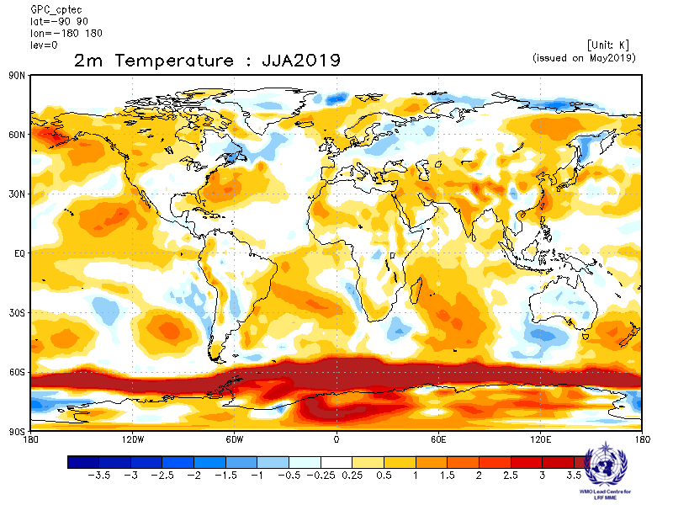
ECMWF Exeter
Baseline:1993-2009 Baseline:1993-2009
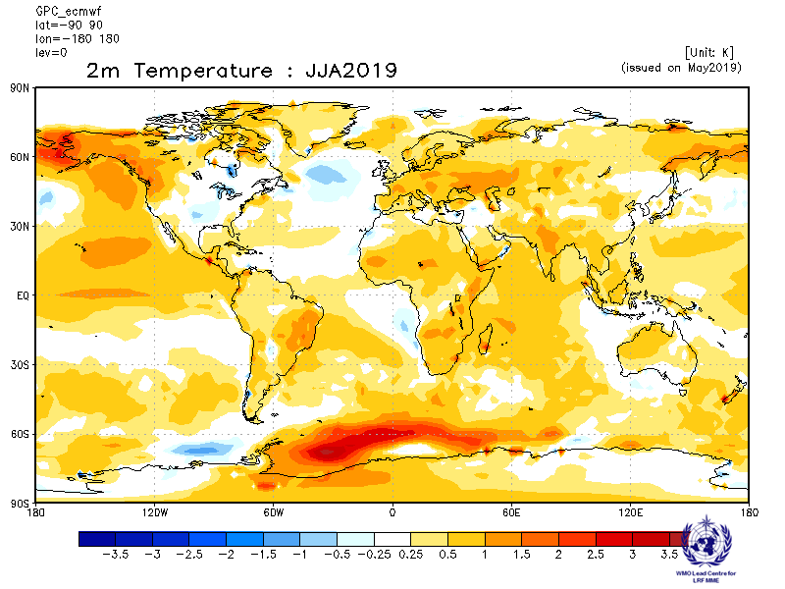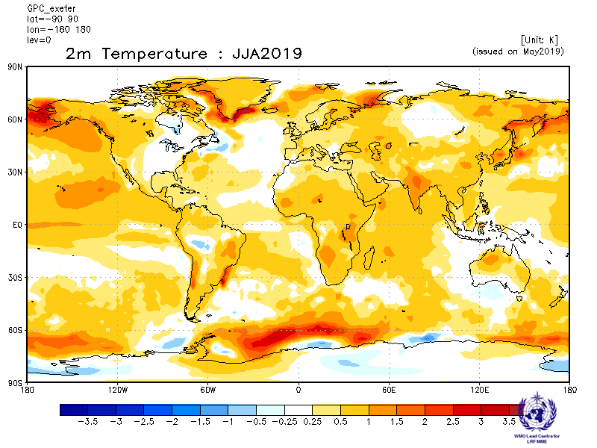
Melbourne Montreal
Baseline:1993-2009 Baseline:1993-2009
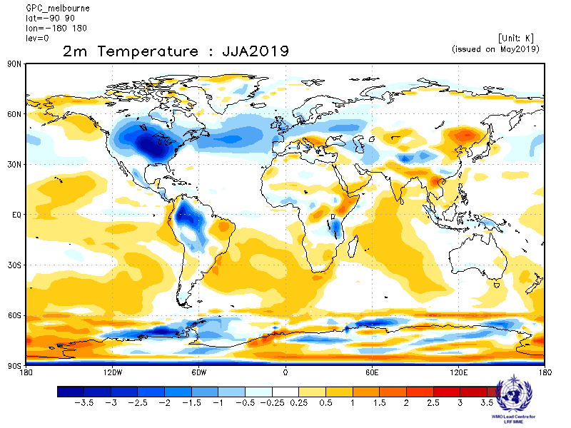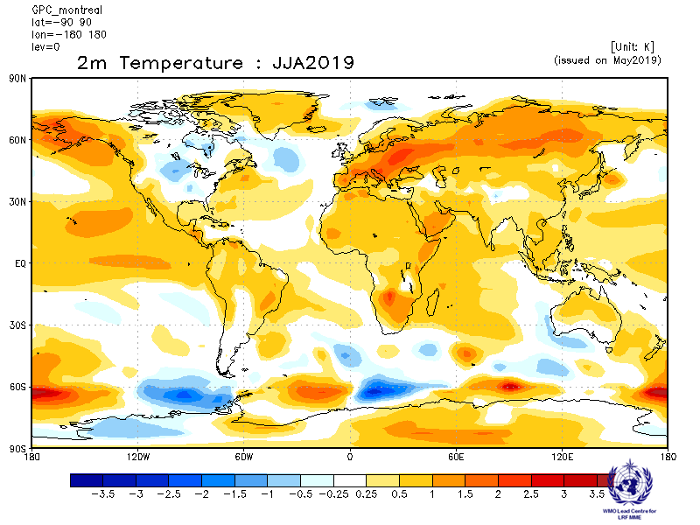
Moscow Offenbach
Baseline:1993-2009 Baseline:1993-2009
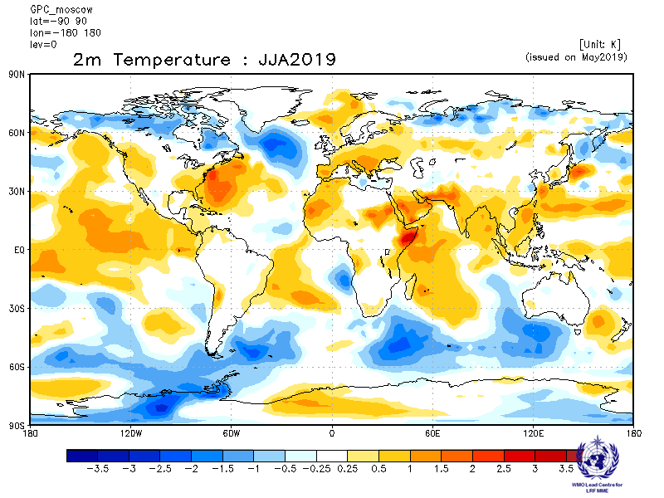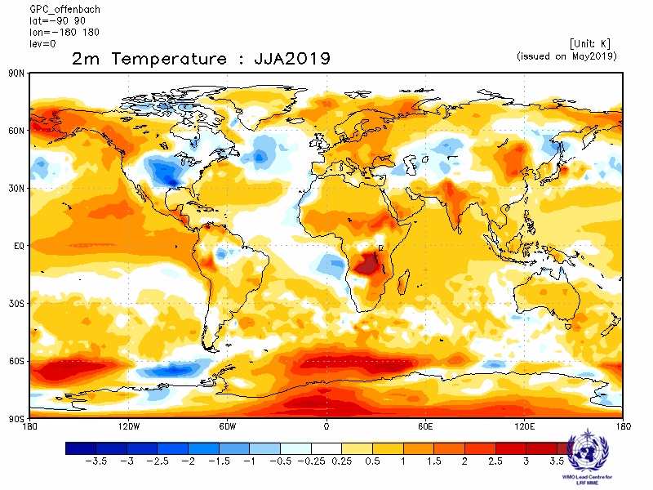
Pretoria Seoul
Baseline:1993-2009 Baseline:1993-2009
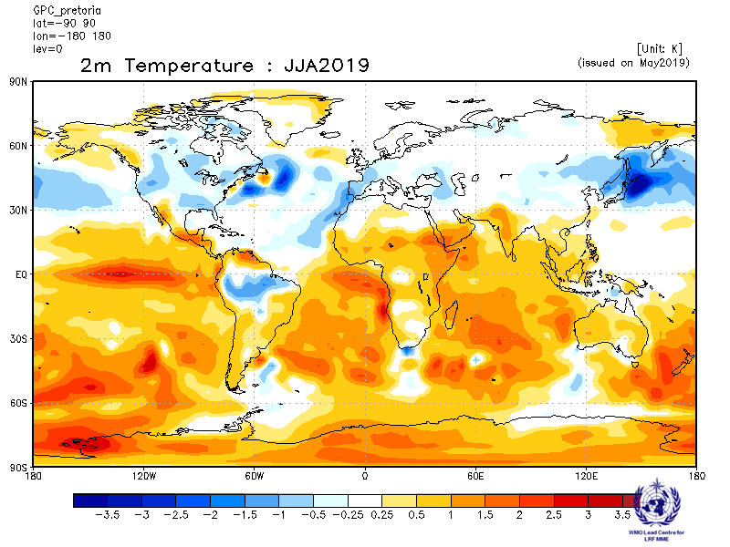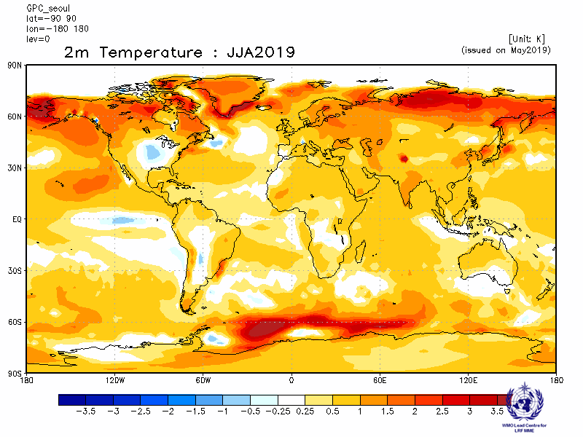
Tokyo Toulouse
Baseline:1993-2009 Baseline:1993-2009
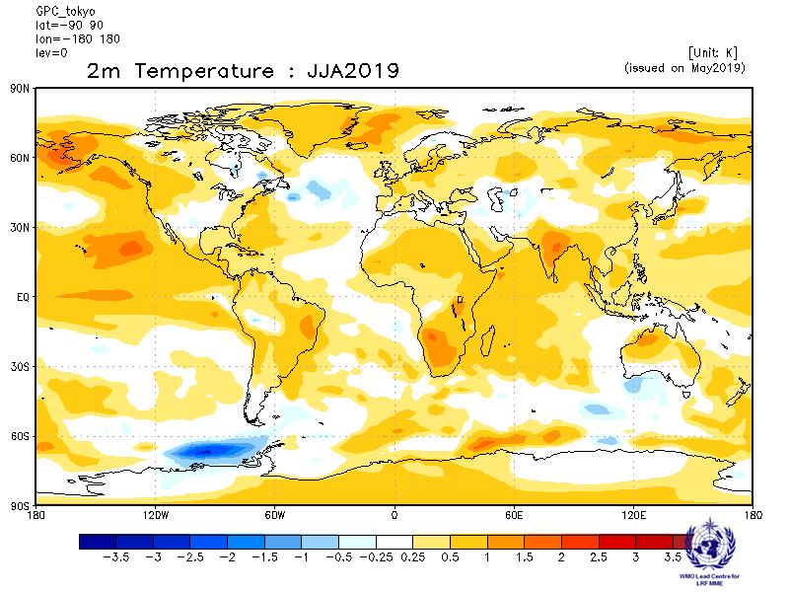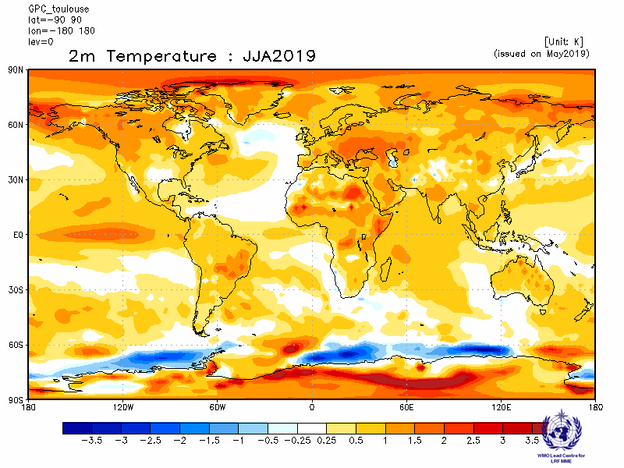
Washington
Baseline:1993-2009
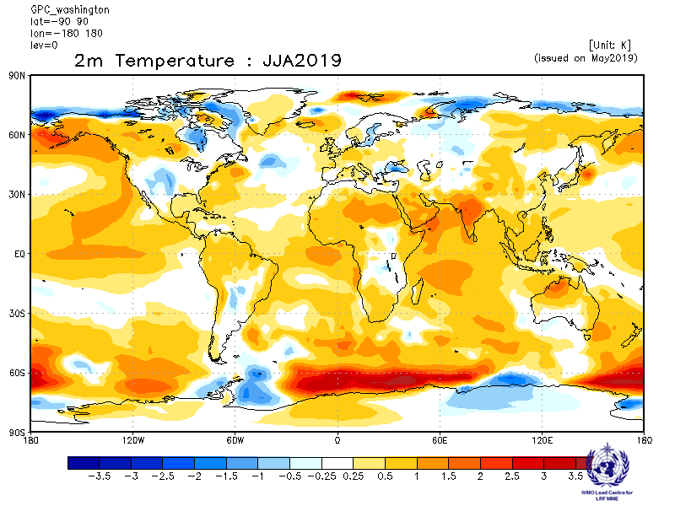

2.1.3 Forecast consistency map (13 GPCs): 2m Temperature
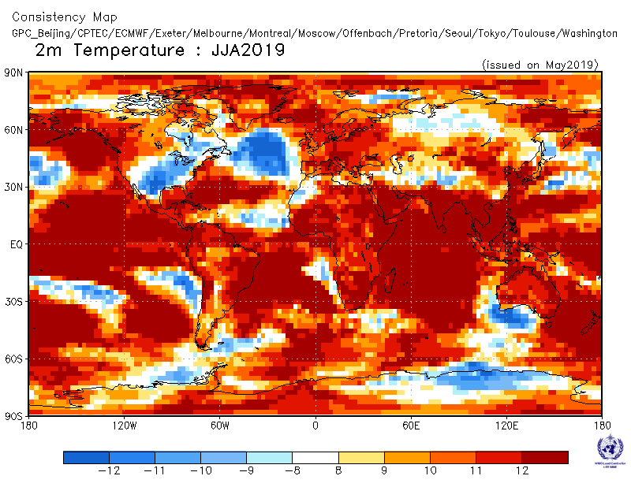

Number of GPCs with positive/negative ensemble mean anomalies – relative to own baseline

2.1.4 DMME (13GPCs), using the same baseline for all models (1993-2009): 2m temperature
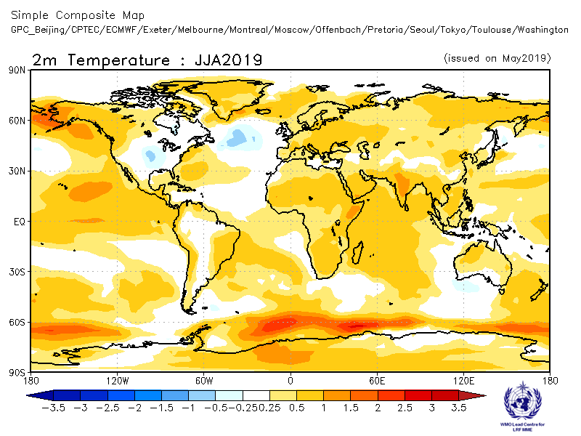
Ensemble mean anomaly

2.1.5 DMME (13GPCs), for each model using its own baseline: 2m temperature
Ensemble mean anomaly
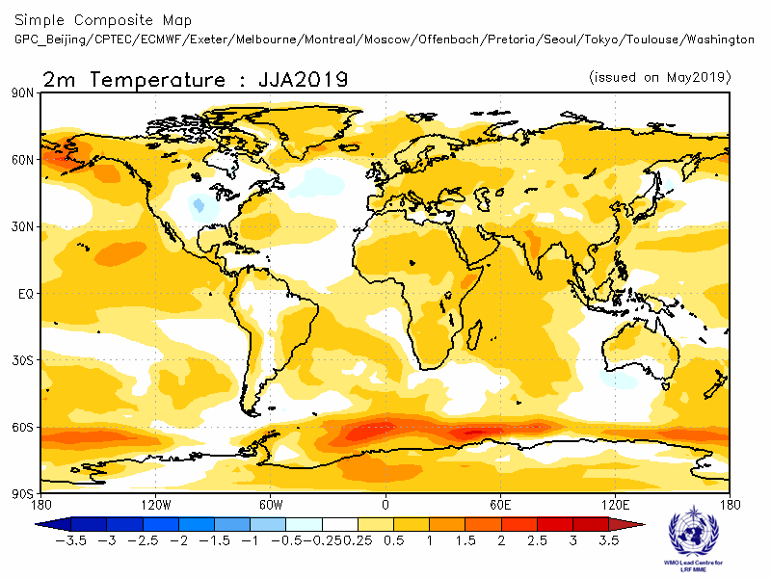
2.1.6 PMME (13 GPCs), using the same baseline for all models (1993-2009): 2m temperature
Probability of most likely tercile category
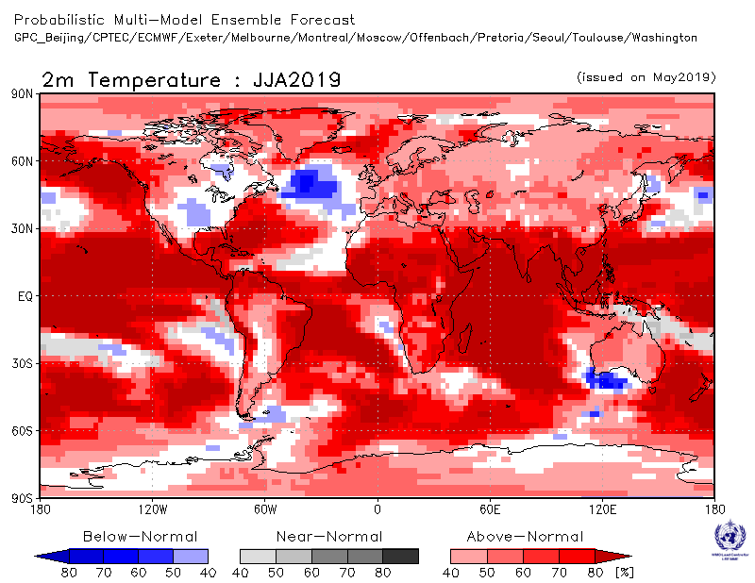

2.1.7 Verification of GPC ensemble mean 2m temperature anomaly forecasts, 1993-2009
Verification measure: Anomaly Correlation Coefficient (ACC)
Verification dataset: ERA-interim
DMME Beijing
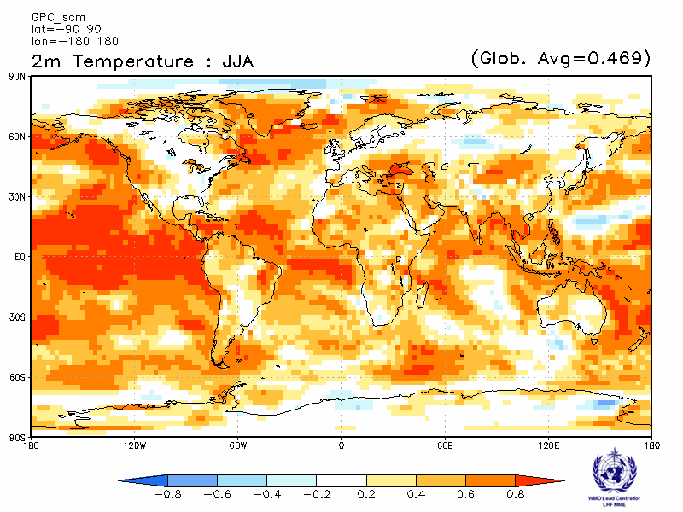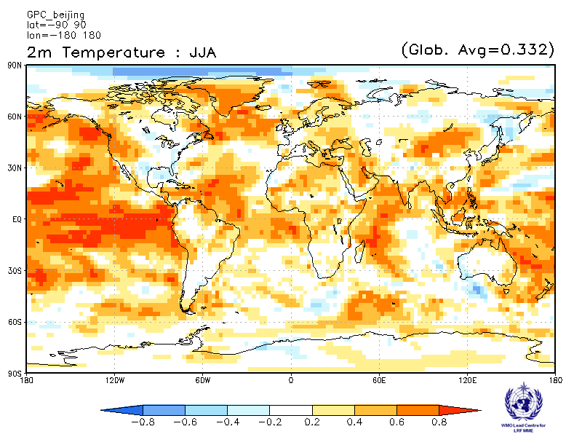

CPTEC ECMWF
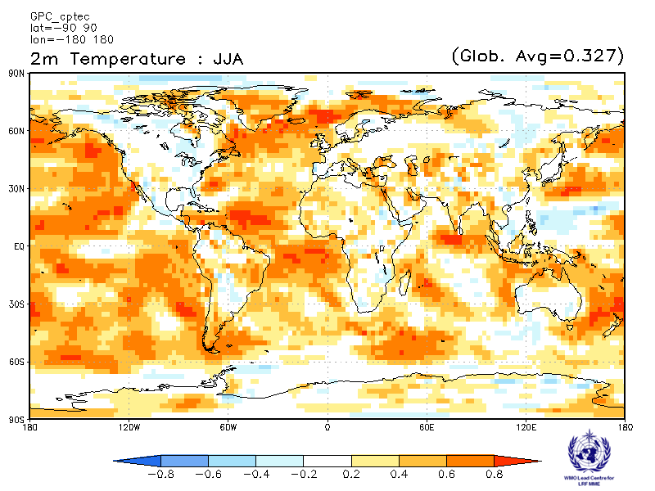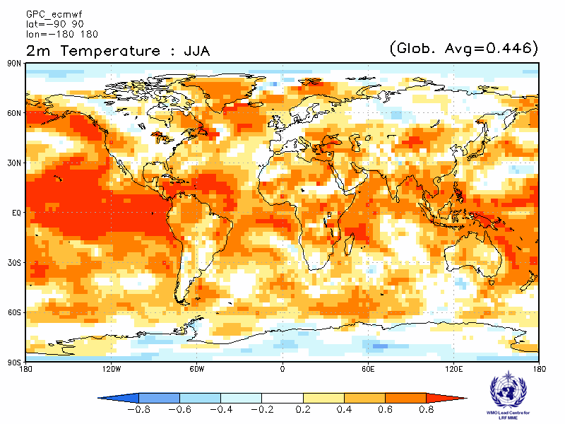

Exeter Melbourne
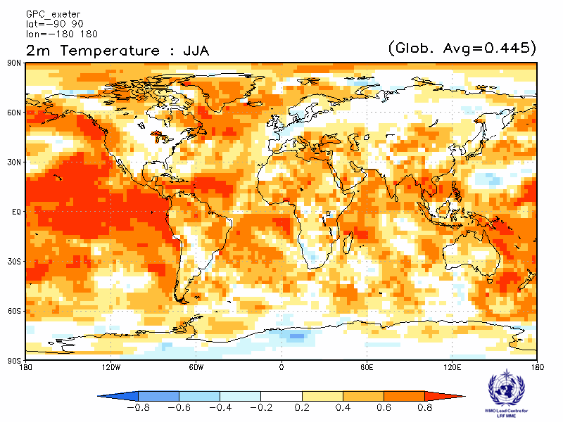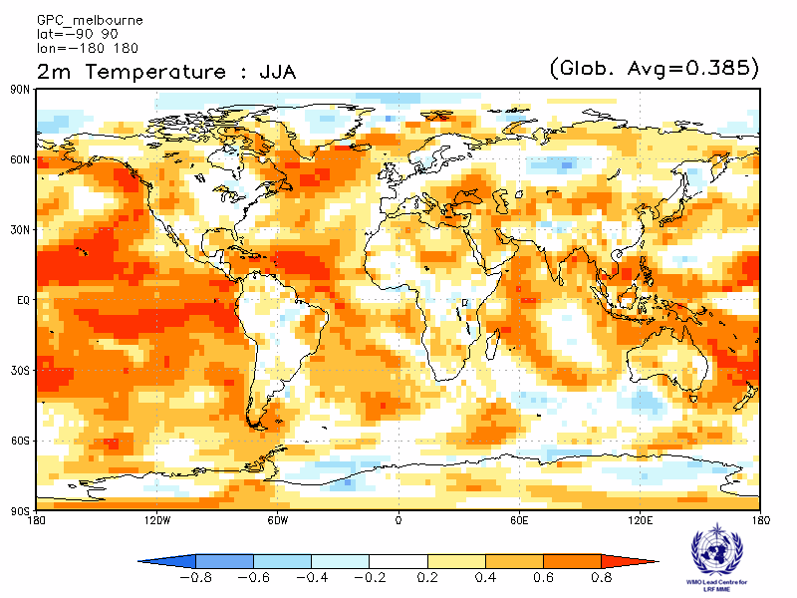

Montreal Moscow
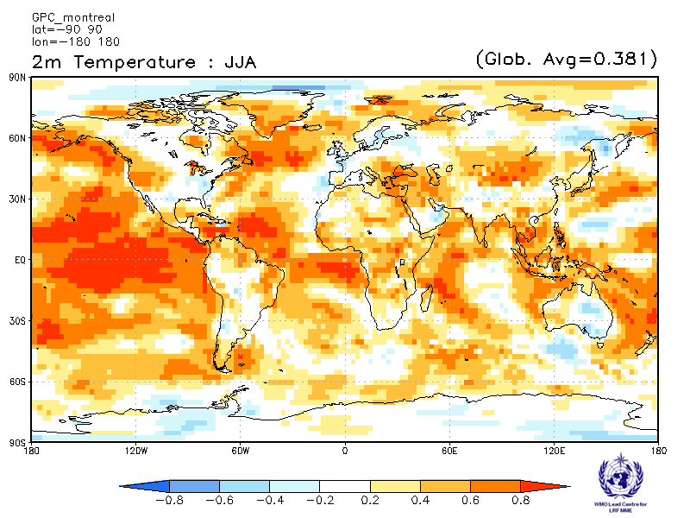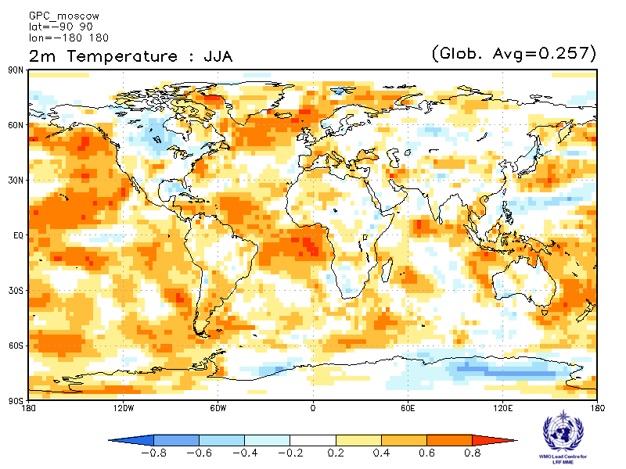

Offenbach Pretoria
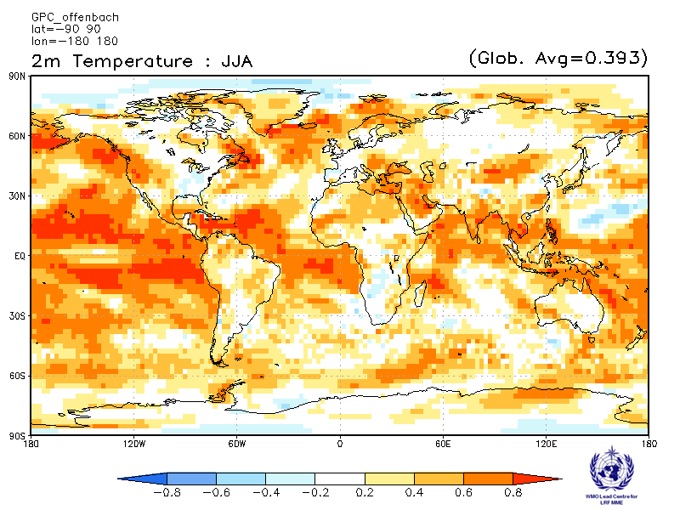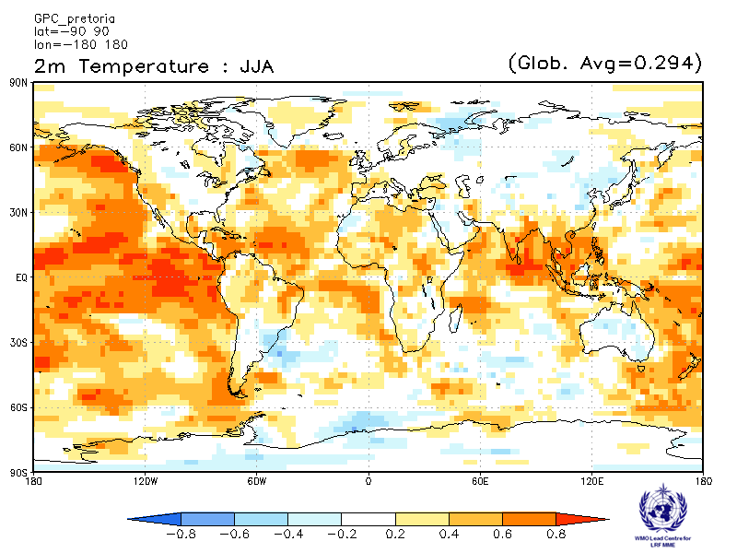

Seoul Tokyo
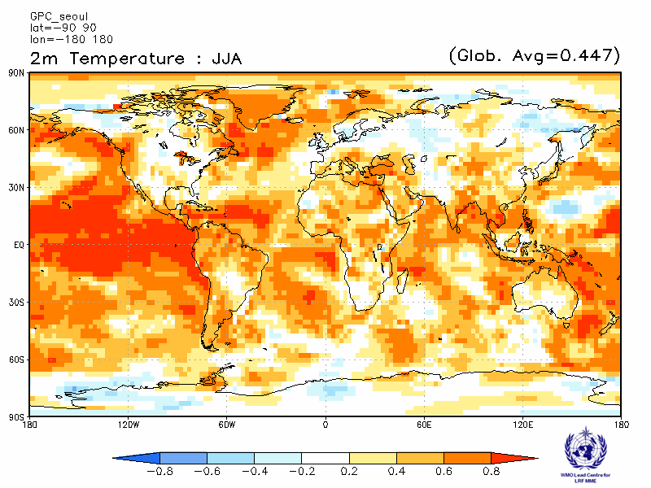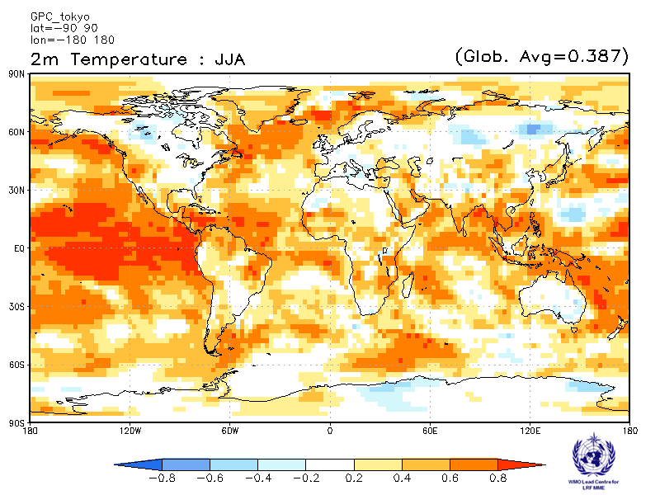

Toulouse Washington
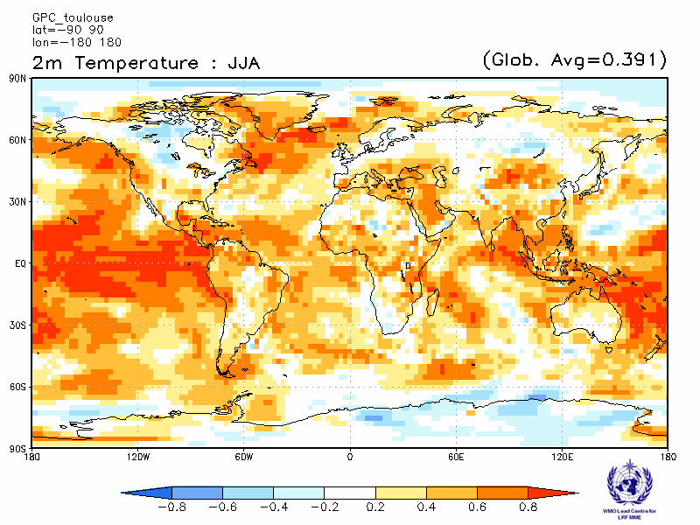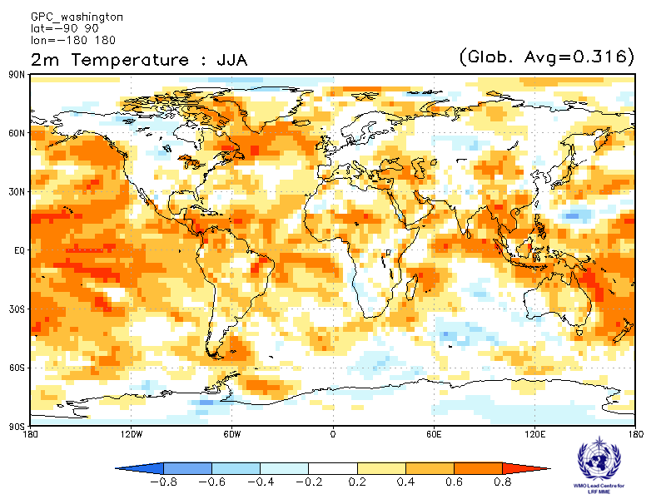

2.1.8 Verification of GPC 2m temperature probabilistic forecasts, 1993-2009
Verification measure: Relative Operating Characteristics (ROC) score for tercile forecast
Verification dataset: ERA-interim

PMME Beijing
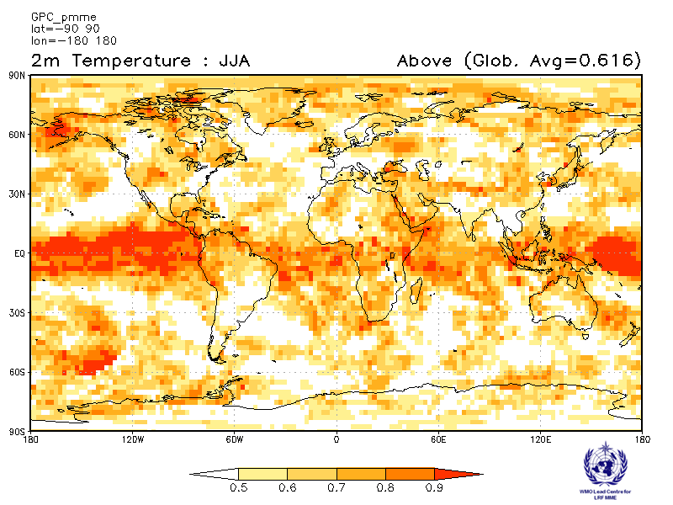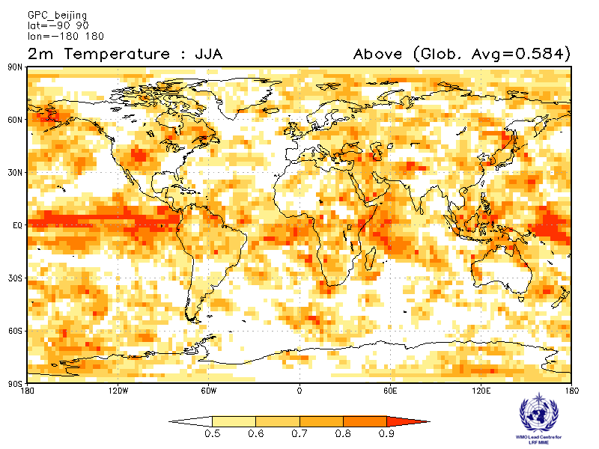
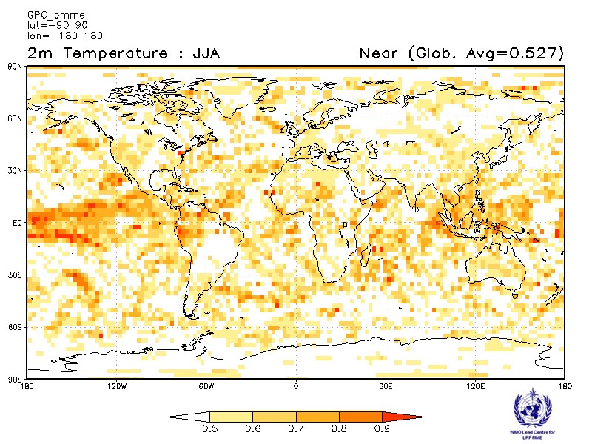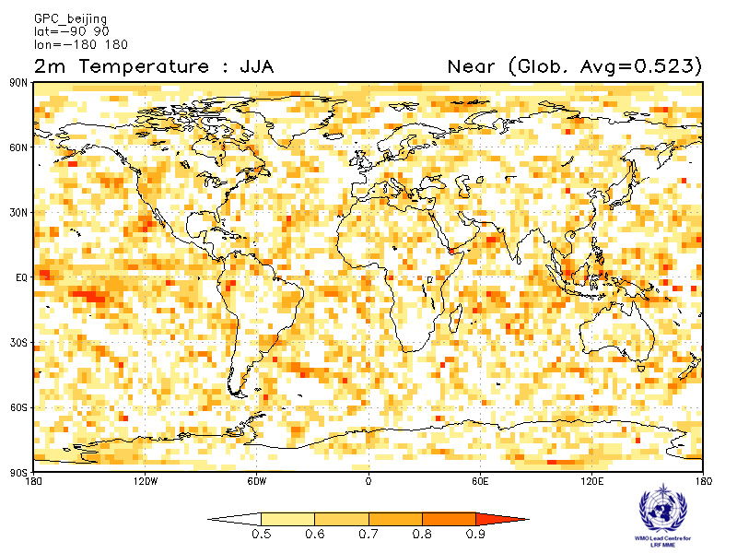
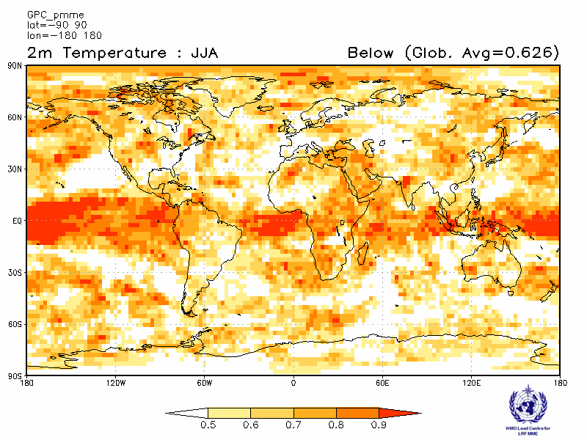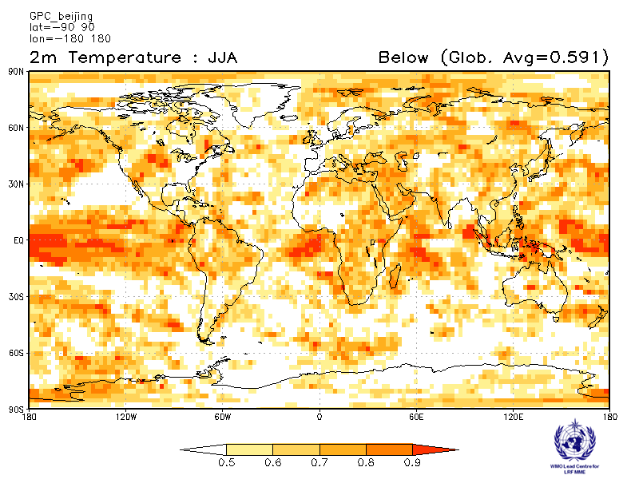

CPTEC ECMWF
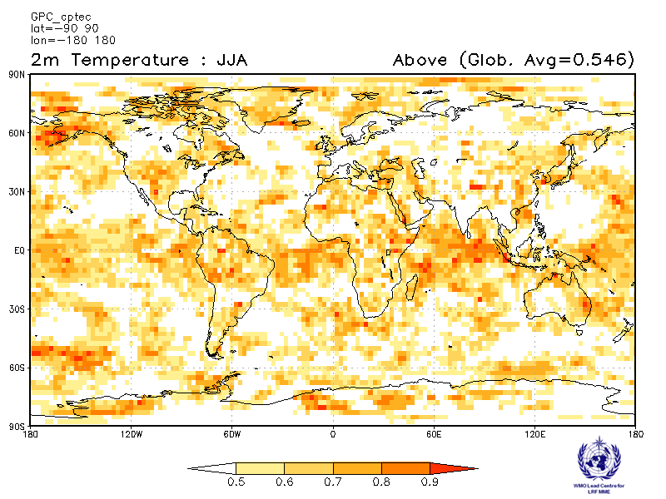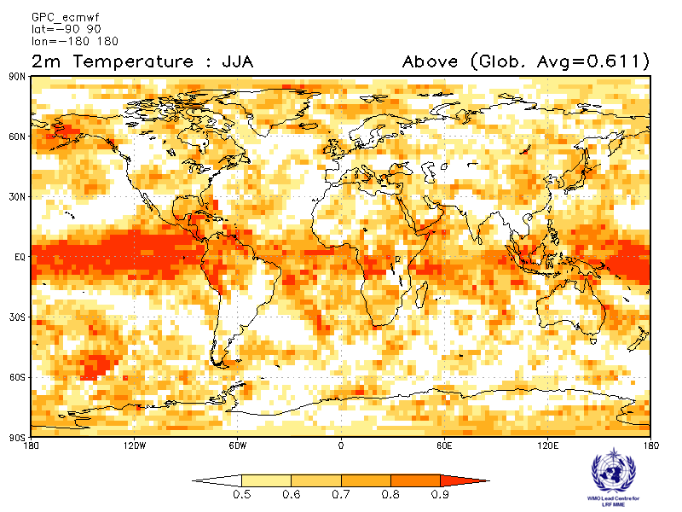
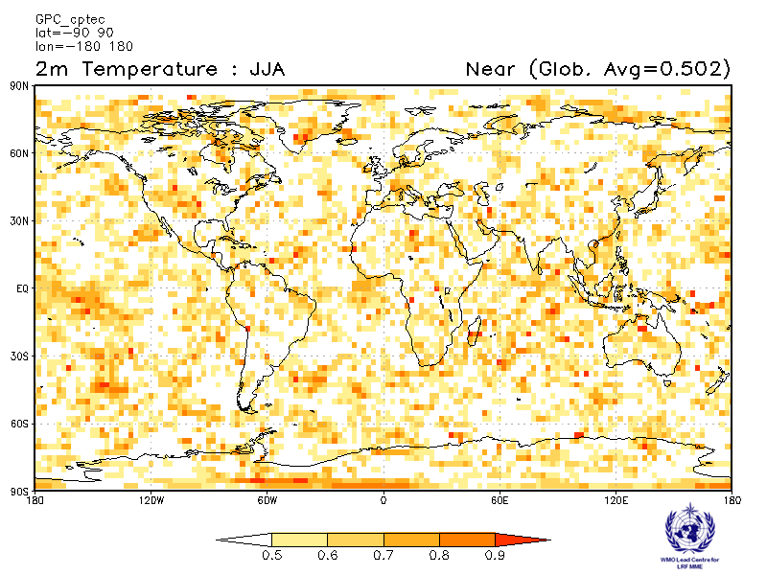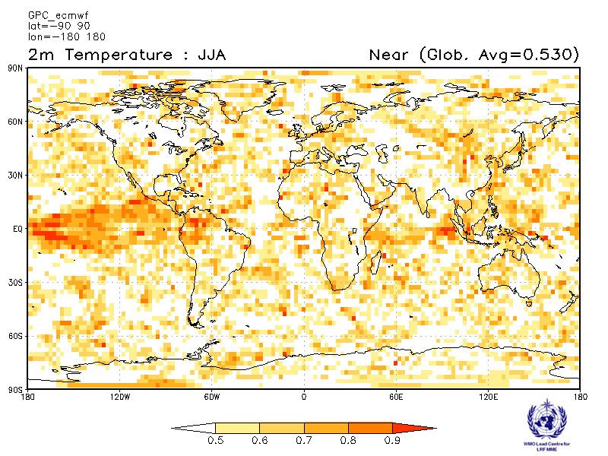
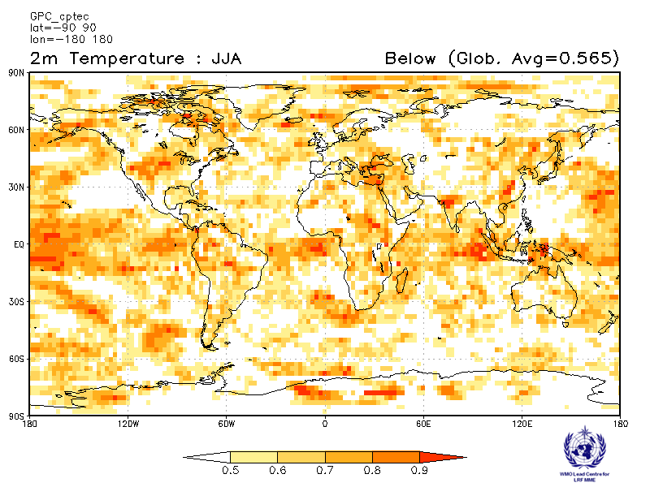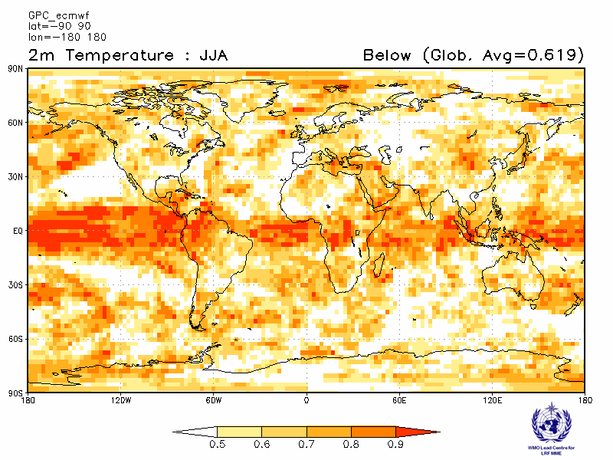

Exeter Melbourne
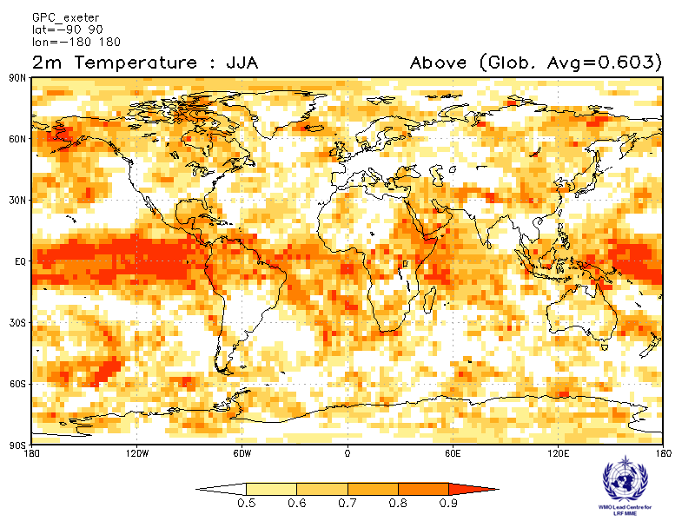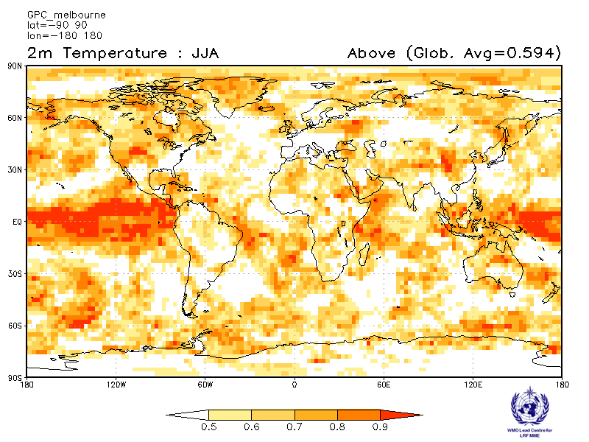
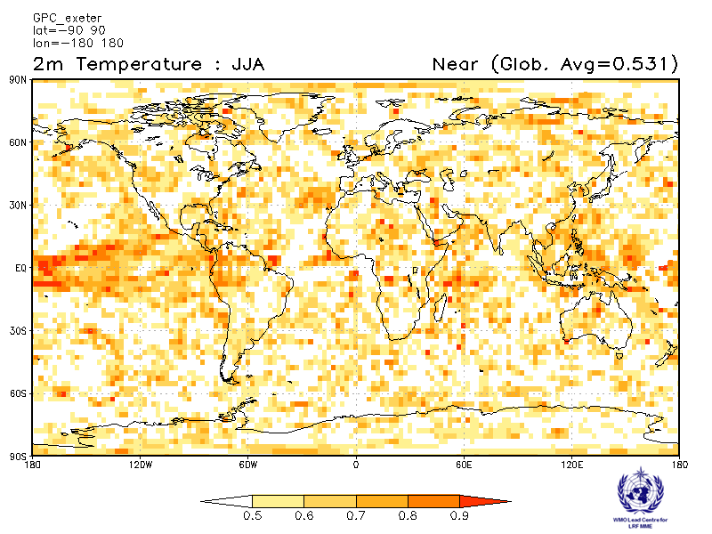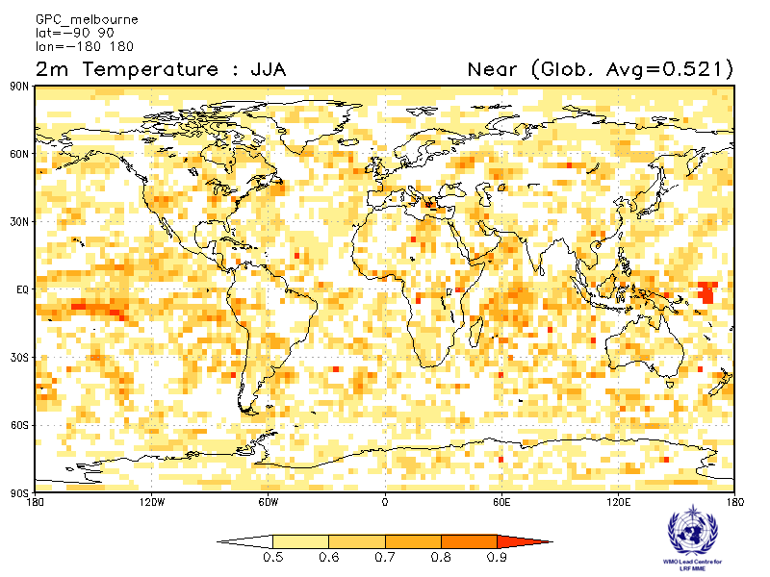
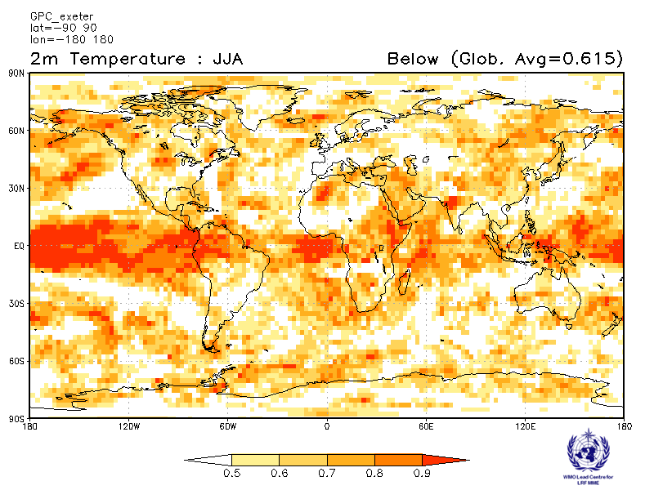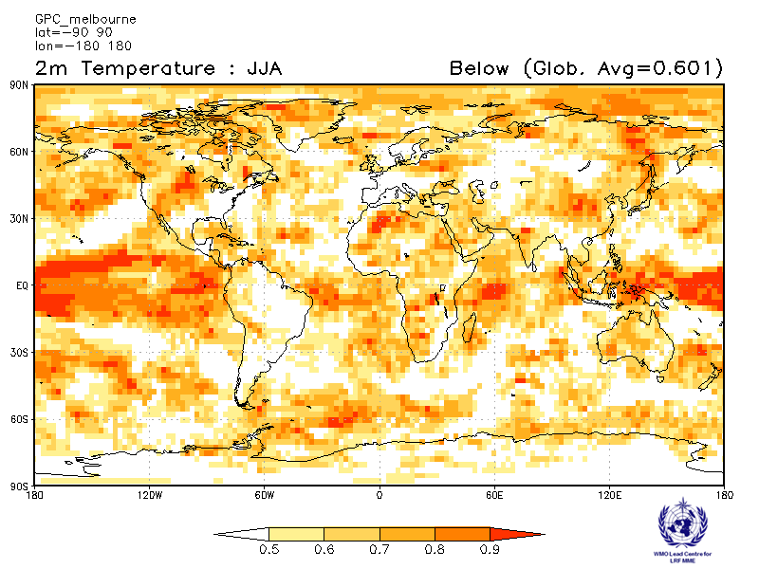

Montreal Moscow
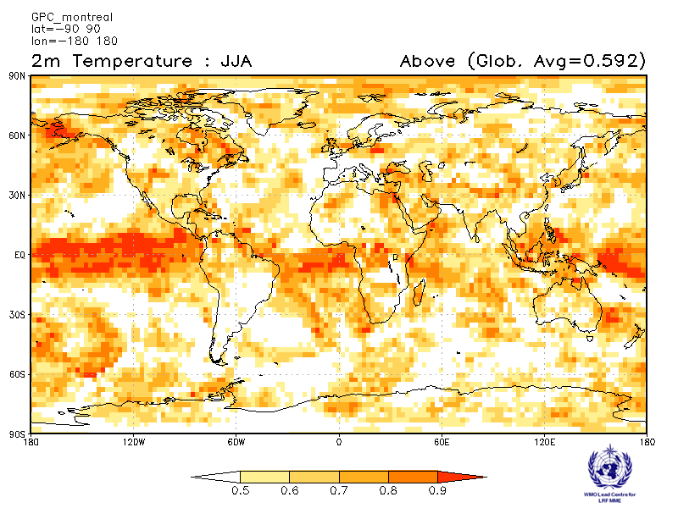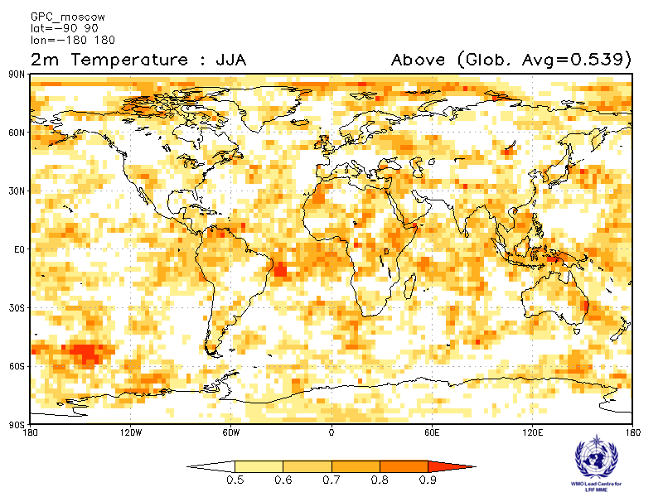
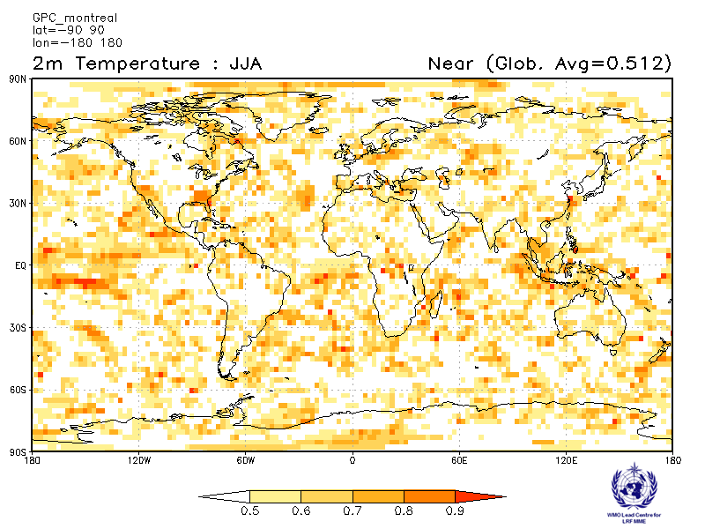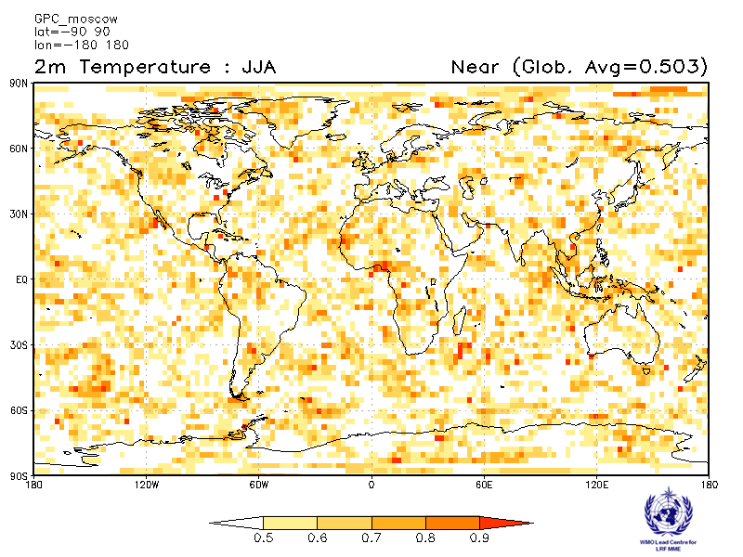
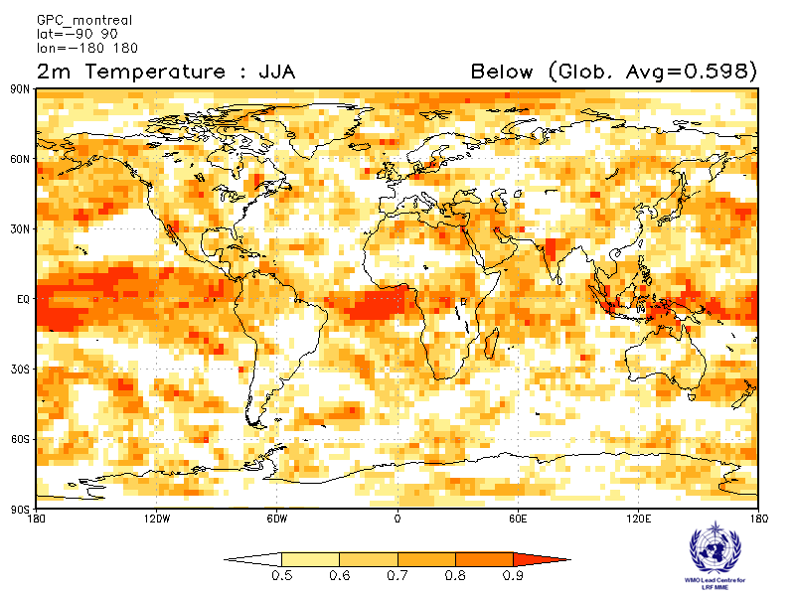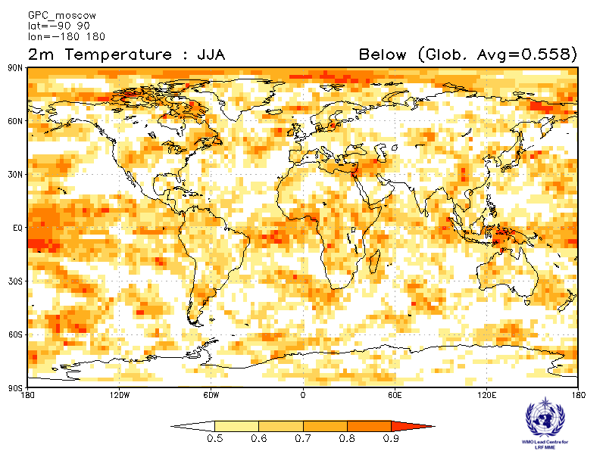

Offenbach Pretoria
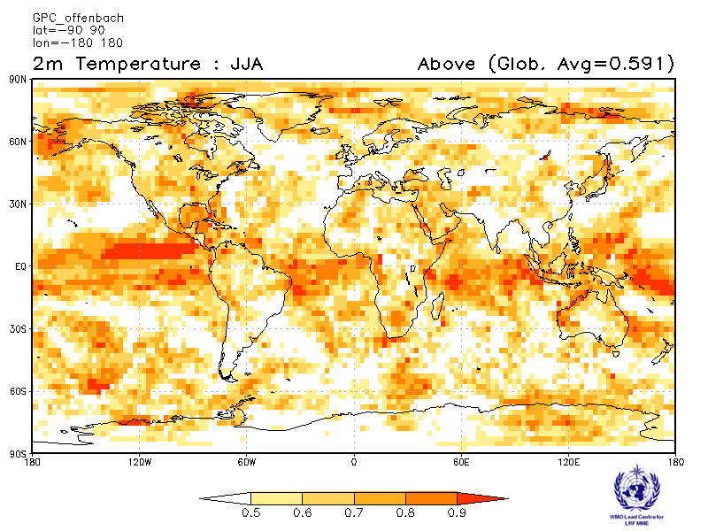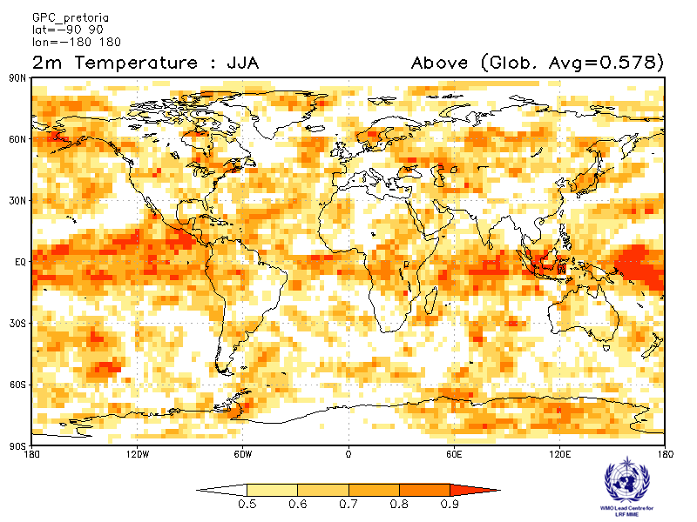
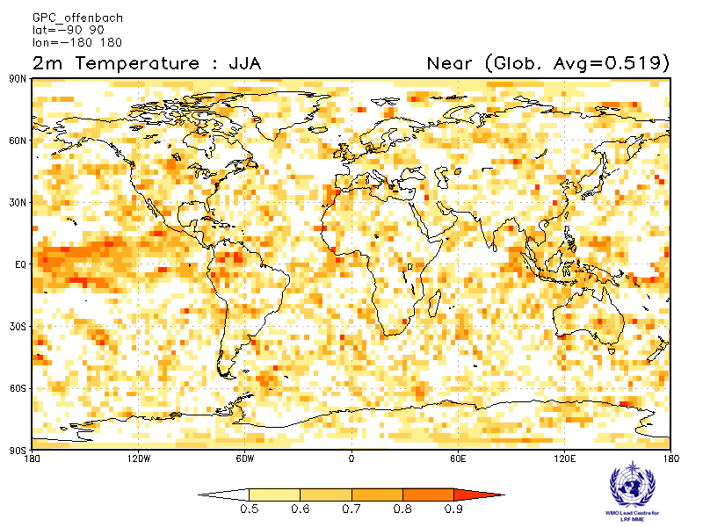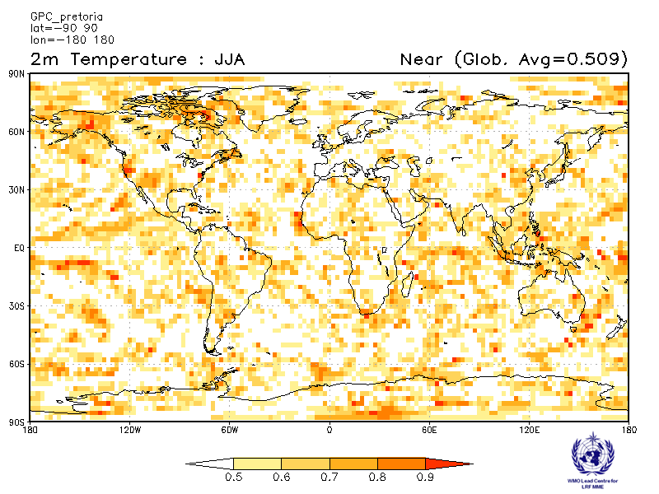
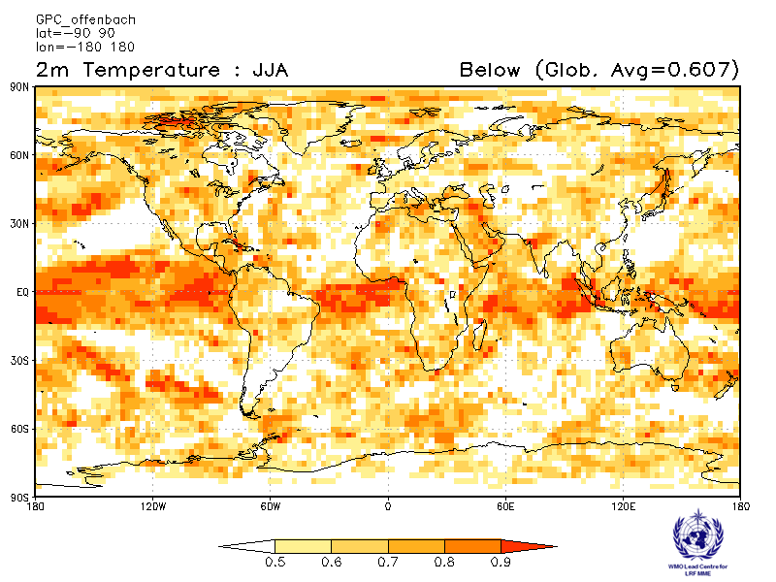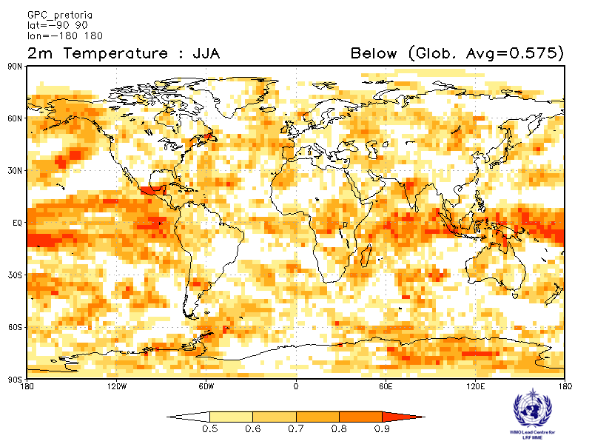

Seoul Tokyo
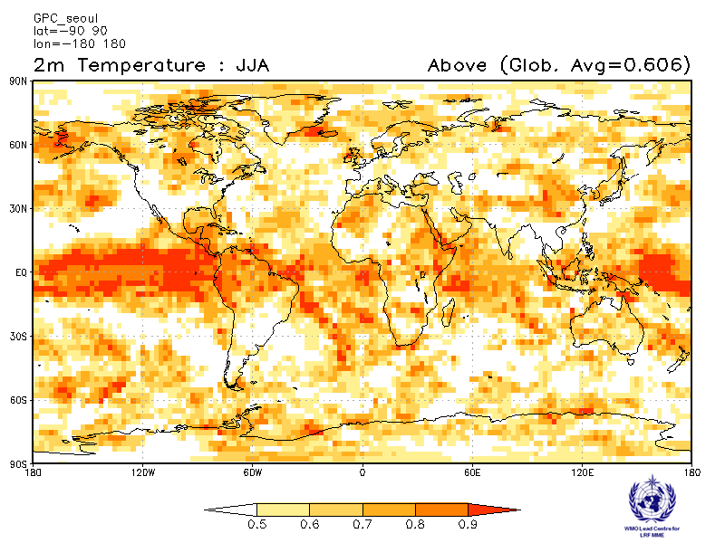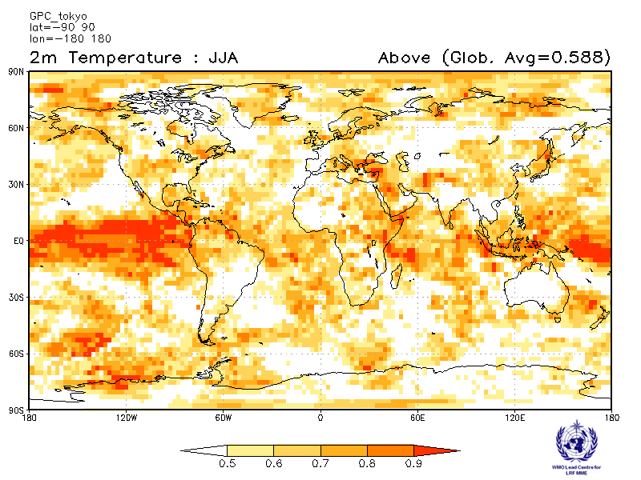
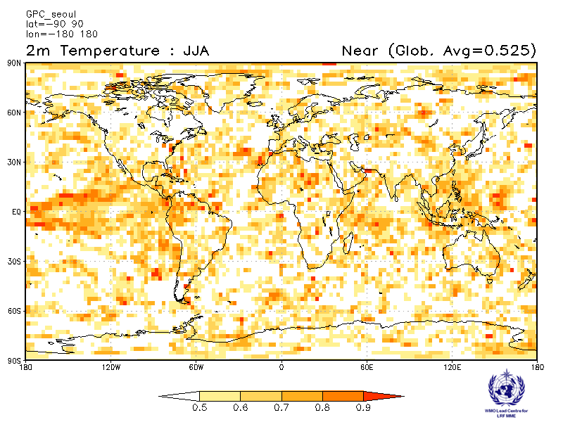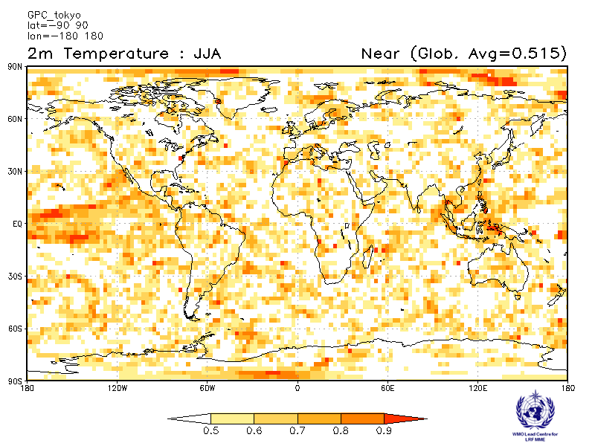
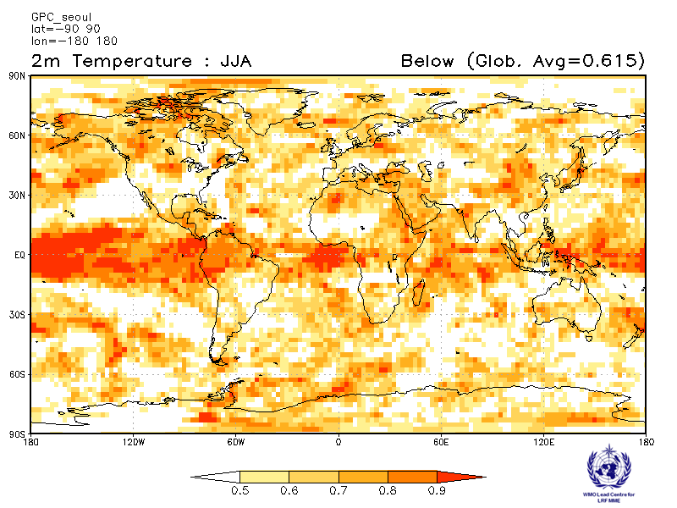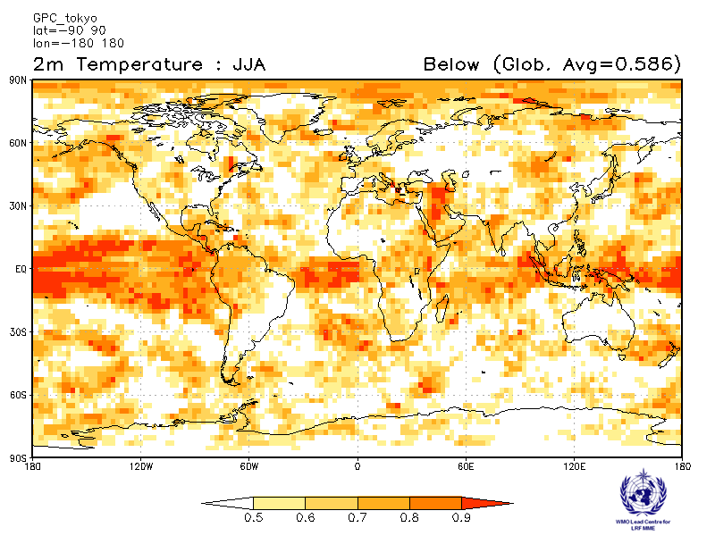

Toulouse Washington
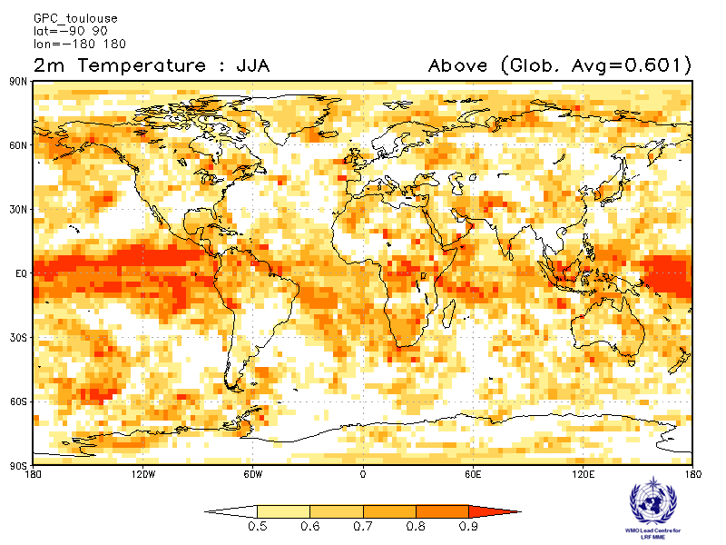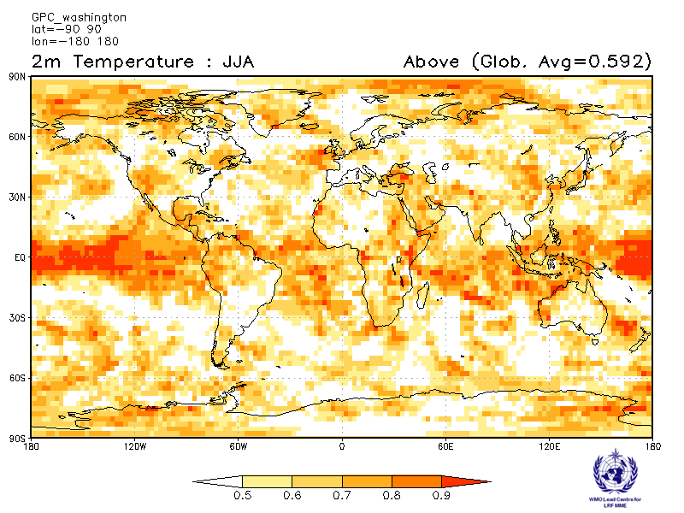
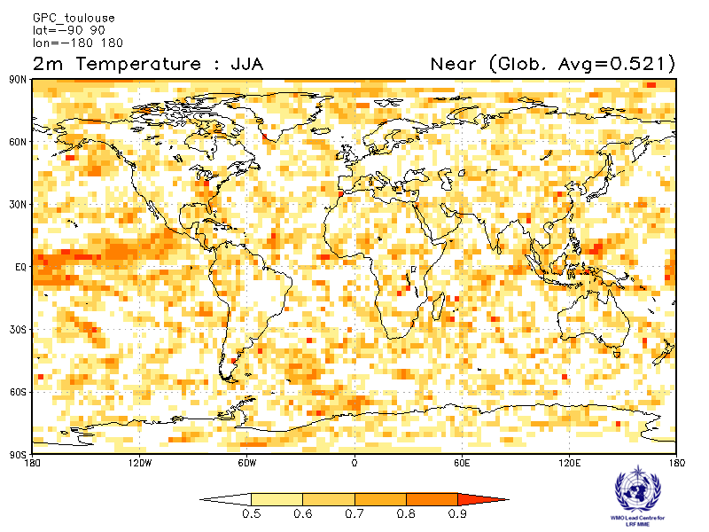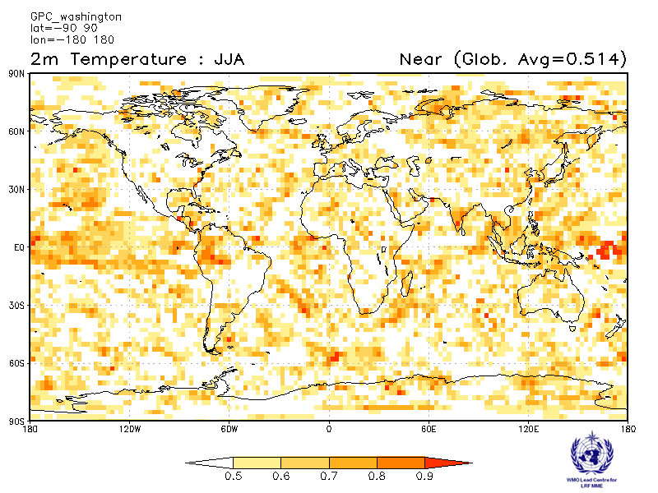
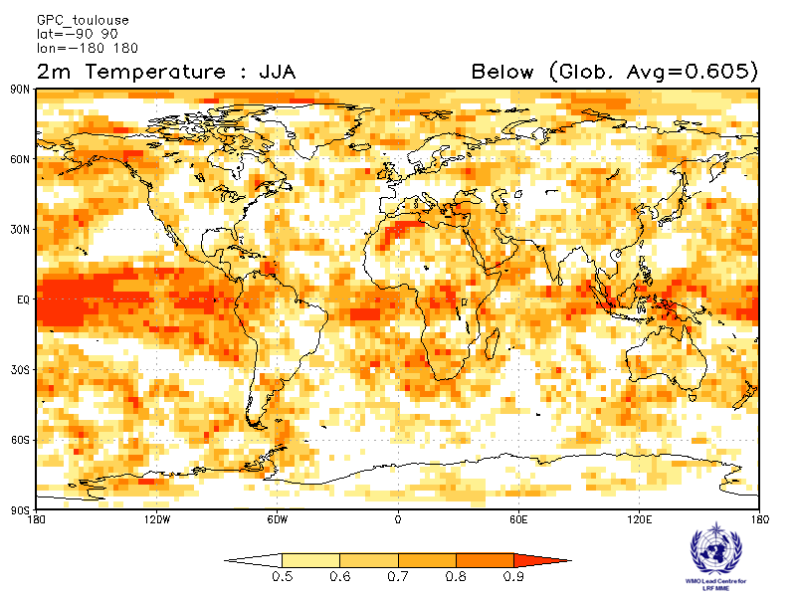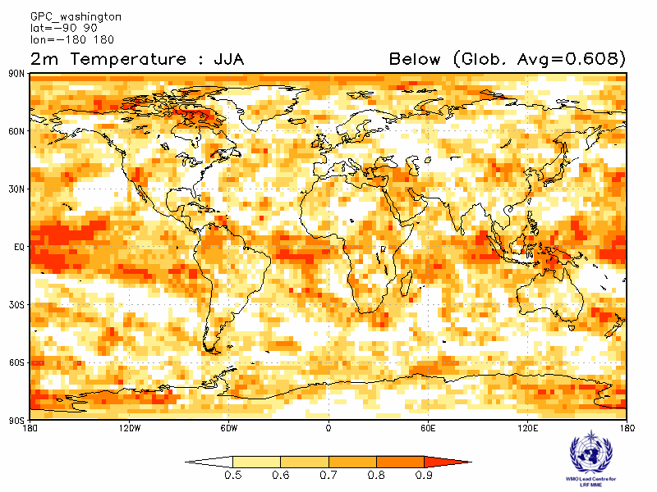

2.1.9 Verification of GPC 2m temperature probabilistic forecasts, 1993-2009
Verification measure: Relative Operation Characteristics (ROC) Curve and Score over globe
Verification dataset: ERA-interim
PMME Beijing
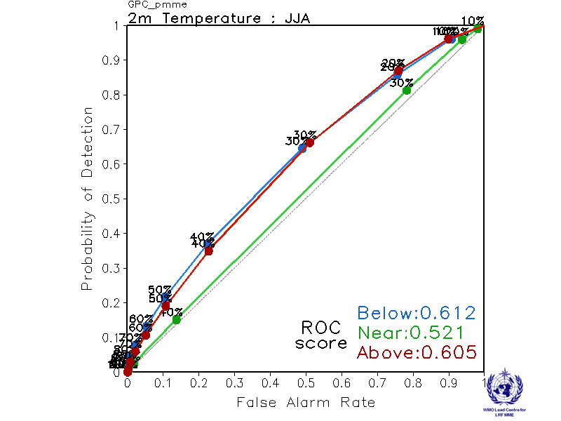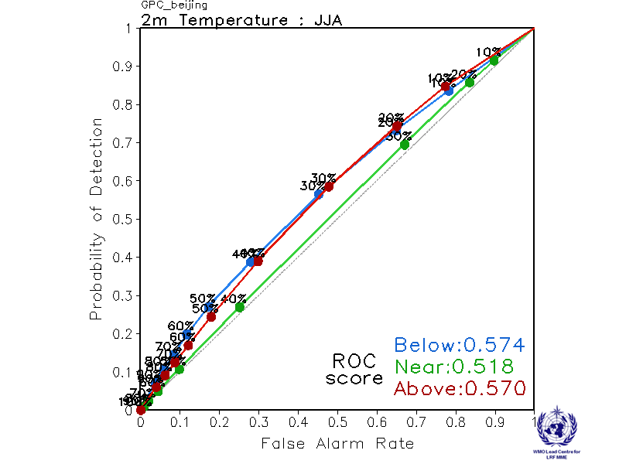
CPTEC ECMWF
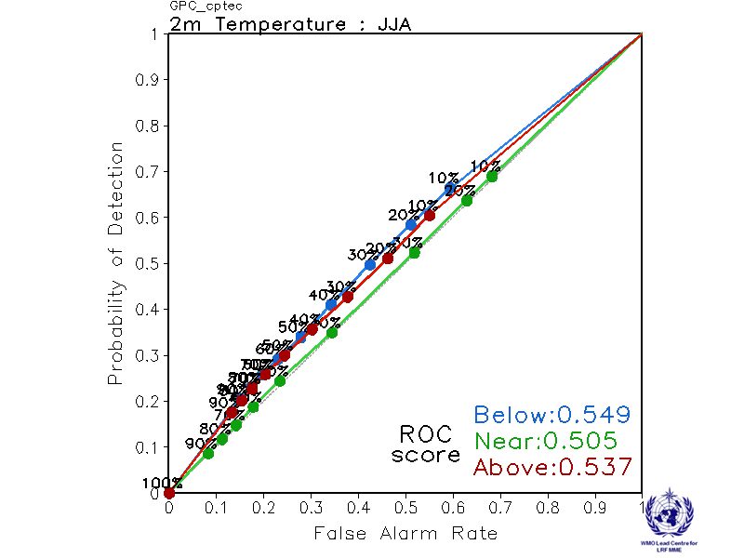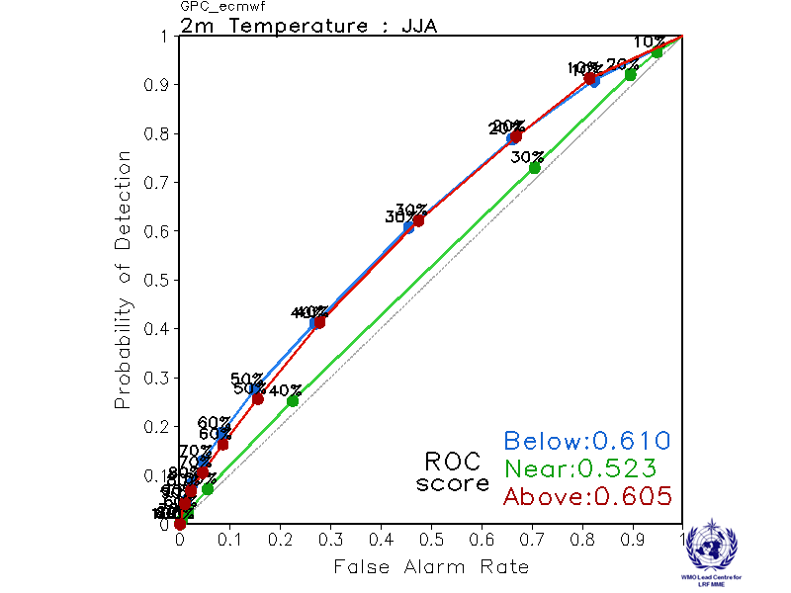

Exeter Melbourne
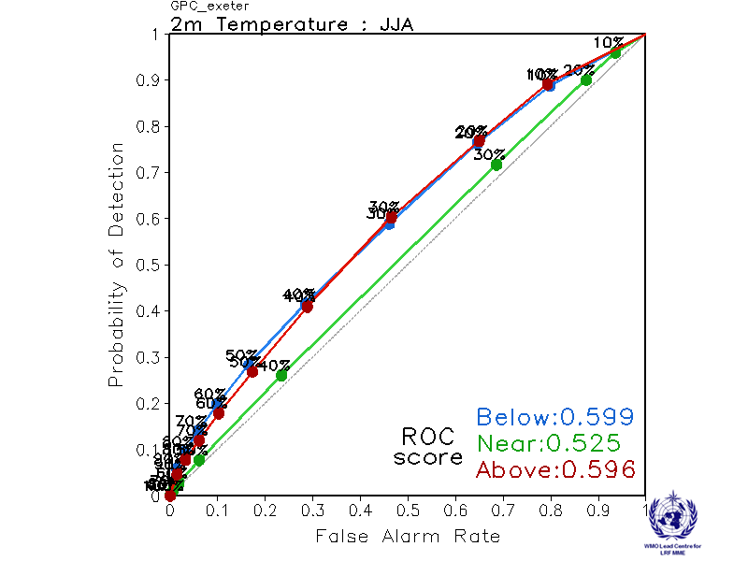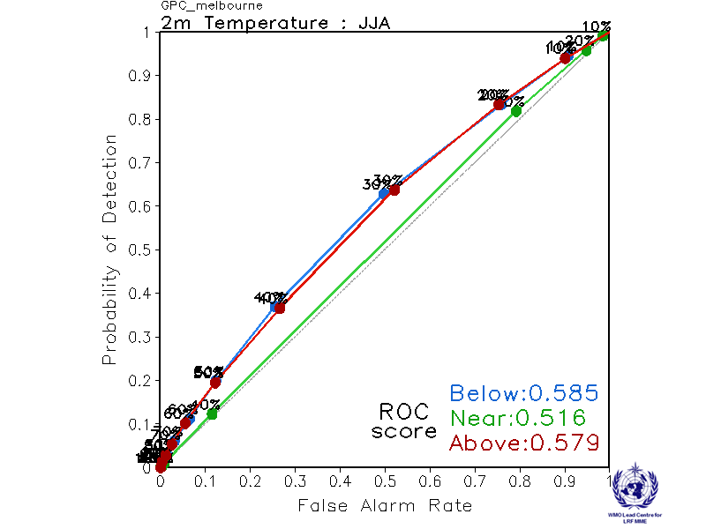

Montreal Moscow
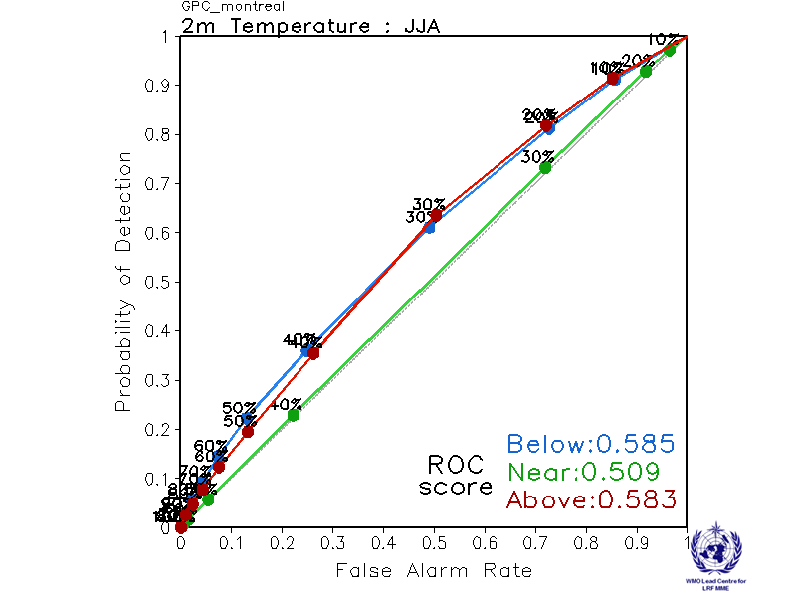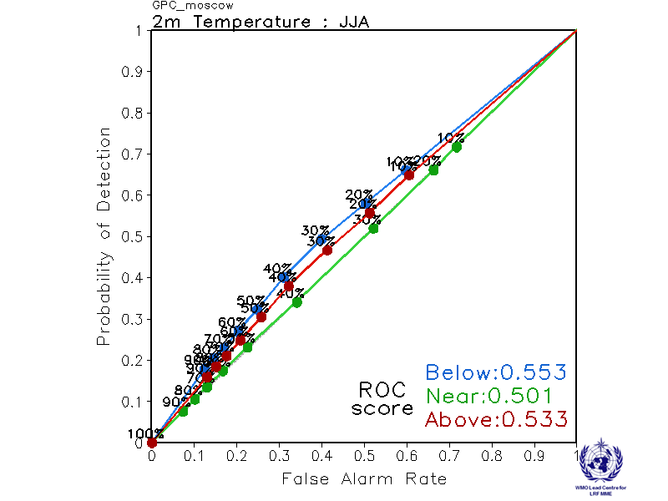

Offenbach Pretoria
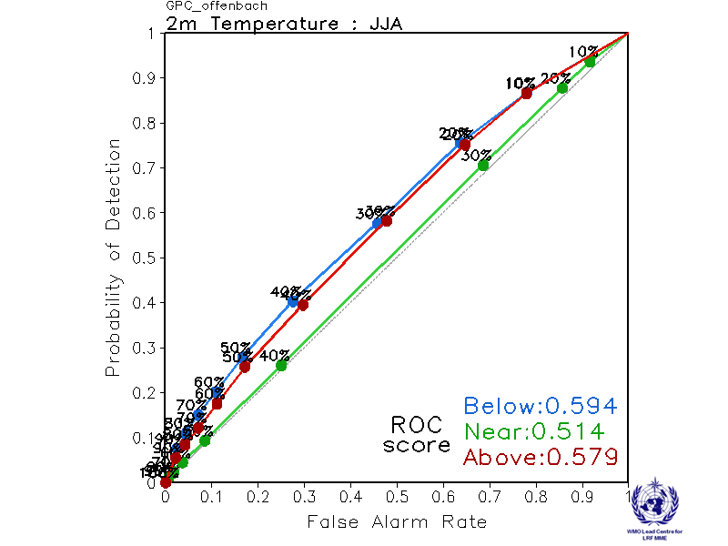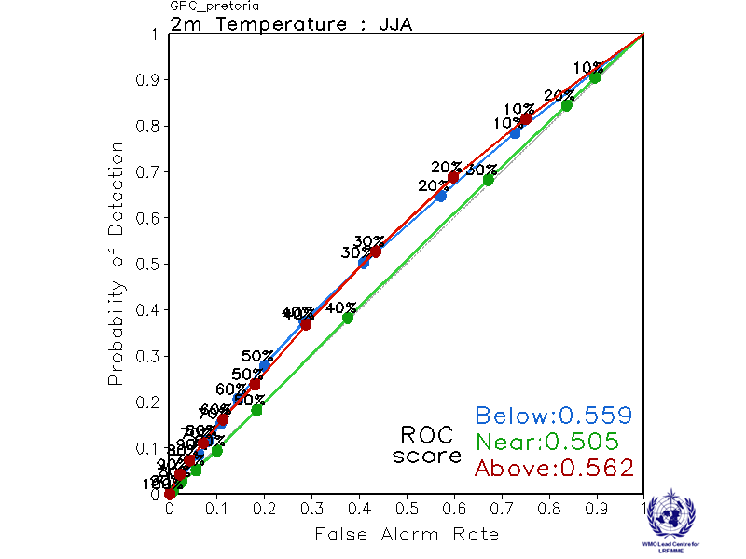

Seoul Tokyo
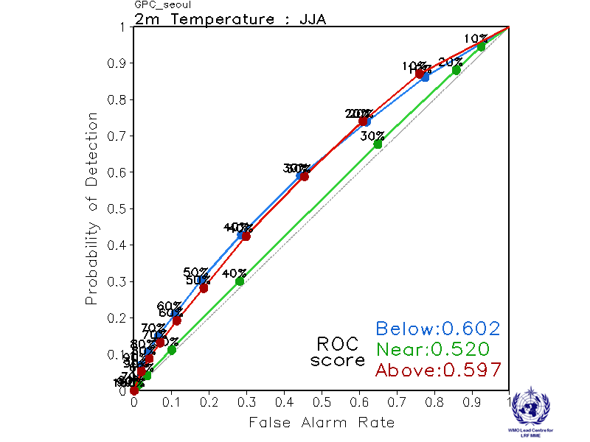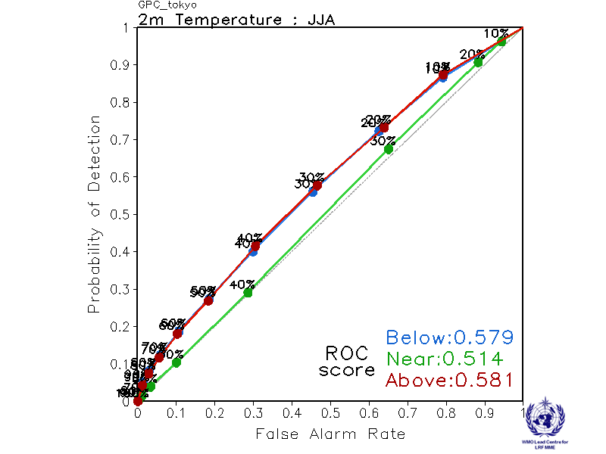

Toulouse Washington
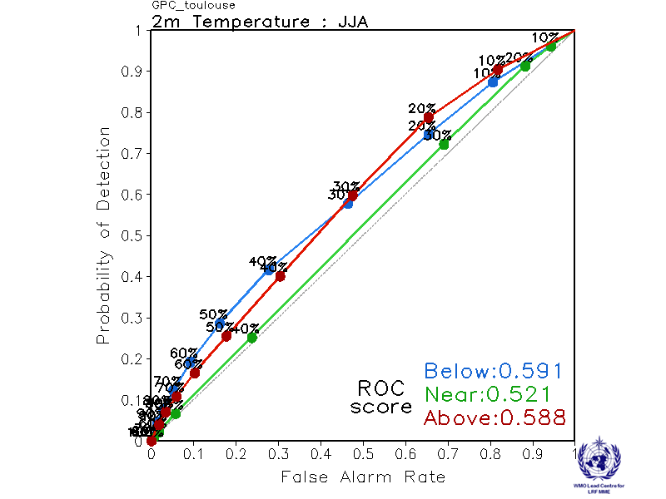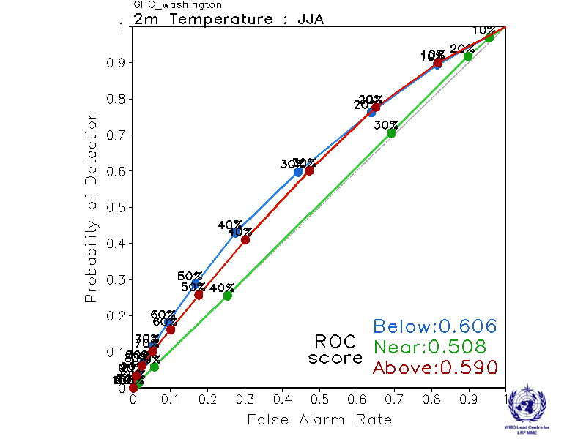

2.1.10 Verification of GPC 2m temperature probabilistic forecasts, 1993-2009
Verification measure: Reliability Diagram over globe
Verification dataset: ERA-interim
PMME Beijing
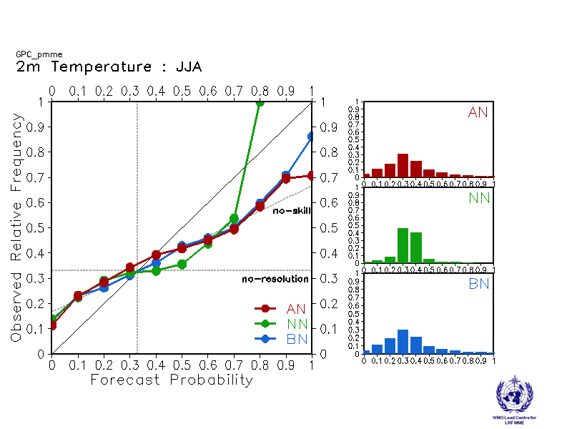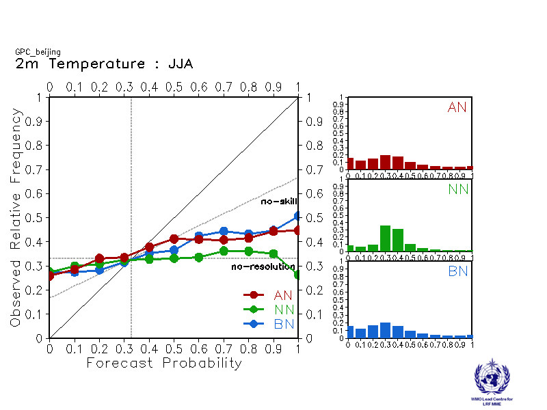
CPTEC ECMWF
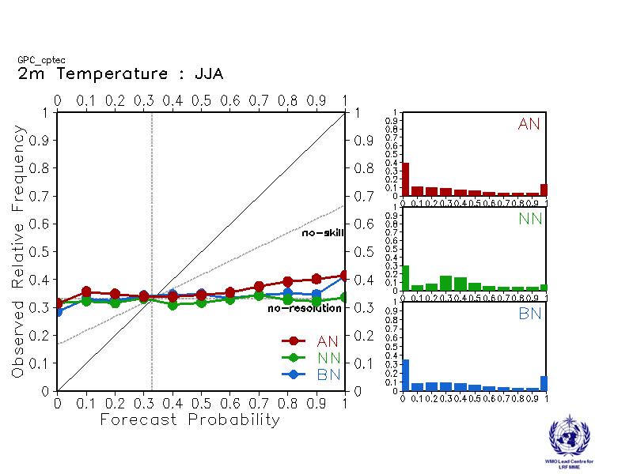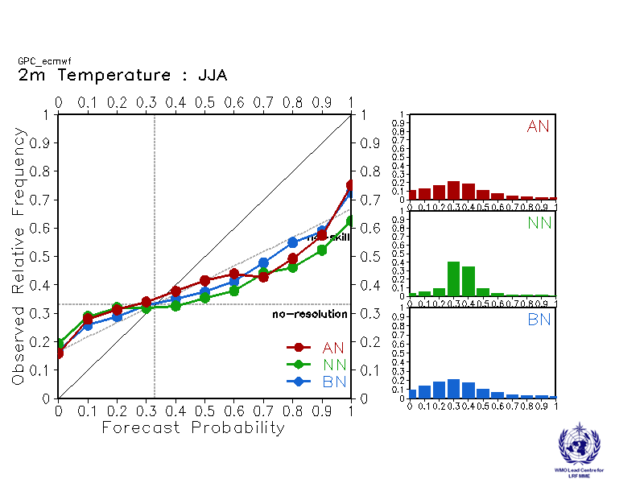

Exeter Melbourne
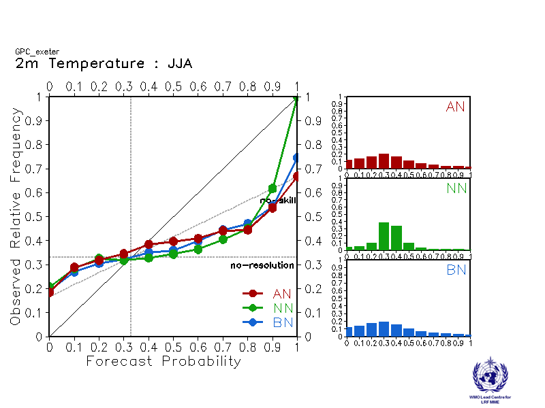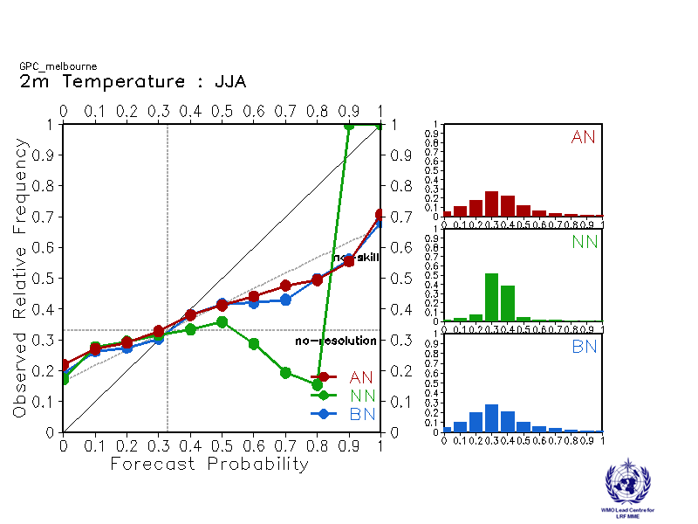

Montreal Moscow
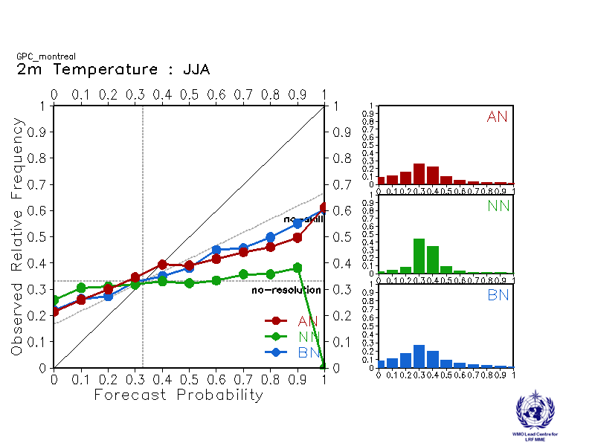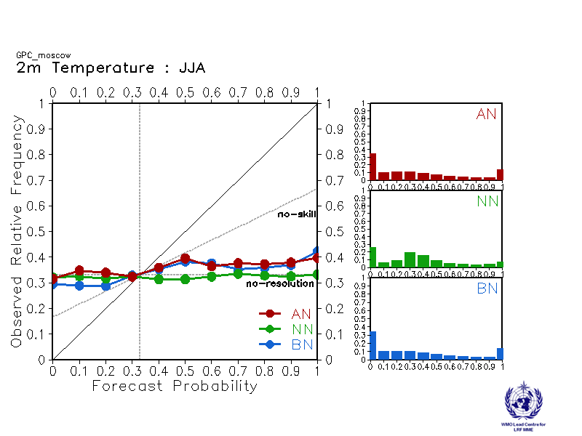

Offenbach Pretoria
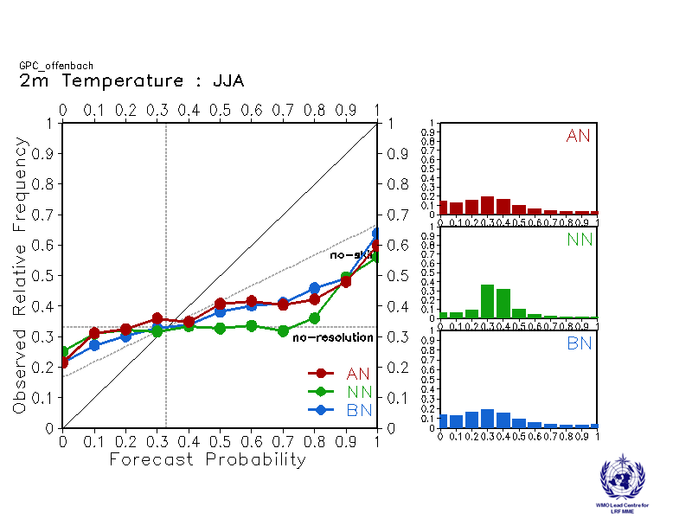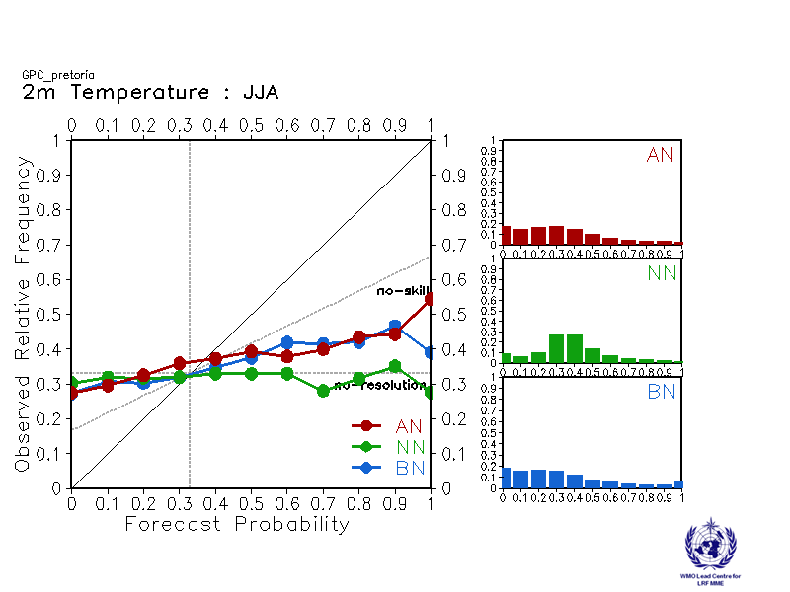

Seoul Tokyo
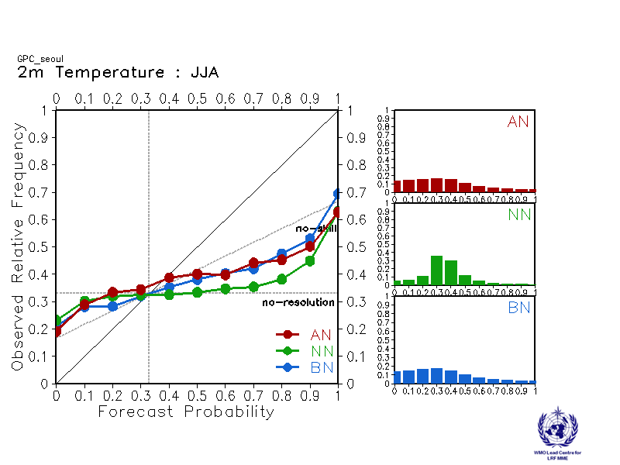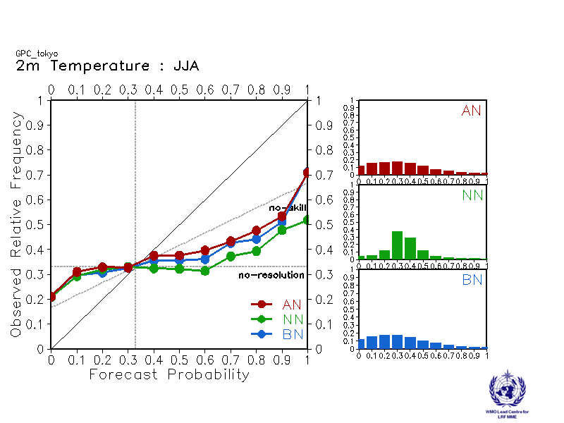

Toulouse Washington
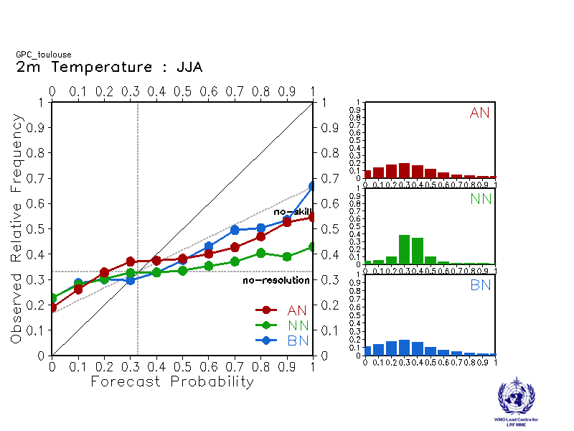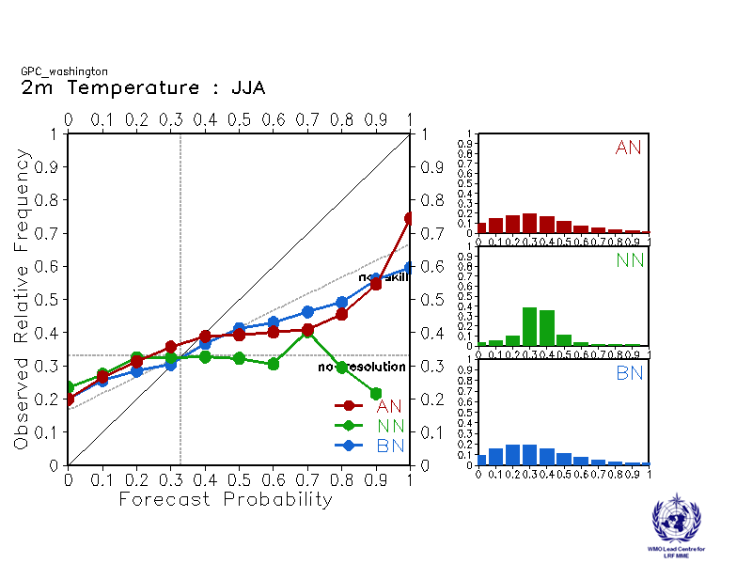

2.2 Precipitation

2.2.1 Individual GPC ensemble mean forecasts of precipitation anomalies relative to 1993-2009
Beijing CPTEC
Baseline:1993-2009 Baseline:1993-2009
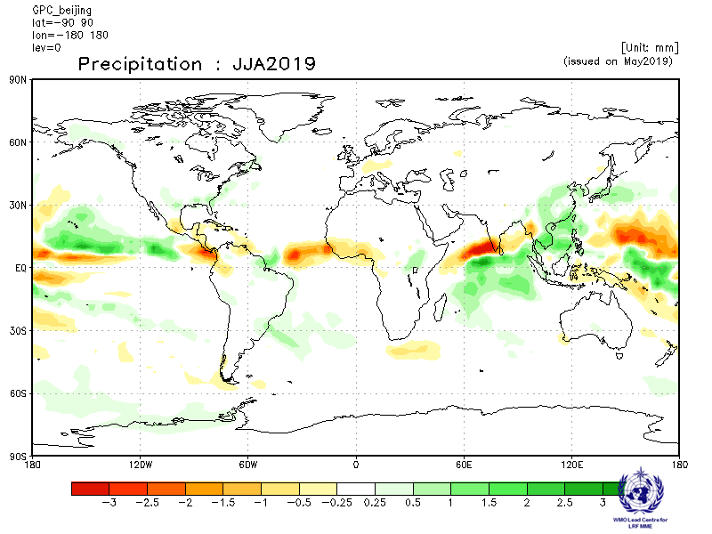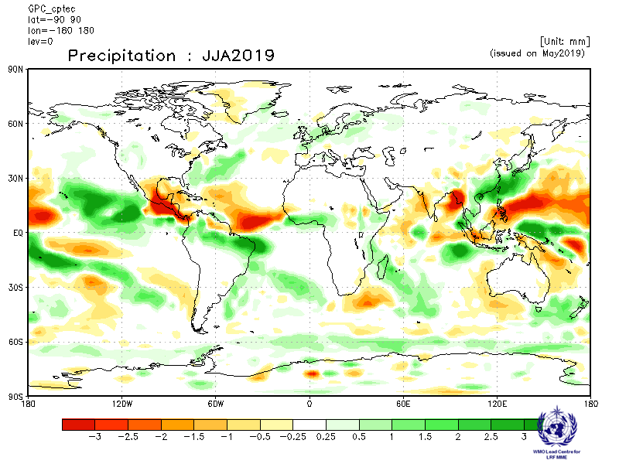

ECMWF Exeter
Baseline:1993-2009 Baseline:1993-2009
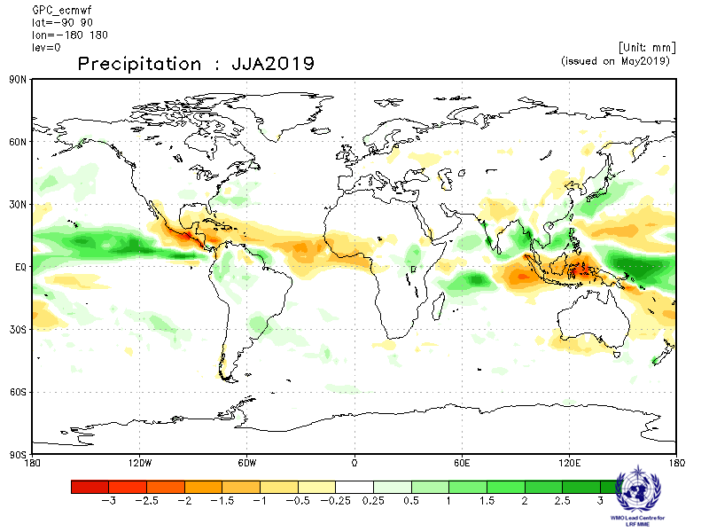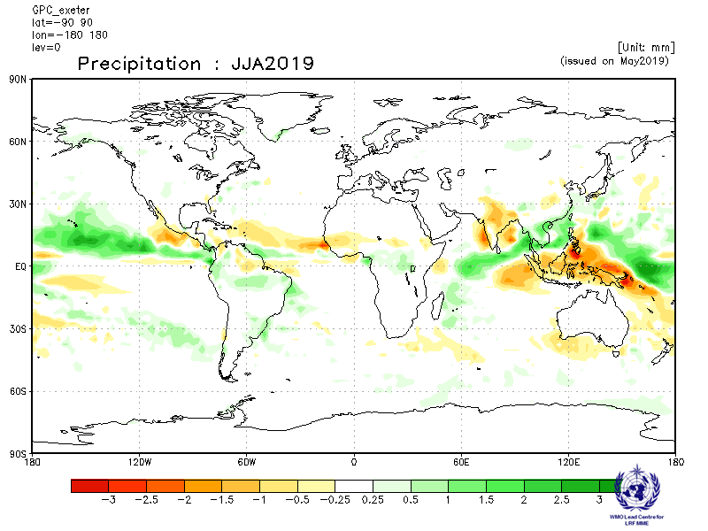

Melbourne Montreal
Baseline:1993-2009 Baseline:1993-2009
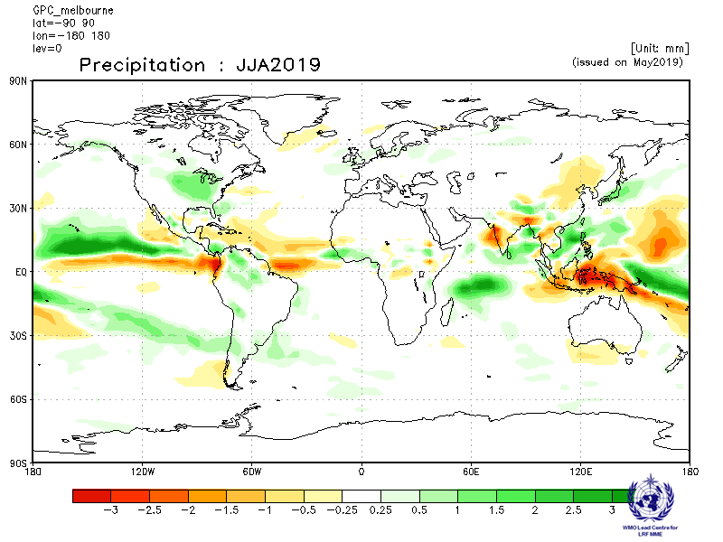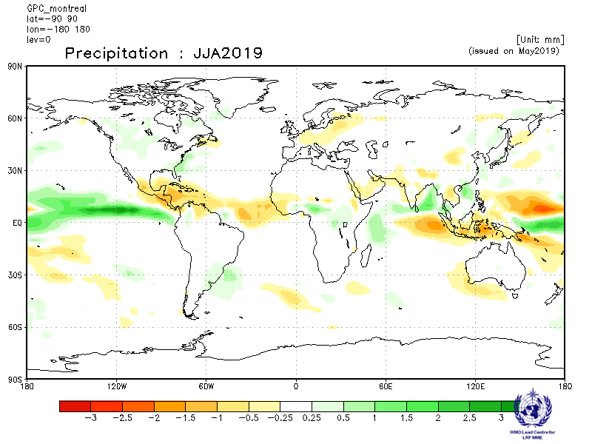

Moscow Offenbach
Baseline:1993-2009 Baseline:1993-2009
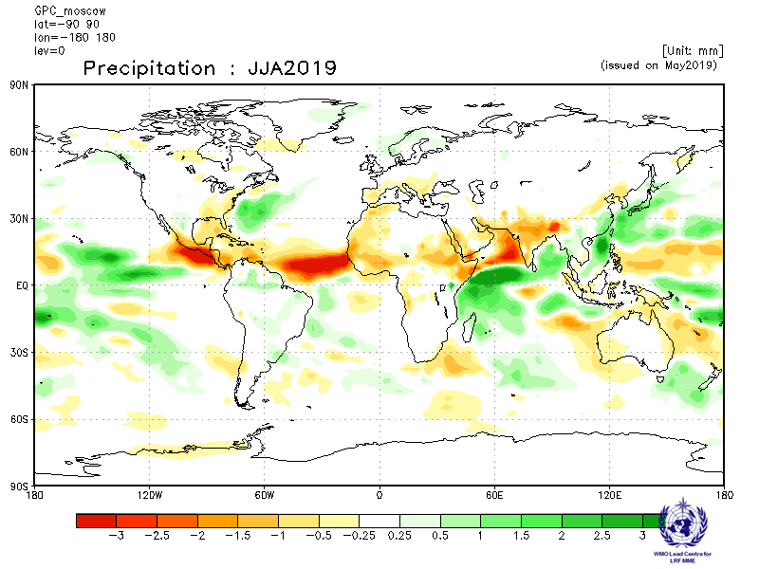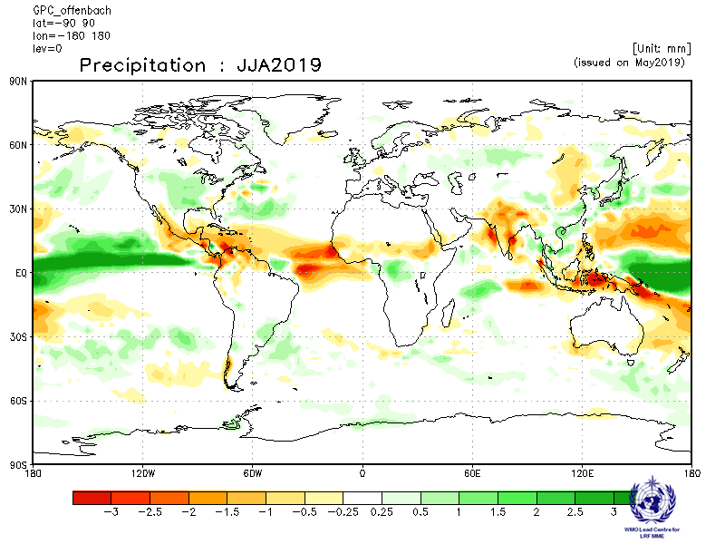

Pretoria Seoul
Baseline:1993-2009 Baseline:1993-2009
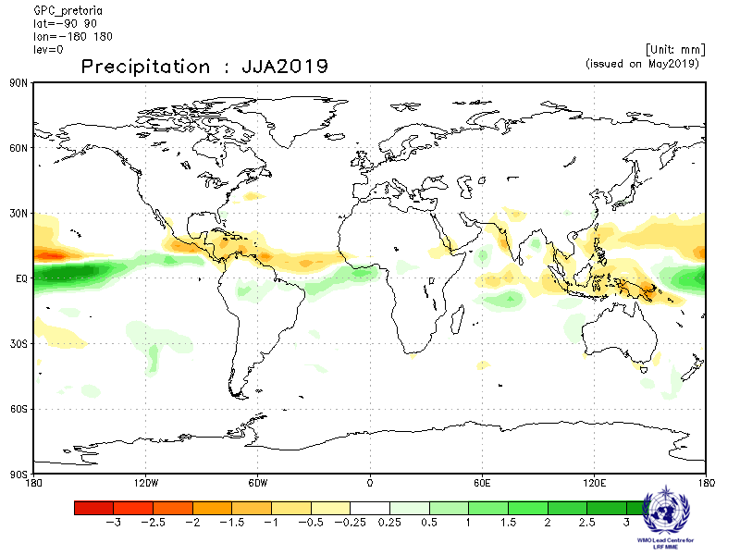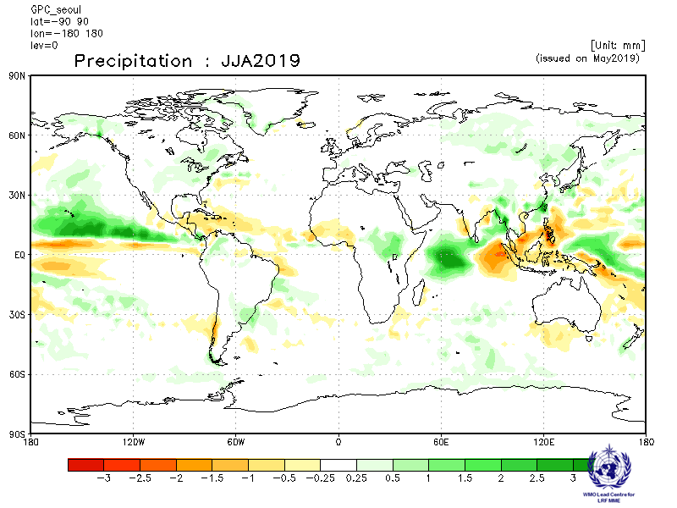

Tokyo Toulouse
Baseline:1993-2009 Baseline:1993-2009
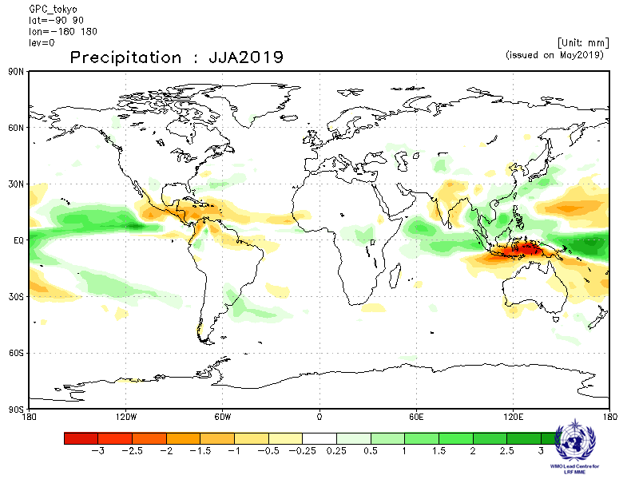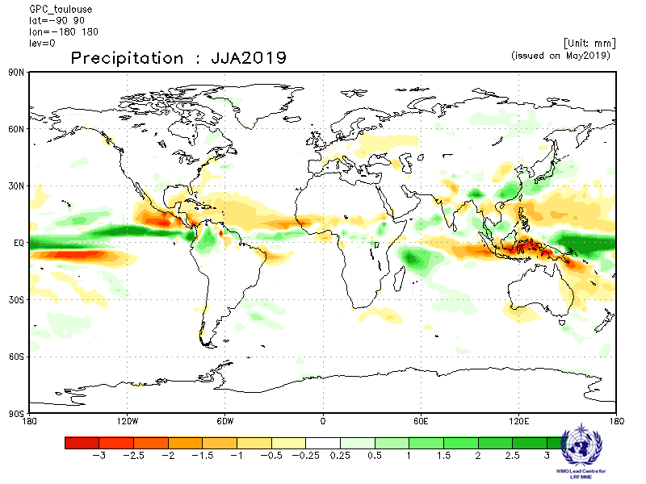
Washington
Baseline:1993-2009
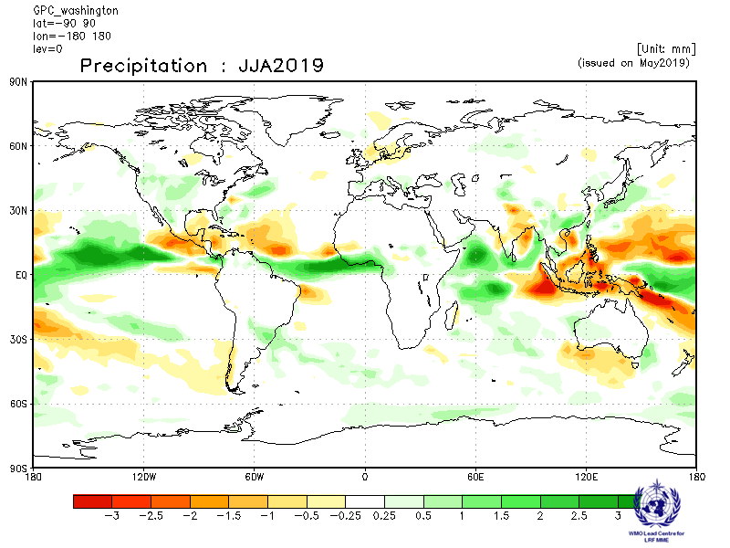
2.2.3 Forecast consistency map (13 GPCs): precipitation
(number of GPCs with positive/negative ensemble mean anomalies – relative to own baseline)
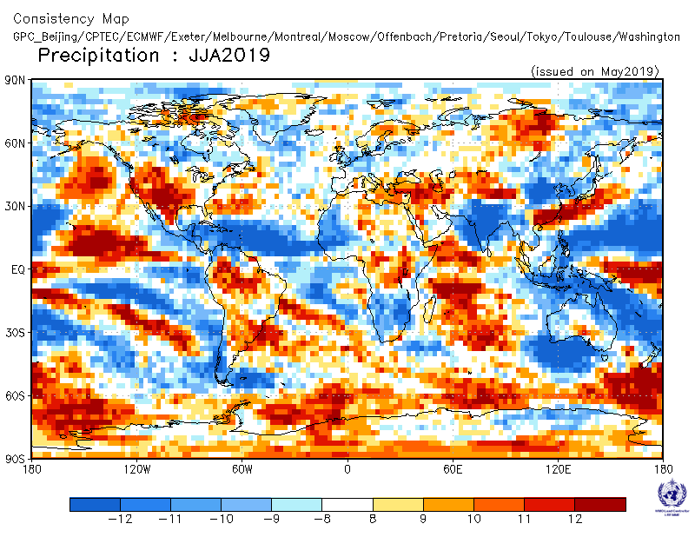

2.2.4 DMME (13 GPCs), using the same baseline for all models (1993-2009): precipitation
Ensemble mean anomaly
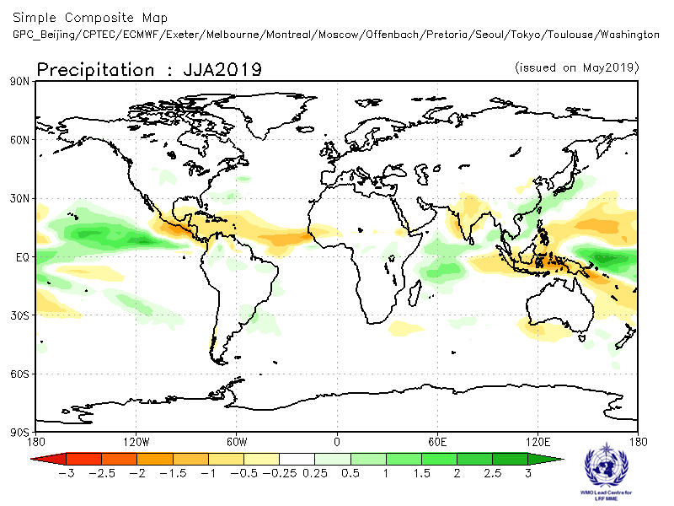

2.2.5 DMME (13 GPCs), for each model using its own baseline: precipitation
Ensemble mean anomaly
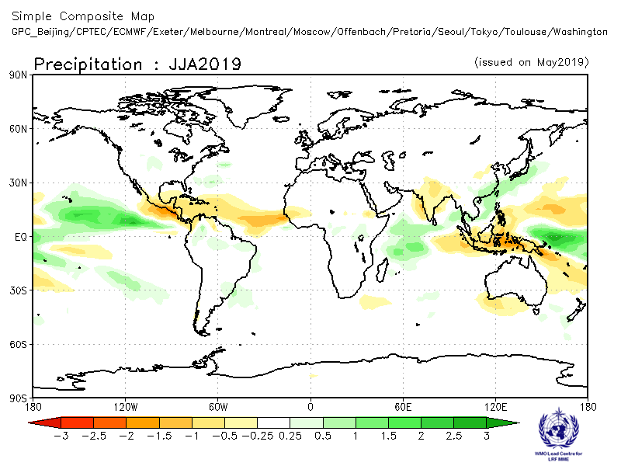

2.2.6 PMME (13 GPCs), using the same baseline for all models (1993-2009): precipitation
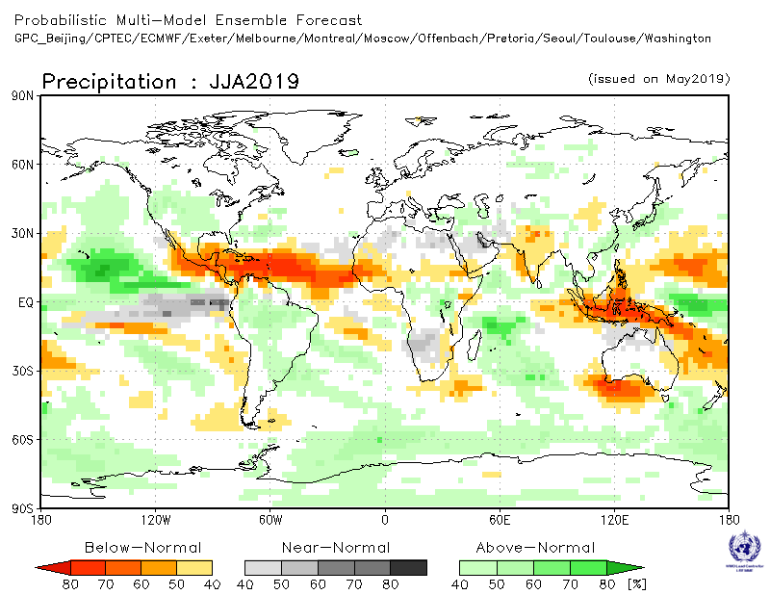

2.2.7 Verification of GPC ensemble mean precipitation anomaly forecasts, 1993-2009
Verification measure: Anomaly Correlation Coefficient (ACC)
Verification dataset: GPCP
DMME Beijing
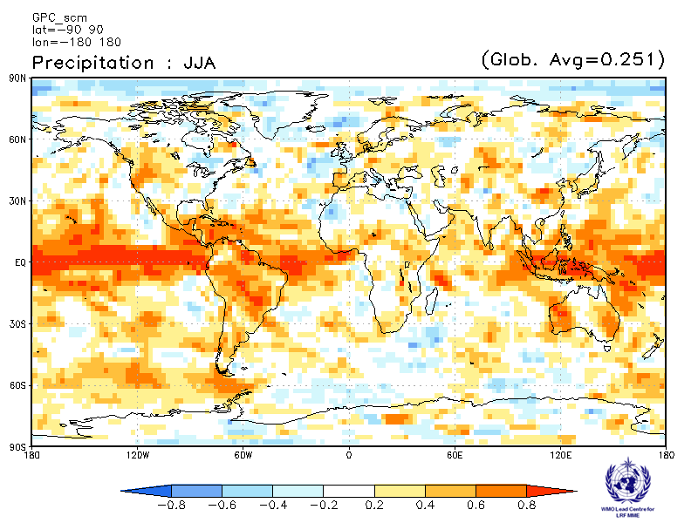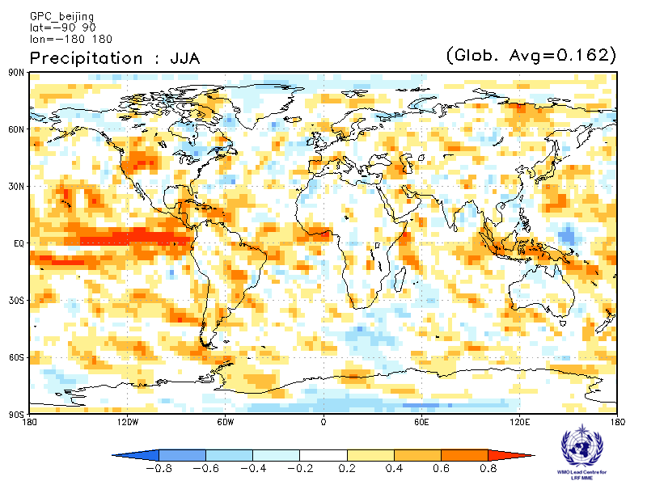
CPTEC ECMWF
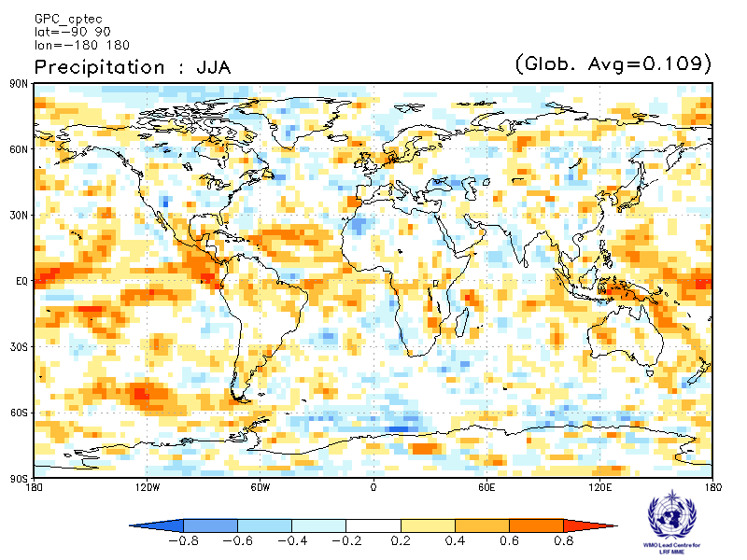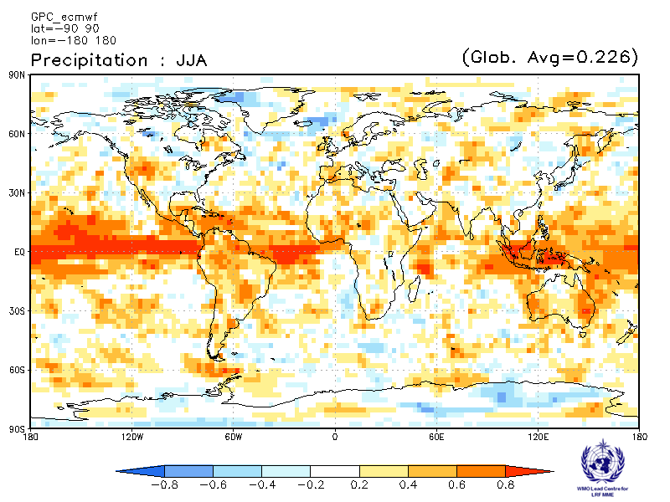

Exeter Melbourne
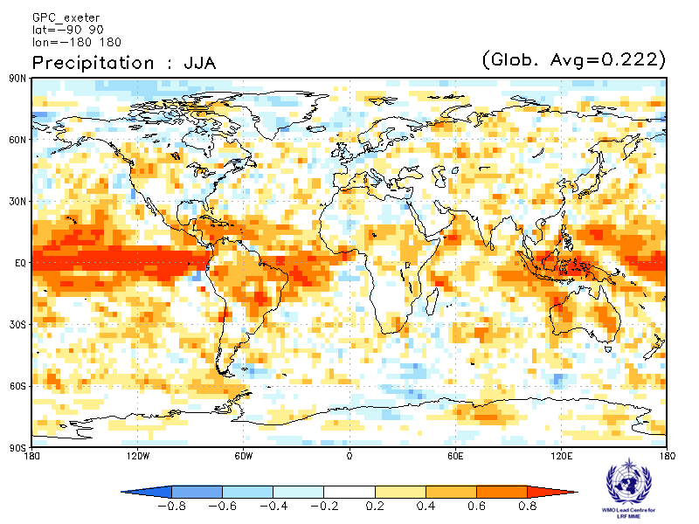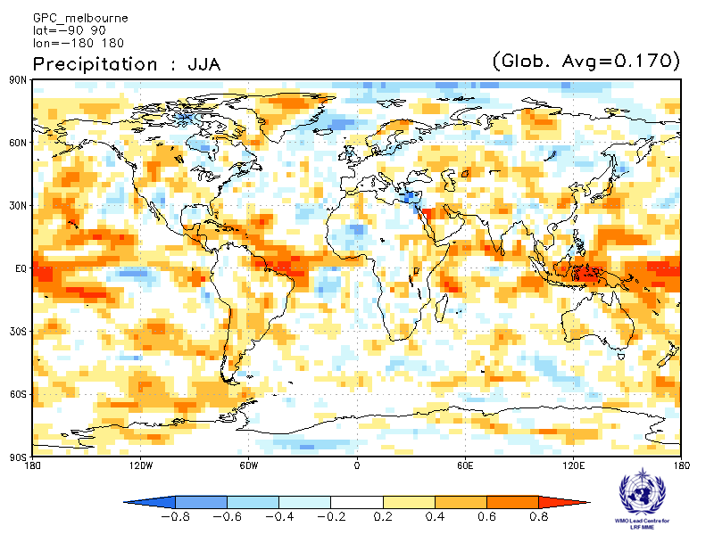

Montreal Moscow
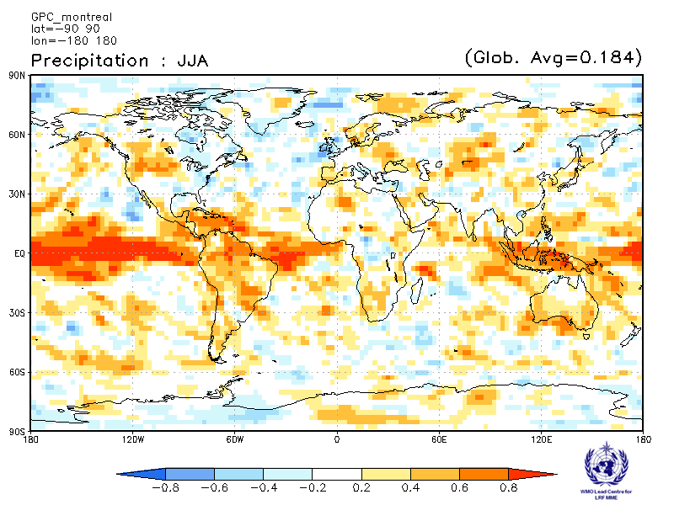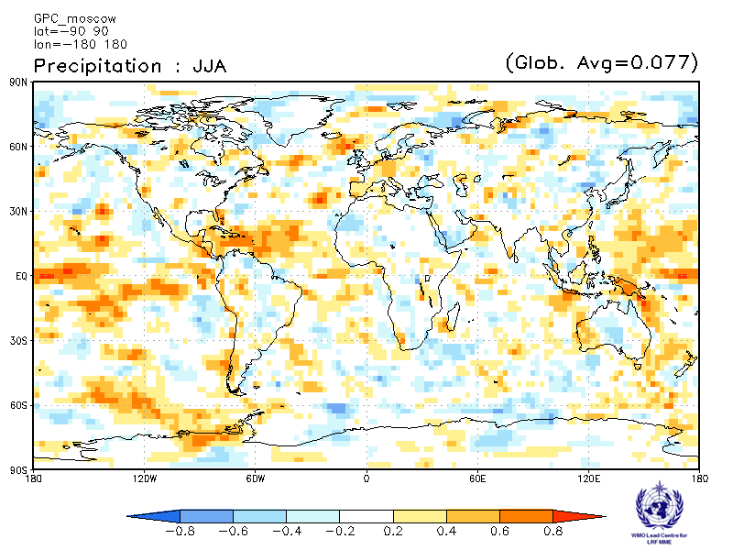

Offenbach Pretoria
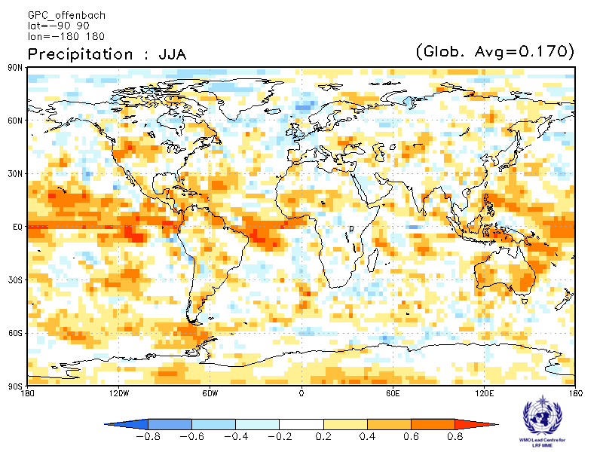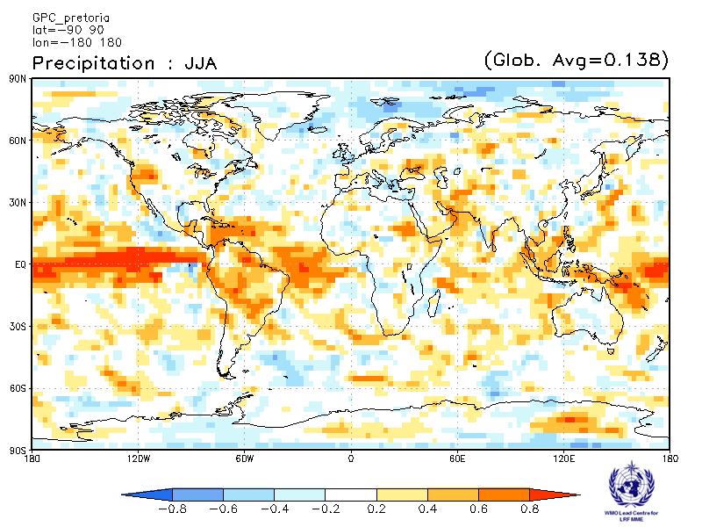

Seoul Tokyo
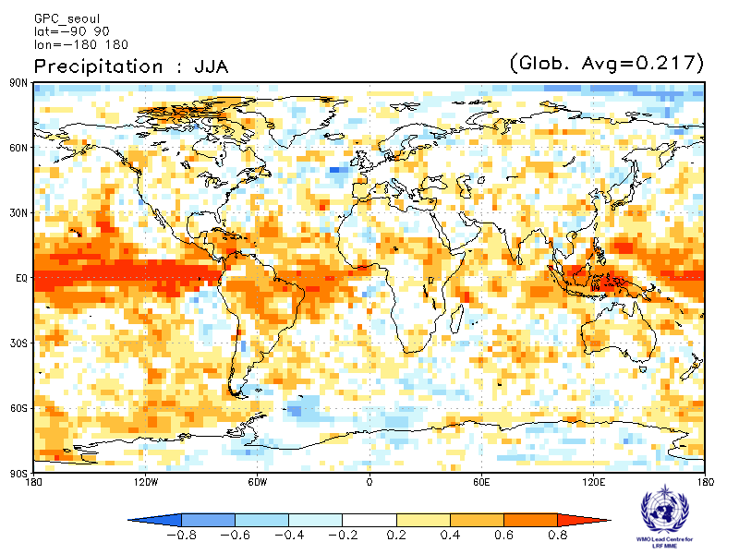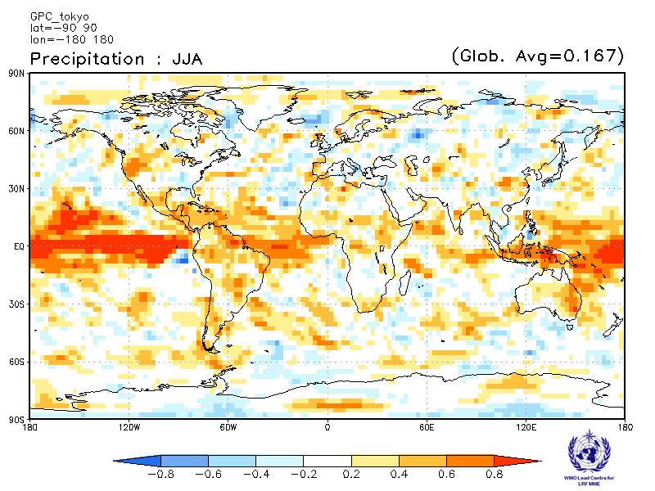

Toulouse Washington
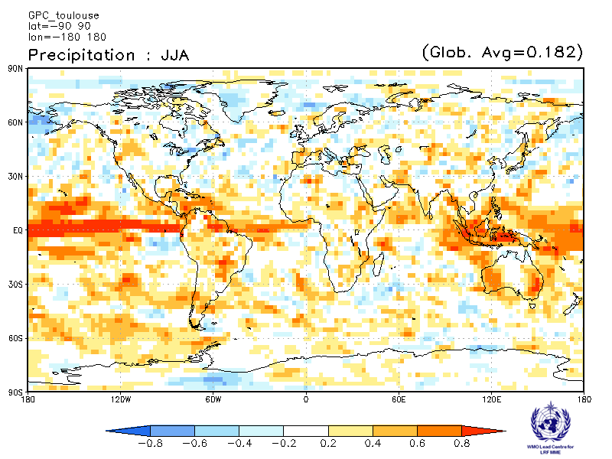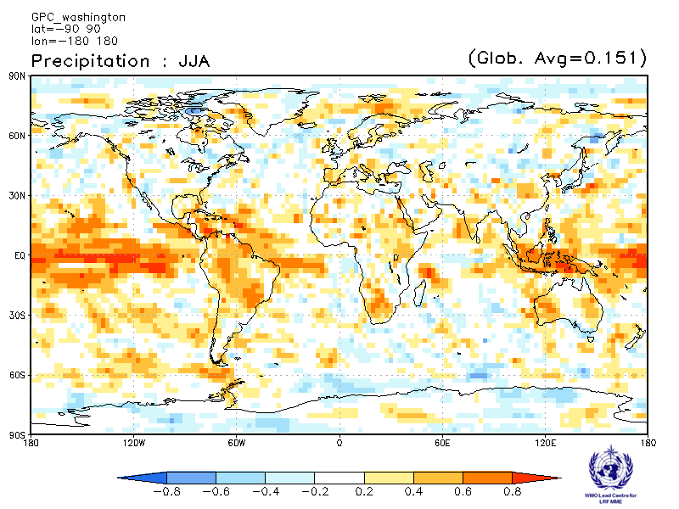

2.2.8 Verification of GPC precipitation probabilistic forecasts, 1993-2009
Verification measure: Relative Operating Characteristics (ROC) score for tercile forecast
Verification dataset: GPCP
PMME Beijing
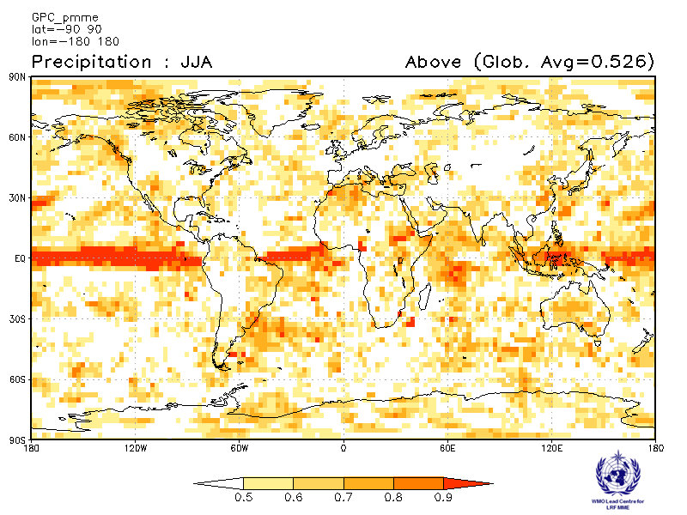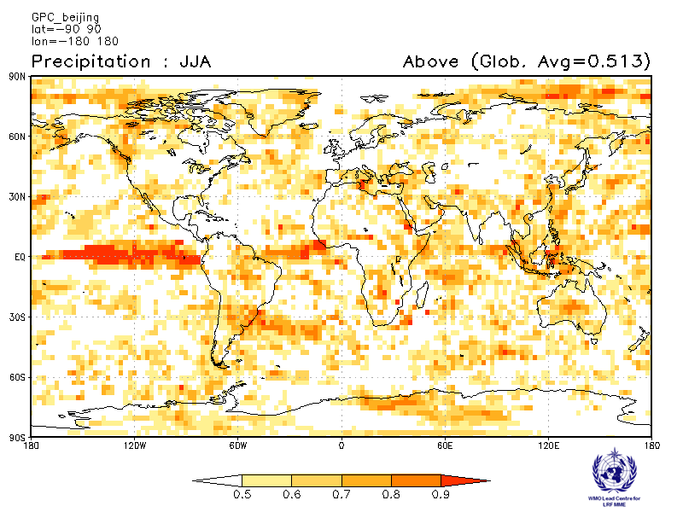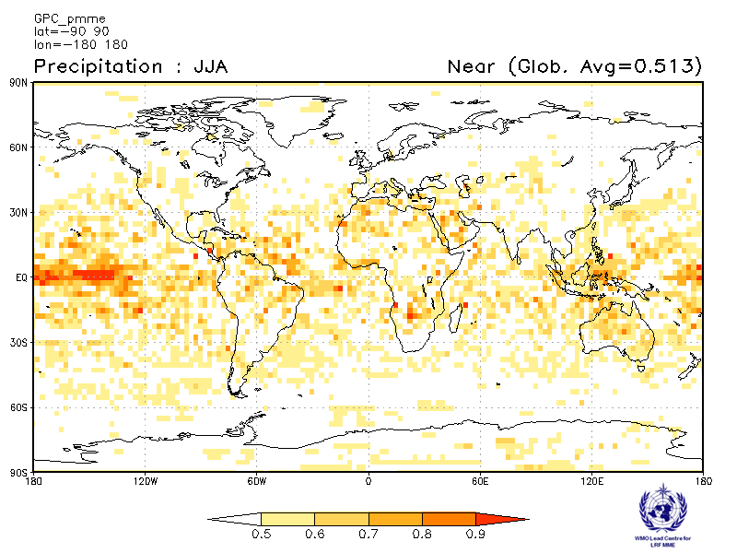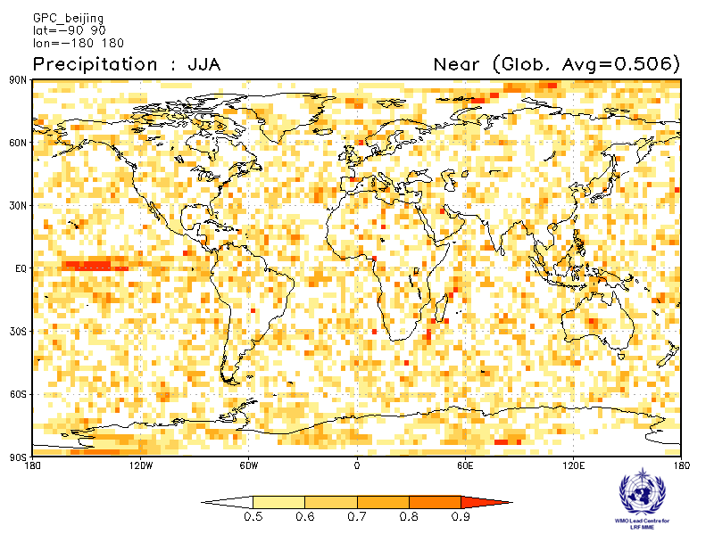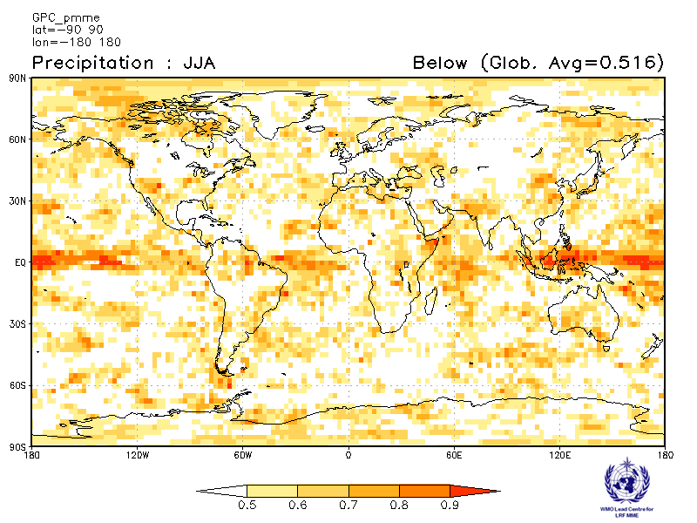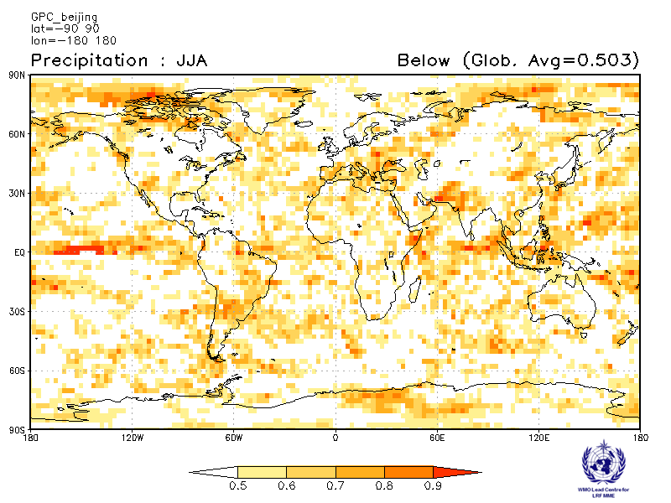
CPTEC ECMWF
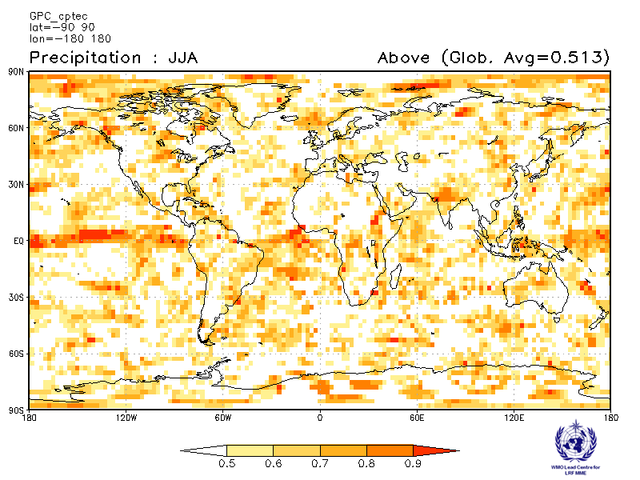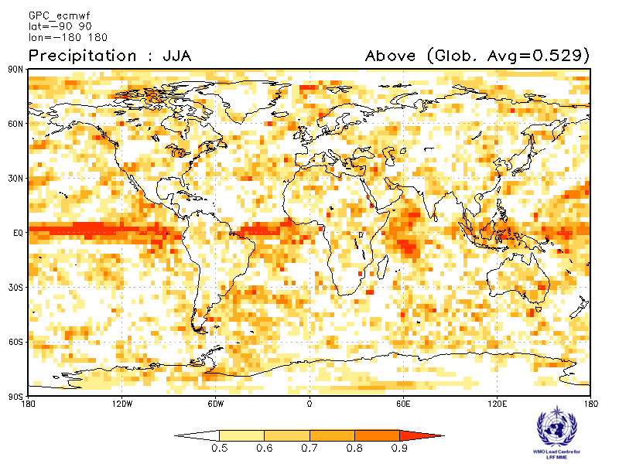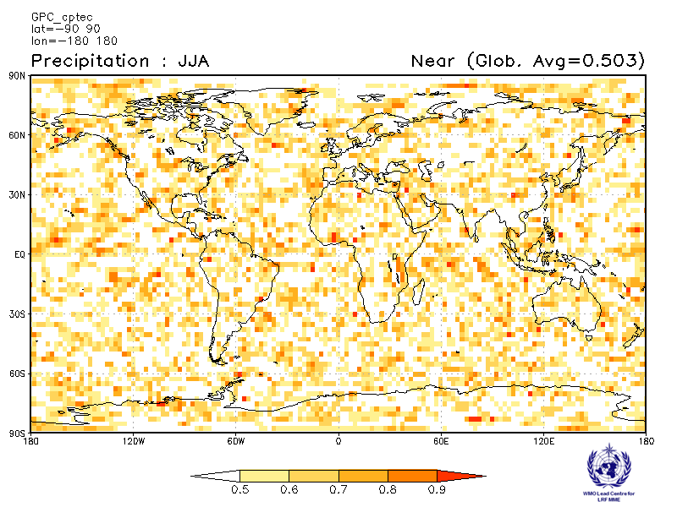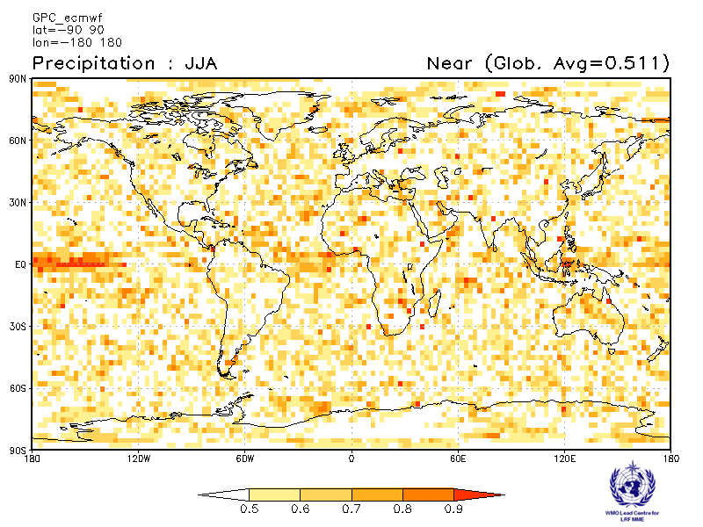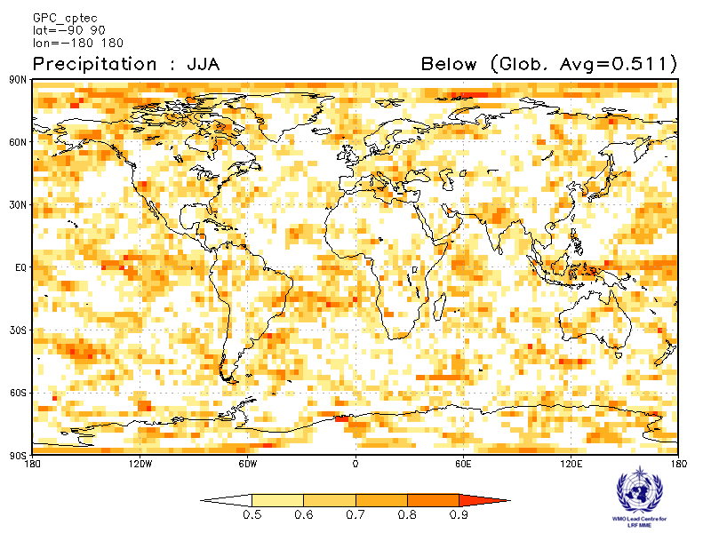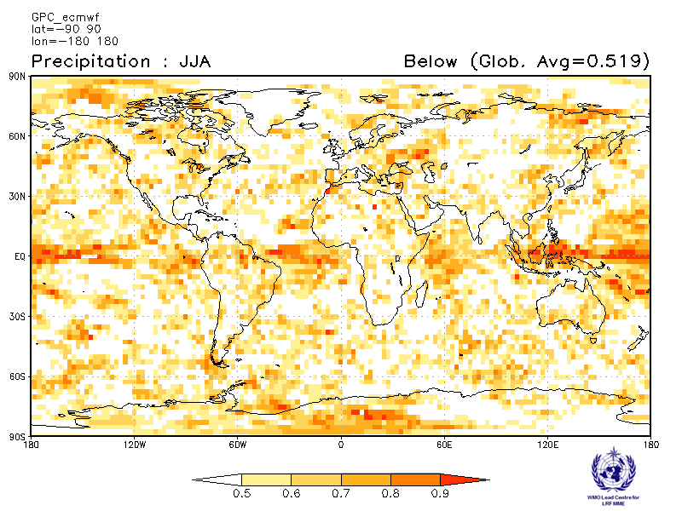

Exeter Melbourne
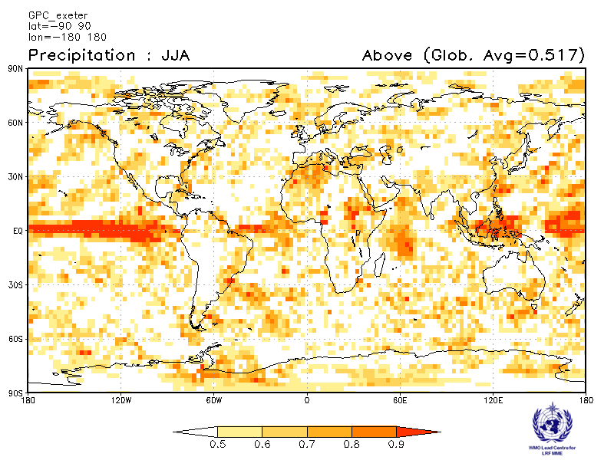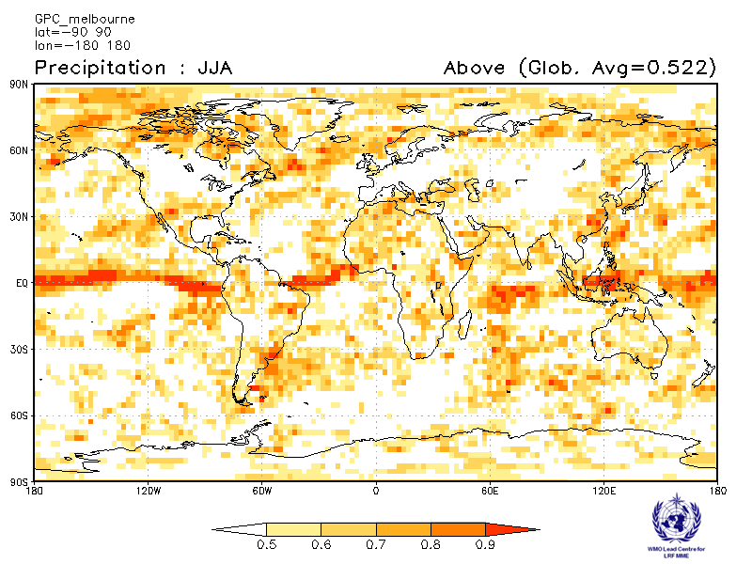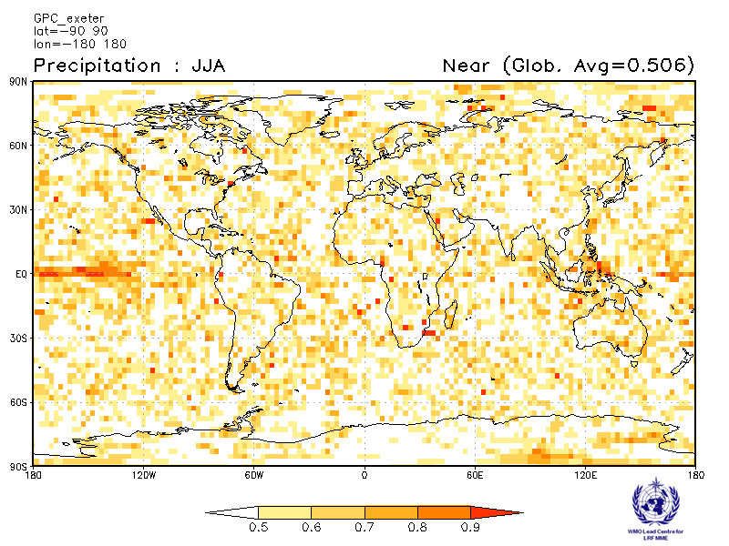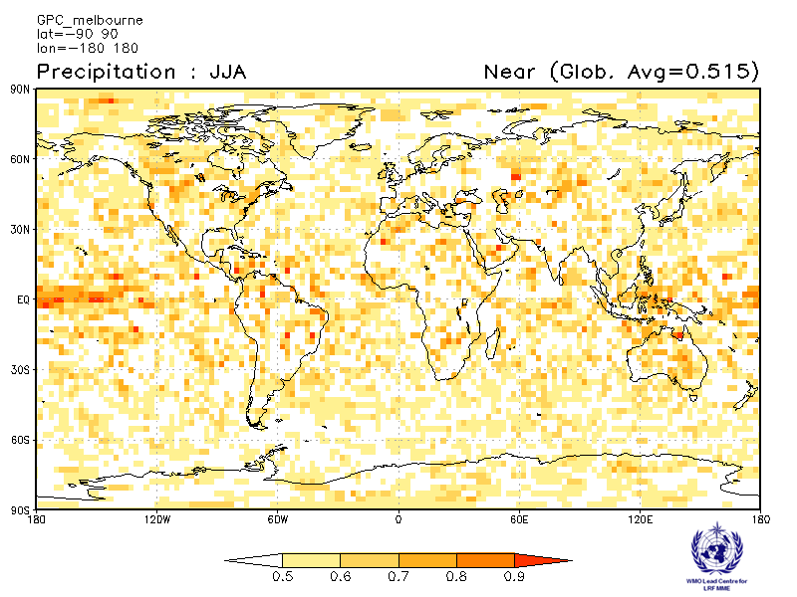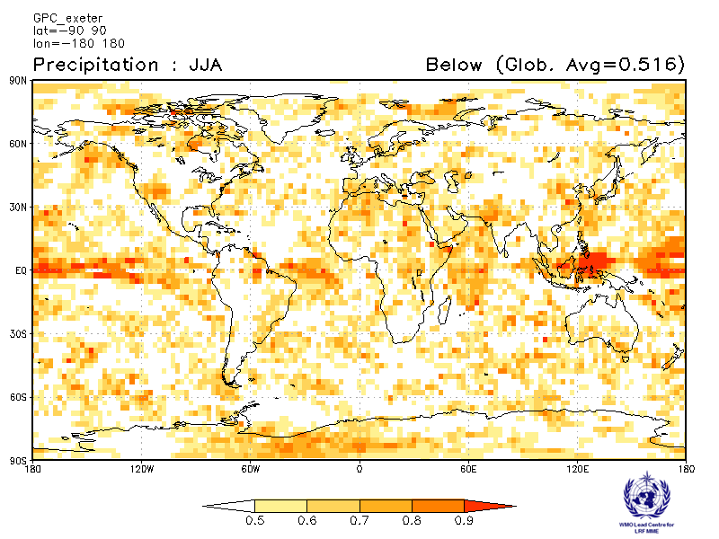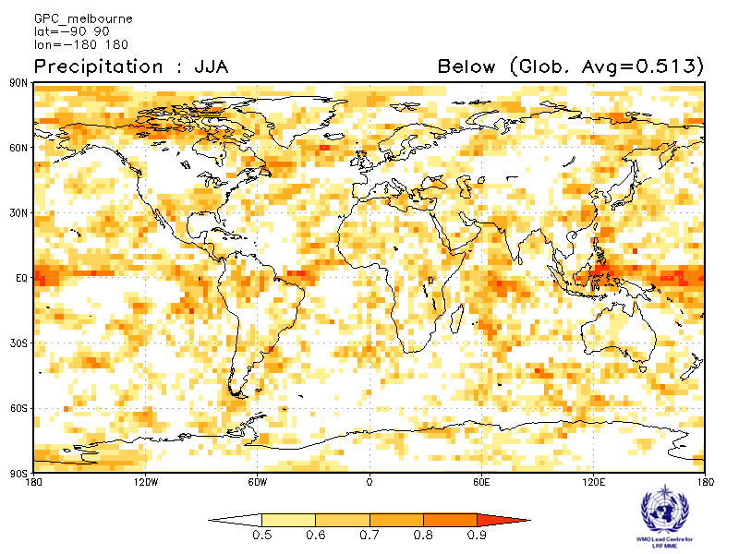

Montreal Moscow
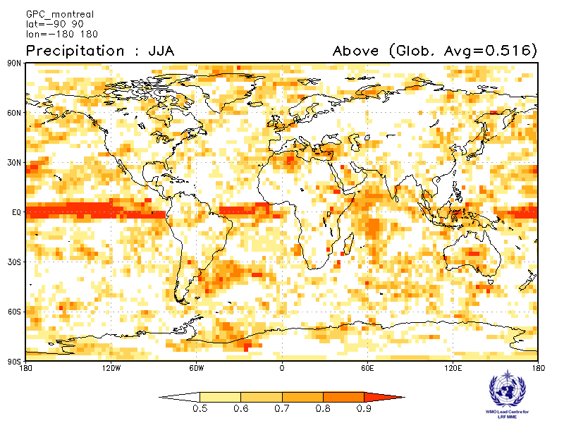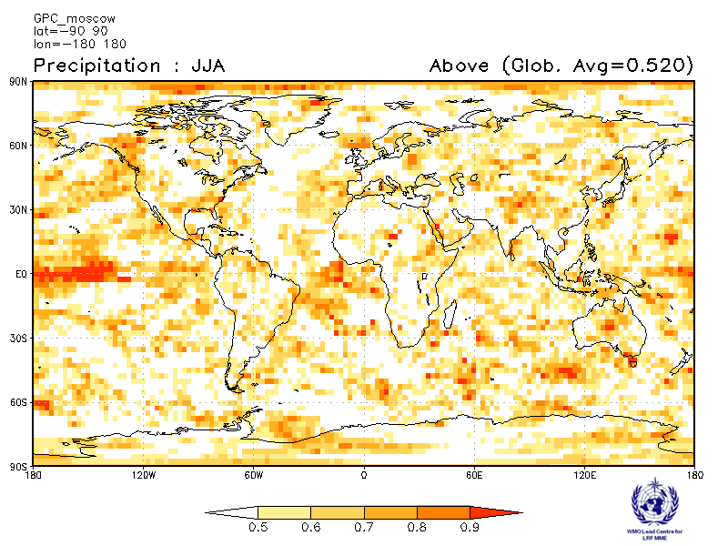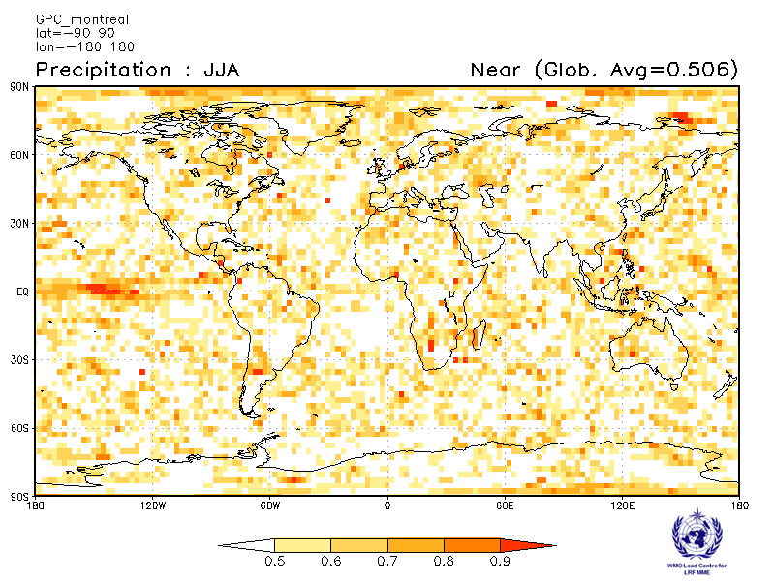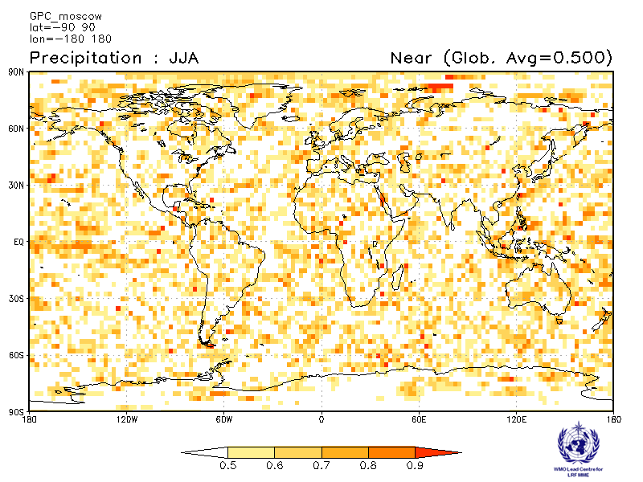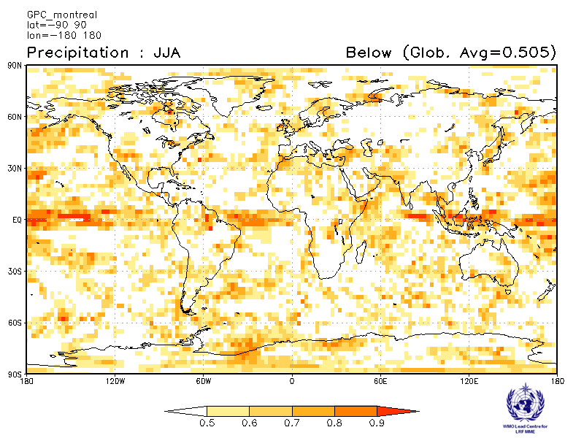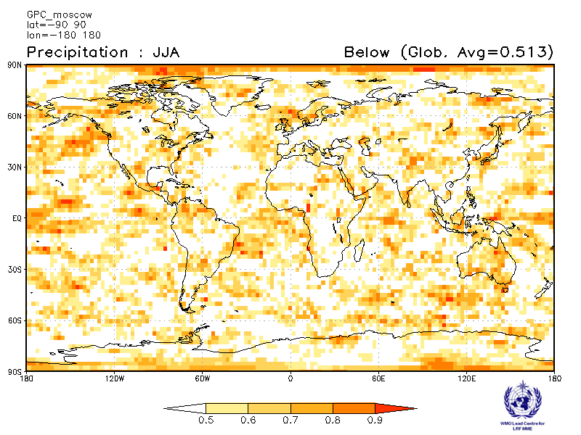

Offenbach Pretoria
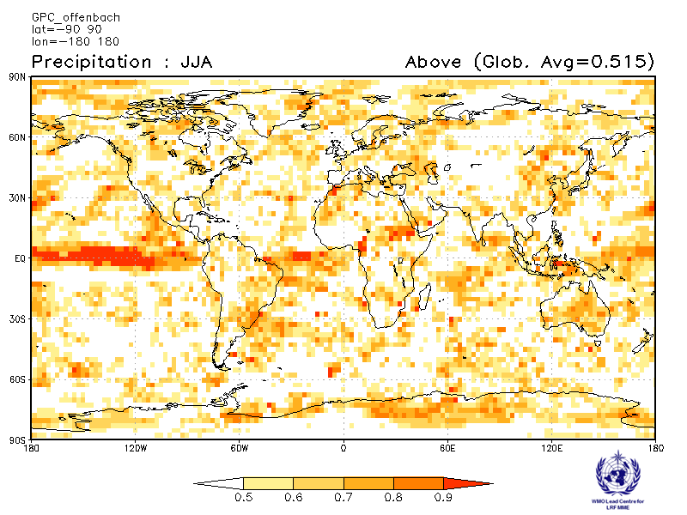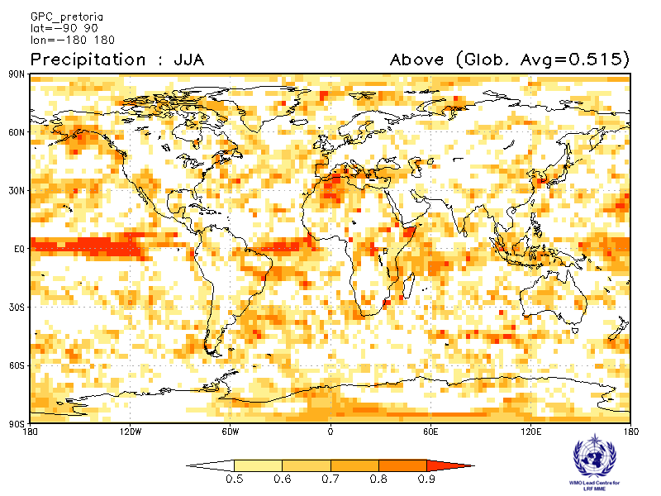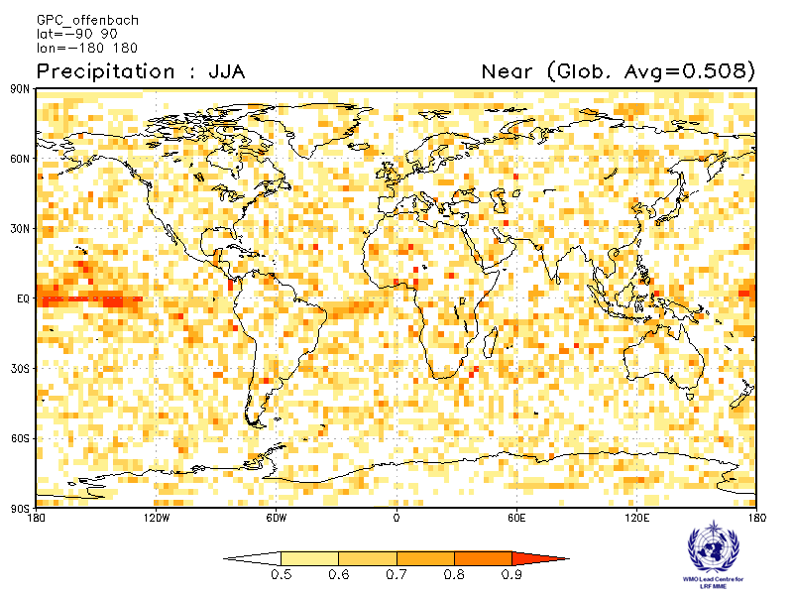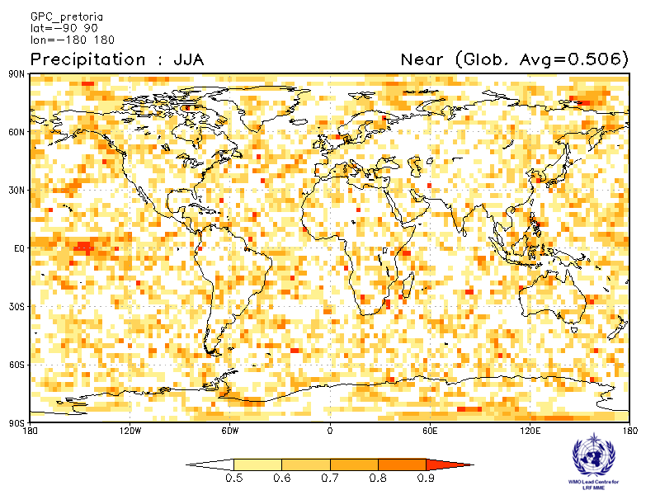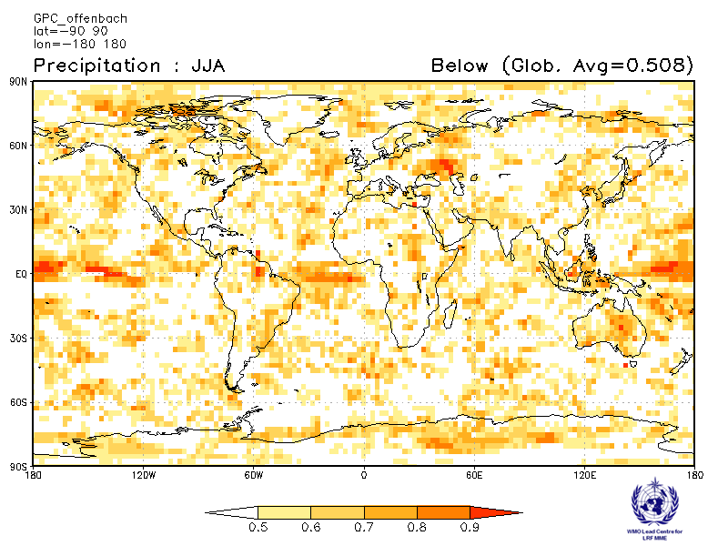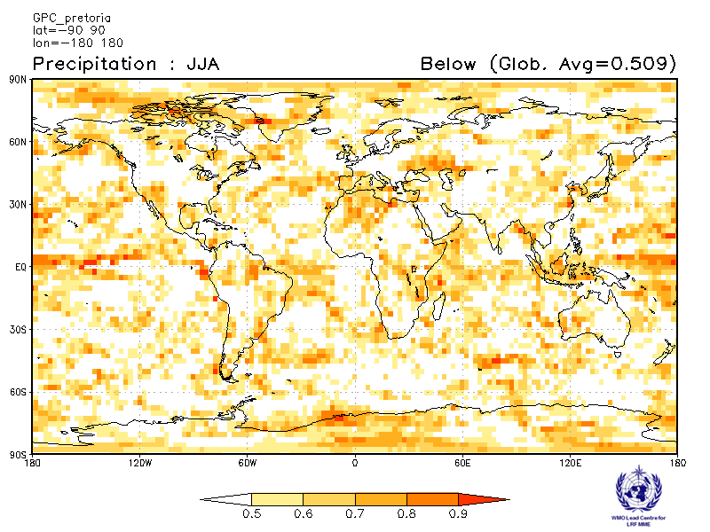

Seoul Tokyo
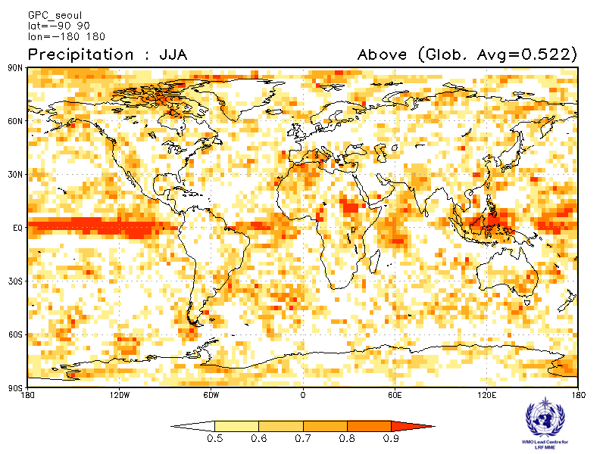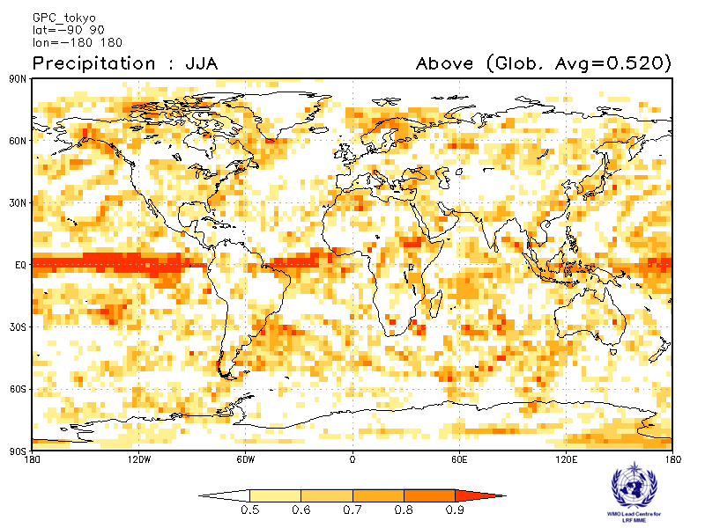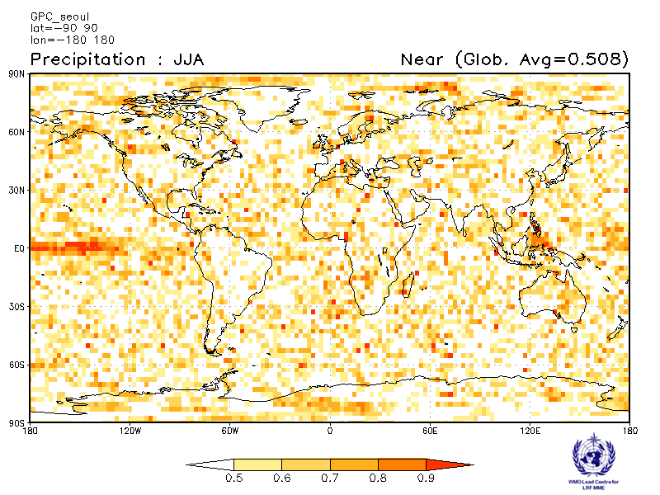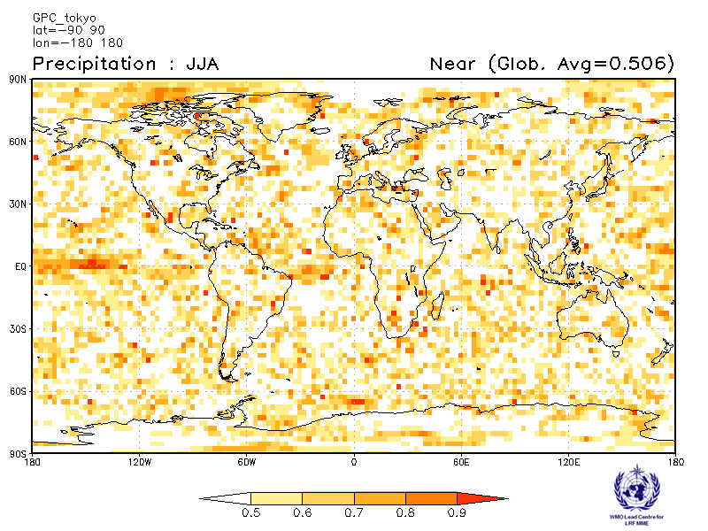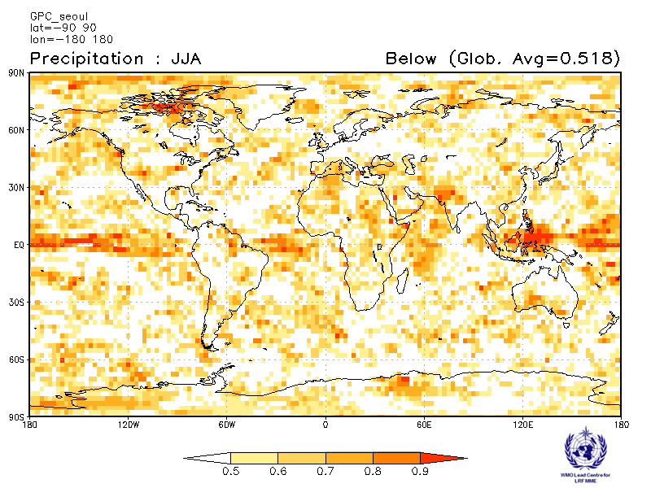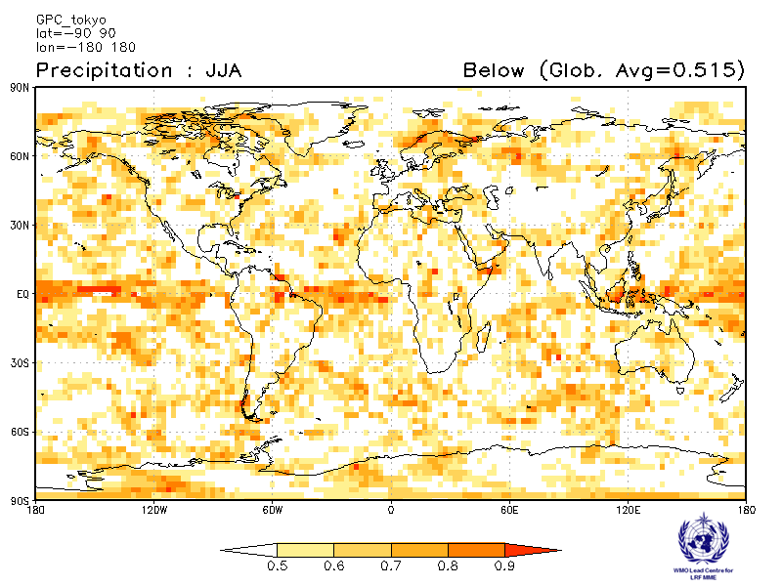

Toulouse Washington
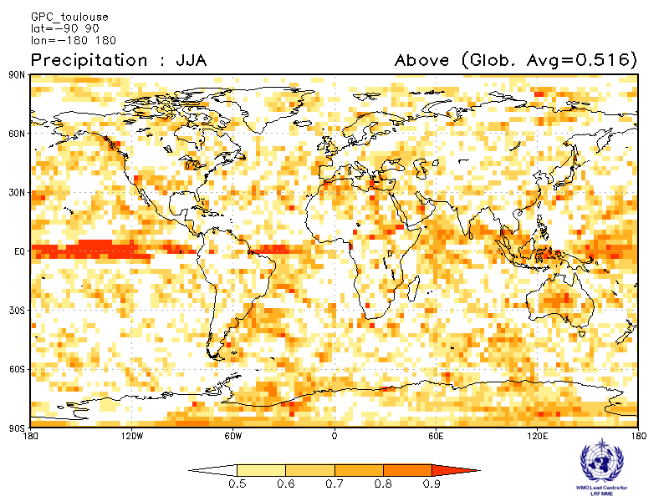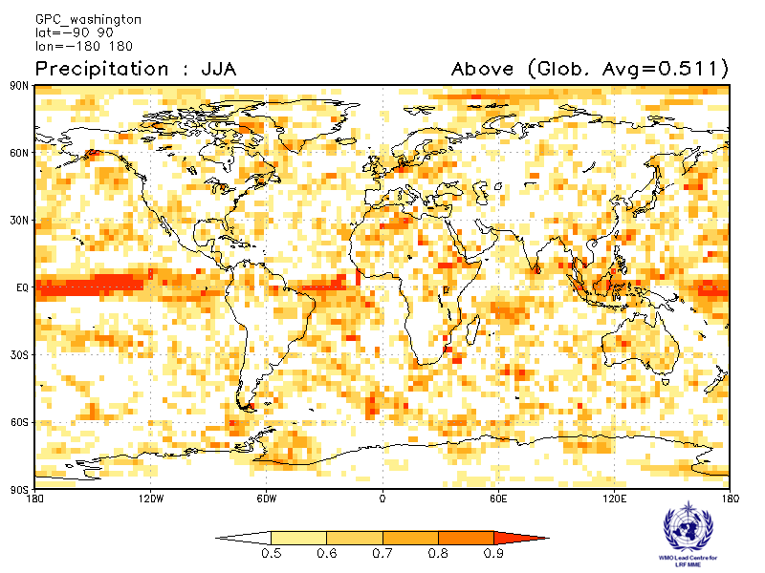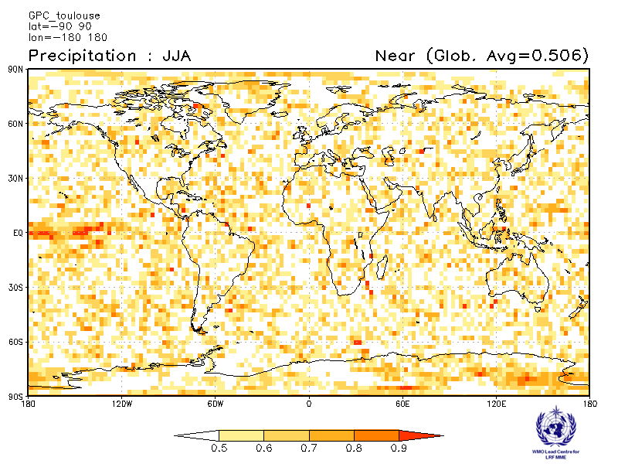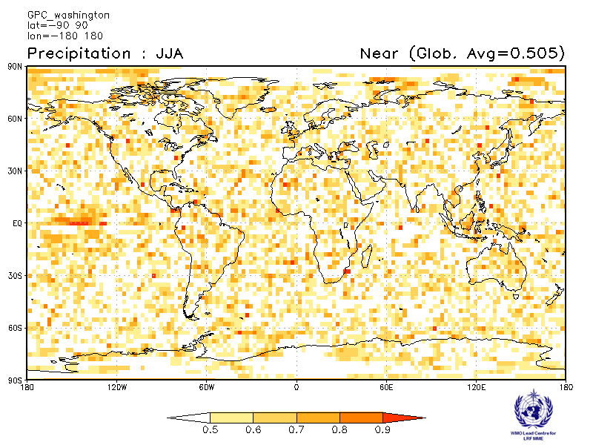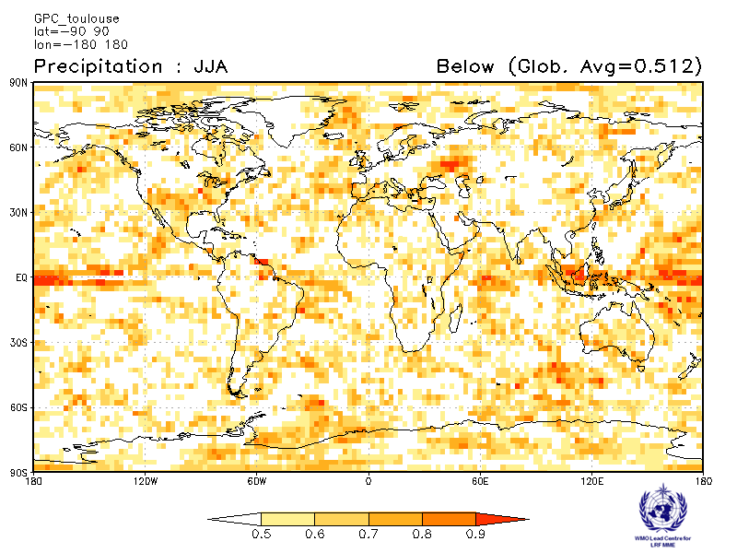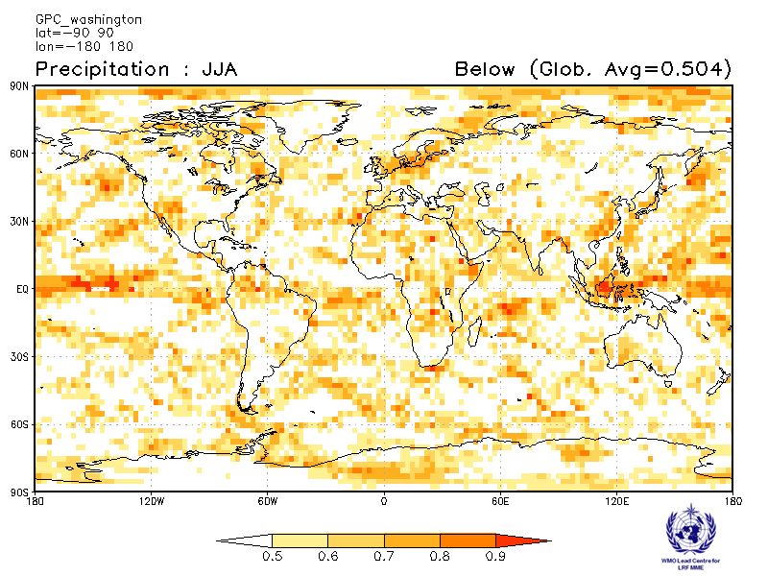

2.2.9 Verification of GPC precipitation probabilistic forecasts, 1993-2009
Verification measure: Relative Operating Characteristics (ROC) Curve and Score over globe
Verification dataset: GPCP
PMME Beijing
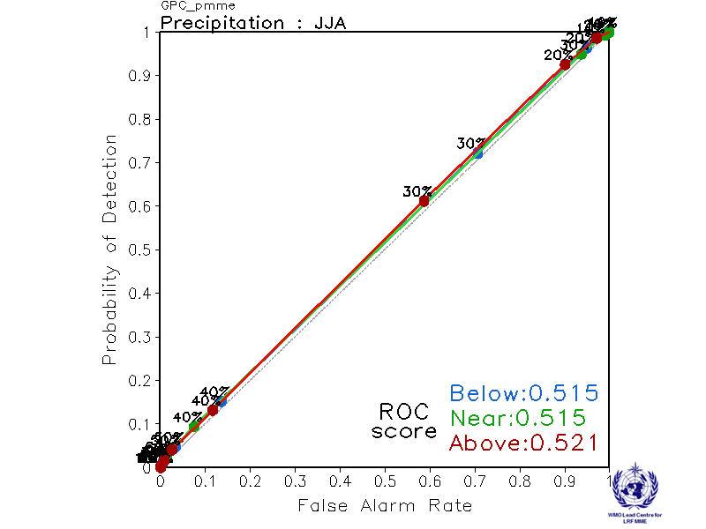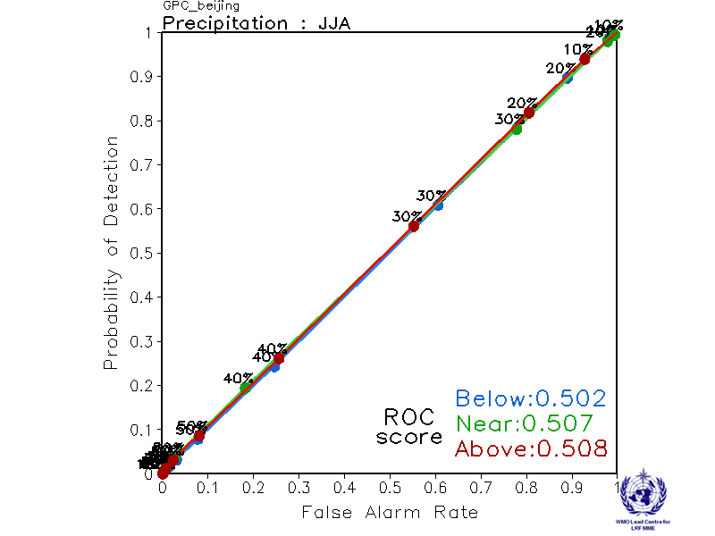
CPTEC ECMWF
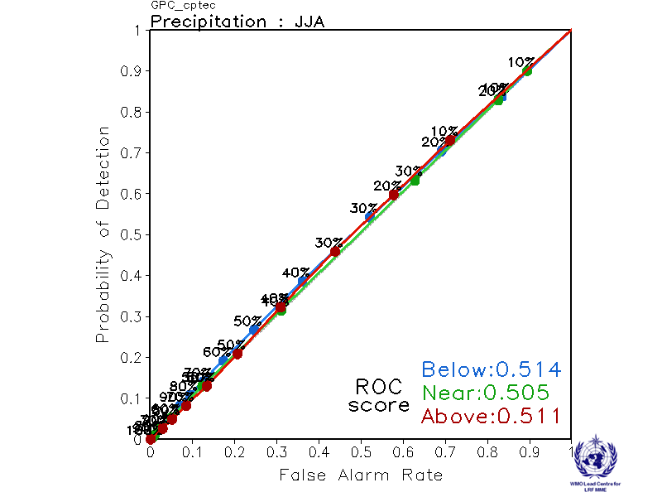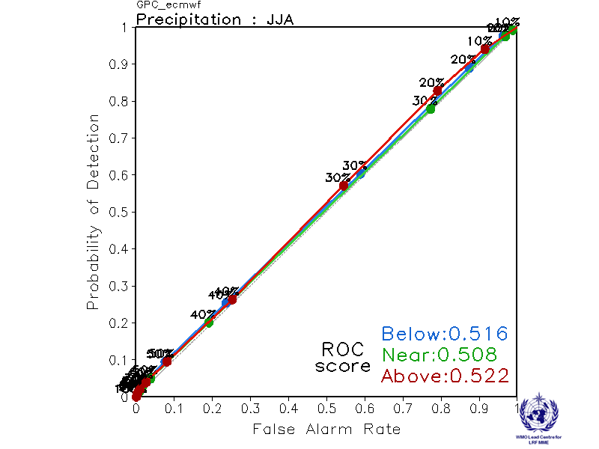

Exeter Melbourne
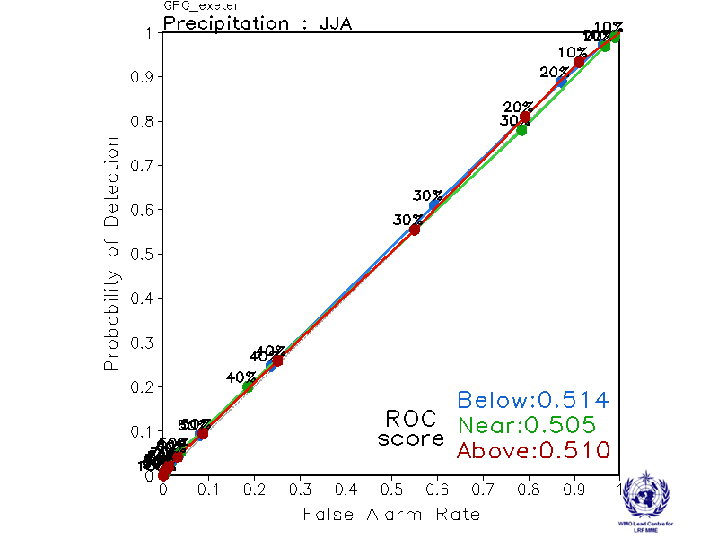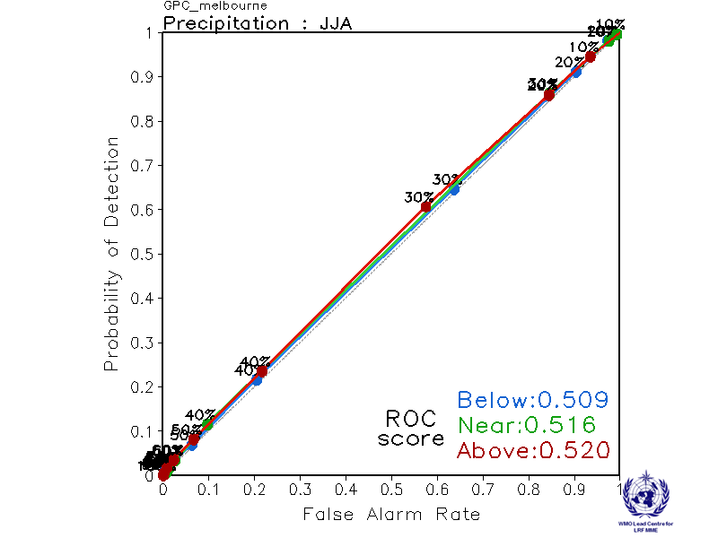

Montreal Moscow
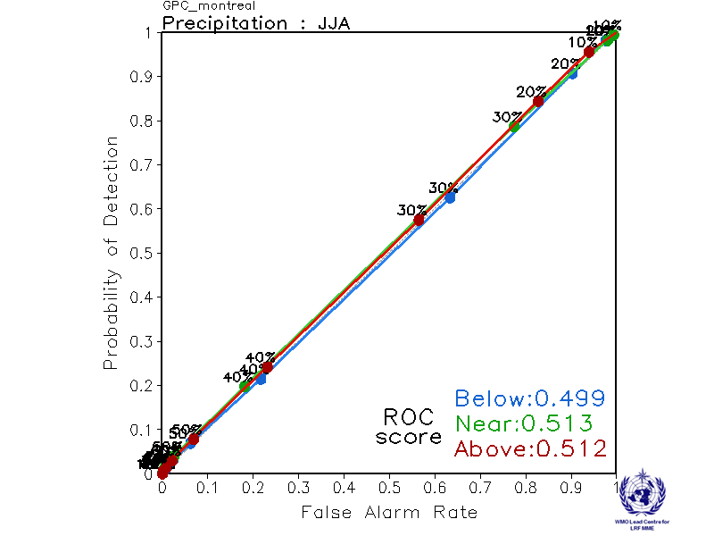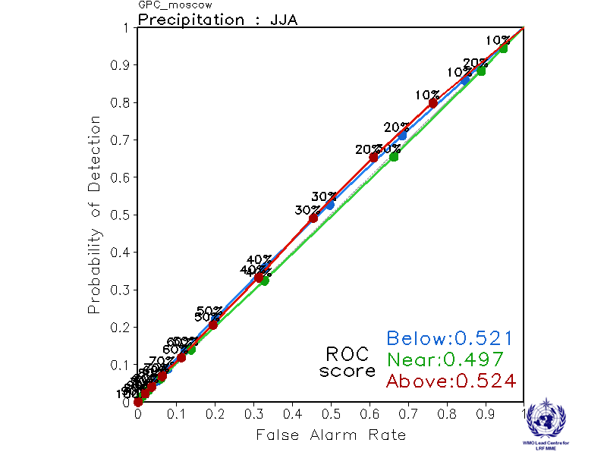

Offenbach Pretoria
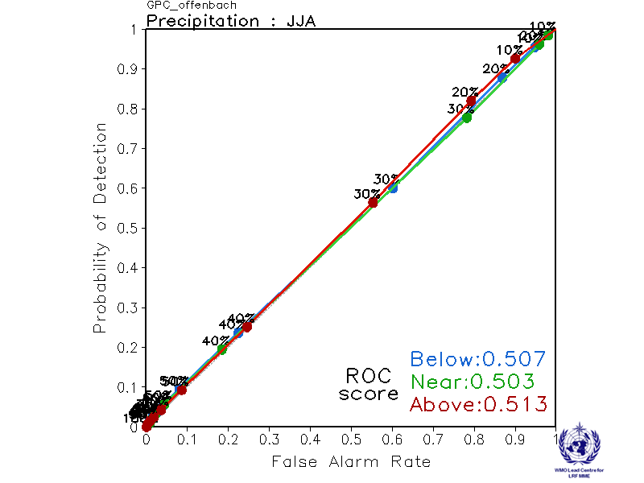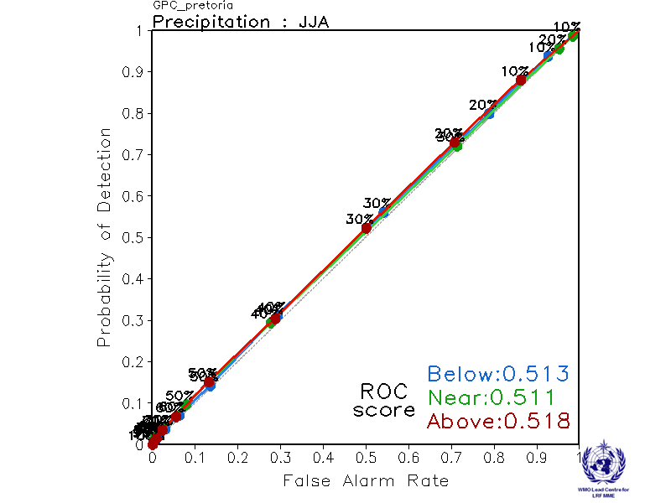

Seoul Tokyo
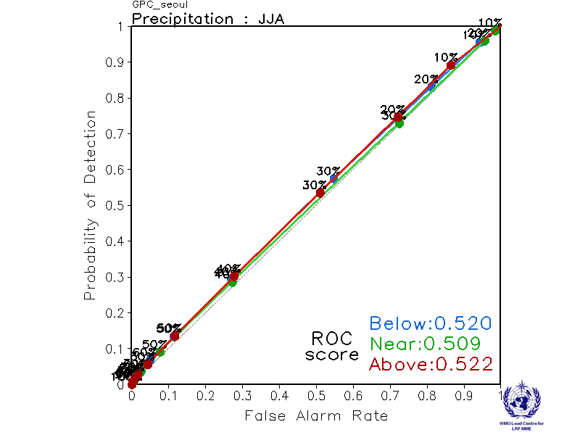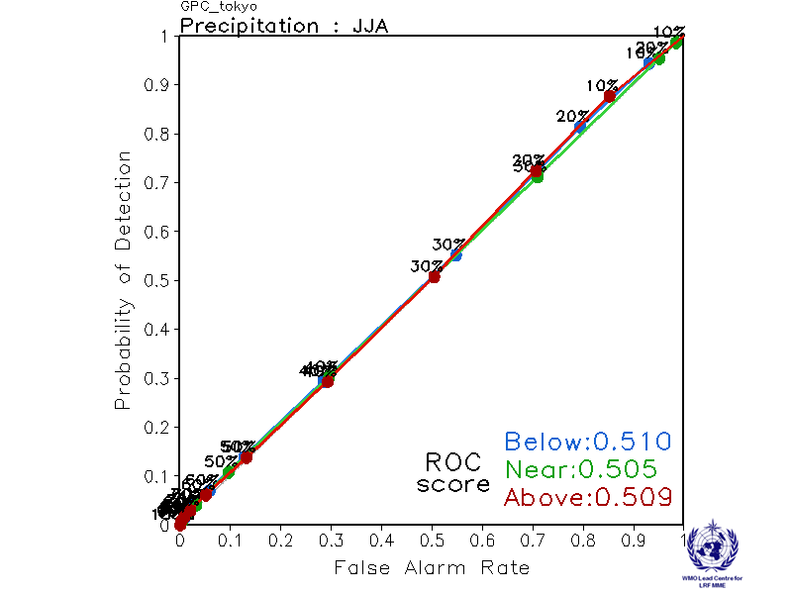

Toulouse Washington
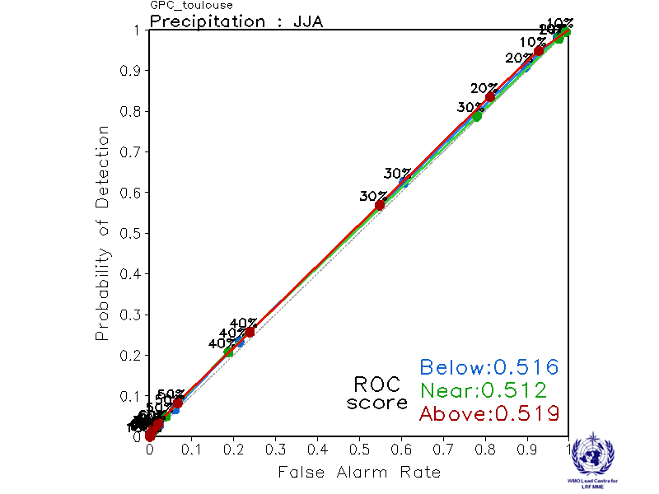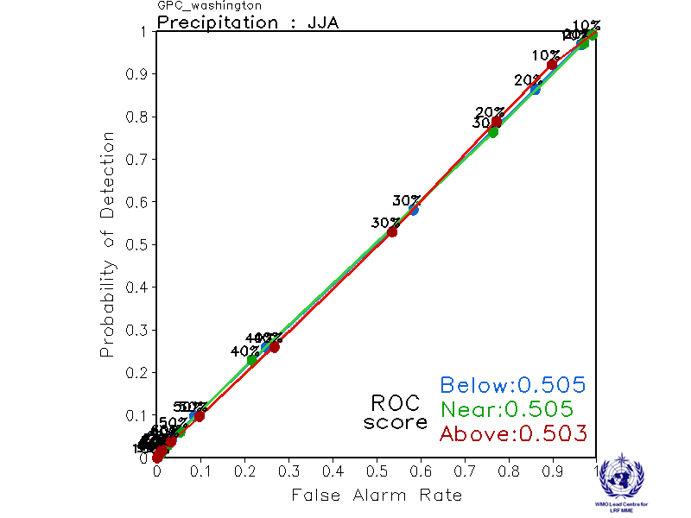

2.2.10 Verification of GPC precipitation probabilistic forecasts, 1993-2009
Verification measure: Reliability Diagram over globe
Verification dataset: GPCP
PMME Beijing
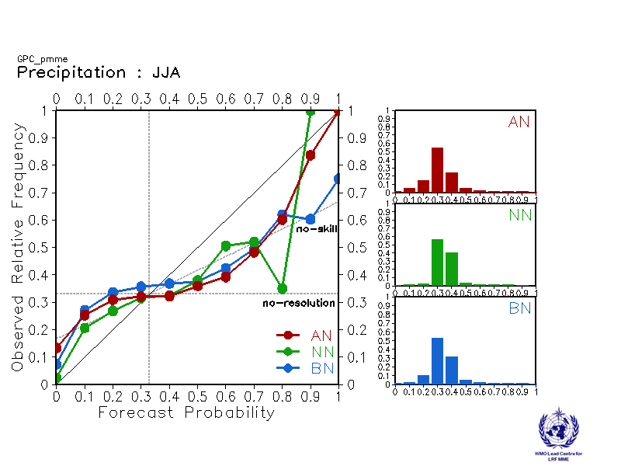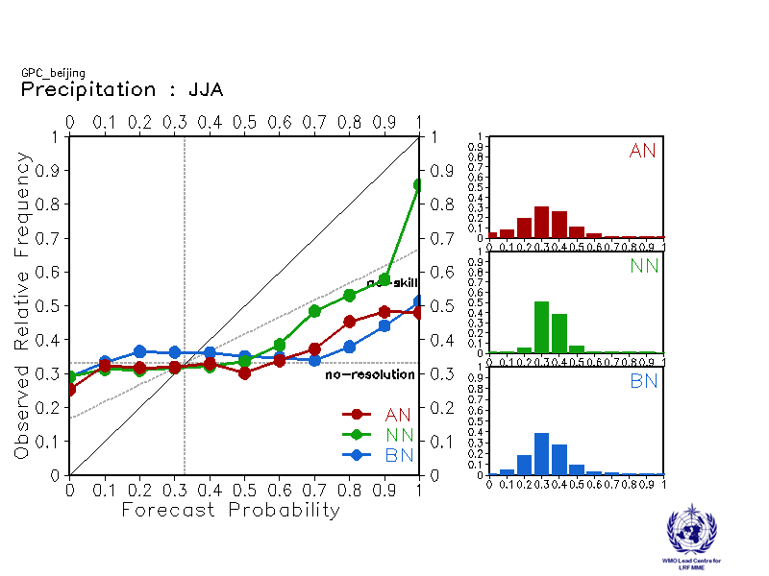
CPTEC ECMWF
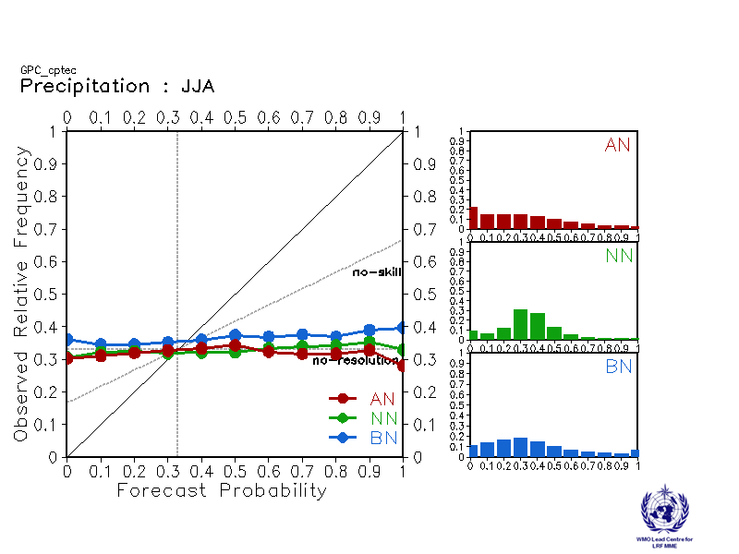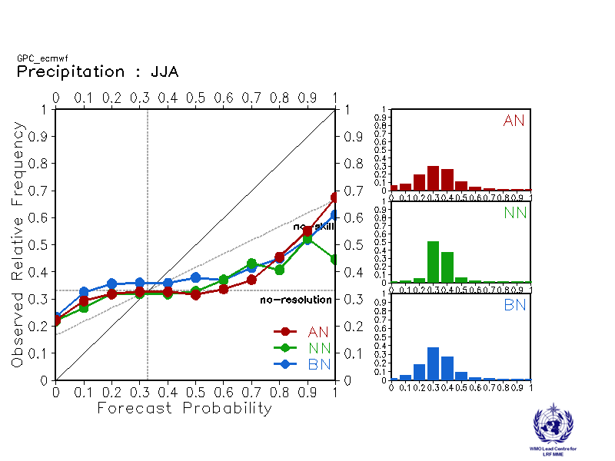

Exeter Melbourne
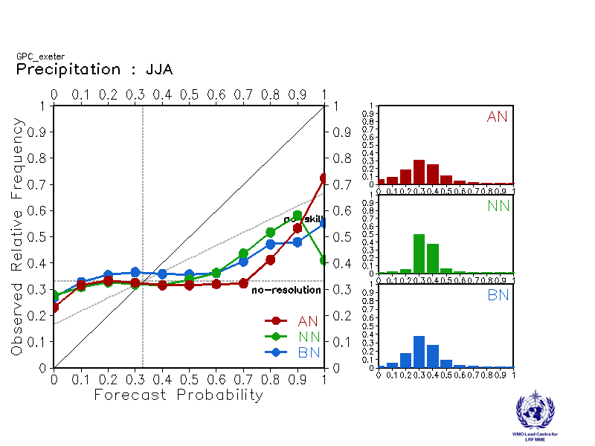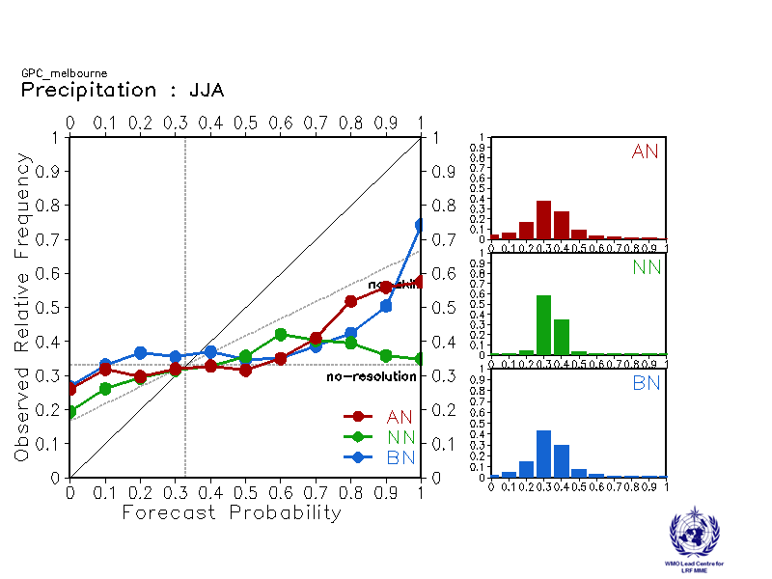

Montreal Moscow
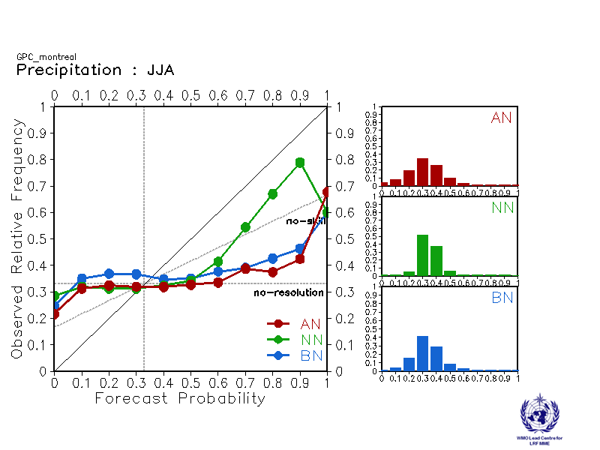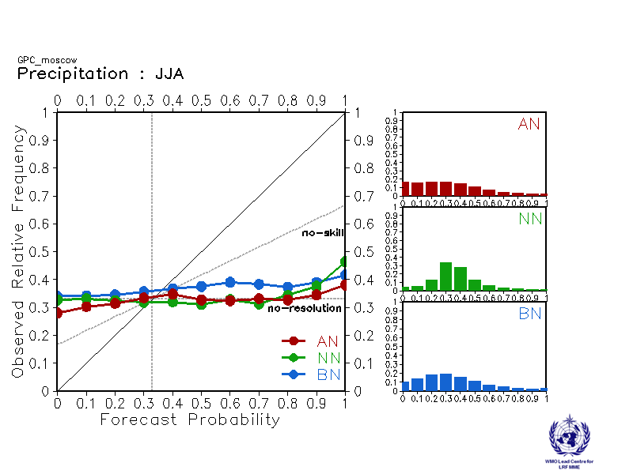

Offenbach Pretoria
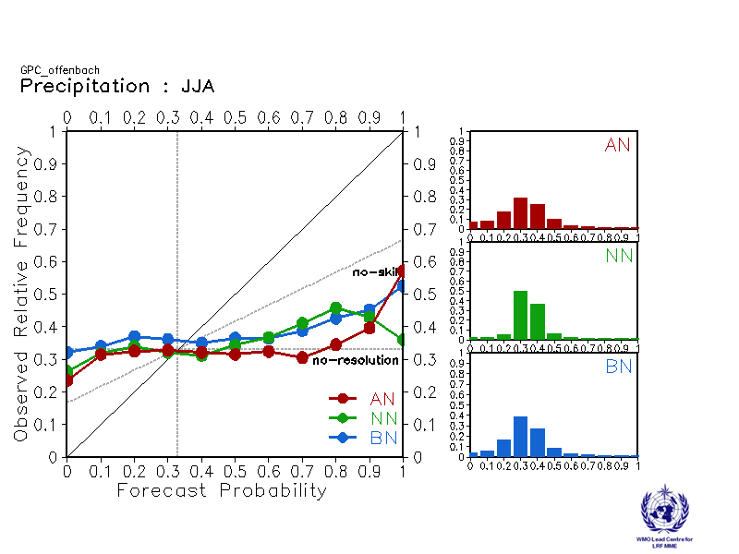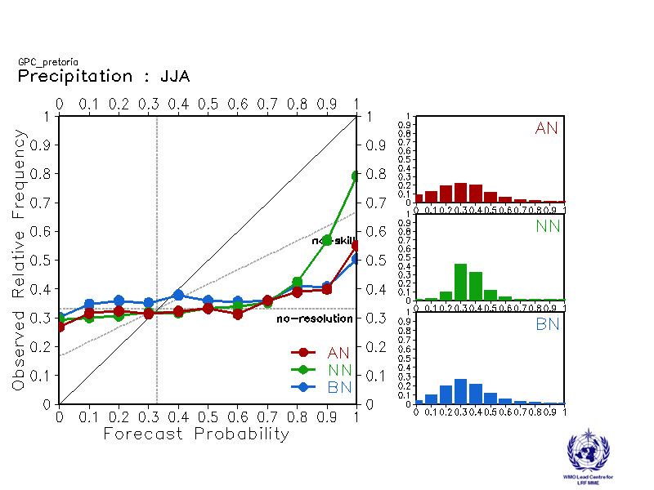

Seoul Tokyo
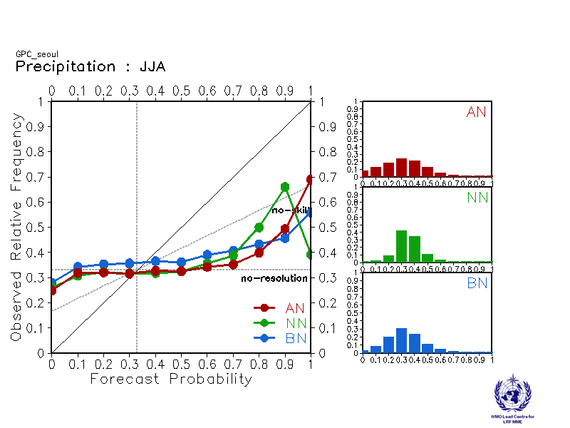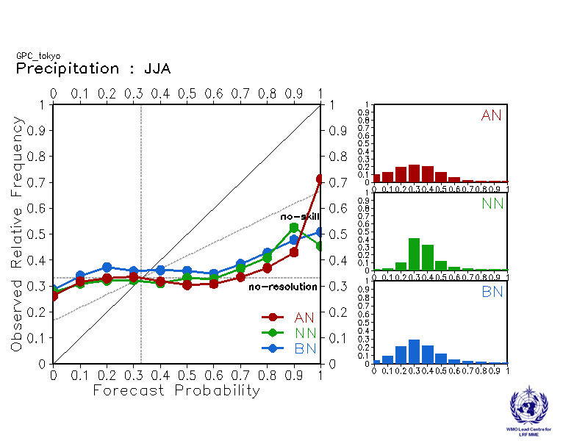

Toulouse Washington
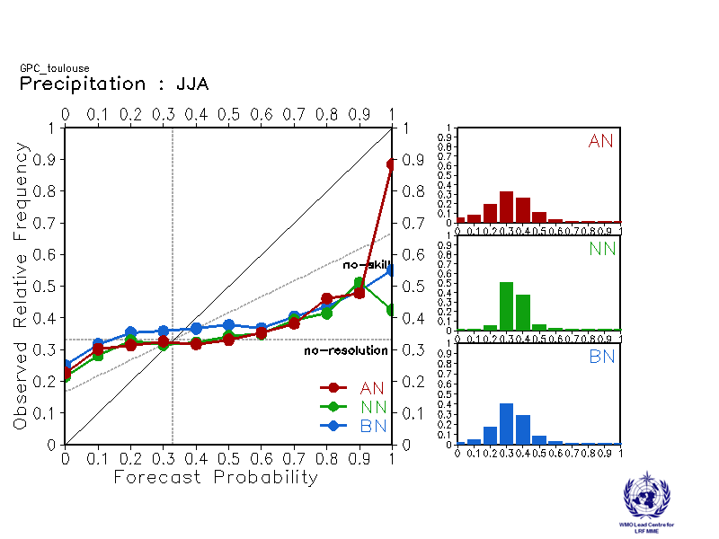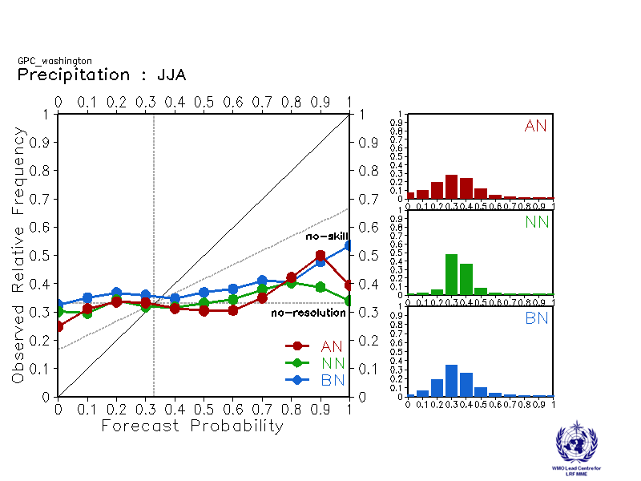

2.3 Sea Surface Temperature (SST)

2.3.1 Individual GPC ensemble mean forecasts of SST anomalies relative to 1993-2009

Beijing ECMWF
Baseline:1993-2009 Baseline:1993-2009
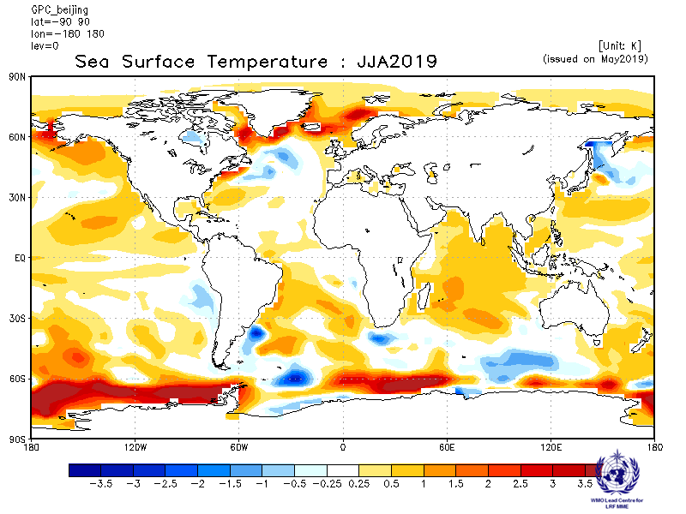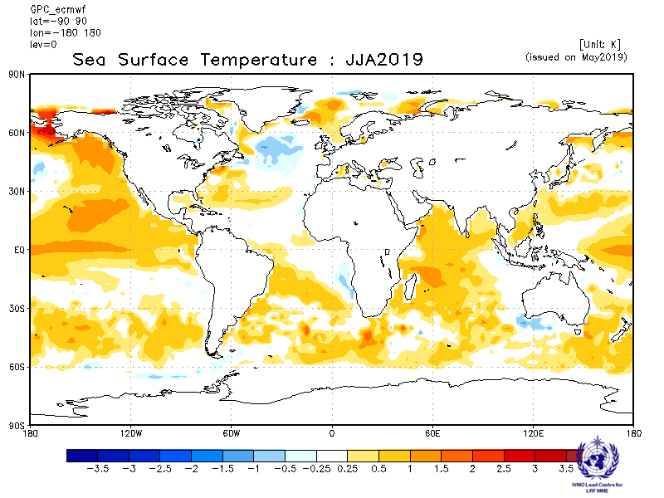

Exeter Melbourne
Baseline:1993-2009 Baseline:1993-2009
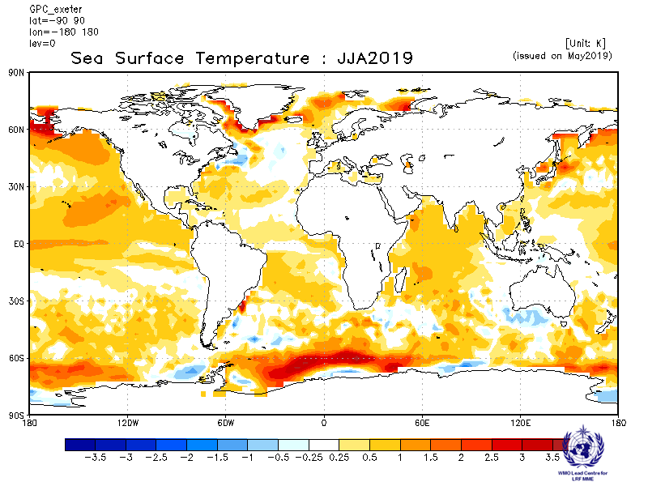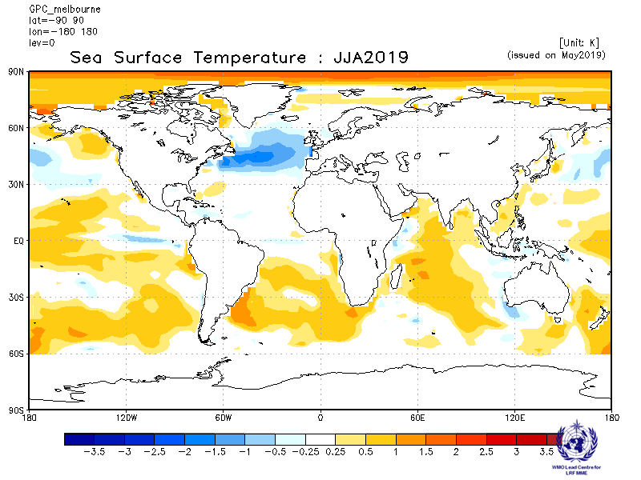

Montreal Moscow
Baseline:1993-2009 Baseline:1993-2009
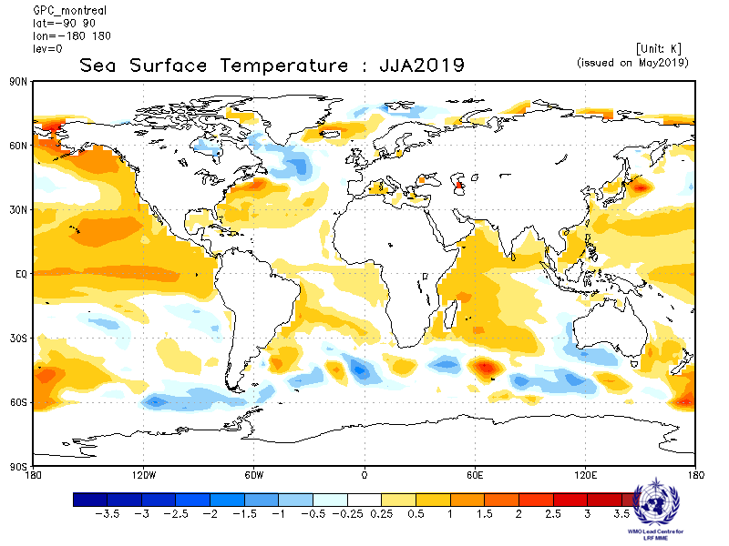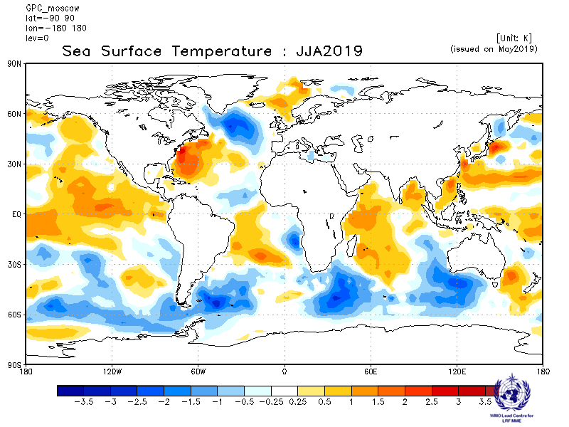

Offenbach Pretoria
Baseline:1993-2009 Baseline:1993-2009
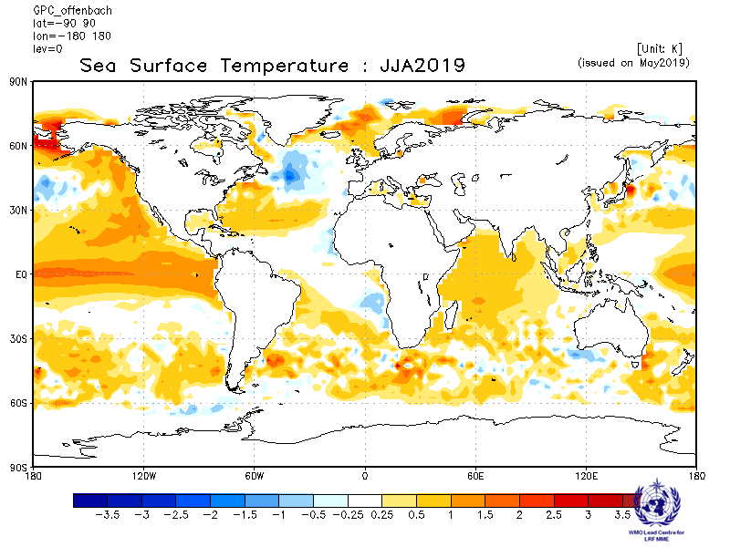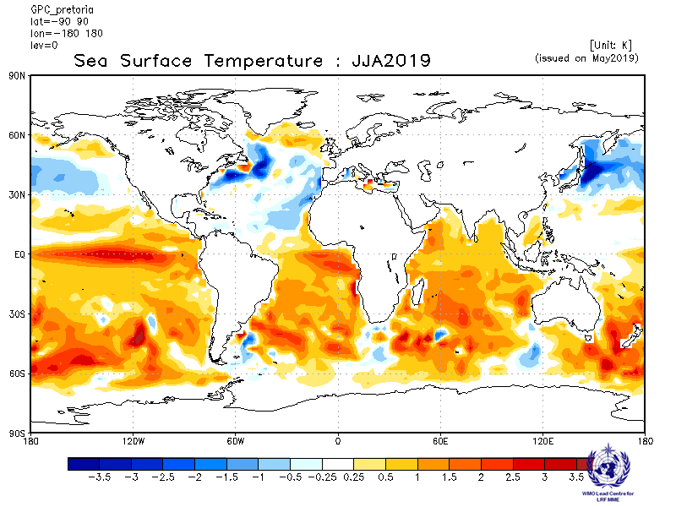

Seoul Tokyo
Baseline:1993-2009 Baseline:1993-2009
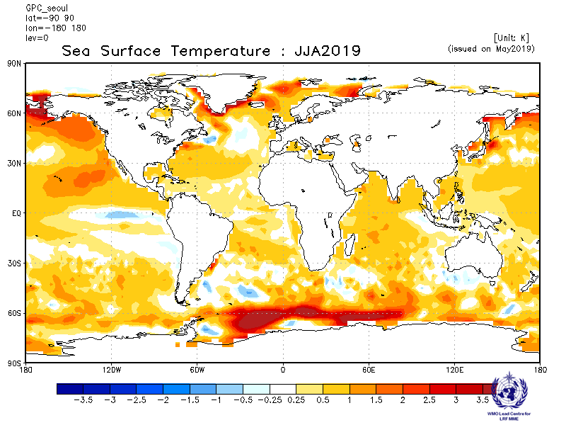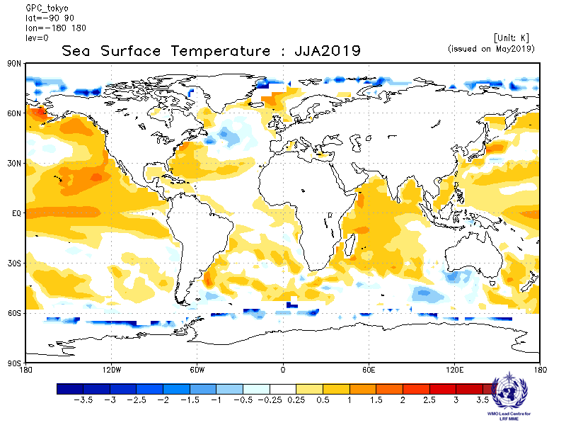

Toulouse Washington
Baseline:1993-2009 Baseline:1993-2009

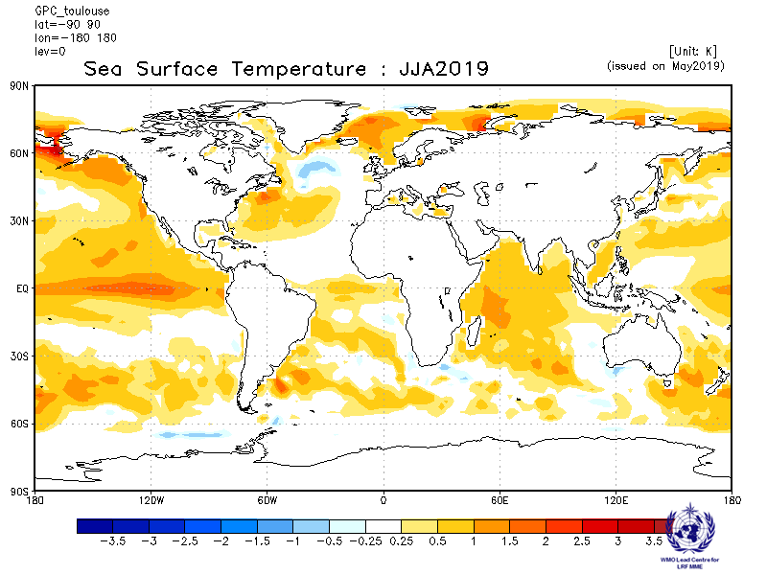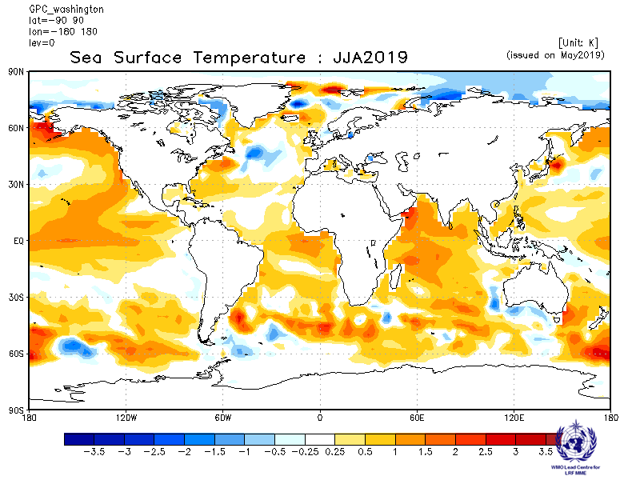

2.3.3 Forecast consistency map (12 GPCs): SST
(number of GPCs with positive/negative ensemble mean anomalies – relative to own baseline)
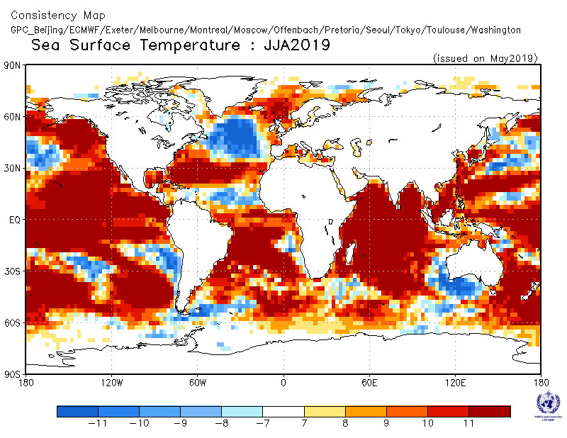
2.3.4 DMME (12 GPCs), using the same baseline for all models (1993-2009): SST

Ensemble mean anomaly
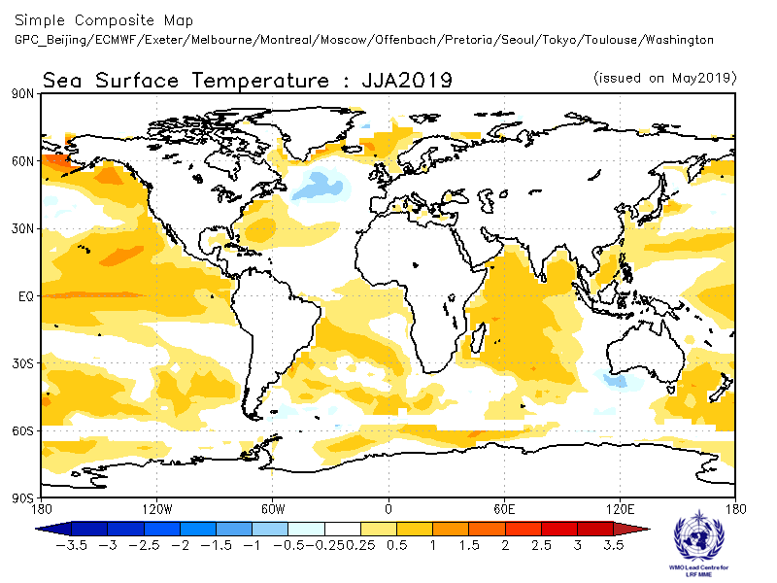

2.3.5 DMME (12 GPCs), for each model using its own baseline: SST

Ensemble mean anomaly
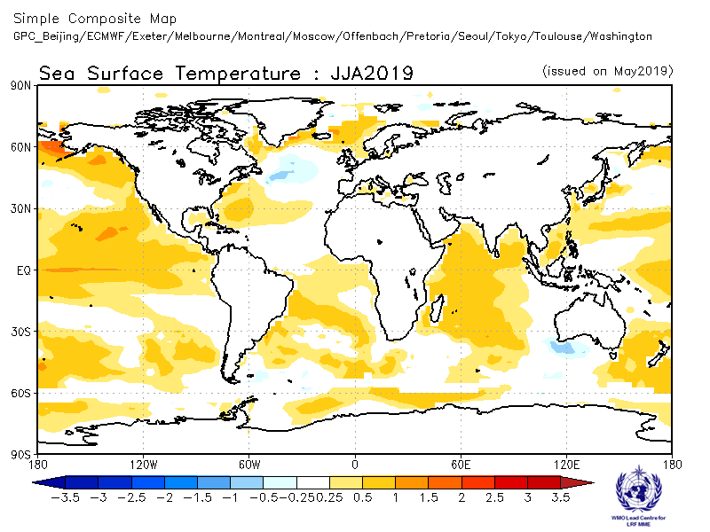

2.3.6 Verification of GPC ensemble mean SST anomaly forecasts, 1993-2009
Verification measure: Anomaly Correlation Coefficient (ACC)
Verification dataset: Reynolds SST
DMME Beijing
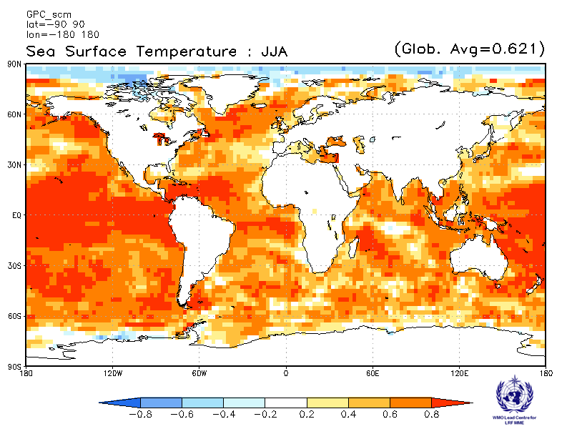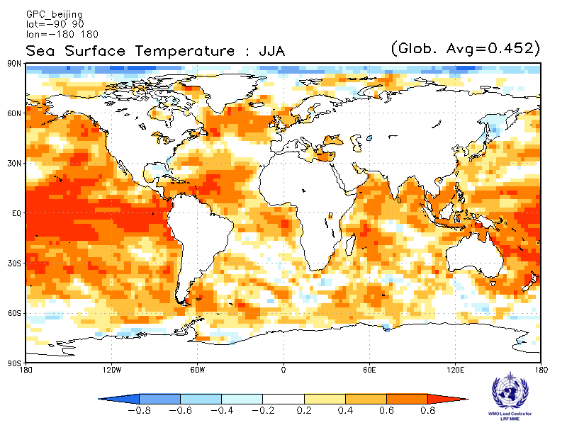

ECMWF Exeter
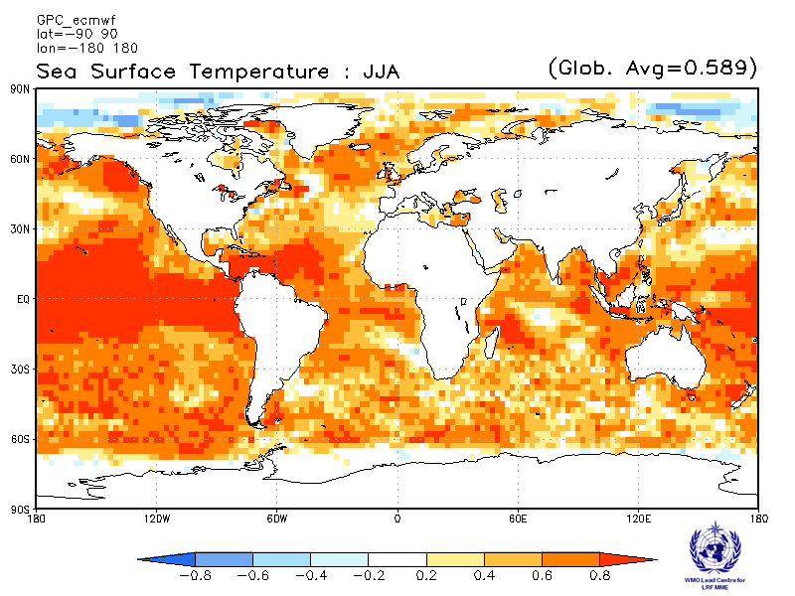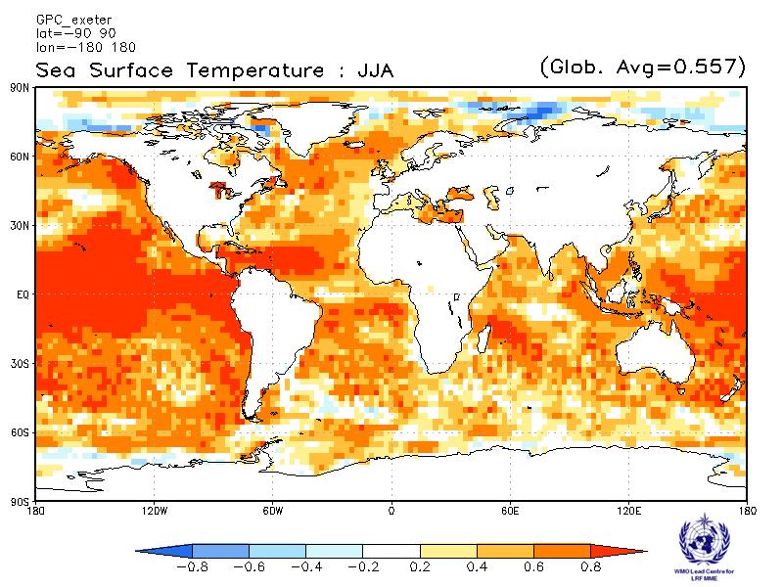
Melbourne Montreal
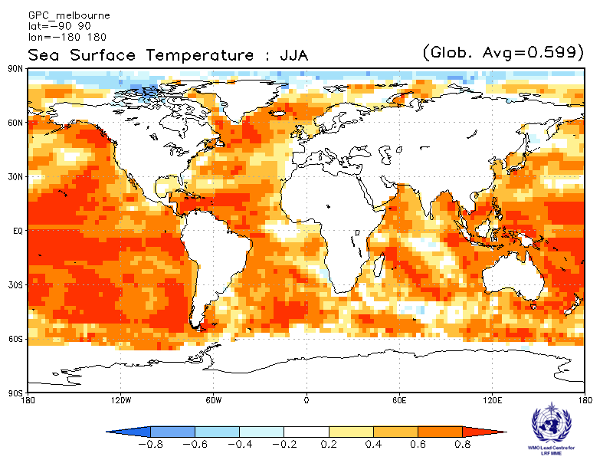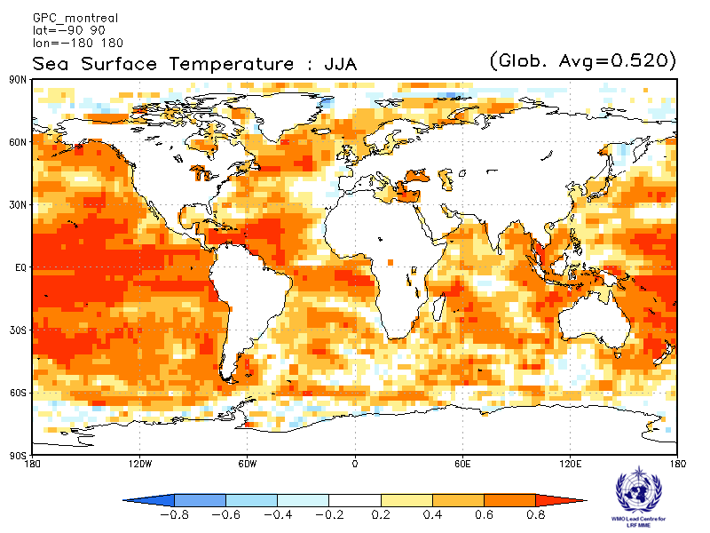
Moscow Offenbach
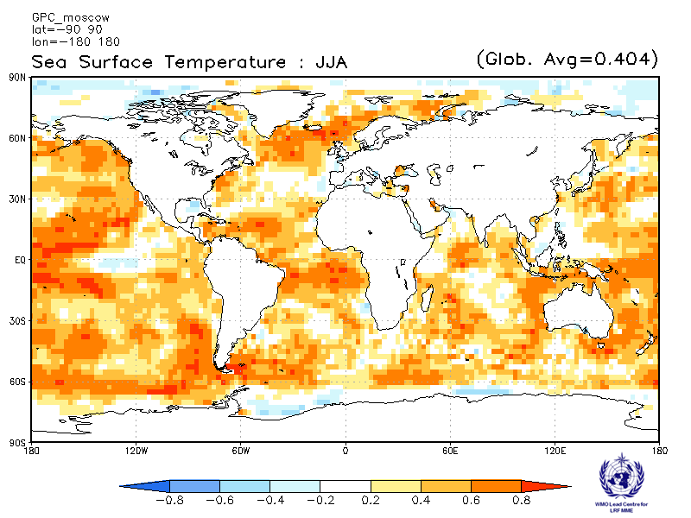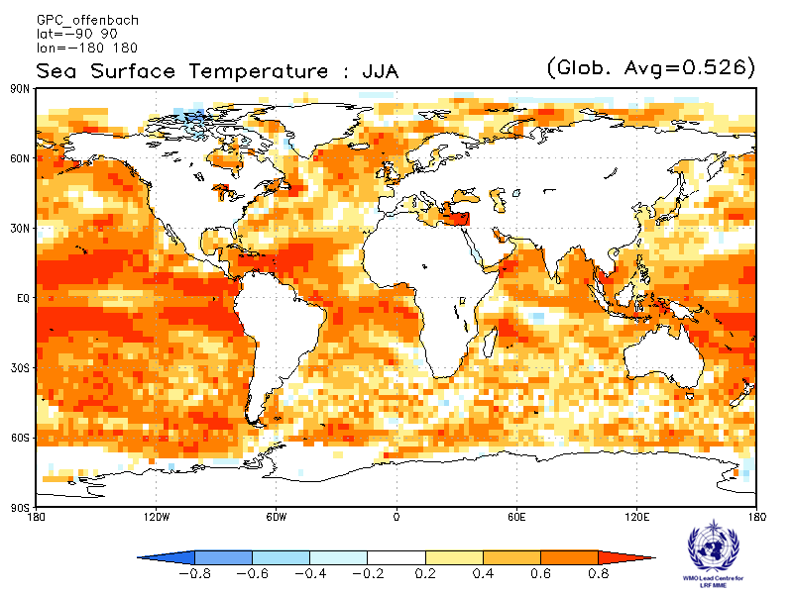
Pretoria Seoul
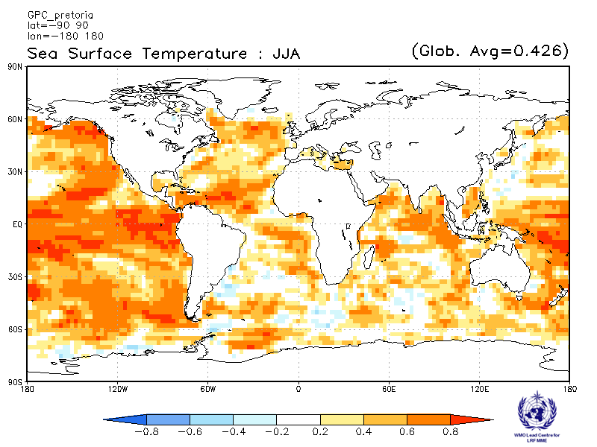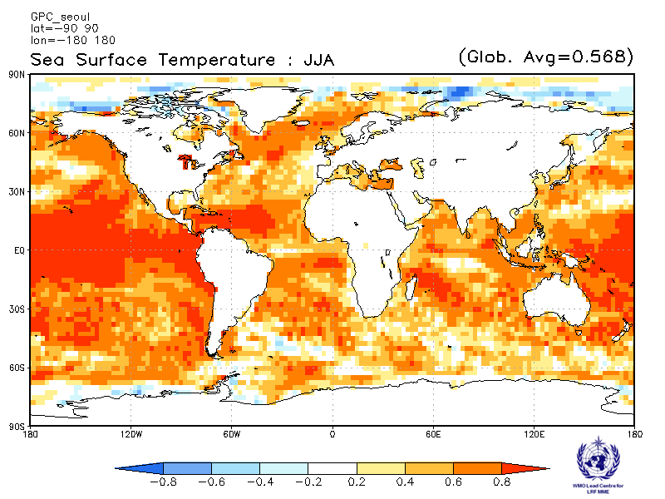
Tokyo Toulouse
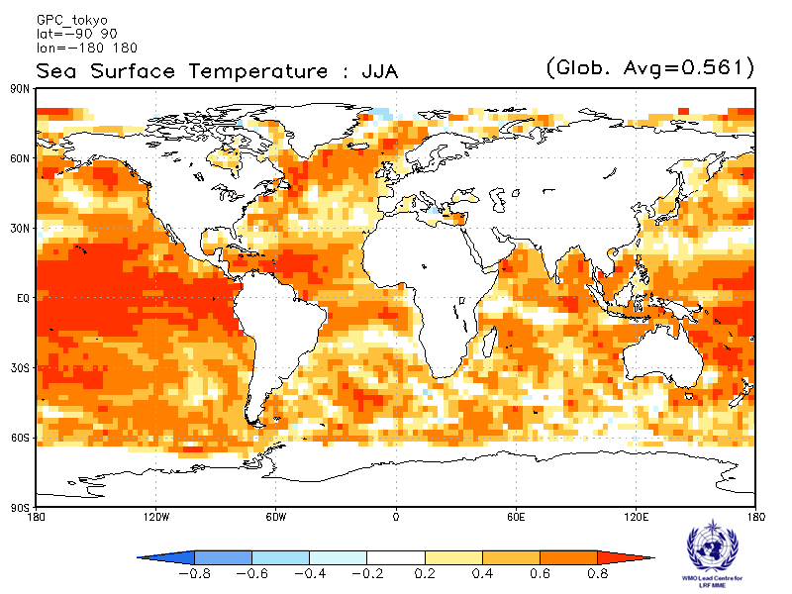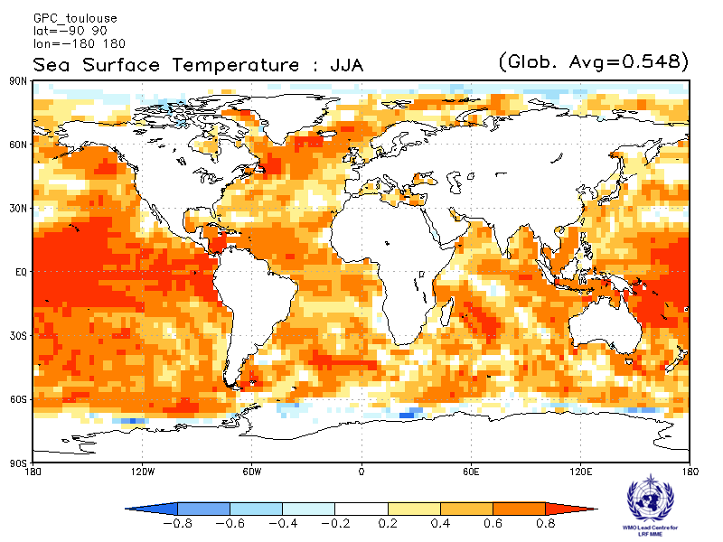
Washington
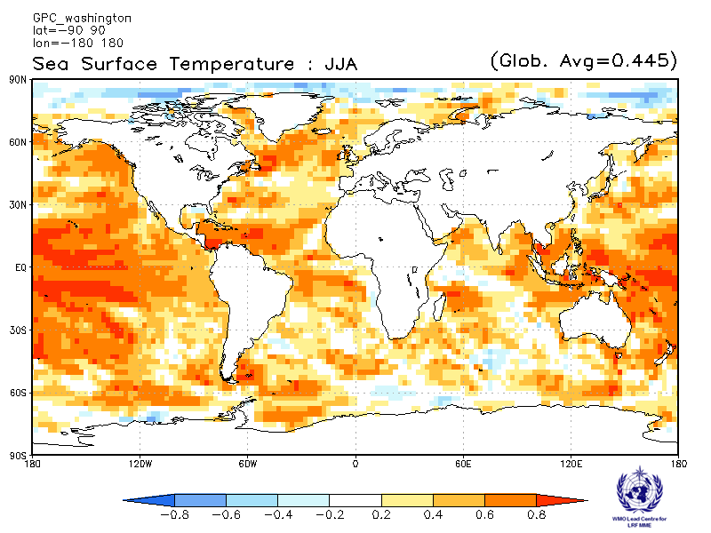

2.4 500 hPa Geopotential Height

2.4.1 Individual GPC ensemble mean forecasts of 500hPa height anomalies relative to 1993-2009
Beijing CPTEC
Baseline:1993-2009 Baseline:1993-2009
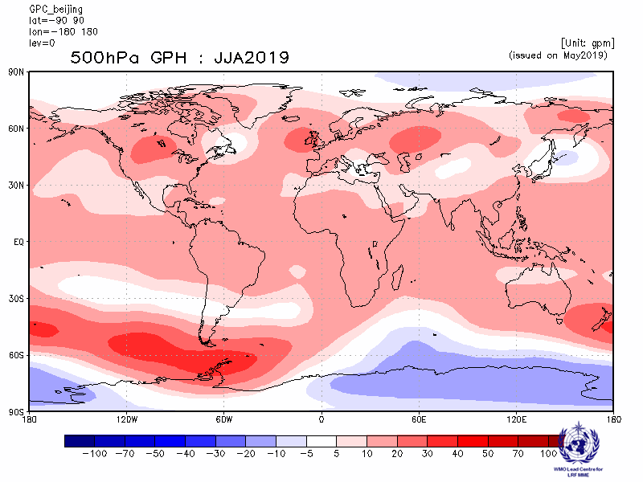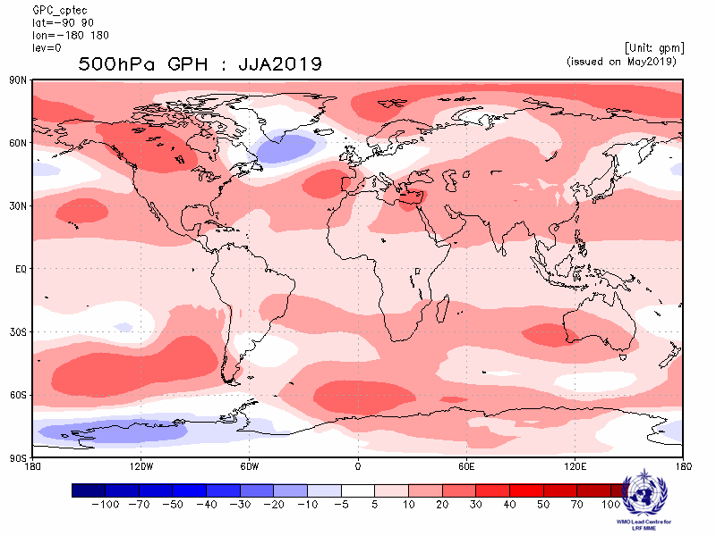
ECMWF Exeter
Baseline:1993-2009 Baseline:1993-2009
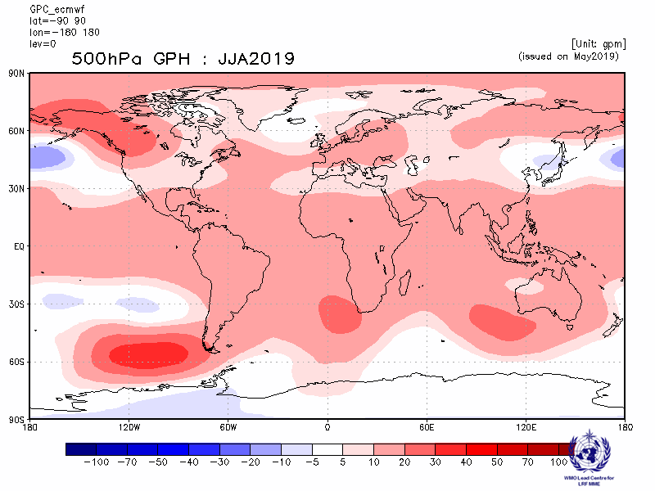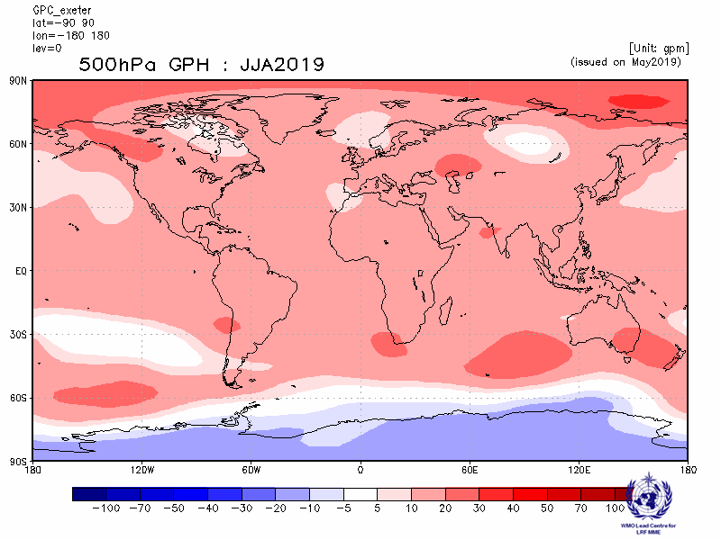
Melbourne Montreal
Baseline:1993-2009 Baseline:1993-2009
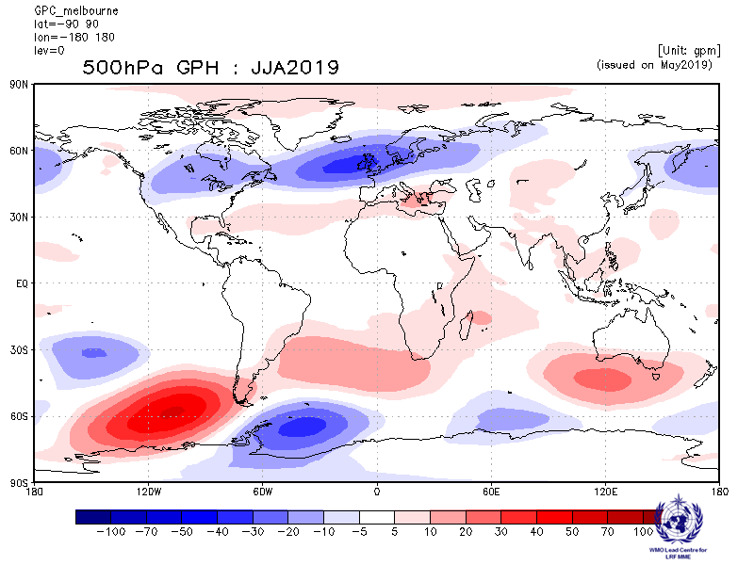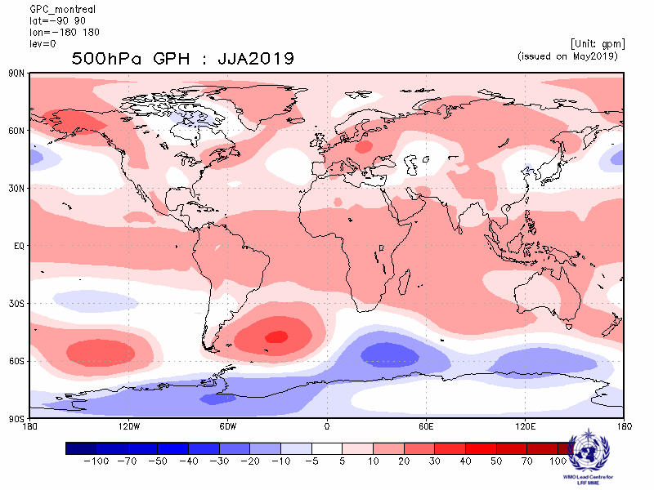
Moscow Offenbach
Baseline:1993-2009 Baseline:1993-2009
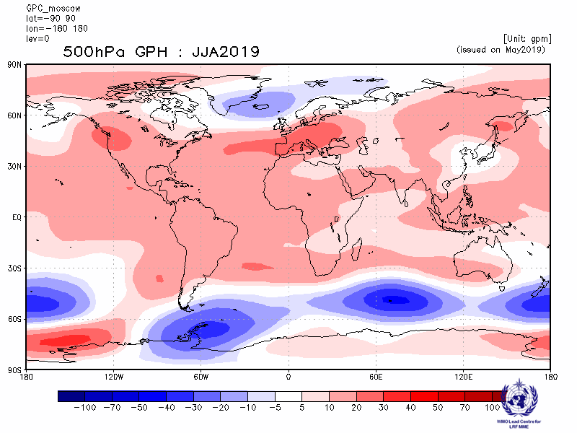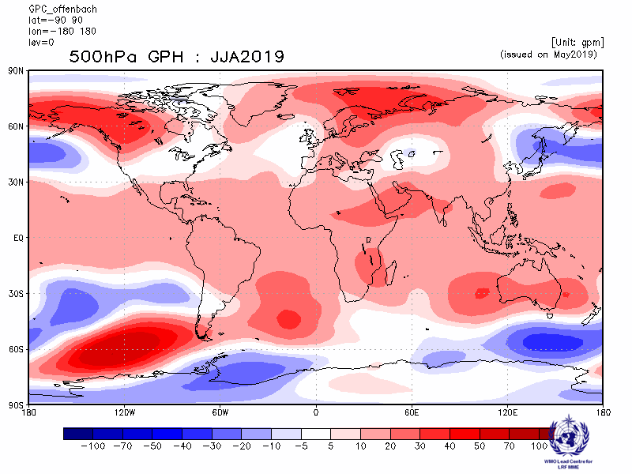
Pretoria Seoul
Baseline:1993-2009 Baseline:1993-2009
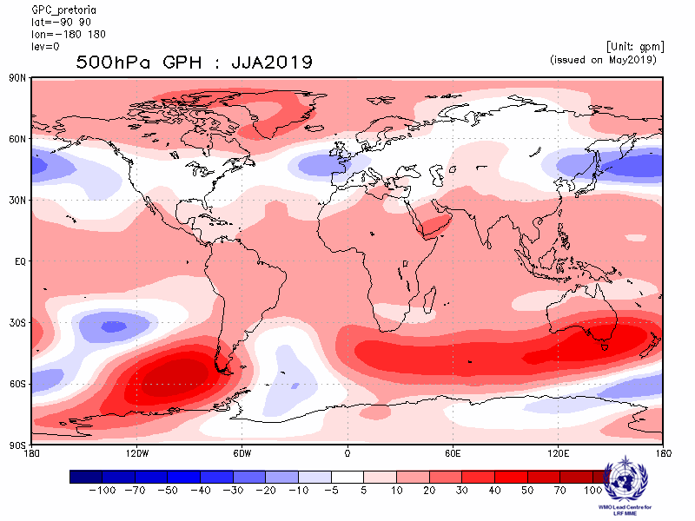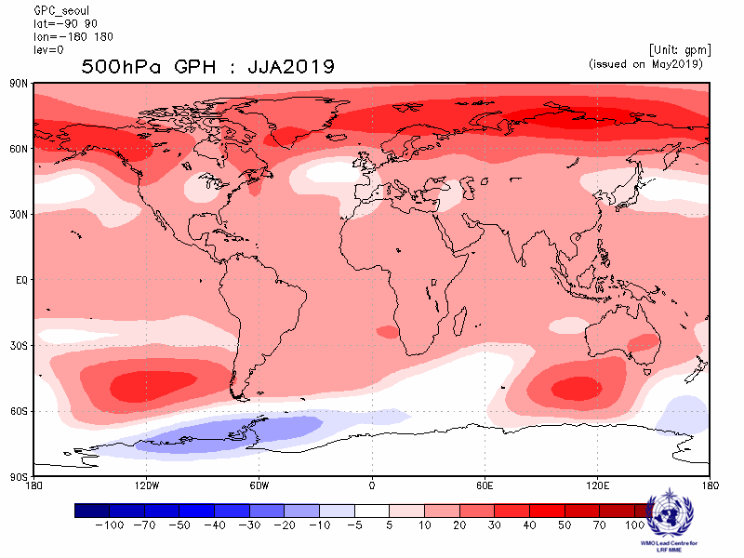
Tokyo Toulouse
Baseline:1993-2009 Baseline:1993-2009
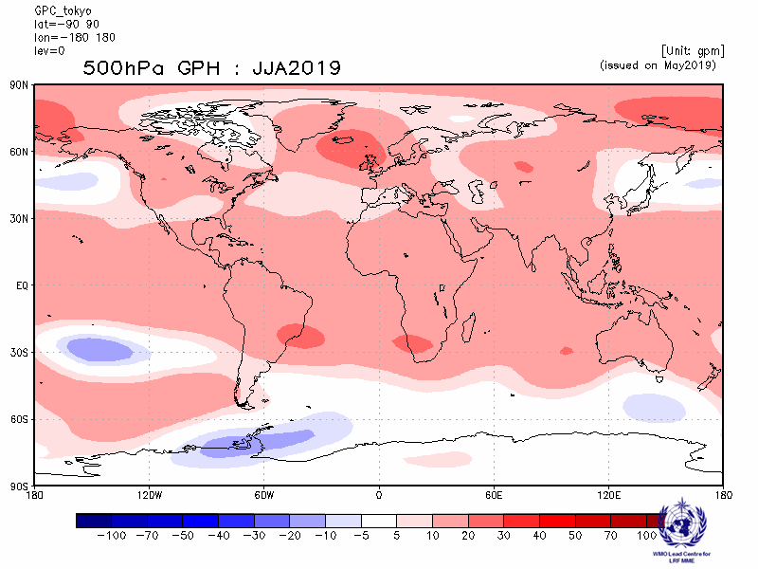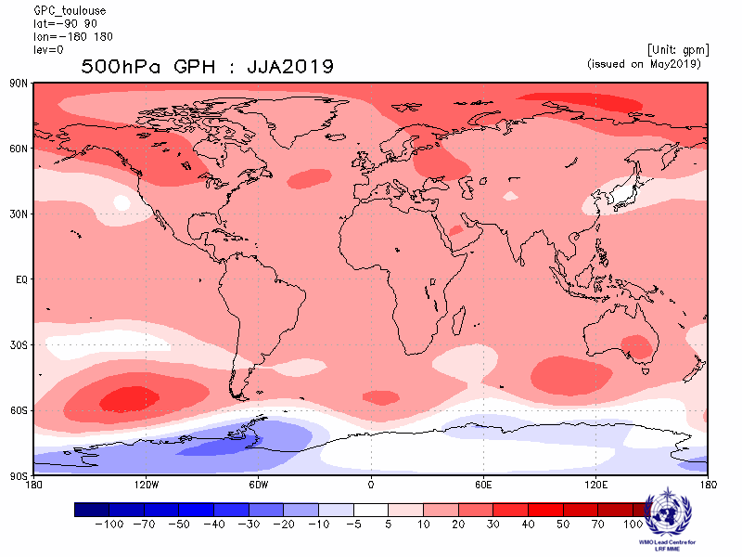
Washington
Baseline:1993-2009
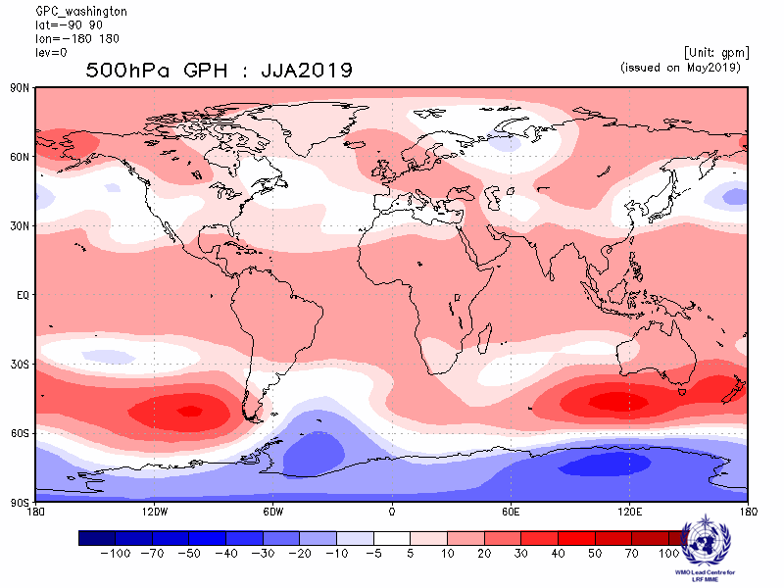

2.4.3 Forecast consistency map (13 GPCs): 500hPa height
(number of GPCs with positive/negative ensemble mean anomalies – relative to own baseline)
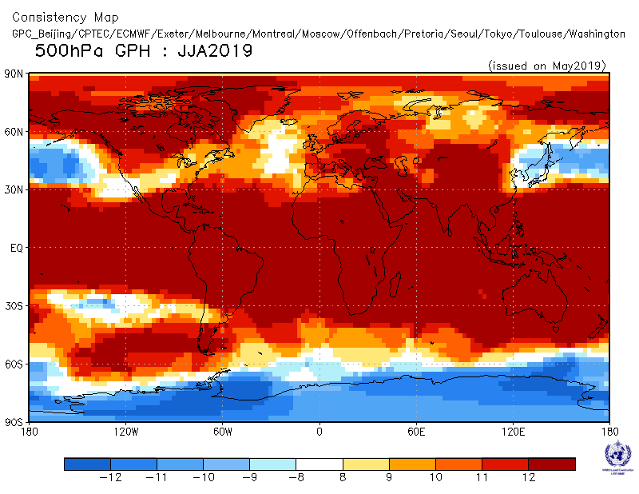

2.4.4 DMME (13 GPCs), using the same baseline for all models (1993-2009): 500hPa height

Ensemble mean anomaly
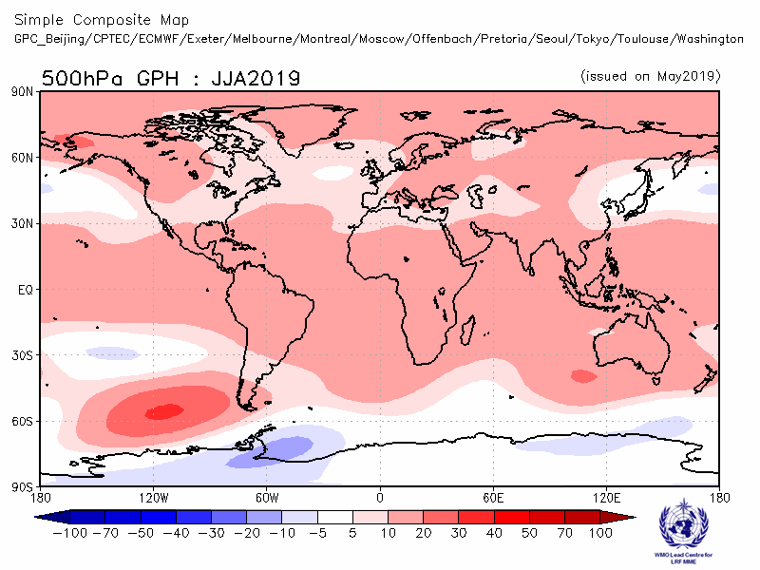

2.4.5 DMME (13 GPCs), for each model using its own baseline: 500hPa height
Ensemble mean anomaly
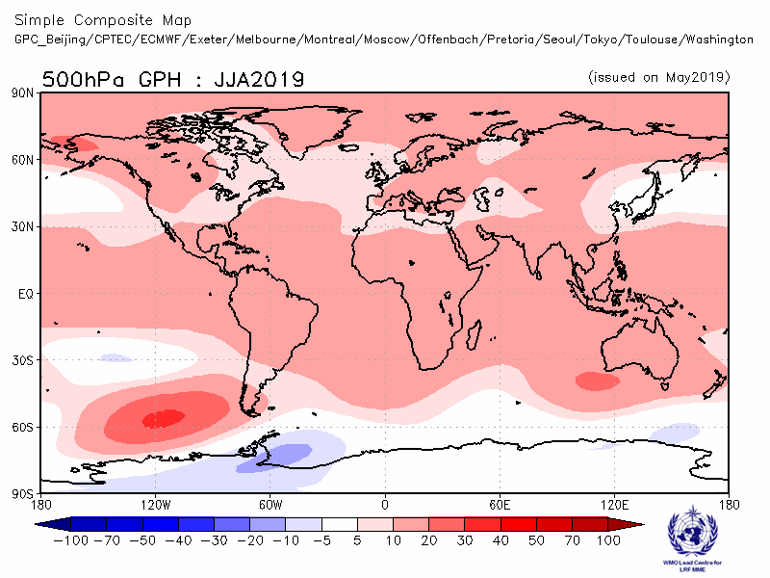

2.4.6 PMME (13 GPCs), using the same baseline for all models (1993-2009): 500hPa height
Probability of most likely tercile category
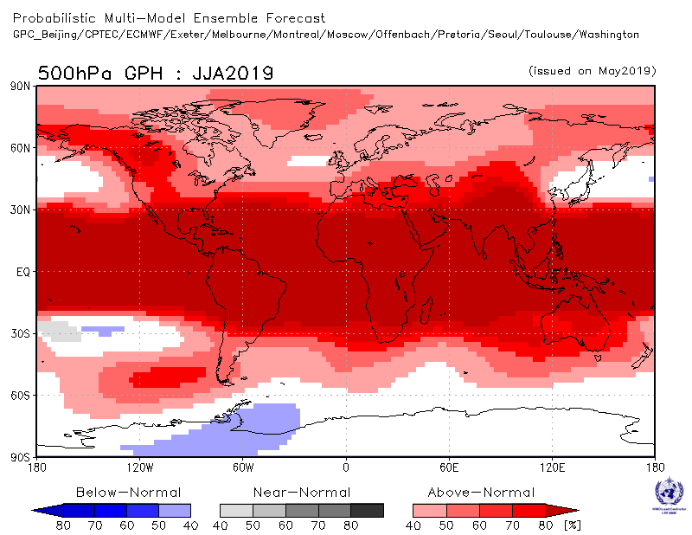

2.4.7 Verification of GPC ensemble mean 500hPa height anomaly forecasts, 1993-2009
Verification measure: Anomaly Correlation Coefficient (ACC)
Verification dataset: ERA-Interim
DMME Beijing
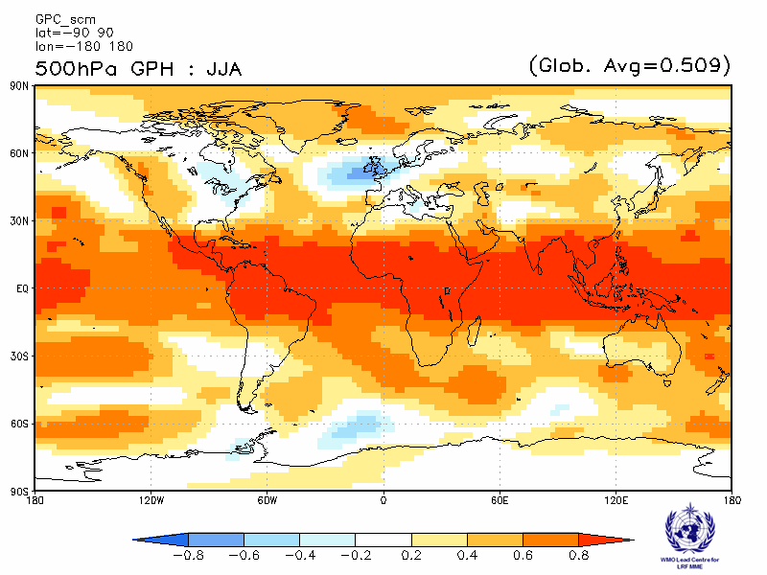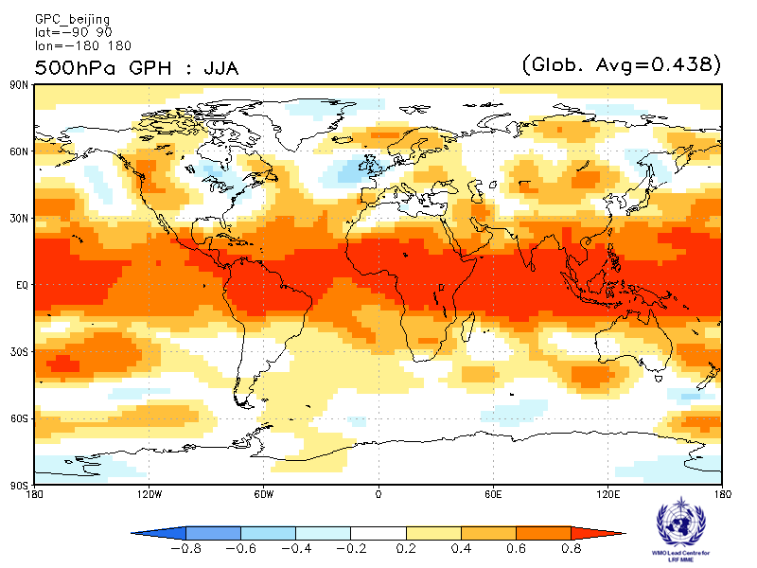
CPTEC ECMWF
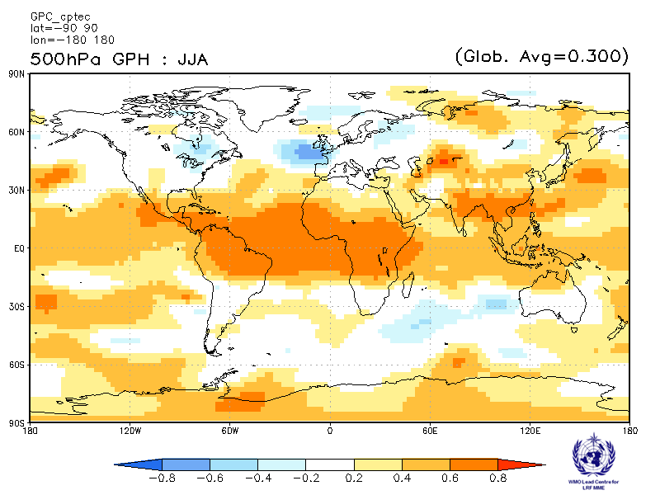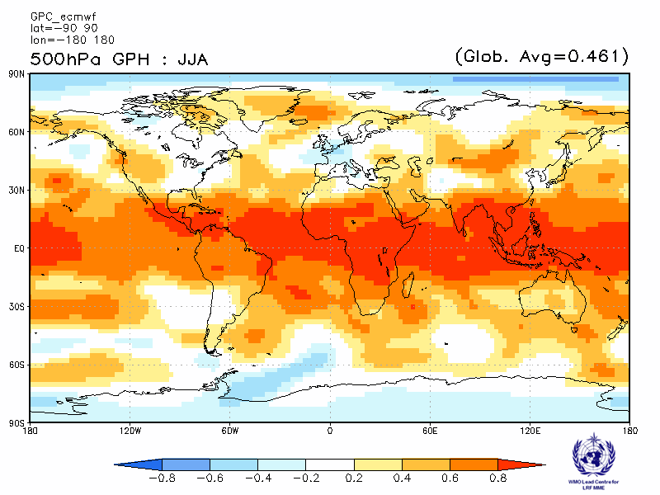

Exeter Melbourne
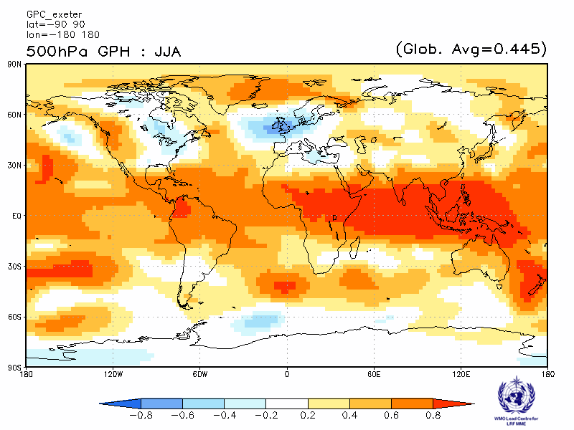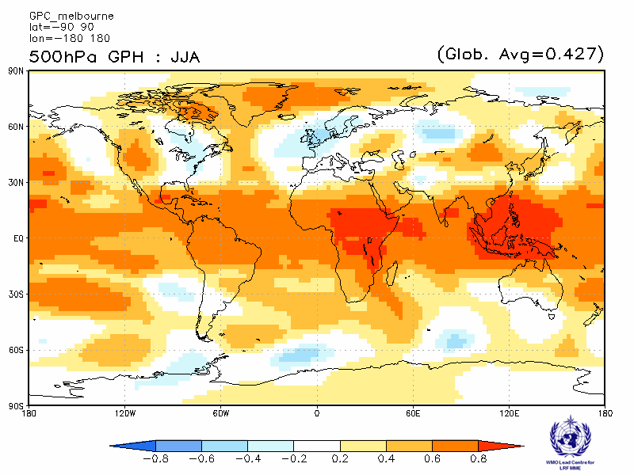

Montreal Moscow
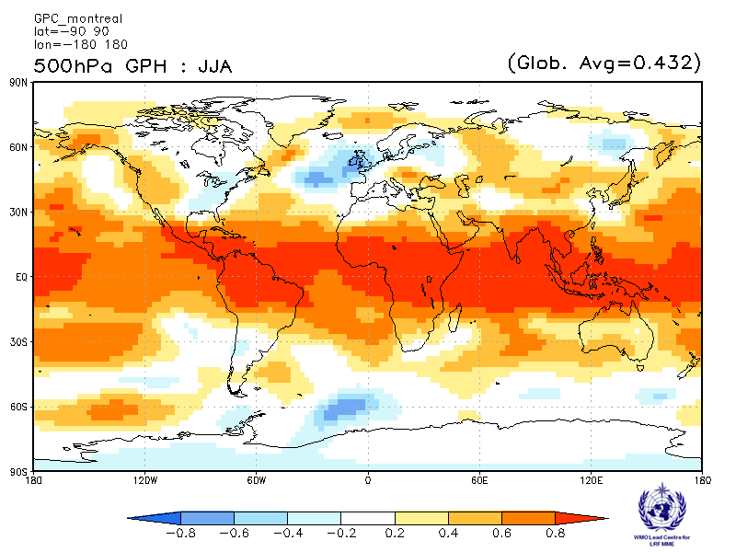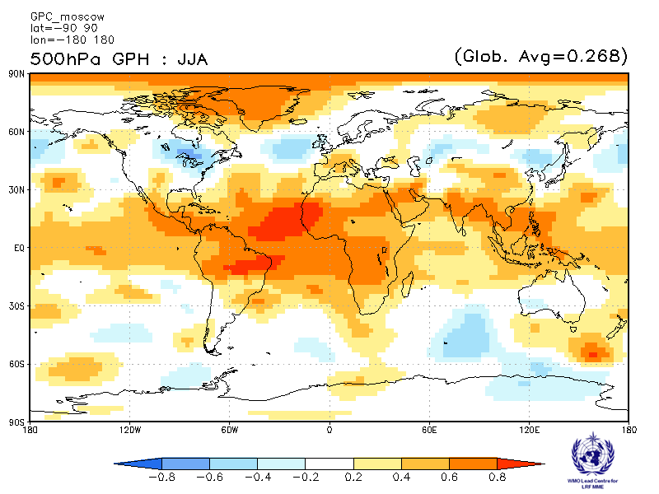

Offenbach Pretoria
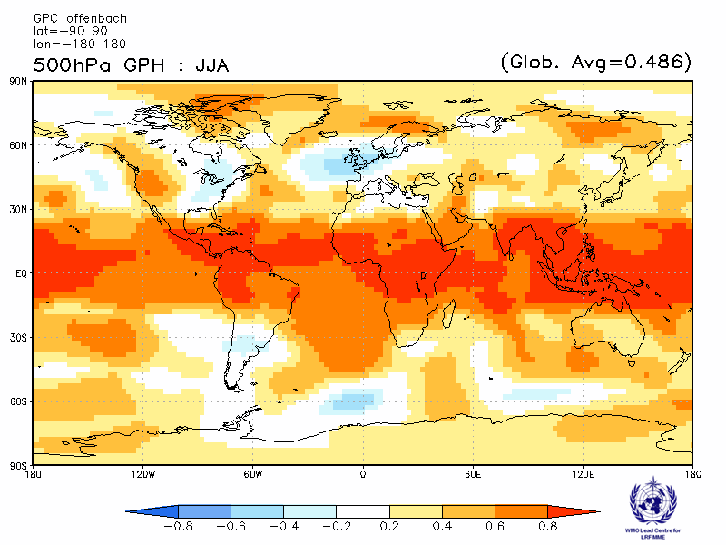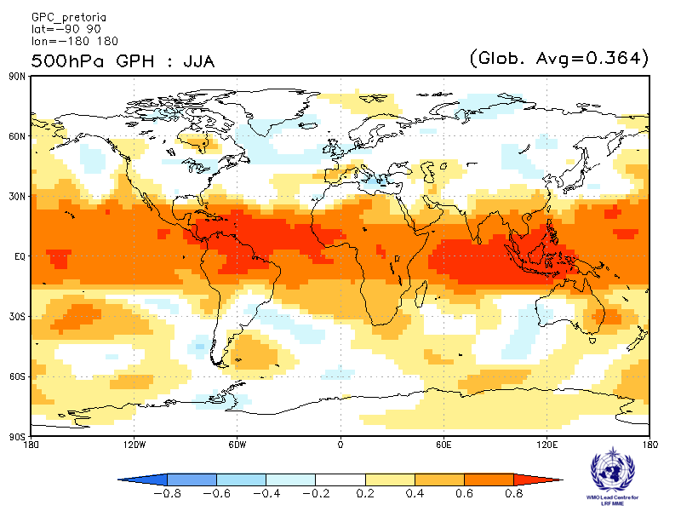

Seoul Tokyo
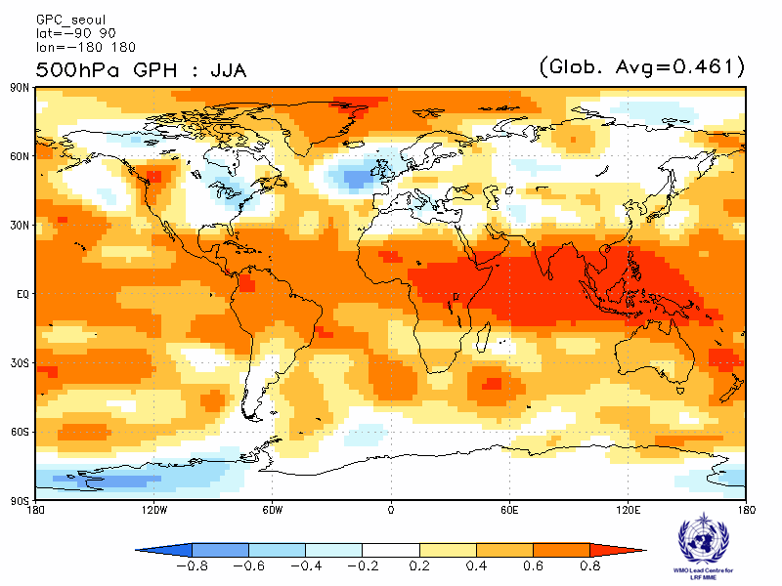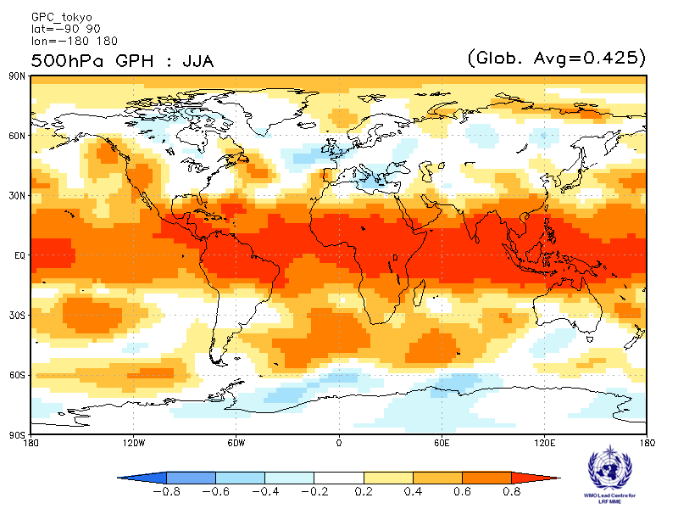

Toulouse Washington
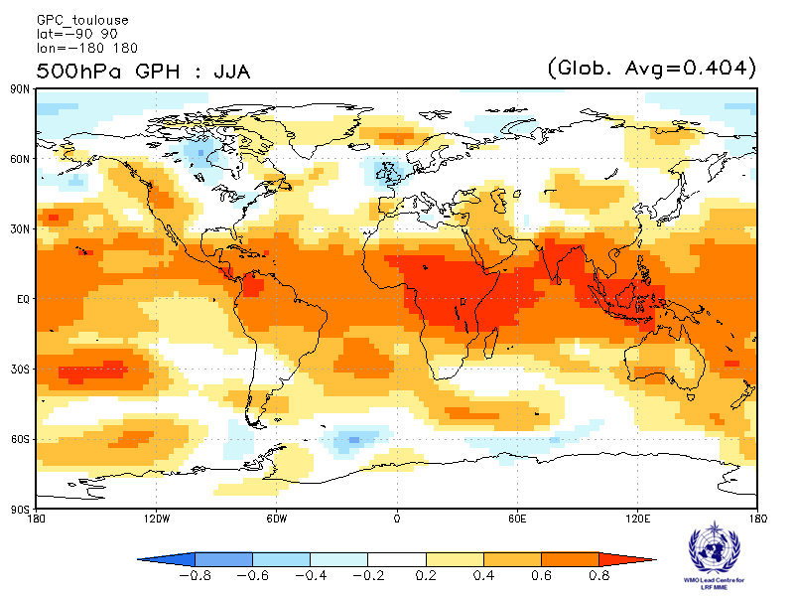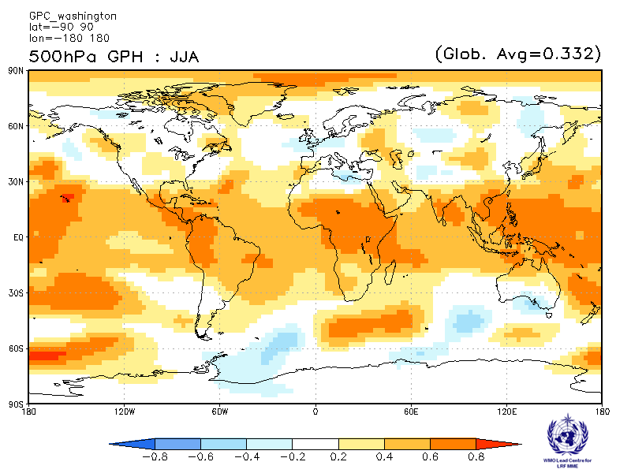

2.4.8 Verification of GPC 500hPa height probabilistic forecasts, 1993-2009
Verification measure: Relative Operating Characteristics (ROC) score for tercile forecast
Verification dataset: ERA-Interim
PMME Beijing
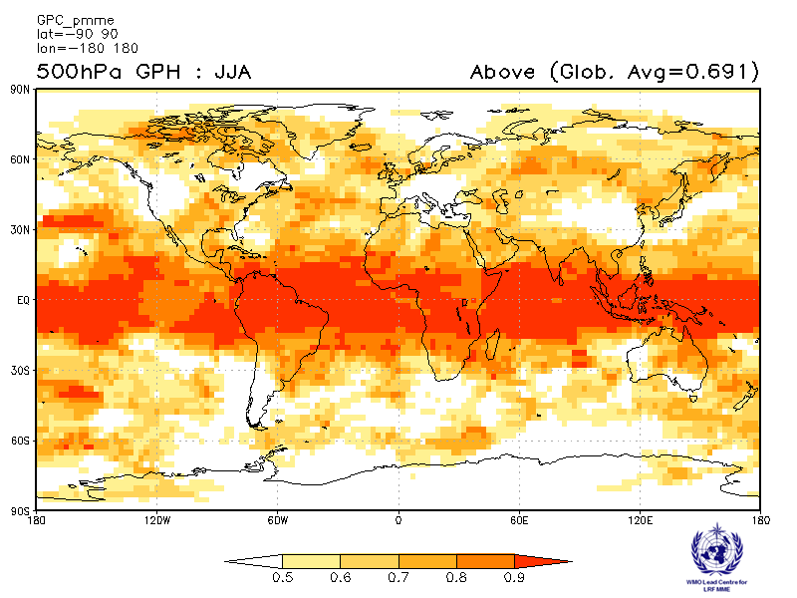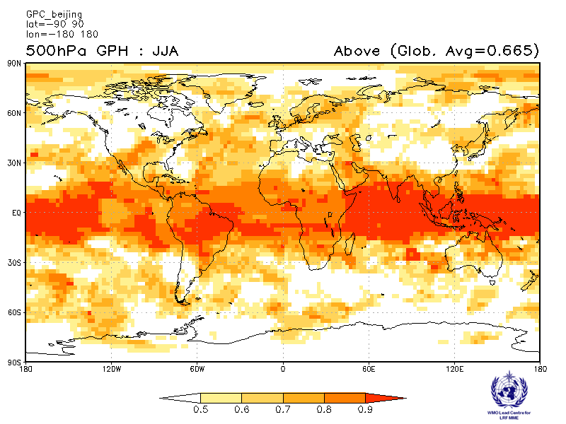
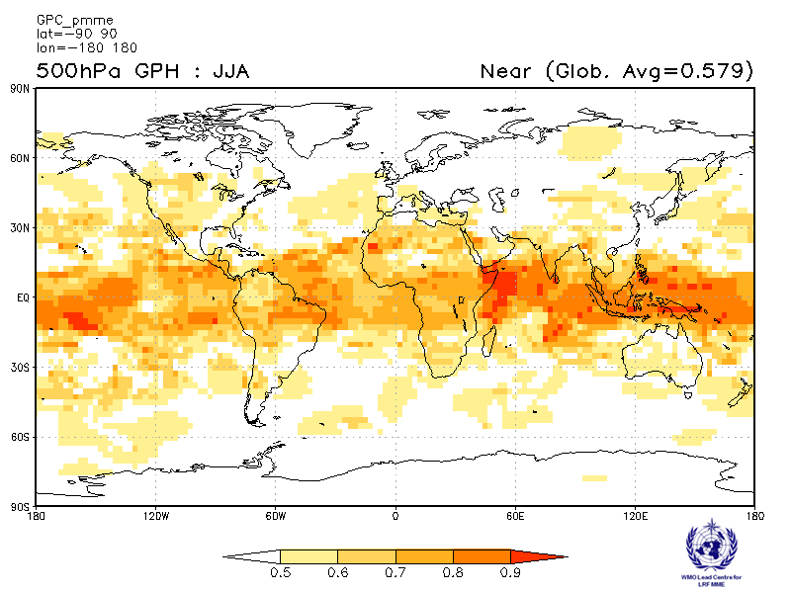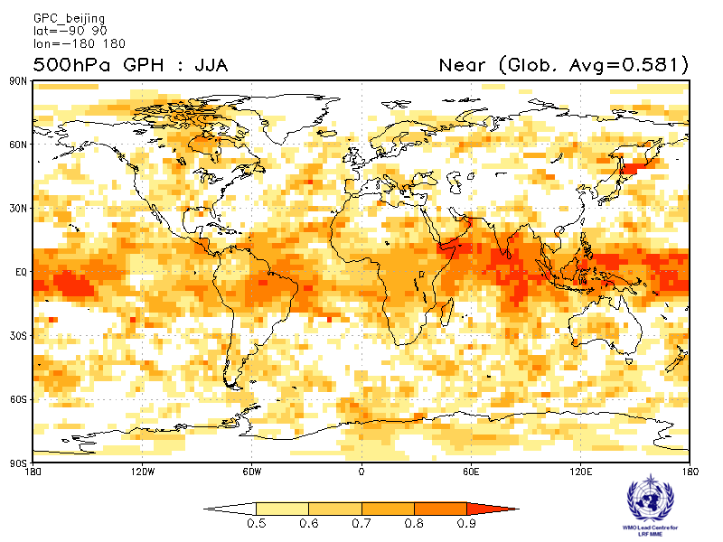
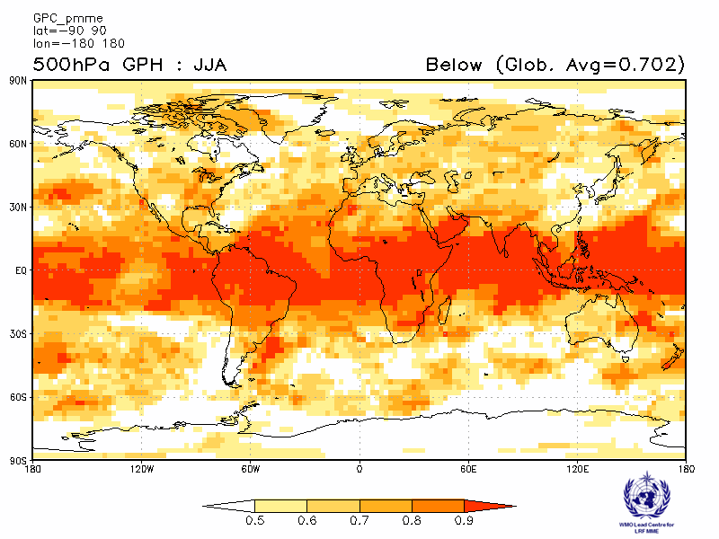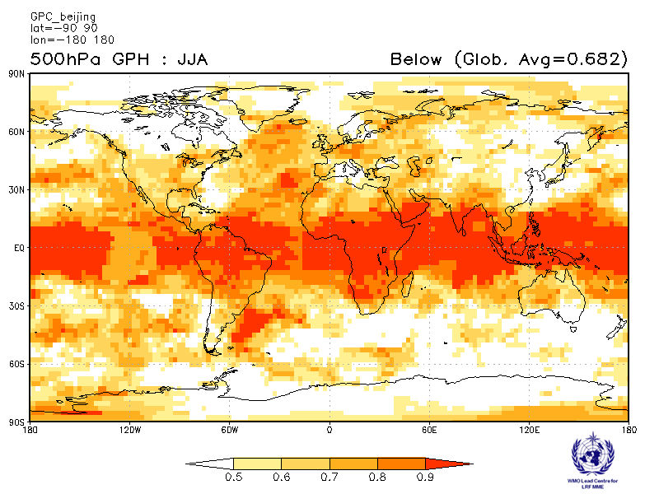

CPTEC ECMWF
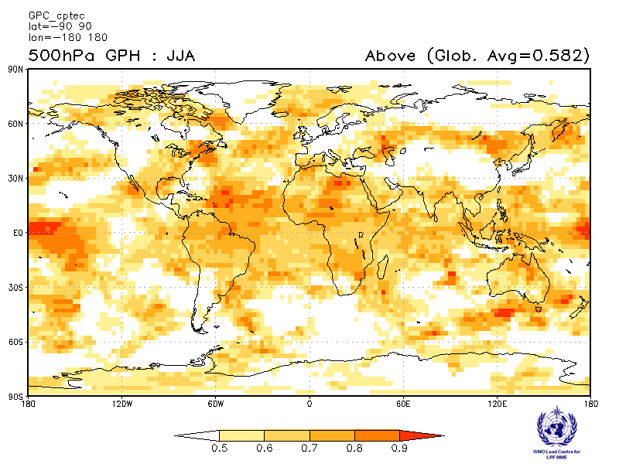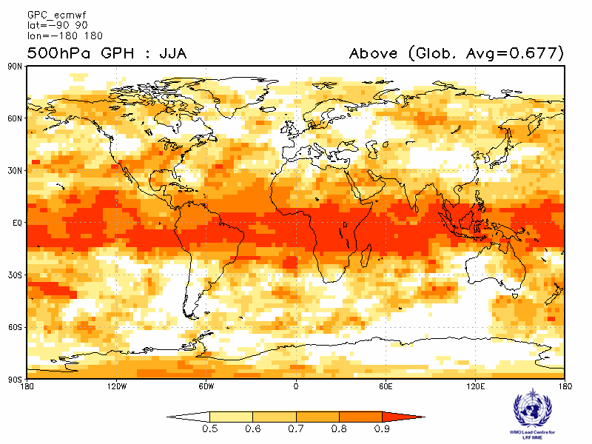
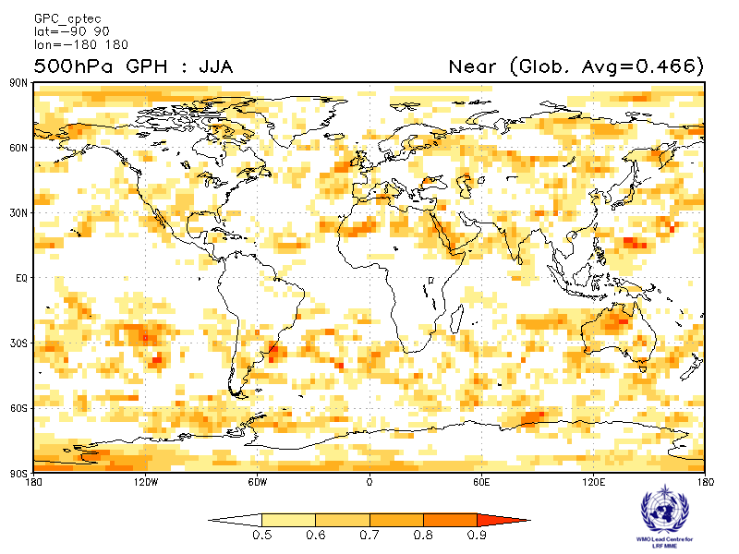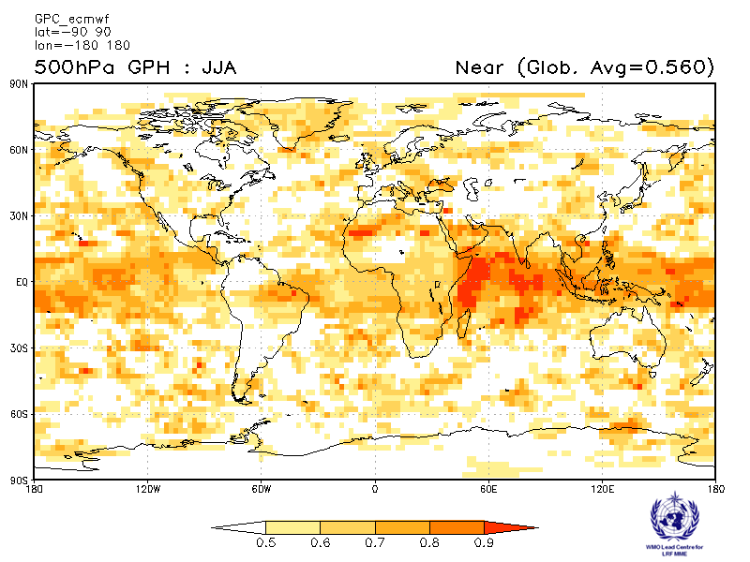
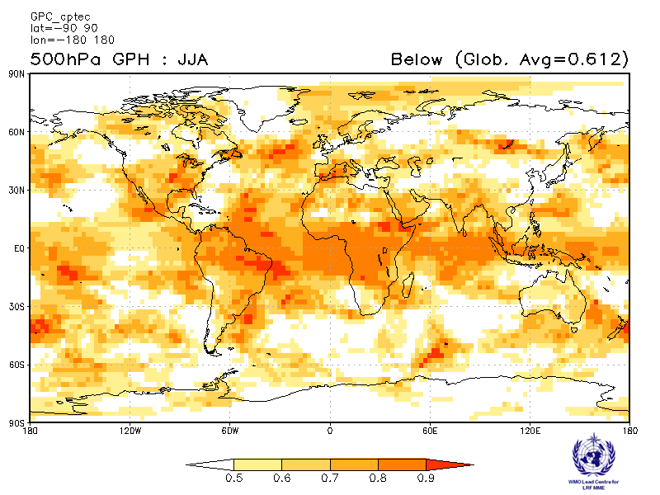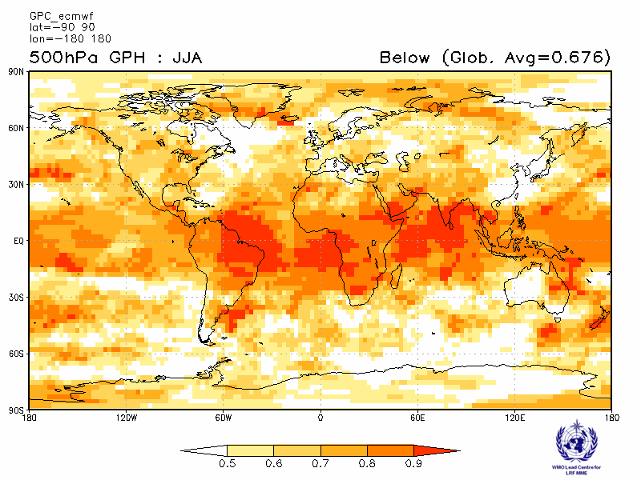
Exeter Melbourne
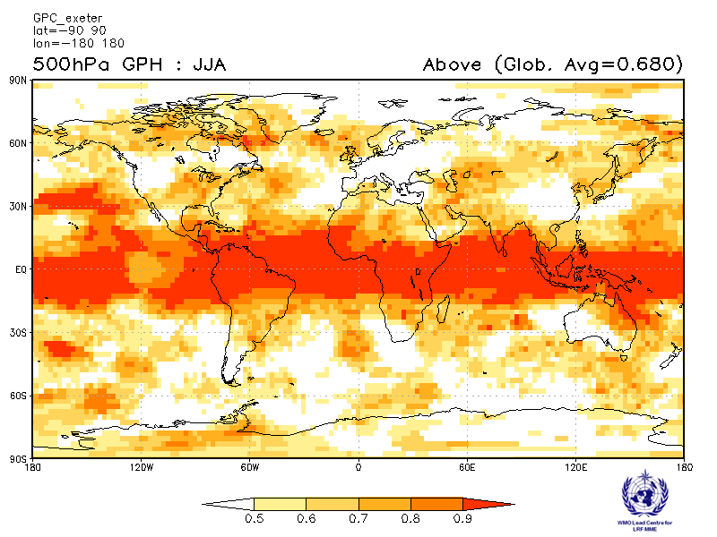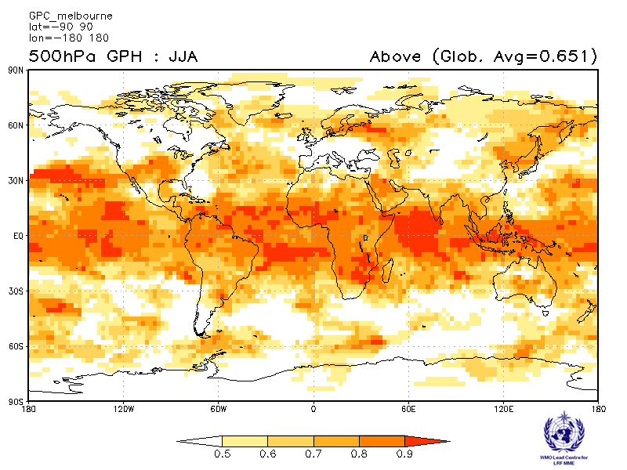
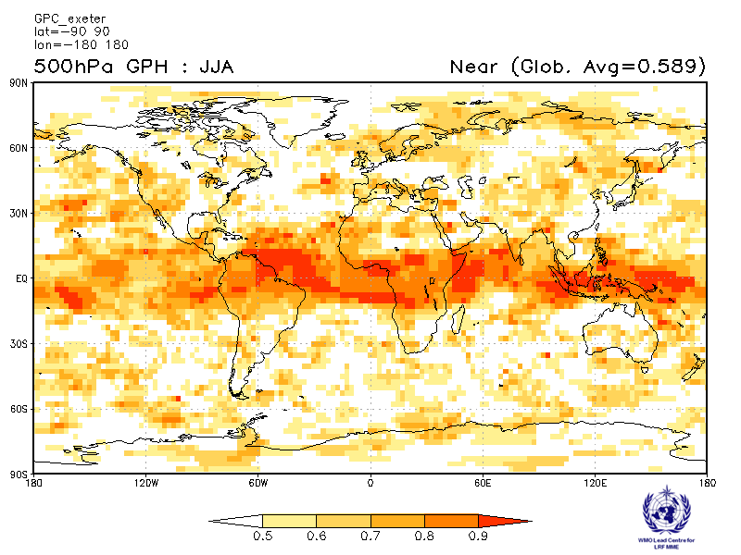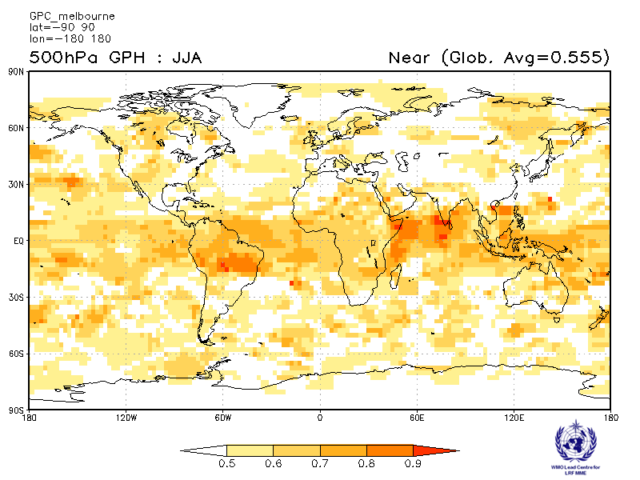
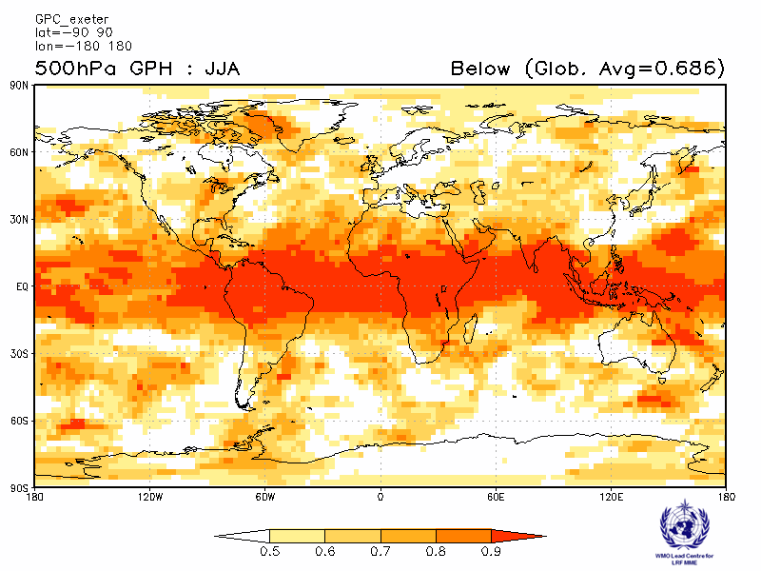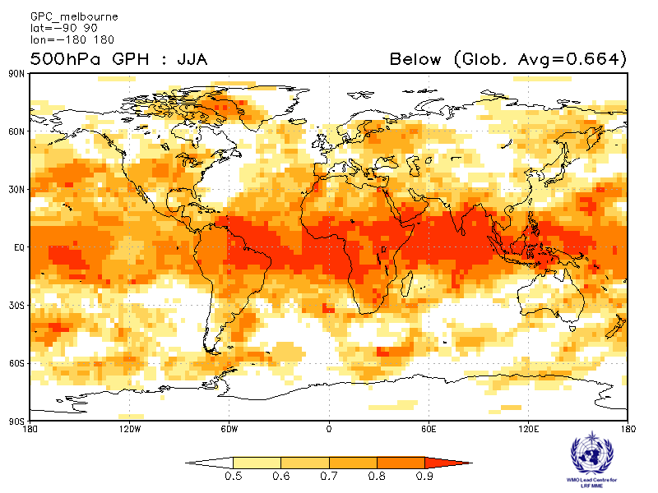
Montreal Moscow
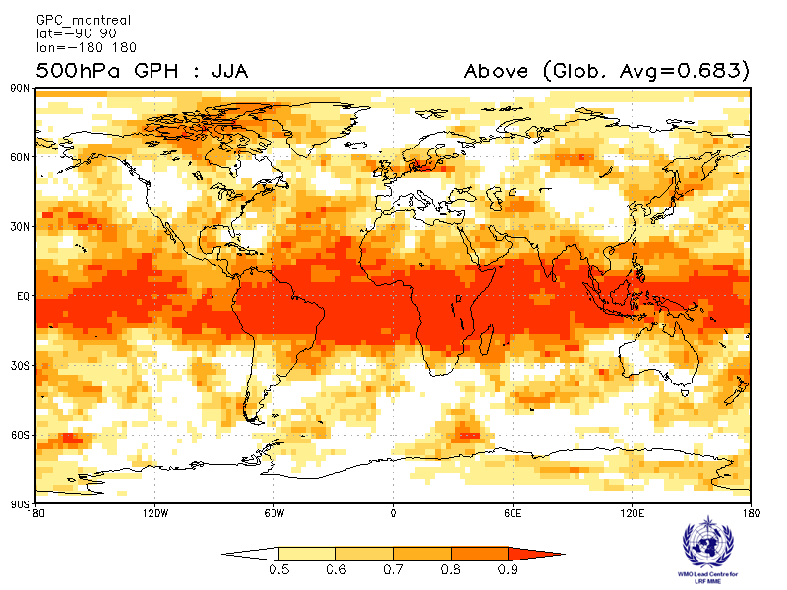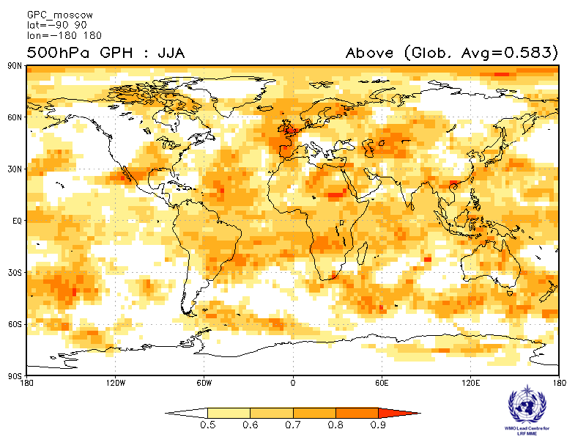
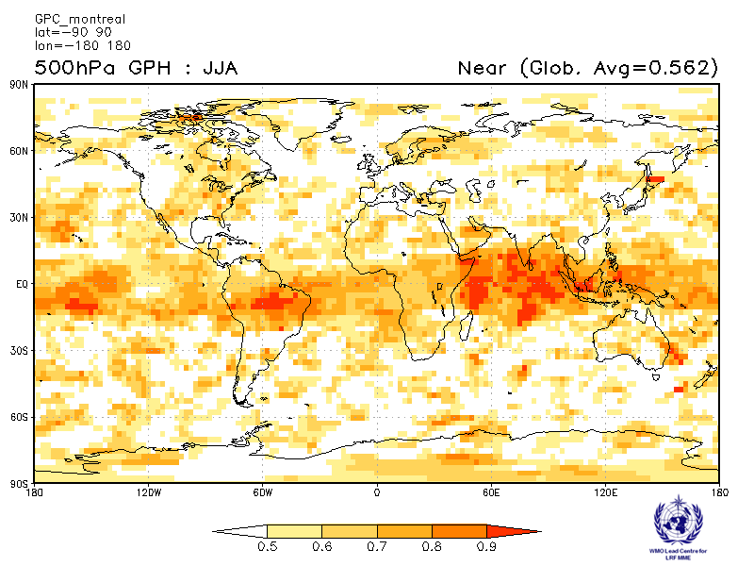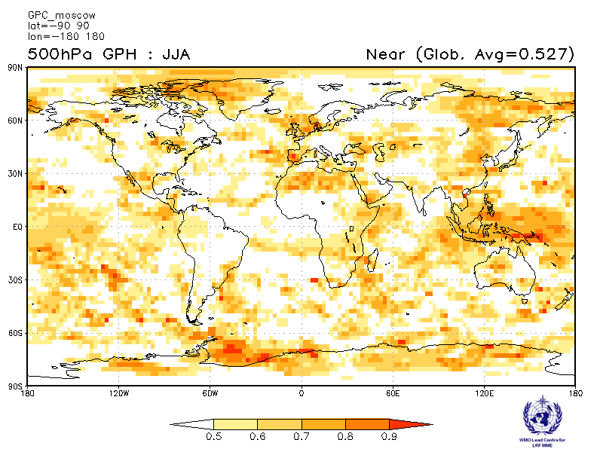
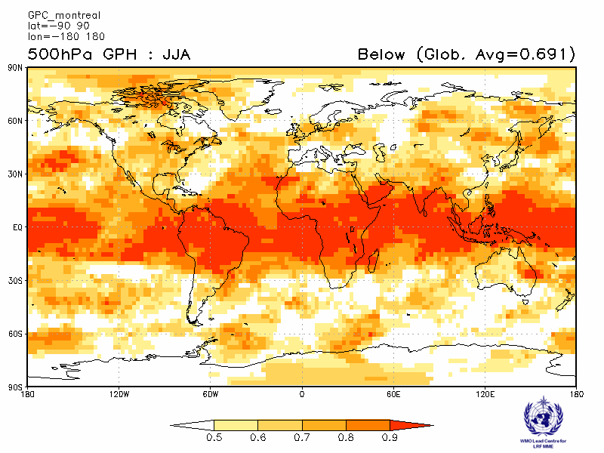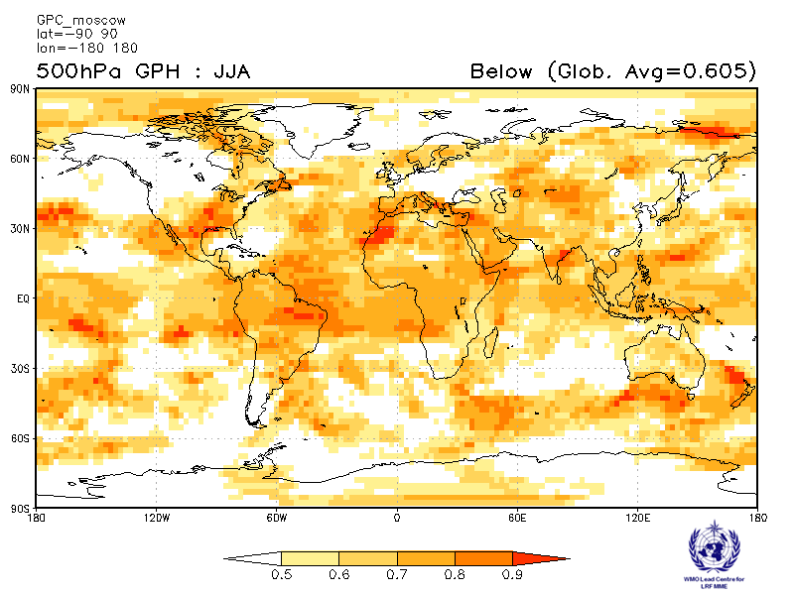
Offenbach Pretoria
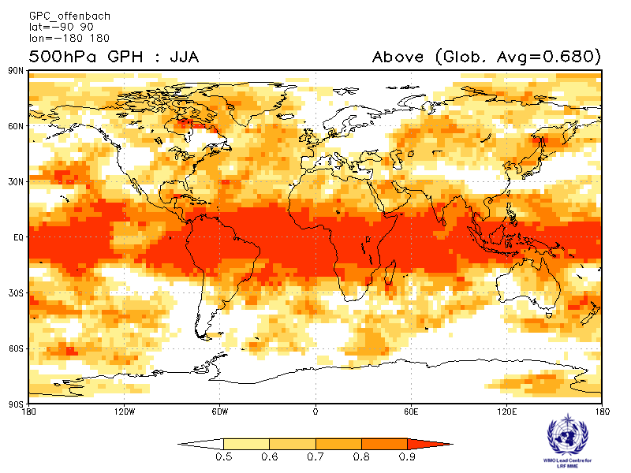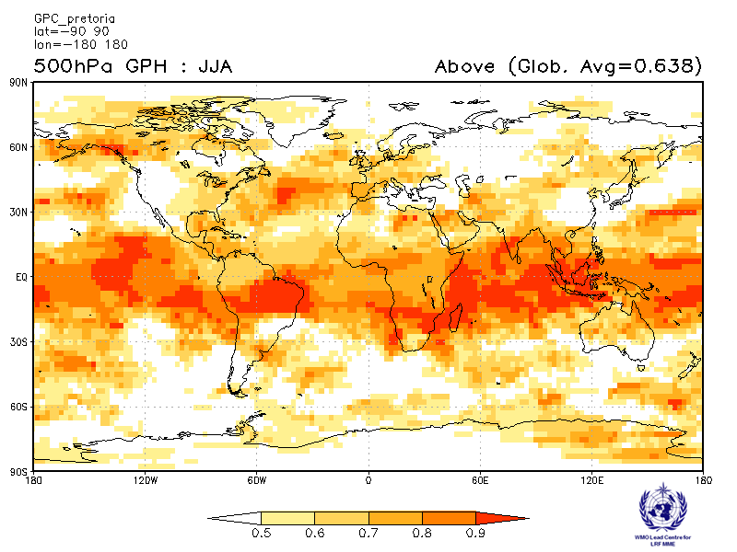
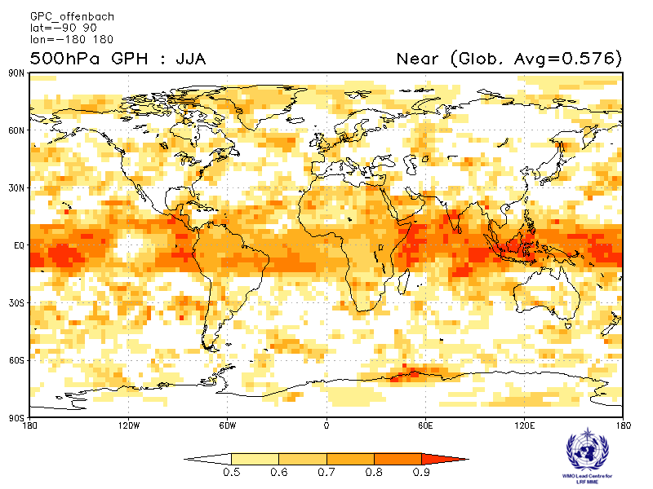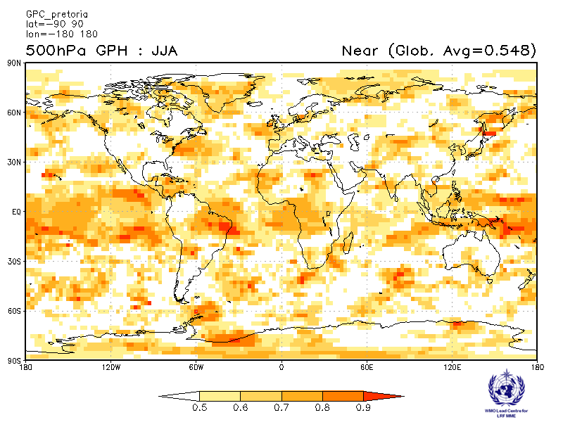
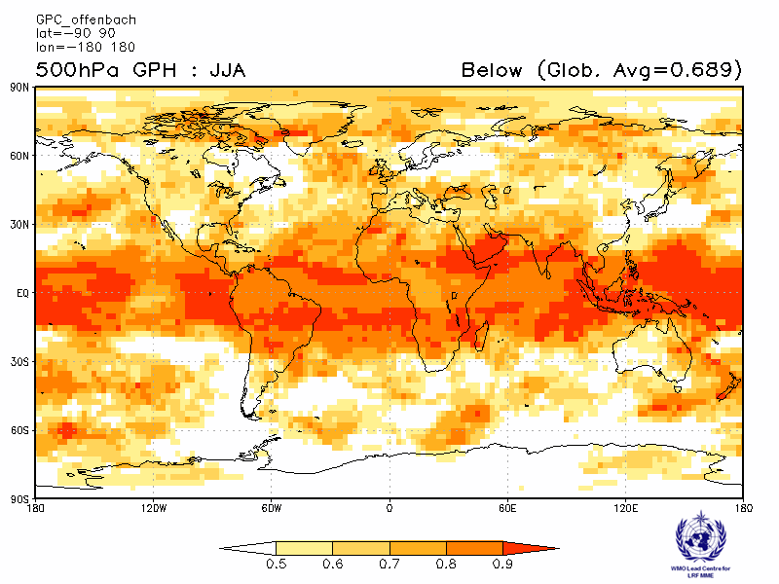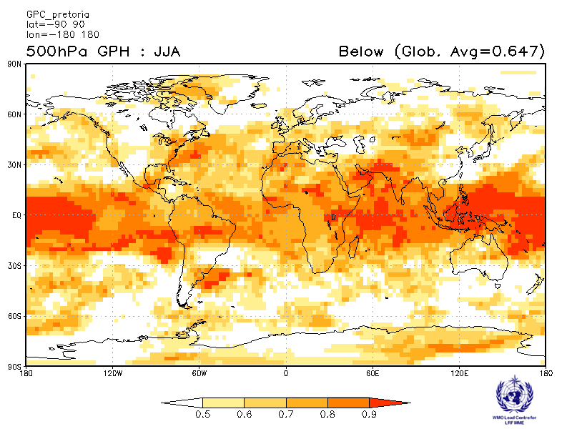
Seoul Tokyo
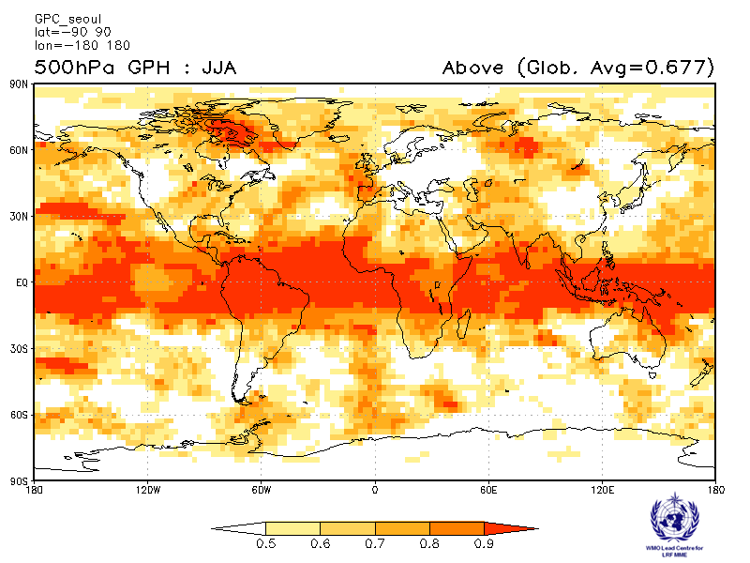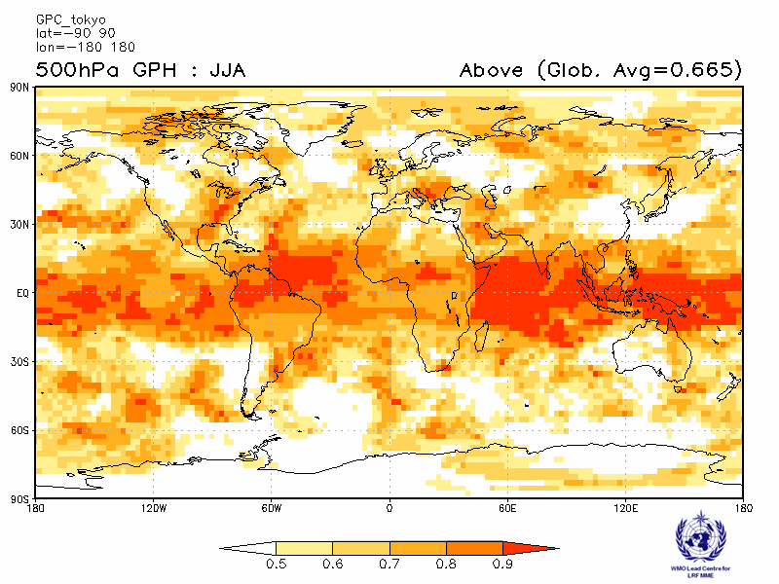
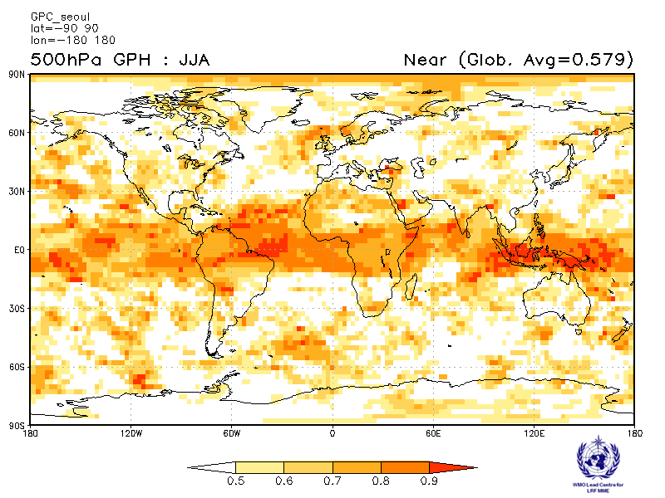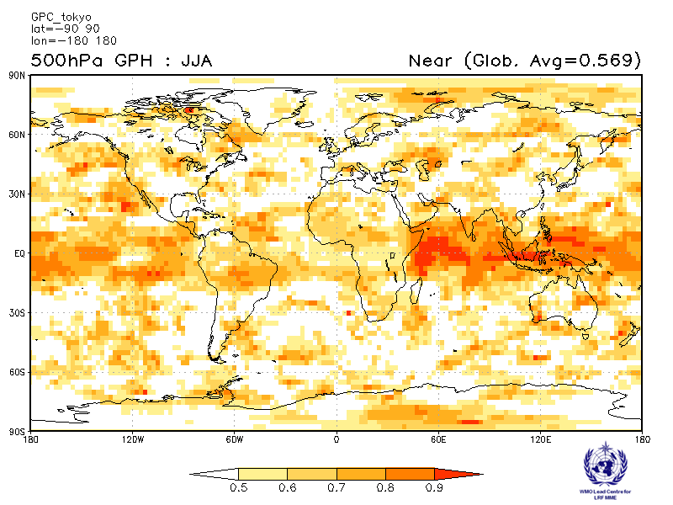
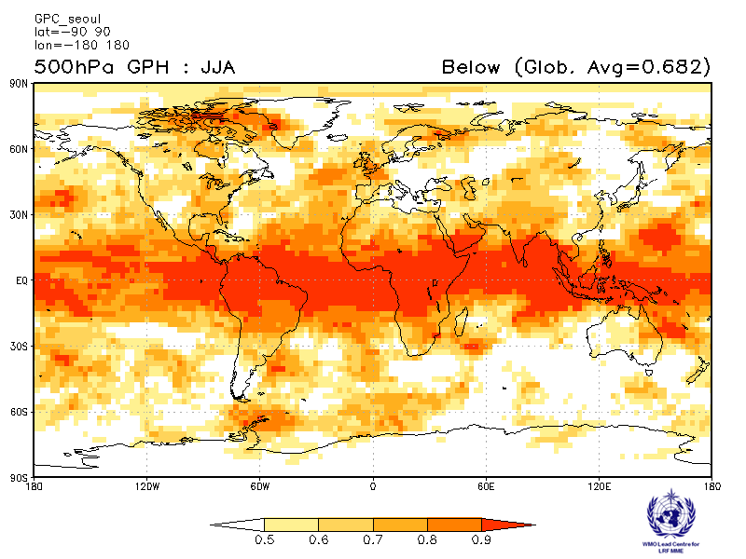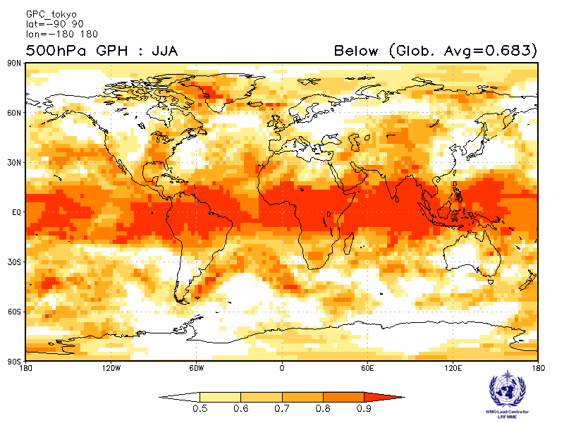
Toulouse Washington
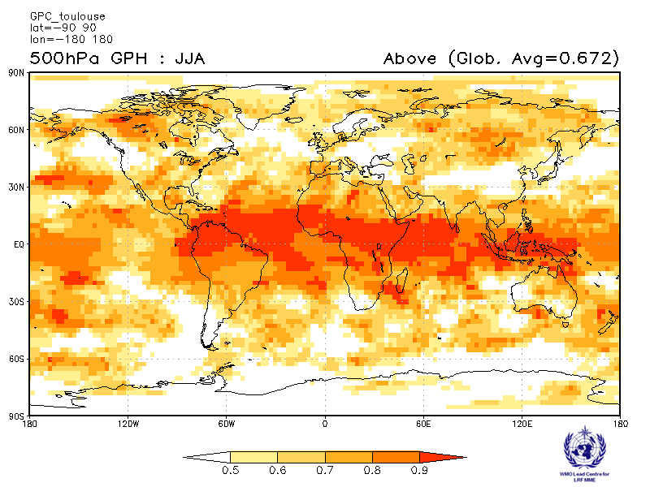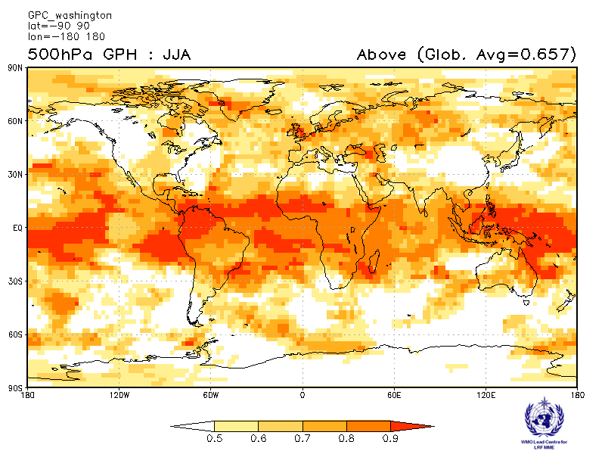
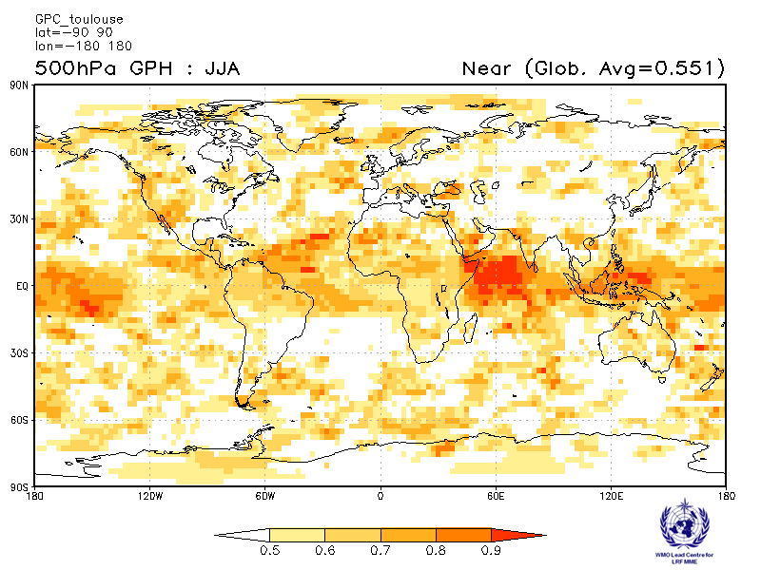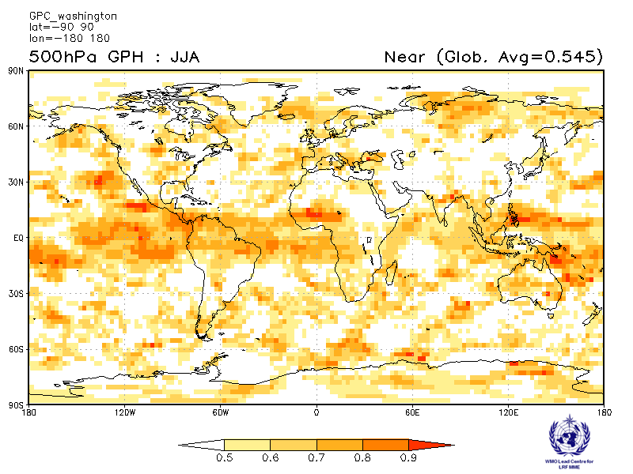
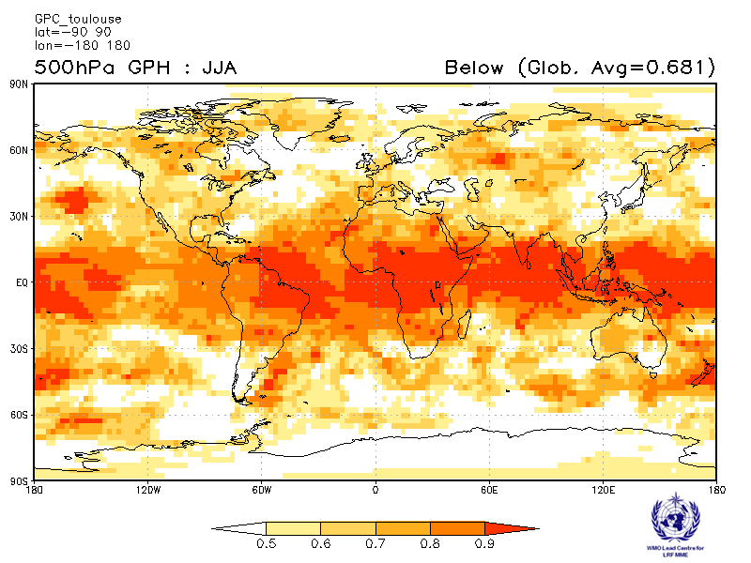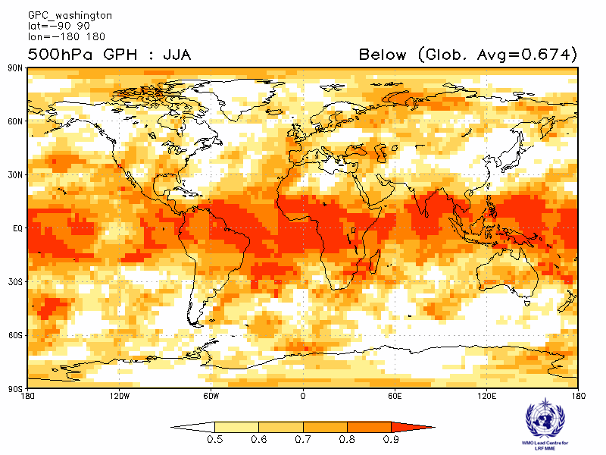

2.4.9 Verification of GPC 500hPa height probabilistic forecasts, 1993-2009
Verification measure: Relative Operating Characteristics Curve (ROC) and Score over globe
Verification dataset: ERA-interim
PMME Beijing
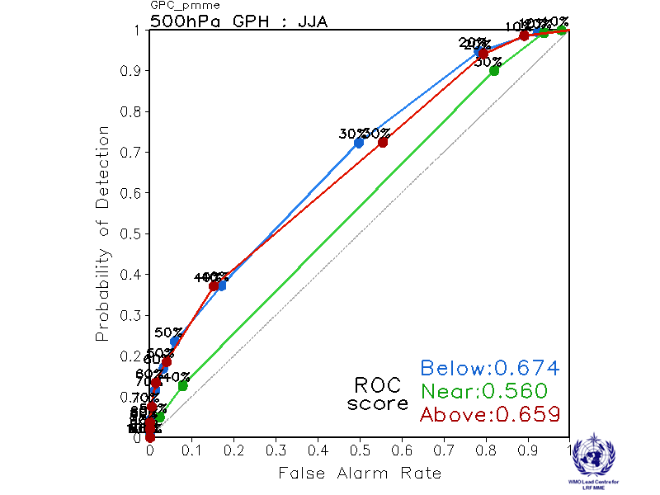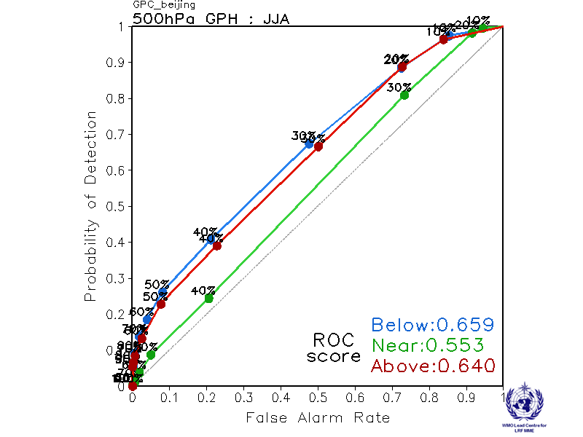
CPTEC ECMWF
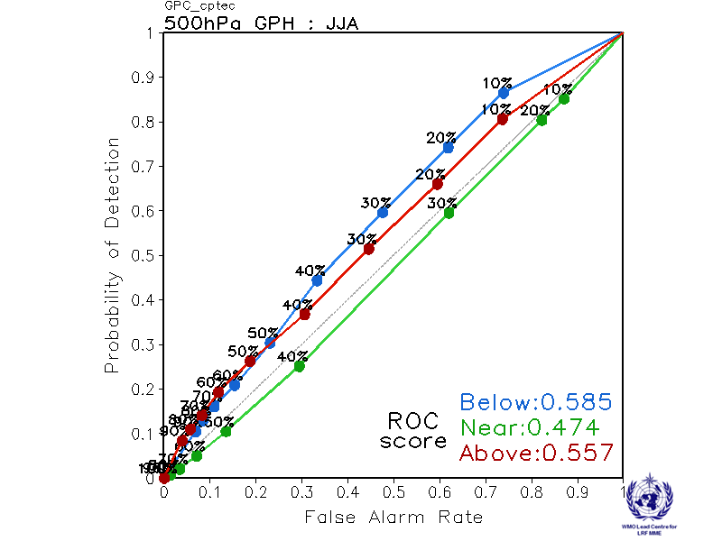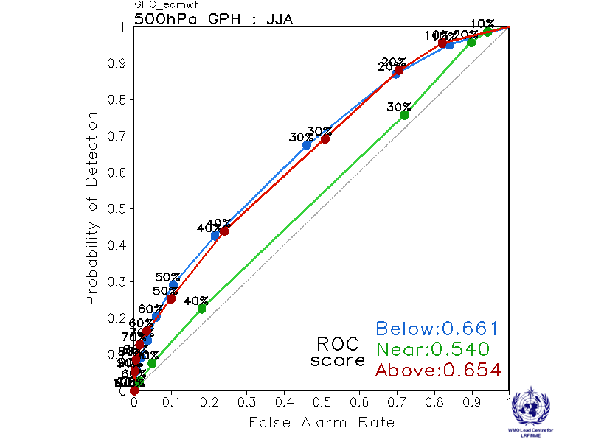

Exeter Melbourne
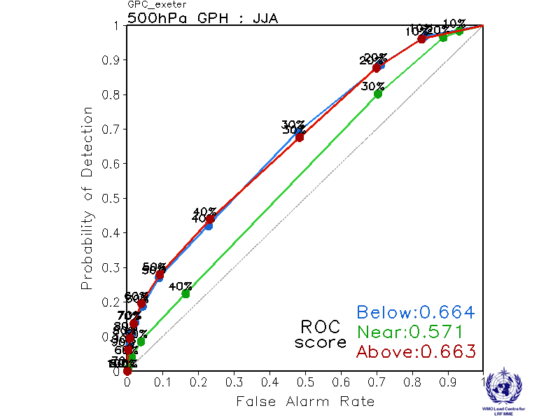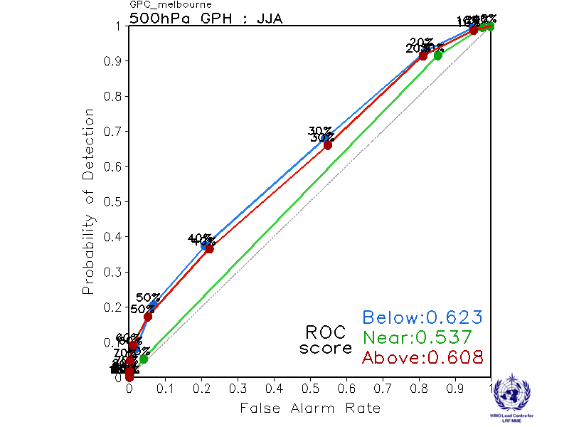

Montreal Moscow
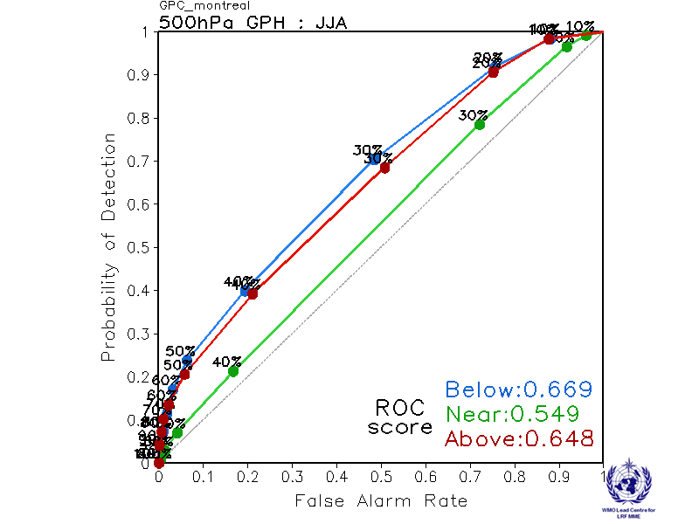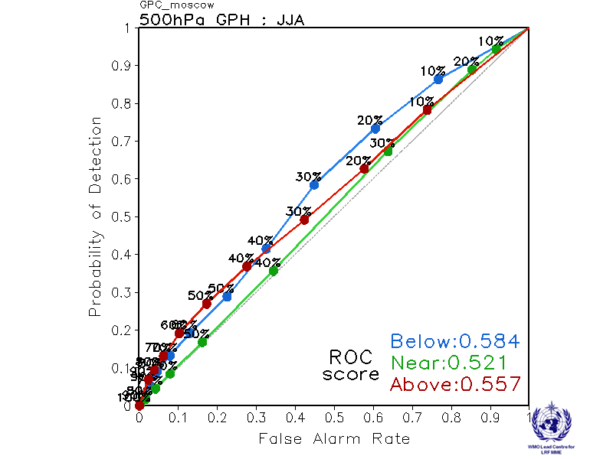

Offenbach Pretoria
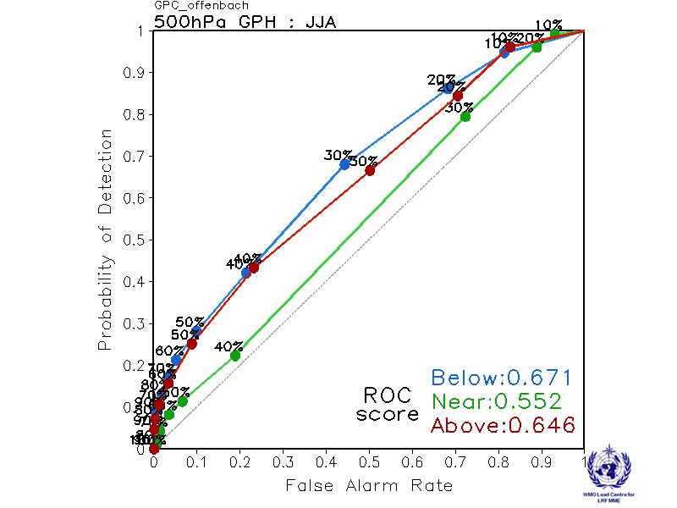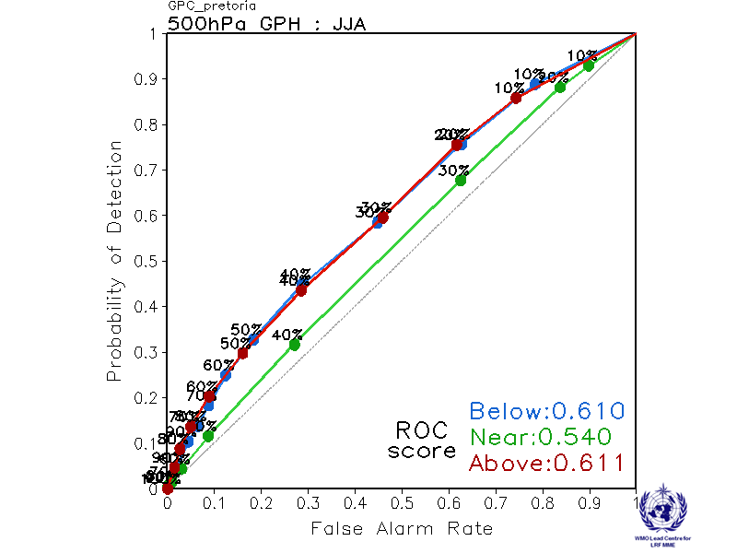

Seoul Tokyo
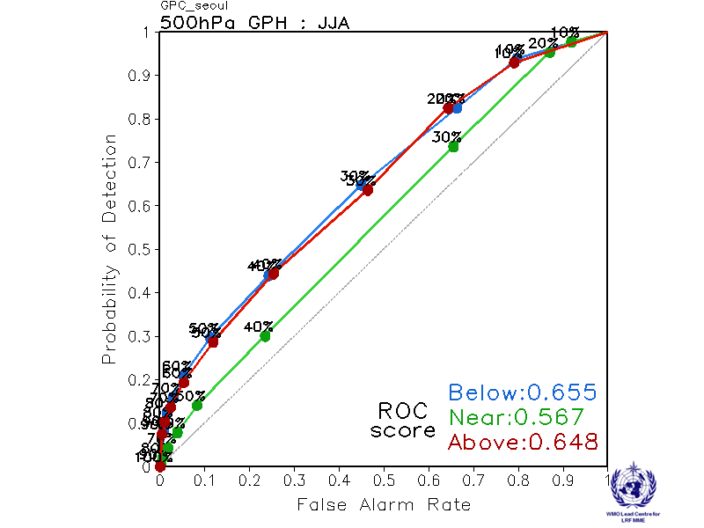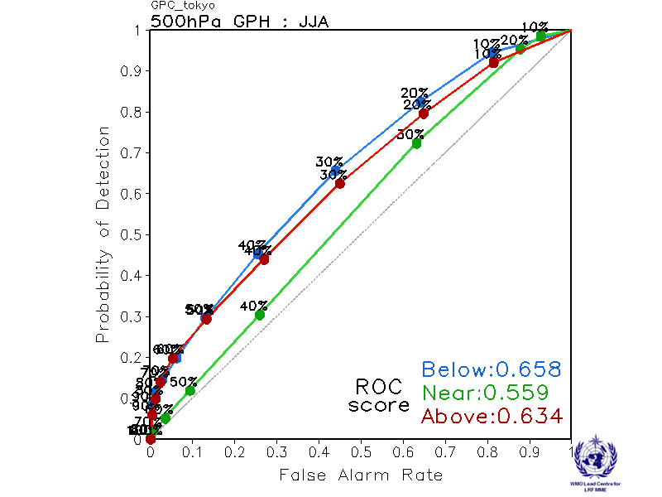

Toulouse Washington
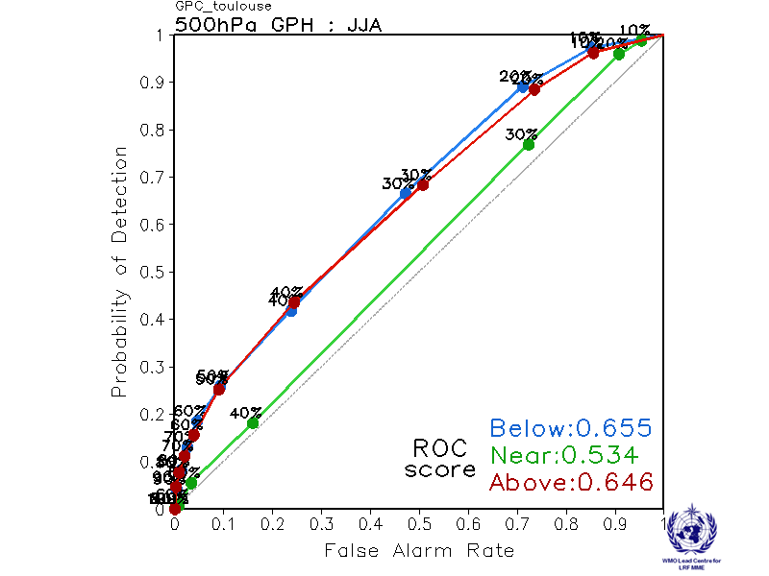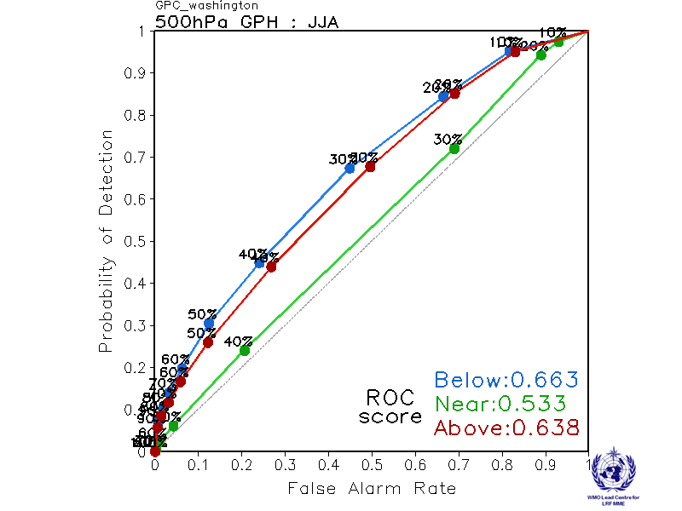

2.4.10 Verification of GPC 500hPa height probabilistic forecasts, 1993-2009
Verification measure: Reliability Diagram over globe
Verification dataset: ERA-interim
PMME Beijing
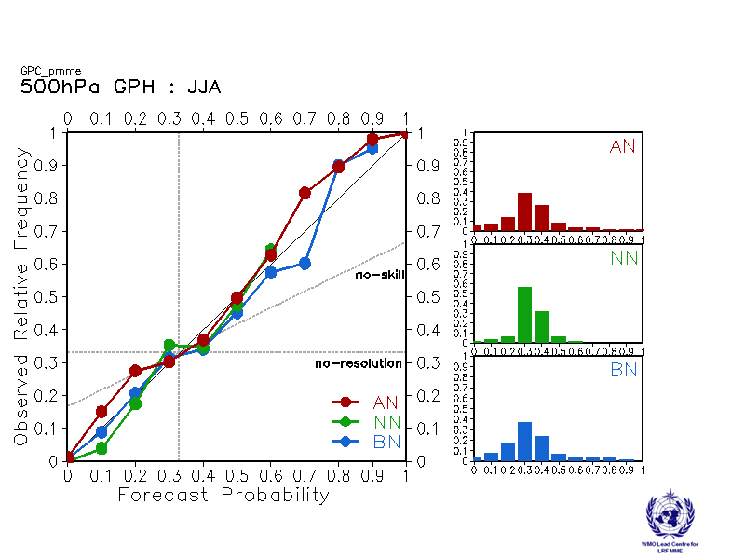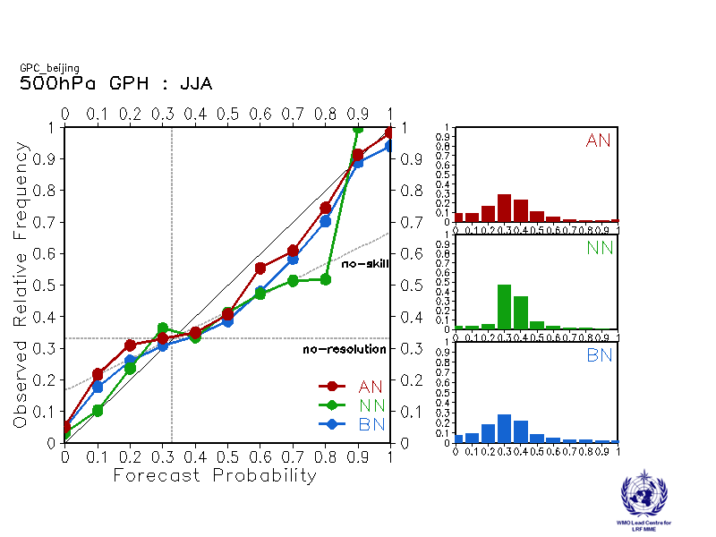
CPTEC ECMWF
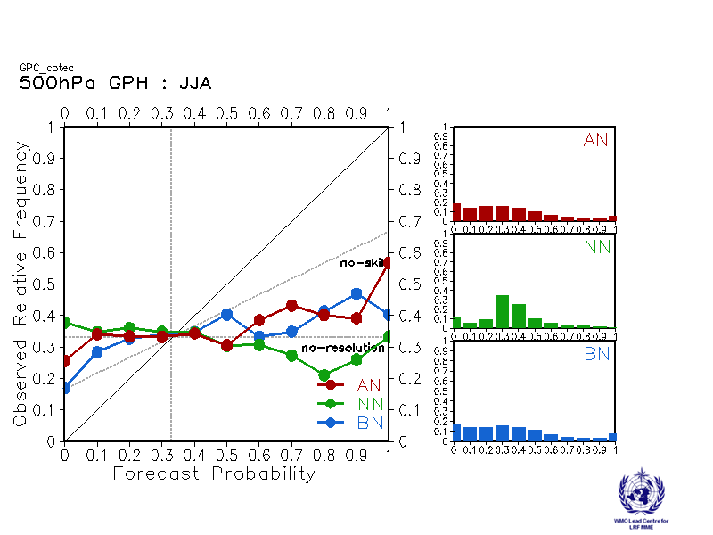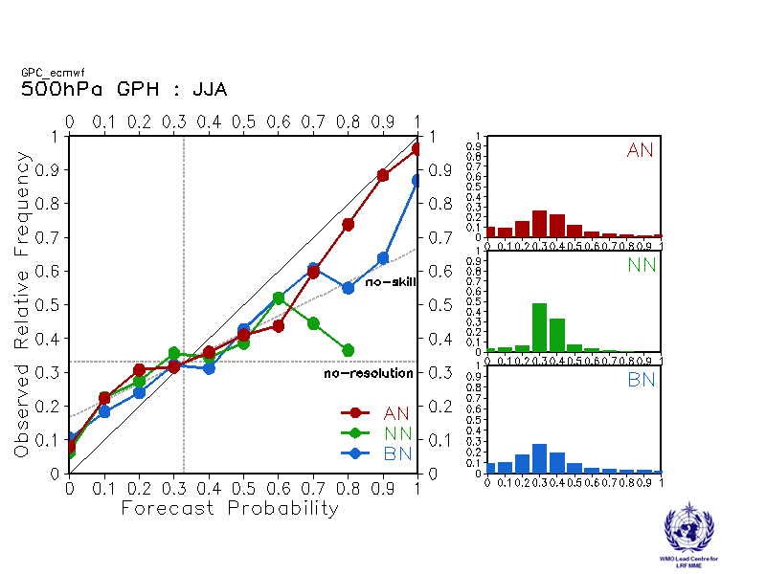

Exeter Melbourne
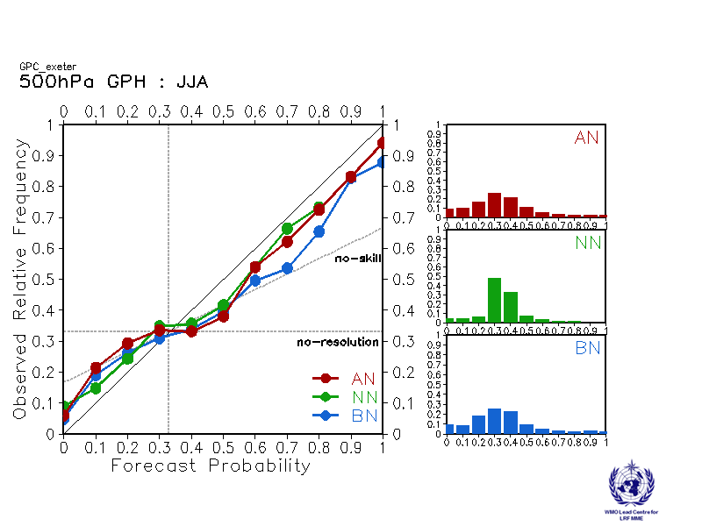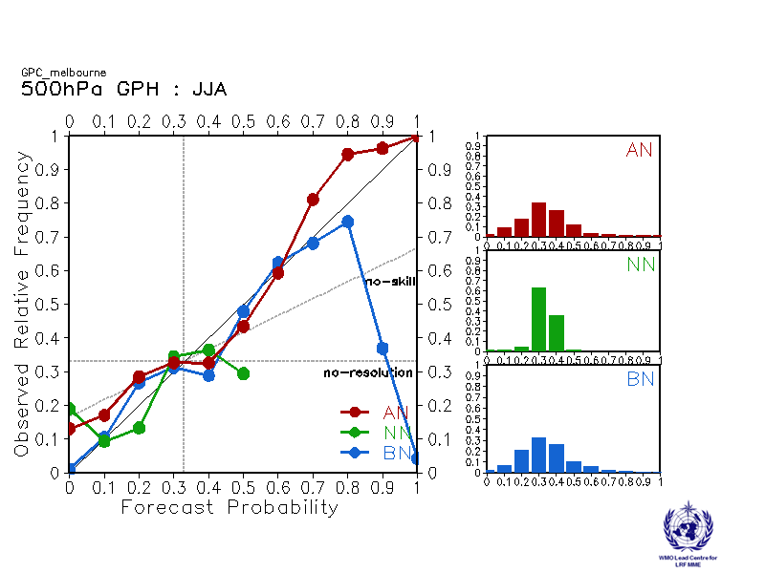

Montreal Moscow
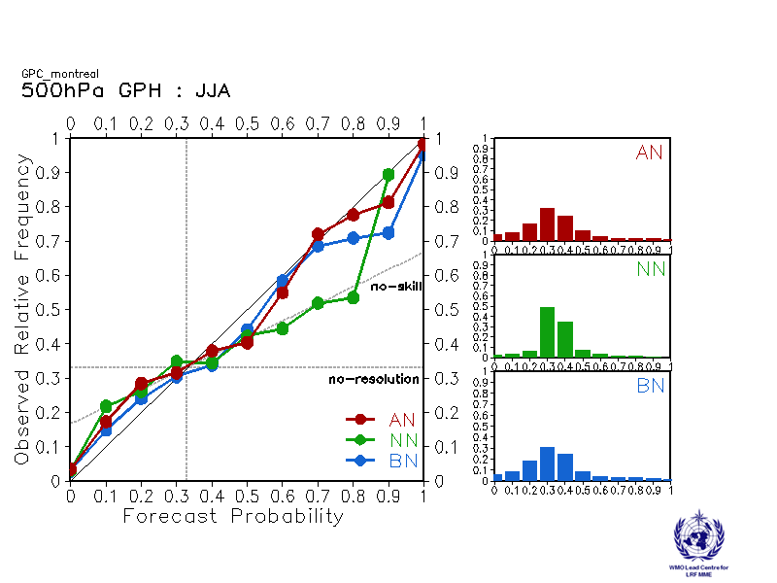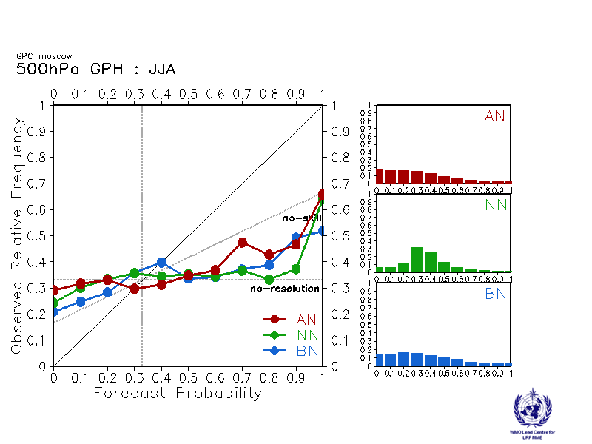

Offenbach Pretoria
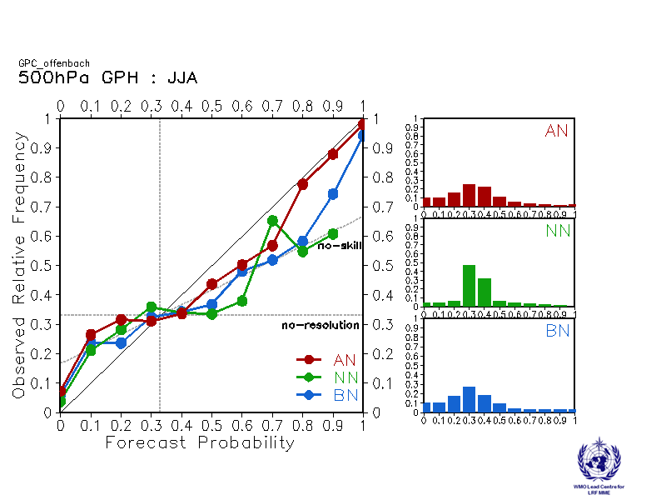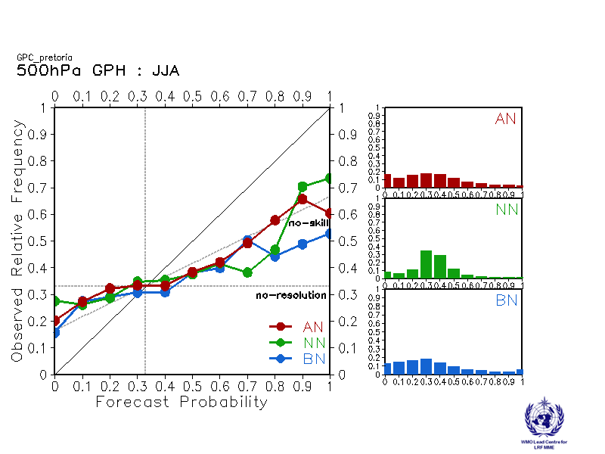

Seoul Tokyo
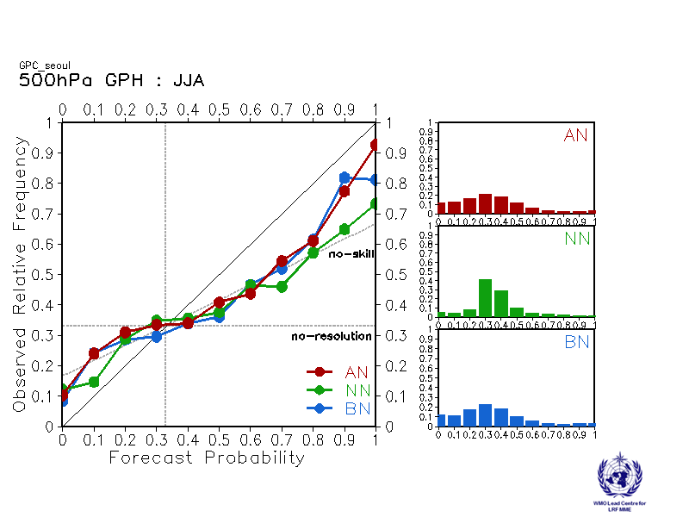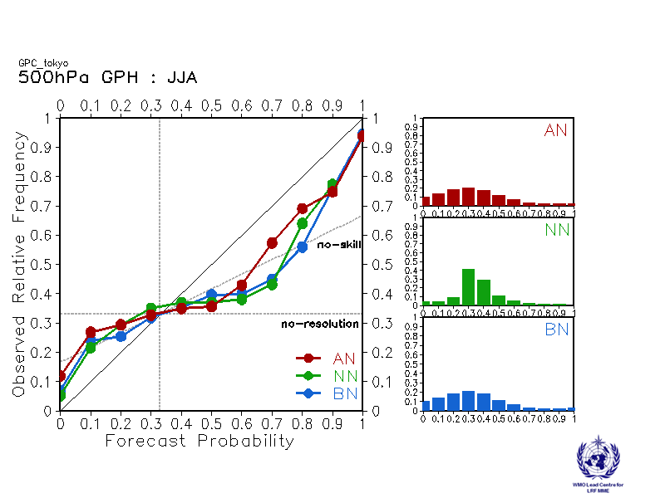

Toulouse Washington
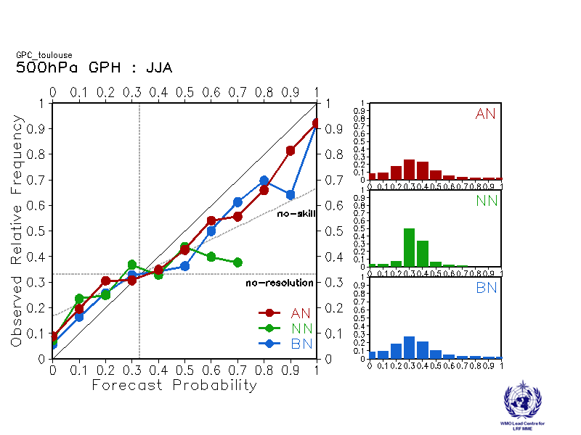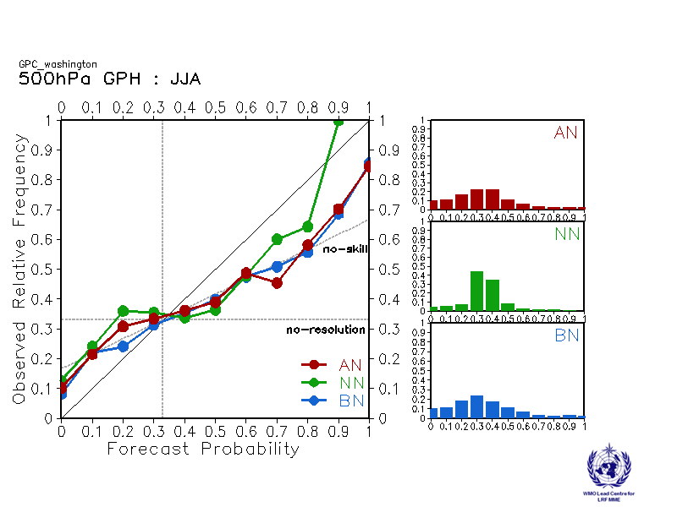

2.5 Mean Sea Level Pressure

2.5.1 Individual GPC ensemble mean forecasts of MSLP anomalies relative to 1993-2009

Beijing CPTEC
Baseline:1993-2009 Baseline:1993-2009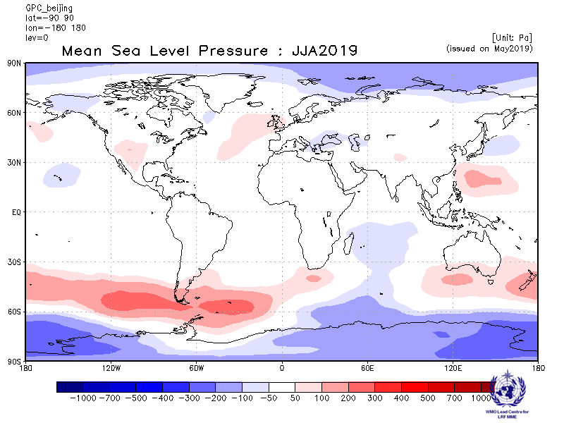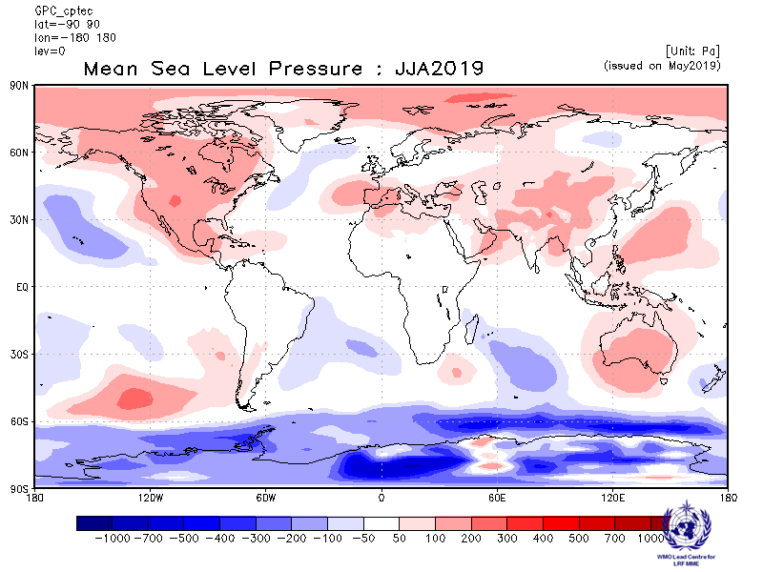

ECMWF Exeter
Baseline:1993-2009 Baseline:1993-2009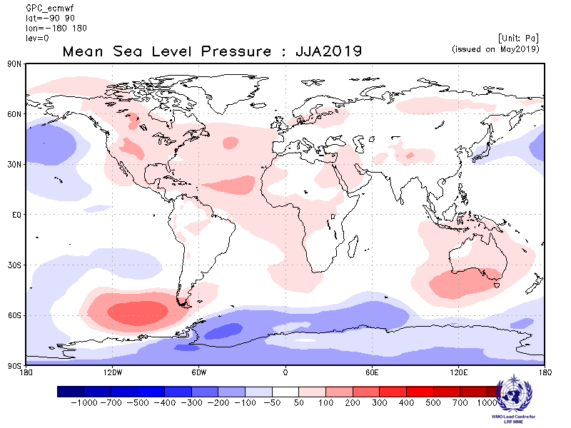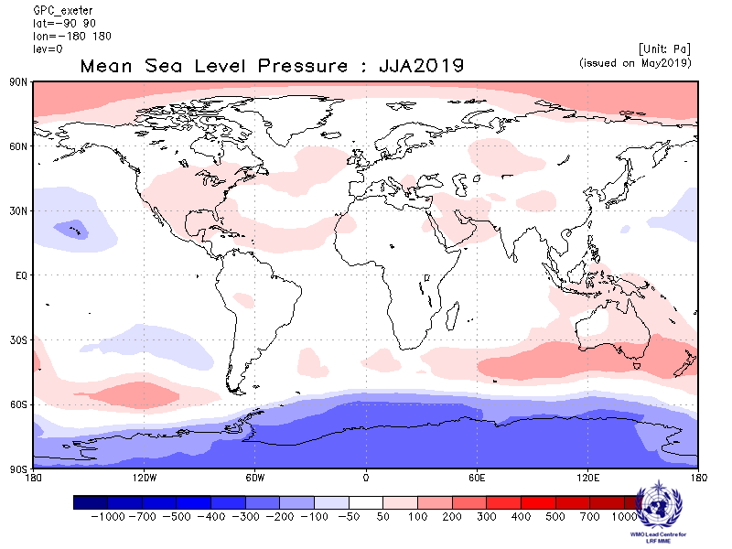

Melbourne Montreal
Baseline:1993-2009 Baseline:1993-2009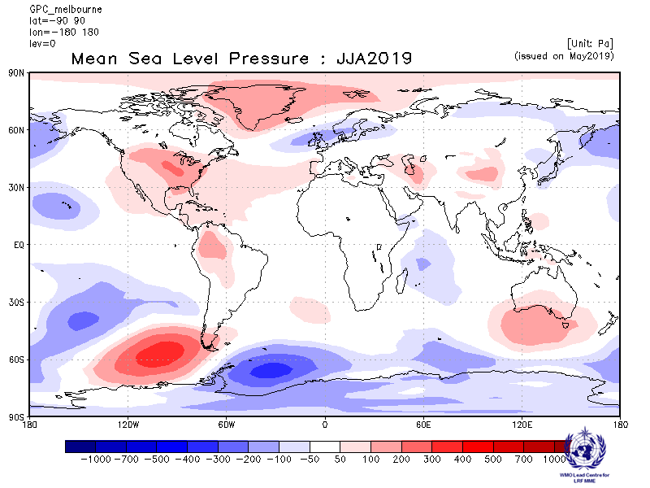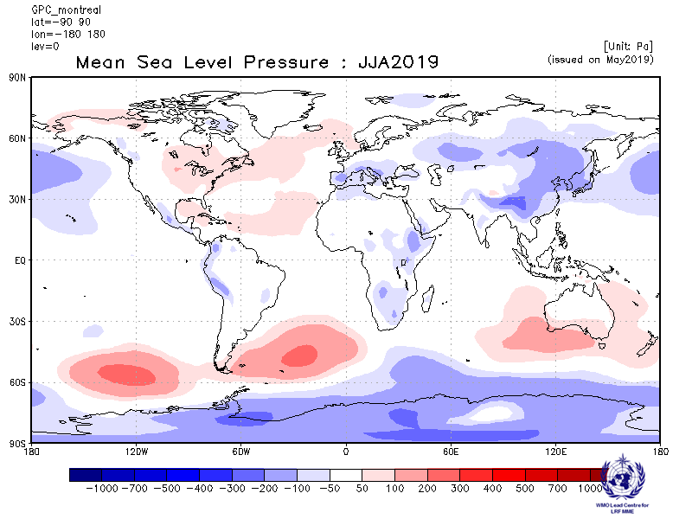

Moscow Offenbach
Baseline:1993-2009 Baseline:1993-2009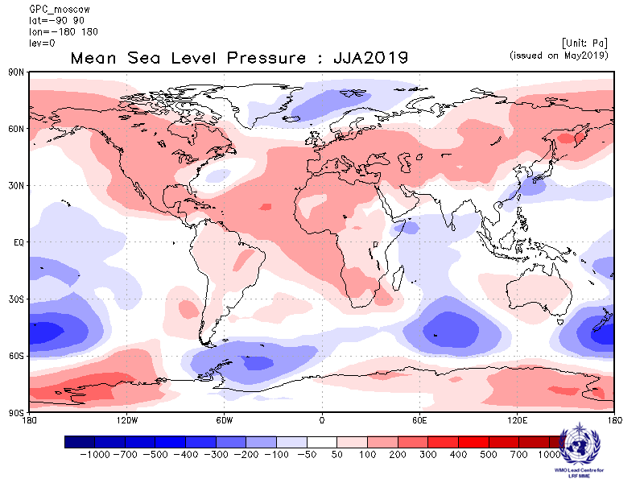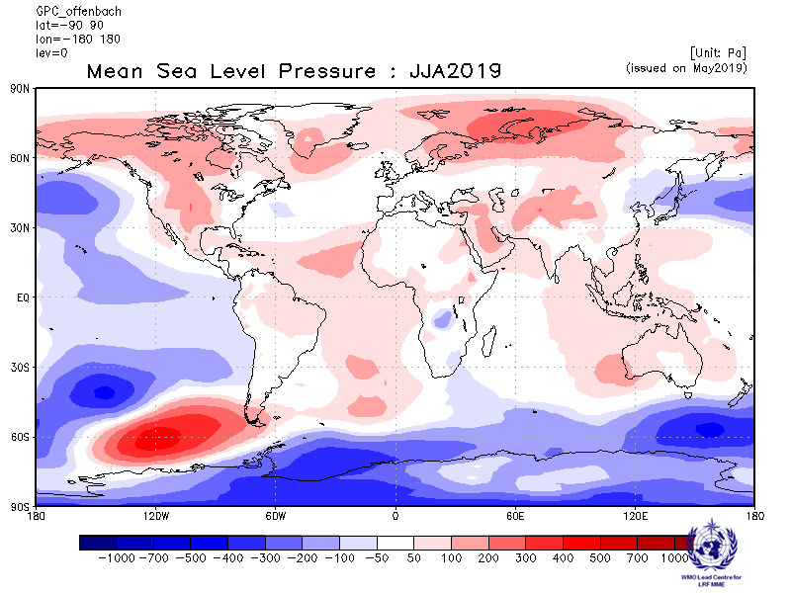

Pretoria Seoul
Baseline:1993-2009 Baseline:1993-2009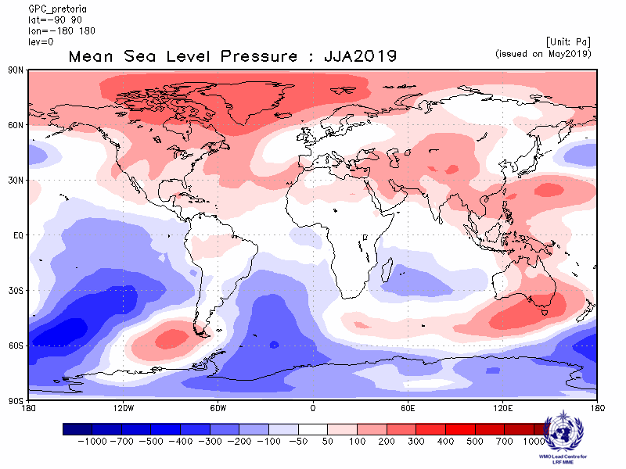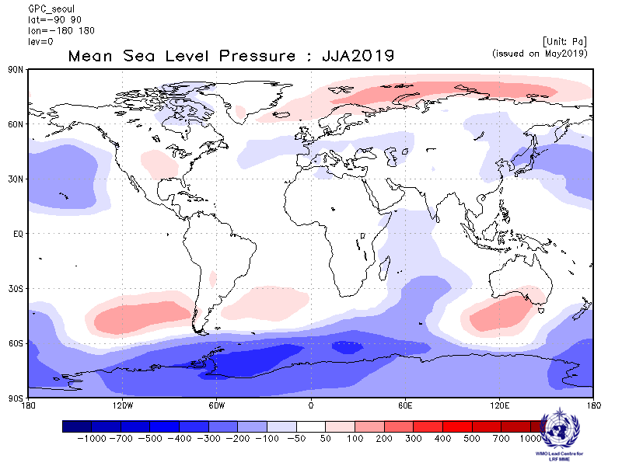
Tokyo Toulouse
Baseline:1993-2009 Baseline:1993-2009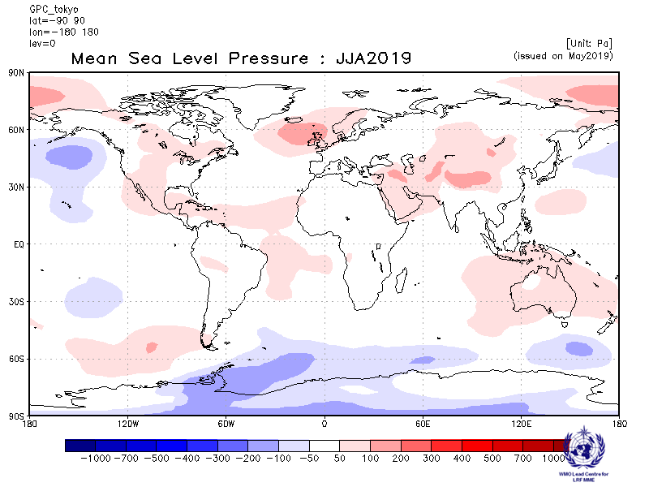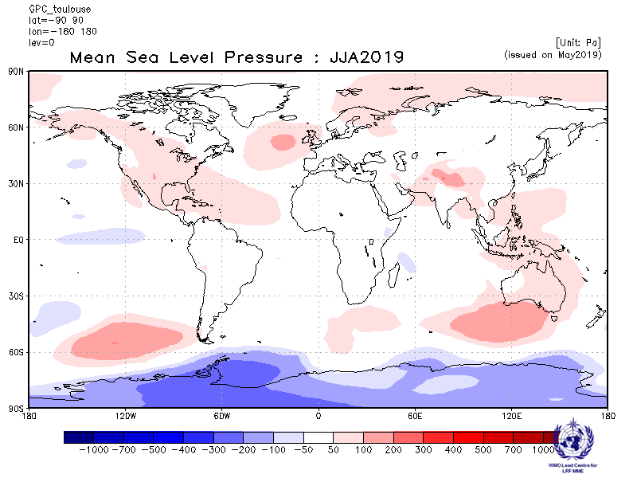

Washington
Baseline:1993-2009
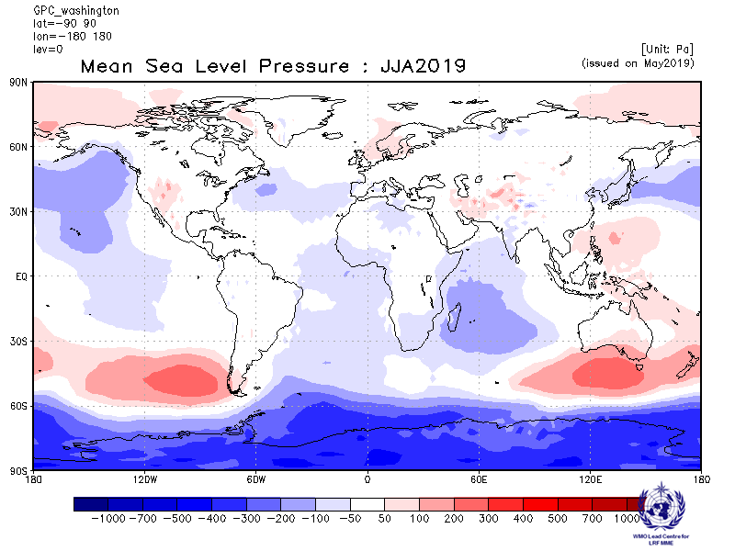

2.5.3 Forecast consistency map (13 GPCs): MSLP
(number of GPCs with positive/negative ensemble mean anomalies – relative to own baseline)
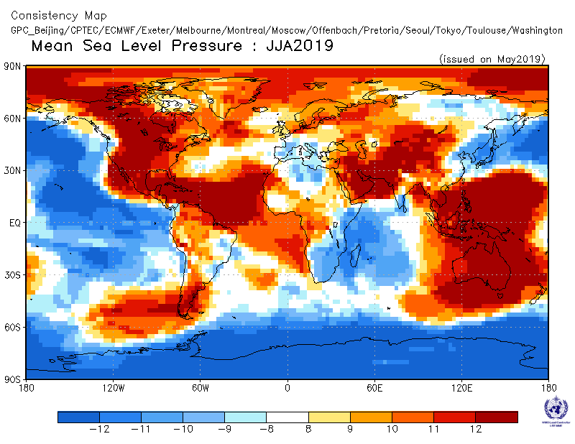

2.5.4 DMME (13 GPCs), using the same baseline for all models (1993-2009): MSLP
Ensemble mean anomaly
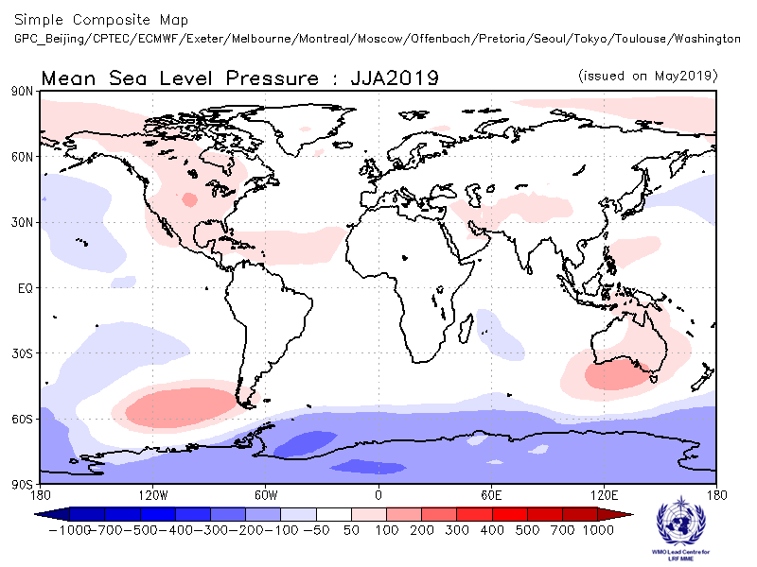

2.5.5 DMME (13 GPCs), for each model using its own baseline: MSLP
Ensemble mean anomaly
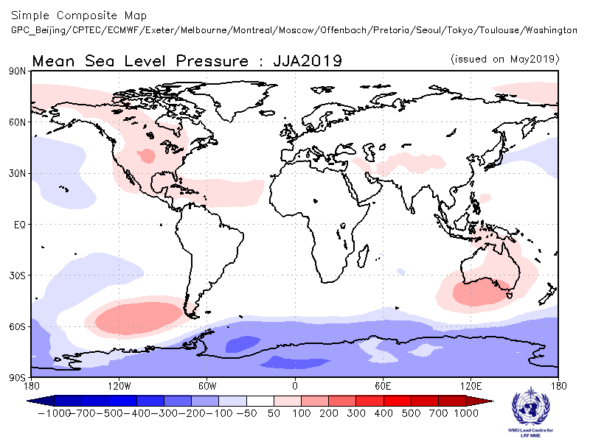

2.5.6 PMME (13 GPCs), using the same baseline for all models (1993-2009): MSLP
Probability of most likely tercile category
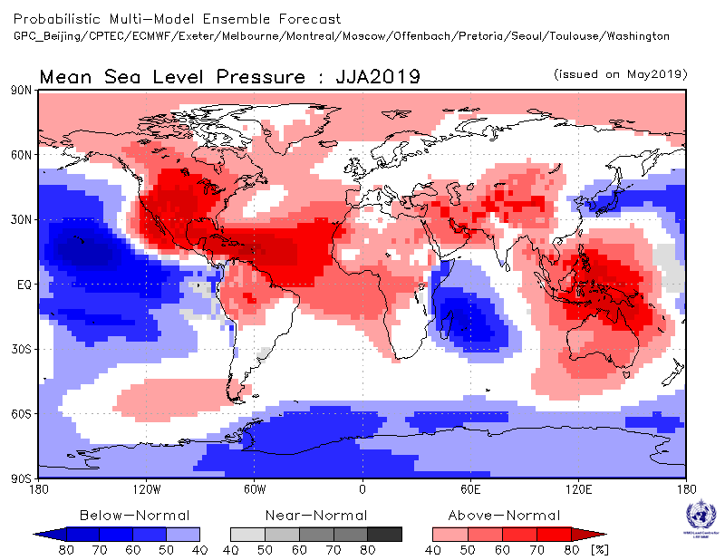

2.5.7 Verification of GPC ensemble mean MSLP anomaly forecasts, 1993-2009
Verification measure: Anomaly Correlation Coefficient (ACC)
Verification dataset: ERA-interim
DMME Beijing
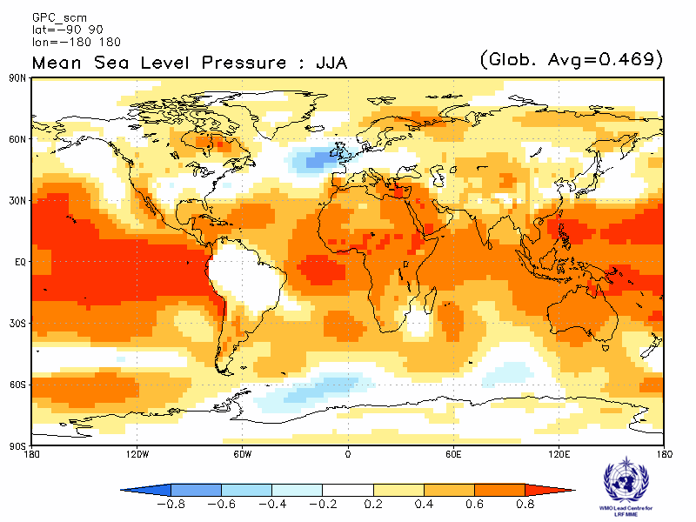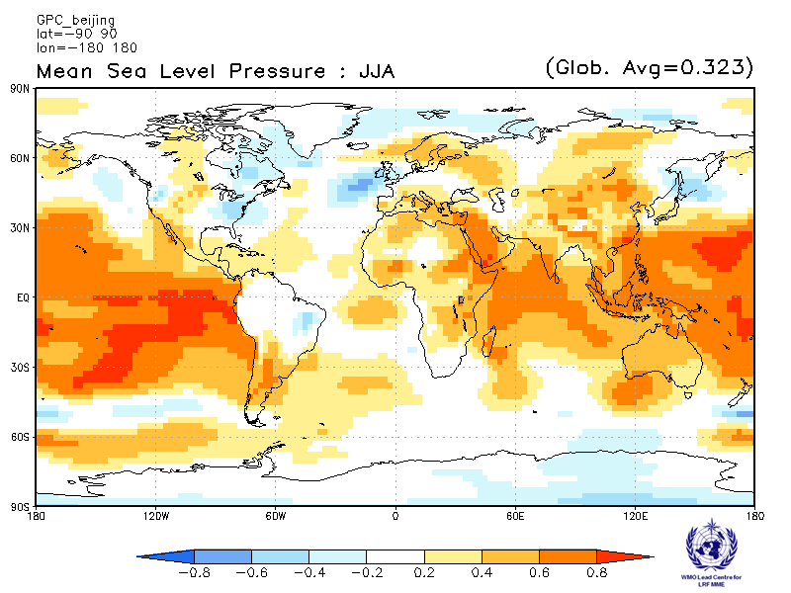
CPTEC ECMWF
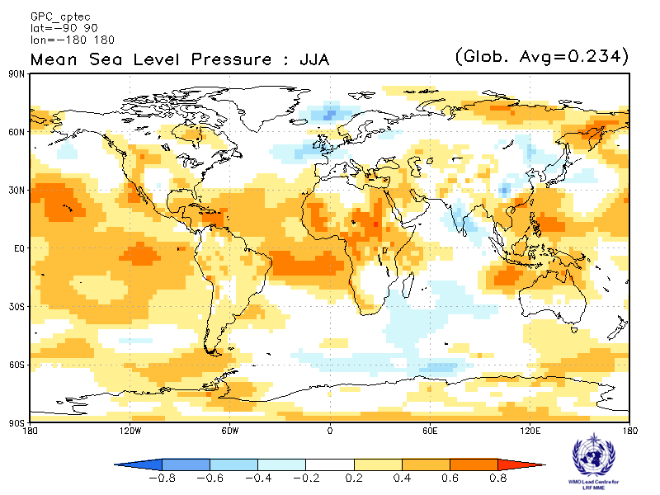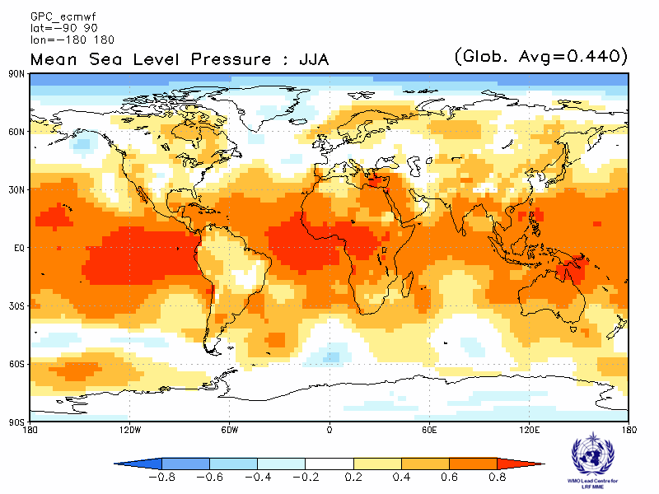

Exeter Melbourne
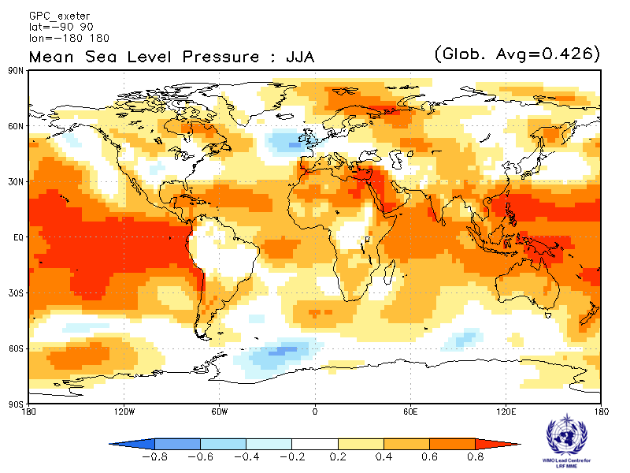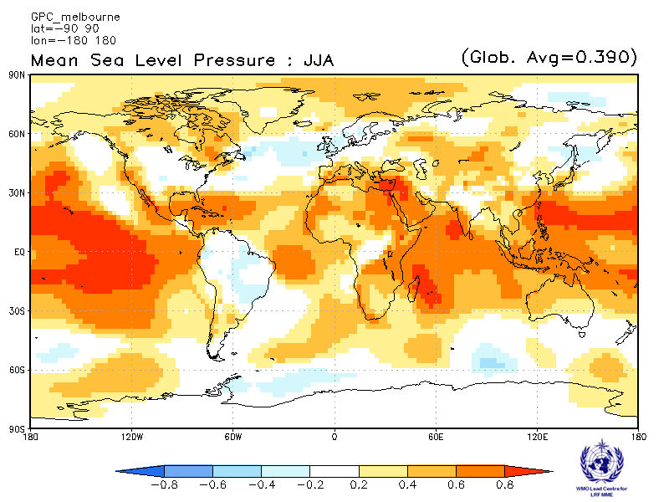

Montreal Moscow
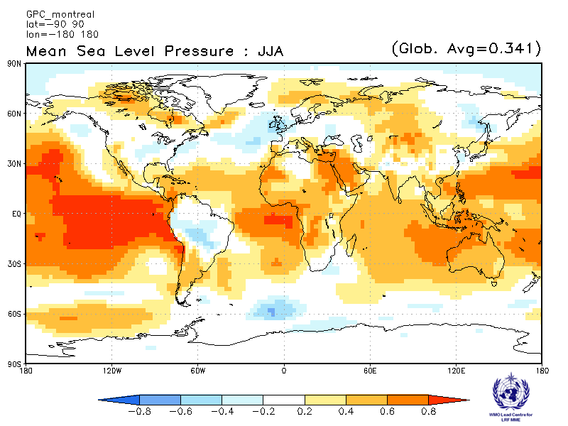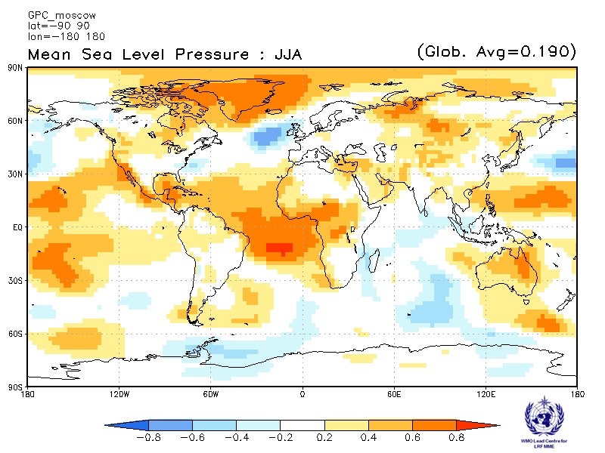

Offenbach Pretoria
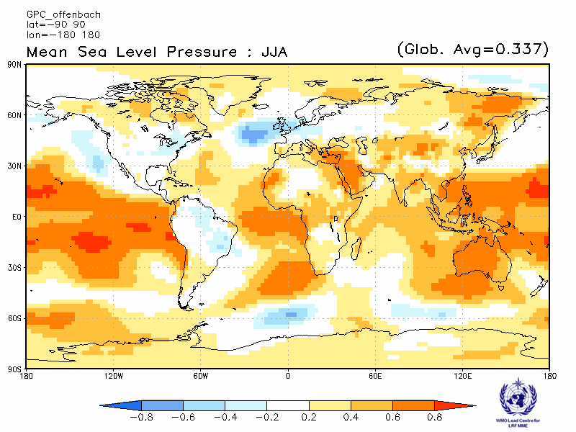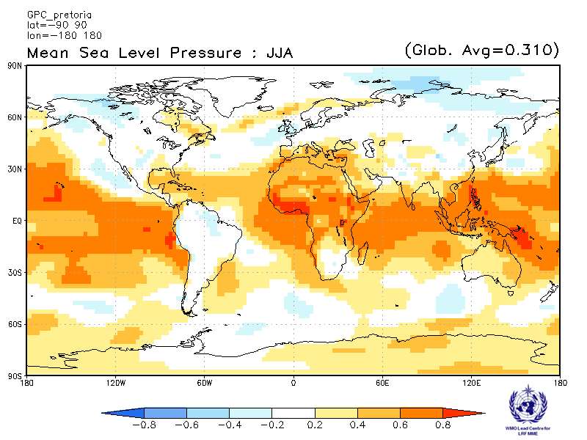

Seoul Tokyo
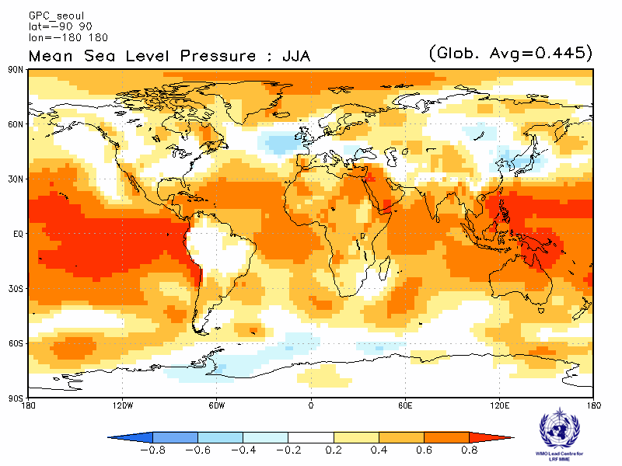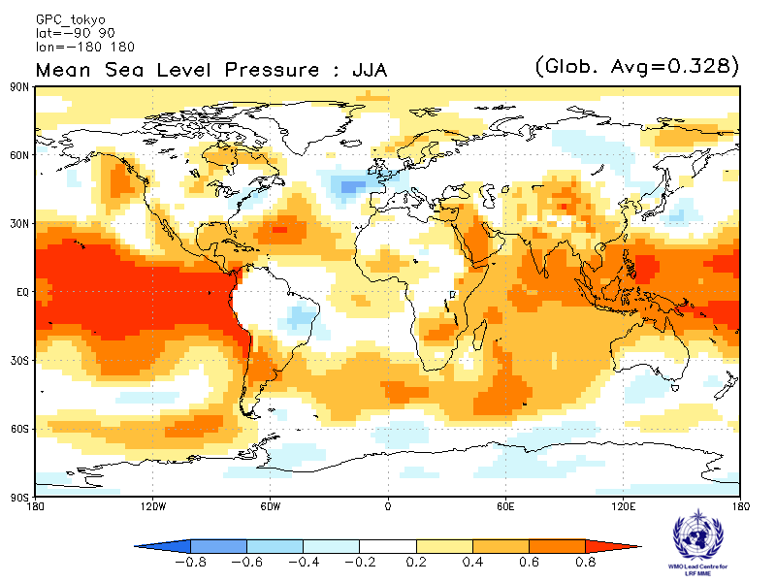

Toulouse Washington
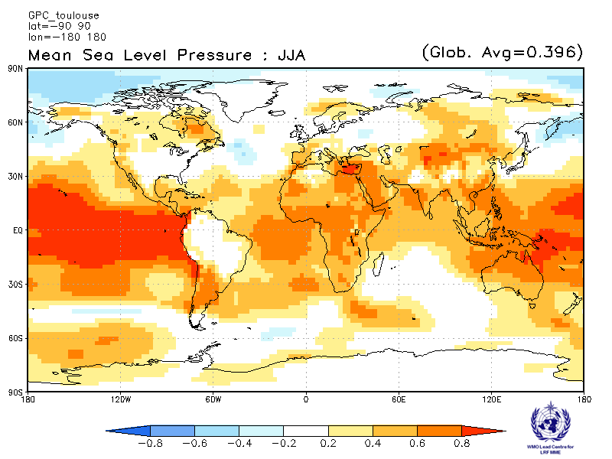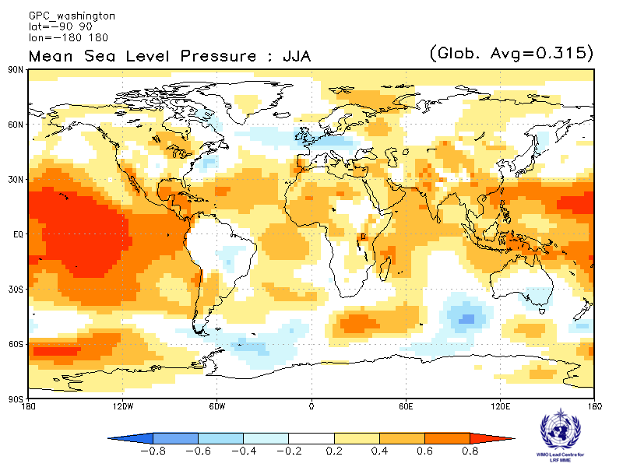

2.5.8 Verification of GPC MSLP probabilistic forecasts, 1993-2009
Verification measure: Relative Operating Characteristics (ROC) score for tercile forecast
Verification dataset: ERA-interim
PMME Beijing
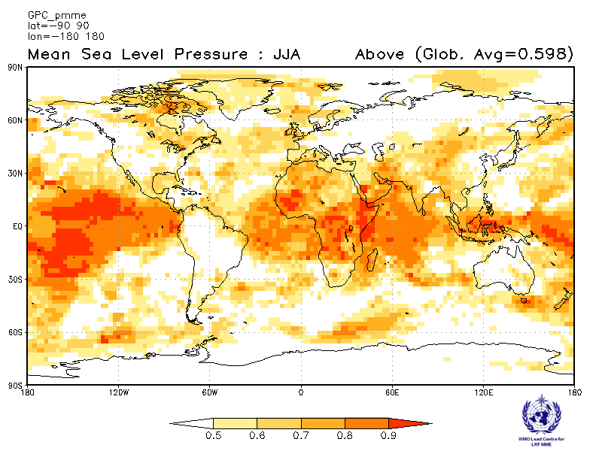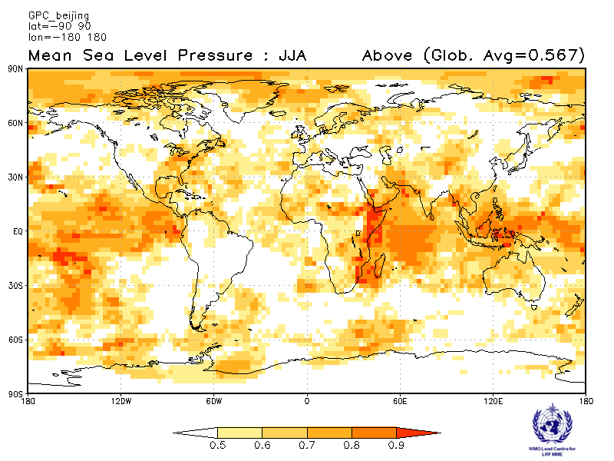
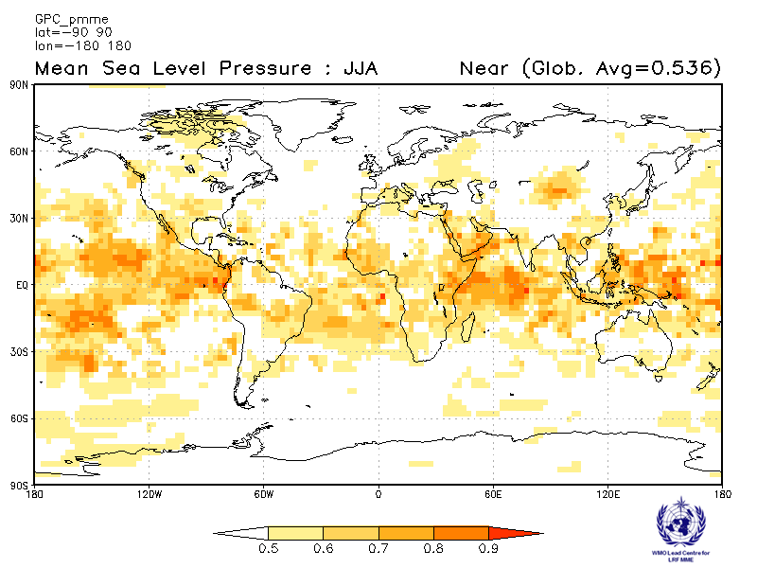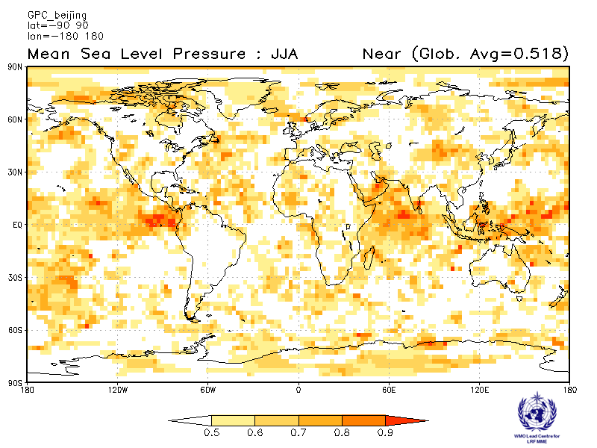
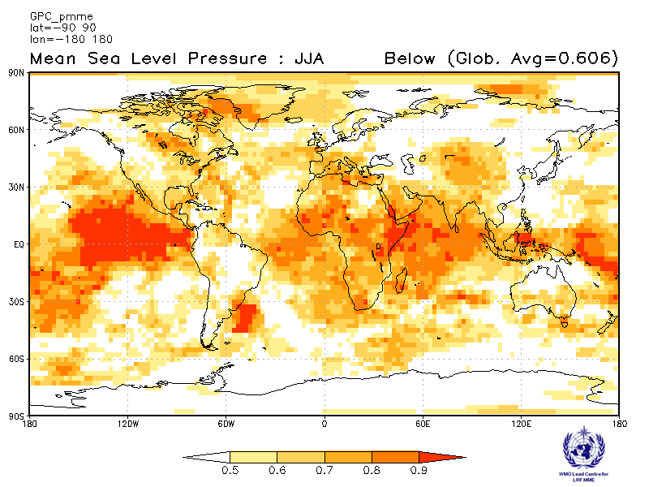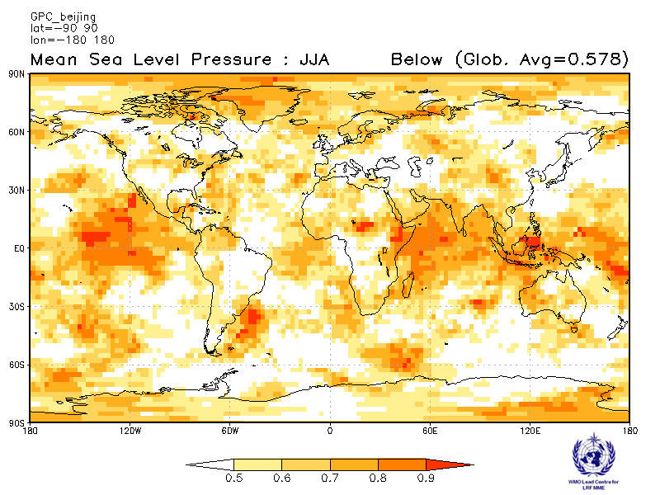

CPTEC ECMWF
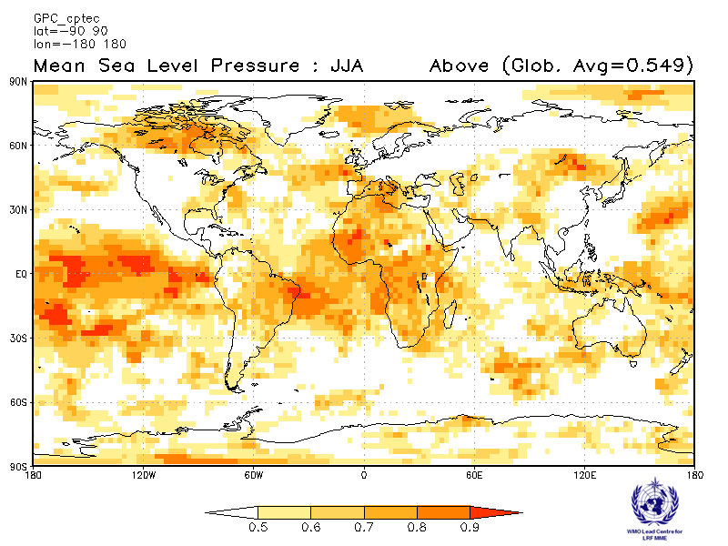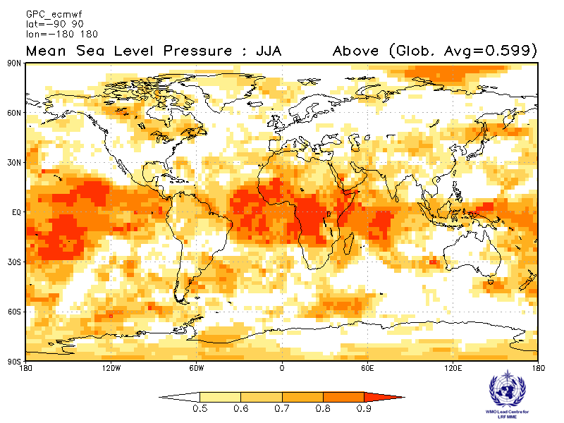
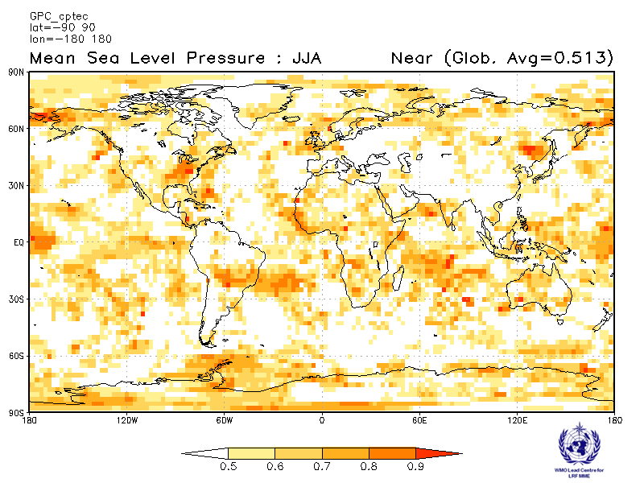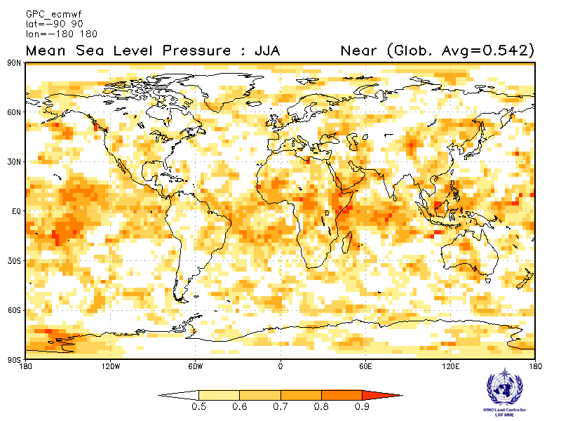
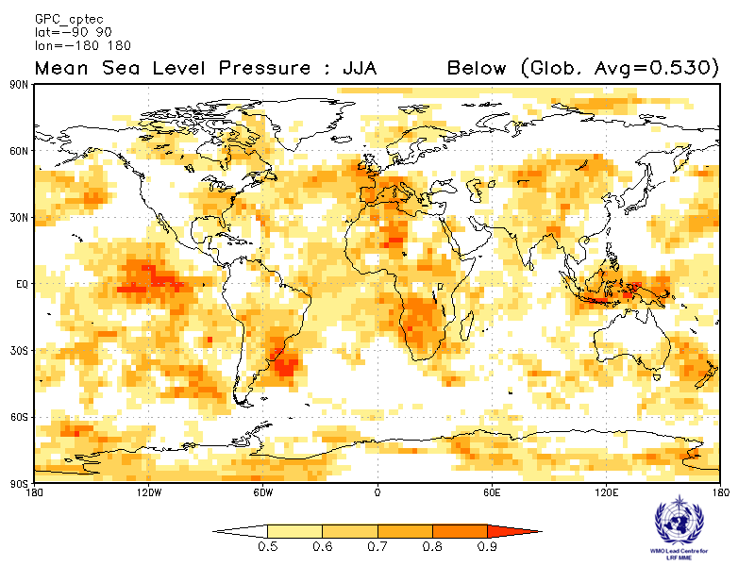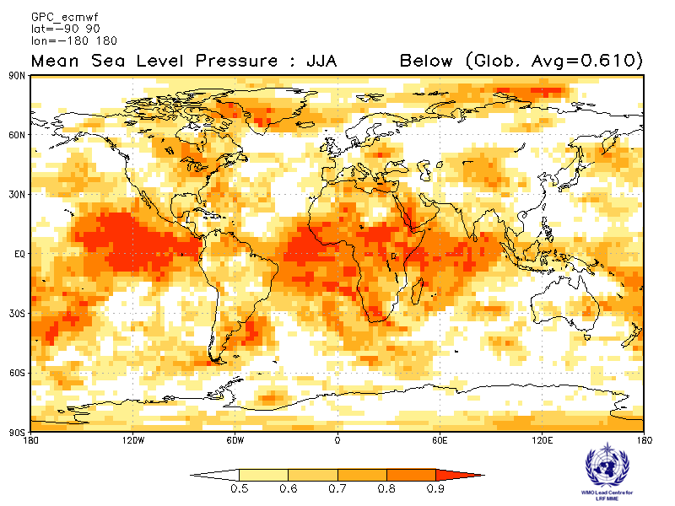
Exeter Melbourne
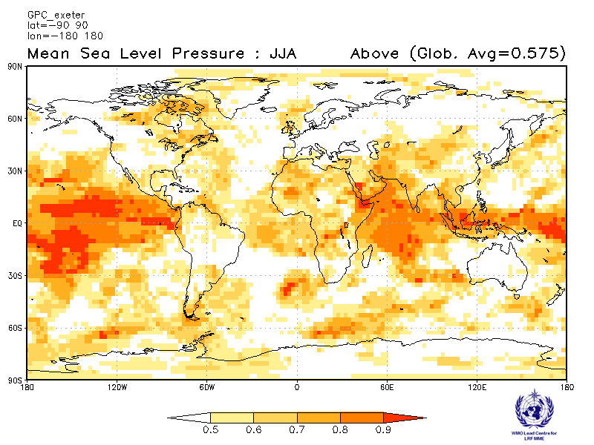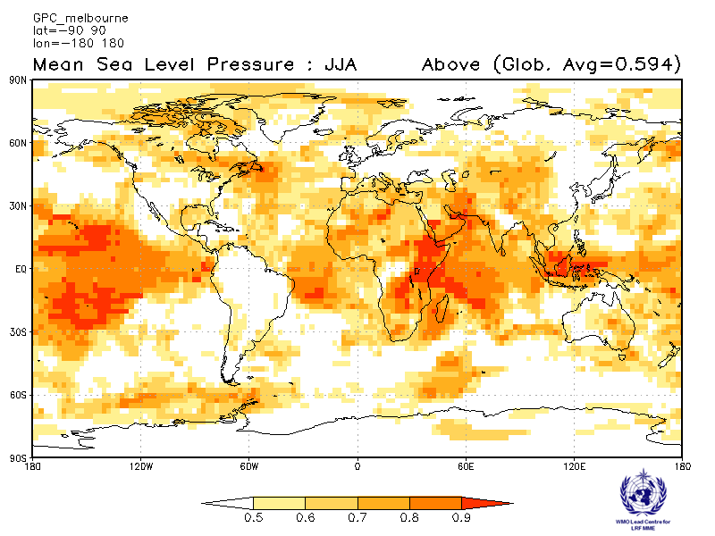
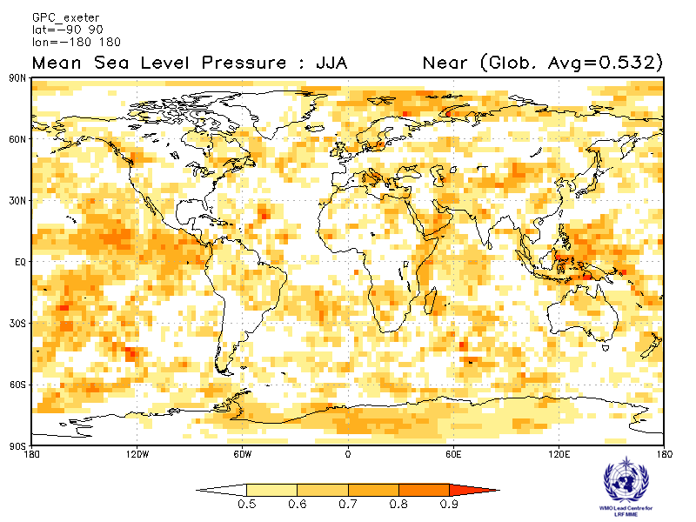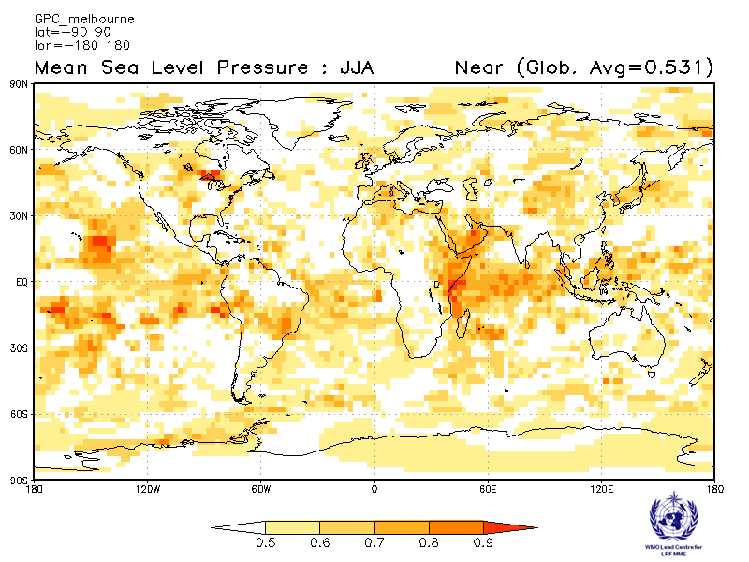
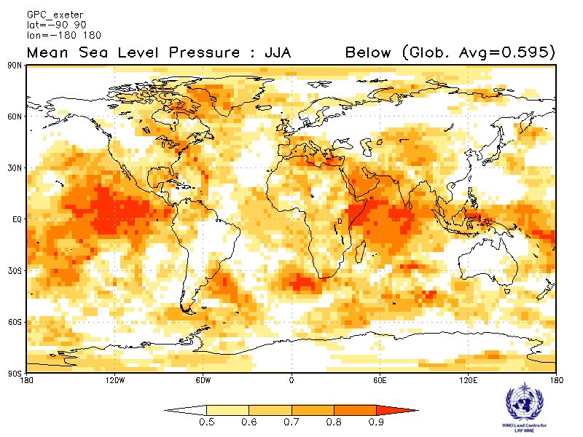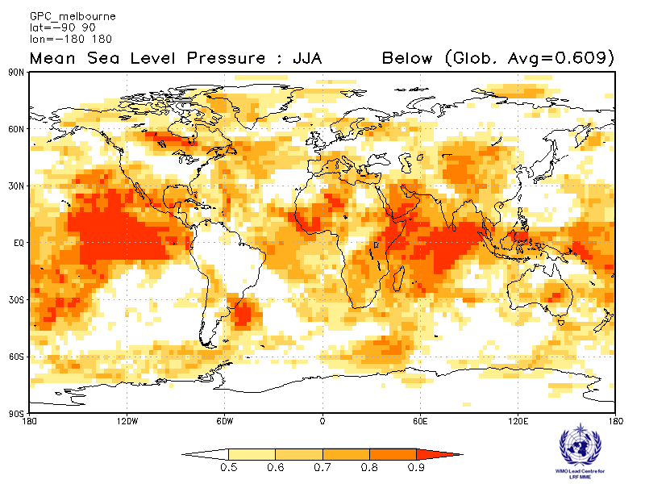
Montreal Moscow
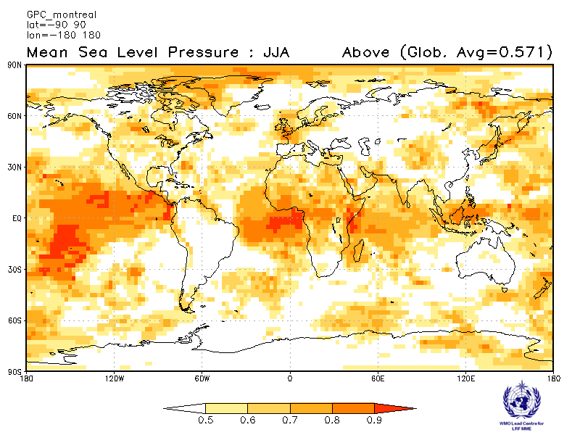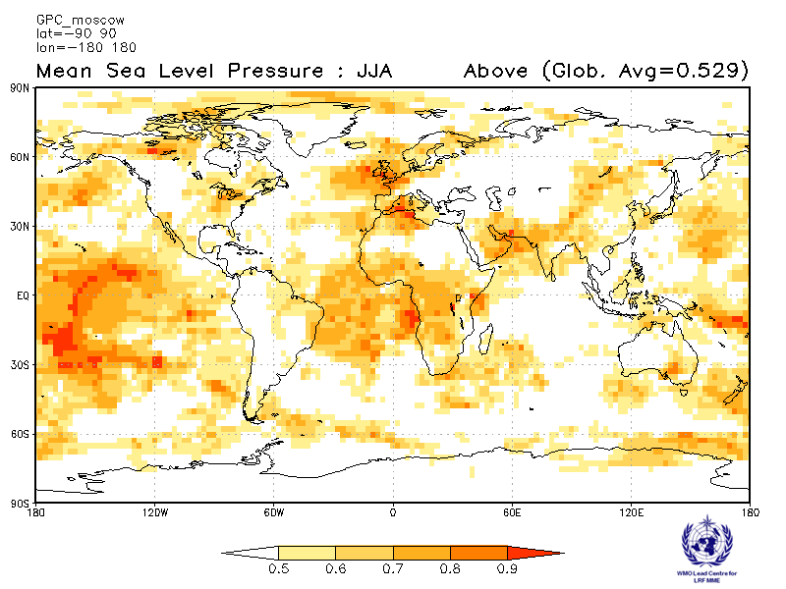
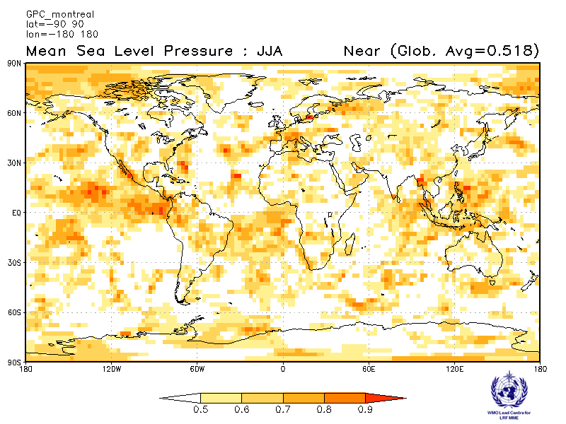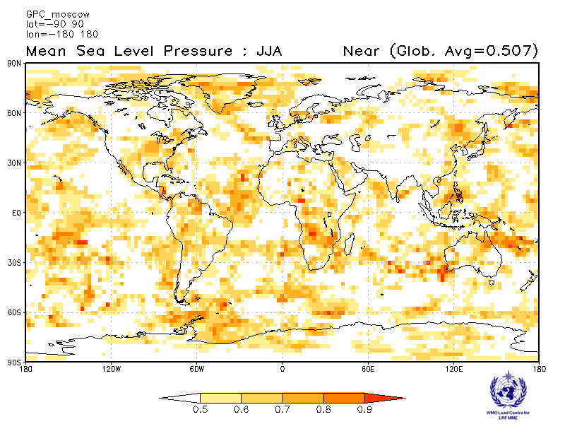
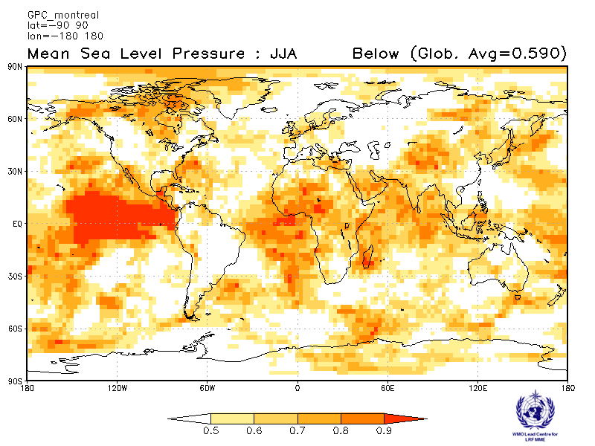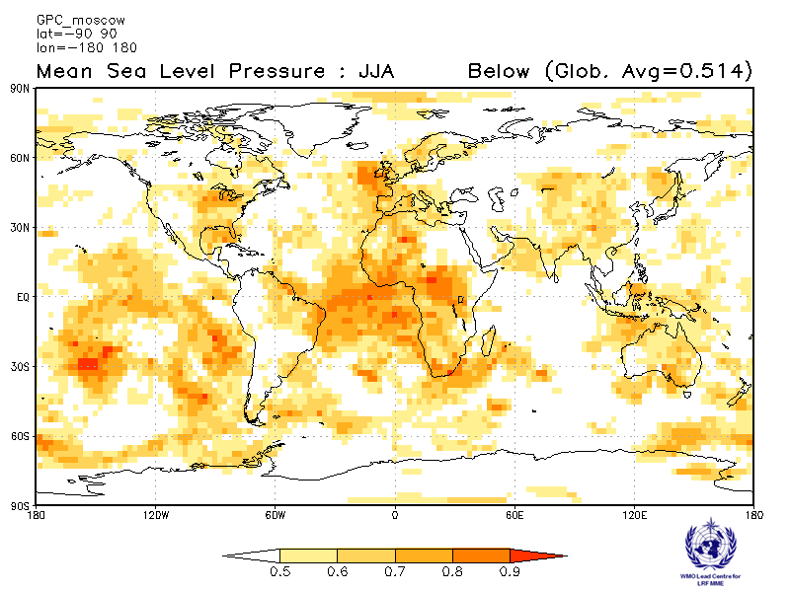
Offenbach Pretoria
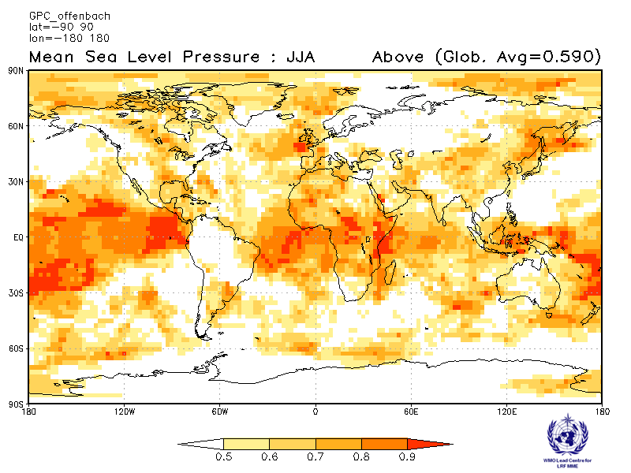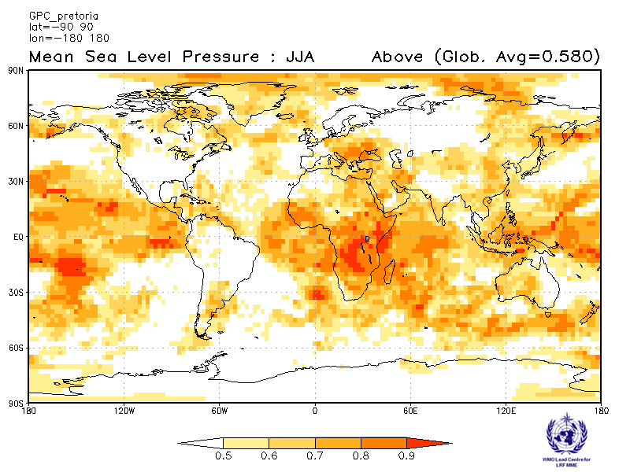
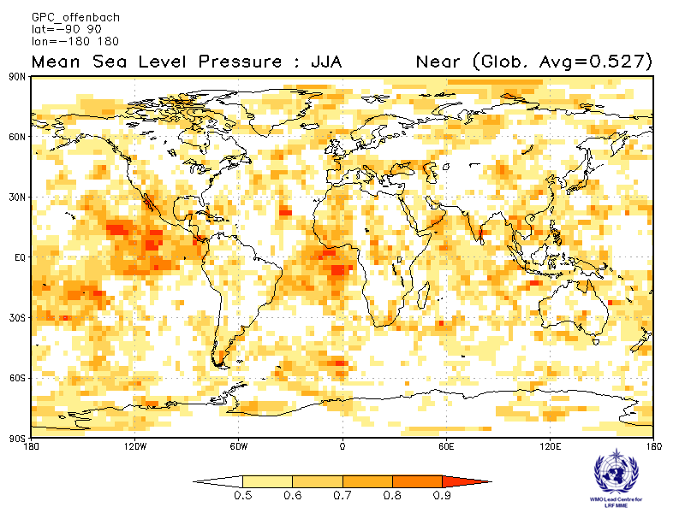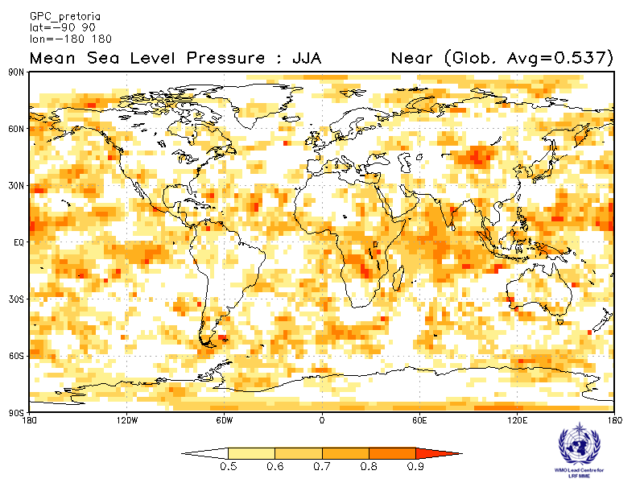
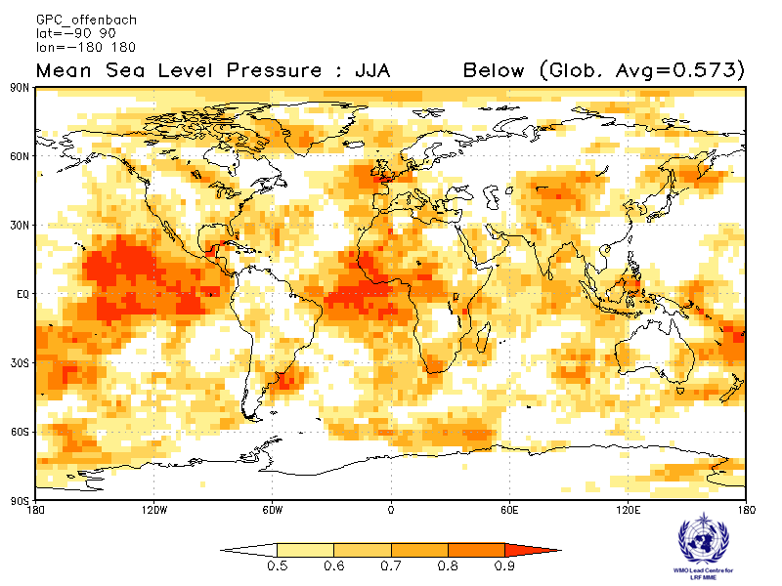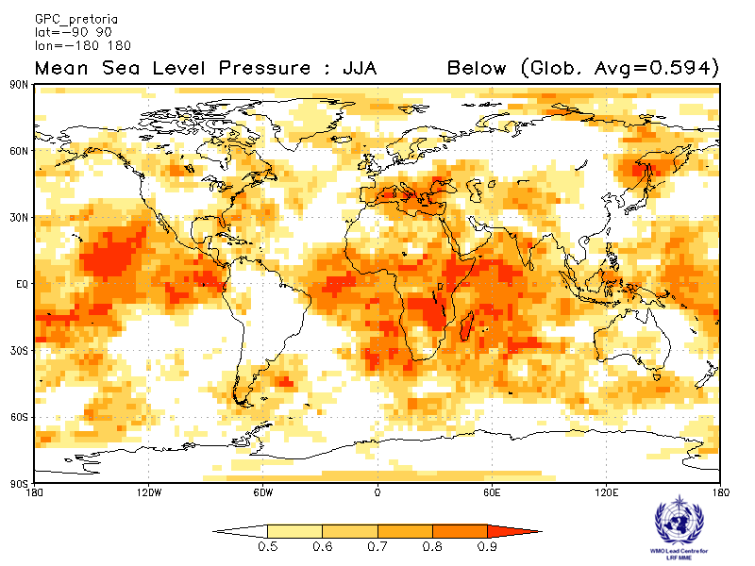
Seoul Tokyo
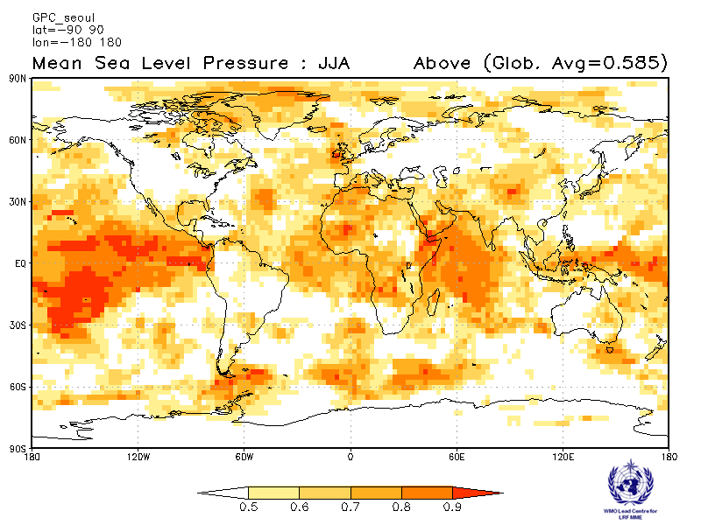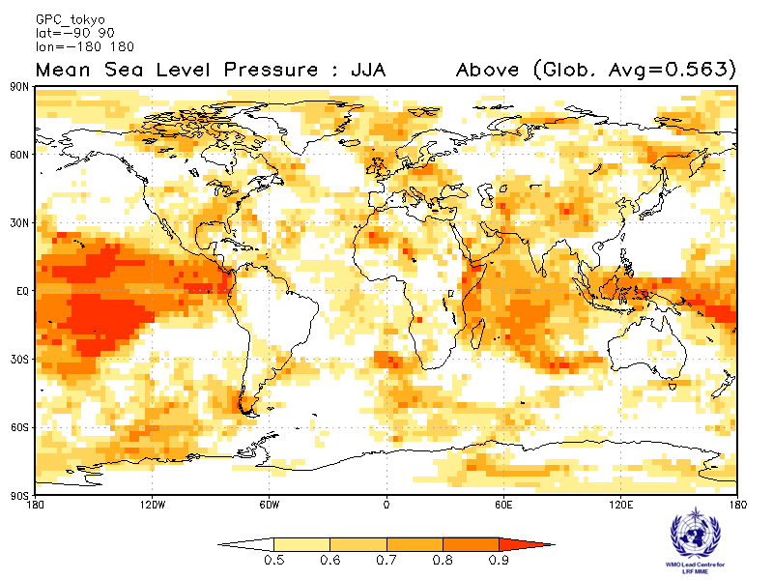
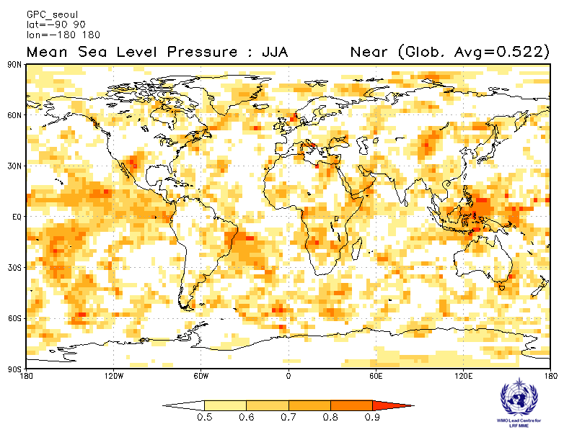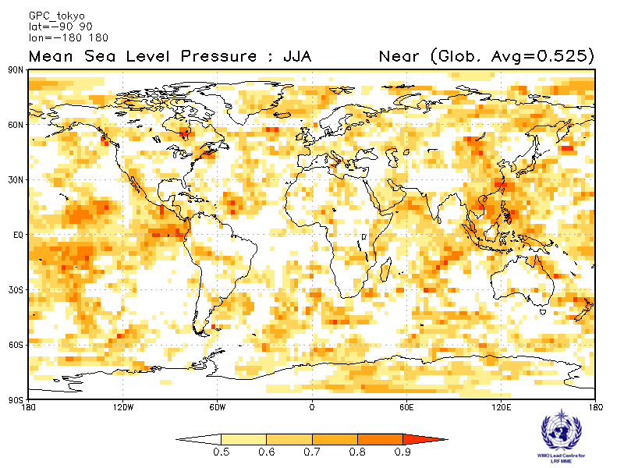
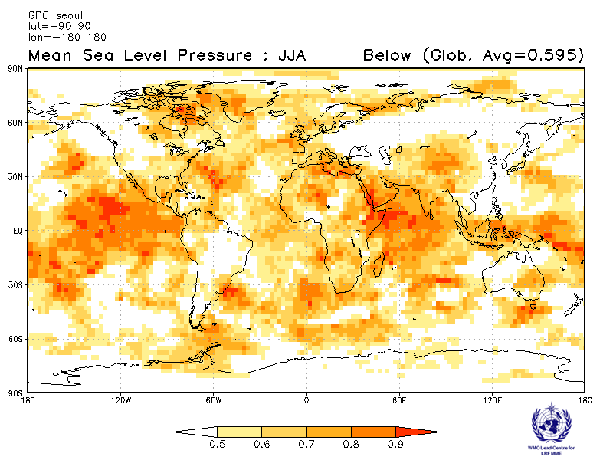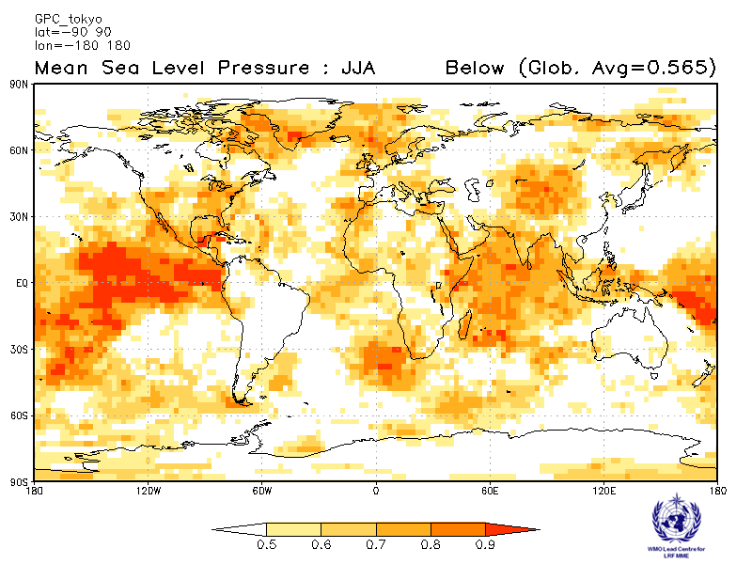
Toulouse Washington
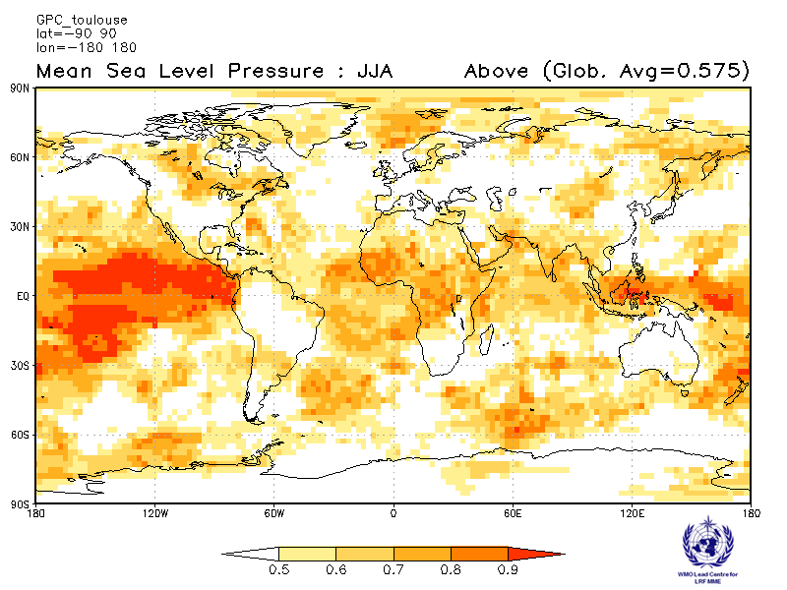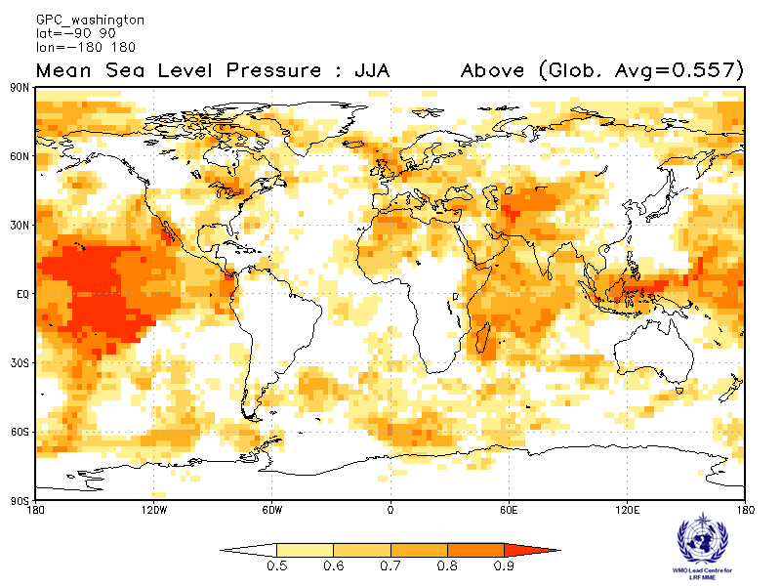
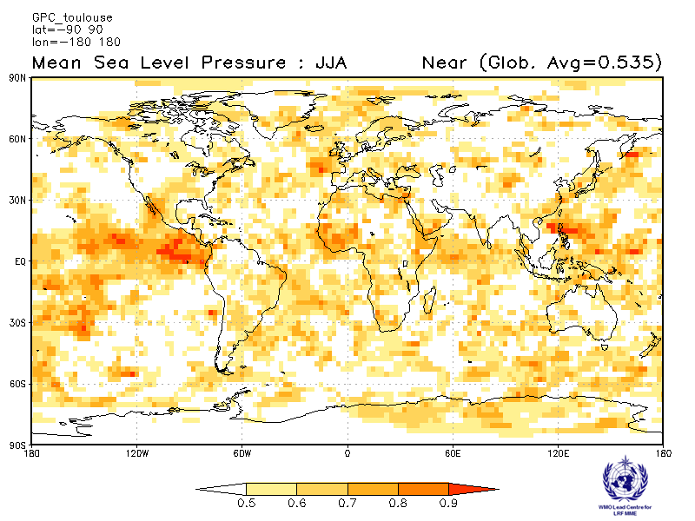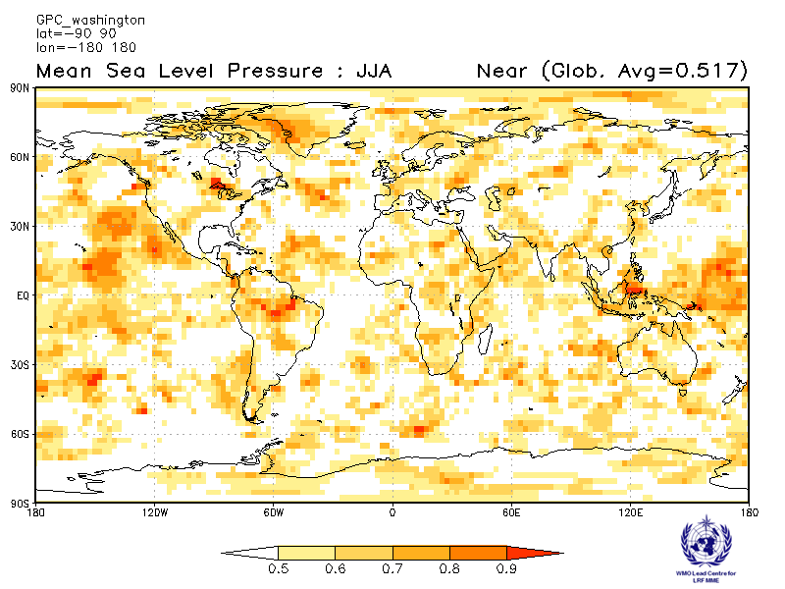
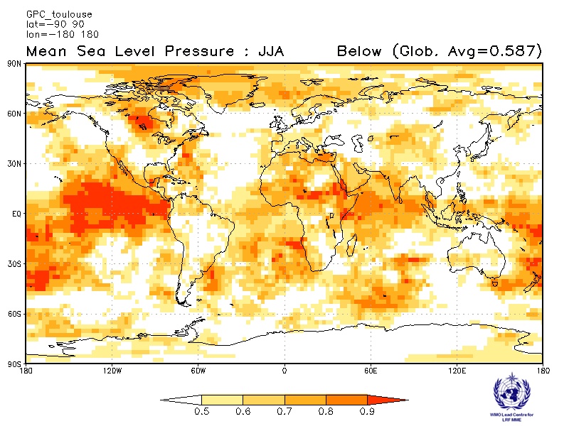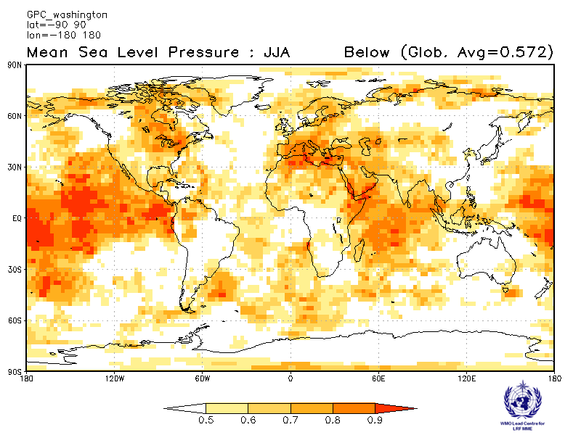

2.5.9 Verification of GPC MSLP probabilistic forecasts, 1993-2009
Verification measure: Relative Operating Characteristics (ROC) Curve and Score over globe Verification dataset: ERA-interim
PMME Beijing
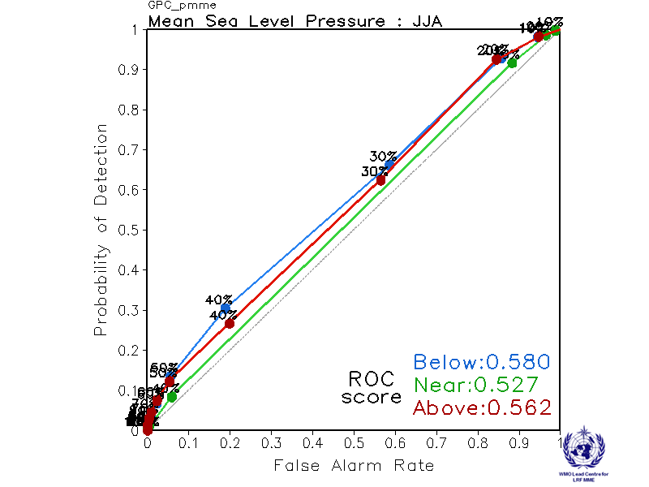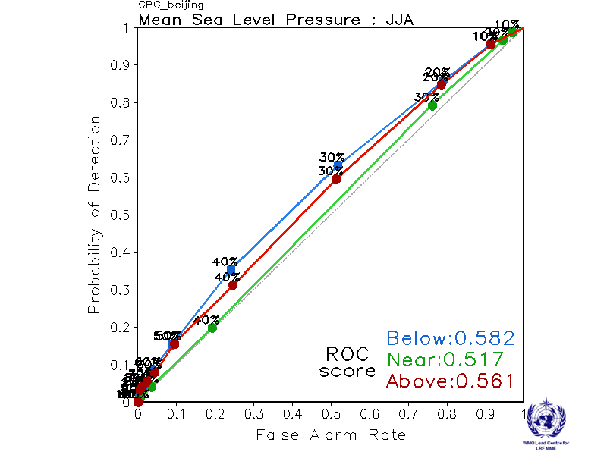
CPTEC ECMWF
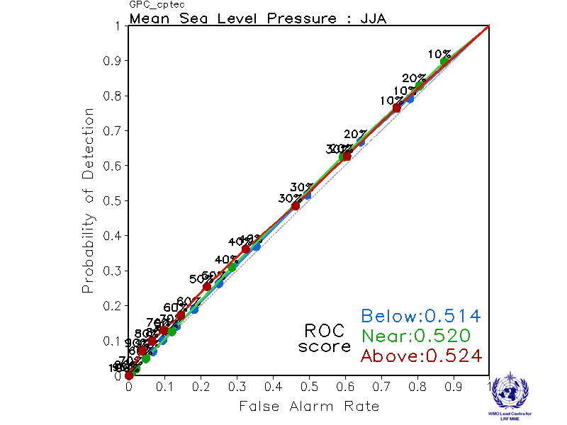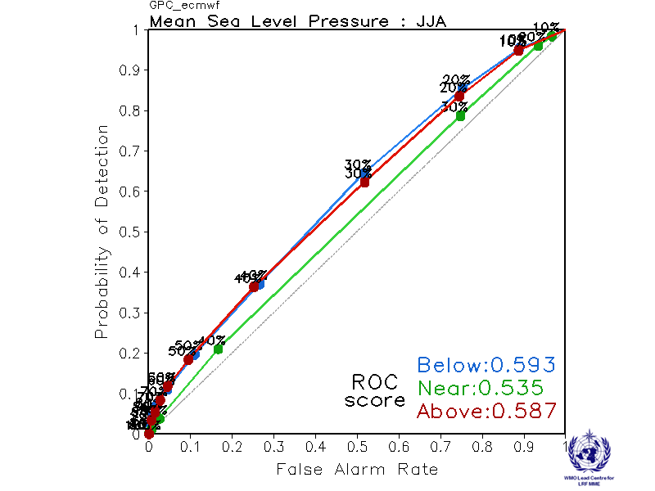

Exeter Melbourne
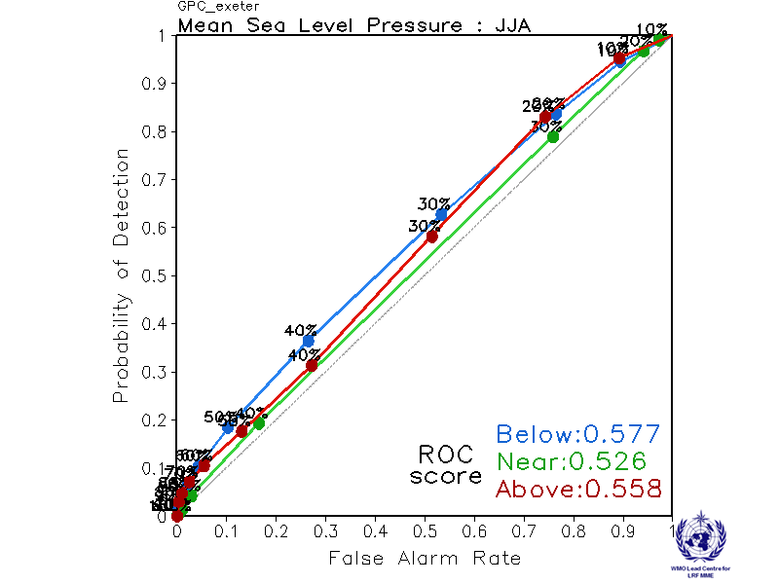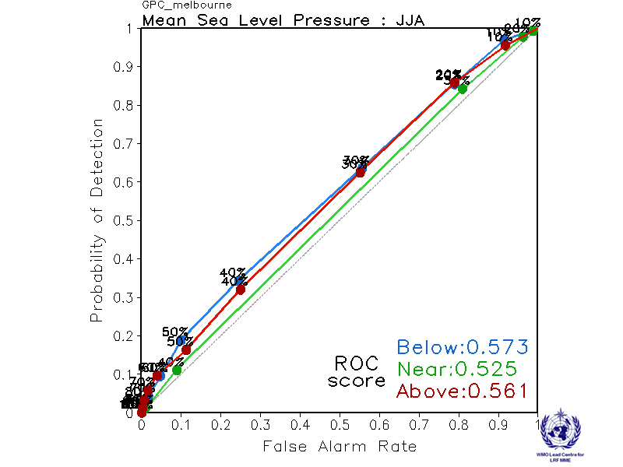

Montreal Moscow
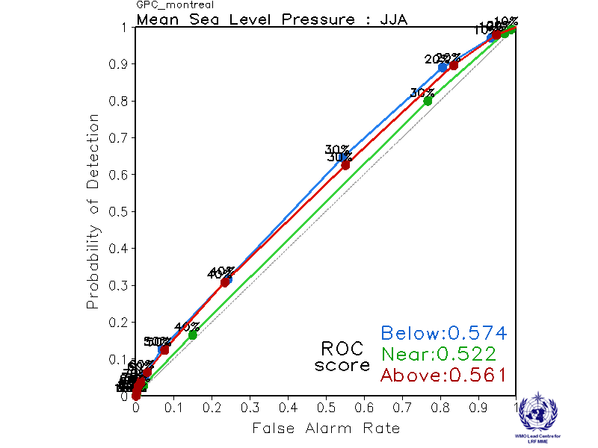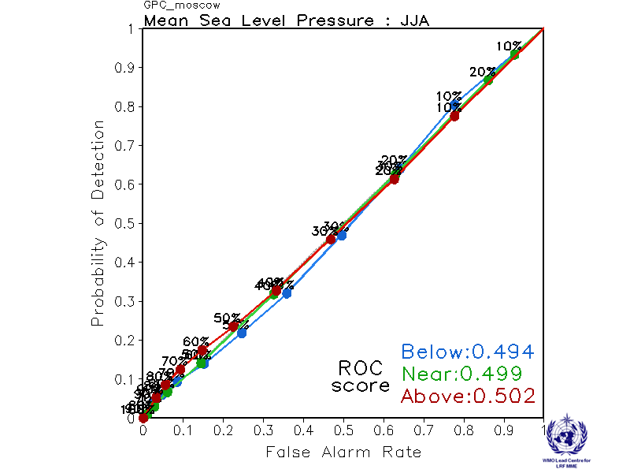

Offenbach Pretoria
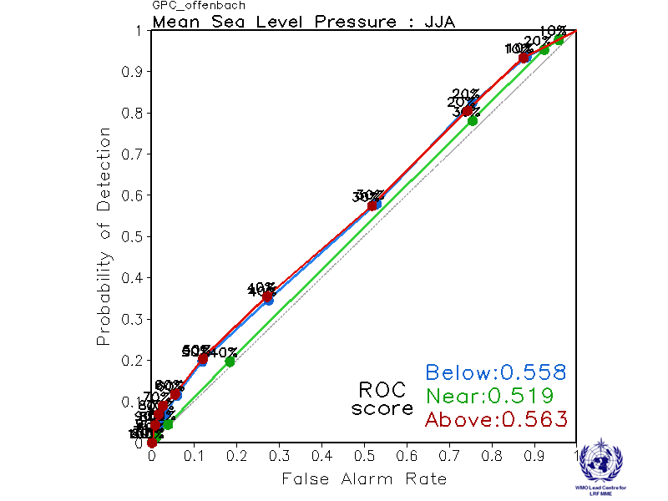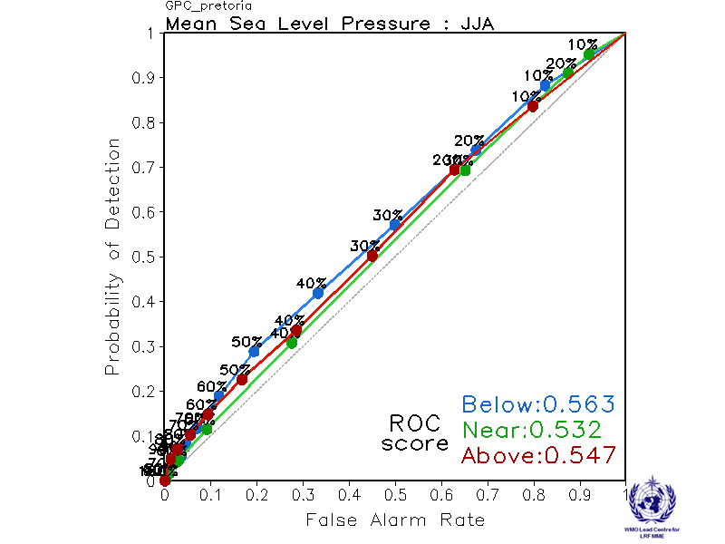

Seoul Tokyo
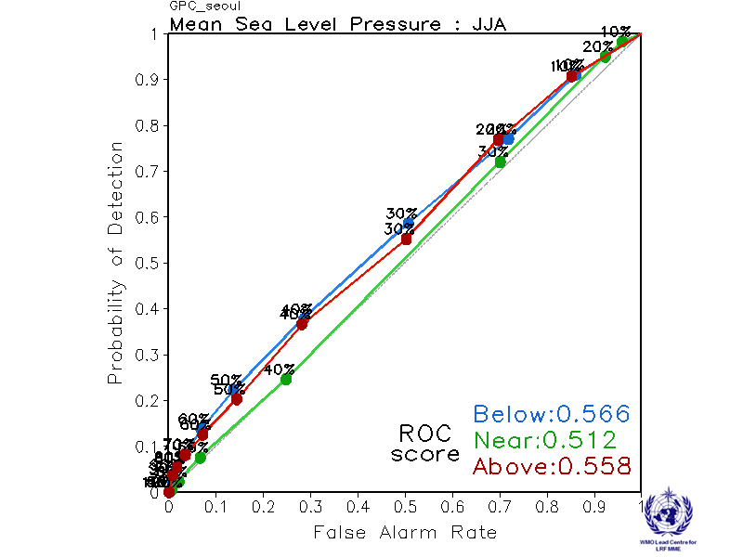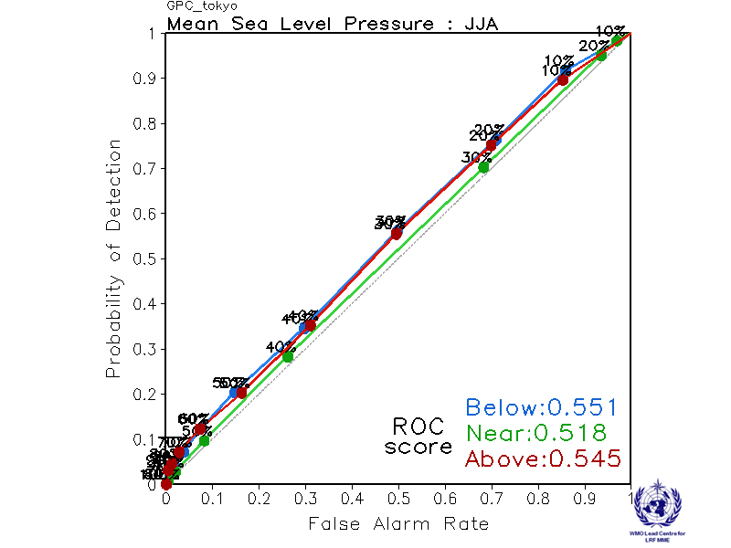

Toulouse Washington
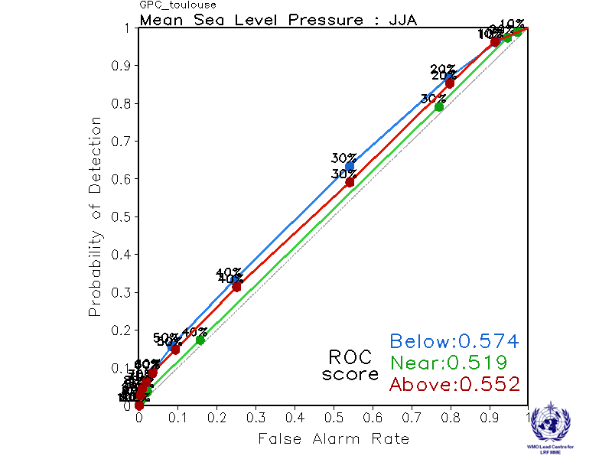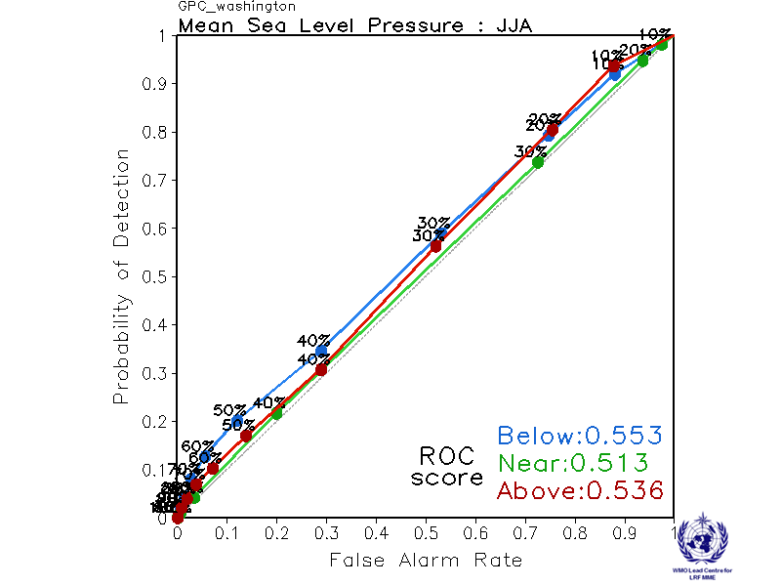

2.5.10 Verification of GPC MSLP probabilistic forecasts, 1993-2009
Verification measure: Reliability Diagram over globe
Verification dataset: ERA-interim
PMME Beijing
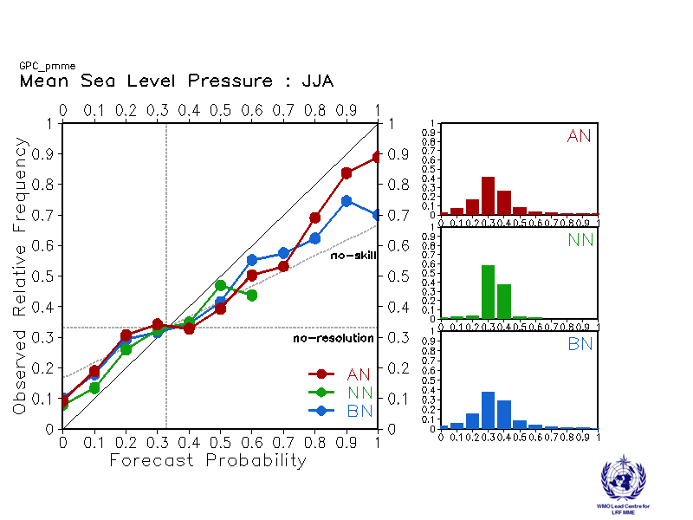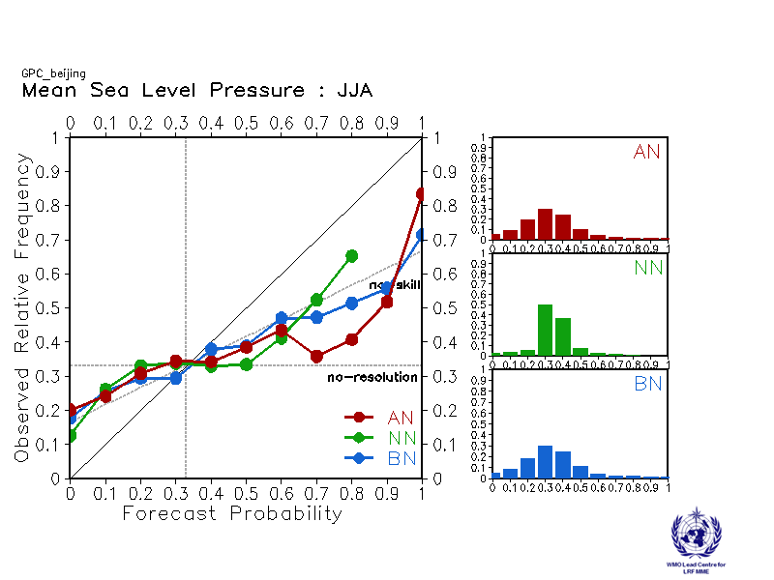
CPTEC ECMWF
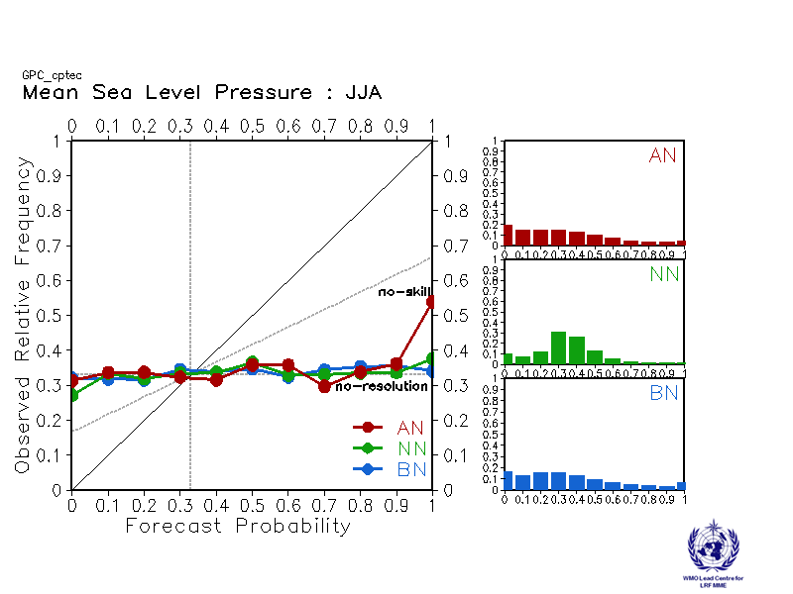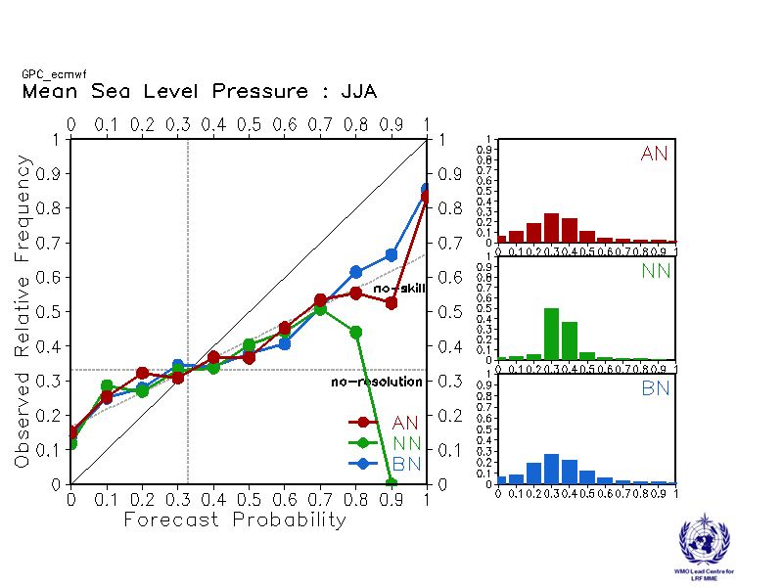

Exeter Melbourne
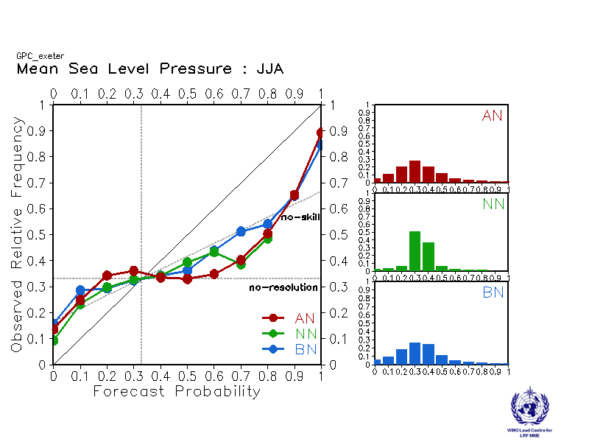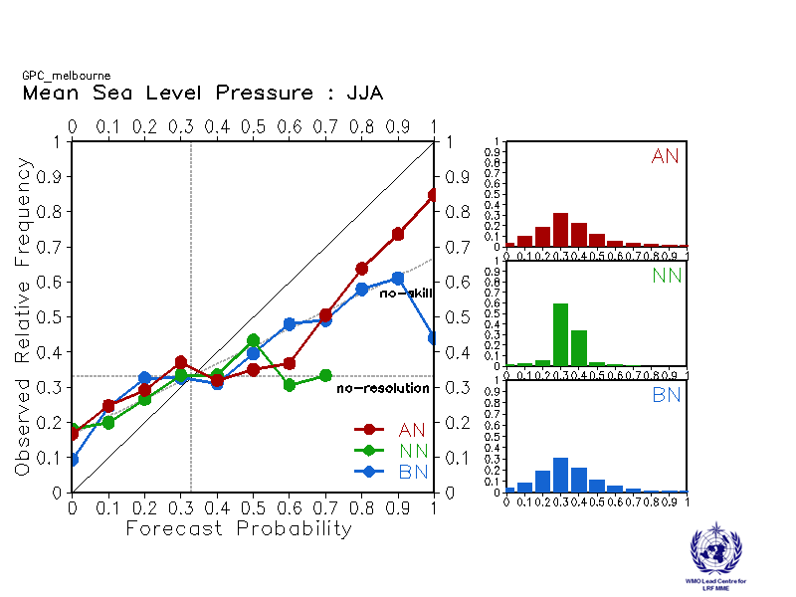

Montreal Moscow
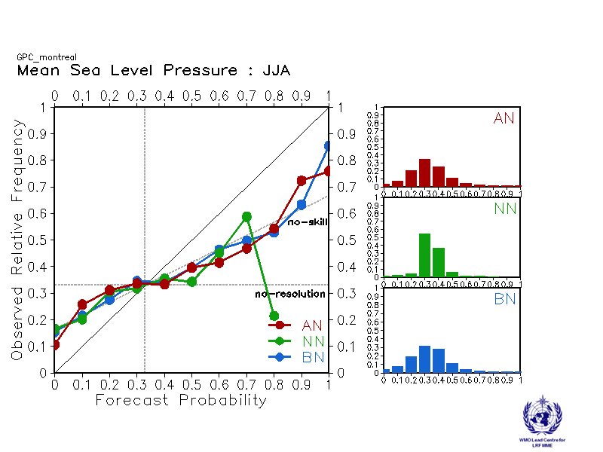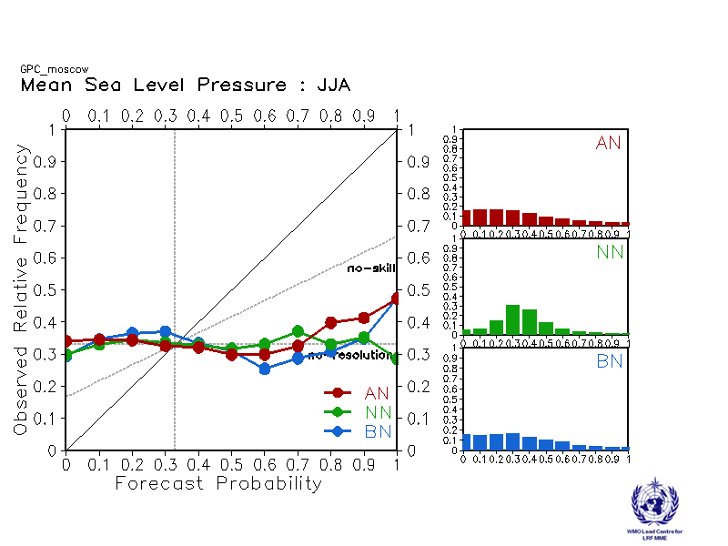

Offenbach Pretoria
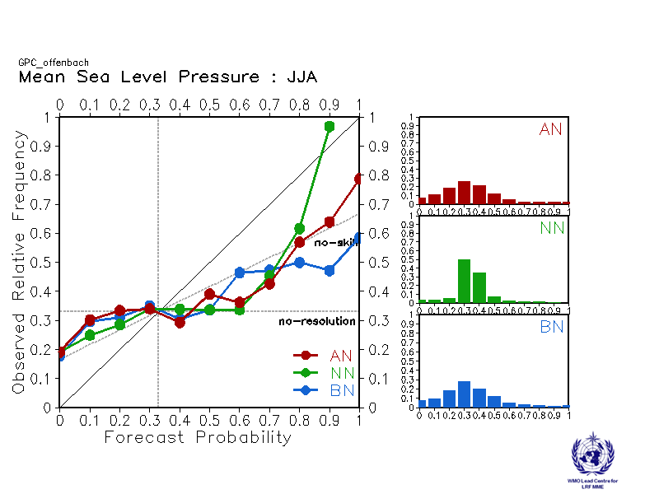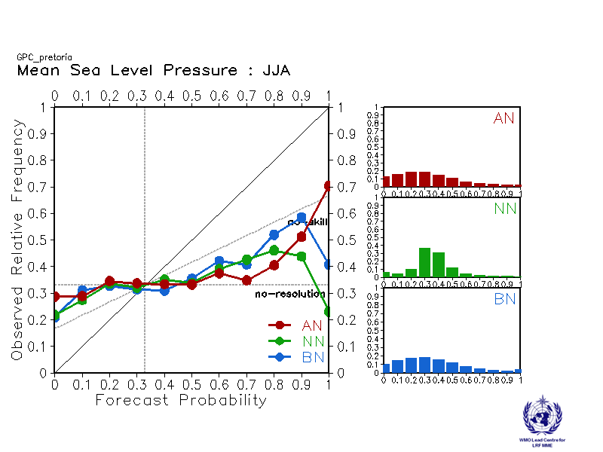

Seoul Tokyo
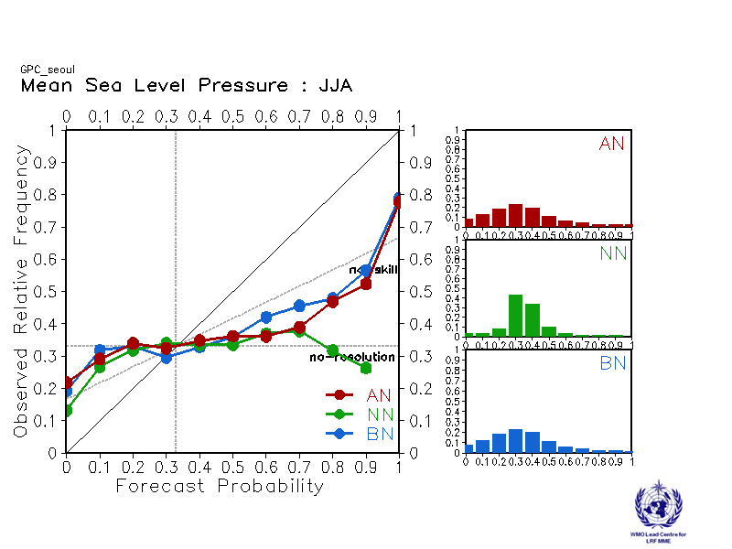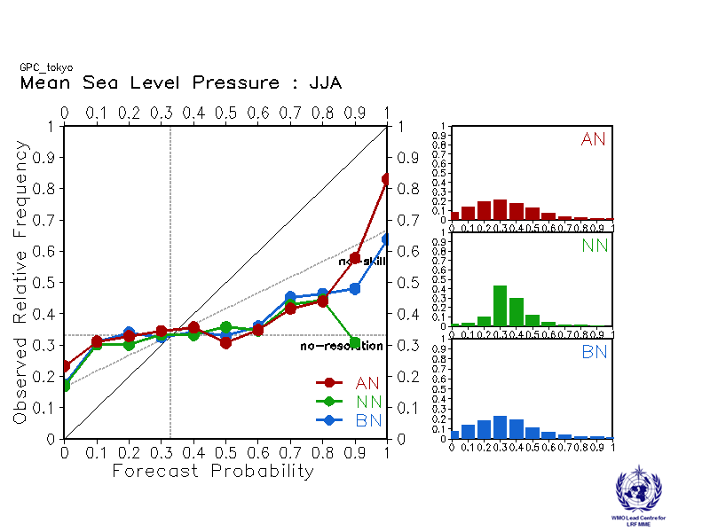

Toulouse Washington
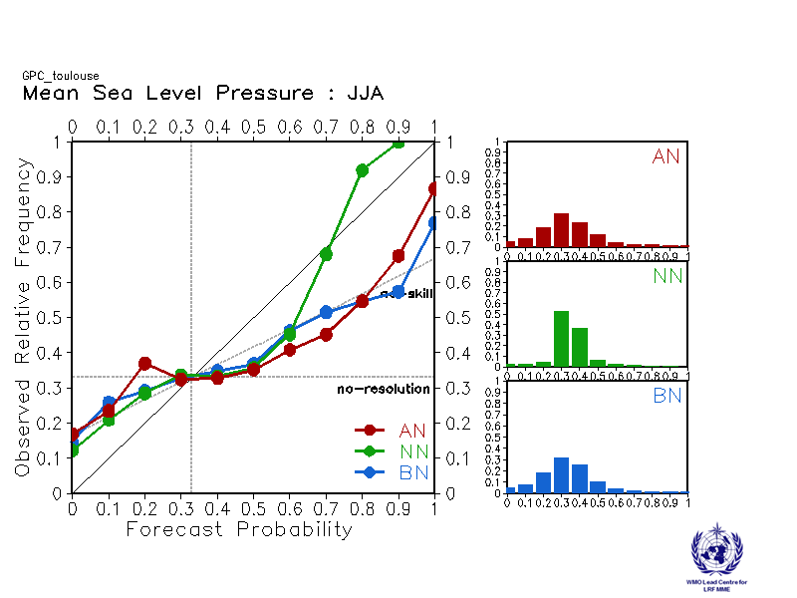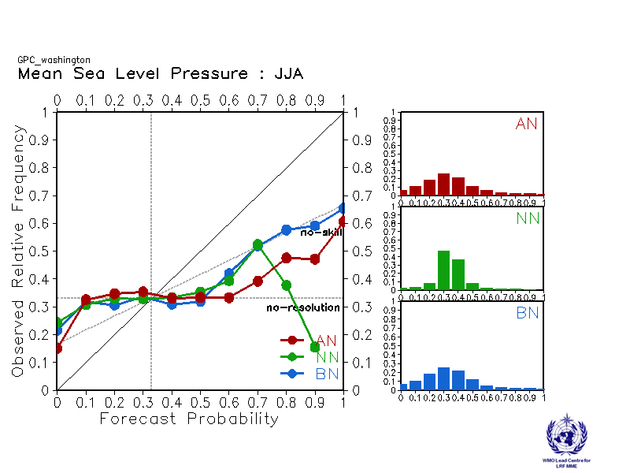

2.6 Ensemble mean predictions of global mean seasonal temperature anomaly for 1993-2009
GPC | Global average Temp.(K)  (baseline of 1993-2009) | Global average Temp.(K)  (with models own baseline)
Beijing | 0.46 | 0.47
CPTEC | 0.59 | 0.64
ECMWF | 0.45 | 0.42
Exeter | 0.51 | 0.43
Melbourne | 0.08 | 0.14
Montreal | 0.41 | 0.44
Moscow | 0.09 | 0.1
Offenbach | 0.52 | 0.47
Pretoria | 0.46 | 0.47
Seoul | 0.67 | 0.67
Tokyo | 0.37 | 0.43
Toulouse | 0.57 | 0.51
Washington | 0.48 | 0.56
MME(13 GPCs) | N/A | 0.44
MME(12 GPCs) | 0.44 | 0.44

2.7 Predictions of monthly SST indices: each model with its own baseline
Nino 1+2
SSTA[90°W-80°W, 10°S-0°]
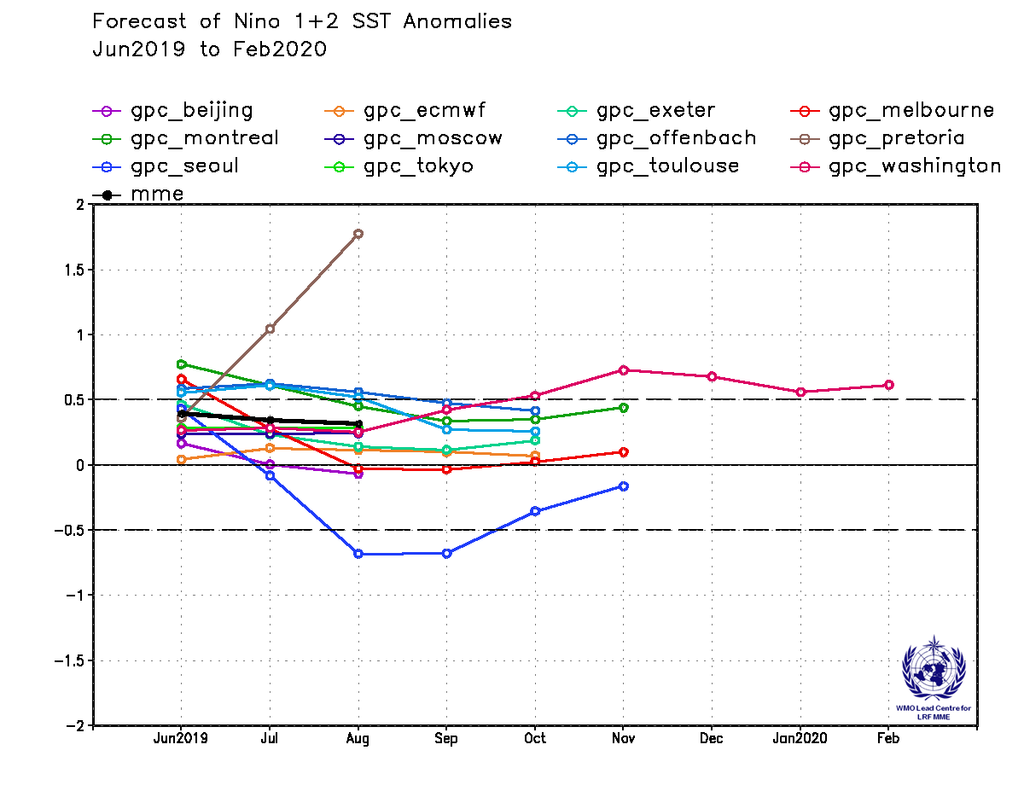
Nino 3
SSTA[150°W-90°W, 5°S-5°N]
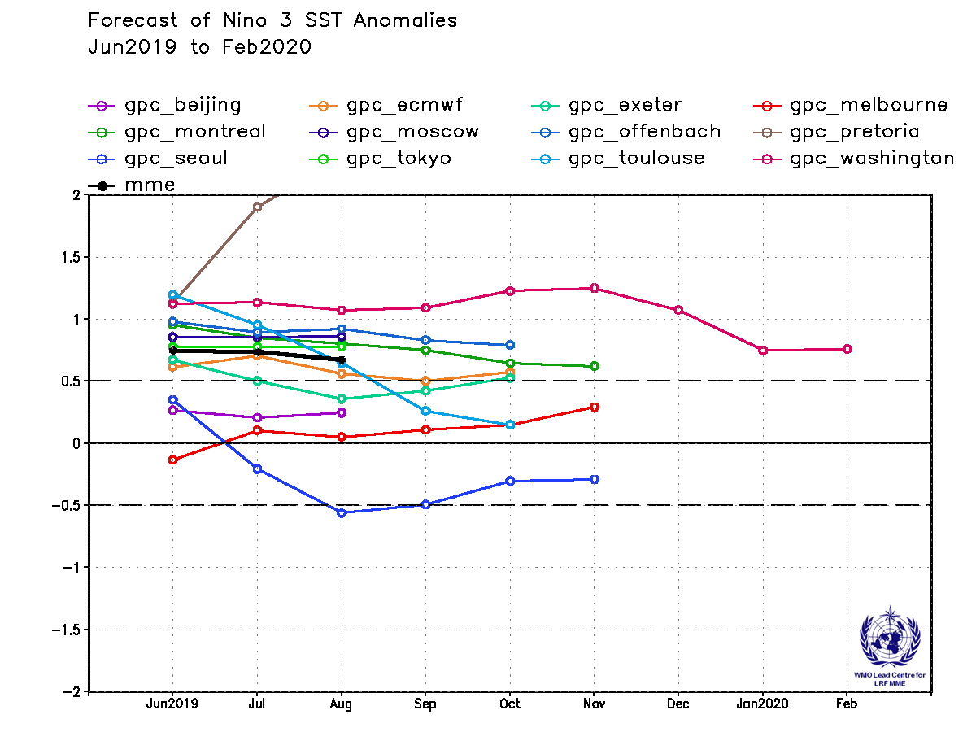
Nino 4
SSTA[160°E-150°W, 5°S-5°N]
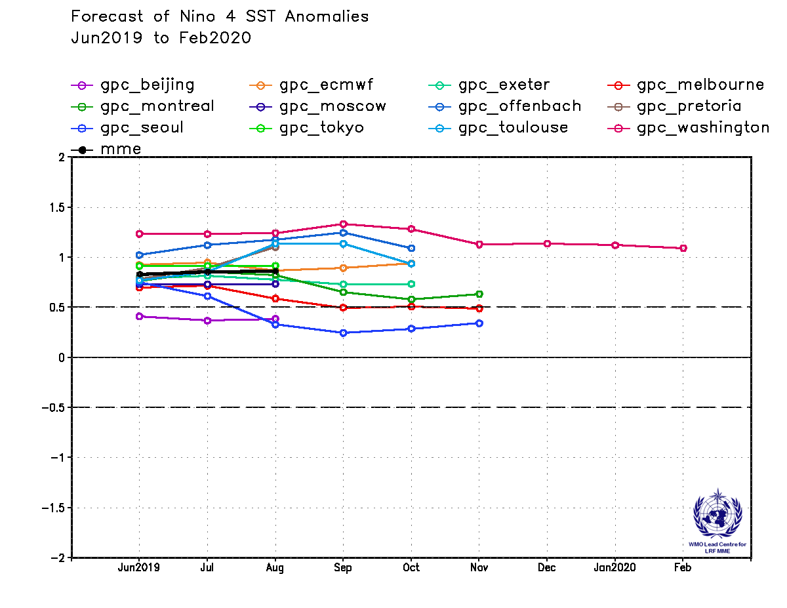
Nino 3.4
SSTA[170°W-120°W, 5°S-5°N]
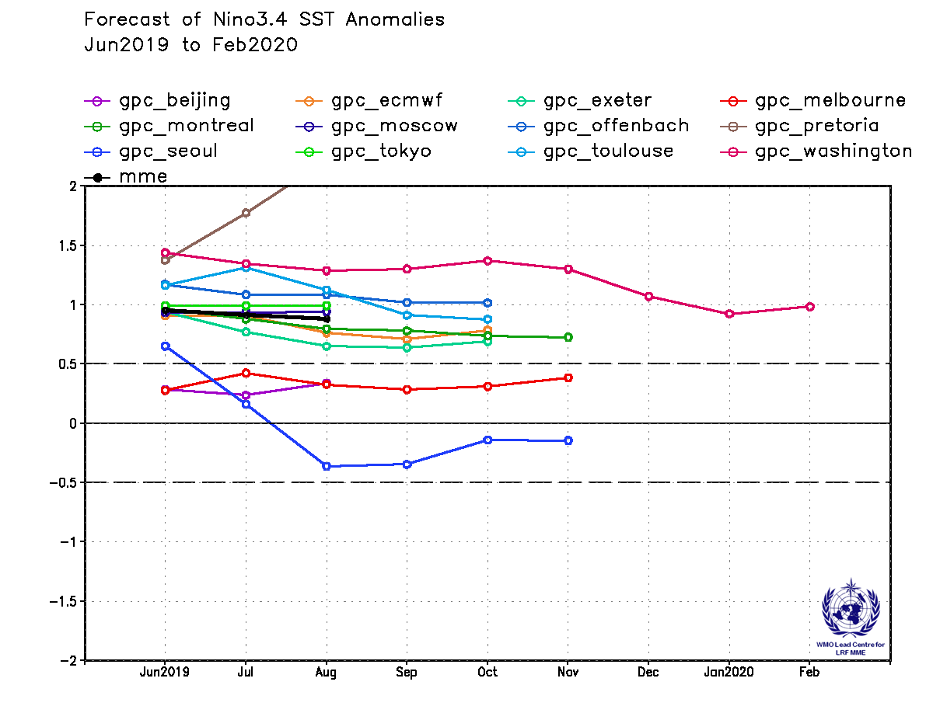
IOD
SSTA[50°E-70°E, 10°S -10°N]-SSTA[90°E-110°E, 10°S -0°]
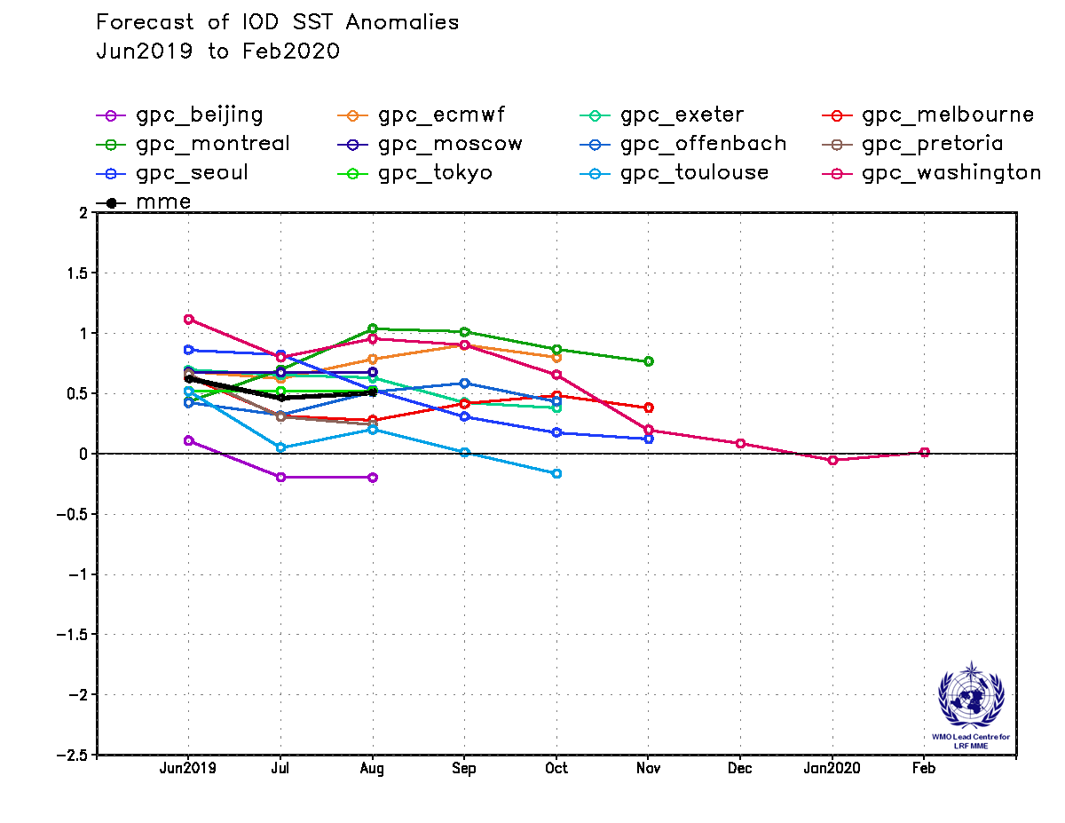
North Tropical Atlantic (NTA)
SSTA[60°W-30°W, 5°N-20°N]
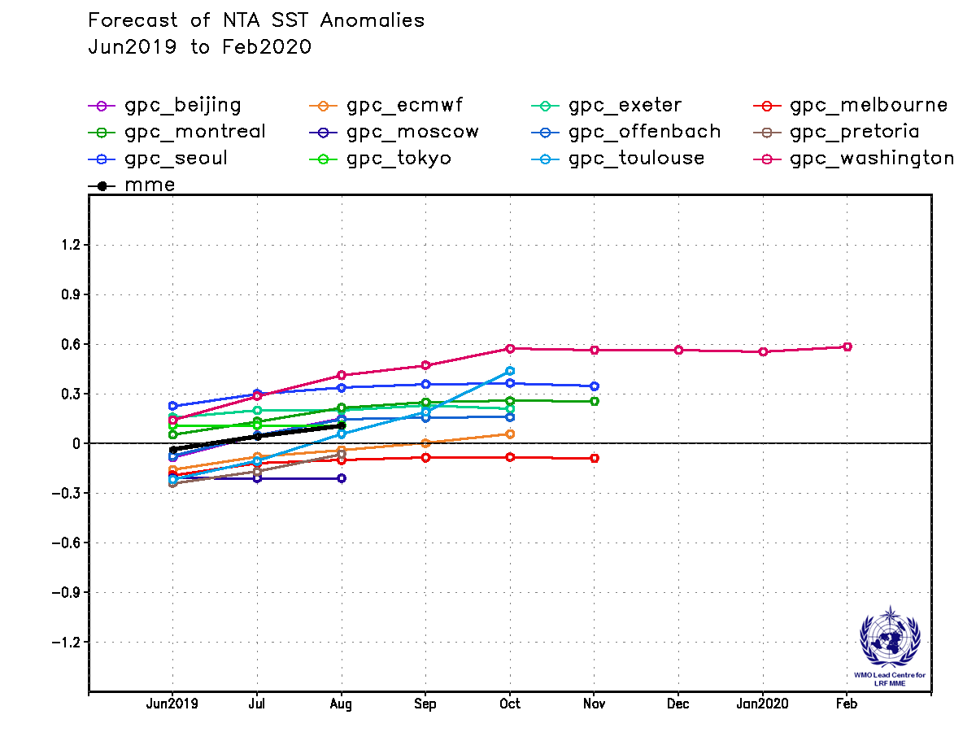
Southern Tropical Atlantic (STA)
SSTA[30°W-10°E, 20°S-0°]
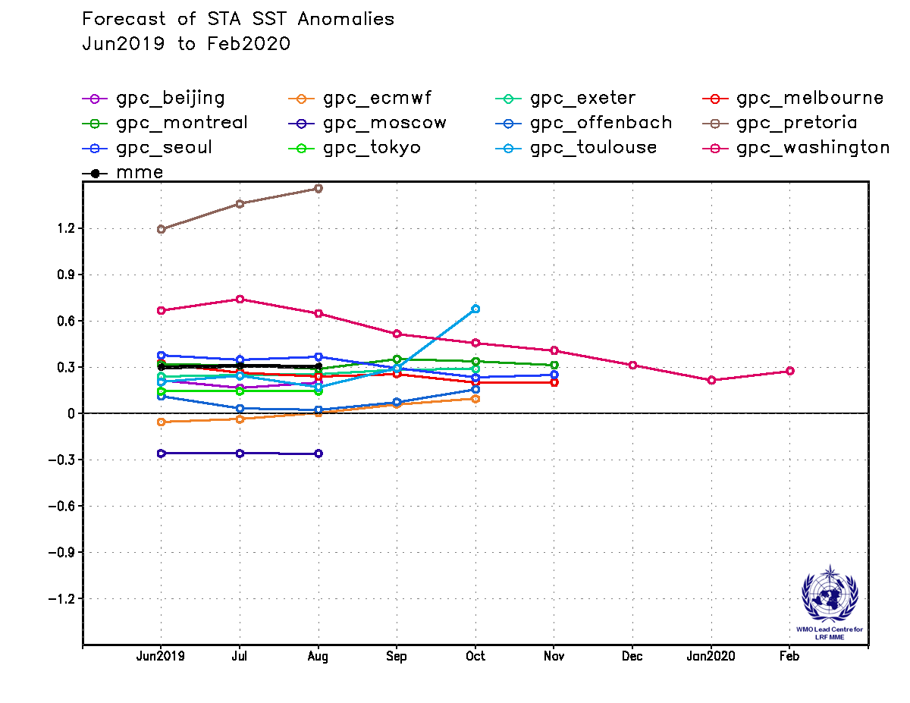

2.8 Further information on GPC hindcasts and forecasts
The probabilistic multi-model ensemble (PMME) prediction maps are generated from 12 GPCs operating models with hindcast periods that include the 1993-2009 (17 year) period, which is used as a common baseline in the multi-model products. The following table summarizes the information on the hindcast period, number of hindcast members and number of forecast members supplied by each of the 13 GPCs. An “X” indicates that hindcast data is not currently available from the corresponding GPC.
GPC | Hosting  Agency | Hindcast  Period | Hindcast  Data | Hindcast  Members | Forecast  Members
Beijing | BCC | 1991-2010 | O | 24 | 24
CPTEC | CPTEC | 1979-2010 | O | 10 | 15
ECMWF | ECMWF | 1993-2016 | O | 25 | 51
Exeter | UKMO | 1993-2016 | O | 28 | 42
Melbourne | BoM | 1980-2011 | O | 99 | 33
Montreal | CMC | 1981-2010 | O | 20 | 20
Moscow | HMC | 1986-2010 | O | 10 | 20
Offenbach | DWD | 1990-2017 | O | 30 | 50
Pretoria | SAWS | 1982-2009 | O | 10 | 40
Seoul | KMA | 1991-2010 | O | 12 | 42
Tokyo | JMA | 1979-2014 | O | 10 | 51
Toulouse | Meteo-France | 1993-2016 | O | 25 | 51
Washington | NCEP | 1982-2010 | O | 20 | 40

