Covariation of the Indian Ocean Dipole and ENSO associated with ocean subsurface variability
Hui Wang¹, Arun Kumar¹, Raghu Murtugudde²
¹ NOAA/NWS/NCEP/Climate Prediction Center
² ESSIC, University of Maryland
Abstract
Previous studies have suggested that a positive (negative) phase of the Indian Ocean Dipole (IOD) tends to co-occur with El Niño (La Niña), and therefore, the IOD may help predict ENSO at a longer lead time. In this study, the covariation of the IOD and ENSO is examined using the extended empirical orthogonal function (EEOF) method. The evolution of the IOD and ENSO is linked to two leading EEOF modes of subsurface ocean temperature in the tropical Indian and Pacific Oceans. In the first EEOF mode, the development of a positive phase of the IOD follows the growth of El Niño, suggesting a potential influence of ENSO on the IOD. In the second mode, the subsurface temperature anomalies in the eastern Indian Ocean associated with the IOD may initiate ocean temperature anomalies in the subsurface western Pacific, where the associated thermocline variability can lead to the development of ENSO. This indicates the influence of the IOD on ENSO. Both 10-m wind and SSH anomaly patterns associated with the two modes are consistent with the interaction between the IOD and ENSO. We will also show that it is the IOD related to the second EEOF mode that can improve the ENSO prediction at longer lead times.

Data used
480-year CFSv1 ENSO run and no-ENSO run
36-year (1980–2015) GODAS

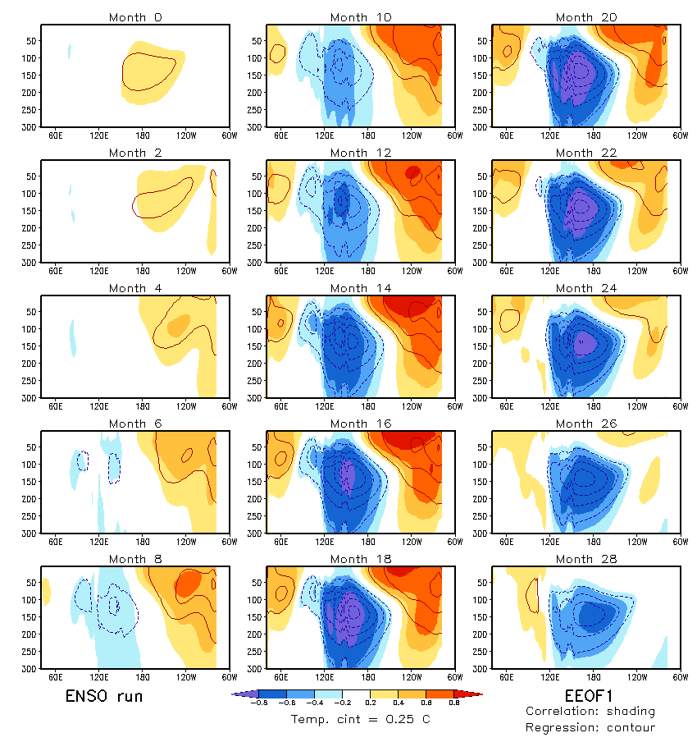
First extended EOF (EEOF) mode of ocean subsurface temperature averaged between 10ºS and 5ºN over the domain of (50ºE–180º, 0–300-m depth) for the 480-year ENSO run. Shadings are correlation coefficients and contours are regression coefficients against the EEOF PC time series.
The development of the IOD follows the growth of El Niño. Associated with the evolution of El Niño (developing, peak, and decaying stages), the IOD also goes through forming, intensifying, and transition phases.
/cpc/home/hwang/2014_IOD/EOF_freerun/EEOF_c_IOD-ENSO_b2/Fig_Eeof1.gs
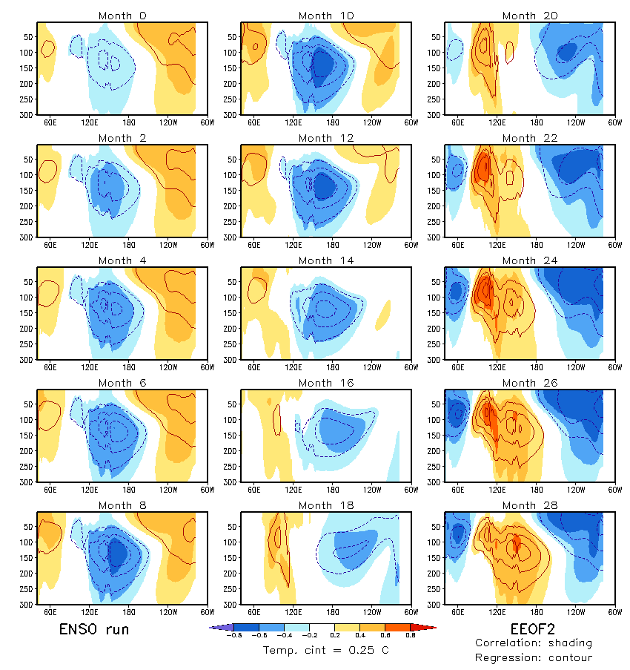
The second EEOF mode for the ENSO run.
There are covariations between the positive phase of the IOD and El Niño and between the negative phase of the IOD and La Niña. The development of the warm temperature anomalies in the western Pacific follows the warm temperature anomalies in the eastern Indian Ocean (months 18–28). This type of the IOD is expected to help improve ENSO prediction because the IOD may affect the thermocline variability in the western Pacific.
/cpc/home/hwang/2014_IOD/EOF_freerun/EEOF_c_IOD-ENSO_b2/Fig_Eeof2.gs
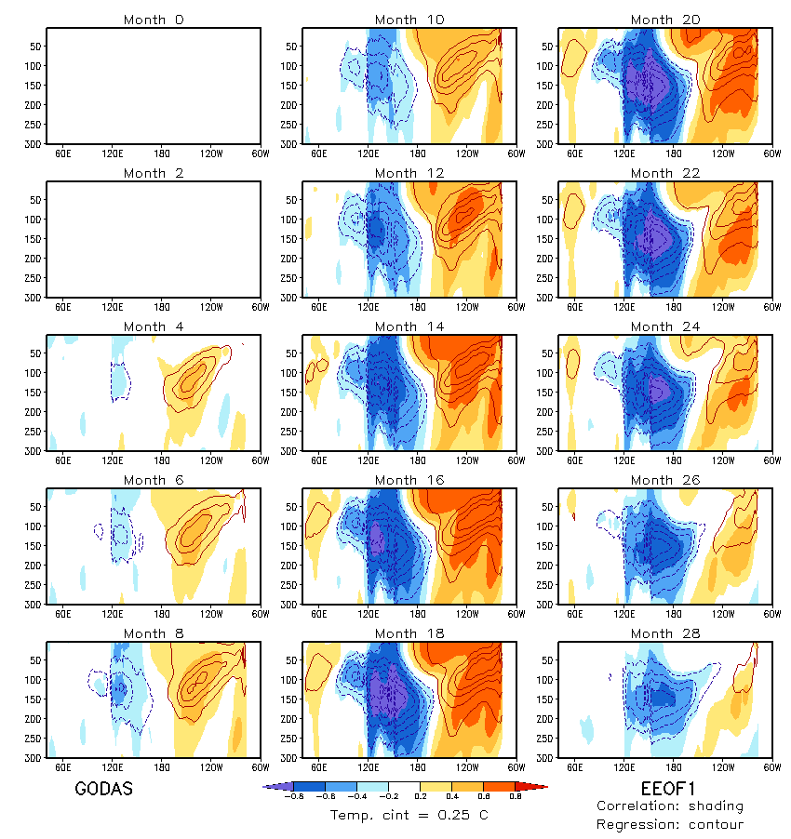
The first EEOF of GODAS (1981–2015)
The EEOF results are consistent with the EEOFs of GODAS.

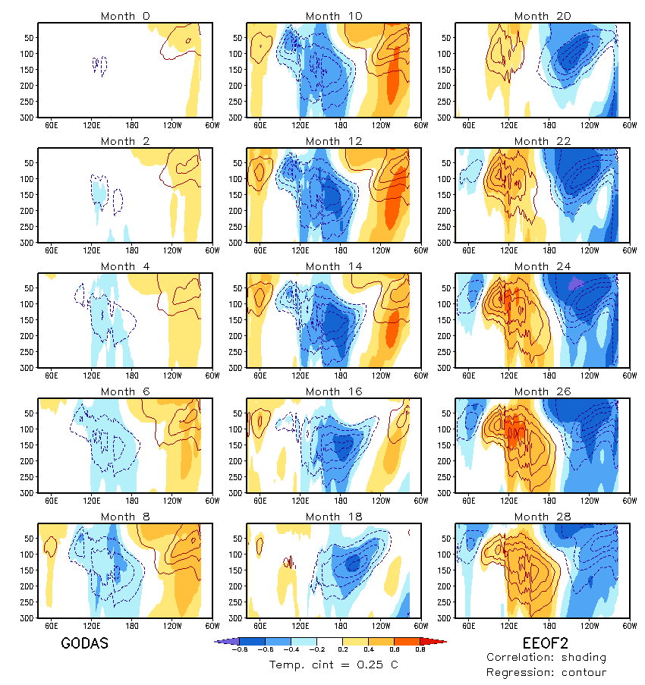
EEOF2 of GODAS (1981–2015)

Lead and lag correlations between EEOF1 and EEOF2 PC time series. Red is for ENSO run, blue is for GODAS, and orange is for no-ENSO run.
The evolutions of both ENSO and IOD involve the oscillation between EEOF1 and EEOF2. Comparing the ENSO run and no-ENSO run, ENSO increases the period of the IOD.
(Maybe not:
/cpc/home/hwang/2014_IOD/EOF_freerun/EEOF_c_IOD-ENSO_b2/pc1_pc2_lead-lag.gs

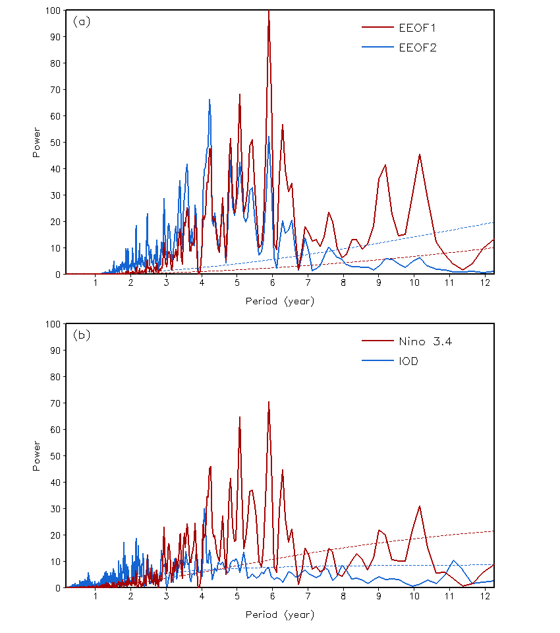
Power spectra of (a) the 480-year EEOF1 (red) and EEOF2 (blue) PC time series and (b) the 480-year Nino-3.4 SST index (red) and the IOD index (blue) time series for the ENSO run.
Both PC time series are dominated by the variability at the interannual time scale (3–7 years). A comparison between (a) and (b) suggests that EEOF1 is more related to ENSO, whereas EEOF2 is more related to the IOD.
/cpc/home/hwang/2014_IOD/Ana_freerun/Power_IOD.gs
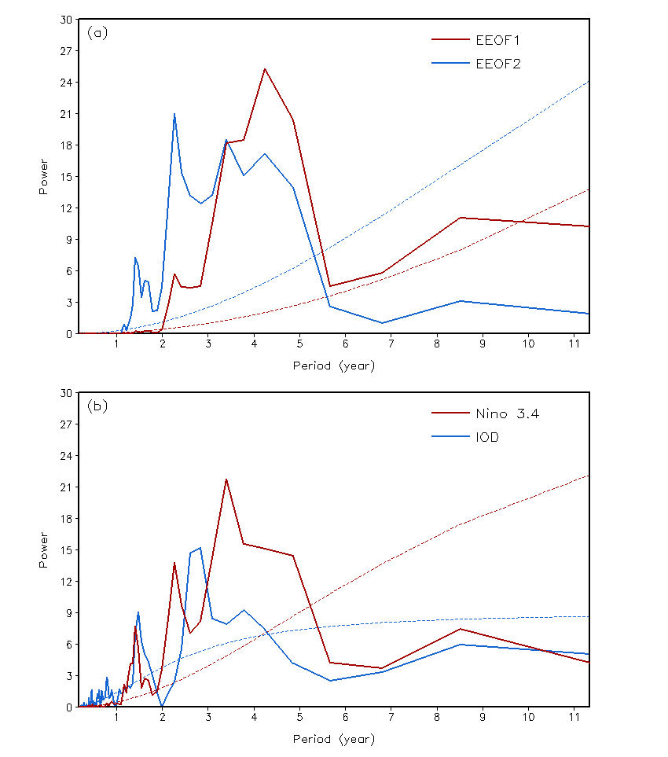
Power spectra of (a) the 36-year (1981–2015) EEOF1 (red) and EEOF2 (blue) PC time series and (b) the 36-year Nino-3.4 SST index (red) and the IOD index (blue) time series for GODAS.
The results of the power spectra for the ENSO run are similar to those of GODAS.

Auto-correlation of the 480-year EEOF1 (red) and EEOF2 (blue) PC time series for the ENSO run.
Consistent with the power spectrum analysis, the period of EEOF1 is slightly longer than EEOF2.

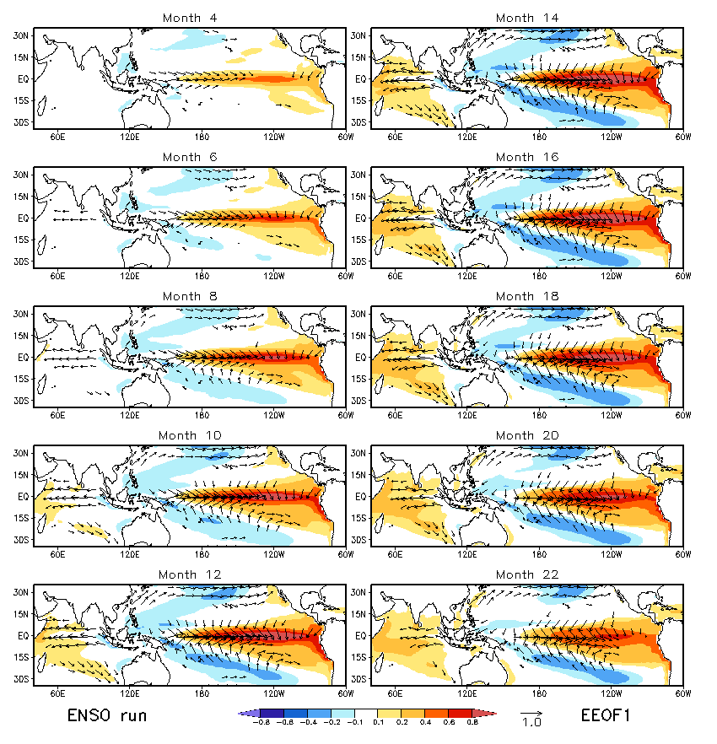
Regression SST (shading; unit: K) and 10-m wind (vector; unit: m s⁻¹) anomalies associated with EEOF1 in the ENSO run.
Associated with EEOF1, El Niño may induce easterly wind anomalies in the Indian Ocean through the changes in the Walker circulation (ENSO influences the IOD).

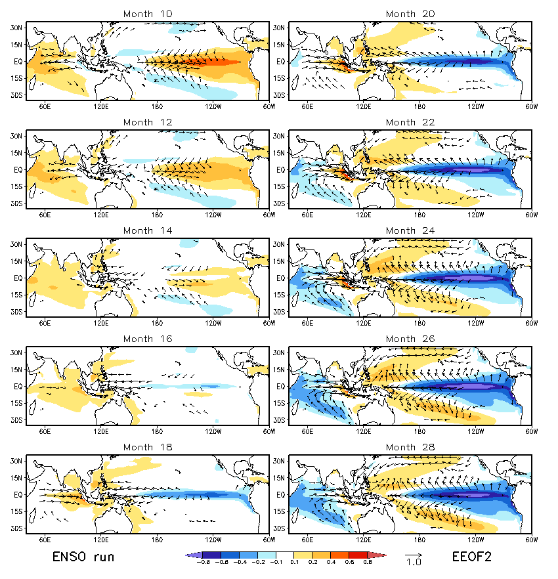
Regression SST (shading; unit: K) and 10-m wind (vector; unit: m s⁻¹) anomalies associated with EEOF2 in the ENSO run.
Associated EEOF2, the transition of the IOD from a positive phase to a negative phase (months 10–18) may cause a collapse of zonal wind anomalies in the tropical Pacific, leading to the development of La Niña (The IOD influences ENSO).

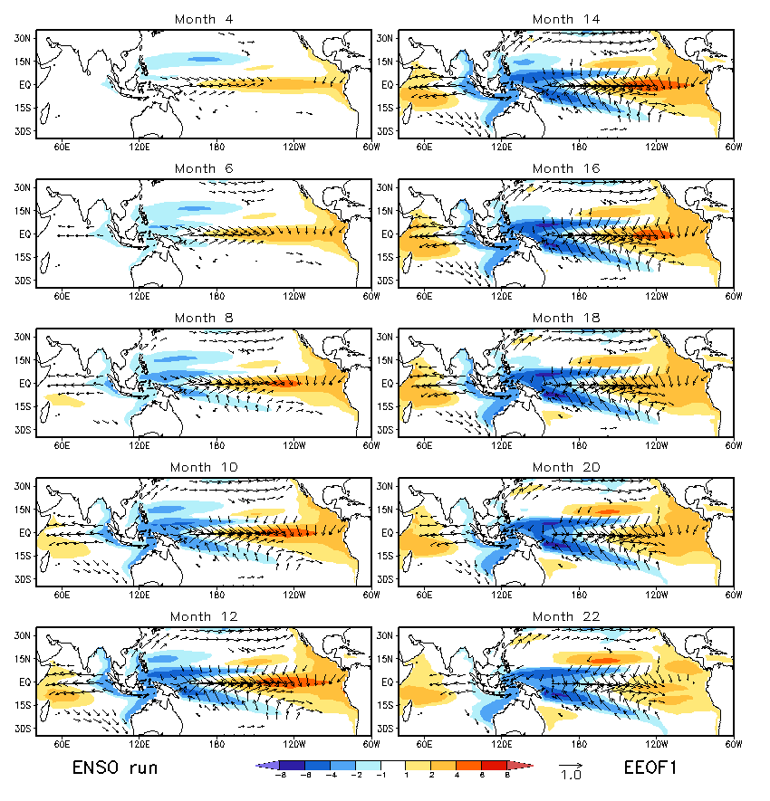
Regression SSH (shading; unit: cm) and 10-m wind (vector; unit: m s⁻¹) anomalies associated with EEOF1 in the ENSO run.
The patterns of SSH and 10-m wind anomalies are consistent with the SST anomalies and ocean subsurface variability in the tropical Indian Ocean and the tropical Pacific.

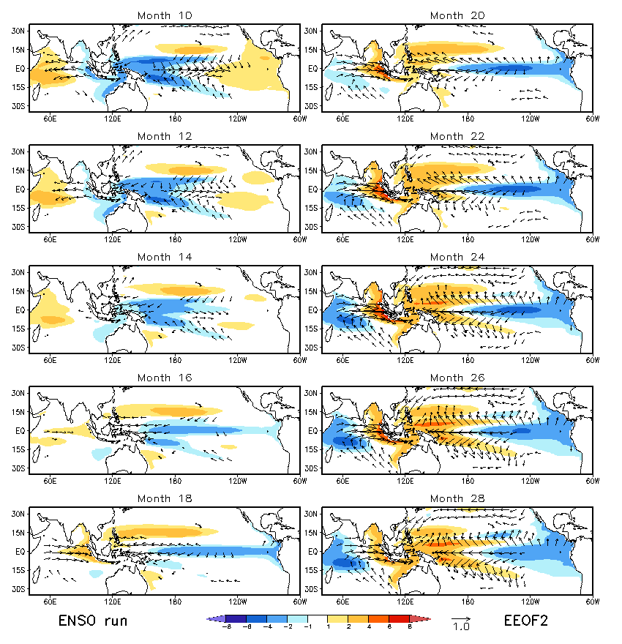
Regression SSH (shading; unit: cm) and 10-m wind (vector; unit: m s⁻¹) anomalies associated with EEOF2 in the ENSO run.

